California Department of Education  SBE-002-1 (REV 11/16/06) | info-cib-pdd-feb07item01
State of California | Department of Education

memorandum

Date: | January 30, 2007

TO: | Members, STATE BOARD of EDucation

FROM: | GAVIN PAYNE  Chief Deputy Superintendent of Public Instruction

SUBJECT: | National Board Certified Teachers: Distribution of California Teachers

The National Board for Professional Teaching Standards (NBPTS) recently announced the names of 293 California teachers who have achieved the distinction of National Board Certified Teacher (NBCT). With a total of 3,659 NBCTs, California is ranked fourth in the nation in the total number of NBCTs. The number of NBCTs in California has nearly tripled in the past five years (1,303 in 2001 to 3,659 in 2006).

Nationwide, nearly 7,800 teachers earned national certification in 2006, bringing the national total to 55,306. A directory of these exemplary teachers is available at http://www.nbpts.org/resources/nbct_directory with search parameters of name, state, city, district, or certification area.

The following graph illustrates the growth in the number of NBCTs since 1994, when the first group of teachers earned certification from the NBPTS.

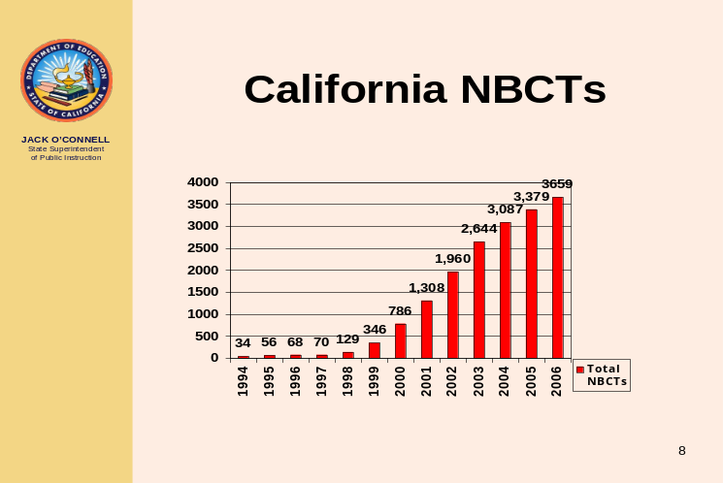

California Education Code Section 44395 provides a $20,000 incentive for NBCTs who teach in high-priority schools, which is paid over four consecutive years. Approximately 40 percent of California’s NBCTs received a $5,000 payment for the 2005-06 school year.
National Board Certification attests that a teacher was judged by his or her peers as one who is accomplished, makes sound professional judgments about students, and acts effectively on those judgments. It allows teachers to gauge their skills and knowledge against objective standards of advanced practice. National Board Certification complements, but does not replace state licensing. While state-licensing systems set entry-level standards for novice teachers, National Board Certification establishes advanced standards for experienced teachers.

For each of 24 certificate areas, the NBPTS offers a performance-based assessment, which takes from one to three years to complete. The assessment process includes two components:
National Board Certified Teachers…
Page 4 of 4

- Candidates must submit a portfolio comprised of three classroom-based entries, including videos, to document the candidate’s teaching practice. The fourth entry documents the teacher’s work with students’ families and the community, as well as the teacher’s professional growth.
- Candidates are also required to sit for a three-hour assessment of their content knowledge.

National Board Certification raises the quality of the teaching profession. It creates a high standard for the profession and the process leading to national certification offers high quality professional development. Accomplished teachers form the core of the teaching profession. Their knowledge and leadership are central to any effort to educate each of our students to high academic standards.

The following graphic illustrates where NBCTs are distributed throughout California.

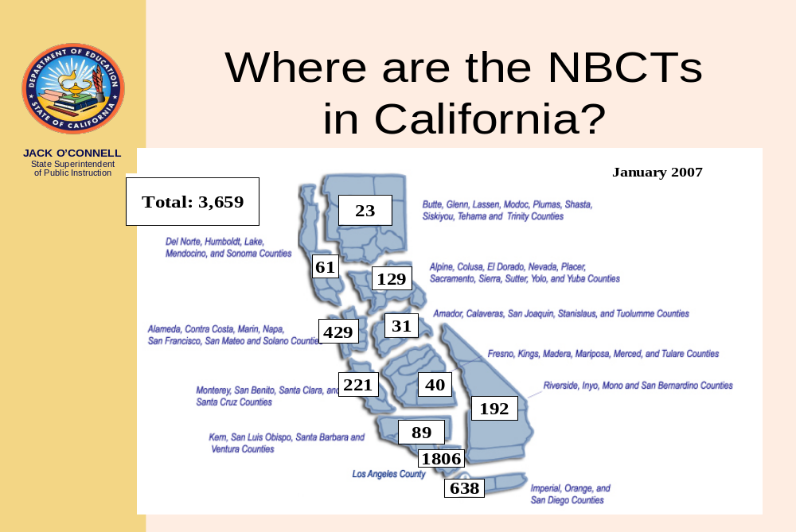
Of the 366 school districts with NBCTs, the following districts have at least 15.

Anaheim City SD | New Haven USD | San Jose USD
Chaffey Joint Union HSD | Newport-Mesa USD | San Juan USD
Chula Vista ESD | Oakland USD | Santa Ana USD
East Side Union HSD | Oceanside USD | Santa Clara USD
Elk Grove USD | Palo Alto USD | Santa Monica Blvd. Charter
Fairfield-Suisun USD | Pasadena USD | Santa Monica – Malibu USD
Folsom-Cordova USD | Poway USD | Sequoia Union HSD
Glendale USD | Riverside USD | Sweetwater Union HSD
Grossmont Union HSD | San Bernardino City USD | Walnut Valley USD
Long Beach USD | San Diego City USD | Whittier Union HSD
Los Angeles USD | San Francisco USD | William S. Hart Union HSD
Anaheim City SD | New Haven USD | San Jose

Additional information regarding National Board Certification for California teachers is available at http://www.cde.ca.gov/pd/ps/te/nbpts.asp.

