California Department of Education  Executive Office  SBE-002 (REV. 01/2011) | memo-dsib-adad-dec14item01

memorandum

Date: | December 2, 2014

TO: | MEMBERS, State Board of Education

FROM: | TOM TORLAKSON, State Superintendent of Public Instruction

SUBJECT: | Smarter Balanced Member States Approve Achievement Levels

Summary of Key Issues

California and other member states of the Smarter Balanced Assessment Consortium recently voted to approve achievement levels for the English-language arts (ELA)/literacy and mathematics Smarter Balanced assessments that will be administered as part of the California Assessment of Student Performance and Progress System. Attachment 1 provides Smarter Balanced’s press release that includes information regarding the approval of the Smarter Balanced achievement levels. Included in Attachment 1 are achievement level charts that display the threshold scores that distinguish the four achievement levels and the estimated percentages of students across all member states that would have scored at each achievement level based on data from the spring 2014 Field Test. Also included in Attachment 1 is a position paper on broad guidelines for interpreting scores and achievement levels approved by the Smarter Balanced member states.

Attachment 1 describes how sources and achievement levels can be interpreted by states in the Smarter Balanced Assessment Consortium. It explains that while achievement levels are a reporting feature that is federally required under the No Child Left Behind Act, characterizing a student’s achievement solely in terms of these levels is an oversimplification. Scale scores are more precise for describing student gains over time or changes in achievement gaps among groups of students. Smarter Balanced states, including California, will continue to investigate methods of analyzing and reporting achievement data to students, parents/guardians, and teachers in 2015 and beyond.

Information about the achievement levels can be found on the Smarter Balanced Achievement Levels Web page [Note: the link to the Achievement Levels is no longer valid as of 2017]. Detailed in the achievement level charts (Attachment 1) Smarter Balanced estimates that the percentage of students who would have scored “Level 3 or higher” in mathematics ranged from 39 percent in grade three to 32 percent in grade eight. In ELA/literacy, the percentage of students who would have scored “Level 3 or higher” ranged from 38 percent in grade three to 44 percent in grade five. Please see pages 3 and 4 of Attachment 1 for broad guidelines for the interpretation and use of scores and achievement levels.

Smarter Balanced has also developed a set of policy achievement level descriptors for ELA/Literacy and mathematics that are aligned with the Common Core State Standards and the Smarter Balanced assessment claims (ELA/literacy and mathematics are each composed of four claims). More information on the four ELA/literacy claims is available in the Smarter Balanced Web document Claims for the English Language Arts/Literacy Summative Assessment [Note: the link to the Summative Assessment is no longer valid as of 2017]. Also, details on the four mathematics claims can be found on the Smarter Balanced Web document Claims for the Mathematics Summative Assessment [Note: the link to the Mathematics Summative Assessment is no longer valid as of 2017]. The purpose of these descriptors is to specify, in content terms, the knowledge and skills that students display at four levels of achievement (i.e., Level 1, Level 2, Level 3, and Level 4). The titles of these four levels are yet to be determined.

Recommendations for the full implementation of Smarter Balanced Summative Assessments as required by Education Code (EC) Section 60648.5 were presented and approved by the State Board of Education in November 2014. A memorandum of understanding between California and the University of California at Los Angeles (UCLA) was also approved. Oversight for Smarter Balanced now transfers to UCLA. As a Consortium member, California has accepted the Smarter Balanced achievement level recommendations, consistent with EC Section 60648.

Attachment(s)

Attachment 1: Smarter Balanced States Approve Achievement Level Recommendations
Press Release (6 Pages)

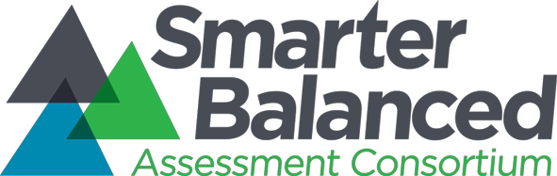

FO R I M M E D I ATE R E LE AS E Co n t a c t : Nov. 17, 2014 media@smarterbalanced.org 657-222-1257
Smarter Balanced States Approve Achievement Level Recommendations

Inclusive, collaborative process collected input from thousands of educators and community members using rigorous design; initial achievement levels will help teachers and parents monitor student progress and focus support in the classroom

OL Y M P I A , W A S H. (November 17, 2014) —Members of the Smarter Balanced Assessment Consortium have voted to approve initial achievement levels for the mathematics and English language arts/literacy (ELA) assessments that will be administered in 17 states and one territory this school year. The vote marks an important milestone in the development of the assessment system.

“These initial achievement levels were developed with input from thousands of educators and community members, reflecting a diverse cross-section of views on education. Moving forward, the achievement levels, along with scale scores that also will be reported, will help teachers and parents understand student performance and needs for support,” said Smarter Balanced Executive Director, Joe Willhoft.

The achievement levels serve as a starting point for discussion about the performance of individual students and of groups of students in mathematics and English Language arts. There are other measures that students, teachers and parents can also use to help evaluate the academic progress of students and schools, such as scale scores, growth models, and portfolios of student work. The states also unanimously approved a position paper to provide broad guidelines for how the scores and achievement levels can be used and interpreted by state officials, parents, teachers and other stakeholders (see attached).

Since Smarter Balanced is offering assessments for both ELA and math for grades 3-8 and high school, the recommendations include achievement level scores for both subject areas and at each of those grade levels. The attached charts display the threshold scores that distinguish four achievement levels and display the estimated percentage of students across all Smarter Balanced states who would have scored at each level based on data from the Consortium’s spring 2014 field test. Smarter Balanced estimates that the percentage of students who would have scored “Level 3 or higher” in math ranged from 32 percent in Grade 8 to 39 percent in Grade 3. In English language arts, the percentage of students who would have scored “Level 3 or higher” ranged from 38 percent in Grade 3 to 44 percent in Grade 5. See the attached charts for further details.

“Because the new content standards set higher expectations for students and the new tests are designed to assess student performance against those higher standards, the bar has been raised. It’s not surprising that fewer students could score at Level 3 or higher. However, over time the performance of students will improve,” said Willhoft.

Willhoft added, “It’s important to note that the figures released today are a Consortium-wide estimate based on the spring 2014 Field Test. Once the operational assessment is administered in 2015, states will have a much clearer picture.”

To create the achievement levels, Smarter Balanced organized an unprecedented level of educator and public input, involving thousands of interested constituents, using a rigorous process known as the “bookmarkprocedure.”

During an in-person panel, held in Dallas, Texas, close to 500 teachers, school leaders, higher education faculty, parents, business and community leaders reviewed test questions and determined the threshold scores for four achievement levels for each grade and subject area. Member states had representatives at each grade level for grades 3 through 8 and high school. Educators with experience teaching English language learners, students with disabilities and other traditionally under-represented students participated to help ensure that the achievement levels are fair and appropriate for all students.

In addition, an online panel was open to educators, parents and other interested members of the community to provide unprecedented input on the achievement levels. More than 2,500 people participated in the online panel.

A cross-grade review committee composed of 72 members of the in-person panels then took the results of the online and in-person panels into account to develop recommendations that coherently aligned across grades and that reflected student progress from year to year.

As an additional step, Smarter Balanced engaged an external auditor, an Achievement Level Setting Advisory Panel and its standing Technical Advisory Committee to review the recommendations before they were presented to the states for approval. The auditor and both advisory panels certified that Smarter Balanced conducted a valid process that is consistent with best practice in the field.

In approving the Achievement Levels, Smarter Balanced member states relied primarily on the recommendations from the Achievement Level Setting process. Members also gave consideration to other sources of information about the general content readiness of high school students to engage in credit-bearing college-level work. This included a comprehensive body of research on college academic preparedness of high school students conducted by the National Assessment Governing Board (NAGB), the oversight body for the National Assessment of Educational Progress.

Over the coming months, member states will present these achievement level recommendations to the policy-making entities that have the authority to formally adopt achievement levels in each state. This authority most typically rests with the state board of education.

###

Ab o ut Sm ar t e r B al an c e d

The Smarter Balanced Assessment Consortium brings together states to create a shared, innovative assessment system for mathematics and English language arts/literacy that is aligned with the Common Core State Standards and helps prepare students for success in college and careers. The Consortium involves educators, researchers, policymakers, and community groups in a transparent and consensus-driven assessment development process. For more information, please visit http://www.smarterbalanced.org

Interp retation and Use of Scores and Achievem ent Levels

States in the Smarter Balanced Assessment Consortium (Smarter Balanced) will report scores on its assessments in several ways, which can serve different purposes for their stakeholders. Scale scores are the basic units of reporting. These scores, which fall along a continuous vertical scale (from approximately 2000 to 3000) that increases across grade levels, can be used to illustrate students’ current level of achievement and their growth over time in a relatively fine-grained fashion. When aggregated, these scores can also describe school- or district-level changes in performance on the tests and can measure gaps in achievement among different groups of students.

Smarter Balanced has also developed a set of initial, policy achievement level
descriptors (ALDs) for English language arts/Literacy (ELA/Literacy) and mathematics that are aligned with the Common Core State Standards (CCSS) and the Smarter Balanced assessment claims. The purpose of these descriptors is to specify, in content terms, the knowledge and skills that students display at four levels of achievement (i.e., Level 1, Level 2, Level 3, and Level 4), which in some contexts may also be described qualitatively in terms such as “novice, developing, proficient, advanced” or others.1

Defining these levels of achievement (“Achievement Levels”) is a reporting feature that is federally required under the No Child Left Behind Act, and one that has become familiar to many educators. However, characterizing a student’s achievement solely in terms of falling in one of four categories is an oversimplification. Achievement Levels should serve only as a starting point for discussion about the performance of students and of groups of students. That is, the Achievement Levels should not be interpreted as infallible predictors of students’ futures. They must continuously be validated, and should be used only in the context of the multiple sources of information that we have about students and schools. Achievement level descriptors do not equate directly to expectations for “on-grade” performance; rather, they represent differing levels of performance for students within a grade level. Additionally, the Achievement Levels do not preclude or replace other methods of evaluating assessment results, including measures of year-to-year growth that use the underlying scale scores.

1 The Achievement Level Descriptors were developed based on the feedback of reviewers who engaged in a validation process based on examining the Common Core State Standards in each content area and the items on the examination. Additional research will be needed to validate the achievement level descriptors in relation to the actual success rates of students when they enter college and careers.
Although the Achievement Level Descriptors are intended to aid interpretation of Achievement Levels, they will be less precise than scale scores for describing student gains over time or changes in achievement gaps among groups, since they do not reveal changes of student scores within the bands defined by the achievement levels. Furthermore, there is not a critical shift in student knowledge or understanding that occurs at a single cut score point. Thus, the achievement levels should be understood as representing approximations of levels at which students demonstrate mastery of a set of concepts and skills, and the scale scores just above and below an achievement level as within a general band of performance.

As Smarter Balanced states consider these Achievement Levels, they will continue to investigate and apply a variety of methods of analyzing and reporting the data that provide information to their students, parents and teachers, including but not limited to student and student subgroup averages, medians, and other descriptive statistics that utilize the underlying vertical scale.

The Achievement Level Descriptors presented here are linked to an operational definition of college content-readiness to inform score interpretation for high schools and colleges. In particular, a score at or above “Level 3” in 11th grade is meant to suggest conditional evidence of readiness for entry-level, transferable, credit-bearing college courses. Since college readiness encompasses a wide array of knowledge, skills, and dispositions, only some of which can be measured by the Smarter Balanced assessments, “college readiness” in this context is defined as “content-readiness” in the core areas of ELA/Literacy and mathematics.

High schools may combine scores at 11th grade with additional data (courses completed, grades, portfolios, performance assessments, other test data) to determine appropriate courses of study and supports for students in the 12th grade. Similarly, as colleges interpret scores on Smarter Balanced assessments, they are encouraged to evaluate additional data (courses completed, grades, portfolios, performance assessments) to determine admissions, advisement, and placement in developmental or credit-bearing courses.

Smarter Balanced does not yet have a parallel operational definition and framework for
career readiness.

Adopted November 14, 2014

2800

2750

2700
Threshold Scale Score

2650

2600

2550

2500

2450

2400

2350

2300
Mathematics: Threshold Scale Scores

3 4 5 6 7 8 9 10 11

Grade

Level 4
Level 3
Level 2

Adopted November 14, 2014

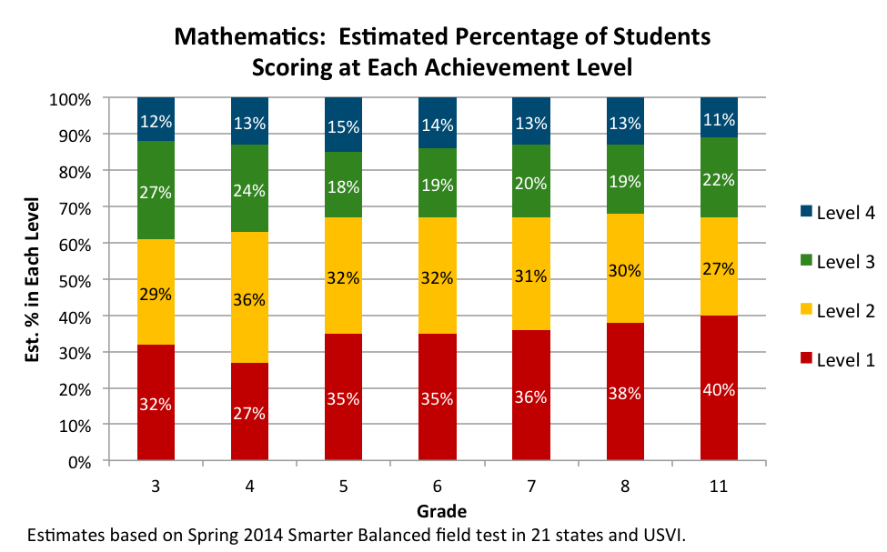

.

2800

2750

2700
Threshold Scale Score

2650

2600

2550

2500

2450

2400

2350

2300
English Language Arts/Literacy: Threshold Scale Scores

3 4 5 6 7 8 9 10 11

Grade

Level 4
Level 3
Level 2

Adopted November 14, 2014

