California Department of Education  Executive Office  SBE-002 (REV. 01/2011) | memo-dsib-adad-dec15item01

memorandum

Date: | December 16, 2015

TO: | MEMBERS, State Board of Education

FROM: | TOM TORLAKSON, State Superintendent of Public Instruction

SUBJECT: | Conducted and Planned Studies of the Validity, Reliability, and Fairness of the California Assessment of Student Performance and Progress System

Summary of the Key Issues

The 2014–15 school year was the second year of the California Assessment of Student Performance and Progress (CAASPP) System, and the first year of operational testing for the new Smarter Balanced assessments in English language arts/literacy (ELA) and mathematics. In the 2013–14 school year, California students participated in a statewide field test that provided important information about the test and the test items, but provided only limited information on student performance.

With the conclusion of the 2014–15 reporting cycle, data on student performance, as well as data on item performance, will be available to the California Department of Education (CDE), Educational Testing Service (ETS), the Smarter Balanced Assessment Consortium, and Human Resources Research Organization (HumRRO) that is the independent evaluator of the CAASPP System.

The purpose of this memo is to outline the work that has been done, and the work that is being undertaken to assess the validity, reliability, and fairness of the assessments that comprise the CAASPP System. Also discussed are studies that will occur as new assessments are developed and administered. The current contract with ETS includes the Smarter Balanced assessments in ELA and mathematics, development of the California Alternate Assessment (CAA), the primary language assessment, and new science assessments aligned to the Next Generation Science Standards (NGSS).

California Education Code (EC) Section 60640 established the CAASPP System, and EC Section 60649 specifies the desired characteristics of the assessments, including the requirement that they be valid, reliable, and fair to all students. The law also calls for the independent evaluation of the CAASPP System.

Framework for Validity, Reliability, and Fairness

The Standards for Educational and Psychological Testing, 2014 (Standards) lay out the characteristics of valid, reliable, and fair assessments. The Standards define validity as the degree to which the results of an assessment support the intended uses of the results. Reliability is the consistency of scores across instances of the testing procedure. Fairness is the degree to which the assessment maximizes the opportunity for test takers to demonstrate their understanding on the construct the test is intended to measure.

Establishing validity is an ongoing process. There is no single indicator of validity. The process of validation involves accumulating relevant evidence to provide a sound scientific basis for the proposed score interpretations. This evidence begins with the stated purpose of the test and includes: (1) documentation of the construct(s) to be measured, (2) development of test specifications and blueprints, (3) item development specifications, (4) content and bias review procedures, (5) studies of the alignment of tests and test items with the content knowledge to be measured, (6) test administration procedures, and (7) reporting and use of test results.

Information documenting the validity, reliability, and fairness of an assessment are contained in the technical reports provided by the test developer and the test administration contractors. For the CAASPP System, additional reports will be produced by HumRRO, the independent evaluator. Multiple studies are required to establish the validity, reliability, and fairness of any assessment.

For example, studies of the performance and alignment of the test and test items will be largely the responsibility of the consortia through the National Center for Research on Evaluation, Standards, and Student Testing (CRESST). Studies related to the administration of the assessment, as well as reporting of results, will primarily be the responsibility of ETS, the assessment administration contractor. Studies of the interaction of the schools with the assessments will be conducted by both ETS and the independent evaluator, HumRRO. Included will be studies of the impact of the CAASPP System as a whole on teaching and learning, including the use of the interim assessment and formative assessment components of the system. Each of the organizations studying the performance of the assessments will be completing studies that, taken together, will provide substantiation for the validity, reliability, and fairness of the assessments.

As part of the ongoing collection of evidence to establish validity, these studies will in turn form the basis for California’s submission to the U.S. Department of Education (ED) peer review process. Guidance released by the ED on September 25, 2015, outlines the main components of the peer review process, which draw heavily on the Standards. Figure 1 presents the main elements of peer review, and the ED’s view of which organizations may be responsible for the various required elements.

Figure 1. Critical Elements of State Assessment System Peer Review
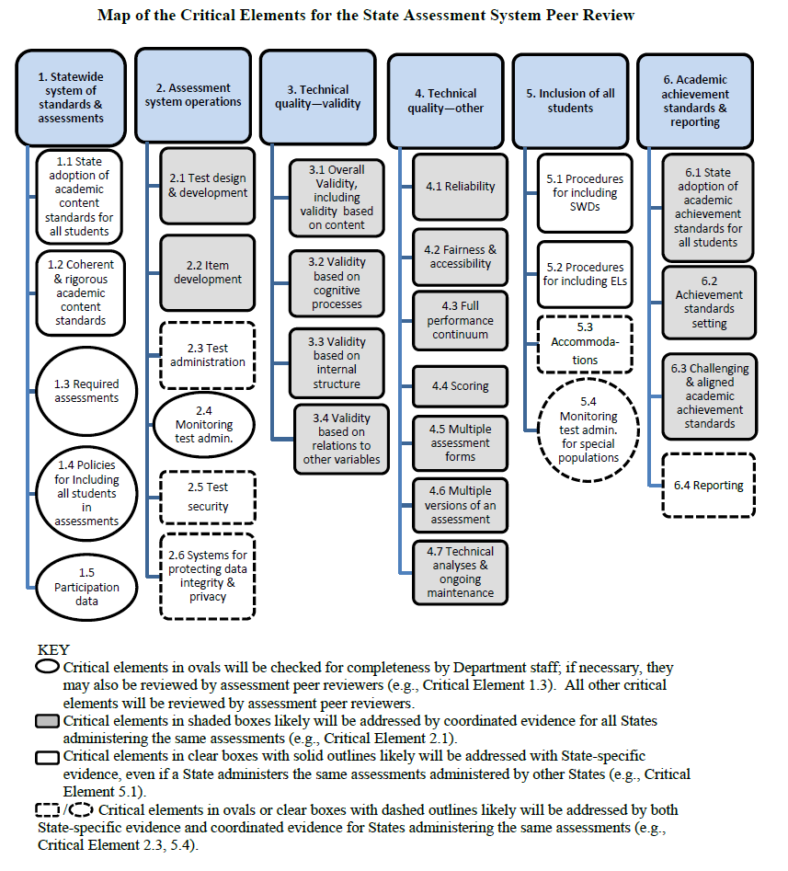
The Accessible Alternative Version (AAV) of Figure 1 can be located on CDE Assessment Peer Review Critical Elements Map Web page at http://www.cde.ca.gov/ta/tg/ai/saspeerreview.asp.

Evidence for the Validity, Reliability, and Fairness of the Smarter Balanced Assessments

The development of the Smarter Balanced assessments has included extensive documentation of how the assessments were designed, as well as numerous studies addressing various elements of validity, reliability, and fairness.

Reports and studies conducted to date include:

Test Blueprints – The following documents show how the computer adaptive test (CAT) items and performance task items are assessed in the Smarter Balanced Summative Assessments for ELA and mathematics:
- ELA/Literacy Smarter Balanced Summative Assessment Blueprint [Note: Invalid link removed.]
- Mathematics Smarter Balanced Summative Assessment
[Note: Invalid link removed.]
Content Specifications – The Smarter Balanced Assessment Consortium developed content specifications in ELA and mathematics to ensure that the assessments cover the range of knowledge and skills in the Common Core State Standards (CCSS). The content specifications serve as the basis for the Smarter Balanced system of summative and interim assessments and formative assessment support for teachers. The following are Web links to the content specifications:
- ELA/Literacy Content Specifications
[Note: Invalid link removed.]
  - Appendix B: Grade Level Tables for All Claims and Assessment Targets and Item Types
[Note: Invalid link removed.].
- Mathematics Content Specifications
[Note: Invalid link removed.]
Item and Performance Task Specifications – The specifications provide guidance on how to translate the Smarter Balanced content specifications into actual assessment items. In addition, guidelines for bias and sensitivity, accessibility and accommodations, and style help item developers and reviewers ensure consistency and fairness across the item bank. The specifications and guidelines were reviewed by member states, school districts, higher education leaders, and other stakeholders. These documents are available on the Smarter Balanced Web site at http://www.smarterbalanced.org/smarter-balanced-assessments/.
The Smarter Balanced Field Test Technical Report (Smarter Balanced Assessment Consortium) – This report documents extensively the process used to develop the assessments, test items, testing procedures, cut scores and reporting metrics and provides comprehensive and detailed evidence in support of the validity of the Smarter Balanced assessment system. Validity information is provided from the initial Pilot Test and the later Field Test phases. The report also documents item development, test design, test fairness, field test design, item analyses, scaling and linking analyses, and includes a report on the achievement level setting. The report is located on the Smarter Balanced Web site at [Note: Invalid link removed.].
Alignment Study – An independent study of the alignment of the tests with the CCSS in ELA and mathematics was conducted by HumRRO under subcontract with CTB/McGraw Hill (CTB). The goal of this project was to gather evidence to examine the validity of the Smarter Balanced Summative Assessments in terms of their alignment to the CCSS.

Automated Scoring Studies – CTB conducted a set of research studies regarding the use of automated scoring for short-text and essay items on the Smarter Balanced assessments. The report documents how automated scoring procedures were designed and how they performed, including comparisons of the reliability of human and machine scoring of items.

Test Scoring Specifications – These specifications document how item scores are combined to calculate an overall test scaled score.

Achievement Level Setting Auditors’ Report (Smarter Balanced Assessment Consortium) – This report documents the findings of an independent audit of the procedures used to set the achievement levels for the Smarter Balanced assessments. This report is located on the Smarter Balanced Assessment Consortium Web site at [Note: Invalid link removed.]

For the 2015 administration of the Smarter Balanced assessments and for each year going forward, CRESST will produce a technical report containing detailed documentation and analyses. CRESST will also produce a series of special studies designed to examine various elements of the assessment. These include on-going psychometric and data analysis, validity studies, and supplemental studies.

The ETS Technical Report for 2014–15 will contain extensive documentation of the test administration process as well as extensive documentation of test results and will include the following:

- Average Discrimination and Difficulty Parameter Estimates of Operational Online Summative Item Pool
- Characteristics of the Vertical Scale and Reporting Metrics
- Participation Rate by Subjects and Grades
- Access to Universal Tools, Designated Supports, and Accommodations
- Item Utilization Rates for Items Presented in the 2015 Online Summative Assessments
- Percentage of Students Who Were Administered the Full Blueprint
- Performance of Students on the Summative Assessments for Each Subgroup
- Score Report Descriptions
- Reliabilities and Standard Errors of Measurement for All Subgroups
- Conditional Standard Error of Measurement at the Performance Level Cut Points
- Inter-rater Reliability for Performance Tasks
- Statistical Summaries of Simulations
- Item Incompletion and Omit Rates for ELA and Mathematics
- Conditional Exposure by Difficulty by Content Area and Grade
- Marginal Reliability for Overall and Claim Scores for All Subgroups
- Smarter Balanced Content Area Correlations

Finally, the independent evaluation of the CAASPP being conducted by HumRRO will include studies in the following areas:

- Validity and Alignment – Evaluation of the validity of scores produced by the CAASPP assessments for measuring performance and progress in learning the CCSS in ELA and mathematics including evidence from studies of the alignment of delivered computer adaptive tests.

- Test, Bias, Fairness, and Access – Evaluation of the utilization of available testing accommodations and supports among districts and the degree of access afforded to students with disabilities and English learners.

- Test Administration and Security – Observation of test administrations to evaluate fidelity with test administration procedures and test security protocols.

- Scoring Processes – Observation of scorer training sessions and evaluation of training procedures. Evaluation of procedures used to ensure acceptable inter-rater reliability and to prevent score drift.

- Score Reporting and Utility – Evaluation of the ability of teachers, schools and districts to retrieve, analyze, and interpret CAASPP test scores. Evaluation of the usefulness of the CAASPP assessments including both the Smarter Balanced Summative and Interim Assessments.

Overall, the reports and studies that have been conducted, and will be conducted on the Smarter Balanced assessments will provide extensive evidence of the validity, reliability, and fairness of the assessments. Taken together, the body of evidence will not only provide information about how the assessments have performed, but will also inform the process of improving the assessments and the utility of the information they provide.

Validity, Reliability, and Fairness of Newly Developed CAASPP Assessments

The current CAASPP contract with ETS includes the development of three new assessments: The CAA, the primary language assessment, and new science assessments aligned to the CA NGSS. ETS will document the development of each test in the annual technical reports containing much of the same information as the Smarter Balanced assessments.

For the science assessments, it is anticipated that HumRRO will conduct an alignment study assessing the degree to which the new assessments measure the CA NGSS and an evaluation of the development processes for new assessments. For all of the assessments, the evaluator will conduct a review of the adequacy of technical reporting and make recommendations for improvement.

Attachment(s)

None.

