School |  | The School of Arts and Enterprise  Pomona, CA 91767-5429  CDS 19-75697-1996693  Charter Number: 0505
Charter Term |  | July 1, 2011 – June 30, 2016
Approved Grade Span | Grades Served | 9-12 |  | 9-12
Enrollment Cap |  | 430
Numerically Significant Subgroups |  | Hispanic or Latino, Socioeconomically Disadvantaged, English Learners
Title I Funded/ PI Status |  | Yes/ Year 2 PI for 2013–14
School Data and Demographics
 |  |  | 2010–11 |  | 2011–12 | 2012–13
Percent Free and Reduced Lunch |  |  | 81 |  | 78 | 60
Percent English Learner |  |  | 28 |  | 21 | 11
Percent Student with Disabilities |  |  | 9 |  | 10 | 6
Fall Enrollment |  |  | 437 |  | 401 | 419
Number of Suspensions |  |  | -- |  | 14 | 0
Number of Expulsions |  |  | -- |  | 0 | 0
Growth API |  |  | 704 |  | 702 | 744
Growth from Prior Year |  |  | 59 |  | 1 | 42
Grade 10 CAHSEE ELA Pass Rate |  |  | 82 |  | 83 | 84
Grade 10 CAHSEE MATH Pass Rate |  |  | 73 |  | 79 | 85
Statewide Rank |  |  | 3 |  | 3 | NA
Similar Schools Rank |  |  | 9 |  | 4 | NA
Cohort Drop Out Rate (High School Only) |  |  | 8.7 |  | 5.1 | NA
Cohort Graduation Rate (High School Only) |  |  | 87 |  | 82.9 | NA
Data suppressed by CDE or not provided by school is indicated by a ‘--‘
Data that is not currently available at this time is indicated by ‘NA’
Data that is not applicable is indicated by ’na’
A school that did not have a valid 2012 Base API and will not have any growth or target information is indicated by ‘B’
2012–13 SBE Actions and Official Correspondence

The School of Arts and Enterprise (SAE) materially revised their petition during the 2012–13 school year to include a middle school component. The SBE approved their revision at the March 2013 meeting.

The SAE received a letter of concern regarding academic achievement from the CDE on November 1, 2012. The SAE was required to submit a SAP for the 2012–13 school year for failing to meet AYP proficiency target in English Language Arts, schoolwide.

2012–13 Key Actions by the Governing Board (as reported in SBE-Authorized Charter School - General Information Form)

The following actions were taken by The SAE’s governing board:

- Approval of school budget 12-13 year long budget
- Personnel and Salary changes
- All required fiscal requirements
- Facility acquisitions for short term and long term middle school occupancy
- Approval of middle school expansion (material revision)
- Negotiations
- Updated parent / student handbook
- Approval of building refinance
- Change of back office services

Fiscal Management
Based on the April SBE Authorized Schools Fiscal Memo, SAE demonstrates an ability to operate with a balanced budget, maintain stable enrollment and attendance ratios, manage cash liquidity and maintain low debt levels, maintain positive fund balances, and the school has met the recommended reserve levels specified in the MOU. The CDE continues to monitor SAE as they report during the fiscal year.
September 2013 SBE-Authorized Charter School Self-Reporting Update on the 2012–13 Measureable Pupil Outcomes

Name of School: The School of Arts and Enterprise

Target Population (including outreach efforts made this year):

During our 2012–13 school year (our 10 year anniversary), we utilized the opportunity to review and revise our outreach materials for parents, students and the community. We promoted our school at community centers, city events and other schools in our geographic area. Our initial efforts of using social media and attending community events increased our student base that resides outside the city of Pomona, thus The SAE made a decision to use target specific messages through e-blasts, direct mail pieces and weekly open houses to increase local awareness and attention.
During the summer of 2012, the SAE initiated a free summer arts program open to all students grades 6-12 to provide an orientation to our school and the programs we offer.

Measurable Pupil Outcome  (PREPOPULATED BY CSD  FROM SCHOOL’S CHARTER) | Outcome Met (Yes/No) | List of Evidence or Narrative on Progress Made Towards Meeting Outcome  (To Be Completed by Charter School)
Meet API growth target each year, both school-wide and in reported subgroups | Yes | This year, The SAE’s growth target was 5 points. We grew 42 points. All subgroups exceeded their targets. Please see the CDE API table below. This data is embargoed from the public until 8/29/13.
Meet AYP | Yes | Please see the CDE AYP table below. This data is embargoed from the public until 8/29/13.
Close the achievement gap between the EL subgroup and overall student population by increasing the subgroup's API by at least 9 points per year until it reaches parity with overall student population. | Yes | The EL students at The SAE exceeded the target with growth of 17 points this year. (See chart below.)
Meet or exceed statewide average CAHSEE Passage Rate | Yes | CAHSEE 10th Grade Census  ELA percent passing: The SAE 80 percent, CA 79 percent  Math percent passing: The SAE 80 percent, CA 77 percent
Maintain high school graduation, college admittance, and retention rates for EL subgroup that are comparable to those of overall student population. | Yes | Please see the table below.
Maintain or exceed the 2009–10 high school graduation rates and college acceptance data | N/A | Because the graduation rate formula has changed since 2009–10 cohort to a four-year cohort calculation, grad rates from 2009–10 are not comparable to current rates. However, the SAE has increased its graduation rate each year since the transition to the new calculation, and has met its AYP target for the past two years. See the AYP table below for the current rates. See link below for more info on the grad rate change.
 | N/A | http://www.cde.ca.gov/ta/ac/ay/glossary11k.asp#gk35
Track college retention rates for The SAE’s high school graduates | Yes | Retention rates are being tracked through the Nationwide Student Clearinghouse database.
Exceed the percentage of students performing at Basic, Proficient, and Advanced levels of proficiency on the California Standards Tests in English/ Language Arts and Algebra I at Ganesha High School, Garey High School, and Pomona High School. | Yes | Please see comparison tables below.

API Chart- Data embargoed until 8/29/13

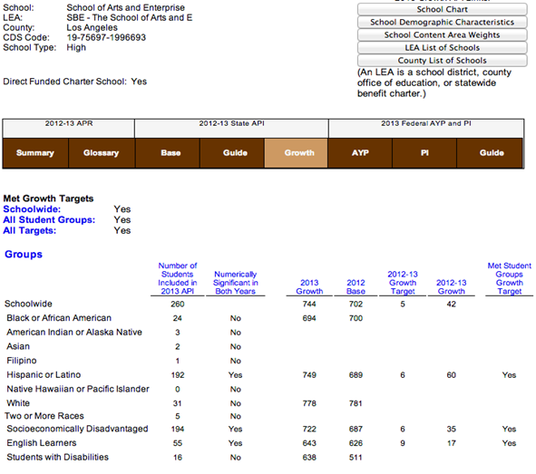
AYP Chart- Data embargoed until 8/29/13
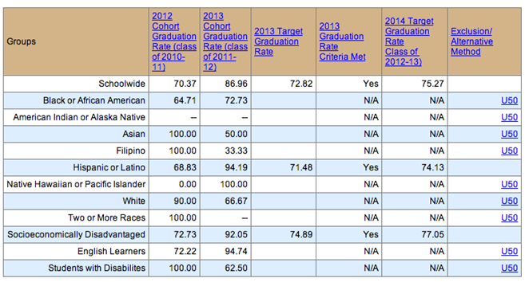

CST Comparison Tables

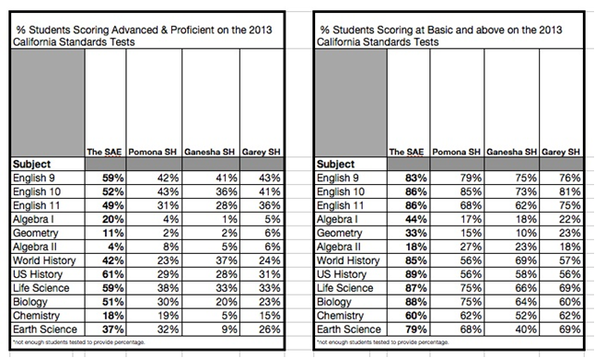

Additional Areas of Student Success:

In the space below, describe any additional ways students are excelling and/or showing improvement. These areas should be unique to the charter school and go beyond standardized test results.
- Students have been accepted to 71 different colleges and universities including UCs, Cal State, and Private art colleges since our class of 2007 (first graduation)
- Continued to implement Linked Learning models of colleges and career education
- Encore (after school tutoring) for immediate assignment completion
- Continued commitment to SAP to include a higher level of rigor throughout all core classes
- College On Track and Portfolio for all students
- Initiated three AP classes
- Commitment to access and equity (additional professional development)
- All students participate in team – taught project based curriculum that connect real world application of content standards
- The SAE students were invited to be the primary performances at most city events
- Alumni continue to volunteer with multiple programs during the summer and various times throughout the year
- SAE Students selected The Music Center Spotlight Awards, Los Angeles County Visual Arts Awards, and Digital Media Awards
- SAE Students completed the following:
  - Competed in for the Voice (TV Program)
  - Selected for student advisory Committee for the Center Theatre Group of LA
  - Created and directed a short film that debuted at a local film festival
  - Selected student on SABE ( Student Advisory Board on Education – CA)
  - Collaboration with Cal Poly Pomona in a Practicum Challenge with local business
  - Participated in performance with the Claremont Symphony
  - Competed in Spanish TV Reality Show
  - Industry partnership with SAE students to write and record with music professionals
  - Collaboration with Cal Poly Pomona Music Department and college students to develop a music festival project.
  - Initiating student run galleries and small businesses
  - Performances in a fundraising Gala and Fox Theatre for our yearly Student Showcase.

Content submitted by school, formatted by the California Department of Education, Charter Schools Division
October 2013.

