California Department of Education
Executive Office
SBE-002 (REV. 11/2017)
memo-pptb-amard-apr19item03

MEMORANDUM
DATE: April 2, 2019
TO: MEMBERS, State Board of Education
FROM: TONY THURMOND, State Superintendent of Public Instruction
SUBJECT: Update on Continuous Improvement of the State and Federal Accountability System: A Review of the Design, Development, and Implementation of the California School Dashboard.

Summary of Key Issues
In December 2017, the California Department of Education (CDE) launched the first operational release of the California School Dashboard (Dashboard). After a major redesign, the second operational Dashboard was released in December 2018. The third operational release of the Dashboard is scheduled for December 2019. Given the recent addition of new State Board of Education (SBE) member(s), this memorandum provides a summary of the:
- Construction of the Dashboard
  - Background on state and local indicators
- Methodology for setting the standards for state indicators, which includes:
  - A description of Status
  - A description of Change
  - How cut scores are set separately for each state indicator
  - The application of the five-by-five colored tables, the three-by-five colored tables, and performance levels (colors)
- Annual review by the SBE of the Dashboard indicators and standards
- Modified methods for schools with a Dashboard Alternative School Status (DASS) status

New Multiple Measures Accountability System: Statutory Requirements
Signed into law in 2013, the Local Control Funding Formula (LCFF) significantly changed how California provides resources to public schools and holds local educational agencies (LEAs) accountable for improving student performance. The LCFF includes eight priority areas for school districts and charter schools (with an additional two priority areas for county offices of education [COEs]), which signifies that a quality education is defined more broadly than a single test score and requires that the accountability system consider all LCFF priority areas.
The LCFF also included a requirement for the SBE to adopt “evaluation rubrics”—now known as the Dashboard—as an accountability tool that includes state and local performance and improvement standards for all LCFF priorities. Specifically, California Education Code (EC) Section 52064.5 identifies statutory purposes for these evaluation rubrics: (1) to assist LEAs in identifying strengths, weaknesses, and areas in need of improvement; and (2) to use performance standards to identify LEAs in need of additional assistance or intervention.
In December 2015, Congress enacted the Every Student Succeeds Act (ESSA), which required states to develop a new multiple measures accountability system by the 2017–18 school year. Since many of the metrics required in this new multiple measures system overlapped with the LCFF priority areas, California leveraged the opportunity to streamline local, state, and federal requirements into a single, coherent accountability and continuous improvement system. This allowed California to avoid developing one state accountability system and a separate federal accountability system.
The Dashboard was developed based on several years of input from numerous stakeholders and allows parents/guardians, educators, and the public to access how LEAs and schools are meeting the needs of California’s diverse student population based on performance on specific indicators using set standards.

Establishing State and Local Indicators
Under ESSA, states are required to use a minimum of five indicators in their accountability systems. These required indicators must be collected at the student level to allow reporting of performance for all students and by student groups and must be comparable statewide. For California, many of these indicators were already identified as metrics within an LCFF state priority:
- Student test scores in English language arts and mathematics (LCFF Priority 4–Pupil Achievement)
- Progress of English learners toward English language proficiency (LCFF Priority 4–Pupil Achievement)
- High school graduation rates (LCFF Priority 5–Pupil Engagement)
- Another academic indicator for K–8 (chronic absenteeism) (LCFF Priority 5–Pupil Engagement)
- At least one other indicator of school quality or student success (suspension rates and College/Career Indicator) (LCFF Priority 6–School Climate and LCFF Priority 8–Outcomes in a Broad Course of Study)
The SBE established a goal of adopting a concise set of indicators for state accountability purposes that met both state and federal requirements. Additionally, the SBE established four criteria for including state indicators in the new accountability system:
- Currently collected and available for use at the state level
- Collected using a consistent definition
- Disaggregated to the school and student group level, and
- Supported by research as a valid measure
Because each of the five indicators required under ESSA met these criteria, the SBE designated them as “state indicators” with the potential for inclusion in the Dashboard following a full analysis of each indicator that involved: (a) running data analyses at the student group and school level; and (b) presenting performance results based on outcomes. The review also included input from a broad range of stakeholders (including the SBE-appointed California Practitioners Advisory Group, various policy and ad-hoc work groups established by the CDE, the LCFF Stakeholder Group, and the Technical Design Group [TDG], which advises the CDE on technical issues related to accountability). Upon SBE approval of these state indicators, the CDE began the technical process for calculating and uploading these data and results to the Dashboard.
While the overlap between the federal indicators and the LCFF state priorities further promoted the alignment of state and federal requirements under one accountability system, the state indicators only addressed four of the LCFF state priorities. There were still four remaining LCFF priorities that were not addressed by the state indicators:
- Priority 1: Appropriately Assigned Teachers, Access to Curriculum-Aligned Instructional Materials, and Safe, Clean and Functional School Facilities
- Priority 2: Implementation of State Academic Standards
- Priority 3: Parent Engagement
- Priority 7: Access to a Broad Course of Study
Additionally, two LCFF priorities that apply only to COEs were not addressed by the state indicators:
- Priority 9: Coordination of Services for Expelled Students
- Priority 10: Coordination of Services for Foster Youth
California does not currently collect data on a statewide basis that is comparable across LEAs within these LCFF priorities. As noted, the LCFF required the SBE to develop performance and improvement standards for all the LCFF priorities. The SBE approved “local indicators” for the LCFF priorities where statewide data was not available, which include self-reflection tools that apply at the LEA level only. LEAs (which includes charter schools) are responsible for annually completing the self-reflection tools using locally collected data and uploading the results to the Dashboard, following review of the results at a regularly scheduled school board meeting. The standards for the local indicators are reported as a Met / Not Met / Not Met for Two or More Years, based on whether the LEA collected and reported the local data through the Dashboard consistent with these requirements. All the self-reflection tools are available in the Local Performance Indicator Quick Guide located on the on the CDE California School Dashboard and System of Support web page at https://www.cde.ca.gov/ta/ac/cm/documents/localindquickref2018.docx. The remainder of this memorandum focuses on the state indicators.

Methodology for Setting Standards for State Indicators
EC Section 52064.5(c) required the LCFF evaluation rubrics, now the Dashboard, to include standards for performance and expectations for improvement for each LCFF priority. In May 2016, the SBE approved the methodology for calculating performance for state indicators. The adopted methodology, which is explained in detail in the following sections, uses equally weighted percentile cut scores for “Status” and “Change”, which, when combined, produces a performance level (or color). This approved methodology is applied to all LEAs, including charter schools and COEs, and to individual school sites, as required by federal law. It is also applied to 13 student groups, which fosters equity by identifying any disparities and focusing decisions about assistance, support and intervention on addressing performance gaps.

Status
“Status” is determined by using the current year performance (e.g., current year graduation rate). To determine the percentile cut scores for “Status” for each state indicator, the distribution of LEAs (including charter schools as they are identified as LEAs under LCFF) are categorized from highest to lowest, and four cut scores within the percentile distribution are selected. These cut scores created five “Status Levels” (very high, high, medium, low, and very low).
The “very low” Status cut score is based on the performance of a small percent of LEAs that had the lowest performance. The “high” Status cut score is then determined next as this level is used to meet the ESSA requirement for states to set ambitious long-term goals for the graduation rate, academic, and English learner progress indicators. A status of “high” is the goal that all LEAs, schools, and student groups are expected to attain. Once the “very low” and “high” levels are established, the remaining cut scores are set to determine the low, medium, and very high levels. To provide an example of how the cut scores are set, Table 1 on the following page displays the data for the Graduation Rate Indicator and shows the placement of the five Status levels after setting the cut scores.
Table 1: Percentile Distribution for Status for Graduation Rate Indicator
Percentile | Graduation Rate | Status Level
5 | 65.2 | Very Low
5.4 | 67.2 | Low
10 | 78.0 | Low
11.5 | 80.2 | Medium
15 | 83.3 | Medium
20 | 86.5 | Medium
25 | 88.4 | Medium
30 | 89.9 | Medium
31 | 90.1 | High
35 | 90.9 | High
40 | 91.8 | High
45 | 92.6 | High
50 | 93.25 | High
55 | 94.0 | High
60 | 94.6 | High
65 | 95.1 | Very High
70 | 95.7 | Very High
75 | 96.3 | Very High
80 | 96.8 | Very High
85 | 97.5 | Very High
90 | 98.1 | Very High
95 | 99.0 | Very High

Change
“Change” is the difference between performance from the current year and the prior year (i.e., the difference between the current year graduation rate and prior year graduation rate). As with “Status,” cut scores created five “Change Levels” (increased significantly, increased, maintained, declined, and declined significantly). To determine the cut scores for “Change,” LEAs (including charter schools) were categorized into two different distributions, one where there was positive change and one where there was negative change. The “declined significantly” is set first representing a small percent of LEAs with the most decline in performance. Next, “increased” is set, which represents an increase in performance achieved by the majority of LEAs. Once the “declined significantly” and “increased” cut scores are established, the remaining cut scores are set to finalize the remaining change levels (i.e., declined, maintained, and increased significantly).

Setting Cut Scores Separately for Each State Indicator
After CDE staff presented multiple simulations on various approaches for setting Status and Change cut scores to the Technical Design Group (TDG), the TDG recommended to the CDE that cut scores be set separately for each indicator (i.e., each state indicator will have its own unique set of cut scores) to reflect the varying performance among the indicators. For example, the range of graduation rates differs significantly from the range of scale scores on the California Assessment of Student Performance and Progress mathematics assessment, which differ significantly from the range of suspension rates.
In adopting the cut scores for the state indicators, and as noted in California’s ESSA State Plan, the SBE will, as part of its annual review process (discussed in a later section), assess progress on all state indicators and potentially revise the cut scores for state indicators every seven years.

Five-by-Five Colored Table and Performance Levels (Colors)
The LCFF statute specifies that the accountability system take into account not only current performance but also whether there has been improvement. Rather than adopting two standards for each state indicator (one for Status and one for Change), the SBE approved an approach that combines Status and Change to determine overall performance. For each state indicator, the SBE adopted a five-by-five colored table: The combination of the five Status levels and the five Change levels results in 25 cells displayed in a five-by-five colored table. Each of the 25 cells receive one of five colors: blue (highest performance), green, yellow, orange, and red (lowest performance).
This methodology reflects the reality that improvement is more difficult for very high performing LEAs and schools, while incentivizing improvement among lower performing LEAs and schools. For example, if very high performing districts and schools declined significantly from one year to the next, they receive a lower overall performance color than if they had maintained or improved its performance. In reverse, a very low performing school that improved significantly from the prior year receives a higher performance color than if its performance declined or was maintained. This approach creates an incentive for all LEAs and schools to continuously improve and also focuses attention within the accountability system on areas where there may be declines in performance.
An LEA, school, or student group’s performance (or color) for each state indicator is determined using the five-by-five colored table for that indicator. For instance, a school with a “High” Status and an “Increased” in Change will receive an overall performance level of Green for most of the state indicators. Table 2 on the following page illustrates this example.

Table 2: How to Get a Performance Level (Color)
Level | Declined Significantly  from Prior Year | Declined  from Prior Year | Maintained  from Prior Year | Increased  from Prior Year | Increased Significantly  from Prior Year
Very High  in Current Year | Yellow | Green | Blue | *Blue | Blue
High  in Current Year | *Orange | *Yellow | *Green | *Green | Blue
Medium  in Current Year | Orange | Orange | Yellow | Green | Green
Low  in Current Year | Red | Orange | Orange | Yellow | Yellow
Very Low  in Current Year | Red | Red | Red | Orange | Yellow
Once the performance levels (colors) are established for all LEAs, schools, and student groups for each applicable state indicator, they are reported in the Dashboard reflected as gauges as illustrated in Figure 1 below.
Figure 1: Dashboard Gauges
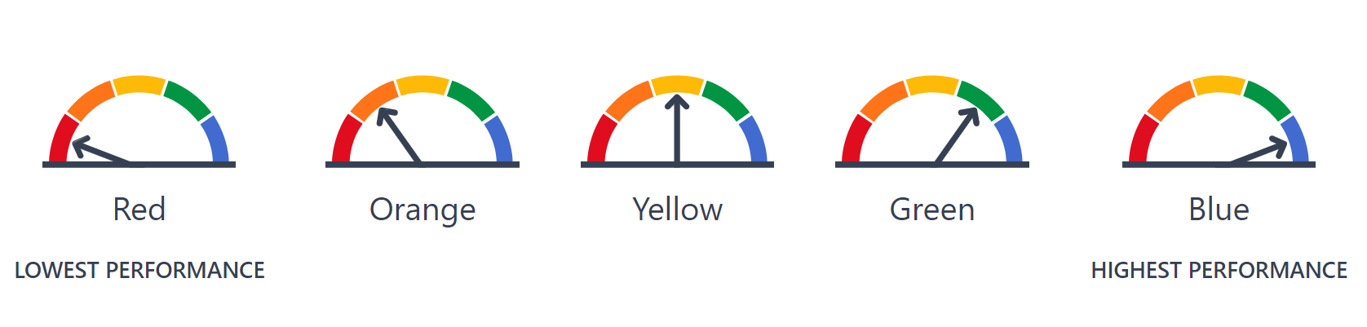

Annual Review Process
Because data availability may change over time, the SBE approved an annual review process that allows state and local indicators to be reviewed to determine if new indicators should be added or if existing indicators should be replaced or modified. This review process includes coverage of the indicators and performance standards and consideration as to whether changes or improvements are needed based on newly available data, recent research, or feedback from stakeholders. It also ensures continuous improvement in the state’s accountability system.
The review process requires the CDE to annually update the SBE at the March SBE meeting on the indicators under consideration for review and/or revisions for action ideally by the September, or at the latest, November SBE meeting. This process allows for a gradual and deliberate approach to improving the state and local indicators and incorporating changes prior to the annual release of the Dashboard. Additionally, the time between the SBE meetings is sufficient to allow CDE staff to conduct the analysis of any indicators identified in March, consult with policy and technical working groups, obtain stakeholder input, and ultimately recommend to the SBE whether or not to modify any of the indicators by their September meeting.
Application of Three-by-Five Colored Tables for Small Student Populations
In September 2017, the SBE approved the application of the three-by-five colored tables—an alternative methodology for assigning performance levels (colors) to LEAs and schools with small student populations. (https://www.cde.ca.gov/be/ag/ag/yr17/documents/sep17item02.doc).
This methodology is applied when there are between 30 and 149 students at the LEA, school level, and student group levels for graduation rate, suspension rate, and chronic absenteeism, with plans to apply it to the College/Career Indicator (CCI) for the 2019 Dashboard.
The application of the three-by-five results in a refiguring of the performance level tables—from a five-by-five grid to a three-by-five grid—by removing two Change levels (Increased Significantly and Decreased Significantly) which limits the extreme change in results that occur in small student populations.
Figure 2 on the following page illustrates the three-by-five colored table for the Graduation Rate Indicator. As referenced above, the two Change columns “Declined Significantly” and “Increased Significantly” are removed, resulting in a table that has three Change columns (i.e., Declined, Maintained, and Increased) and five Status rows (i.e., Very High, High, Medium, Low, and Very Low). There are still five possible performance levels (colors) that LEAs, schools, and student groups can receive if their graduating cohort size is between 30 to 149 students.
Figure 2: Three-by-Five Colored Table for the Graduation Rate Indicator
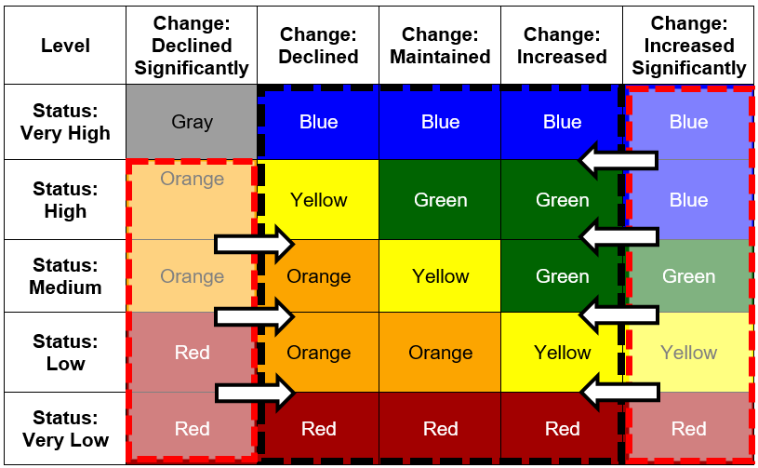

Proposal of Three-by-Five Colored Table for CCI
As discussed in the March 2019 SBE agenda item (https://www.cde.ca.gov/be/ag/ag/yr19/documents/mar19item17.docx), the CDE proposed to the Technical Design Group and the California Practitioners Advisory Group (CPAG) the application of the three-by-five colored table to the CCI. This proposal was made because the CCI is based on the same cohort of students used in the calculations for the Graduation Rate Indicator, which already applies the three-by-five to small student populations. Both the TDG and the CPAG supported the proposal, and the CDE will be sharing the statewide results of applying the three-by-five to the CCI at the July 2019 SBE meeting.

Dashboard Alternative School Status and Modified Methods
During the development of the Dashboard, the SBE and stakeholders raised concerns that the state indicators and standards did not fairly evaluate the success or progress of alternative schools that serve high-need students (e.g., continuation, juvenile court, opportunity, county community, etc.). For instance, it is not appropriate to hold alternative schools accountable to a four-year cohort rate because many of these schools serve students who, when they enroll at the alternative school, are credit deficient and are not on track to graduate in four-years. Because some of the established indicators did not fairly evaluate alternative schools, Dashboard Alternative Schools Status (DASS) schools did not receive a 2017 Dashboard.
Under the direction of the SBE, the CDE began exploring the development of robust measurements, or “modified methods,” for alternative schools. To start this process, the SBE approved at their May and July 2017 meetings the criteria to identify alternative schools that would be eligible for modified methods. The CDE, in collaboration with the Gardner Center at Stanford University (through a grant from the Stuart Foundation), coordinated a Statewide Advisory Task Force (Task Force) to focus on alternative education accountability. The Task Force held its first meeting in May 2017 to consider what modifications could be made to current state indicators that would be appropriate to apply to alternative schools. The goal was to recommend to the SBE modified methods for inclusion in the 2018 Dashboard.

DASS Graduation Rate
The Task Force recommended beginning with developing a modified method for the Graduation Rate Indicator because most students who enroll at DASS schools are not on track to graduate within four-years after entering grade nine. Over the course of five meetings, the Task Force reviewed numerous simulation results using a “one-year” graduation rate, which is based on all students in grade twelve. After receiving recommendations from the Task Force, the TDG for technical soundness, and other stakeholders, the CDE recommended, and the SBE approved, the methodology for calculating the DASS graduation rate at the May 2018 meeting. In September 2018, the SBE approved cut scores for the DASS graduation rate, which was produced for the first time in the 2018 Dashboard.
The CDE will continue to work with the Task Force to determine if other modified methods are appropriate for inclusion in the Dashboard.

Next Steps
During the annual review of the Dashboard at the March 2019 SBE meeting (https://www.cde.ca.gov/be/ag/ag/yr19/documents/mar19item17.docx), the SBE approved the CDE’s recommendation to explore the following revisions to the Dashboard for 2019:
- Incorporation of the California Alternate Assessments in the Academic Indicator
- Incorporation of the Five-Year Graduation Rate into the Dashboard
- Application of the Three-by-Five Color Grid for the CCI
- Inclusion of Status for the English Learner Progress Indicator into the Dashboard
- Inclusion of Additional Measures in the CCI for Students with Disabilities
As data analyses and input from stakeholders become available, the CDE will share additional information and propose any potential changes in future SBE agenda items and memoranda.

Attachment(s)
None.

