California Department of Education
Executive Office
SBE-002 (REV. 11/2017)
memo-pptb-amard-feb19item04

MEMORANDUM
DATE: February 14, 2019
TO: MEMBERS, State Board of Education
FROM: TONY THURMOND, State Superintendent of Public Instruction
SUBJECT: Overview of California’s Implementation of a New Accountability and Continuous Improvement System based on the Local Control Funding Formula.

Summary of Key Issues
Signed by Governor Jerry Brown in 2013, the Local Control Funding Formula (LCFF) significantly changed how California funds, evaluates and supports public schools. LCFF holds local educational agencies (LEAs) accountable for improving student performance and addressing opportunity and achievement gaps. This summary is provided to assist new State Board of Education (SBE) members and the general public with the historical context for the development and implementation of the Local Control Funding Formula.
The SBE and the California Department of Education (CDE) are responsible for implementing key provisions of LCFF. Three principles reflected in the LCFF statutes have served as the foundation for that work:
- More than a Single Number. Quality education is defined by more than just test scores.
- Resource Decisions Driven by Student Need. Educators and policymakers should adapt services to meet identified needs, including disparities in opportunities and outcomes.
- LEAs Are the Primary Unit of Change. LEAs play the essential role in supporting schools to sustain improvement.
These principles reflect a shift from California’s past approaches to school improvement. They are the foundation for the ongoing work toward achieving the goal that all Californians share: that LEAs and schools are able to meet the needs of each student and increase performance and effectively address inequities across multiple measures of student success.

Elements of California’s New Accountability and Continuous Improvement System
LCFF substantially changed four elements of California’s public school funding and accountability system: (1) school finance; (2) local planning and community engagement; (3) state accountability; and (4) the system for providing state support to LEAs.
These elements are intended to work together as complementary components of a single system. The LCFF’s statutes included a phased schedule for implementing these elements. Details have been built out through this phased implementation, and the SBE and CDE made adjustments to various elements throughout the development process to strengthen the system as other elements were developed.
Additionally, in December 2015, Congress passed the Every Student Succeeds Act (ESSA), which reauthorized the Elementary and Secondary Education Act of 1965 and required every state to develop a plan for using supplemental federal funding that states receive under ESSA for low-income students and English learners. The SBE was responsible for developing California’s state plan as a condition of receiving approximately $2.5 billion in annual federal funding under ESSA. The state plan, which the U.S. Department of Education approved in July 2018, aligned California’s approach to meet federal requirements to the greatest extent possible with state law. By building upon the SBE’s work to implement LCFF, California has been able to streamline what were previously distinct state and federal accountability systems into a single, coherent system aligned to the vision reflected in LCFF.
Notably, these changes to California’s public school funding and accountability system coincided with major changes to curriculum, instruction, and assessment. Over the past eight years, California has overhauled all four major curriculum areas, beginning with the adoption of the California State Standards for English Language Arts and Mathematics. These new standards expect students to demonstrate critical thinking, analytical writing, and problem-solving skills needed to be ready for college and the 21st century job market. The new assessment system is designed to better measure these skills through computer adaptive tests and performance tasks. California also adopted the California Next Generation Science Standards, which emphasize how to be a scientist through study of the natural world instead of memorization of terms and is in the midst of developing an innovative new assessment aligned to the new science standards. Finally, the SBE recently overhauled the curriculum frameworks for History/Social Science, which include a renewed focus on inquiry, diversity, and civic engagement.
There are ongoing efforts to build capacity within schools to support educators in delivering instruction aligned to these standards and frameworks, with ongoing work to integrate that work and the overall approach to supporting schools to improve state and local accountability outcomes.

School Finance.
Immediately upon its passage (for the 2013–14 fiscal year), LCFF overhauled the way state education funds are distributed to LEAs.
First, LCFF eliminated more than 40 earmarked “categorical” funds, giving local districts more flexibility to spend state money to address local needs. Second, LCFF dramatically simplified the formula for giving money to LEAs so it is now standardized across the state. Finally, LCFF recognized that students with greater needs require greater resources by providing extra funds to LEAs that serve high-need student groups: low-income students, foster youth and English learners. These funds are known as “supplemental” and “concentration” grants.
By reducing the amount of time and money spent tracking expenditures at the state and local level, more funding is available to invest in classrooms and services that improve learning for all students and especially those high-need students that generate additional funding under LCFF. This embodies LCFF’s focus on outcomes rather than inputs: It shifts the focus to whether services and programs supported by the funds are improving outcomes for students.

Local Planning and Community Engagement.
In exchange for more funding and freedom from many state compliance mandates, LEAs must engage parents, educators and community members in decisions about how they use those resources to meet the needs of their students and communities.
Specifically, LCFF requires LEAs to engage their local stakeholders in an annual planning process to evaluate their progress within eight state priority areas encompassing 21 statutory metrics. LEAs document the results of this planning process in the Local Control and Accountability Plan (LCAP), which must include goals that address all eight priority areas and actions and related expenditures to achieve those goals over a three-year period. Additionally, LCFF requires LEAs to increase or improve services for the high-need student groups that generate supplemental and concentration grants in proportion to the amount of additional funding those students generate under the formula. LEAs must demonstrate that they meet this requirement within the LCAP.
Under LCFF, the SBE was charged with adopting the LCAP template and regulations governing the requirement to increase or improve services for high-need student groups. The SBE adopted the initial template and expenditure regulations, which were both in effect beginning with the 2014–15 fiscal year, the second year of LCFF’s implementation.
- The LCAP Template. The LCAP template is intended to support LEAs in focusing on outcomes and addressing disparities in opportunities. LEAs review data, analyze student and community needs, set goals and align spending to actions that will help accomplish those goals. LEAs annually review whether goals and actions are actually leading to improved outcomes and opportunities for students. LCFF also requires LEAs to engage with local stakeholders in developing the LCAP. Finally, as explained below, the current LCAP template requires LEAs to highlight the steps they are taking to address any significant disparities in performance among student groups.
- The Expenditure Regulations. Expenditure regulations require LEAs to explain in their LCAPs how they are increasing or improving services for high-need students in proportion to the amount of additional supplemental and concentration funds the LEAs receive. This includes identifying any LEA-wide or school-wide services that are primarily focused on helping the high-need students who generate additional funding.
The SBE has updated the template twice since its initial adoption in January 2014 based on feedback from LEAs and community stakeholders.

State Accountability (California School Dashboard).
LCFF required the SBE to adopt “evaluation rubrics” to assist LEAs in identifying strengths, weaknesses, and areas in need of improvement. The evaluation rubrics are also used to identify LEAs that require additional assistance.
CDE developed the California School Dashboard (Dashboard) to publicly report performance data on the indicators that the SBE included in the evaluation rubrics. The Dashboard provides parents and educators with meaningful information on LEA and school progress so they can participate in decisions to improve student learning. The Dashboard highlights areas where LEAs, schools, and student groups are doing well and areas where they are struggling, to spark conversations and help focus the local planning process.
The Dashboard includes:
- A concise set of state performance indicators based on data reported to CDE (graduation rates, suspension rates, test scores, chronic absenteeism, English learner progress, and college/career readiness).
- Performance data on the statewide indicators for all students and disaggregated for student groups at the LEA and school levels. There are five color-coded performance levels for these indicators (from highest to lowest: Blue, Green, Yellow, Orange, Red), which are based on a combination of current performance (Status) and whether there has been improvement compared to the prior year (Change).
- Local indicators for LCFF priority areas for which comparable statewide data is not currently available. LEAs report locally-collected data through the Dashboard based on SBE-approved reflection tools. Performance on these indicators for state accountability purposes is based on whether LEAs collect and report local data through the required reflection tools.
The Dashboard complements the local planning process by providing clear statewide performance expectations that incorporate how current performance compares to past performance. This provides a more complete picture of performance than a point-in-time snapshot and shows differences in performance across LEAs, schools, and student groups. It helps LEAs and schools focus on where to improve, while helping the state prioritize where to focus assistance and support efforts.
The SBE also updated the LCAP template in conjunction with developing the Dashboard. These changes complemented the rollout of the Dashboard, and the interaction between these two tools is critical:
- Each fall, LEAs receive updated performance data through the Dashboard to inform their planning and stakeholder engagement leading up to adoption of an updated LCAP in the spring. In conjunction with locally-collected data, the Dashboard helps show LEAs and local stakeholders whether the strategies they are using are working or not.
- If the Dashboard highlights low performance or significant disparities for one or more indicator, the updated LCAP template requires LEAs to specifically address those areas. This helps LEAs prioritize where to focus within the local planning process and also ensures that large gaps in performance across student groups are not overlooked.
The Dashboard completes the local planning process as it was intended when LCFF was enacted—local planning informed by performance on indicators with consistent performance expectations statewide. This will result in a much stronger process for planning and stakeholder engagement going forward as a result. The Dashboard also improves transparency and public access to data on multiple measures of student success.
The Dashboard was field tested in spring 2017, and its first operational release was fall 2017. The 2018 Dashboard, released in December, included a major redesign to be more parent-friendly and welcoming than the initial Dashboard design.

System of Support for LEAs and Schools.
In conjunction with the changes to state accountability, LCFF changed how California supports LEAs and identifies those that need extra assistance due to low performance.
In adopting the evaluation rubrics, the SBE was also required to establish performance standards within each of the LCFF priority areas, including criteria for identifying LEAs in need of additional assistance due to low performance by one or more student group. The lowest performance level for each of the Dashboard indicators (Red for state indicators and Not Met for Two or More Years for local indicators) generally serve as these criteria.
County offices of education must provide additional assistance to school districts that have one or more student group in the lowest performance level for indicators in two or more LCFF state priority areas. LEAs may be subject to more intensive state intervention due to persistent low performance by multiple student groups. LCFF also created a new state agency, the California Collaborative for Educational Excellence (CCEE), to provide assistance and support to LEAs. Finally, LCFF gave new responsibilities to CDE to support county offices of education, in addition to CDE’s existing responsibilities to provide guidance and support to LEAs related to the state accountability system.
SBE staff convened the agencies charged with providing assistance under LCFF to develop a common framework and avoid mixed messages about the expectations or approach. This work extended beyond the statutorily mandated assistance to develop a structure for general support to all LEAs. The agencies also engaged stakeholders in this developmental work.
This collaborative process led to a focused System of Support for LEAs and schools, with three levels of assistance. The goal at all three levels is to help LEAs and their schools meet the needs of each student, with a focus on building capacity to sustain improvements and address student opportunity and outcome gaps.
- Support for All (Level 1): All school districts and schools can access resources and assistance, such as trainings, conferences, voluntary technical assistance, and various tools. This support builds the overall capacity of school districts and schools to improve opportunities and outcomes for all students.
- Differentiated Assistance (Level 2): County offices of education are required to provide customized assistance to school districts that meet eligibility criteria based on student performance.
- Intensive Intervention (Level 3): The Superintendent of Public Instruction may intervene in school districts if there are persistent performance issues over multiple years.
The system acknowledges that LEAs face new expectations and a new local planning process. LEAs are now expected to consider a range of factors that affect student achievement and engage their local communities in developing actions and services to improve performance and address gaps. LEAs—as they adjust to the new system—need help to meet these new expectations and to develop effective improvement strategies in consultation with local stakeholders through the local planning process. Similarly, county offices of education are also adjusting to new roles that require new knowledge and skills.
The recently enacted state budget clarifies roles and responsibilities within the System of Support and provides ongoing funding for county offices of education and the CCEE to support this work. These changes created a structure with specifically defined responsibilities that ensures a base-level of support is available statewide and relevant expertise can be leveraged regardless of where a school district is located. The budget also established and provided funding to support coordination and communication among agencies responsible for providing assistance to LEAs. These investments ensure there are people or roles within the system whose duties specifically include supporting coordination and communication among agencies.
The graphic below illustrates the System of Support’s design and how the agencies responsible for providing assistance work together to support and build capacity of LEAs. As the graphic reflects, the job of the support agencies is to work together to help school districts get what they need to improve outcomes for students and to improve the reliability, timeliness, quality, and local relevance of support provided to school districts. An accessible description of this image can be found in Appendix A.
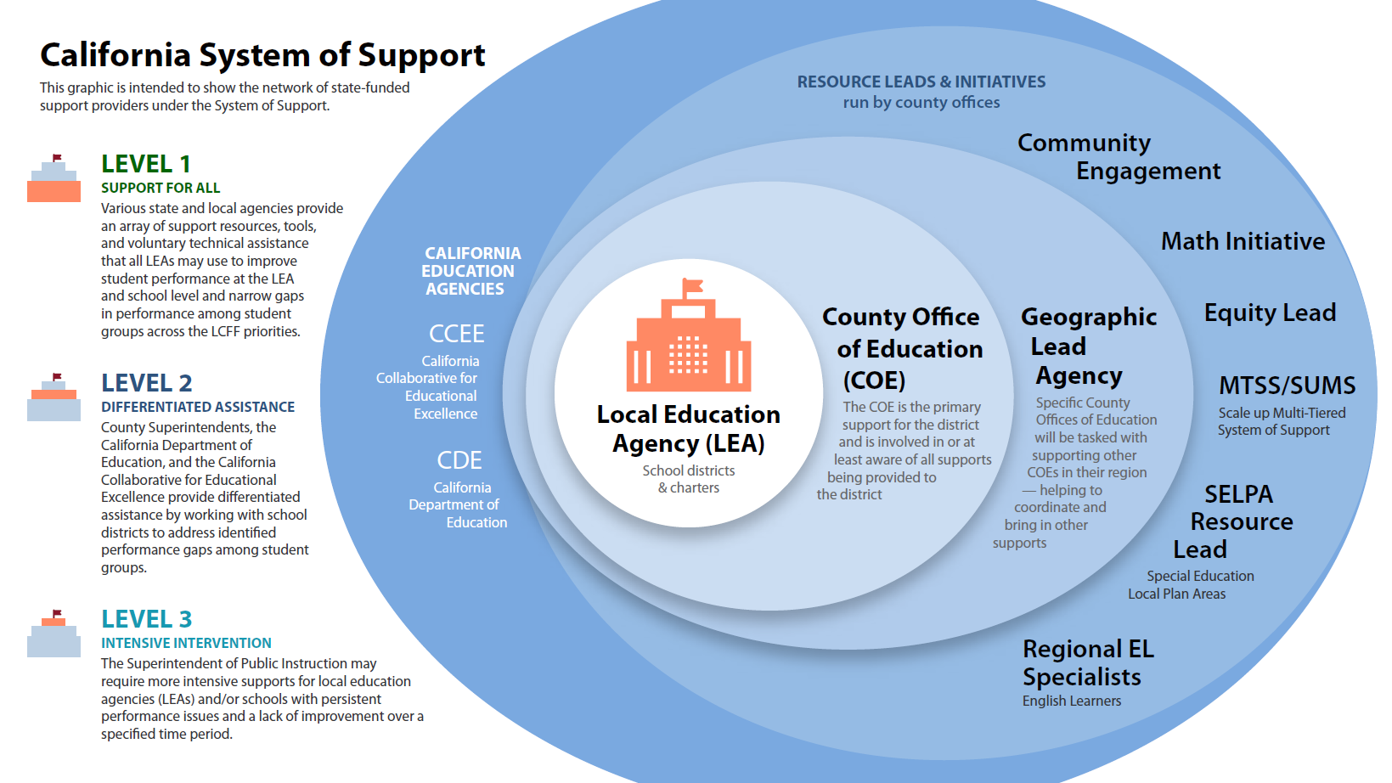
The graphic below reflects a key concept for the System of Support, that there should be “No Wrong Door” for LEAs. All doors should lead to support, either directly or via referral (with active support to ensure a connection is made), and the LEA should not have to manage figuring out how to access it. An accessible description of this image can be found in Appendix B.
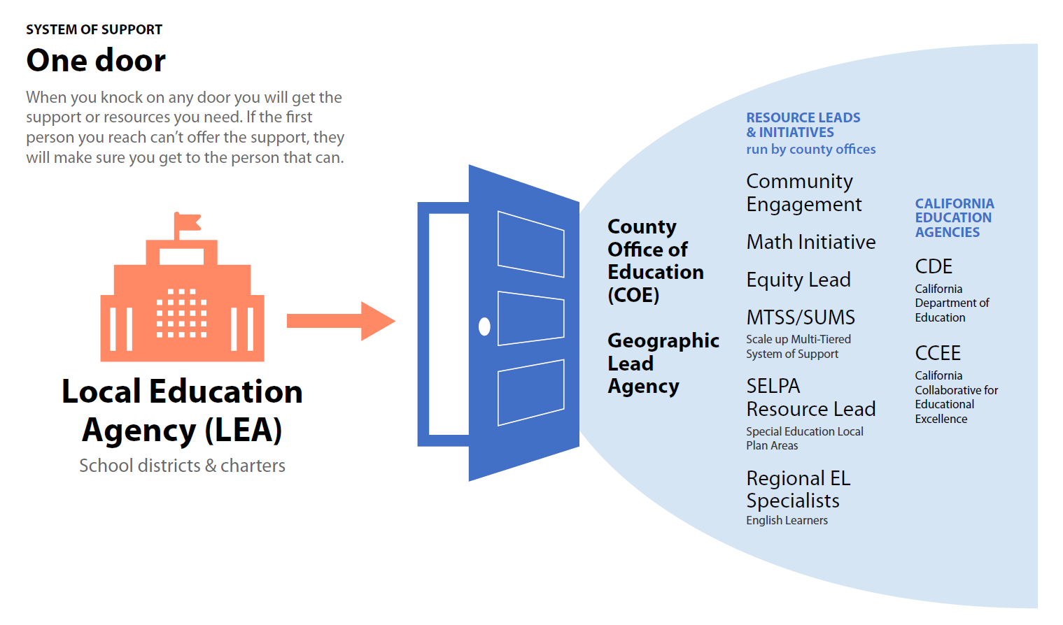
The 2018 Budget Act included language and funding to clarify and strengthen the System of Support, which now includes: (1) a clear point of contact for a school district or county office of education to seek support responsive to a locally identified need, (2) a clear process and responsibility for agencies within the system of support to work together to connect the school district or county office of education with relevant resources or avenues for assistance, and (3) improved visibility of the resources, expertise, and services available across the state through various agencies and state-funded initiatives.
By codifying a coordinated approach to assistance, the new system creates opportunities to determine whether statewide resources and expertise are adequate to respond to emerging needs; whether existing resources should be redirected; or whether the Governor and Legislature should consider making further targeted investments.

Integration of Federal Accountability Requirements.
After more than two years of development, including extensive input from California’s education stakeholders, the U.S. Department of Education (ED) approved California’s ESSA state plan on July 12, 2018. The ESSA state plan covers a range of programs tied to approximately $2.5 billion in annual federal funding, including nearly $1.8 billion linked to school accountability requirements. Under federal law, the SBE was responsible for developing the state plan.
The SBE’s goal throughout the plan development process was to take advantage of the additional flexibility provided to states under ESSA to align, to the greatest extent possible, the approach for meeting federal requirements with the work California had started before ESSA was even under consideration in Congress. In contrast to the separate—at times dueling—systems of state and federal accountability that existed under ESSA’s predecessor, No Child Left Behind, the SBE set out to develop an integrated local, state, and federal accountability system.
Through extensive discussions with ED staff leading up to plan approval, California was able to address ED’s interpretation of federal law without fundamentally altering the foundation of California’s accountability and support systems. As a result, the approved state plan maintains the core principles of California’s approach to accountability and continuous improvement based on LCFF and reflects the extensive stakeholder input received over the past five years:
- Importantly, the indicators and performance standards approved for the Dashboard serve state, local, and federal accountability purposes under the ESSA State Plan. LEAs use the Dashboard for their annual LCAP development; Dashboard performance determines whether LEAs receive differentiated assistance under LCFF through the statewide system of support; and Dashboard performance determines whether LEAs must provide additional support for one or more of their schools under ESSA.
- Additionally, the SBE incorporated ESSA’s school-focused accountability and planning requirements in a manner that aligns with the existing LCAP process and ensures that LEAs appropriately focus on how they are supporting their schools within that process. LEAs are responsible for using additional federal funds they receive to support school improvement efforts at identified schools. As a result, the LEA remains the primary focus of responsibility for improving opportunity and outcomes for students.
- Finally, the state plan aligns state activities using federal funds within the System of Support. For example, 11 county offices of education receive federal funds to support English learner programming statewide. This existing program was updated so these county offices collectively serve as an “expert lead” within the statewide system of support. They have designated one member to participate in regular meetings with other leads to coordinate and align approaches. Continued work remains to align all activities and careful attention will be required to avoid the creation of new siloes across program areas and between initiatives funded with state funds and federal funds.

Rationale for Approach to California’s New Accountability and Continuous Improvement System
Narrowing achievement gaps is a central focus of California’s current approach under LCFF. These gaps persisted, and in some cases increased, under the former approach to accountability and school improvement. Those prior approaches had several common characteristics that differentiate them from the current approach under LCFF.
- A common feature of our past accountability and school improvement efforts—whether derived from state or federal laws—was that they sought to improve outcomes by setting quantitative targets, providing time-limited funding tied to prescriptive interventions, and threatening sanctions for failure to meet these targets. Research and evaluations of those programs generally reached the same conclusion: they did not lead to sustained improvement in student outcomes.
Several factors contributed to this lack of improvement. First, because the interventions were externally imposed, there was no assurance of internal capacity to implement the strategies effectively or in a sustained manner. Second, the interventions (and any associated funding) were generally time-limited and of short duration, which limited their impact and the willingness of LEAs and stakeholders to invest in changing systems. Third, setting targets and imposing sanctions did little to help LEA and school leaders and stakeholders diagnose problems or learn how to improve performance on their own. The top-down approach also undermined local buy-in for and ownership of the solutions. Finally, many of the interventions focused on schools, without accounting for the critical role LEAs play in supporting their schools and developing equitable system-wide policies and practices.
- California’s past accountability systems also focused exclusively on student test scores. The old state rating system for schools, known as the Academic Performance Index, evaluated districts on a 200-to-1000 scale based solely on test scores. The old federal accountability program, known as Adequate Yearly Progress, also focused almost exclusively on test scores.
This limited focus artificially narrowed the view of what support and improvement activities would improve student outcomes, which in turn caused educators to overlook factors that impact the opportunity that students have to learn and teachers have to teach. For example, high suspension rates or high rates of chronic absence may be barriers to improved student outcomes despite effective instruction. Similarly, the strongest professional development strategies for teachers are unlikely to impact student outcomes if there are high and constant levels of teacher turnover at school sites.
- Finally, the prior support systems tied to accountability were not coordinated. The burden was on districts and schools to navigate disparate systems and rationalize the resources and supports to design programs that met the particular needs of their students.
As one example, California created a regional system of support under the federal Title I program, which focuses on low-income students, and another regional system under the federal Title III program, which focuses on English learners. Those regional support systems operated independently. One-time investments of state funding by the Legislature often relied on regional structures for implementation, which were also divorced from these ongoing programs.
At a systems level, our former approach rarely addressed the complexity of student- and school-level needs that do not fall neatly into categorizations used for funding purposes.
LCFF applies the lessons learned from these past efforts to more effectively address the underlying barriers that lead to persistent low student performance.
- Local control and responsibility for improved outcomes: At its core, our new accountability system insists that local decision-makers own the challenges and, together with their local stakeholders, identify underlying causes for low student performance and develop solutions within the LCAP process that they are responsible for implementing using the resources they receive through LCFF.
- Multiple measures of student success: The multiple measures approach ensures that our accountability system addresses ALL the factors that impact student learning. Poor student attendance and outdated discipline policies may be barriers to improved student outcomes despite effective instruction. LEAs now receive information about a number of factors that may impact student achievement, and are expected to consider that information in an annual local planning process that engages their local communities. The Dashboard gives parents and the public a fuller picture of student performance by displaying statewide data on graduation rates, suspension rates, school attendance rates, college/career readiness rates and test scores, as well as local information about school climate and conditions, parent engagement and basic services.
- A focus on student groups: Student group performance and improvement is the core focus under LCFF. All LEAs must annually engage stakeholders to complete a local accountability plan that requires them to identify steps to narrow significant performance gaps among student groups. Student group performance is also the basis for receiving additional support. As a result, high overall performance cannot mask low performance by one or more student groups.
- LEAs as the focus rather than schools: LEAs are the focus of responsibility for improving opportunities and outcomes for students at schools. School-level strategies should align with the LEA’s overall strategies, which should reflect the needs of the school communities within the LEA.
- Capacity-building rather than externally-developed interventions: Assistance focuses on building the skill and will within school districts to address underlying issues that LEAs identify in working with their stakeholders. This includes capacity of LEAs to support schools if necessary to meet student needs.
- State supports respond to local needs: There is collective responsibility among the agencies legally responsible for assisting LEAs to provide support in a manner that is responsive to their identified needs and to coordinate their efforts through the statewide system of support.
As former SBE President Michael Kirst stated repeatedly over the past five years, the mantra for the SBE’s work has been “Patience, Persistence, and Humility.” By no means is the work complete, and no one has suggested the current system is perfect. California’s current approach is novel, with key aspects developed in response to what did not work in the past. As implementation continues and additional information and data become available, policymakers and stakeholders will likely identify areas where the current approach can be improved or refined.
Rather, the work to-date reflects the best thinking, in partnership with California’s diverse education stakeholders, on how to learn from past efforts and chart a path that is more likely to lead to the outcomes that all Californians want: a safe and supportive school for every student, increased performance for all students across multiple measures of student success, and meaningful progress in narrowing the performance gaps that have persisted in California and nationally for decades.

Attachment(s)
Appendix A (1 Page)
Appendix B (1 Page)

Appendix A
This Information Memorandum features a pictorial representation of the California System of Support. The left side of the graphic descripts the three levels of support:
- Support for All, the level at which all local educational agencies (LEAs) can receive resources and tools to improve student success.
- Differentiated Assistance, the level in which County Superintendents, the California Department of Education (CDE), and the California Collaborative for Educational Excellence (CCEE) will help LEAs to address identified performance gaps among student groups.
- Intensive Intervention, the level in which the State Superintendent of Public Instruction may require more intensive support for LEAs based on persistent performance issues and lack of improvement over a specific period of time.
The right side of the graphic depicts the structure of statewide system of support for LEAs that are identified for differentiated assistance:
- County Offices of Education (COEs) are the primary support for districts.
- The Geographic Lead Agency, in turn, supports COEs and may provide direct services to LEAs.
- COEs have a number of resource leads and initiatives that may be utilized to support their LEAs (e.g., Community Engagement, Math Initiative, Equity Lead, Scale Up Multiple-Tiered System of Support (MTSS/SUMS), Special Education Local Plan Area (SELPA) Resource Lead, and regional English learner Specialists).
- The California Educational Agencies (CDE and CCEE) support the entire statewide system of support.

Appendix B
This Information Memorandum features an image which depicts that districts and charter schools can go directly to their county offices of education for support. If the county office does not have the resources or expertise to assist the district or charter school, it will broker the requested support from one or more of the following institutions:
- The Geographic Lead Agency.
- Subject Matter Resource Leads and Initiatives, such as Community Engagement, Math Initiative, Equity Lead, Scale Up Multiple-Tiered System of Support (MTSS/SUMS), Special Education Local Plan Area (SELPA) Resource Lead, and regional English learner Specialists.
- California Educational Agencies, such as the California Department of Education and the California Collaborative for Educational Excellence.

