State Board of Education  Executive Office  SBE-002 (REV. 01/2011) | memo-sbe-feb16item03

memorandum

Date: | February 23, 2016

TO: | MEMBERS, State Board of Education

FROM: | STAFF, California Department of Education, WestEd and State Board of Education

SUBJECT: | California’s Emerging Accountability System: Potential Architecture of a Single, Coherent System
This information memo responds to a request from Board members during the January 2016 Board meeting to provide more clarity around how the pieces of the emerging, integrated accountability system will fit together. It is the third in a series of information memos that will be used to inform the March 2016 SBE item. This memo builds on the introductory memo (http://www.cde.ca.gov/be/pn/im/documents/memo-sbe-feb16item01.doc) and the memo about proposed terminology (http://www.cde.ca.gov/be/pn/im/documents/memo-sbe-feb16item02.doc) .

For purposes of this memo, the emerging accountability system includes three distinct pieces or components: the Local Control and Accountability Plan (LCAP) and Annual Update; the Local Control Funding Formula (LCFF) evaluation rubrics; and the support and assistance system established by LCFF and the federal Every Student Succeeds Act (ESSA), for local educational agencies (LEAs) and schools, respectively.

This memo describes one potential “architecture” for how these pieces could interact and complement each other to support continuous improvement within a single, coherent system. It is structured around two graphics:

- The first graphic is a flow-chart style representation showing the interaction of the LCAP/Annual Update, LCFF evaluation rubrics, and support and assistance system from a policy perspective.
- The second graphic presents similar information from a process perspective, focusing on the pieces’ interaction within a single fiscal year (which coincides with the annual budget cycle and the LCAP/Annual Update cycle) from the perspective of an LEA.

Policy Overview. The first graphic presented in Attachment 1 organizes the overall system into two parts: (1) local continuous improvement and accountability; and (2) an integrated state and federal continuous improvement, support, and accountability system.

The left side of the graphic depicts the foundation of the system—the 8 LCFF Priorities and any Local Priorities that LEAs identify—and tools that support local continuous improvement and accountability for LEAs (school districts, county offices of education, and charter schools).

Starting with the box at the left, the LCAP and Annual Update template currently organizes the 8 LCFF Priorities into three categories: Conditions of Learning, Pupil Outcomes, and Engagement. Although not listed on this graphic, the LCFF statutes identify 22 distinct metrics across the LCFF Priorities. As the bottom of this box indicates, LEAs must address the LCFF Priorities (and specified metrics) annually in the LCAP and Annual Update adopted by their local board and must engage local stakeholders in that process.

Moving to the right, the next box shows how the LCFF evaluation rubrics will support local continuous improvement and accountability. The current LCFF evaluation rubrics prototype organizes the LCFF metrics into “key” and “associated” indicators. The key indicators are designed as a concise set of indicators, and the associated indicators are designed as grouped with one or more key indicators based on relationships among the indicators (e.g., the associated indicator is a leading indicator for the key indicator).

The bottom of the “LCFF Evaluation Rubrics” box shows that the LCFF evaluation rubrics will advance continuous improvement as part of the annual planning process by framing reflection on local practices in the context of performance on the key and associated indicators. The current LCFF evaluation rubrics prototype would present information about performance on two dimensions (outcome and improvement) for each indicator.

Although not listed on this graphic, the current LCFF evaluation rubrics prototype also includes “quality standards” for indicators that have state-level data available; these would support continuous improvement by representing ambitious yet attainable goal for each indicator. And, as noted in the memo on proposed terminology (http://www.cde.ca.gov/be/pn/im/documents/memo-sbe-feb16item02.doc), the current LCFF evaluation rubrics prototype also includes “practice standards,” which are qualitative narrative statements that convey research supported practices.

The arrow pointing back to the box on the left (“8 LCFF Priorities and Local Priorities”) shows how this reflection and planning will flow into an LEA’s LCAP and Annual Update process.

The right portion of the graphic represents the integrated state-level system of assistance and support. The arrow with the text “Key indicators” that crosses from the left portion of the graphic into the right portion demonstrates that the key indicators from the LCFF evaluation rubrics will be central to the assistance and support system and will by a key connection between the local process and the state and federal system.

In the Integrated State and Federal System portion of the graphic (the far right column), the top of the box explains that the LCFF evaluation rubrics will include an assistance and support standard for each key indicator. These assistance and support standards will help identify LEAs and/or schools in need of assistance and support. This box also shows the five indicators required by the federal Every Student Succeeds Act (ESSA) and reflects that the LCFF evaluation rubrics would include, at a minimum, assistance and support standards for these five federal indicators (i.e., would include the ESSA-required indicators as key indicators within the LCFF evaluation rubrics). This would ensure alignment of the state system with ESSA.

The next segment of this box, together with the arrow pointing back to the left, shows that LEAs and schools that meet the assistance and support standard(s) would go back into the left portion of the graphic (local continuous improvement and accountability)—they would therefore continue using the LCFF evaluation rubrics for self-reflection and planning to inform the LCAP and Annual Update process as part of the local continuous improvement and accountability process. The small number of LEAs and/or schools that do not meet the assistance and support standard(s) would receive technical assistance and support as noted in the bottom right of the graphic. This assistance and support would increase in intensity over time if the LEA and/or school continues to be unable to meet the standard(s).

Process Overview. The second graphic in Attachment 2 presents largely the same information about the potential architecture the system, but in the context of an LEA’s annual budget cycle (which is also the LCAP and Annual Update cycle).

The circle in the graphic coincides to a calendar year, with July 1 at the top and January 1 at the bottom. The information in the graphic could also be presented as a line (beginning and ending with July 1). But the circle emphasizes that this will be an annual process to underscore the implications for supporting continuous improvement.

The top of the circle shows the July 1 statutory deadline for LEAs to adopt the LCAP and Annual Update. The arrow to the right of the circle shows the October 8 statutory deadline for LCAP/Annual Update approval.

Moving clockwise on the circle from July 1, the text inside this segment of the circle shows that the LEA begins to implement the LCAP going into the start of the school year. The November box indicates a potential date by which all state-available data would be populated in the LCFF evaluation rubrics.

At this point, the LCFF evaluation rubrics data display would present information to LEAs about their overall and school-level performance, for all pupils and for student subgroups, for all key and associated indicators that have state-level data. Although not reflected in this graphic, the current LCFF evaluation rubrics prototype would also allow LEAs to add certain locally held data to the rubrics data tool, so the data display would also present information about performance on those indicators. The rubrics display would also show the LEA’s performance (for all pupils and at the student subgroup and school levels, if available) relative to quality standards and, for key indicators, the assistance and support standards.

The arrow pointing down from the November box shows the connection between the LCFF evaluation rubrics and the integrated state and federal continuous improvement and accountability system. The box to which this arrow points, entitled “Integrated State and Federal Continuous Improvement and Accountability System,” shows the multiple purposes for which this information might be used at the state level.

Moving clockwise on the circle from November, the text inside this segment of the circle shows that the LEA continues implementing the LCAP, but can also use the information from the LCFF evaluation rubrics to support self-reflection and planning for developing the next year’s LCAP in the spring. The text outside this segment of the circle indicates that, although not required by statute, a recommended practice would engage stakeholders in the self-reflective and planning uses of the LCFF evaluation rubrics.

The February-March box indicates an approximate latest date by which LEAs would complete the self-reflective and internal planning use of the LCFF evaluation. At this point, the LEA would have begun the public LCAP and Annual Update process. It also reflects the expectation that information from the self-reflective process would be incorporated into the draft of the next year’s LCAP and Annual Update.

Moving clockwise on the circle from February-March, the text inside this segment shows that the LEA continues to implement the current-year LCAP and that the LEA finalizes and adopts the next year’s LCAP and Annual Update for the next fiscal year by July 1. The text outside the circle reflects the statutory requirements that LEAs involve stakeholders in developing the LCAP and Annual Update.

Conclusion. As noted, these graphics show how the current LCFF evaluation rubric prototype could be an important component of an integrated, coherent accountability system. The current LCFF evaluation rubrics prototype can be further refined as a tool that: (a) supports all LEAs in reflecting on practice and planning within the 8 LCFF Priorities and any local priorities through the LCAP and Annual Update process; and (b) frames the state and federal system of assistance and support for the small set of LEAs and schools that need assistance and support.

ATTACHMENT(S)

Attachment 1: California’s Emerging Accountability System: Potential Architecture of a Single, Coherent System (1 Page)

Attachment 2: Annual Interaction Among the LCAP, the LCFF Evaluation Rubrics, and Assistance & Support Process (1 Page)

GRAPHIC: Annual Interaction Among
the LCAP, the LCFF Evaluation Rubrics and Assistance and Support Process
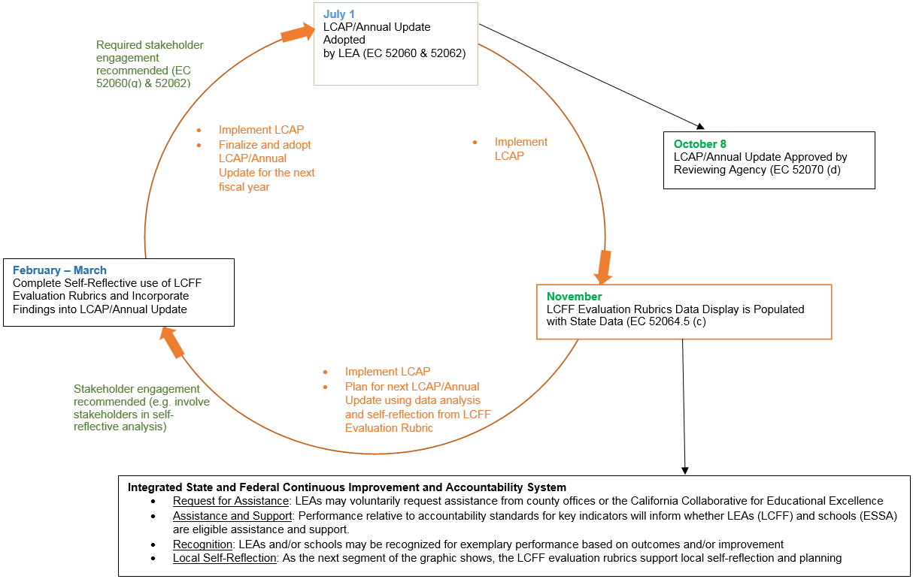

There are two additional LCFF Priorities—for a total of 10 LCFF Priorities—for county offices of education: coordination of services for expelled students, and coordination of services for foster youth. For the sake of simplicity, however, this memo and the accompanying graphic references only the 8 LCFF Priorities that apply to all LEAs.
The caption of the right portion reflects the intent to integrate the requirements under ESSA into the state system of technical assistance and more intensive assistance established by LCFF. But, for simplicity, this graphic does not attempt to address differences between LCFF and ESSA.

