State Board of Education  Executive Office  SBE-002 (REV. 01/2011) | memo-sbe-feb16item05

memorandum

Date: | February 24, 2016

TO: | MEMBERS, State Board of Education

FROM: | STAFF, California Department of Education, WestEd and State Board of Education

SUBJECT: | Potential “Key Indicators” for the LCFF Evaluation Rubrics:  Options that Meet the Criteria for Metric Selection and the Statutory Requirements of LCFF and ESSA

This information memorandum builds on past information memos and board items that proposed organizing the Local Control Funding Formula (LCFF) evaluation rubrics into groupings of “key indicators” and related “associated indicators.” This is the fifth in a series of information memos that will be used to inform the March 2016 SBE item on accountability and continuous improvement.

This memo identifies potential options for selecting key indicators that would also satisfy the requirements of the federal Every Student Succeeds Act (ESSA). It responds to a request from State Board members during the January 2016 meeting for a more complete picture of how the current LCFF evaluation rubrics prototype would function by identifying indicators other than graduation rate that could be used as key indicators and by analyzing how these potential key indicators align with the indicators required under ESSA.

Overview of Key Decision Points

As noted in the January 2016 Board item (http://www.cde.ca.gov/be/ag/ag/yr16/documents/jan16item02rev.doc), ESSA requires that states use a minimum of 5 indicators for accountability purposes.

ESSA identifies 3 of the 5 indicators that must be used: (1) student test scores; (2) progress of English learners toward English language proficiency; and (3) high school graduation rate. The LCFF statutes include these three indicators within the LCFF Priorities, with student test scores and progress of English learners toward English language proficiency included in Priority 4 (Pupil Achievement) and high school graduation rate included in Priority 5 (Pupil Engagement).

The State Board of Education (SBE), as California’s state education agency, must select at least two additional indicators under ESSA: (4) another academic indicator for K–8 and (5) another indicator (which can be non-academic) that applies to all grades. Using the indicators selected under ESSA as key indicators under the current the LCFF evaluation rubrics prototype would promote alignment of the state and federal accountability systems.

A table summarizing the overlap between the minimum 5 indicators required by ESSA and potential key indicators within the LCFF evaluation rubrics is included as Attachment 1.

The next two sections identify options for the additional K–8 indicators and the additional indicator for all grades under ESSA, which would also be considered key indicators under the current LCFF evaluation rubrics prototype. Attachment 2 includes graphical representations for each of the options.

An indicator is listed as an option only if meets criteria identified in an earlier information memo (http://www.cde.ca.gov/be/pn/im/documents/memo-sbe-jun15item01.doc): the indicator is (1) currently collected and available for use at the state level (2) using a consistent definition, (3) can be disaggregated to the school and subgroup level, and (4) is supported by research as a valid measure.

Additional K–8 Academic Indicator

Two options for this indicator are identified below. These potential K–8 Academic Indicators meet the following identified criteria: (1) currently collected and available for use at the state level, (2) using a consistent definition, (3) can be disaggregated to the school and subgroup level, and (4) is supported by research as a valid measure. The discussion of each option includes bullet points that identify the LCFF Priority that the indicator would address, additional information about the indicator, and areas that would require further analysis before staff could recommend whether the indicator should be included as a key indicator.

- Middle School Drop Out Rate
  - This is a metric identified in the LCFF statutes as part of Priority 5 (Pupil Engagement).
  - ESSA requires the inclusion of grade 9–12 graduation rate, so including middle school drop out rate would help support alignment between the K–8 indicators and the 9–12 indicators.
  - The LCFF statutes define middle school drop out rate as “dropout rates for pupils who drop out of school while enrolled in grade 8 or 9.” Because the definition in LCFF includes grade 9, it is unclear if it would serve as an appropriate K–8 indicator.
  - Calculating the rate under the current statutory definition presents potential analytical challenges due to the underlying data set that may undermine the validity or value of these data. The CDE may be able to use the underlying data to calculate another rate that is valid, but it would not precisely track the current statutory definition.

- Composite Index of Two Indicators for Proficiency on Grade 3 Reading and Grade 8 Math (On Track for College & Career Ready)
  - Research has identified these as strongly predictive of future attainment (http://www.cde.ca.gov/be/pn/im/documents/memo-sbe-jun15item01.doc) .
  - These test scores are already included in the academic achievement indicator, so using this indicator would give additional weight to these particular test scores.
  - The overall weighting of test scores in the accountability system for K–8 would increase, leaving the required additional indicator for K–12 as the only non-test-based indicator applicable to K–8.
  - This metric is relevant to Priority 4 (Pupil Achievement) and could apply to Priority 7 (access to broad course of study) given its predictive value of future educational attainment/ability to take advanced coursework.
  - Test scores for K-8 is already one of the required indicators. Further analysis is required to determine if using the same test scores as part of two different indicators presents serious analytical issues.

Note: Chronic absence is one of the metrics identified as part of Priority 5 (Pupil Engagement). An earlier information memo from June 2015 noted research supporting the reliability of this metric for predicting future outcomes (http://www.cde.ca.gov/be/pn/im/documents/memo-sbe-jun15item01.doc), and various stakeholders have identified additional research supporting the reliability of this metric. Data on this metric, however, is not currently collected on a statewide basis in a manner that can be disaggregated to the student subgroup level, so it is not presented as one of the options in this memo. The CDE anticipates collecting this data for the 2016-17 school year in response to requirements in ESSA. Chronic absence may therefore be a candidate for inclusion as a key indicator in the future, pending verification of the quality and reliability of the underlying data

Note: Although it would be possible to use a discrete analysis of growth on test scores for grades 3–8 as the additional K–8 academic indicator, there is currently data for only one year of assessment results. Data for another year will not be available until this fall.

At Least One Other Indicator

Three potential options for addressing this indicator are summarized below. These potential K–8 Academic Indicators meet the following identified criteria: (1) currently collected and available for use at the state level, (2) using a consistent definition, (3) can be disaggregated to the school and subgroup level, and (4) is supported by research as a valid measure. The discussion of each option includes bullet points that identify the LCFF Priority that the indicator would address, additional information about the indicator, and areas that would require further analysis before staff could recommend whether the indicator should be included as a key indicator.

  - Williams settlement legislation requirements.
    - The Williams requirements include three distinct components:
    - Whether teachers are appropriately assigned (misassignments and vacancies);
    - Whether students have access to sufficient instructional materials (access to a copy of standards-aligned instructional materials both at school and at home);
    - Whether facilities are in good repair (maintained in a manner that is clean, safe, and functional).
  - The three components from Williams settlement legislation are identified as metrics within State Priority 1 (Basics).
  - Sufficiency of instructional materials also could be used as an indicator for Priority 2 (Implementation of State Content Standards). “Sufficiency” is defined to include the requirement that the instructional materials are “standards-aligned.” Educ. Code § 60119(c)(1).
  - These requirements have been in the Education Code since 2004. School districts and county offices of education should therefore be familiar with them as existing legal requirements.
  - LCFF incorporated the Williams settlement legislation standards as an LCFF Priority. The underlying legal standards from the Williams settlement legislation, however, do not apply to charter schools, unless they have opted in.
  - The Williams settlement legislation established a single definition for each component, but data on percentage of schools meeting those requirements is held locally and reported through the School Accountability Report Card. It thus may not be available for use at the state level. Further analysis is required to assess how the locally held data could be incorporated into the LCFF evaluation rubrics; to determine how to set standards using these indicators, including the implications for analysis down to the student subgroup level; and to assess whether standards for these indicators can be applied uniformly to all LEAs.

- College & Career Ready
  - A separate information memo will explore possible options for establishing an indicator for college and career readiness. All of the options rely on metrics that are identified as part of Priority 4 (Pupil Achievement).
  - Research presented to the SBE (http://www.cde.ca.gov/be/pn/im/documents/memo-sbe-jun15item01.doc) summarized the significance of college and career indicators, and stakeholders have identified additional research to inform the LCFF evaluation rubrics.
  - Depending on how the indicator is calculated, this indicator could also apply to Priority 5 (Pupil Engagement) and/or Priority 7 (Access to a Broad Course of Study).
  - It may not be possible to apply this indicator at the K-8 level, which would likely require the inclusion of another metric for K-8 grades to meet the requirements of ESSA.
  - Further analysis is required to assess the reliability of various state data, to identify a specific metric or combination of metrics for possible consideration, and to determine whether using this indicator would require including an additional K-8 indicator.

- Suspension Rate
  - This is one of the metrics identified as part of Priority 6 (School Climate).
  - An earlier memo (http://www.cde.ca.gov/be/pn/im/documents/memo-sbe-jun15item01.doc) identified some research showing a relationship between suspensions and future outcomes, and stakeholders have identified additional research along these lines. This indicator could therefore apply to Priority 5 (Pupil Engagement).
  - There is a statutory definition for suspensions that applies to school districts and county offices of education. But local policies and practices regarding the application of the legal authority to suspend students from school vary, raising some question about how comparable the suspension rates are across the state.
  - Additionally, the statutory definition does not apply to charter schools, adding further potential variability among the underlying data.
  - Further analysis is required to determine how local variation in policies and practices and differing legal requirements across school types may affect the reliability and/or comparability of the underlying data for all LEAs and schools.

Note: Chronic absence as referenced above, is a candidate for inclusion as a key indicator in the future, pending verification of the quality and reliability of the underlying data after state-level collection begins.

Areas for Future Analysis

The next step for completing the current LCFF evaluation rubrics prototype is to complete a full analysis of each potential key indicator that is similar to the analysis being completed for graduation rate. This involves: (a) running data analyses down to student subgroup and school level; and (b) presenting one or more options for applying the results into the Alberta-like framework.

Before staff proceed with these analyses, the SBE may wish to consider the following questions:
- Should the CDE, WestEd, and SBE staff complete the full data analysis for each potential key indicator identified above?
- Are there any additional indicators that meet the selection criteria identified in the memo and that should be considered as potential key indicators?

Additionally, the LCFF evaluation rubrics must include standards for performance and expectations for improvement for each LCFF Priority, EC 52064.5(c). As noted in an earlier information memo (http://www.cde.ca.gov/be/pn/im/documents/memo-sbe-feb16item02.doc), identification of LEAs for assistance and support is based on performance relative to standards established within each LCFF Priority. Staff may need to develop one or more possible approaches to setting standards for any LCFF Priority that is not covered by a key indicator, including for any LCFF Priority that does not have an indicator that meets the selection criteria identified at the beginning of this memo.

ATTACHMENT(S)

Attachment 1: Comparison of Potential LCFF Key Indicators and Indicators Required by Every Student Succeeds Act (ESSA) (1 Page)

Attachment 2: Graphics Illustrating Potential Options for Key Indicators that Meet ESSA’s Requirements (4 Pages)

Comparison of Potential LCFF Key Indicators and Indicators Required by Every Student Succeeds Act (ESSA)

The table displays how selection of key indicators under the current Local Control Funding Formula (LCFF) evaluation rubrics prototype could address the minimum 5 indicators required by ESSA.

The column on the left shows which LCFF Priority is addressed by each ESSA-required indicator. The columns on the right show the ESSA-required indicators for elementary and middle school, and high school, respectively.

LCFF | Every Student Succeeds Act
Potential “Key Indicators” from LCFF Priorities | Elementary and Middle School Indicators | High School Indicators
Pupil achievement (Priority 4)  - Student achievement scores (English language arts and mathematics; all relevant grade spans) | Academic Achievement  - English language arts and mathematics in grades 3 through 8, inclusive | Academic Achievement  - English language arts and mathematics assessed one time in grades 9 through 12
Pupil achievement (Priority 4)  - Percentage of English learners (ELs) making progress toward English proficiency | English Proficiency  - Progress ELs in achieving English proficiency | English Proficiency  - Progress of EL) in achieving English proficiency
Pupil engagement (Priority 5)  - High school graduation rate  TBD (Priority will vary based on indicator selected)  - Other K-8 Additional Academic | Another Academic Indicator  - Other academic factor that can be broken out by subgroup | Another Academic Indicator  - 4-year adjusted cohort graduation rate (states can add extended rate)
TBD (Priority will vary based on indicator selected)  - At least one other indicator | At Least One Other Indicator  - Additional indicator (e.g., student engagement and school climate/safety) | At Least One Other Indicator  - Additional indicator (e.g., opportunity to learn and college/career readiness)

Graphics Illustrating Potential Options for Key Indicators that Meet ESSA’s Requirements

The following graphics illustrate the LCFF evaluation rubrics with key indicators aligned to ESSA requirements. The graphics organize the indicators within the LCFF evaluation rubrics policy statements presented at the September 2015 board meeting (http://www.cde.ca.gov/be/ag/ag/yr15/documents/jul15item01.doc, Attachment 3).

The initial graphic shows the three indicators that ESSA specifies—student test scores, progress of English learners toward English language proficiency, and high school graduation rate—as white boxes and the two additional indicators that states must identify—other K-8 academic indicator and one other indicator—as gray boxes.

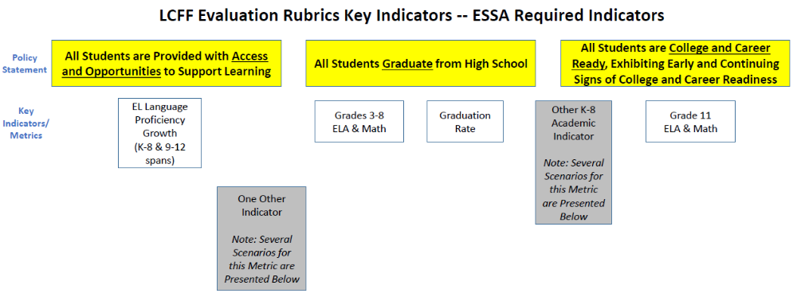

The graphics in the last two sections of this Attachment update the initial graphic by showing in blue the potential key indicators identified in the accompanying memo for other K-8 academic indicator and one other indicator, respectively.

Options for Additional K-8 Academic Indicator

The graphics below update the initial graphic with the options for the Additional K-8 Academic Indicator.

Option 1: Middle School Dropout Rate

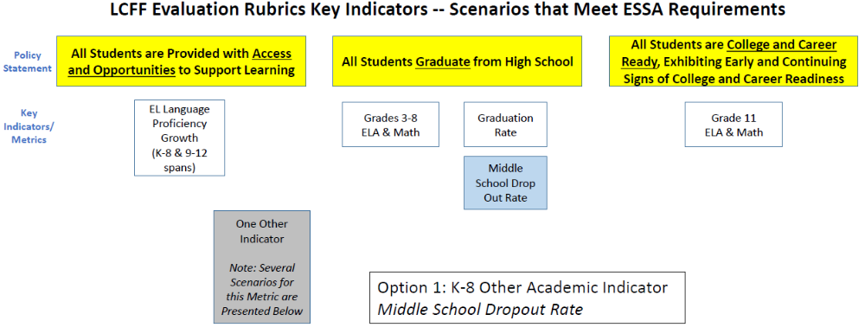

Option 2: College & Career Ready Composite (K-8)

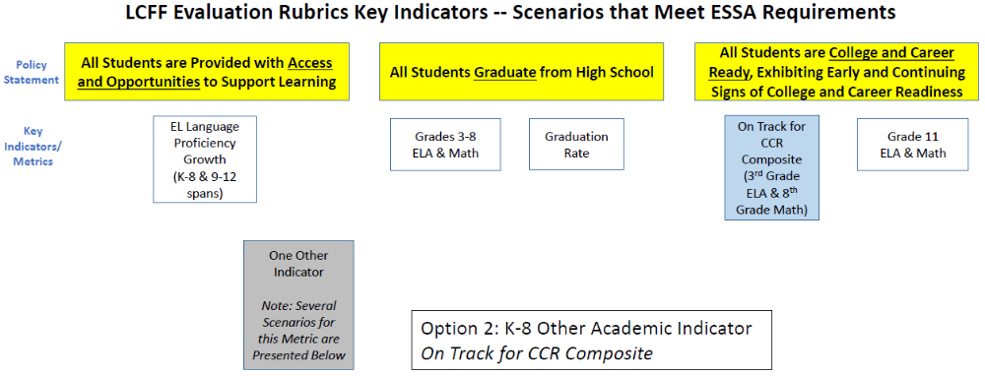

Options for At Least One Other Indicator

The graphics below update the original graphic based on each of the options identified in the accompanying memo. These graphics also identify which State Priorities are addressed by the key indicators included within each of the options.

Option 1: Williams Settlement Legislation
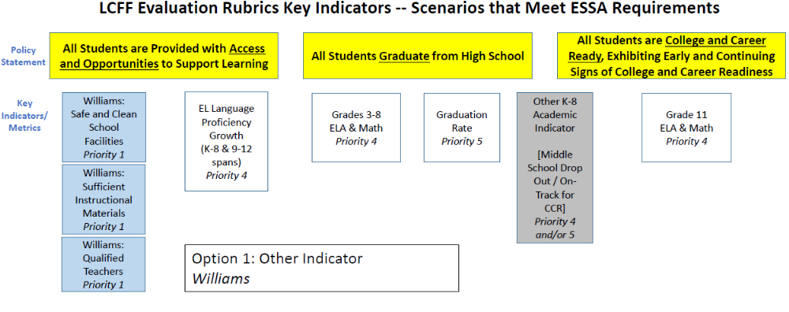

Option 2: College & Career Ready Composite (9-12)
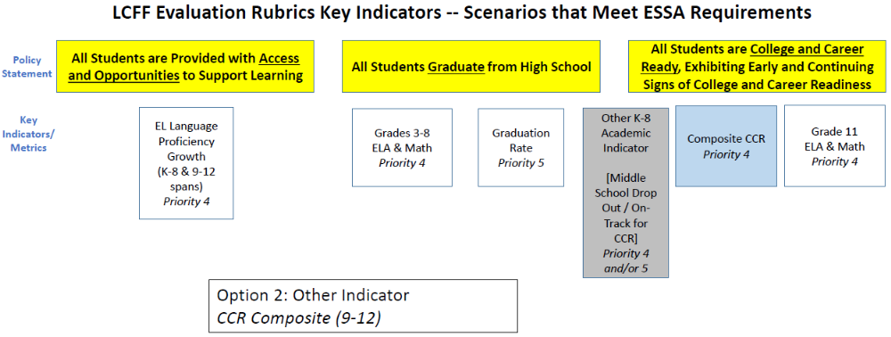

Option 3: Suspension Rate
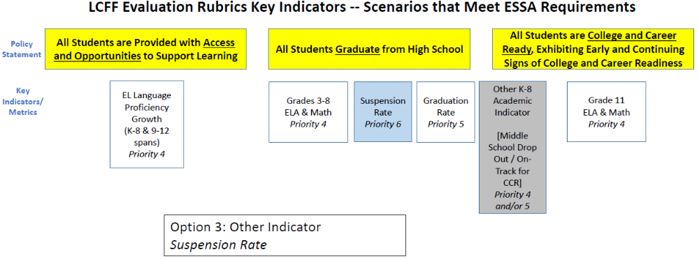

This memo focuses only on potential key indicators. The lack of discussion of associated indicators is not intended to suggest a change in the design of the current LCFF evaluation rubrics prototype. Additional analysis will be conducted in the future to identify potential associated indicators and appropriate groupings or clusters of associated with the potential key indicators.
ESSA requires states to administer an assessment for science at least once each during grades 3-5, grades 6-9, and grades 10-12, see 20 USC 6311(b)(2)(B)(v)(II), as amended by ESSA, Section 1005, but does not require that states use the results of these assessments for purposes of identifying schools for support and assistance, see 20 USC 6311(c)(4)(B), as amended by ESSA, Section 1005. The Academic Performance Index currently includes scores for science and history-social science, in addition to English language arts and mathematics, but with minimal weight given to science and history-social science relative to the other two subjects. See, e.g., California Department of Education, Executive Summary Explaining the Academic Performance Index (API), available at http://www.cde.ca.gov/ta/ac/ap/documents/apiexecsummary.pdf.
The Additional K-8 Academic Indicator applies only to LCFF Priorities that the three indicators specified by ESSA (test scores, EL progress toward proficiency, and graduation rate) already address.

