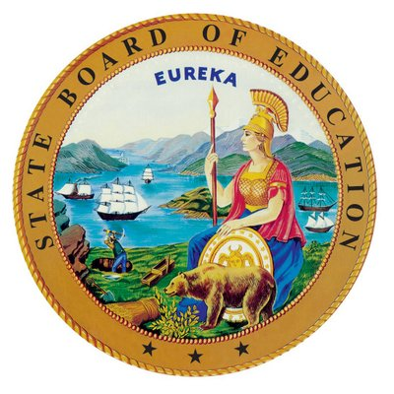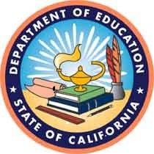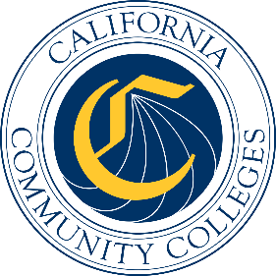

California Workforce Pathways
Joint Advisory Committee
July 11, 2025
Agenda Item 03

Subject
Career Technical Education Model Curriculum Standards Update

Type of Action
Information

Summary of the Issue(s)
The California Department of Education (CDE) is initiating the process of updating the Career Technical Education (CTE) Model Curriculum Standards and Framework (MCS) to bring California into alignment with the Advance CTE National Career Clusters Framework. This framework serves as the foundation for CTE programs in every state and is used for reporting processes at the national level. This alignment will ensure California's CTE programs stay current, skills-based, and aligned to today’s workforce needs.
Central to this process is the commitment to begin with educator voice. The update will be grounded in a comprehensive, stakeholder-engaged approach that prioritizes input from California's CTE educators at every stage. This ensures that the framework not only aligns with national expectations but also reflects the practical needs of those delivering CTE instruction across the state.
The revised MCS will emphasize emerging technologies, occupational alignment, and industry-driven guidance preparing students for career and college opportunities. By aligning California's standards with national frameworks and contemporary workforce needs, the updated MCS will ensure our CTE programs remain competitive and relevant in preparing students for both immediate employment and continued educational advancement.
A component of this update is planned collaboration among the core leadership of the California Longitudinal Pupil Achievement Data System (CALPADS) team and the California Commission on Teacher Credentialing. These teams working together will ensure that information systems and processes remain consistent with the new standards as they are adopted. The plan to update MCS was shared with the California State Board of Education (SBE) in June 2025 via a Memo. The SBE Memo is available for viewing on the CDE SBE web page at https://www.cde.ca.gov/be/pn/im/infomemojun2025.asp.

Brief History of Key Issues
Background Context
Since the most recent update to the MCS in 2013, the state's education and workforce priorities have shifted significantly. California's Master Plan for Career Education and the State Superintendent of Public Instruction's (SSPI) initiatives have prioritized systems alignment and career readiness. While California currently organizes CTE programs into 15 sectors, the national framework consists of 14 Career Clusters that reflect the current workforce and industry trends. Adopting the national framework will improve transparency and access for all students in California.
The Need for Alignment
Advance CTE recently released the National Career Clusters Framework, which is informed by labor market information and industry sector research, and validation. The Advance CTE Framework also aligns California's CTE programs with the O-Net Standard Occupational Classification (SOC) system, streamlining the collection of labor market information and supporting alignment to workforce development efforts.

Approach and Areas of Focus
The broad intent of updating the MCS is to provide integration and direction to current state, regional, and local level CTE work that are relevant for stakeholders, particularly students and employers, as the system's ultimate beneficiaries. The scope of this work is organized into three key areas with equity and access being foundational threads throughout:
- Workforce supply that meets demand: industry interactions and partnerships, in-demand skills and clusters, labor market alignment
- Delivery systems: competency-based education, emerging technologies integration, experiential/work-based learning, curriculum alignment
- Systems alignment: dual enrollment, teacher preparation, credentialing, career pathways coordination
The following cross-cutting themes further support the key areas above:
- Career Pathway Integration
- Dual Enrollment
- CTE Teacher Preparation Pipeline
Framework Principles
The update will ground programs in the context of education and workforce development priorities, including Career Education and the Future of Work initiative. The CDE will continue to draw on resources such as the Federal Strengthening Career and Technical Education for the 21st Century Act (Perkins V) and stakeholder input to ensure the standards reflect the diverse needs of California's education landscape.

Implementation
Collaborative Infrastructure
This collaboration between CDE, CALPADS, and the California Commission on Teacher Credentialing will:
- Ensure CTE pathways and course sequences are thoughtfully mapped to the 14 career cluster frameworks
- Foster alignment between CTE pathways, course sequences, and broader state initiatives
- Promote integration of teacher credentialing to inform educator preparation and program development
Implementation Approach
A comprehensive implementation approach will be utilized to support adoption of the updated Model Curriculum Standards and Framework. Stakeholder input will guide every step of the update, ensuring programs reflect real-world needs and classroom realities.
This update represents a timely reflection of the vision set forth in the Governor's Master Plan for Career Education and the SSPI’s CTE Initiatives, ensuring that California's
TK–12 CTE teachers are provided with updated instructional guidance and that students are well-prepared for the evolving world of work.

Attachment(s)
No Attachments

“THE BASICS: The National Career Clusters Framework.” https://careertech.org/wp-content/uploads/2024/11/The_Basics_Career_Cluster_Framework_Oct_2024.pdf
“TECHNICAL REPORT: Advancing the National Career Clusters® Framework” https://careertech.org/wp-content/uploads/2024/10/Technical_Document_National_Career_Clusters_Framework_12_2024.pdf
“FRAMEWORK CROSSWALK: CIP, SOC, NAICS, Career Cluster, and Sub-Cluster” https://careertech.org/resource/framework-crosswalk/
“Emerging Sectors, Responsive Career Pathways: Bridging Education and Industry” "https://careertech.org/wp-content/uploads/2025/06/NSrn_Emerging_Sectors_Responsive_Career_Pathways.pdf
“Putting LMI in the Right Hands” https://careertech.org/wp-content/uploads/2023/01/Putting_LMI_in_the_Right_Hands_2017.pdf

