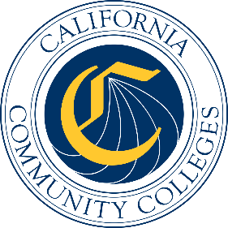

California Workforce Pathways
Joint Advisory Committee
March 13, 2026
Agenda Item 04

Subject
Cradle to Career – Informational Session.

Type of Action
Information

Summary of the Issue(s)
This information item will be a follow-up presentation by leadership from the California Department of Education’s (CDE) Education Data Management Division joined by leadership from the California College Guidance Initiative (CCGI). The presentation will review the legislation authorizing the CCGI and then transition to the CCGI who will provide an in-depth presentation on the statewide scaling of the use of student-friendly tools, referred to as operational tools in statute, provided through the CCGI platform, CaliforniaColleges.edu. CCGI will highlight how data from CDE as well as partner local educational agencies (LEAs) supports California public schools and students with free, one-stop resources for career assessment and exploration; college, career, and financial aid knowledge development; post-secondary planning; and application integrations.

Brief History of Key Issues
The CCGI was written into California Education Code (EC) Section 60900.5 as an authorized provider of an institutional service to all California School Districts and as part of the state’s efforts to provide free college and career planning for pupils in grades 6 to 12, make the college and financial aid application process a more streamlined experience for students and the educators who support them (EC Section 60900.5(a)), and create new tools related to career and technical education pathways (EC Section 60900.5(g)(12)). The CDE is a key partner of both the C2C Data System and the CCGI by providing data to both systems.

Attachment(s)
None

