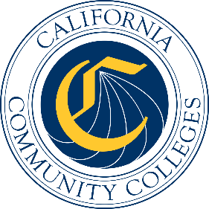

California Workforce Pathways
Joint Advisory Committee
November 7, 2025
Agenda Item 02

Subject
California Cradle-to-Career Data System Updates and Progress

Type of Action
Information

Summary of the Issue(s)
This information item will be a presentation by leadership from the California Department of Education’s (CDE) Education Data Management Division. The presentation will provide an overview of the legislation creating the Office of the California Cradle-to-Career (C2C) Data System and the California College Guidance Initiative (CCGI). The presentation will describe the CDE’s role in both statewide investments including data provided to the C2C as well as data shared with the CCGI for the establishment and statewide scaling of the use of student-friendly tools, referred to as operational tools in statute, provided through the CCGI platform, CaliforniaColleges.edu.

Brief History of Key Issues
The California’s C2C Data System is authorized in California Education Code (EC) Section 10860 for the “purpose of connecting individuals and organizations to trusted information and resources.” The CCGI was written into California EC Section 60900.5 as an authorized provider of an institutional service to all California School Districts and as part of the state’s efforts to make college-going a more streamlined experience for students (EC Section 60900.5(a)). The CDE is a key partner of both the C2C Data System and the CCGI by providing data to both systems.

Attachment(s)
None

