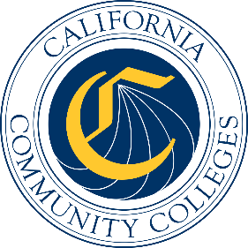

California Workforce Pathways
Joint Advisory Committee
November 7, 2025
Agenda Item 04

Subject
Non-Credit and Adult Education

Type of Action
Information

Summary of the Issue(s)
This item provides a joint update from the California Community Colleges Chancellor’s Office and the California Department of Education on noncredit and adult education activity.

Brief History of Key Issues
Noncredit and adult education are essential to equity and economic mobility. These programs provide skills to address workforce needs for which degrees are not required and provide professional certifications leading to transitions to employment or enrollment in a credit degree program, which lead to gains in individual economic security and a relevantly skilled workforce.
Students participate in noncredit and adult education to complete a variety of goals, including:
- Improving skills in English for non-native speakers
- Learning the pathways to U.S. citizenship
- Learning basic adult literacy skills in math and English
- Obtaining a high school diploma, prepare for the General Education Development (GED)/High School Equivalency Test (HiSET) exam
- Building skills for a new job or promotion
- Preparing for community college or university education
- Building self-sufficiency and independence
- Pursuing personal enrichment
California’s noncredit programs are also supported by the California Adult Education Program (CAEP). CAEP funding provides educational and training programs to these individuals in the following seven allowable areas:
- Programs in elementary and secondary skills, including those leading to a high school diploma or high school equivalency certificate.
- Programs for immigrants in citizenship, ESL, and workforce preparation.
- Programs for adults, including, but not limited to, older adults, that are primarily related to entry or reentry into the workforce.
- Programs for adults, including, but not limited to, older adults, that are primarily designed to develop knowledge and skills to assist elementary and secondary school children to succeed academically in school.
- Programs for adults with disabilities.
- Programs in career technical education that are short term in nature with high employment potential.
- Programs offering pre-apprenticeship training conducted in coordination with one or more apprenticeship programs approved by the Division of Apprenticeship Standards.
Noncredit programs have proven to be a gateway into the credit programs of the System, bringing in students from the program areas mentioned above and showing them the possibilities beyond noncredit such as ability to earn an associate degree, a vocational certificate, or the prospect of transferring to a four-year institution.
Adult learners are a fundamental focus in Vision 2030, emphasizing equitable access, support, and success for all Californians. Aiming to create an inclusive higher education system that provides pathways for every learner regardless of their background, Vision 2030 provides intentional on-ramps for adult learners who can face significant barriers to educational attainment and career advancement. Noncredit programs are at the forefront in achieving these goals to support our most vulnerable population as these programs offer flexible and accessible pathways that lead to meaningful credentials and employment.

Attachment(s)
None
Posted By: California Department of Education – October 2025

