California Workforce Pathways Joint Advisory Committee
Page 1 of 1
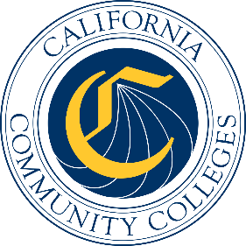

California Workforce Pathways
Joint Advisory Committee
November 7, 2025
Agenda Item 05
Posted by the California Department of Education

Subject
GENERAL PUBLIC COMMENT. Public comment is invited on any matter not included on the printed agenda.
Depending on the number of individuals wishing to address the California Workforce Pathways Joint Advisory Committee (CWPJAC), the presiding officer may establish specific time limits on presentations.

Type of Action
Information

Summary of the Issue(s)
This is a standing Agenda Item which allows the members of the public to address the CWPJAC on any matter that was not included on the posted November 7, 2025, meeting agenda.

