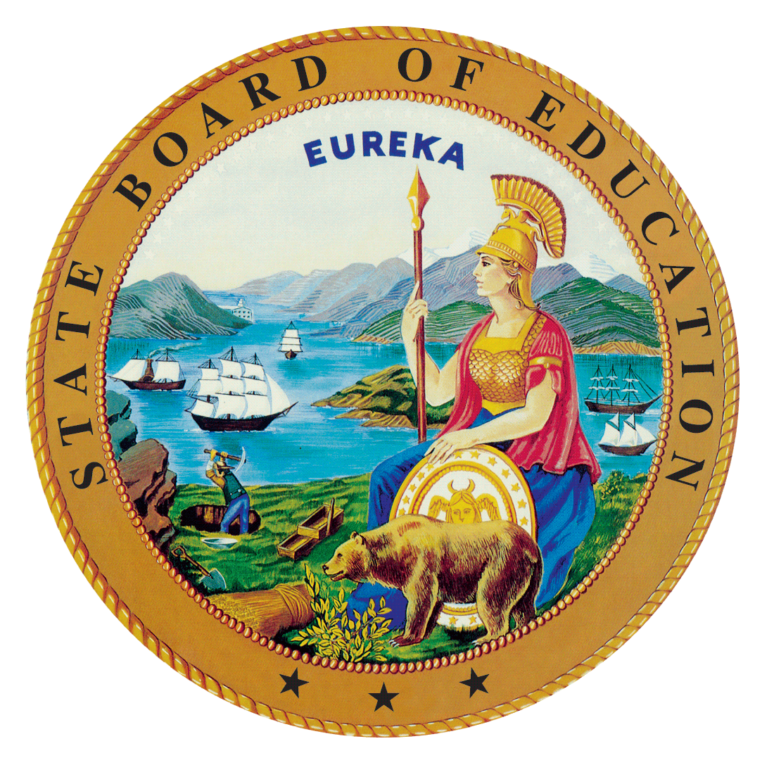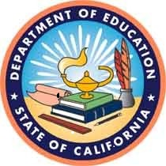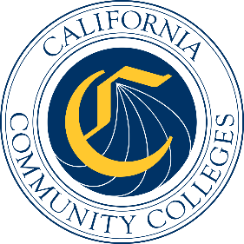

California Workforce Pathways

Joint Advisory Committee
April 2019

Agenda Item 01

Subject
Proposed Revisions to the Guiding Policy Principles to Support K–14+ Pathways, as approved by the California Workforce Pathways Joint Advisory Committee (CWPJAC) in 2018.

Type of Action
Action, Information

Summary of the Issue(s)
This item is to share with CWPJAC members the proposed revisions to the Guiding Policy Principles to Support K–14+ Pathways document based on member comments received at the March 2019 CWPJAC meeting.

Recommendation
Staff of the CWPJAC recommends that the CWPJAC review and approve the proposed changes to the Guiding Policy Principles to Support K–14+ Pathways document.

Brief History of Key Issues
The CWPJAC reconvened in March, 2017. After several meetings of obtaining information about career technical education programs throughout California’s kindergarten through grade twelve and California community college systems, staff of the CWPJAC drafted the Guiding Policy Principles to Support K–14+ Pathways document to help focus the committee’s work, the CWPJAC approved the document at the March and May 2018 meetings.
Summary of Previous California Workforce Pathways Joint Advisory Committee Discussion(s) and Action(s)
March 2019: A review of proposed language additions from the February 2019 CWPJAC meeting to include more student centered language throughout the document. Members provided additional feedback.
February 2019: A review of all the public feedback comments received were provided to the CWPJAC. To include more student centered language in the document, Member Costa provided staff with some suggested additions.
January 2019: A summary of the public feedback received was presented to the CWPJAC. Some of the committee members requested to review all of the feedback as a way to determine if revisions were necessary.
March/May 2018: The CWPJAC approved the Guiding Policy Principles to Support K–14+ Pathways document, and requested that staff obtain public feedback on the Guiding Policy Principles to Support K–14+ Pathways document. Subsequently, staff developed a survey to collect public comments which opened on August 24, 2018 and closed on November 30, 2018. Staff also conducted a public meeting to obtain feedback on August 22, 2018. On September 7, 2018, Chair Sun, and Vice Chair Haynes presented the Guiding Policy Principles to Support K–14+ Pathways document to the State Board of Education.

Attachment(s)
The supporting materials (e.g., attachments, addendums, CWPJAC commentary, or related reports) will be listed below as they become available electronically.
Attachment 1: Proposed Changes to the Guiding Policy Principles to Support K–14+ Pathways

