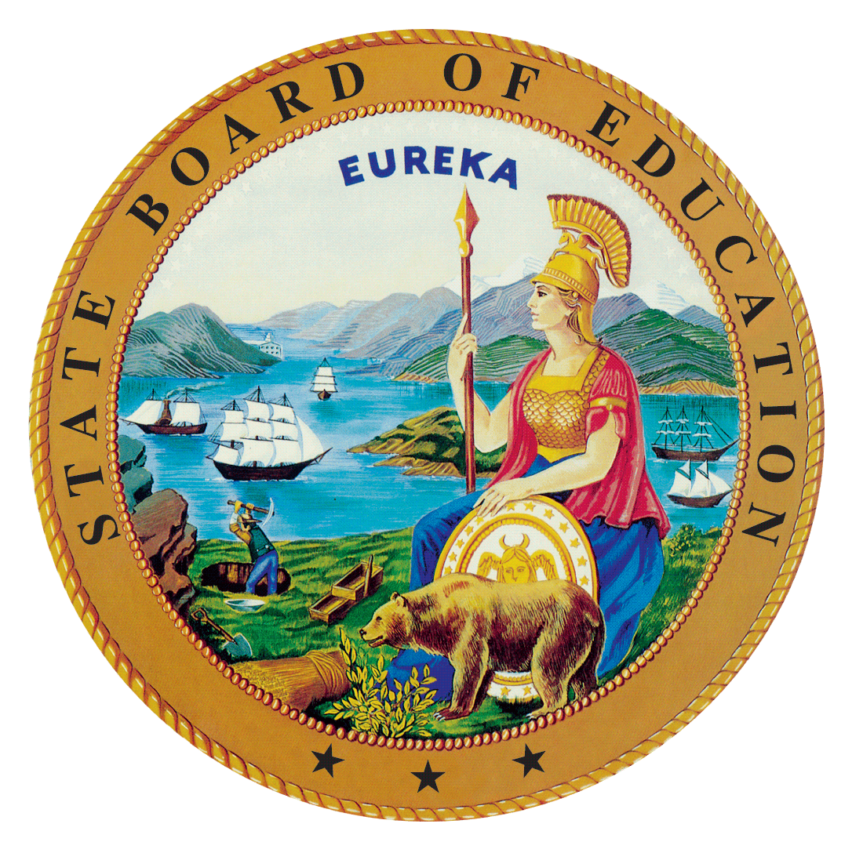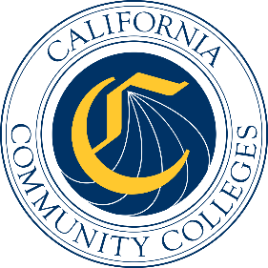

California Workforce Pathways
Joint Advisory Committee
February 03, 2023
Agenda Item 03
Posted by the California Department of Education

Subject
The Career Technical Education Incentive Grant (CTEIG) and the Kindergarten through Grade Twelve Strong Workforce Program (K–12 SWP): Update on the 2022–23 CTEIG 8B Application Process and Timeline; the 2022–23 K–12 SWP Application Process and Timeline; and Kindergarten through Grade Fourteen (K–14) Technical Assistance (TA) Providers and Workforce Pathways Coordinators.

Type of Action
Information

Summary of the Issue(s)
This agenda item provides updates on various aspects of the CTEIG and K–12 SWP:
- The Fiscal Year (FY) 2022–23 CTEIG application process and timeline and the K–12 SWP application Process and Timeline; and K–14 TA Providers and Workforce Pathways Coordinators.

Recommendation
This is an information item only; there is no recommendation at this time.

Brief History of Key Issues
The CTEIG was originally established by the Budget Act of 2015 with a one-time investment of $900 million to cover a three-year span, and acted as a bridge for local educational agencies (LEAs) to support career technical education (CTE) programs until the Local Control Funding Formula was fully funded.
In the 2018 Budget Act, the CTEIG was allocated $150 million in ongoing funds. An additional $13.5 million was provided annually, through the K–12 Strong Workforce Program, to establish TA providers and workforce pathway coordinators to support CTEIG. The CTEIG is administered by the California Department of Education (CDE).

The FY 2022–23 CTEIG Application Process and Timeline
The FY 2022–23 CTEIG Request for Applications (RFA) was released to LEAs in August 2022, with the due date for LEAs to submit completed applications by September 30, 2022. The CDE held a series of webinars to provide LEAs with information on how to complete the RFA process and continues to provide TA to LEAs who contact CDE’s CTEIG Regional Consultants. The CDE continues provide professional development to the K–14 TA Providers and Pathway Coordinators regarding the 2022–23 CTEIG RFA process to enable them to better assist LEAs in completing the application. The 2021 Budget Act added an additional $150 million to the available CTEIG funding that brings the total available funding to $300 million. It is anticipated that the proposed allocations for the FY 2022–23 CTEIG program will be recommended for approval at the January 2023 State Board of Education meeting.
The 2021 Budget Act also included language that amended the match requirement and programs eligible to apply for the CTEIG funding. The CTEIG match now requires applicants to encumber their match during the first year of the grant. CTE-based Advanced Placement, International Baccalaureate, and Dual Enrollment programs are now eligible to apply for CTEIG funds.

The FY 2022–23 (Round 5) K–12 SWP Application Process and Timeline for FY 2023–24 (Round 6)
The California Community Colleges Chancellor’s Office (CCCCO) will provide an update on the Round 5 RFA process and timeline for funding for Round 6.

For the Round 5 FY 2022–23 allocation, the CCCCO received 300 K–12 SWP applications with a total request of $211,207,227 in funding. The CCCCO awarded 224 K–12 SWP applications for a total amount of $143,668,212 in funding.
The round 6 application timeline is as follows:

K–12 SWP 2023–24 Timeline:
Date | Event
Aug 2023 | Launch Round 6 K–12 SWP Application
Oct-2023 | K–12 SWP Applications due in NOVA system
Oct-2023 | Selection Committee member training
Nov-2023 | Selection Committees review applications and submit nominations of proposed grantees to the CCCCO
Dec-2023 | K–12 SWP preliminary intent to award announced
Dec-2023 | Appeals due to SWP Regional Consortium
Jan-2024 | Regional Consortia communicate intent to award funds to LEAs and initiate subcontract process
Jan-2024 | K–12 SWP Round 6 project term begins

Summary of Previous California Workforce Pathways Joint Advisory Discussion(s) and Action(s)
November 29, 2022: The CDE provided an update on the 2022–23 Round 8A CTEIG Application, Timeline and Preliminary Allocations.
August 11, 2022: The CDE provided an update on the 2022–23 Round 8 CTEIG Application Process and Timeline.
March 25, 2022: The CDE provided an update on the 2021–22 Round 7B CTEIG Application Process and Timeline.
November 19, 2021: The CDE provided an update on the 2021–22 CTEIG Application Process and Timeline, for the CTEIG 2021–22 Application Process. The CCCCO provided a brief update on the 2021–22 K–12 SWP Application Process and Timeline, and the K–14 TA Providers and Workforce Pathway Coordinators.
September 29, 2021: The CDE provided an update on the 2021–22 CTEIG Application Process and Timeline, including Addendum 1 and Addendum 2 to the CTEIG 2021–22 Application Process. The CCCCO provided the update on the 2021–22 K–12 SWP Application Process and Timeline, and the K–14 TA Providers and Workforce Pathway Coordinators.
May 14, 2021: The CDE provided an update on the 2021–22 CTEIG Application Process and Timeline; the 2021–22 K–12 SWP Application Process and Timeline; and K–14 TA Providers and Workforce Pathways Coordinators.
January 29, 2021: The CDE provided updates on the approved CTEIG allocations for FY 2020–21 and the FY 2021–22 CTEIG application; the CCCCO provided updates on the K–12 SWP funding allocations and interim measures; and an update was provided on the K–14 TA Providers and Pathway Coordinators.
November 20, 2020: The CDE presented updates on the FY 2020–21 CTEIG funding allocations; the FY 2020–21 K–12 SWP application process; and the Memorandum of Understanding data sharing agreement between the CDE and CCCCO. Staff recommended that there be no change to the data metrics for both the CTEIG and K–12 SWP, and that a phased approach be used to operationalize the data metrics.

Fiscal Analysis (as appropriate)
Funding available to eligible recipients under the CTEIG is $300 million for the program year (PY) 2022–23, and funding available to eligible recipients under the K–12 SWP is $150 million for PY 2022–23. In addition, $13.5 million is provided to support eight K–14 TA Providers and 72 Workforce Pathway Coordinators for both CTEIG and K–12 SWP initiatives.

Attachment(s)
None

