California Workforce Pathways Joint Advisory Committee
cwpjac-jul26item01
Page 1 of 2
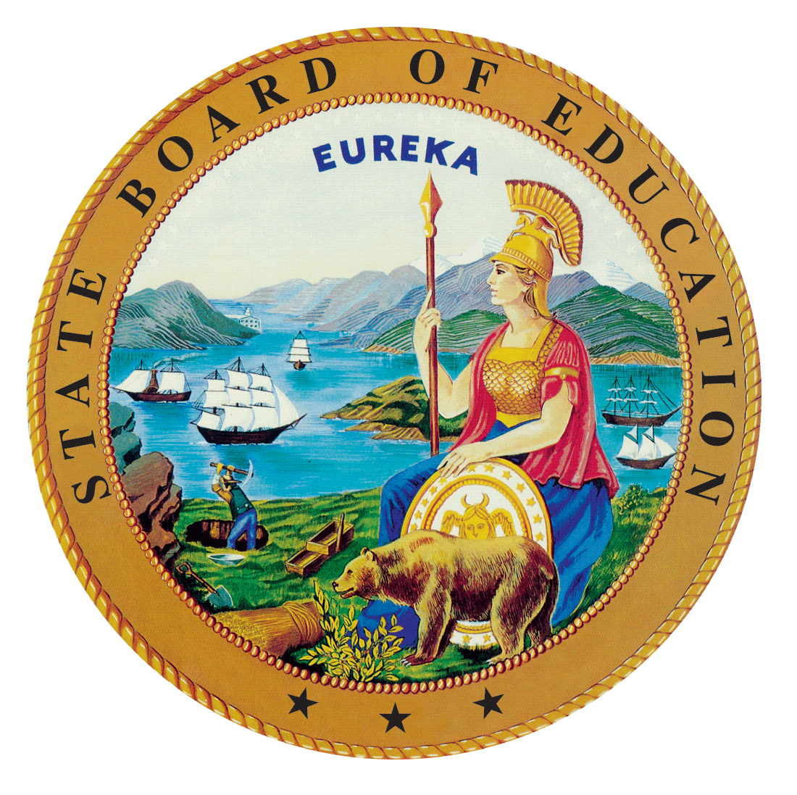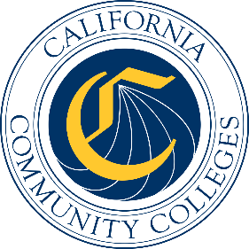

California Workforce Pathways
Joint Advisory Committee
July 10, 2026
Agenda Item 01
Posted by the California Department of Education

Subject
CAREER WORKFORCE PATHWAYS JOINT ADVISORY COMMITTEE PROJECTS AND PRIORITIES.
Including, but not limited to, future meeting plans; agenda items; Advisory Committee appointments and direction for staff; Committee policy; approval of minutes; Committee Chair and liaison reports; Department staffing updates; and other matters of interest.

Type of Action
Information, Action

Summary of the Issue(s)
- Career Workforces Pathways Joint Advisory Committee (CWPJAC) Draft Preliminary Report of Actions/Minutes for the March 13, 2026, meeting
- Committee Member reports
- Department Staffing Updates:
  - California Department of Education (CDE)
  - California Community Colleges Chancellor’s Office (CCCCO)
  - State Board of Education (SBE)

Recommendation
CDE and CCCCO staff jointly recommend that the CWPJAC review and approve the March 13, 2026, Preliminary Report of Actions/Draft Minutes (Attachment 1).

Brief History of Key Issues
The CWPJAC addresses systems alignment policies specific to career pathways within the context of state and federal investments, furthering California’s policy objectives regarding workforce pathways in the state’s regional economies.

Summary of Previous California Workforce Pathways Joint Advisory Committee Discussion(s) and Action(s)
This is a standing Agenda Item which allows the CWPJAC members to review and approve the Preliminary Report of Actions/Draft Minutes for the previous CWPJAC meeting and any other topics necessary to run the CWPJAC.

Attachment
Attachment 1: Preliminary Report of Action/Draft Minutes (4 pages)

