California Workforce Pathways Joint Advisory Committee
cwpjac-marb23item02
Page 1 of 7
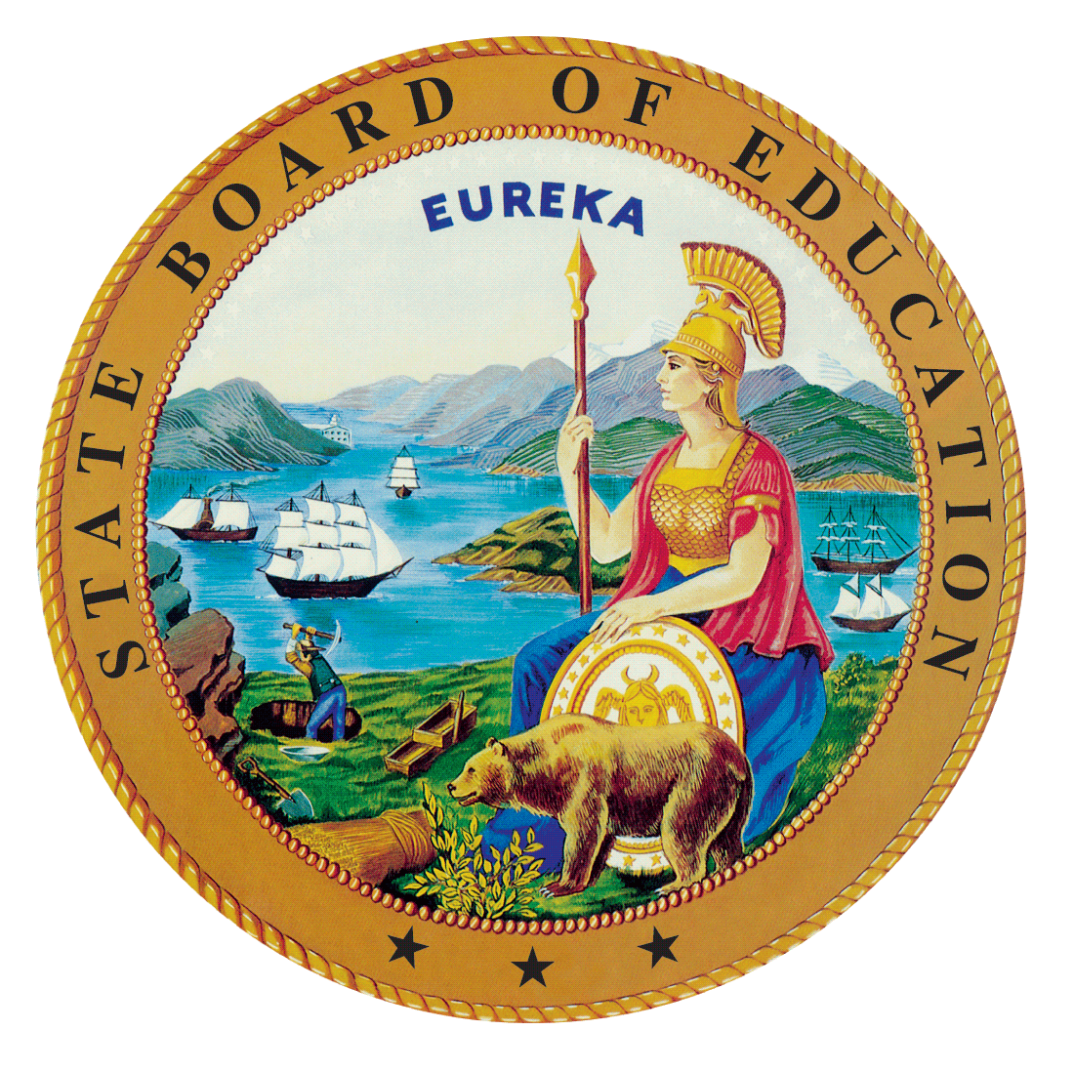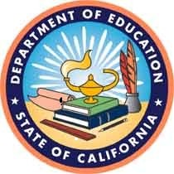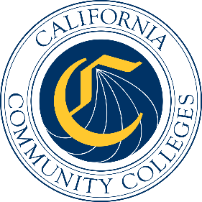

California Workforce Pathways
Joint Advisory Committee
March 10, 2023
Agenda Item 02
Posted by the California Department of Education

Subject
Approval of the Final Draft California State Plan for Career Technical Education presented by Jobs for the Future and California Department of Education staff.

Type of Action
Information/Action

Summary of the Issue(s)
The California State Team (CAST), consisting of core leadership of the State Board of Education (SBE), the California Department of Education (CDE), and the California Community Colleges Chancellor’s Office (CCCCO) was formed in October 2019 to oversee the development of the comprehensive California State Plan for Career Technical Education (CTE). At the July 2020 California Workforce Pathways Joint Advisory Committee (CWPJAC) meeting, the CAST presented a recommended approach to create a Strategic Plan/Call to Action in the development of the California State Plan for CTE.
At the September 2020 meeting, the CAST provided an update regarding the framing of the State Plan using a Call to Action approach, as outlined in the Brief History of Key Issues below.
The CAST discussions have centered on developing: (a) specific strategic areas of focus; (b) expertise required to assist with providing necessary bandwidth to accomplish the work; and (c) a detailed scope of work.
Upon advice and guidance from CWPJAC members on the more detailed scope of work, the CAST team has begun the process of developing a draft outline of a forward-looking document that becomes California’s Strategic Plan/Call to Action for CTE. With a fully executed contract with Jobs for the Future (JFF) has been secured, work on the first and second phase of the work is underway. The first phase was focused on engaging with various interest holders to gain an understanding of the context of the development process. The first phase included a planning session with the CWPJAC at its August 6, 2021, meeting to receive guidance and recommendations on JFF’s recommended approach of hosting study sessions, as well as focus group sessions to gather input from various interest holders and practitioners, both of which were conducted virtually. A survey of parents and students is also in progress to ensure that their input is gathered at the outset of the development phase.
The second phase is the actual State Plan development work, including the draft and updating of the plan, and the public comments that were collected during a 45-day Public Comment period.

Recommendation
The CDE and the CCCCO staff recommend that the CWPJAC approve the final draft of the California State Plan for CTE.

Brief History of Key Issues

Approach and Areas of Focus
This session will provide an updated draft California State Plan for CTE, along with the themes of the comments that were submitted during the 45-day Public Comment period, along with an update on the timeline.
The broad intent of the Strategic Plan/Call to Action approach for the California State Plan for CTE is to provide cohesion and direction to the current state, regional, and local level work through visionary and innovative approaches that are relevant for interest holders, and particularly for students and employers as the system’s ultimate benefactors. The goal of the Strategic Plan/Call to Action is to lay out the state’s future vision for CTE, both in the short-term (i.e., in the next five years) and long-term (i.e., in ten years), using creative strategies while preserving intentionality of California’s student-centered approach and the California Way.
In the immediate term, the Strategic Plan/Call to Action will also address lessons learned from the COVID-19 pandemic in order to build from our collective experiences and knowledge for the benefit of student learning and skills obtainment, and to tie them into efforts shared from Future of Work initiative and future employability. During this time, college and career pathway programs have become more critical for helping to stabilize the economy and enable employers to hire workers with skills they need.
In the development of the State Plan for CTE, the scope of work has been organized into four key areas with equity and access being foundational threads throughout:
- Workforce supply that meets demand (industry interactions and partnerships, in-demand skills and clusters, etc.)
- Delivery (competency-based education, CTE online, experiential/work-based learning, apprenticeship, adult education, curriculum, etc.)
- Data that informs the investments (common outcomes, aligned data systems that captures cradle to career, etc.)
- Systems alignment (dual enrollment, teacher and faculty preparation, teacher credentialing, career pathways, etc.)
The following cross cutting themes will further support the key areas above:
- Career Pathways
- Dual Enrollment
- Regional Partnership Development
- CTE Teacher and Faculty Preparation Pipeline
- Work-based Learning
Sources of Inspiration
The CWPJAC’s Guiding Policy Principles to Support Student-Centered K–14+ Pathways and the 12 Essential Elements of a High-Quality College and Career Pathway are foundational to guide a student-centered approach. They feature topics such as online education; competency-based education; credential transparency; and facilitation of education and workforce transitions (from elementary to middle to high school to all segments of postsecondary education and training). Because students come with a diverse set of knowledge, skills, and abilities, the system must be ready to meet them at their level. Exploring these and other topics will set the stage for a forward-looking Strategic Plan/Call to Action that becomes the California State Plan for CTE.
A comprehensive California State Plan for CTE should be grounded within the larger context of state education and workforce development priorities and initiatives, as exemplified in the work surrounding the Future of Work and its focus on high road employment and training opportunities to create high quality jobs, use a job quality index as a way to intentionally address economic inequities and lift communities up, and to build on worker demands. More information on the Future of Work Commission is available on their web page at https://www.labor.ca.gov/labor-and-workforce-development-agency/fowc/.
Additional important resources are the citations within the Federal Strengthening Career and Technical Education for the 21st Century Act (Perkins V) State Plan, as well as input provided by stakeholders and public comment that are intended to be considered in the development of a California State Plan for CTE. These include:
- Continuing to align Perkins V accountability indicators to current state measures, and data collection methodology.
- Refining the definition of size, scope, and quality to consider the many variations that exist within kindergarten through grade twelve local educational agencies and community colleges across California.
- Strengthening inter-segmental and inter-sectoral connections.
- Exploring options for teacher and faculty preparation, including considering how industry experience can support and strengthen college and career pathways, in partnership with staff of the California Commission on Teacher Credentialing as the options relate to preparing kindergarten through grade twelve educators.
- Addressing barriers and strategies to increase dual/concurrent enrollment opportunities.
- Considering ways to promote work-based learning within high-quality college and career pathways across diverse communities in California.
Even before the development of the federal Perkins V State Plan, the above list had been under discussion for several years through the development of high-quality CTE programming, and funded through state and federal funding sources. A goal of the Strategic Plan/Call to Action for CTE is to signal priority areas and efforts to achieve greater alignment and outcomes to the field.

Scope of Work Outline in Developing the California State Plan for CTE
More recent discussion among the CAST has centered on how best to focus the scope of work in a manner that is both innovative and practical, where action can be taken in the field through an implementation plan to advance the goals of transforming CTE programs. A contract with JFF has been executed to assist with conducting the next phase of the work to be completed, including project management.

Summary of Previous California Workforce Pathways Joint Advisory Committee Discussion(s) and Action(s)
February 3, 2023: CDE and JFF staff presented the final draft of the California State Plan for CTE. The presentation included the summary of the work that has led up to the final draft of the plan and a review of the themes from the 45-day Public Comment Period.

November 29, 2022: CDE staff presented the updated draft of the California State Plan for CTE. The presentation also included the themes of the public comments that were submitted during the 45-day Public Comment period.
September 29, 2022: JFF presented a draft of the California State Plan for CTE to the CWPJAC members. Participants and committee members participated in the discussion and provided feedback and guidance on the draft of the California State Plan for CTE that would assist JFF and CAST staff in refining the language in the plan.
March 25, 2022: JFF presented a recap of the study sessions, key takeaways from focus groups, and the outline of the California State Plan for CTE. Representatives from two regions in California presented on their work related to regional collaboration and partnerships. Participants and committee members participated in the discussion and provided guidance and feedback on the outline of the California State Plan for CTE that would assist JFF and CAST staff with the development of the draft California State Plan for CTE.
November 19, 2021: JFF presented the second of two study sessions as part of the development process for the California State Plan for CTE. The session helped participants explore bold and visionary ideas and drivers of transformation and change for an equitable future of work and CTE. Participants heard from national leaders about the current and future demand for skills and jobs, and how the lines between kindergarten through grade twelve education, postsecondary education, and the labor market must be blurred to better meet the needs of those in the workforce, those seeking to enter the workforce, and employers who are seeking talent, connecting the dots to help prepare for success in the world of work. Speakers shared research, insights, and forward-looking innovations for consideration and potential adaptation to the California context as the state develops and implements the State Plan for CTE to increase economic mobility. The study session was designed to be interactive and engaging, and speakers were again invited to challenge and inspire CWPJAC members and to inform the Committee’s thinking.
September 29, 2021: JFF presented the development process for the California State Plan for CTE. This was the first of two study sessions to help participants explore what has changed, what is working, and what lies ahead as education and workforce systems evolve with the changing world of work and to be responsive to the needs of employers and students’ career goals. Participants learned about issues and trends shaping the future of work and skills nationally and in California, considering what has changed since the State Plan development process first began and including lessons learned from the COVID-19 pandemic. Participants heard from states and leaders at the forefront of systems change and alignment, who shared how they have driven innovation in high-quality CTE and bolstered regional partnerships to support local design and implementation. Participants also learned about the role that high-quality work-based learning plays in equitable CTE programs and systems. Speakers from outside of California shared lessons learned, insights, and ideas for participants to consider and potentially adapt to the California context as the state develops and implements the State Plan for CTE. The study session was designed to be interactive and engaging, and speakers were invited to challenge and inspire CWPJAC members and to inform the Committee’s thinking.
August 6, 2021: JFF presented the Project Overview (review of the project timeline, including key milestones and decision points for the CWPJAC), Focus Groups (review the proposed structure and list of stakeholder groups to be included in the focus groups to solicit stakeholder feedback for the State Plan for CTE), and the Study Sessions (provide an overview of the proposed topics for the study sessions for CWPJAC members to be held at the September and November 2021 meetings).
May 14, 2021: The CAST presented a revised project outline and timeline for the scope of work to be undertaken based on feedback received from the CWPJAC members at the January 2021 meeting.
January 29, 2021: The CAST presented an outline and projected timeline for the scope of work to be undertaken, that included an implementation phase through 2023 to facilitate the adoption of the State Plan by the field once the State Plan has been finalized and approved by the CWPJAC.
September 25, 2020: The CAST presented a framework for organization the approach and development of the State Plan/Call to Action into four key areas that encompasses the broad work under development.
July 10, 2020: The CAST presented a Strategic Plan/Call to Action approach to completing the California State Plan for CTE as a set of inter-related steps that require reviewing public and non-public documentation, as well as interaction with a wide swathe of stakeholders.
November 25, 2019: The CWPJAC discussed the development of a comprehensive California State Plan for CTE, along with an extended timeline beyond the Federal Perkins V State Plan submission to the U.S. Department of Education (ED). The CWPJAC advised staff to continue work on developing the comprehensive California State Plan for CTE.
October 11, 2019: The CWPJAC reviewed, discussed, and provided initial input to a preliminary draft of the California State Plan for CTE. The CWPJAC directed staff to focus on the Federal Perkins V State Plan and present a draft federal application to the CWPJAC at its November 2019 meeting. The CWPJAC also reviewed and discussed an updated draft timeline of completed and future meetings for completing the Federal Perkins V State Plan.
September 13, 2019: The CWPJAC reviewed a preliminary draft of the revisions to California’s State Plan for CTE, as well as an updated draft timeline.
July 12, 2019: The SBE, CCCCO, and CDE staff together updated the draft timeline and planned activities for completing the revisions to California’s State Plan for CTE.
May 29, 2019: The SBE, CCCCO, and CDE staff together introduced a draft timeline and planned activities for revising California’s State Plan for CTE.
March 12, 2008: On March 12, 2008, the SBE unanimously approved the 2008–2012 California State Plan for Career Technical Education, as required by the Perkins IV, which had been previously approved by the Board of Governors on March 3, 2008. The Perkins IV State Plan was subsequently approved by the ED on July 1, 2008.

Attachment(s)

Attachment 1: Final Draft California State Plan for Career Technical Education (27 pages)

