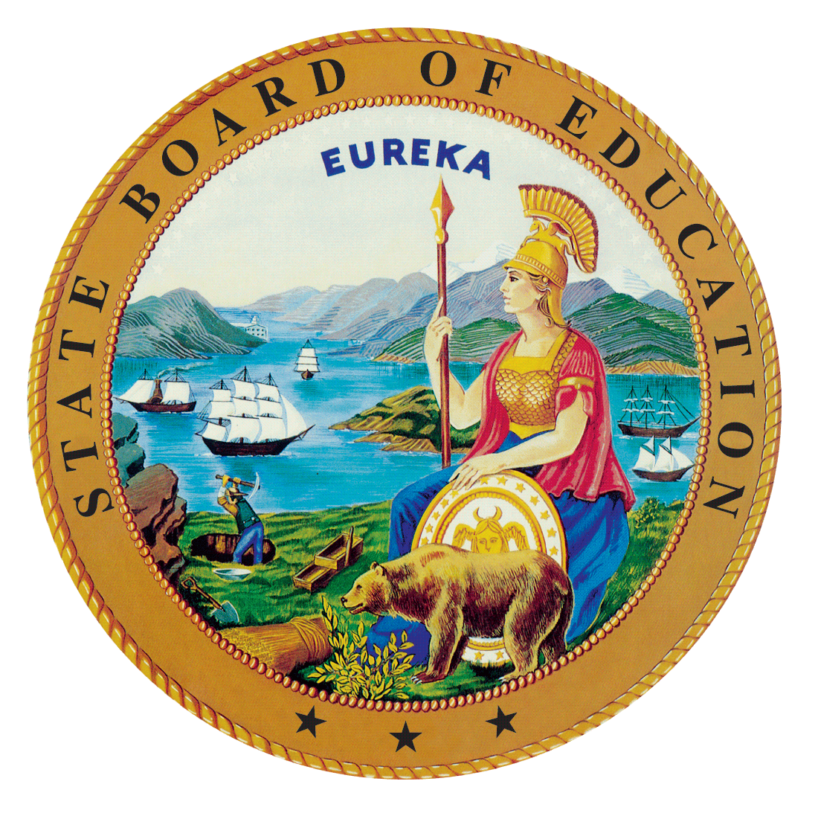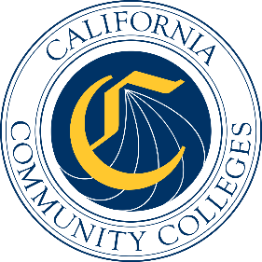

California Workforce Pathways
Joint Advisory Committee
September 29, 2021
Agenda Item 03
Posted by the California Department of Education

Subject
The Career Technical Education Incentive Grant (CTEIG) and the Kindergarten through Grade Twelve Strong Workforce Program (K–12 SWP): Update on the 2021–22 CTEIG Application Process and Timeline; the 2021–22 K–12 SWP Application Process and Timeline; and Kindergarten through Grade Fourteen (K–14) Technical Assistance Providers and Workforce Pathways Coordinators.

Type of Action
Information

Summary of the Issue(s)
This agenda item provides updates on various aspects of the CTEIG and K–12 SWP programs, including:
- The Fiscal Year (FY) 2021–22 CTEIG application process and timeline
- The FY 2021–22 K–12 SWP Application Process and timeline
- Technical Assistance Providers and Workforce Pathway Coordinators

Recommendation
This is an information item only; there is no recommendation at this time.

Brief History of Key Issues
The CTEIG was originally established by the Budget Act of 2015 with a one-time investment of $900 million to cover a three-year span, and acted as a bridge for local educational agencies (LEAs) to support career technical education (CTE) programs until the Local Control Funding Formula was fully funded.
In the 2018 Budget Act, the CTEIG and the K–12 SWP were each allocated $150 million in ongoing funds. An additional $13.5 million was provided annually to establish technical assistance providers and workforce pathway coordinators in support of both state initiatives. The CTEIG and the K–12 SWP are administered by the California Department of Education (CDE) and the California Community Colleges Chancellor’s Office (CCCCO), respectively.

The FY 2021–22 CTEIG Application Process and Timeline
The FY 2021–22 CTEIG Request for Applications (RFA) was released to LEAs on April 6, 2021, with the due date for LEAs to submit completed applications by June 2, 2021. Prior to the release of the FY 2021–22 CTEIG application was updated to allow LEAs to provide specific information regarding the pathways they will support with CTEIG funds. This update was made within the Program Grant Management System that LEAs use to complete Part I of the application process and it allows LEAs to easily select all of the pathways they are supporting with grant funds. In addition, they are able to provide information on new pathways they are supporting by selecting a “yes” button for each new pathway that they select. Additional clarifying information and instructions were added to the RFA to help LEAs with the application process.
The CDE held a series of webinars to provide LEAs with information on how to complete the RFA process and continues to provide technical assistance to LEAs who contact CDE’s CTEIG Regional Consultants. The CDE provided two days of professional development to the K–14 Technical Assistance Providers and Pathway Coordinators regarding the 2021–22 CTEIG RFA process to enable them to better assist LEAs in completing the application. The 2021 Budget Act has added an additional $150 million to the available CTEIG funding that brings the total available funding to $300 million. The 2021 Budget Act also included language that added CTEIG application requirements. It is anticipated that the proposed allocations for the FY
2021–22 CTEIG program will be recommended for approval at the January 2022 State Board of Education meeting.
The 2021 Budget Act also included language that amended the match requirement and programs eligible to apply for the CTEIG funding. The CTEIG match now requires applicants to encumber their match during the first year of the grant. CTE-based Advanced Placement, International Baccalaureate, and Dual Enrollment programs are now eligible to apply for CTEIG funds.

The FY 2021–22 (Round 4) K–12 SWP Application Process and Timeline
The CCCCO will also provide an update on the Continuous Process for improvement efforts related to the RFA process and the recommended improvements for the next round of funding.
The round 4 application timeline is contingent on the seamless adoption and integration of the recommended improvements for the next round of funding. The proposed timeline is as follows:

K–12 SWP 2021–22 Proposed Timeline:
Date | Event
Sep-21 | Launch Round 4 K–12 SWP Application
Oct-21 | K–12 SWP Applications due in NOVA system
Oct-21 | Selection Committee member training
Nov-21 | Selection Committees review applications and submit nominations of proposed grantees to CCCCO
Dec-21 | K–12 SWP preliminary intent to award announced
Dec-21 | Appeals due to SWP Regional Consortium
Jan-22 | Regional Consortia communicate intent to award funds to LEAs and initiate subcontract process
Jan-22 | K–12 SWP Round 4 project term begins

The K–14 Technical Assistance Providers and Pathway Coordinators
The final two Technical Assistance Providers have been hired as of February 2021 for the Los Angeles and Orange County Regions. The table below reflects the current list of Technical Assistance Providers and Pathway coordinators per region. You can also view the entire lists of technical assistance providers on the California Community Colleges web page at https://www.cccco.edu/About-Us/Chancellors-Office/Divisions/Workforce-and-Economic-Development/K12-Strong-Workforce/K12-Pathway-Coordinators.

K–14 Technical Assistance Providers by Region:
Region | K–14 Technical Assistance Providers
Bay Area | Sharon Turner & Don Harjo Daves-Rougeaux
Central/Mother Lode | Diane Baeza
Inland Empire/Desert | Stephanie Murillo
Los Angeles | Linda Bermudez
North/Far North | Tanya Meyer
Orange County | Michael Sacoto
San Diego/Imperial | Leslie Wisdom
South Central Coast | Dr. Giselle Bice

Summary of Previous California Workforce Pathways Joint Advisory Discussion(s) and Action(s)
May 14, 2021: The CDE provided an update on the 2021–22 CTEIG Application Process and Timeline; the 2021–22 K–12 SWP Application Process and Timeline; and K–14 Technical Assistance Providers and Workforce Pathways Coordinators.
January 29, 2021: The CDE provided updates on the approved CTEIG allocations for FY 2020–21 and the FY 2021–22 CTEIG application; the CCCCO provided updates on the K–12 SWP funding allocations and interim measures; and an update was provided on the K–14 Technical Assistance Providers and Pathway Coordinators.
November 20, 2020: The CDE presented updates on the FY 2020–21 CTEIG funding allocations; the FY 2020–21 K–12 SWP application process; and the Memorandum of Understanding (MOU) data sharing agreement between the CDE and CCCCO. Staff recommended that there be no change to the data metrics for both the CTEIG and K–12 SWP, and that a phased approach be used to operationalize the data metrics.
September 25, 2020: The CDE presented an update to the CTEIG application, and the CCCCO provided an update on the status of the K–12 SWP application process. Staff presented summary data reports, a status report of the CTEIG and the K–12 SWP Data MOU, and recommended revisions to the CTEIG and the K–12 SWP Matrix of Metrics.
July 10, 2020: The CDE presented a 12 Essential Elements of a High-Quality College and Career Pathway Framework document. The Framework document will be used to develop a new CTEIG CTE Program Self-Evaluation. The CCCCO presented how the Guiding Policy Principles to Support Student-Centered K–14+ Pathways have been intentionally incorporated into the K–12 SWP application.
January 31, 2020: The CWPJAC reviewed an updated Matrix of Metrics, an overview of both the CTEIG and K–12 SWP FY 2019–20 grant processes, and the 2018–19 CTE Postsecondary Status of CTE Completers Survey Template.
November 7, 2019: The CWPJAC approved the Matrix of Metrics revisions which incorporated the requirements of Perkins V language.

Fiscal Analysis (as appropriate)
Funding available to eligible recipients under the CTEIG is $300 million for the program year (PY) 2021–22, and funding available under the K–12 SWP is $150 million for PY 2021–22 for eligible recipients. In addition, $13.5 million is provided to support eight K–14 Technical Assistance Providers and 72 Workforce Pathway Coordinators for both CTEIG and K–12 SWP initiatives.

Attachment(s)
None

