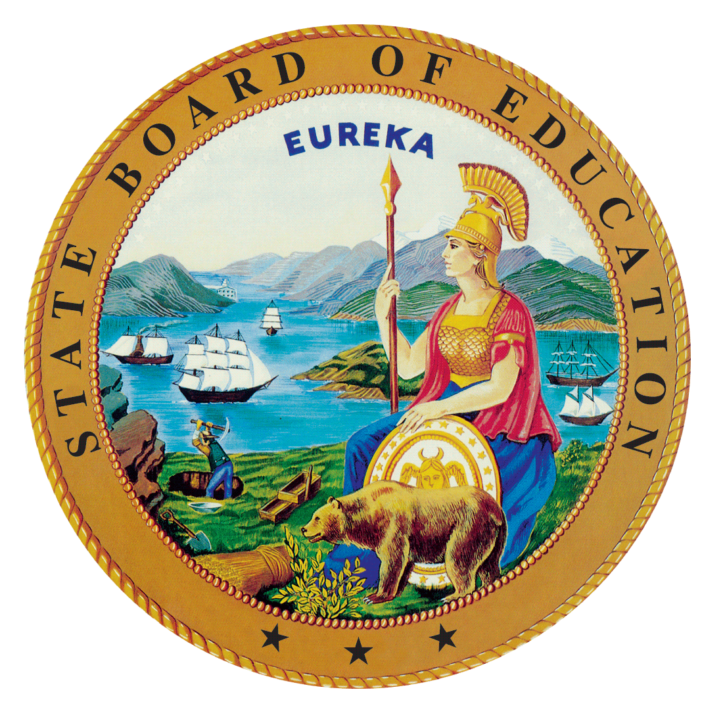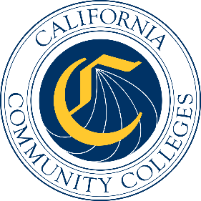

California Workforce Pathways
Joint Advisory Committee
January 29, 2021
Agenda Item 02
Posted by the California Department of Education

Subject
The Career Technical Education Incentive Grant (CTEIG) and the Kindergarten through Grade Twelve Strong Workforce Program (K–12 SWP): Update on the Approved Allocations for 2020–21 and the 2021–22 CTEIG Application; the 2020–21 K–12 SWP Funding Allocations and Interim Measures; and K–14 Technical Assistance Providers and Workforce Pathways Coordinators.

Type of Action
Information

Summary of the Issue(s)
This agenda item provides updates on various aspects of the CTEIG and K–12 SWP programs, including:
- The Fiscal Year (FY) 2020–21 approved allocations and the FY 2021–22 CTEIG application process
- The FY 2020–21 K–12 SWP Application Process and awards, interim data collection efforts and analysis
- Technical Assistance Providers status

Recommendation
This is an information item only; there is no recommendation at this time.

Brief History of Key Issues
The CTEIG was originally established by the Budget Act of 2015 with a one-time investment of $900 million to cover a three-year span, and acted as a bridge for local educational agencies (LEAs) to support career technical education (CTE) programs until the Local Control Funding Formula was fully funded.
In the 2018 Budget Act, the CTEIG and the K–12 SWP were each allocated $150 million in ongoing funds. An additional $13.5 million was provided annually to establish technical assistance providers and workforce pathway coordinators in support of both state initiatives. The CTEIG and the K–12 SWP are administered by the CDE and the CCCCO, respectively.
The FY 2020–21 Approved Allocations and the FY 2021–22 CTEIG Application Process
For the CTEIG program, California Education Code Section 53076(a) requires the Superintendent to determine, in collaboration with the Executive Director of the State Board of Education (SBE), and make public at a regularly scheduled meeting of the SBE, the allocation formula, specific funding amounts, the purposes for which grant funds may be used, allowable and nonallowable expenditures, and the number of grants to be awarded. The SBE item on the FY 2020–21 CTEIG funding allocation was approved during the January 2021 SBE meeting, see Item 7 on the SBE Agenda web page at https://www.cde.ca.gov/be/ag/ag/yr21/agenda202101.asp.
The FY 2020–21 K–12 SWP Funding Allocations and Interim Measures
The CCCCO will provide an update regarding the K–12 SWP application and awards for Round 3 (2020-21 funding cycle); the interim data collection efforts and analysis of the data collected about Round 1 program participants (2018-19 funding cycle).
The K–14 Technical Assistance Providers (TAPs) and Pathway Coordinators (PCs)
The CCCCO and CDE will provide an update on the K–14 TAPs and PCs including trainings and webinars that have been provided.

Summary of Previous CWPJAC Discussion(s) and Action(s)
November 20, 2020: The CDE presented updates on the FY 2020–21 CTEIG funding allocations; the FY 2020–21 K–12 SWP application process; and the Memorandum of Understanding (MOU) data sharing agreement between the CDE and CCCCO. Staff recommended that there be no change to the data metrics for both the CTEIG and K–12 SWP, and that a phased approach be used to operationalize the data metrics.
September 25, 2020: The CDE presented an update to the CTEIG application, and the CCCCO provided an update on the status of the K–12 SWP application process. Staff presented summary data reports, a status report of the CTEIG and the K–12 SWP Data MOU, and recommended revisions to the CTEIG and the K–12 SWP Matrix of Metrics.
July 10, 2020: The CDE presented a 12 Essential Elements of a High-Quality College and Career Pathway Framework document. The Framework document will be used to develop a new CTEIG CTE Program Self-Evaluation. The CCCCO presented how the Guiding Policy Principles to Support Student-Centered K–14+ Pathways have been intentionally incorporated into the K–12 SWP application.
January 31, 2020: The CWPJAC reviewed an updated Matrix of Metrics, an overview of both the CTEIG and K–12 SWP FY 2019–20 grant processes, and the 2018–19 CTE Postsecondary Status of CTE Completers Survey Template.
November 7, 2019: The CWPJAC approved the Matrix of Metrics revisions which incorporated the requirements of Perkins V language.

Fiscal Analysis (as appropriate)
Funding available to eligible recipients under the CTEIG is $150 million for the program year (PY) 2020–21, and funding available under the K–12 SWP is $150 million for PY 2020–21 for eligible recipients. In addition, $13.5 million is provided to support eight K–14 Technical Assistance Providers and 72 workforce pathway coordinators for both CTEIG and K–12 SWP initiatives.

Attachment(s)
None

