Attachment 2: Career Technical Education (CTE) Participation for the 2018–19 Four-Year Cohort Period by Gender, Race/Ethnicity, and Special Populations and by State and Federal Funding Mix

Figure 1A. CTE Participation for the 2018–19 Four-Year Cohort Period by Gender and by No State and Federal Grant Funding
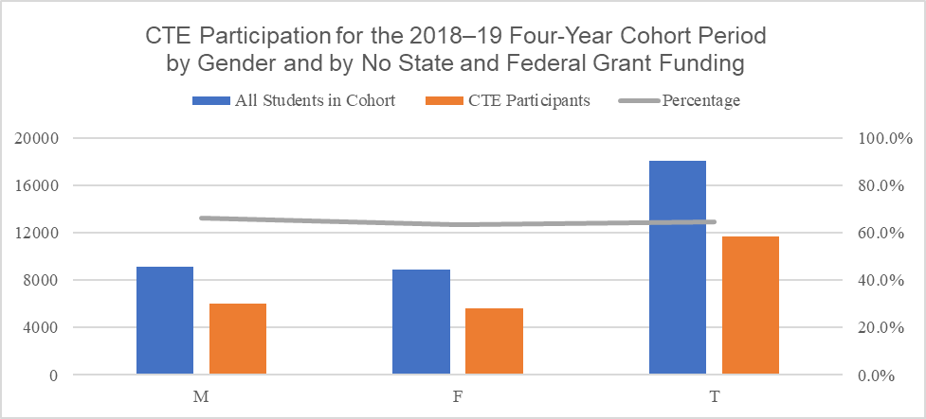
The vertical bar chart pictured above is a visual representation of the CTE participation data listed in Table 1A directly below.

Table 1A. CTE Participation for the 2018–19 Four-Year Cohort Period by Gender and by No State and Federal Grant Funding
Gender | All Students in Cohort | CTE Participants | Percentage (PCT)
Male (M) | 9138 | 6042 | 66.1%
Female (F) | 8915 | 5636 | 63.2%
Total (T) | 18054 | 11678 | 64.7%

Figure 1B. CTE Participation for the 2018–19 Four-Year Cohort Period by Gender and by CTEIG Funding
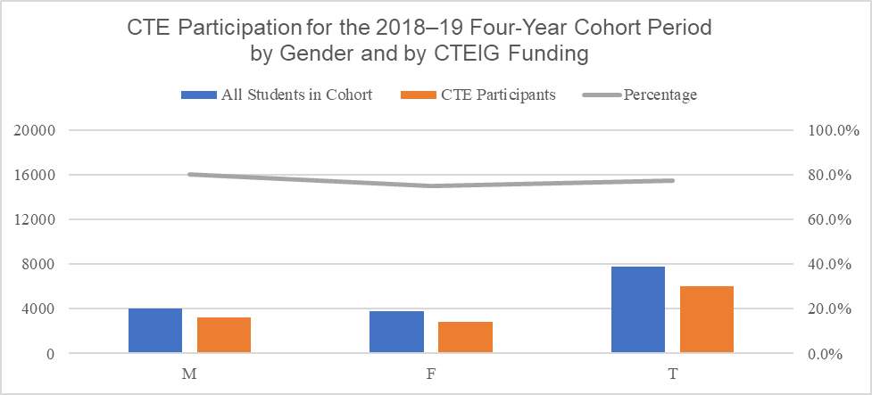
The vertical bar chart pictured above is a visual representation of the CTE participation data listed in Table 1B directly below.

Table 1B. CTE Participation for the 2018–19 Four-Year Cohort Period by Gender and by CTEIG Funding
Gender | All Students in Cohort | CTE Participants | PCT
M | 4058 | 3245 | 80.0%
F | 3747 | 2803 | 74.8%
T | 7805 | 6048 | 77.5%

Figure 1C. CTE Participation for the 2018–19 Four-Year Cohort Period by Gender and by K–12 SWP Grant Funding
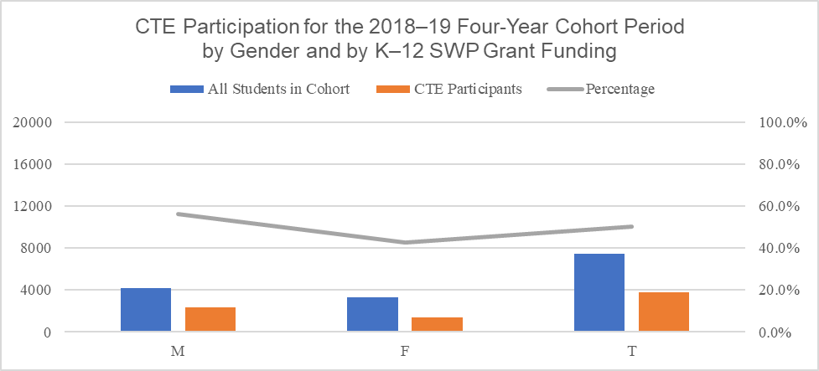
The vertical bar chart pictured above is a visual representation of the CTE participation data listed in Table 1C directly below.

Table 1C. CTE Participation for the 2018–19 Four-Year Cohort Period by Gender and by K–12 SWP Grant Funding
Gender | All Students in Cohort | CTE Participants | PCT
M | 4159 | 2334 | 56.1%
F | 3304 | 1412 | 42.7%
T | 7463 | 3746 | 50.2%

Figure 1D. CTE Participation for the 2018–19 Four-Year Cohort Period by Gender and by Perkins Grant Funding
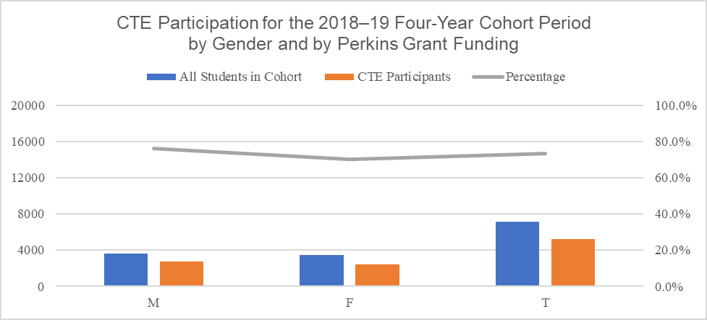
The vertical bar chart pictured above is a visual representation of the CTE participation data listed in Table 1D directly below.

Table 1D. CTE Participation for the 2018–19 Four-Year Cohort Period by Gender and by Perkins Grant Funding
Gender | All Students in Cohort | CTE Participants | PCT
M | 3630 | 2768 | 76.3%
F | 3474 | 2437 | 70.1%
T | 7104 | 5205 | 73.3%

Figure 1E. CTE Participation for the 2018–19 Four-Year Cohort Period by Gender and by CTEIG and K–12 SWP Funding
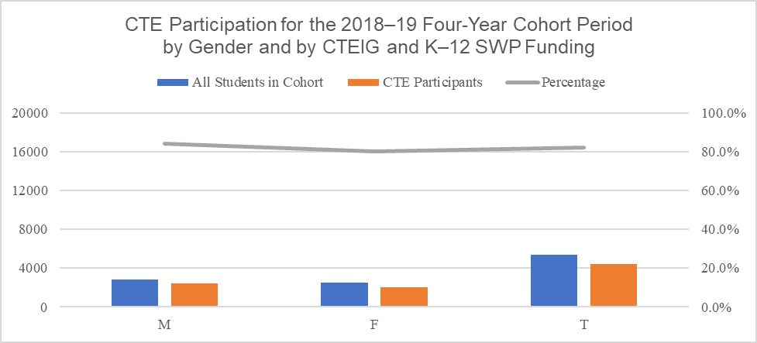
The vertical bar chart pictured above is a visual representation of the CTE participation data listed in Table 1E directly below.

Table 1E. CTE Participation for the 2018–19 Four-Year Cohort Period by Gender and by CTEIG and K–12 SWP Funding
Gender | All Students in Cohort | CTE Participants | PCT
M | 2858 | 2399 | 83.9%
F | 2532 | 2033 | 80.3%
T | 5390 | 4432 | 82.2%

Figure 1F. CTE Participation for the 2018–19 Four-Year Cohort Period by Gender and by CTEIG and Perkins Funding
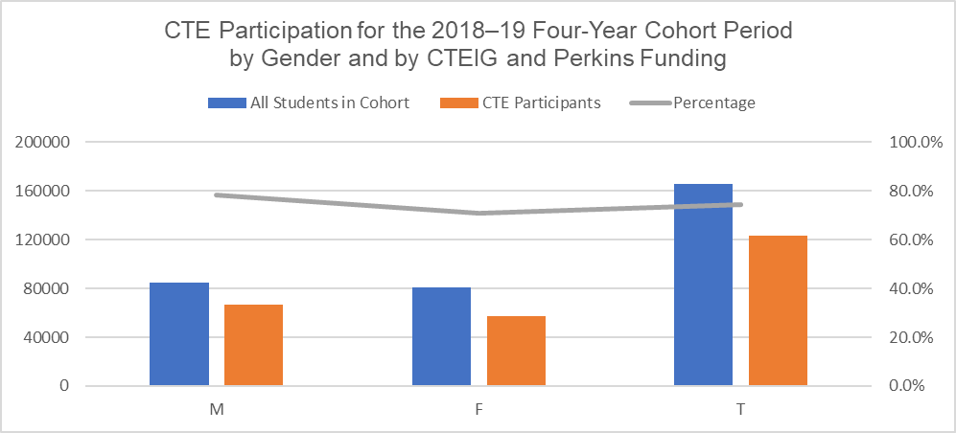
The vertical bar chart pictured above is a visual representation of the CTE participation data listed in Table 1F directly below.

Table 1F. CTE Participation for the 2018–19 Four-Year Cohort Period by Gender and by CTEIG and Perkins Funding
Gender | All Students in Cohort | CTE Participants | PCT
M | 84931 | 66324 | 78.1%
F | 80907 | 57224 | 70.7%
T | 165839 | 123548 | 74.5%

Figure 1G. CTE Participation for the 2018–19 Four-Year Cohort Period by Gender and by K–12 SWP Grant and Perkins Funding
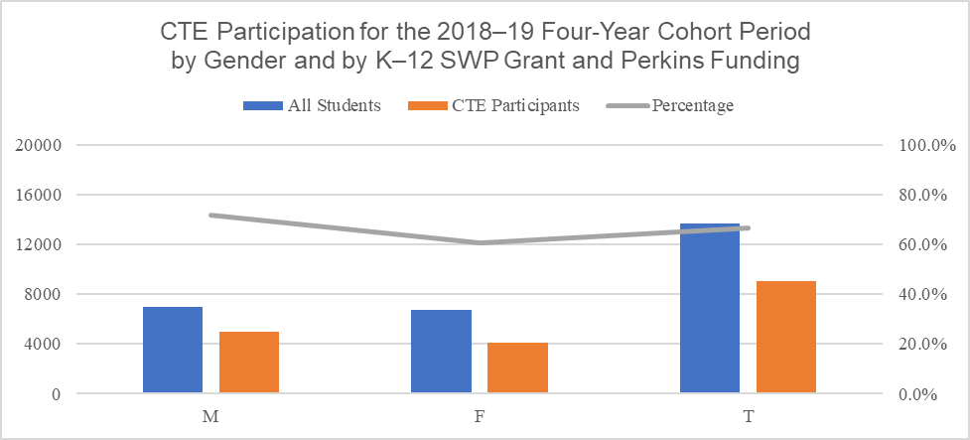
The vertical bar chart pictured above is a visual representation of the CTE participation data listed in Table 1G directly below.

Table 1G. CTE Participation for the 2018–19 Four-Year Cohort Period by Gender and by K–12 SWP Grant and Perkins Funding
Gender | All Students in Cohort | CTE Participants | PCT
M | 6937 | 4985 | 71.9%
F | 6722 | 4085 | 60.8%
T | 13659 | 9070 | 66.4%

Figure 1H. CTE Participation for the 2018–19 Four-Year Cohort Period by Gender and All Three Grants

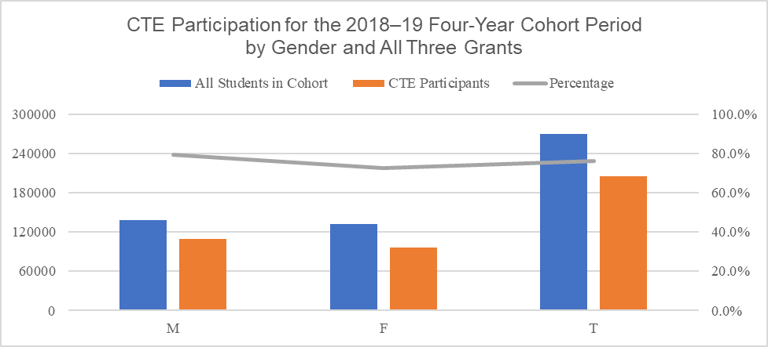
The vertical bar chart pictured above is a visual representation of the CTE participation data listed in Table 1H directly below.

Table 1H. CTE Participation for the 2018–19 Four-Year Cohort Period by Gender and All Three Grants
Gender | All Students in Cohort | CTE Participants | PCT
M | 138043 | 109536 | 79.3%
F | 131825 | 95687 | 72.6%
T | 269868 | 205223 | 760.%

Figure 2A. CTE Participation for the 2018–19 Four-Year Cohort Period and by Race/Ethnicity and by No State and Federal Grant Funding
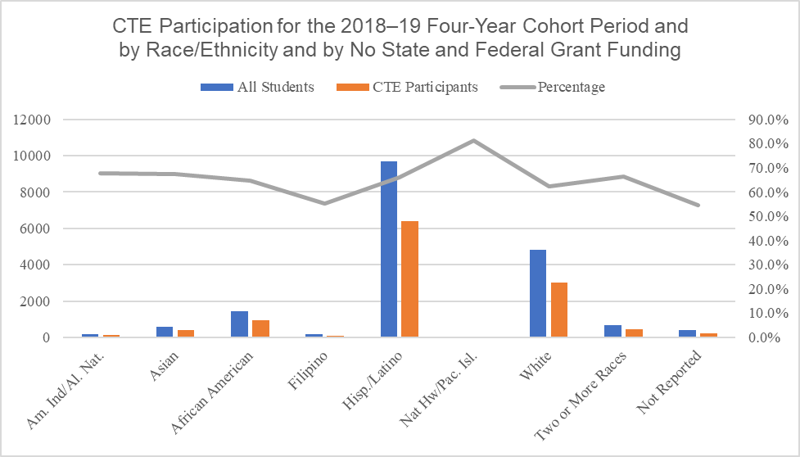
The vertical bar chart pictured above is a visual representation of the CTE participation data listed in Table 2A directly below.

Table 2A. CTE Participation for the 2018–19 Four-Year Cohort Period and by Race/Ethnicity and by No State and Federal Grant Funding
Race/Ethnicity | All Students | CTE Participants | PCT
Am. Ind/Al. Nat. | 199 | 135 | 67.8%
Asian | 589 | 398 | 67.6%
African American | 1448 | 935 | 64.6%
Filipino | 165 | 91 | 55.2%
Hisp. /Latino | 9667 | 6379 | 66.0%
Nat Hw /Pac.Isl. | 59 | 48 | 81.4%
White | 4821 | 3006 | 62.4%
Two or More Races | 691 | 460 | 66.6%
Not Reported | 415 | 226 | 54.5%
Totals and PCT Average | 18054 | 11678 | 64.7%

Figure 2B. CTE Participation for the 2018–19 Four-Year Cohort Period and by Race/Ethnicity and by CTEIG Funding
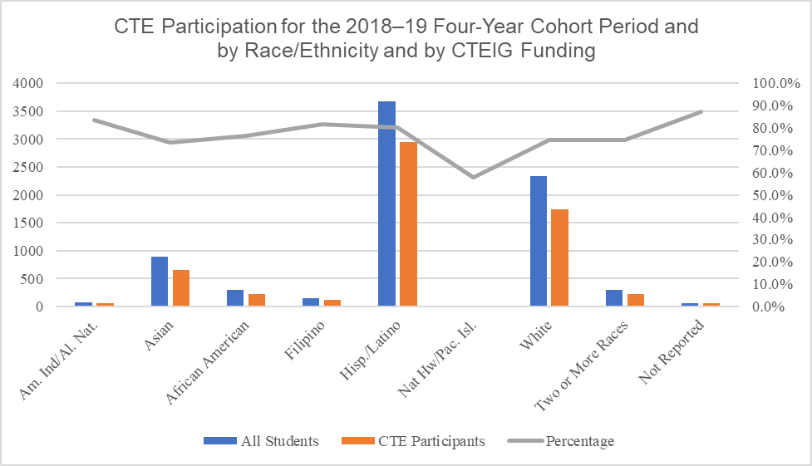
The vertical bar chart pictured above is a visual representation of the CTE participation data listed in Table 2B directly below.

Table 2B. CTE Participation for the 2018–19 Four-Year Cohort Period and by Race/Ethnicity and by CTEIG Funding
Race/Ethnicity | All Students | CTE Participants | PCT
Am. Ind/Al. Nat. | 73 | 61 | 83.6%
Asian | 892 | 655 | 73.4%
African American | 297 | 227 | 76.4%
Filipino | 154 | 126 | 81.8%
Hisp. /Latino | 3676 | 2951 | 80.3%
Nat Hw /Pac.Isl. | 19 | 11 | 57.9%
White | 2338 | 1743 | 74.6%
Two or More Races | 293 | 219 | 74.7%
Not Reported | 63 | 55 | 87.3%
Totals and PCT Average | 7805 | 6048 | 77.5%

Figure 2C. CTE Participation for the 2018–19 Four-Year Cohort Period and by Race/Ethnicity and by K–12 SWP Funding
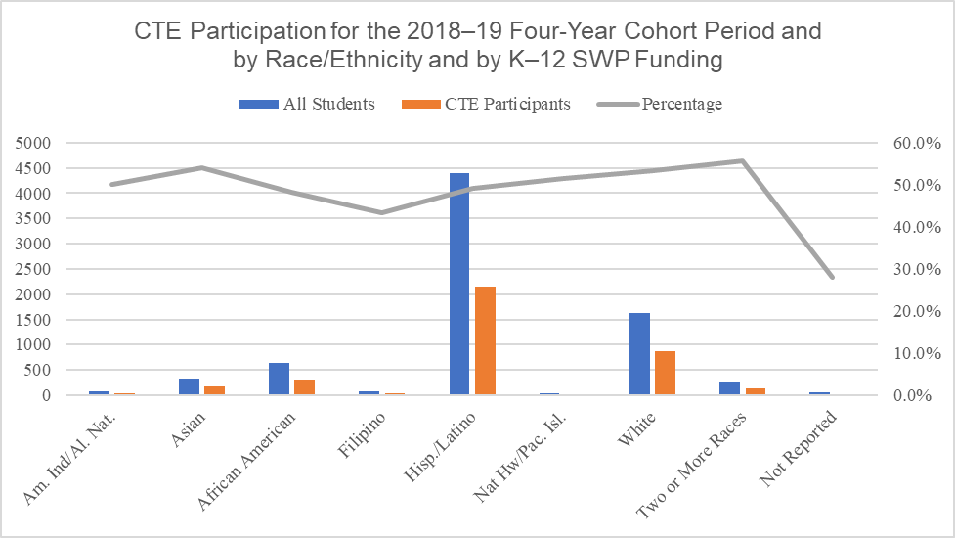
The vertical bar chart pictured above is a visual representation of the CTE participation data listed in Table 2C directly below.

Table 2C. CTE Participation for the 2018–19 Four-Year Cohort Period and by Race/Ethnicity and by K–12 SWP Funding

Data Table for Figure 2C
Race/Ethnicity | All Students | CTE Participants | PCT
Am. Ind/Al. Nat. | 70 | 35 | 50.0%
Asian | 322 | 174 | 54.0%
African American | 639 | 308 | 48.2%
Filipino | 76 | 33 | 43.4%
Hisp. /Latino | 4391 | 2156 | 49.1%
Nat Hw /Pac.Isl. | 37 | 19 | 51.4%
White | 1619 | 865 | 53.4%
Two or More Races | 252 | 140 | 55.6%
Not Reported | 57 | 16 | 28.1%
Totals and PCT Average | 7463 | 3746 | 50.2%

Figure 2D. CTE Participation for the 2018–19 Four-Year Cohort Period and by Race/Ethnicity and by Perkins Funding
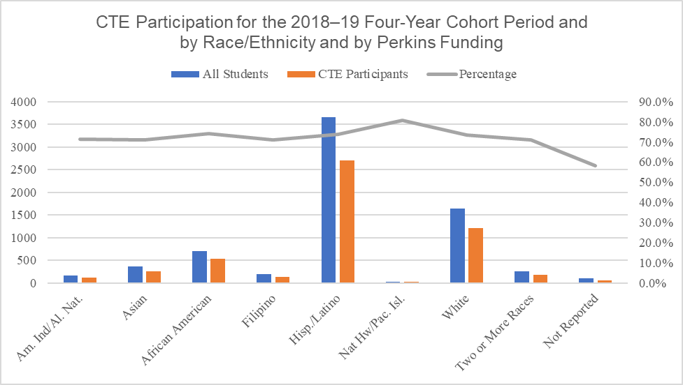
The vertical bar chart pictured above is a visual representation of the CTE participation data listed in Table 2D directly below.

Table 2D. CTE Participation for the 2018–19 Four-Year Cohort Period and by Race/Ethnicity and by Perkins Funding
Race/Ethnicity | All Students | CTE Participants | PCT
Am. Ind/Al. Nat. | 160 | 114 | 71.3%
Asian | 367 | 261 | 71.1%
African American | 709 | 525 | 74.0%
Filipino | 191 | 136 | 71.2%
Hisp. /Latino | 3654 | 2701 | 73.9%
Nat Hw /Pac.Isl. | 31 | 25 | 80.6%
White | 1646 | 1209 | 73.5%
Two or More Races | 250 | 178 | 71.2%
Not Reported | 96 | 56 | 58.3%
Totals and PCT Average | 7104 | 5205 | 73.3%

Figure 2E. CTE Participation for the 2018–19 Four-Year Cohort Period and by Race/Ethnicity and by CTEIG and K–12 SWP Funding
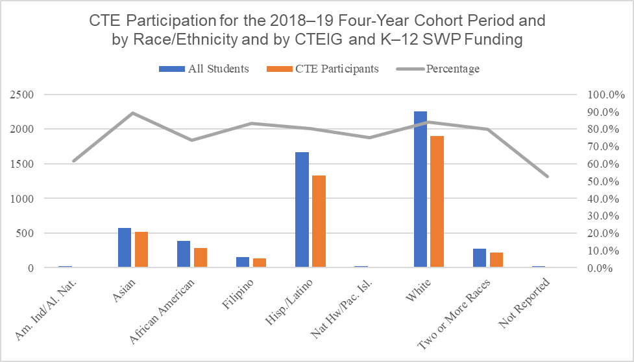
The vertical bar chart pictured above is a visual representation of the CTE participation data listed in Table 2E directly below.

Table 2E. CTE Participation for the 2018–19 Four-Year Cohort Period and by Race/Ethnicity and by CTEIG and K–12 SWP Funding
Race/Ethnicity | All Students | CTE Participants | PCT
Am. Ind/Al. Nat. | 26 | 16 | 61.5%
Asian | 577 | 514 | 89.1%
African American | 387 | 284 | 73.4%
Filipino | 157 | 131 | 83.4%
Hisp. /Latino | 1663 | 1335 | 80.3%
Nat Hw /Pac.Isl. | 24 | 18 | 75.0%
White | 2259 | 1902 | 84.2%
Two or More Races | 278 | 222 | 79.9%
Not Reported | 19 | 10 | 52.6%
Totals and PCT Average | 5390 | 4432 | 82.2%

Figure 2F. CTE Participation for the 2018–19 Four-Year Cohort Period and by Race/Ethnicity and by CTEIG and Perkins Funding
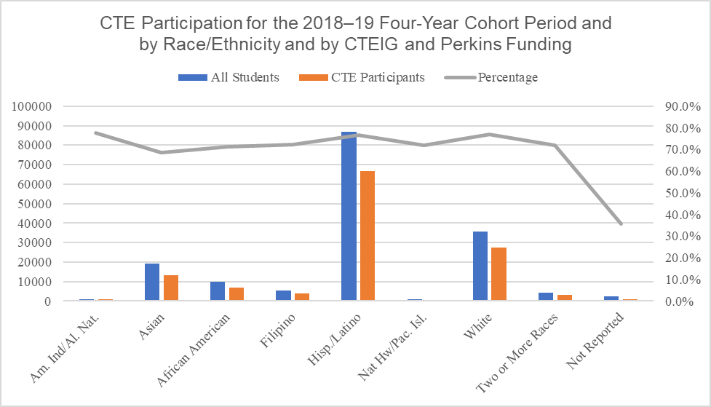
The vertical bar chart pictured above is a visual representation of the CTE participation data listed in Table 2F directly below.

Table 2F. CTE Participation for the 2018–19 Four-Year Cohort Period and by Race/Ethnicity and by CTEIG and Perkins Funding
Race/Ethnicity | All Students | CTE Participants | PCT
Am. Ind/Al. Nat. | 1035 | 804 | 77.7%
Asian | 19213 | 13205 | 68.7%
African American | 9929 | 7085 | 71.4%
Filipino | 5231 | 3776 | 72.2%
Hisp. /Latino | 86952 | 66507 | 76.5%
Nat Hw /Pac.Isl. | 767 | 552 | 72.0%
White | 35774 | 27569 | 77.1%
Two or More Races | 4346 | 3124 | 71.9%
Not Reported | 2592 | 926 | 35.7%
Totals and PCT Average | 165839 | 123548 | 74.5%

Figure 2G. CTE Participation for the 2018–19 Four-Year Cohort Period and by Race/Ethnicity and by K–12 SWP and Perkins Funding
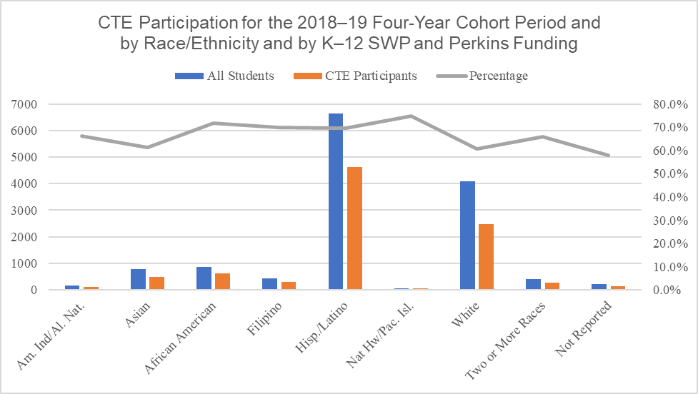
The vertical bar chart pictured above is a visual representation of the CTE participation data listed in Table 2G directly below.

Table 2G. CTE Participation for the 2018–19 Four-Year Cohort Period and by Race/Ethnicity and by K–12 SWP and Perkins Funding
Race/Ethnicity | All Students | CTE Participants | PCT
Am. Ind/Al. Nat. | 160 | 106 | 66.3%
Asian | 791 | 486 | 61.4%
African American | 868 | 623 | 71.8%
Filipino | 423 | 296 | 70.0%
Hisp. /Latino | 6646 | 4634 | 69.7%
Nat Hw /Pac.Isl. | 60 | 45 | 75.0%
White | 4087 | 2486 | 60.8%
Two or More Races | 415 | 273 | 65.8%
Not Reported | 209 | 121 | 57.9%
Totals and PCT Average | 13659 | 9070 | 66.4%

Figure 2H. CTE Participation for the 2018–19 Four-Year Cohort Period and by Race/Ethnicity and by All Three Funding Sources
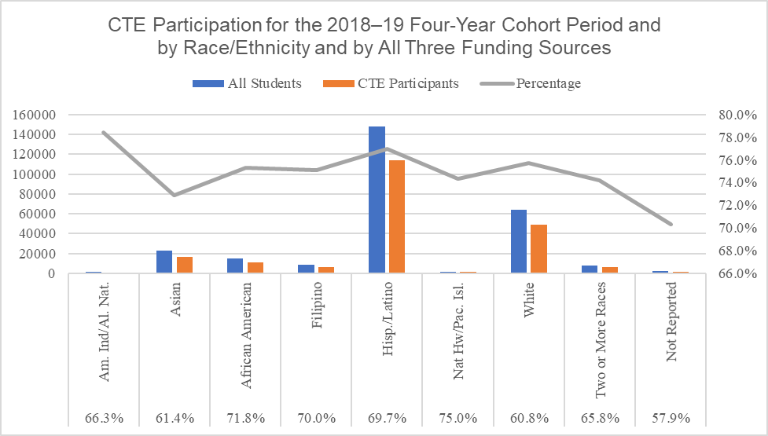
The vertical bar chart pictured above is a visual representation of the CTE participation data listed in Table 2H directly below.

Table 2H. CTE Participation for the 2018–19 Four-Year Cohort Period and by Race/Ethnicity and by All Three Funding Sources
Race/Ethnicity | All Students | CTE Participants | PCT
Am. Ind/Al. Nat. | 1125 | 882 | 78.4%
Asian | 22627 | 16493 | 72.9%
African American | 14896 | 11216 | 75.3%
Filipino | 8239 | 6188 | 75.1%
Hisp. /Latino | 147590 | 113585 | 77.0%
Nat Hw /Pac.Isl. | 1427 | 1061 | 74.4%
White | 64268 | 48676 | 75.7%
Two or More Races | 7865 | 5835 | 74.2%
Not Reported | 1831 | 1287 | 70.3%
Totals and PCT Average | 269868 | 205223 | 76.0%

Figure 3A. CTE Participation for the 2018–19 Four-Year Cohort Period by Special Populations and by No State and Federal Grant Funding
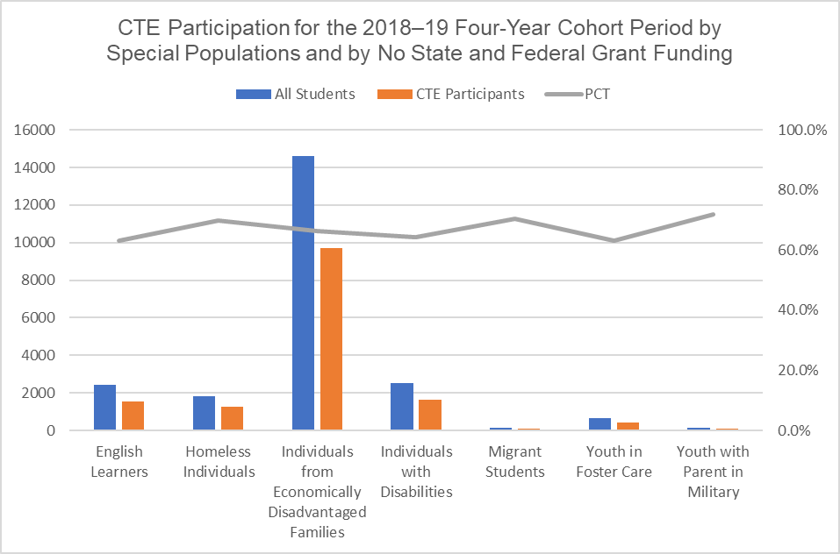
The vertical bar chart pictured above is a visual representation of the CTE participation data listed in Table 3A directly below.

Table 3A. CTE Participation for the 2018–19 Four-Year Cohort Period by Special Populations and by No State and Federal Grant Funding
Special Population | All Students | CTE Participants | PCT
English Learners | 2443 | 1544 | 63.2%
Homeless Individuals | 1800 | 1257 | 69.8%
Individuals from Economically Disadvantaged Families | 14614 | 9692 | 66.3%
Individuals with Disabilities | 2534 | 1632 | 64.4%
Migrant Students | 155 | 109 | 70.3%
Youth in Foster Care | 678 | 429 | 63.3%
Youth with Parent in Military | 146 | 105 | 71.9%

Figure 3B. CTE Participation for the 2018–19 Four-Year Cohort Period by Special Populations and by CTEIG Funding
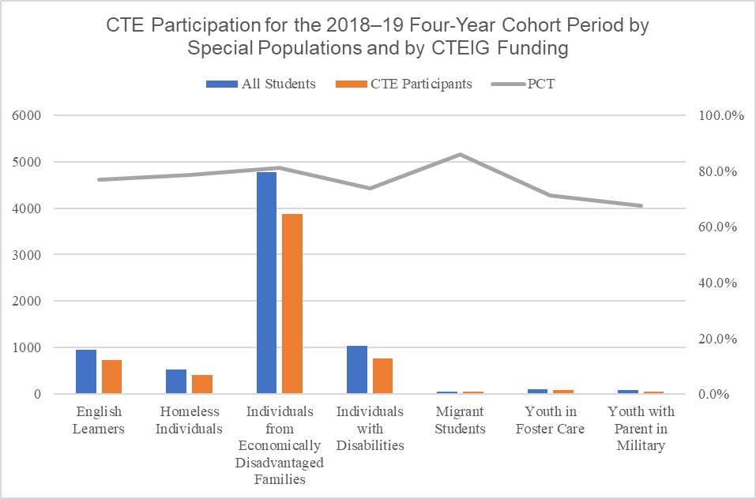
The vertical bar chart pictured above is a visual representation of the CTE participation data listed in Table 3B directly below.

Table 3B. CTE Participation for the 2018–19 Four-Year Cohort Period by Special Populations and by CTEIG Funding
Special Population | All Students | CTE Participants | PCT
English Learners | 950 | 730 | 76.8%
Homeless Individuals | 519 | 408 | 78.6%
Individuals from Economically Disadvantaged Families | 4771 | 3865 | 81.0%
Individuals with Disabilities | 1031 | 759 | 73.6%
Migrant Students | 57 | 49 | 86.0%
Youth in Foster Care | 111 | 79 | 71.2%
Youth with Parent in Military | 80 | 54 | 67.5%

Figure 3C. CTE Participation for the 2018–19 Four-Year Cohort Period by Special Populations and by K–12 SWP Grant Funding
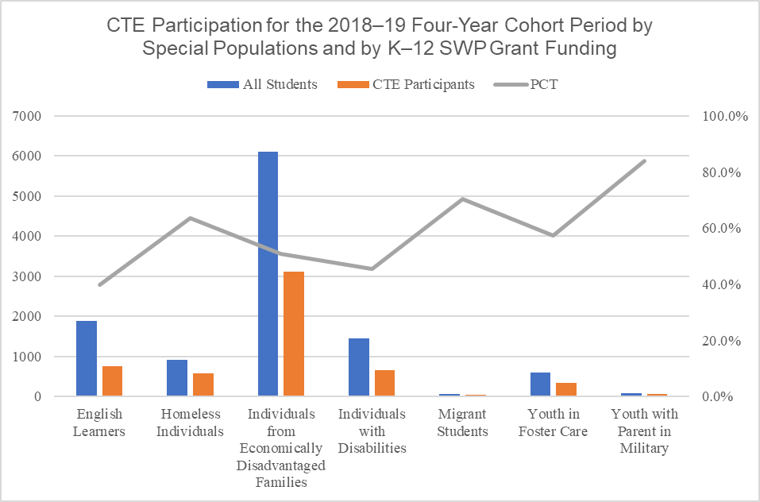
The vertical bar chart pictured above is a visual representation of the CTE participation data listed in Table 3C directly below.

Table 3C. CTE Participation for the 2018–19 Four-Year Cohort Period by Special Populations and by K–12 SWP Grant Funding
Special Populations | All Students | CTE Participants | PCT
English Learners | 1883 | 751 | 39.9%
Homeless Individuals | 911 | 578 | 63.4%
Individuals from Economically Disadvantaged Families | 6113 | 3108 | 50.8%
Individuals with Disabilities | 1443 | 657 | 45.5%
Migrant Students | 54 | 38 | 70.4%
Youth in Foster Care | 605 | 346 | 57.2%
Youth with Parent in Military | 75 | 63 | 84.0%

Figure 3D. CTE Participation for the 2018–19 Four-Year Cohort Period by Special Populations and by Perkins Funding
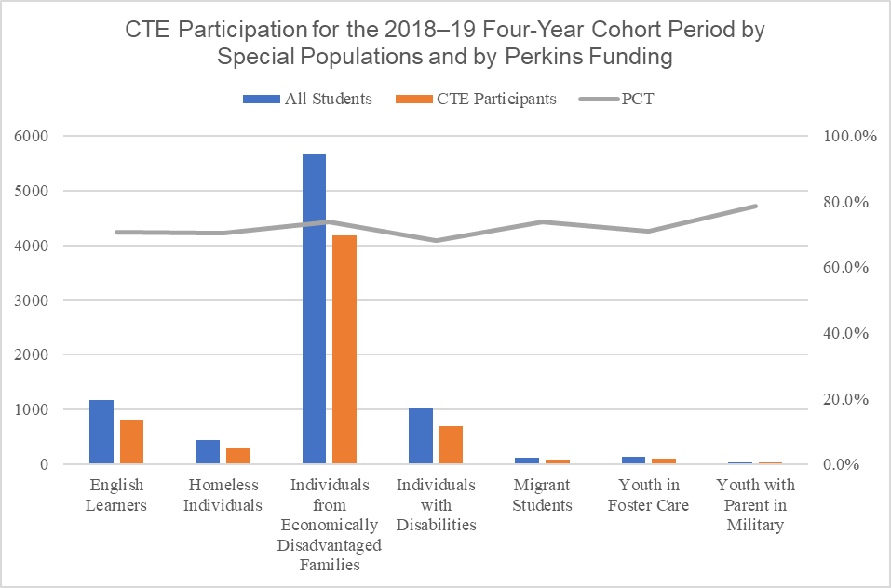
The vertical bar chart pictured above is a visual representation of the CTE participation data listed in Table 3D directly below.

Table 3D. CTE Participation for the 2018–19 Four-Year Cohort Period by Special Populations and by Perkins Funding
Special Populations | All Students | CTE Participants | PCT
English Learners | 1165 | 824 | 70.7%
Homeless Individuals | 444 | 312 | 70.3%
Individuals from Economically Disadvantaged Families | 5671 | 4181 | 73.7%
Individuals with Disabilities | 1020 | 695 | 68.1%
Migrant Students | 118 | 87 | 73.7%
Youth in Foster Care | 144 | 102 | 70.8%
Youth with Parent in Military | 42 | 33 | 78.6%

Figure 3E. CTE Participation for the 2018–19 Four-Year Cohort Period by Special Populations and by CTEIG and K–12 SWP Grant Funding
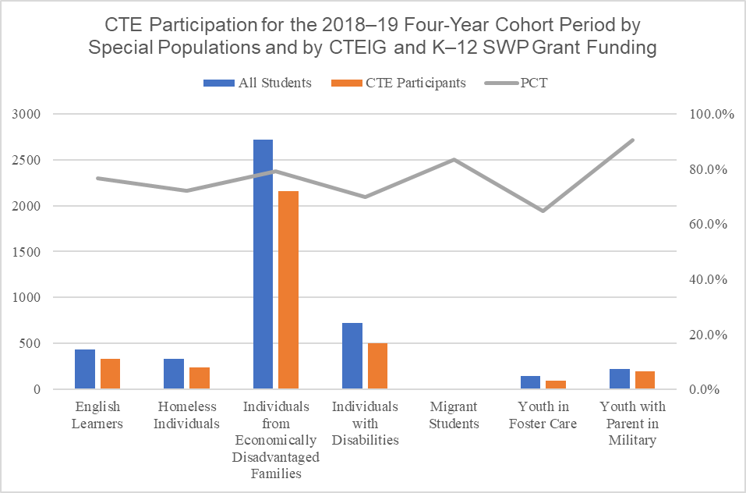
The vertical bar chart pictured above is a visual representation of the CTE participation data listed in Table 3E directly below.

Table 3E. CTE Participation for the 2018–19 Four-Year Cohort Period by Special Populations and by CTEIG and K–12 SWP Grant Funding
Special Populations | All Students | CTE Participants | PCT
English Learners | 435 | 333 | 76.6%
Homeless Individuals | 332 | 239 | 72.0%
Individuals from Economically Disadvantaged Families | 2721 | 2154 | 79.2%
Individuals with Disabilities | 722 | 503 | 69.7%
Migrant Students | 12 | 10 | 83.3%
Youth in Foster Care | 144 | 93 | 64.6%
Youth with Parent in Military | 220 | 199 | 90.5%

Figure 3F. CTE Participation for the 2018–19 Four-Year Cohort Period by Special Populations and by CTEIG and by Perkins Funding
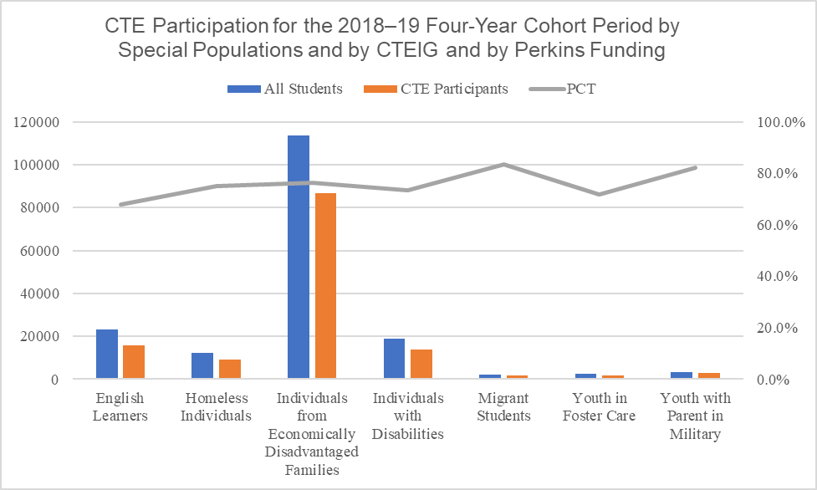
The vertical bar chart pictured above is a visual representation of the CTE participation data listed in Table 3F directly below.

Table 3F. CTE Participation for the 2018–19 Four-Year Cohort Period by Special Populations and by CTEIG and by Perkins Funding
Special Populations | All Students | CTE Participants | PCT
English Learners | 23363 | 15868 | 67.9%
Homeless Individuals | 12226 | 9163 | 74.9%
Individuals from Economically Disadvantaged Families | 113728 | 86726 | 76.3%
Individuals with Disabilities | 18973 | 13929 | 73.4%
Migrant Students | 1963 | 1640 | 83.5%
Youth in Foster Care | 2644 | 1899 | 71.8%
Youth with Parent in Military | 3349 | 2757 | 82.3%

Figure 3G. CTE Participation for the 2018–19 Four-Year Cohort Period by Special Populations and by K–12 SWP and Perkins Grant Funding
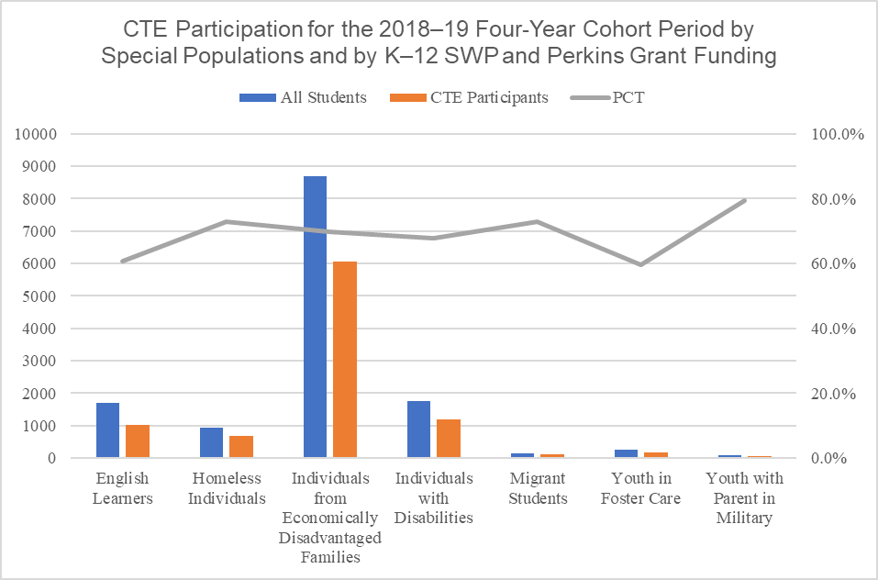
The vertical bar chart pictured above is a visual representation of the CTE participation data listed in Table 3G directly below.

Table 3G. CTE Participation for the 2018–19 Four-Year Cohort Period by Special Populations and by K–12 SWP and Perkins Grant Funding
Special Populations | All Students | CTE Participants | PCT
English Learners | 1694 | 1029 | 60.7%
Homeless Individuals | 925 | 673 | 72.8%
Individuals from Economically Disadvantaged Families | 8686 | 6065 | 69.8%
Individuals with Disabilities | 1759 | 1191 | 67.7%
Migrant Students | 140 | 102 | 72.9%
Youth in Foster Care | 269 | 160 | 59.5%
Youth with Parent in Military | 78 | 62 | 79.5%

Figure 3H. CTE Participation for the 2018–19 Four-Year Cohort Period by Special Populations and by All Three Grants Funding
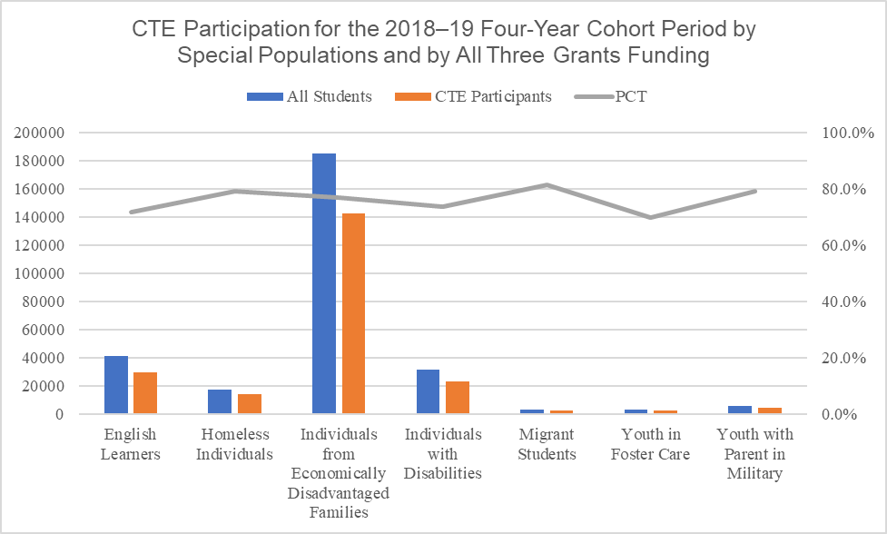
The vertical bar chart pictured above is a visual representation of the CTE participation data listed in Table 3H directly below.

Table 3H. CTE Participation for the 2018–19 Four-Year Cohort Period by Special Populations and by All Three Grants Funding
Special Populations | All Students | CTE Participants | PCT
English Learners | 41185 | 29581 | 71.8%
Homeless Individuals | 17422 | 13788 | 79.1%
Individuals from Economically Disadvantaged Families | 185265 | 142182 | 76.7%
Individuals with Disabilities | 31375 | 23081 | 73.6%
Migrant Students | 3127 | 2542 | 81.3%
Youth in Foster Care | 3128 | 2186 | 69.9%
Youth with Parent in Military | 5480 | 4330 | 79.0%

