Attachment 3: Career Technical Education (CTE) Completion for the 2018–19 Four-Year Cohort Period by Gender, Race/Ethnicity, and Special Populations and by State and Federal Funding Mix

Figure 1A. CTE Completion for the 2018–19 Four-Year Cohort Period by Gender and by No State and Federal Grant Funding
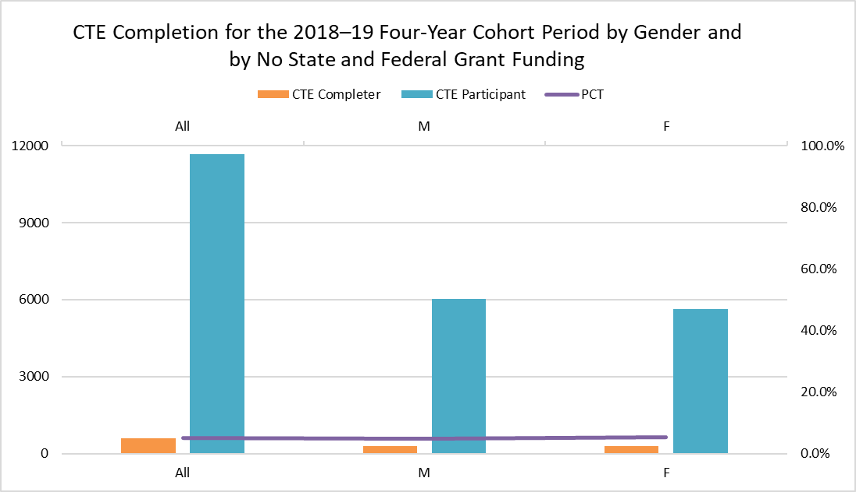
The vertical bar chart pictured above is a visual representation of the CTE completion data listed in Table 1A directly below.

Table 1A. CTE Completion for the 2018–19 Four-Year Cohort Period by Gender and by No State and Federal Grant Funding
Gender | CTE Completer | CTE Participant | Percentage (PCT)
All | 594 | 11678 | 5.1%
Male (M) | 290 | 6042 | 4.8%
Female (F) | 304 | 5636 | 5.4%

Figure 1B. CTE Completion for the 2018–19 Four-Year Cohort Period by Gender and by CTEIG Funding
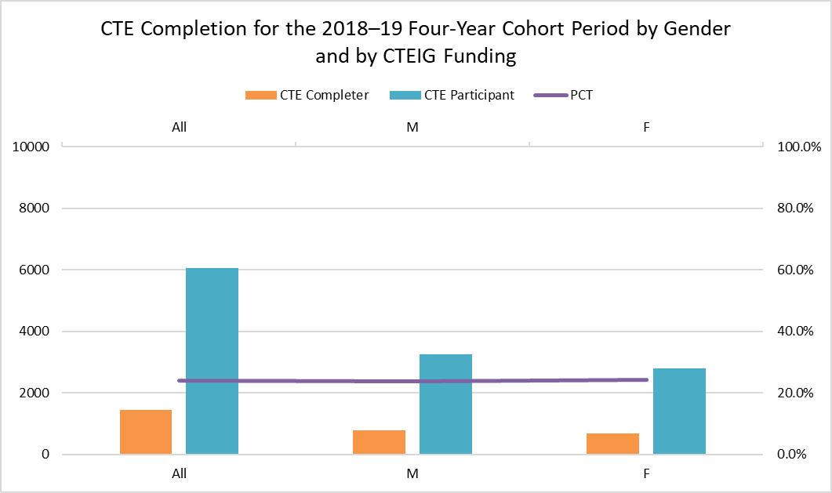
The vertical bar chart pictured above is a visual representation of the CTE completion data listed in Table 1B directly below.

Table 1B. CTE Completion for the 2018–19 Four-Year Cohort Period by Gender and by CTEIG Funding
Gender | CTE Completer | CTE Participant | PCT
All | 1453 | 6048 | 24.0%
M | 771 | 3245 | 23.8%
F | 682 | 2803 | 24.3%

Figure 1C. CTE Completion for the 2018–19 Four-Year Cohort Period and by Gender and by K–12 SWP Grant Funding
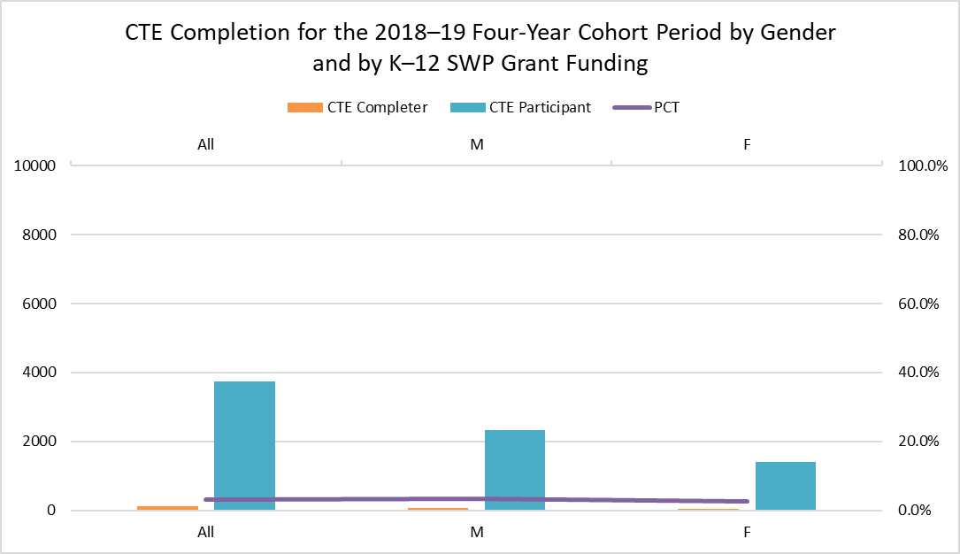
The vertical bar chart pictured above is a visual representation of the CTE completion data listed in Table 1C directly below.

Table 1C. CTE Completion for the 2018–19 Four-Year Cohort Period and by Gender and by K–12 SWP Grant Funding
Gender | CTE Completer | CTE Participant | PCT
All | 114 | 3746 | 3.0%
M | 78 | 2334 | 3.3%
F | 36 | 1412 | 2.5%

Figure 1D. CTE Completion for the 2018–19 Four-Year Cohort Period by Gender and by Perkins Grant Funding
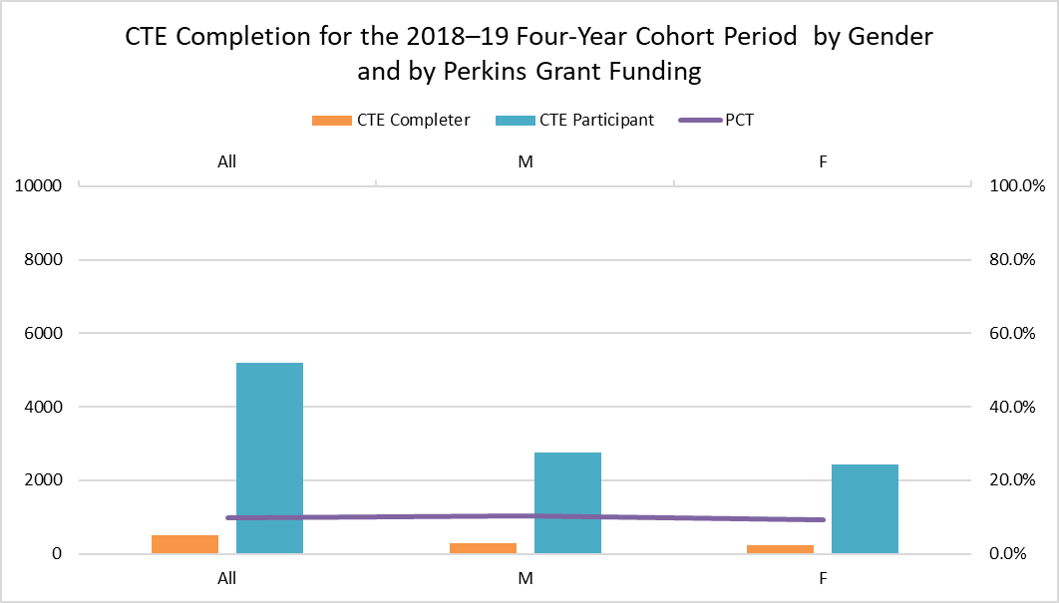
The vertical bar chart pictured above is a visual representation of the CTE completion data listed in Table 1D directly below.

Table 1D. CTE Completion for the 2018–19 Four-Year Cohort Period by Gender and by Perkins Grant Funding
Gender | CTE Completer | CTE Participant | PCT
All | 517 | 5205 | 9.9%
M | 288 | 2768 | 10.4%
F | 229 | 2437 | 9.4%

Figure 1E. CTE Completion for the 2018–19 Four-Year Cohort Period by Gender and by CTEIG and K–12 SWP Grant Funding
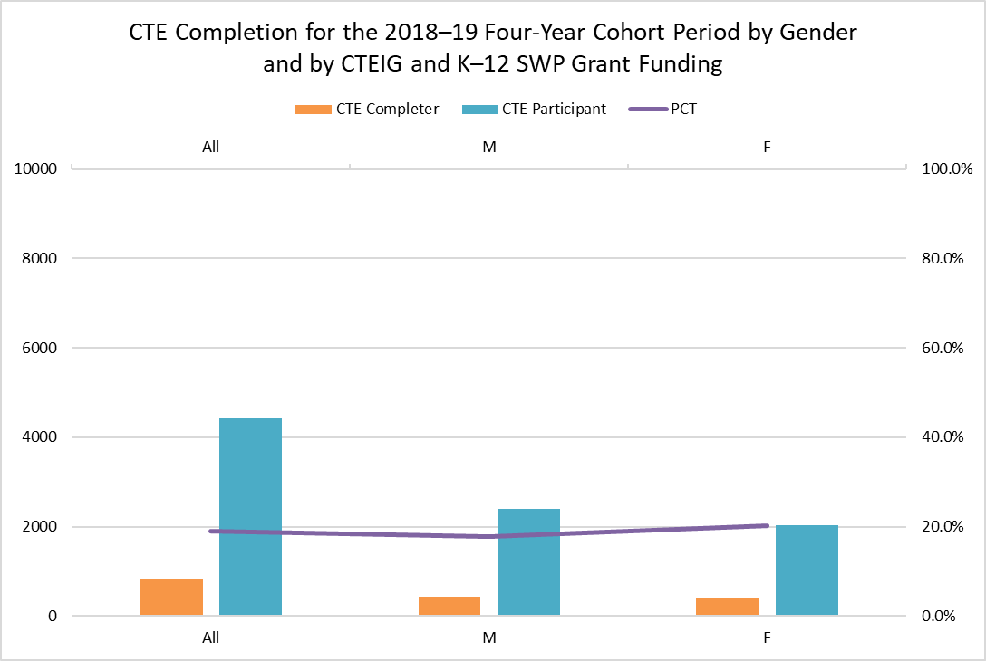
The vertical bar chart pictured above is a visual representation of the CTE completion data listed in Table 1E directly below.

Table 1E. CTE Completion for the 2018–19 Four-Year Cohort Period by Gender and by CTEIG and K–12 SWP Grant Funding
Gender | CTE Completer | CTE Participant | PCT
All | 839 | 4432 | 18.9%
M | 428 | 2399 | 17.8%
F | 411 | 2033 | 20.2%

Figure 1F. CTE Completion for the 2018–19 Four-Year Cohort Period by Gender and by CTEIG and Perkins Grant Funding
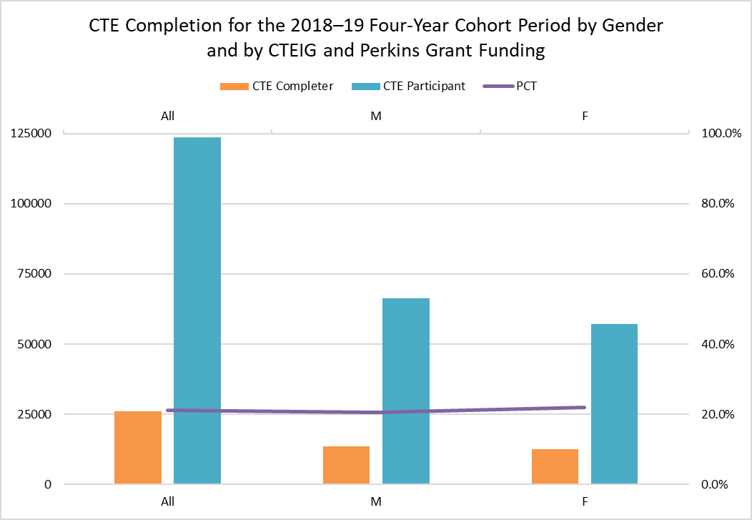
The vertical bar chart pictured above is a visual representation of the CTE completion data listed in Table 1F directly below.

Table 1F. CTE Completion for the 2018–19 Four-Year Cohort Period by Gender and by CTEIG and Perkins Grant Funding
Gender | CTE Completer | CTE Participant | PCT
All | 26115 | 123548 | 21.1%
M | 13579 | 66324 | 20.5%
F | 12536 | 57224 | 21.9%

Figure 1G. CTE Completion for the 2018–19 Four-Year Cohort Period by Gender and by K–12 SWP and Perkins Grant Funding
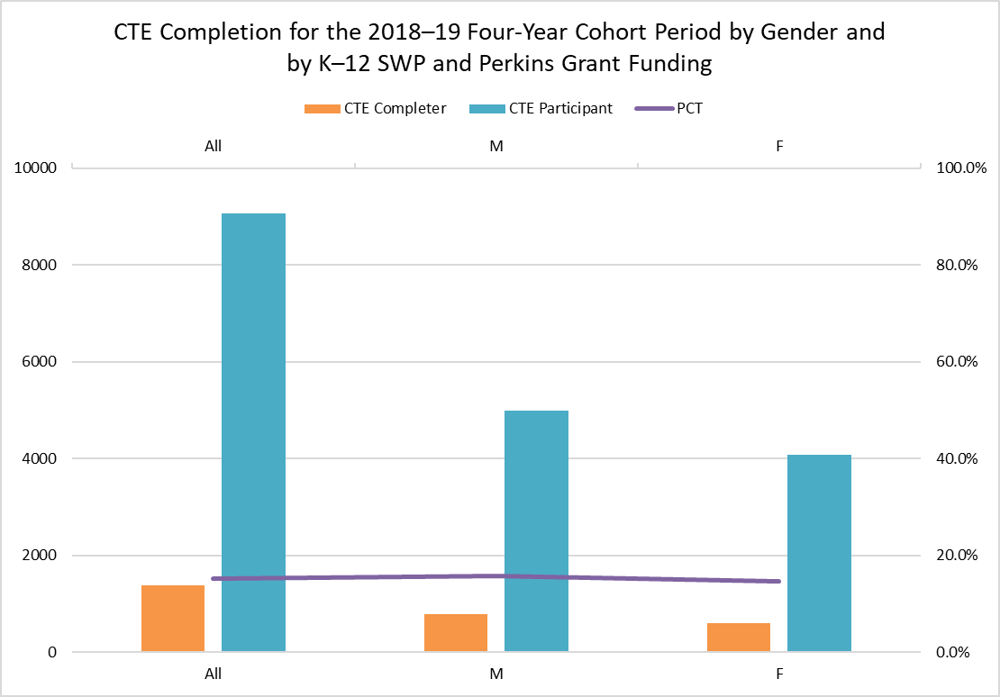
The vertical bar chart pictured above is a visual representation of the CTE completion data listed in Table 1G directly below.

Table 1G. CTE Completion for the 2018–19 Four-Year Cohort Period by Gender and by K–12 SWP and Perkins Grant Funding
Gender | CTE Completer | CTE Participant | PCT
All | 1388 | 9070 | 15.3%
M | 789 | 4985 | 15.8%
F | 599 | 4085 | 14.7%

Figure 1H. CTE Completion for the 2018–19 Four-Year Cohort Period and by Gender and All Three Grants
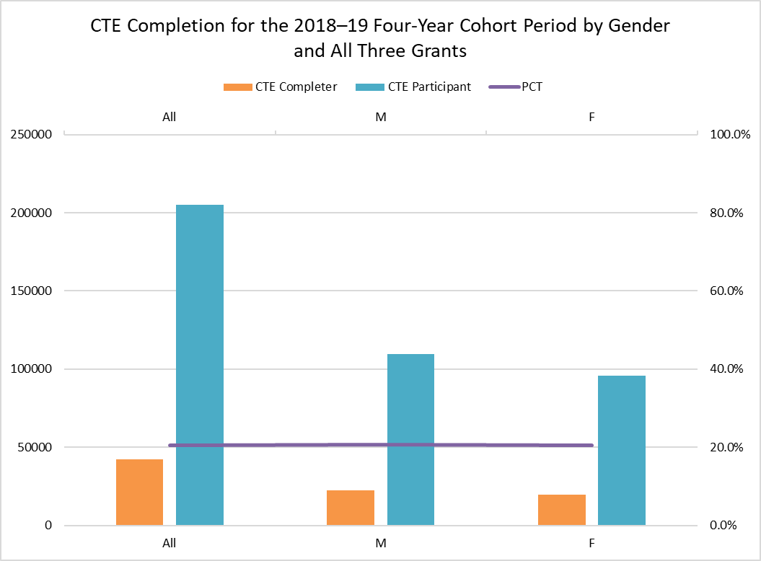
The vertical bar chart pictured above is a visual representation of the CTE completion data listed in Table 1H directly below.

Table 1H. CTE Completion for the 2018–19 Four-Year Cohort Period and by Gender and All Three Grants
Gender | CTE Completer | CTE Participant | PCT
All | 42229 | 205223 | 20.6%
M | 22627 | 109536 | 20.7%
F | 19602 | 95687 | 20.5%

Figure 2A. CTE Completion for the 2018–19 Four-Year Cohort Period by Race and Ethnicity and by No State and Federal Grant Funding
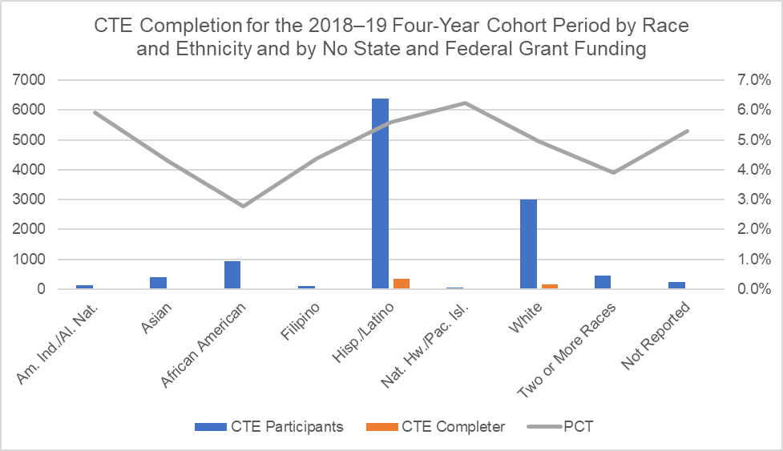
The vertical bar chart pictured above is a visual representation of the CTE completion data listed in Table 2A directly below.

Table 2A. CTE Completion for the 2018–19 Four-Year Cohort Period by Race and Ethnicity and by No State and Federal Grant Funding
Race/Ethnicity | All Students | CTE Participants | PCT
Am. Ind/Al. Nat. | 135 | 8 | 5.9%
Asian | 398 | 17 | 4.3%
African American | 935 | 26 | 2.8%
Filipino | 91 | 4 | 4.4%
Hisp. /Latino | 6379 | 357 | 5.6%
Nat Hw /Pac.Isl. | 48 | 3 | 6.3%
White | 3006 | 149 | 5.0%
Two or More Races | 460 | 18 | 3.9%
Not Reported | 226 | 12 | 5.3%
Totals and PCT Average | 11678 | 594 | 5.1%
Figure 2B. CTE Completion for the 2018–19 Four-Year Cohort Period by Race and Ethnicity and by CTEIG Funding
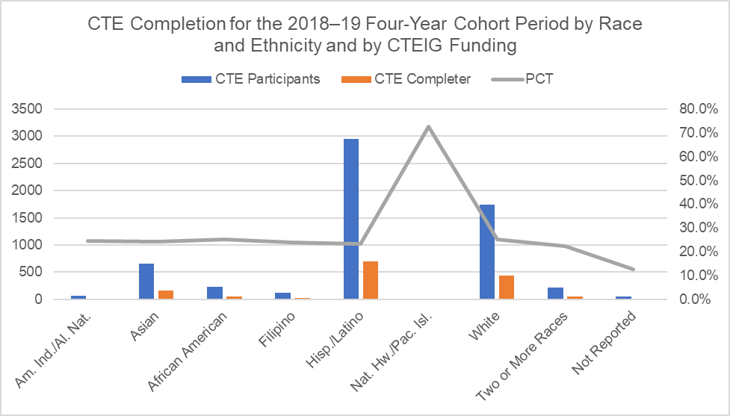
The vertical bar chart pictured above is a visual representation of the CTE completion data listed in Table 2B directly below.

Table 2B. CTE Completion for the 2018–19 Four-Year Cohort Period by Race and Ethnicity and by CTEIG Funding
Race/Ethnicity | All Students | CTE Participants | PCT
Am. Ind/Al. Nat. | 61 | 15 | 24.6%
Asian | 655 | 158 | 24.1%
African American | 227 | 57 | 25.1%
Filipino | 126 | 30 | 23.8%
Hisp. /Latino | 2951 | 692 | 23.4%
Nat Hw /Pac.Isl. | 11 | 8 | 72.7%
White | 1743 | 437 | 25.1%
Two or More Races | 219 | 49 | 22.4%
Not Reported | 55 | 7 | 12.7%
Totals and PCT Average | 6048 | 1453 | 24.0%

Figure 2C. CTE Completion for the 2018–19 Four-Year Cohort Period by Race and Ethnicity and by K–12 SWP Grant Funding
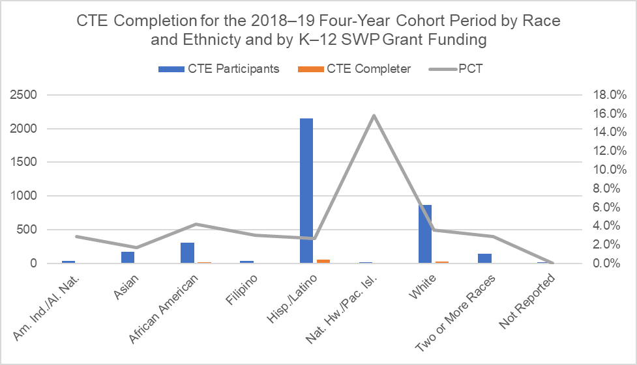
The vertical bar chart pictured above is a visual representation of the CTE completion data listed in Table 2C directly below.

Table 2C. CTE Completion for the 2018–19 Four-Year Cohort Period by Race and Ethnicity and by K–12 SWP Grant Funding
Race/Ethnicity | All Students | CTE Participants | PCT
Am. Ind/Al. Nat. | 35 | 1 | 2.9%
Asian | 174 | 3 | 1.7%
African American | 308 | 13 | 4.2%
Filipino | 33 | 1 | 3.0%
Hisp. /Latino | 2156 | 58 | 2.7%
Nat Hw /Pac.Isl. | 19 | 3 | 15.8%
White | 865 | 31 | 3.6%
Two or More Races | 140 | 4 | 2.9%
Not Reported | 16 | 0 | 0.0%
Totals and PCT Average | 3746 | 114 | 3.0%
Figure 2D. CTE Completion for the 2018–19 Four-Year Cohort Period by Race and Ethnicity and by Perkins Funding
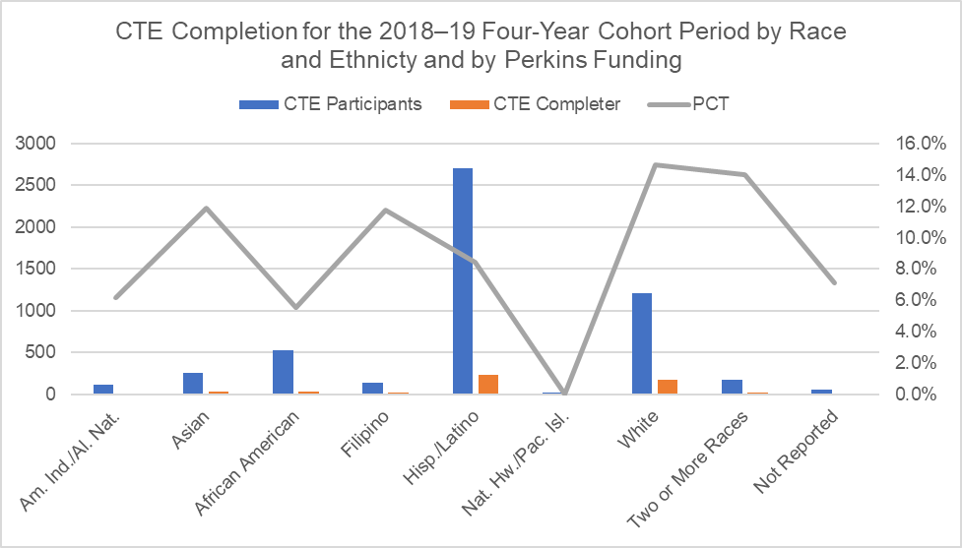
The vertical bar chart pictured above is a visual representation of the CTE completion data listed in Table 2D directly below.

Table 2D. CTE Completion for the 2018–19 Four-Year Cohort Period by Race and Ethnicity and by Perkins Funding
Race/Ethnicity | All Students | CTE Participants | PCT
Am. Ind/Al. Nat. | 114 | 7 | 6.1%
Asian | 261 | 31 | 11.9%
African American | 525 | 29 | 5.5%
Filipino | 136 | 16 | 11.8%
Hisp. /Latino | 2701 | 228 | 8.4%
Nat Hw /Pac.Isl. | 25 | 0 | 0.0%
White | 1209 | 177 | 14.6%
Two or More Races | 178 | 25 | 14.0%
Not Reported | 56 | 4 | 7.1%
Totals and PCT Average | 5205 | 517 | 9.9%

Figure 2E. CTE Completion for the 2018–19 Four-Year Cohort Period by Race and Ethnicity and by CTEIG and K–12 SWP Grant Funding
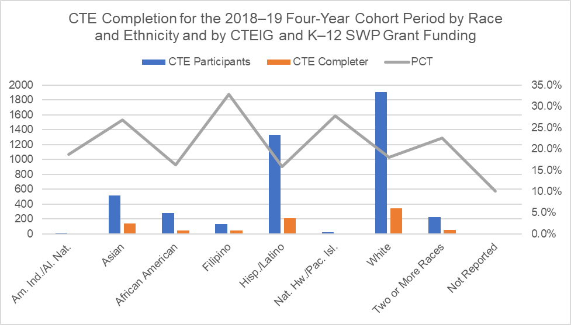
The vertical bar chart pictured above is a visual representation of the CTE completion data listed in Table 2E directly below.

Table 2E. CTE Completion for the 2018–19 Four-Year Cohort Period by Race and Ethnicity and by CTEIG and K–12 SWP Grant Funding
Race/Ethnicity | All Students | CTE Participants | PCT
Am. Ind/Al. Nat. | 16 | 3 | 18.8%
Asian | 514 | 138 | 26.8%
African American | 284 | 46 | 16.2%
Filipino | 131 | 43 | 32.8%
Hisp. /Latino | 1335 | 211 | 15.8%
Nat Hw /Pac.Isl. | 18 | 5 | 27.8%
White | 1902 | 342 | 18.0%
Two or More Races | 222 | 50 | 22.5%
Not Reported | 10 | 1 | 10.0%
Totals and PCT Average | 4432 | 839 | 18.9%
Figure 2F. CTE Completion for the 2018–19 Four-Year Cohort Period Race and Ethnicity and by CTEIG and Perkins Funding
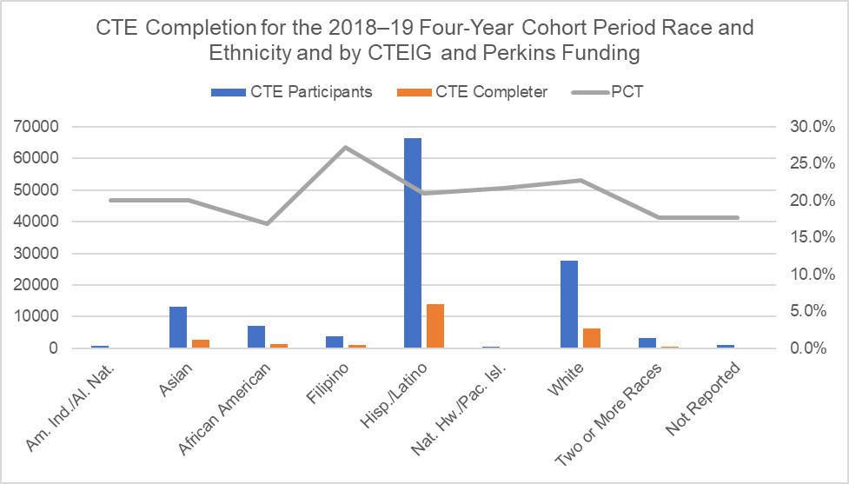
The vertical bar chart pictured above is a visual representation of the CTE completion data listed in Table 2F directly below.

Table 2F. CTE Completion for the 2018–19 Four-Year Cohort Period Race and Ethnicity and by CTEIG and Perkins Funding
Race/Ethnicity | All Students | CTE Participants | PCT
Am. Ind/Al. Nat. | 804 | 161 | 20.0%
Asian | 13205 | 2640 | 20.0%
African American | 7085 | 1191 | 16.8%
Filipino | 3776 | 1026 | 27.2%
Hisp. /Latino | 66507 | 13993 | 21.0%
Nat Hw /Pac.Isl. | 552 | 120 | 21.7%
White | 27569 | 6268 | 22.7%
Two or More Races | 3124 | 552 | 17.7%
Not Reported | 926 | 164 | 17.7%
Totals and PCT Average | 123548 | 26115 | 21.1%
Figure 2G. CTE Completion for the 2018–19 Four-Year Cohort Period by Race and Ethnicity and by K–12 SWP and Perkins Grant Funding
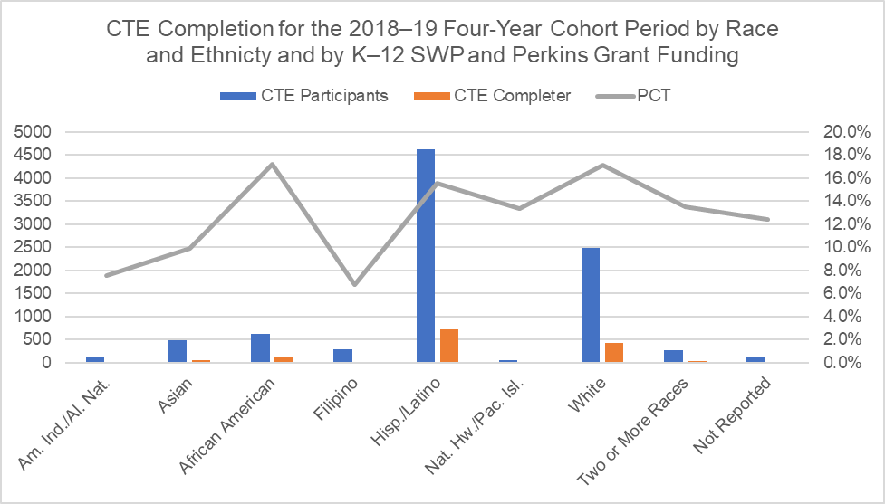
The vertical bar chart pictured above is a visual representation of the CTE completion data listed in Table 2G directly below.

Table 2G. CTE Completion for the 2018–19 Four-Year Cohort Period by Race and Ethnicity and by K–12 SWP and Perkins Grant Funding
Race/Ethnicity | All Students | CTE Participants | PCT
Am. Ind/Al. Nat. | 106 | 8 | 7.5%
Asian | 486 | 48 | 9.9%
African American | 623 | 107 | 17.2%
Filipino | 296 | 20 | 6.8%
Hisp. /Latino | 4634 | 721 | 15.6%
Nat Hw /Pac.Isl. | 45 | 6 | 13.3%
White | 2486 | 426 | 17.1%
Two or More Races | 273 | 37 | 13.6%
Not Reported | 121 | 15 | 12.4%
Totals and PCT Average | 9070 | 1388 | 15.3%
Figure 2H. CTE Completion for the 2018–19 Four-Year Cohort Period by Race and Ethnicity and All Three Grant Funding
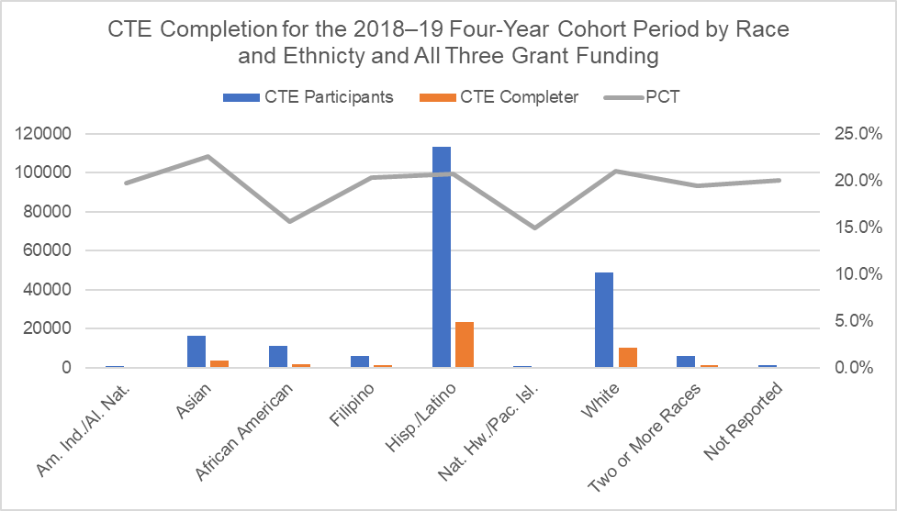
The vertical bar chart pictured above is a visual representation of the CTE completion data listed in Table 2H directly below.

Table 2H. CTE Completion for the 2018–19 Four-Year Cohort Period by Race and Ethnicity and All Three Grant Funding
Race/Ethnicity | All Students | CTE Participants | PCT
Am. Ind/Al. Nat. | 882 | 174 | 19.7%
Asian | 16493 | 3720 | 22.6%
African American | 11216 | 1754 | 15.6%
Filipino | 6188 | 1260 | 20.4%
Hisp. /Latino | 113585 | 23539 | 20.7%
Nat Hw /Pac.Isl. | 1061 | 158 | 14.9%
White | 48676 | 10233 | 21.0%
Two or More Races | 5835 | 1133 | 19.4%
Not Reported | 1287 | 258 | 20.0%
Totals and PCT Average | 205223 | 42229 | 20.6%
Figure 3A. CTE Completion for the 2018–19 Four-Year Cohort Period by Special Populations and by No State and Federal Grant Funding
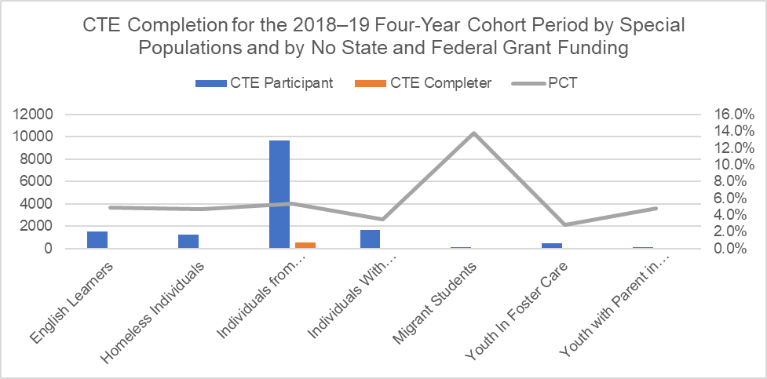
The vertical bar chart pictured above is a visual representation of the CTE completion data listed in Table 3A directly below.

Table 3A. CTE Completion for the 2018–19 Four-Year Cohort Period by Special Populations and by No State and Federal Grant Funding
Special Population | All Students | CTE Participants | PCT
English Learners | 1544 | 75 | 4.9%
Homeless Individuals | 1257 | 59 | 4.7%
Individuals from Economically Disadvantaged Families | 9692 | 516 | 5.3%
Individuals with Disabilities | 1632 | 57 | 3.5%
Migrant Students | 109 | 15 | 13.8%
Youth in Foster Care | 429 | 12 | 2.8%
Youth with Parent in Military | 105 | 5 | 4.8%

Figure 3B. CTE Completion for the 2018–19 Four-Year Cohort Period by Special Populations and by CTEIG Funding
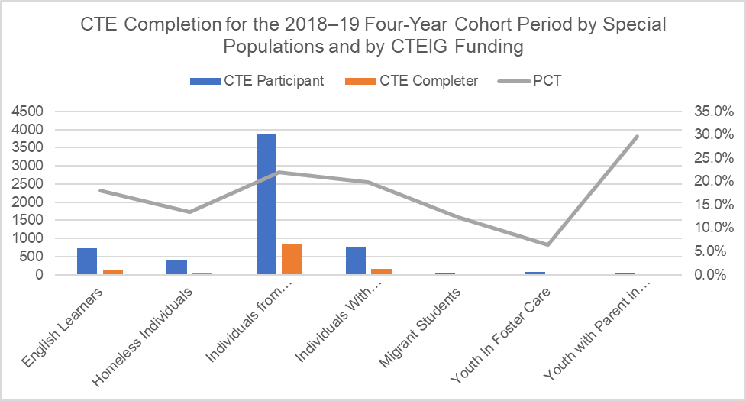
The vertical bar chart pictured above is a visual representation of the CTE completion data listed in Table 3B directly below.

Table 3B. CTE Completion for the 2018–19 Four-Year Cohort Period by Special Populations and by CTEIG Funding
Special Population | All Students | CTE Participants | PCT
English Learners | 730 | 131 | 17.9%
Homeless Individuals | 408 | 55 | 13.5%
Individuals from Economically Disadvantaged Families | 3865 | 846 | 21.9%
Individuals with Disabilities | 759 | 151 | 19.9%
Migrant Students | 49 | 6 | 12.2%
Youth in Foster Care | 79 | 5 | 6.3%
Youth with Parent in Military | 54 | 16 | 29.6%

Figure 3C. CTE Completion for the 2018–19 Four-Year Cohort Period by Special Populations and by K–12 SWP Funding
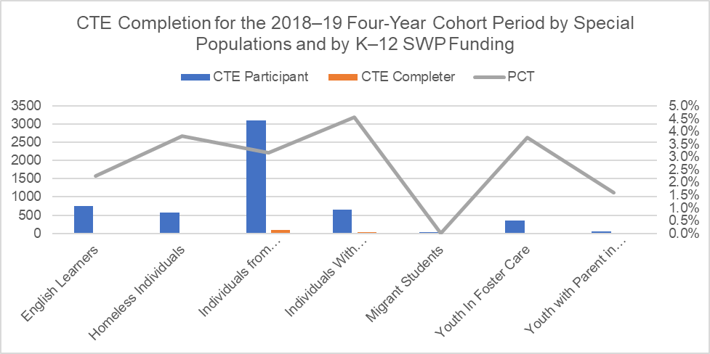
The vertical bar chart pictured above is a visual representation of the CTE completion data listed in Table 3C directly below.

Table 3C. CTE Completion for the 2018–19 Four-Year Cohort Period by Special Populations and by K–12 SWP Funding
Special Population | All Students | CTE Participants | PCT
English Learners | 751 | 17 | 2.3%
Homeless Individuals | 578 | 22 | 3.8%
Individuals from Economically Disadvantaged Families | 3108 | 98 | 3.2%
Individuals with Disabilities | 657 | 30 | 4.6%
Migrant Students | 38 | 0 | 0.0%
Youth in Foster Care | 346 | 13 | 3.8%
Youth with Parent in Military | 63 | 1 | 1.6%

Figure 3D. CTE Completion for the 2018–19 Four-Year Cohort Period by Special Populations and by Perkins Funding
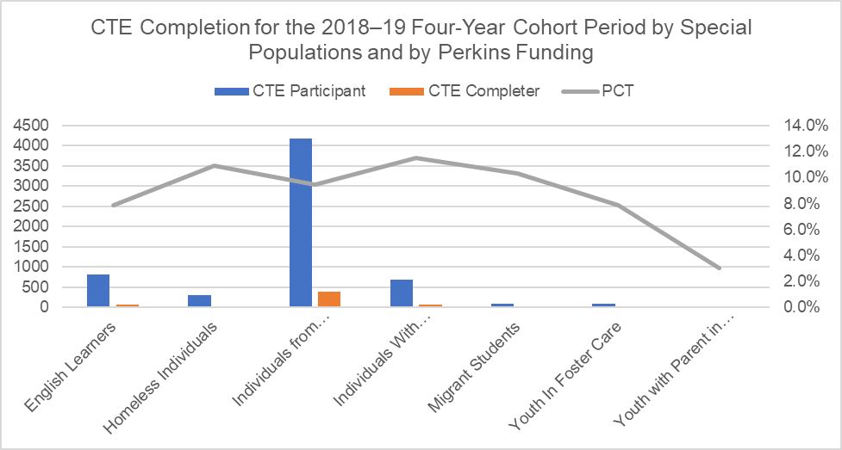
The vertical bar chart pictured above is a visual representation of the CTE completion data listed in Table 3D directly below.

Table 3D. CTE Completion for the 2018–19 Four-Year Cohort Period by Special Populations and by Perkins Funding
Special Population | All Students | CTE Participants | PCT
English Learners | 824 | 65 | 7.9%
Homeless Individuals | 312 | 34 | 10.9%
Individuals from Economically Disadvantaged Families | 4181 | 395 | 9.4%
Individuals with Disabilities | 695 | 80 | 11.5%
Migrant Students | 87 | 9 | 10.3%
Youth in Foster Care | 102 | 8 | 7.8%
Youth with Parent in Military | 33 | 1 | 3.0%

Figure 3E. CTE Completion for the 2018–19 Four-Year Cohort Period by Special Populations and by CTEIG and K–12 SWP Funding
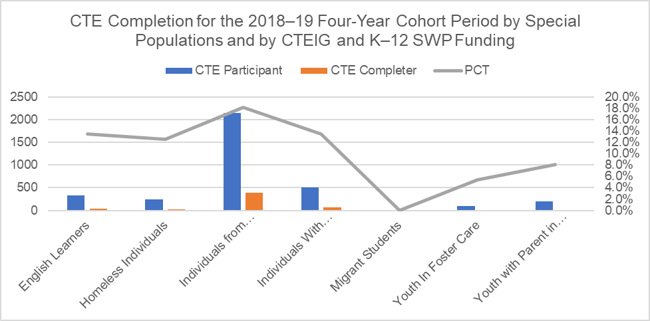
The vertical bar chart pictured above is a visual representation of the CTE completion data listed in Table 3E directly below.

Table 3E. CTE Completion for the 2018–19 Four-Year Cohort Period by Special Populations and by CTEIG and K–12 SWP Funding
Special Population | All Students | CTE Participants | PCT
English Learners | 333 | 45 | 13.5%
Homeless Individuals | 239 | 30 | 12.6%
Individuals from Economically Disadvantaged Families | 2154 | 391 | 18.2%
Individuals with Disabilities | 503 | 68 | 13.5%
Migrant Students | 10 | 0 | 0.0%
Youth in Foster Care | 93 | 5 | 5.4%
Youth with Parent in Military | 199 | 16 | 8.0%

Figure 3F. CTE Completion for the 2018–19 Four-Year Cohort Period by Special Populations and by CTEIG and Perkins Funding
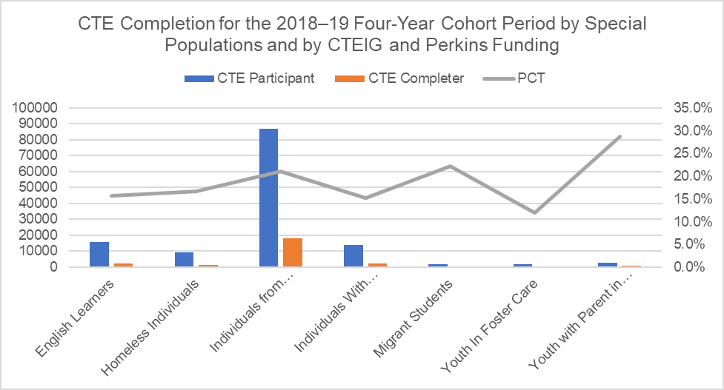
The vertical bar chart pictured above is a visual representation of the CTE completion data listed in Table 3F directly below.

Table 3F. CTE Completion for the 2018–19 Four-Year Cohort Period by Special Populations and by CTEIG and Perkins Funding
Special Population | All Students | CTE Participants | PCT
English Learners | 15868 | 2486 | 15.7%
Homeless Individuals | 9163 | 1523 | 16.6%
Individuals from Economically Disadvantaged Families | 86726 | 18265 | 21.1%
Individuals with Disabilities | 13929 | 2120 | 15.2%
Migrant Students | 1640 | 364 | 22.2%
Youth in Foster Care | 1899 | 228 | 12.0%
Youth with Parent in Military | 2757 | 792 | 28.7%

Figure 3G. CTE Completion for the 2018–19 Four-Year Cohort Period by Special Populations and by K–12 SWP and Perkins Funding
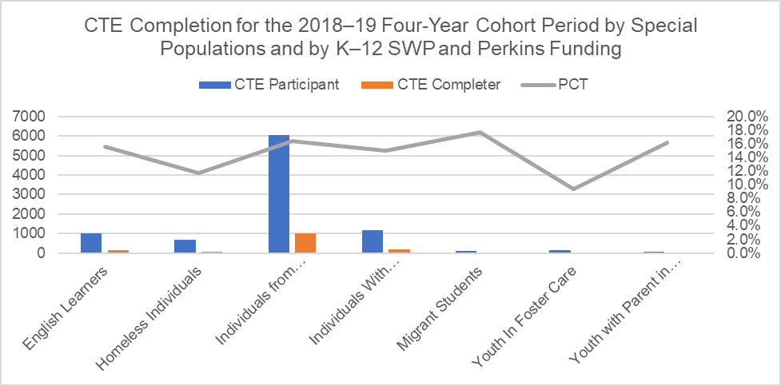
The vertical bar chart pictured above is a visual representation of the CTE completion data listed in Table 3G directly below.

Table 3G. CTE Completion for the 2018–19 Four-Year Cohort Period by Special Populations and by K–12 SWP and Perkins Funding
Special Population | All Students | CTE Participants | PCT
English Learners | 1029 | 160 | 15.5%
Homeless Individuals | 673 | 79 | 11.7%
Individuals from Economically Disadvantaged Families | 6065 | 999 | 16.5%
Individuals with Disabilities | 1191 | 179 | 15.0%
Migrant Students | 102 | 18 | 17.6%
Youth in Foster Care | 160 | 15 | 9.4%
Youth with Parent in Military | 62 | 10 | 16.1%

Figure 3H. CTE Completion for the 2018–19 Four-Year Cohort Period by Special Populations and by All Three Grant Funding

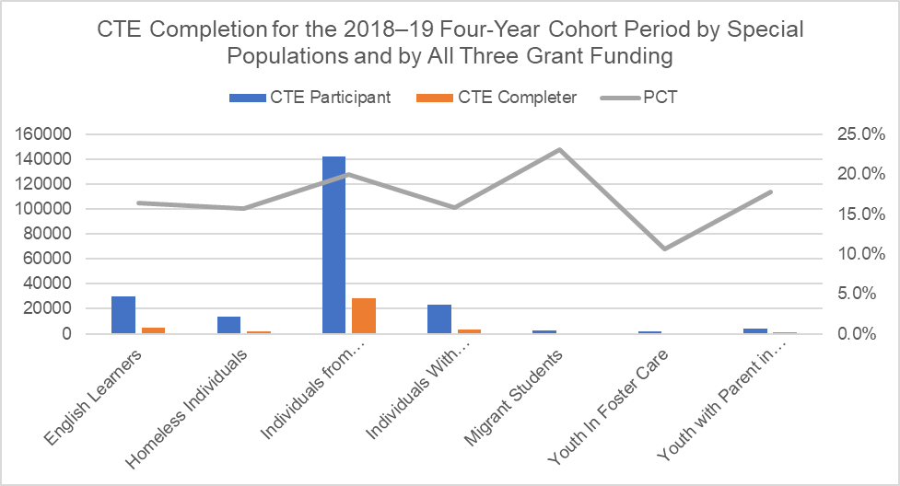
The vertical bar chart pictured above is a visual representation of the CTE completion data listed in Table 3H directly below.

Table 3H. CTE Completion for the 2018–19 Four-Year Cohort Period by Special Populations and by All Three Grant Funding
Special Population | All Students | CTE Participants | PCT
English Learners | 29581 | 4863 | 16.4%
Homeless Individuals | 13788 | 2163 | 15.7%
Individuals from Economically Disadvantaged Families | 142182 | 28343 | 19.9%
Individuals with Disabilities | 23081 | 3639 | 15.8%
Migrant Students | 2542 | 587 | 23.1%
Youth in Foster Care | 2186 | 232 | 10.6%
Youth with Parent in Military | 4330 | 769 | 17.8%

