California Workforce Pathways Joint Advisory Committee
cwpjac-jul10item03
Page 1 of 3
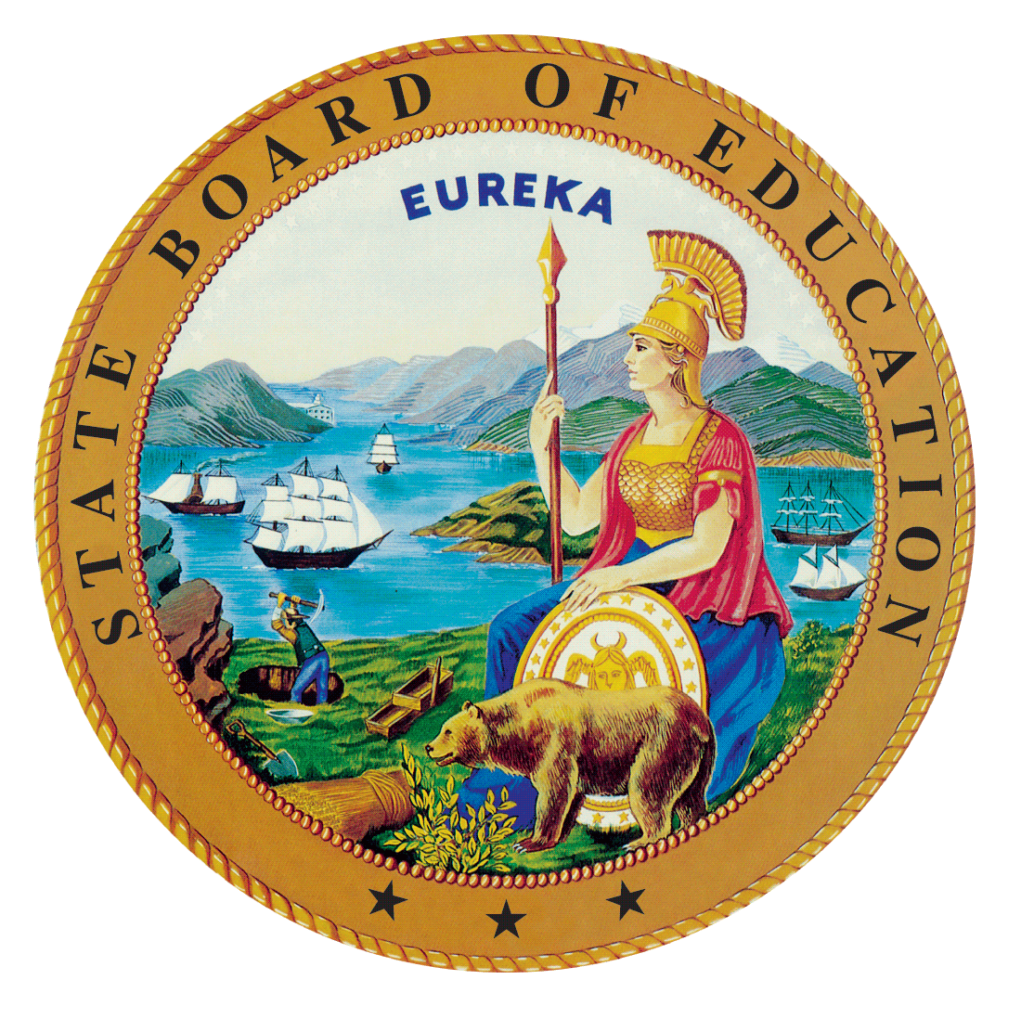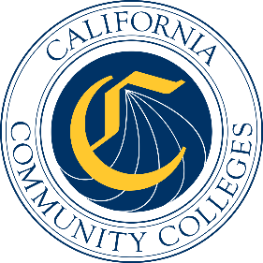

California Workforce Pathways
Joint Advisory Committee
July 10, 2020
Agenda Item 03
Posted by the California Department of Education

Subject
An Update on the California State Plan for Career Technical Education.

Type of Action
Information, Action

Summary of the Issue(s)
A State Team, consisting of core leadership staff of the State Board of Education (SBE), the California Department of Education (CDE) and the California Community Colleges Chancellor’s Office (CCCCO) have been in conversations regarding the development of the comprehensive California State Plan for Career Technical Education (CTE). The State Team has determined that the most effective approach is to develop a Strategic Plan/Call to Action that describes visionary goals and corresponding strategic objectives for CTE that is directly linked to the Guiding Policy Principles to Support Student-Centered K–14+ Pathways and the 12 Essential Elements of a High-Quality College and Career Pathway, as adopted by the California Workforce Pathways Joint Advisory Committee (CWPJAC) in November 2019, which can be located at, https://www.cde.ca.gov/ci/ct/gi/guidingpps.asp. A presentation will be made by State Team staff with an example of the suggested approach outlined.
With changing public health considerations and ensuing economic conditions emanating from the COVID-19 emergency, Governor Newsom issued a series of Executive Orders to shut down schools, community colleges, state offices, and others in March 2020. As a result, the State Team has acknowledged the flexibilities offered by the Governor’s Executive Orders and understand that continued education for the rest of the 2019–20 school year must be provided by distance or online learning. The State Team is aware that continued flexibility may be warranted in the foreseeable future, and will plan any planning meetings with stakeholders, as deemed necessary, accordingly.
In addition, the State Team believes the CWPJAC should consider the larger context of State education and workforce development priorities and initiatives in the beginning phase of developing a comprehensive California State Plan for CTE so that CWPJAC’s planning effort is not done in isolation of the Administration’s other initiatives. As a result, the State Team invited Abby Snay, Deputy Secretary, Future of Work, California Department of Labor and Workforce Development Agency to present at the July meeting to discuss the work of the California Future of Work Commission (Commission), to further inform the plan development.
For more on the Future of Work Commission, please visit the Commission’s web page at: https://www.labor.ca.gov/labor-and-workforce-development-agency/fowc/.

Approach and Areas of Focus
The State Team recommends that the California State Plan for CTE should be viewed as a Strategic Plan/Call to Action that clearly lays out the State’s vision for CTE, both in the near-term (i.e., in five years) and long-term (in ten years). The Strategic Plan/Call to Action will provide cohesion to the current and future state, regional, and local level work regarding the implementation of state and regional programs, supplemented by federal funding. When completed, the Strategic Plan/Call to Action should reflect wholly and fully the CWPJAC Guiding Policy Principles to Support Student-Centered K–14+ Pathways, which includes the 12 Essential Elements of a High-Quality College and Career Pathway.
The State Team has discussed the following approaches in developing the Strategic Plan/Call to Action for the California State Plan for CTE:
- Revisiting comments made by the CWPJAC members during the several reviews of the Federal Strengthening Career and Technical Education for the 21st Century Act (Perkins V) State Plan regarding issues that need further discussion when it came to developing the California State Plan for CTE.
- Feedback received from stakeholders and the public during the Federal Perkins V State Plan development on specific areas that needed to be spelled out more clearly when the state turned to developing the California State Plan for CTE.
- Taking into account existing strategic initiatives such as the CCCCO’s Vision for Success which can be found on the Foundation for California Community Colleges web page at, https://vision.foundationccc.org/, the California Joint Special Populations Advisory Committee which can be found on their web page at, http://www.jspac.org/, approaches taken by other states, or other initiatives in order to improve the delivery of CTE in California.
- Identifying commitments made within the Federal Perkins V State Plan that would be addressed further during the development of the California State Plan for CTE, with the understanding that federal funds are supplementary to state efforts.
The Strategic Plan/Call to Action requires several inter-related steps that the State Team will need to complete, including:
- Providing a holistic review of the approaches outlined above to build out a framework for the Strategic Plan/Call to Action.
- Soliciting feedback from stakeholders and identifying specific areas of interest; significantly expanding the stakeholder group members to include teachers and faculty.
- Producing a high-level, forward-looking document that describes the rationale and urgency for providing CTE programming for K-14+ students to be ready for a variety of career opportunities in California’s vast and ever-changing regional economies.
The State Team looks forward to receiving feedback from the CWPJAC during its July meeting, to continue its work with the recommended approach, and develop an updated timeline, to be presented at the September 2020 CWPJAC meeting.

Recommendation
The CDE and the CCCCO staff recommend that the CWPJAC provide feedback and guidance on the development of the California State Plan for CTE.

Brief History of Key Issues
When the 2008–2012 California State Plan for CTE was adopted by the California Community Colleges Board of Governors (BOG) and the California SBE, and later approved by the U.S. Department of Education (ED) in 2008, it combined both the federal Carl D. Perkins Career and Technical Education Act of 2006 (Perkins IV) application and California’s broad vision for CTE programs in the State. With the enactment of Perkins V and under the direction of the CWPJAC, staff developed and prepared a separate federal Perkins V application, as detailed in the Summary of Previous CWPJAC Discussions and Actions Section below. This also began the process of revising the California State Plan for CTE that reflects new programs and funding investments, as well as changes to economic conditions since 2008. Additionally, stakeholder input received during the initial development of the Federal Perkins V State Plan will also be considered in development of the California State Plan for CTE. Further stakeholder input may be gathered, as needed. At the October 2019 meeting, the CWPJAC requested staff to prioritize the completion of the Federal Perkins V State Plan, allowing additional time to develop revisions to the California State Plan for CTE.
The CWPJAC approved the Federal Perkins V State Plan at its March 2, 2020, meeting, the SBE approved it on March 11, 2020, and the BOG received a presentation of the federal application at its May 17, 2020, meeting. It was subsequently forwarded to the Governor’s Office, and Governor Newsom approved it on June 11, 2020, and it was submitted to the ED for approval on June 12, 2020.

Summary of Previous California Workforce Pathways Joint Advisory Committee Discussion(s) and Action(s)

November 2019: The CWPJAC discussed the development of a comprehensive California State Plan for CTE along with an extended timeline beyond the submission of the federal Perkins V submission to the ED. The CWPJAC advised staff to continue work to develop the comprehensive California State Plan for CTE.

October 2019: The CWPJAC reviewed, discussed, and provided initial input to a preliminary draft of the California State Plan for CTE, and the CWPJAC directed staff to focus on the Perkins V federal application and present a draft federal application to the CWPJAC at its November meeting. The CWPJAC also reviewed and discussed an updated draft timeline of completed and future meetings for completing the Perkins V federal application.

September 2019: The CWPJAC reviewed a preliminary draft of the revisions to California’s State Plan for CTE, as well as an updated draft timeline.

July 2019: The CWPJAC staff updated the draft timeline and planned activities for completing the revisions to California’s State Plan for CTE.

May 2019: The CWPJAC staff introduced a draft timeline and planned activities for revising California’s State Plan for CTE.
March 2008: On March 12, 2008, the SBE unanimously approved the 2008–2012 California State Plan for Career Technical Education, as required by the Perkins IV, which had been previously approved by the Board of Governors on March 3, 2008. The State Plan was subsequently approved by the ED on July 1, 2008.

Fiscal Analysis (as allocated)
Not applicable

Attachment(s)
Attachments: None

