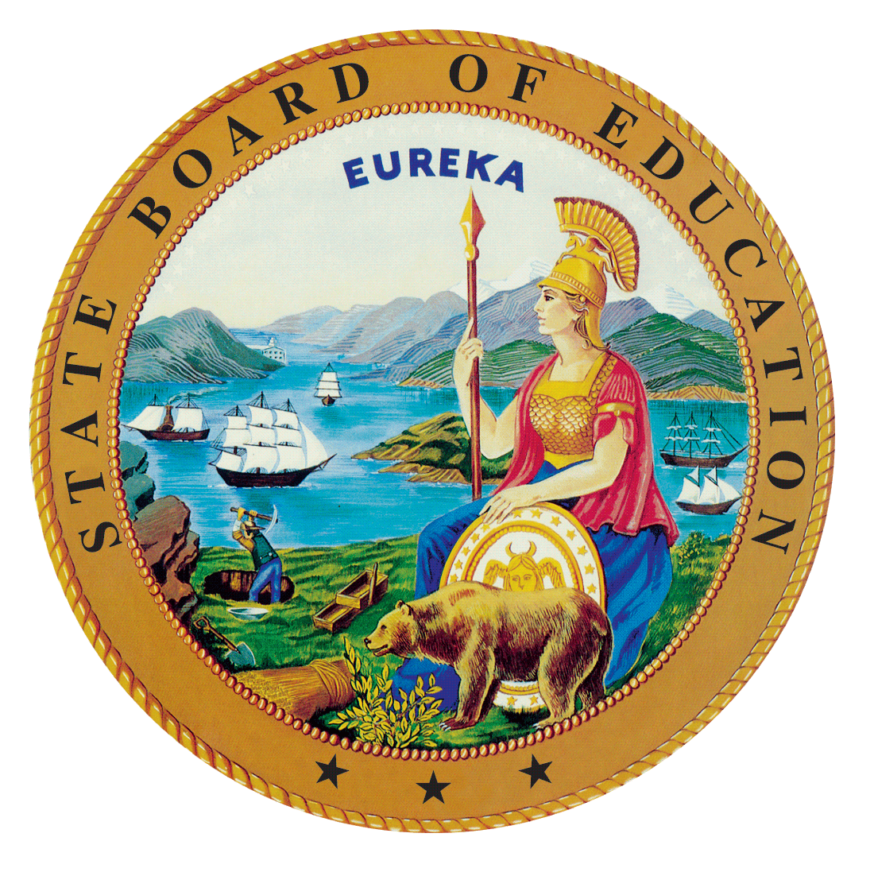 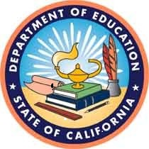 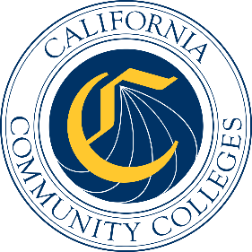

# California Workforce Pathways Joint Advisory Committee November 2019 Agenda Item 01

Posted by the California Department of Education

## Subject

Second Reading and Review of Perkins V State Plan: The federal application to the United States Department of Education for funds to fulfil the requirements for the *Strengthening Career and Technical Education for the 21st Century Act*.

## Type of Action

Action, Information

## Summary of the Issue(s)

The federal application to the United States Department of Education (ED) to fulfil the requirements for *Strengthening Career and Technical Education for the 21st Century Act* (Perkins V) funds will be presented. This is the second reading and review of the Draft Perkins V State Plan. Once the California Workforce Pathways Joint Advisory Committee (CWPJAC) approves this draft of the Perkins V State Plan, staff will open the draft plan for public comment. After public comments are reviewed and incorporated into the draft Perkins V State Plan, a complete Draft Perkins V State Plan will be submitted for approval to the CWPJAC followed by approval from the State Board of Education (SBE), the Board of Governors (BOG), and the Governor’s Office. The full Perkins V State Plan will be submitted to the ED no later than April 15, 2020.

The Draft Perkins V State Plan is an extension and refinement of the 2019–20 Perkins V Transition Plan, which was approved by the SBE at its May 8, 2019 meeting which can be found on the SBE’s webpage at, <https://www.cde.ca.gov/be/ag/ag/yr19/agenda201905.asp>. The BOG of the California Community Colleges received an update on the Perkin V transition plan at its May 21, 2019 meeting which can be found on the BOG’s webpage at, <https://www.cccco.edu/About-Us/Board-of-Governors/Meeting-schedule-minutes-and-agenda>. Submission of the application is required to fulfil the State’s obligation for receiving approximately $127 million in federal funds for career and technical education (CTE) annually.

The first attachment provides a revised version, in track changes, of the Draft Perkins V State Plan identifying the differences from the Plan that was presented to the CWPJAC on November 7, 2019. The second attachment provides an updated version of all the changes from the November 7, 2019 CWPJAC meeting that have been accepted.

The Draft Perkins V State Plan responds to prompts under four different but inter-related strands: plan development and consultation; program administration and implementation; fiscal responsibility; and accountability for results. Input received from the different stakeholder groups has been included within the Draft Perkins V State Plan. Responses are provided to prompts within each major strand with key themes to address and highlight. These themes were placed under each minor prompt, where each minor prompt listed several items to address.

The third attachment provides how the four strands, major prompts, minor prompts, and items are broken down, along with associated page numbers.

While feedback from CWPJAC members is being requested for the entire document, it is suggested that CWPJAC members focus on the following areas within each of these four strands: programs of study (Attachment 2 page 49); size, scope and quality (Attachment 2 page 102); comprehensive local needs assessment (Attachment 2 page 101); local application plan (Attachment 2 page 94); dual enrollment, work-based learning (Attachment 2 page 86); budget and finance (Attachment 2 page 148); and accountability (Attachment 2 page 130). In addition to the four strands and there are several focus areas: vision; goals; Guiding Policy Principles; and the 12 Elements of a High-Quality College and Career Pathway.

Attachment 4 is an updated project timeline that specifies which tasks have been completed, and which tasks need completion in the near future. The updated timeline reflects the inclusion of separate meetings, since completed, with teacher and community college administrators of occupational administrators. Included among this latter group are community college personnel that have responsibility for CTE on their campuses. Also included is the process for how the state will incorporate public comment feedback, and how the state will complete the final required steps that includes BOG, SBE, and the Governor’s Office approval, before submitting the federal application on or before April 15, 2020.

## Recommendation

The SBE, the CDE, and the CCCCO staff jointly recommends that the CWPJAC review and approve the draft Perkins V State Plan to go out for public comment.

## Brief History of Key Issues

In 2008, the SBE approved the *2008-2012 California State Plan for Career Technical Education*. This comprehensive plan, which the CDE and the CCCCO created collaboratively, was developed to not only meet the federal *Carl D. Perkins Career and technical Education Act of 2006* (Perkins IV) requirements, but also to establish a vision and direction for CTE across California.

Staff from the CDE and the CCCCO have been working closely with staff from the SBE since spring 2017 to reconvene the CWPJAC, as required by California *Education Code* Section 12503, in preparation for developing a California State Plan for CTE.

On July 31, 2018, the federal Perkins V was signed into law which reauthorized the federal Perkins IV. As part of the transition to Perkins V, California elected to submit a one-year transition plan in May 2019, with the full State Plan due in April 2020. In April 2019, the Office of Career, Technical, and Adult Education (OCTAE) released the final guidance for the Perkins V, which can be found at the following web link, <https://s3.amazonaws.com/PCRN/docs/1830-0029-Perkins_V_State_Plan_Guide-Expires_4-30-22.pdf>.

The 2019–20 transition plan was approved by the SBE at its May 8, 2019 meeting, and the Board of Governors of the California Community Colleges received an update at its May 21, 2019 meeting. The CDE submitted the approved transition plan to the ED on May 24, 2019. On July 2, 2019, the CDE received notification from the ED that the 2019–20 transition plan was approved and Perkins funding for California was made available starting July 1, 2019. (<https://www.cde.ca.gov/ci/ct/gi/workpathjac.asp>)

Given that there has always been a short timeframe in developing, validating, and finalizing the Perkins V federal application, and after many conversations between the SBE, the CDE, and the CCCCO staff, three options were considered: (1) to only complete a Perkins V state plan, (2) to complete a comprehensive state plan for CTE, including the Perkins V requirements, or (3) to focus on the State Plan for CTE and continue working on the federal Perkins V requirements, making it become a fully comprehensive California State Plan for CTE. Staff presented the third option to the state advisory committee at its May 2019 meeting as a way to develop a comprehensive plan including all state CTE programs administered by both CDE and the CCCCO, and to ensure alignment to the Local Control Accountability Plans submitted by local educational agencies as well as the Student-Centered Funding Formula. Over subsequent meetings of the CWPJAC, the focus continued to be on the State Plan for CTE. At the October 2019 CWPJAC meeting, due to time constraints to submit the federal Perkins V State Plan, it was decided to focus on the Perkins V State Plan and then continue to develop the complete comprehensive State Plan for CTE after the submission of the federal Perkins V State Plan.

Throughout the state plan development process, staff anticipates adjustments and will be providing updates to the CWPJAC, the SBE, and BOG members. The purpose here is to keep CWPJAC, the SBE, and BOG members abreast of any changes that are deemed necessary as a result of public response, stakeholder input, and member comments serving on the CWPJAC, the SBE, BOG, and the Governor’s Office.

## Summary of Previous California Workforce Pathways Joint Advisory Committee Discussion(s) and Action(s)

**November 7, 2019:** Following the October 2019 meeting a decision was made to first complete the Perkins V State Plan. SBE, CDE, and CCCCO staff began putting together the Draft Perkins V State Plan. The version of the Draft Perkins V State Plan includes material from the October 2019 version (known as the California State Plan for CTE) by drawing relevant content and placing it under the four stands, the major prompts, the minor prompts and the items that were listed in the Perkins State Plan Guide (see link above). The Draft Perkins V State Plan was presented to the CWPJAC members on November 7, 2019. After review and input, the members asked staff to continue working on the Draft Perkins V State Plan and present to the CWPJAC members an updated version at the November 25, 2019 meeting.

**October 2019:** A draft State Plan for CTE and a proposed timeline were provided to the CWPJAC members. A chapter-by-chapter review of the draft State CTE Plan was presented, discussed, and input on each chapter was solicited. It was decided that the CWPJAC staff should work on the Perkins V federal application and present it to the CWPJAC members at the November meeting. A proposed draft timeline was presented. Completed and upcoming meetings with regard to the Perkins V federal application were discussed.

**September 2019:** A draft State Plan for CTE and a proposed draft timeline were provided to the CWPJAC members.

**July 2019:** The CWPJAC staff introduced an updated draft timeline and planned activities for completing a new California State Plan for CTE.

**May 2019:** The CWPJAC staff introduced a draft timeline and planned activities for completing a new California State Plan for CTE.

**March 2019:** The CDE and CCCCO staff presented the Draft 2019–20 Perkins V State Transition Plan to the CWPJAC. The CWPJAC members provided feedback for staff to consider while continuing to work on the transition plan.

**February 2019:** The CDE and CCCCO staff presented responses to the Programs of Study, Special Populations, and Fiscal Responsibility sections of the transition plan to the CWPJAC. The CWPJAC members provided extensive feedback for staff to consider while continuing to work on the transition plan.

**January 2019:** The CDE and CCCCO staff presented the current requirements for the state’s 2019–20 transition plan for the new Perkins V legislation.

**December 2018:** The CDE and CCCCO staff presented a draft timeline to the CWPJAC that outlined when items need to be completed in order to meet the deadline for submission of the State’s 2019–20 transition plan to the United States Department of Education.

**November 2018:** The CDE staff provided a brief update on the activities around the new Perkins V legislation.

**September 2018:** Michael Brustein, Brustein & Manasevit, PLLC, Attorneys at Law, provided an overview of the new Perkins V legislation, known as the Strengthening Career and Technical Education for the 21st Century Act.

**March 2008:** On March 12, 2008, the SBE unanimously approved the 2008–2012 California State Plan for Career Technical Education, as required by the Perkins IV, which had been previously approved by the BOG on March 3, 2008. The State Plan was subsequently approved by the ED on July 1, 2008.

**January 2008:** The SBE held a public hearing on the 2008–2012 California State Plan for Career Technical Education, as was required by the Perkins IV.

## Fiscal Analysis (as allocated)

In 2018–19 the Perkins IV allocation was $120,196,084; for 2019–20, the Perkins V allocation is $127,058,834.

## Attachment(s)

**Attachment 1:** Draft Perkins V State Plan with Track Changes

**Attachment 2:** Draft Perkins V State Plan (169 pages)

**Attachment 3:** Perkins V State Plan Page References (3 pages)

**Attachment 4:** California State Plan for CTE Working Timeline (3 pages)