California Workforce Pathways Joint Advisory Committee
cwpjac-sep20item01
Page 1 of 2
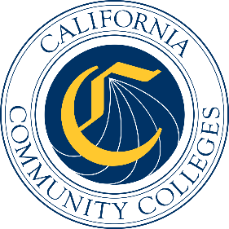

California Workforce Pathways
Joint Advisory Committee
September 25, 2020
Agenda Item 01
Posted by the California Department of Education

Subject
Approval of the California Workforce Pathways Joint Advisory Committee’s July 10, 2020 Preliminary Report of Action.

Type of Action
Information, Action

Summary of the Issue(s)
The California Workforce Pathways Joint Advisory Committee (CWPJAC) typically holds a public meeting every other month. After the meeting has concluded, staff compile a Preliminary Report of Action (meeting minutes) to document the meeting’s main activities. A recording of the meeting is posted within a few days of the meeting and can be found on the CWPJAC’s web page at https://www.cde.ca.gov/ci/ct/gi/workpathjac.asp. The final Report of Action is posted following the CWPJAC’s approval at their subsequent scheduled meeting.

Recommendation
The State Board of Education, the California Department of Education, and the California Community Colleges Chancellor’s Office staff jointly recommend that the CWPJAC review and approve the July 10, 2020 Preliminary Report of Action (Attachment 1).

Brief History of Key Issues
The CWPJAC addresses systems alignment policies specific to career pathways within the context of state and federal investments, furthering California’s policy objectives regarding workforce pathways in the state’s regional economies.

Summary of Previous California Workforce Pathways Joint Advisory Committee Discussion(s) and Action(s)
This is a standing Agenda Item which allows the CWPJAC members to review and approve the Preliminary Report of Action for the previous CWPJAC meeting.

Attachment(s)
Attachment 1: Preliminary Report of Action (6 pages)

