Attachment 1: Career Technical Education Incentive Grant and Kindergarten Through Grade Twelve Strong Workforce Program Data Reports

Figure 1A.
Offers high-quality career technical education (CTE) curriculum and instruction that are aligned to the CTE Model Curriculum Standards.
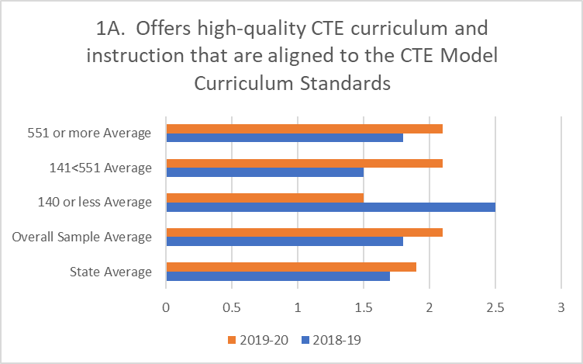
Figure 1A. is a horizontal bar chart that displays how LEAs answered the minimum eligibility requirement question “Offers high-quality CTE curriculum and instruction that are aligned to the CTE Model Curriculum Standards.” Within the display, the average score is provided for 2018–19 and 2019–20 for local education agencies (LEAs) who received CTE Incentive Grant (CTEIG) funds. LEAs with 551 or more average daily attendance (ADA), scored 1.8 in 2018–19 and 2.1 in 2019–20. LEAs with over 141 and less than 550 ADA, scored 1.5 in 2018–19 and 2.1 in 2019–20. LEAs with 140 or less ADA scored 2.5 in 2018–19 and 1.5 in 2019–20. The Overall Sample population of 32 LEAs (10 percent) scored 1.8 in 2018–19 and 2.1 in 2019–20 and the State Average for all participating LEAs was 1.7 in 2018–19 and 1.9 in 2019–20.

Table 1A.
Data table for Figure 1A.
Question 1A | 2018–19 | 2019–20
State Average | 1.7 | 1.9
Overall Sample Average | 1.8 | 2.1
140 or less Average | 2.5 | 1.5
141<551 Average | 1.5 | 2.1
551 or more Average | 1.8 | 2.1

Figure 1B.
Offers CTE Pathway(s) that provide a coherent sequence of courses, are reported in the California Longitudinal Pupil Achievement Data System (CALPADS) as CTE.
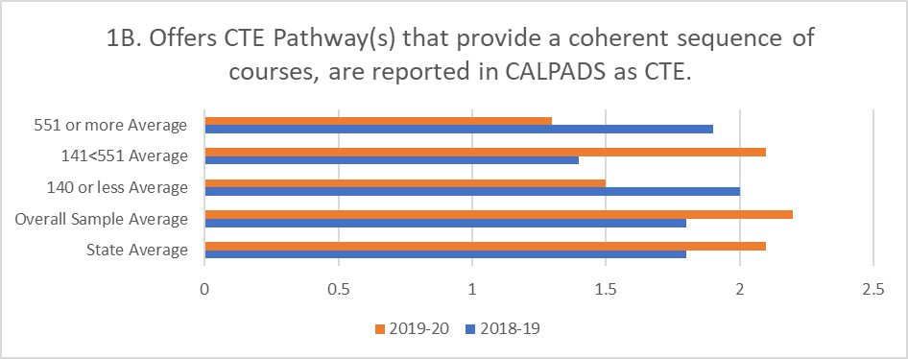
Figure 1B. is a horizontal bar chart that displays how LEAs answered the minimum eligibility requirement question “Offers CTE Pathway(s) that provide a coherent sequence of courses and are reported in CALPADS as CTE.” Within the display, the average score is provided for 2018–19 and 2019–20 for LEAs who received CTEIG funds. LEAs with 551 or more ADA, scored 1.9 in 2018–19 and 1.3 in 2019–20. LEAs with over 141 and less than 550 ADA, scored 1.4 in 2018–19 and 2.1 in 2019–20. LEAs with 140 or less ADA scored 2 in 2018–19 and 1.5 in 2019–20. The Overall Sample population of 32 LEAs (10 percent) scored 1.8 in 2018–19 and 2.2 in 2019–20 and the State Average for all participating LEAs was 1.8 in 2018–19 and 2.1 in 2019–20.

Table 1B.
Data Table for Figure 1B.
Question 1B | 2018–19 | 2019–20
State Average | 1.8 | 2.1
Overall Sample Average | 1.8 | 2.2
140 or less Average | 2 | 1.5
141<551 Average | 1.4 | 2.1
551 or more Average | 1.9 | 1.3

Figure 2.
Provides career exploration and guidance opportunities for all pathway learners.
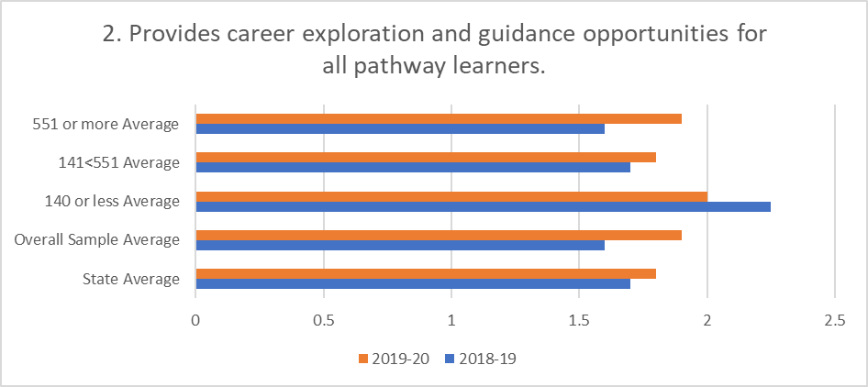
Figure 2. is a horizontal bar chart that displays how LEAs answered the minimum eligibility requirement question “Provides career exploration and guidance opportunities for all pathway learners.” Within the display, the average score is provided for 2018–19 and 2019–20 for LEAs who received CTEIG funds. LEAs with 551 or more ADA, scored 1.6 in 2018–19 and 1.9 in 2019–20. LEAs with over 141 and less than 550 ADA, scored 1.7 in 2018–19 and 1.8 in 2019–20. LEAs with 140 or less ADA scored 2.3 in 2018–19 and 2 in 2019–20. The Overall Sample population of 32 LEAs (10 percent) scored 1.6 in 2018–19 and 1.9 in 2019–20 and the State Average for all participating LEAs was 1.7 in 2018–19 and 1.8 in 2019–20.

Table 2A.
Data Table for Figure 2A.
Question 2 | 2018–19 | 2019–20
State Average | 1.7 | 1.8
Overall Sample Average | 1.6 | 1.9
140 or less Average | 2.3 | 2
141<551 Average | 1.7 | 1.8
551 or more Average | 1.6 | 1.9

Figure 3A.
Provides support services for students, including counseling.
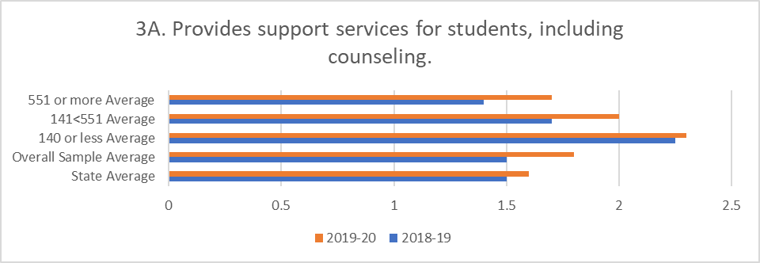
Figure 3A. is a horizontal bar chart that displays how LEAs answered the minimum eligibility requirement question “Provides support services for students, including counseling.” Within the display, the average score is provided for 2018–19 and 2019–20 for LEAs who received CTEIG funds. LEAs with 551 or more ADA, scored 1.4 in 2018–19 and 1.7 in 2019–20. LEAs with over 141 and less than 550 ADA, scored 1.7 in 2018–19 and 2 in 2019–20. LEAs with 140 or less ADA scored 2.3 in 2018–19 and 2.3 in 2019–20. The Overall Sample population of 32 LEAs (10 percent) scored 1.5 in 2018–19 and 1.8 in 2019–20 and the State Average for all participating LEAs was 1.5 in 2018–19 and 1.6 in 2019–20.

Table 3A.
Data Table for Figure 3A.
Question 3A | 2018–19 | 2019–20
State Average | 1.5 | 1.6
Overall Sample Average | 1.5 | 1.8
140 or less Average | 2.3 | 2.3
141<551 Average | 1.7 | 2
551 or more Average | 1.4 | 1.7

Figure 3B.
Student leadership development is embedded into career pathway teaching and learning.
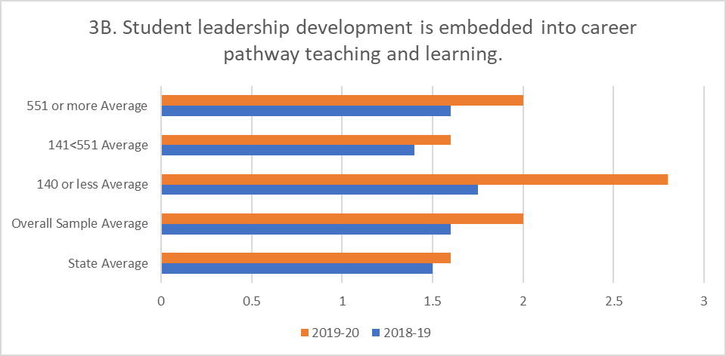
Figure 3B. is a horizontal bar chart that displays how LEAs answered the minimum eligibility requirement question “Student leadership development is embedded into career pathway teaching and learning.” Within the display, the average score is provided for 2018–19 and 2019–20 for LEAs who received CTEIG funds. LEAs with 551 or more ADA, scored 1.6 in 2018–19 and 2 in 2019–20. LEAs with over 141 and less than 550 ADA, scored 1.4 in 2018–19 and 1.6 in 2019–20. LEAs with 140 or less ADA scored 1.8 in 2018–19 and 2.8 in 2019–20. The Overall Sample population of 32 LEAs (10 percent) scored 1.6 in 2018–19 and 2 in 2019–20 and the State Average for all participating LEAs was 1.5 in 2018–19 and 1.6 in 2019–20.

Table 3B.
Data Table for Figure 3B.
Question 3B | 2018–19 | 2019–20
State Average | 1.5 | 1.6
Overall Sample Average | 1.6 | 2
140 or less Average | 1.8 | 2.8
141<551 Average | 1.4 | 1.6
551 or more Average | 1.6 | 2

Figure 4.
Provides for system alignment, coherence, and articulation, including ongoing and structural regional or local partnerships with postsecondary educational institutions documented through written formal agreements.
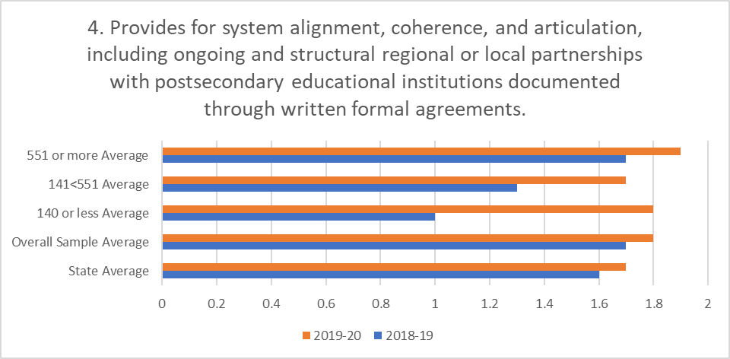
Figure 4. is a horizontal bar chart that displays how LEAs answered the minimum eligibility requirement question “Provides for system alignment, coherence, and articulation, including ongoing and structural regional local partnerships with postsecondary educational institutions documented through written formal agreements.” Within the display, the average score is provided for 2018–19 and 2019–20 for LEAs who received CTEIG funds. LEAs with 551 or more ADA, scored 1.7 in 2018–19 and 1.9 in 2019–20. LEAs with over 141 and less than 550 ADA, scored 1.3 in 2018–19 and 1.7 in 2019–20. LEAs with 140 or less ADA scored 1 in 2018–19 and 1.8 in 2019–20. The Overall Sample population of 32 LEAs (10 percent) scored 1.7 in 2018–19 and 1.8 in 2019–20 and the State Average for all participating LEAs was 1.6 in 2018–19 and 1.7 in 2019–20.

Table 4.
Data Table for Figure 4.
Question 4 | 2018–19 | 2019–20
State Average | 1.6 | 1.7
Overall Sample Average | 1.7 | 1.8
140 or less Average | 1 | 1.8
141<551 Average | 1.3 | 1.7
551 or more Average | 1.7 | 1.9

Figure 5A.
Form ongoing and meaningful industry and labor partnerships, evidenced by written agreements and through participation on advisory committees, and collaboration with business and labor organizations to provide opportunities for pupils.
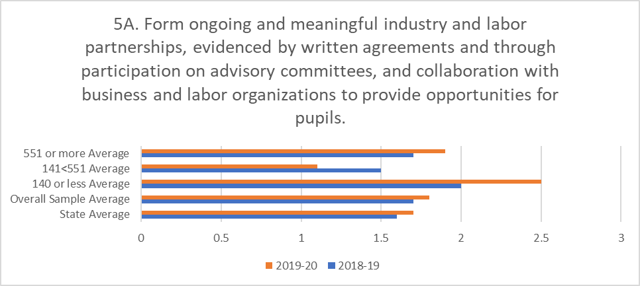
Figure 5A. is a horizontal bar chart that displays how LEAs answered the minimum eligibility requirement question “Forms ongoing and meaningful industry and labor partnerships, evidenced by written agreements and through participation on advisory committees, and collaboration with business and labor organizations to provide opportunities for pupils.” Within the display, the average score is provided for 2018–19 and 2019–20 for LEAs who received CTEIG funds. LEAs with 551 or more ADA, scored 1.7 in 2018–19 and 1.9 in 2019–20. LEAs with over 141 and less than 550 ADA, scored 1.5 in 2018–19 and 1.1 in 2019–20. LEAs with 140 or less ADA scored 2 in 2018–19 and 2.5 in 2019–20. The Overall Sample population of 32 LEAs (10 percent) scored 1.7 in 2018–19 and 1.8 in 2019–20 and the State Average for all participating LEAs was 1.6 in 2018–19 and 1.7 in 2019–20.

Table 5A.
Data Table for Figure 5A.
Question 5A | 2018–19 | 2019–20
State Average | 1.6 | 1.7
Overall Sample Average | 1.7 | 1.8
140 or less Average | 2 | 2.5
141<551 Average | 1.5 | 1.1
551 or more Average | 1.7 | 1.9

Figure 5B.
Provides opportunities for pupils to gain access to pre-apprenticeships, internships, and work-based learning (WBL) opportunities for industry to provide input to the CTE programs and curriculum.
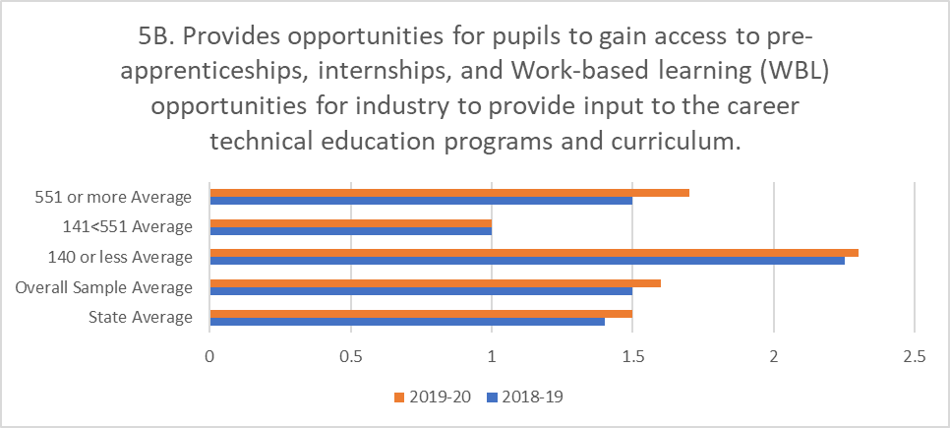
Figure 5B. is a horizontal bar chart that displays how LEAs answered the minimum eligibility requirement question “Provides opportunities for pupils to gain access to pre-apprenticeships, internships, and WBL opportunities for industry to provide input to the CTE programs and curriculum.” Within the display, the average score is provided for 2018–19 and 2019–20 for LEAs who received CTEIG funds. LEAs with 551 or more ADA, scored 1.5 in 2018–19 and 1.7 in 2019–20. LEAs with over 141 and less than 550 ADA, scored 1 in 2018–19 and 1 in 2019–20. LEAs with 140 or less ADA scored 2.3 in 2018–19 and 2.3 in 2019–20. The Overall Sample population of 32 LEAs (10 percent) scored 1.5 in 2018–19 and 1.6 in 2019–20 and the State Average for all participating LEAs was 1.4 in 2018–19 and 1.5 in 2019–20.

Table 5B.
Data Table for Figure 5B.
Question 5B | 2018–19 | 2019–20
State Average | 1.4 | 1.5
Overall Sample Average | 1.5 | 1.6
140 or less Average | 2.3 | 2.3
141<551 Average | 1 | 1
551 or more Average | 1.5 | 1.7

Figure 6.
Provides opportunities for pupils to participate in after school; extended day; out-of-school activities; and competitions.
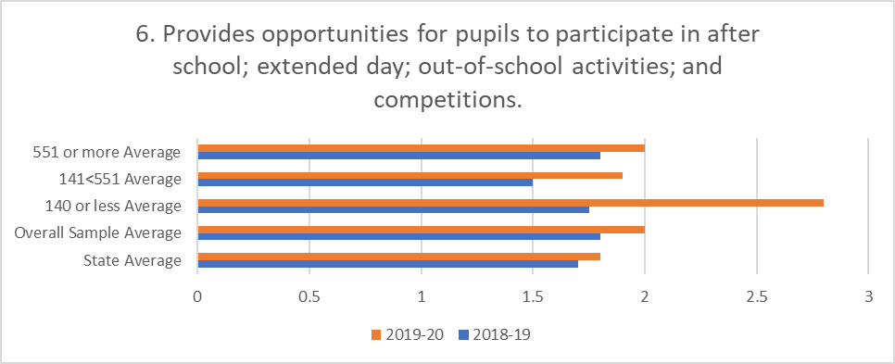
Figure 6. is a horizontal bar chart that displays how LEAs answered the minimum eligibility requirement question “Provides opportunities for pupils to participate in after school; extended day; out-of-school; activities; and competitions.” Within the display, the average score is provided for 2018–19 and 2019–20 for LEAs who received CTEIG funds. LEAs with 551 or more ADA, scored 1.8 in 2018–19 and 2 in 2019–20. LEAs with over 141 and less than 550 ADA, scored 1.5 in 2018–19 and 1.9 in 2019–20. LEAs with 140 or less ADA scored 1.8 in 2018–19 and 2.8 in 2019–20. The Overall Sample population of 32 LEAs (10 percent) scored 1.8 in 2018–19 and 2 in 2019–20 and the State Average for all participating LEAs was 1.7 in 2018–19 and 1.8 in 2019–20.

Table 6.
Data Table for Figure 6.
Question 6 | 2018–19 | 2019–20
State Average | 1.7 | 1.8
Overall Sample Average | 1.8 | 2
140 or less Average | 1.8 | 2.8
141<551 Average | 1.5 | 1.9
551 or more Average | 1.8 | 2

Figure 7A.
CTE pathway program reflects regional and/or local labor market demands and focuses on current or emerging high-skill, high-wage, or high-demand occupations.
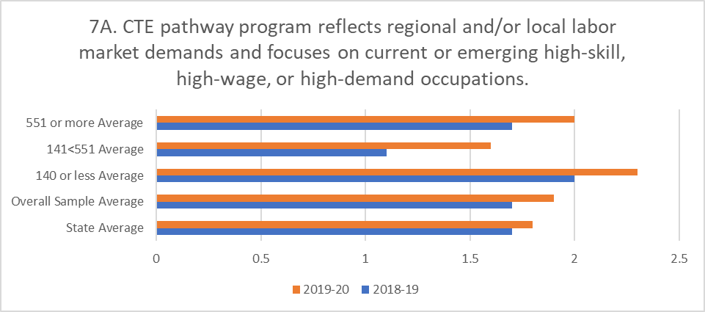
Figure 7A. is a horizontal bar chart that displays how LEAs answered the minimum eligibility requirement question “CTE pathway program reflects regional and/or local labor market demands and focuses on current or emerging high-skill, high-wage, or high-demand occupations.” Within the display, the average score is provided for 2018–19 and 2019–20 for LEAs who received CTEIG funds. LEAs with 551 or more ADA, scored 1.7 in 2018–19 and 2 in 2019–20. LEAs with over 141 and less than 550 ADA, scored 1.1 in 2018–19 and 1.6 in 2019–20. LEAs with 140 or less ADA scored 2 in 2018–19 and 2.3 in 2019–20. The Overall Sample population of 32 LEAs (10 percent) scored 1.7 in 2018–19 and 1.9 in 2019–20 and the State Average for all participating LEAs was 1.7 in 2018–19 and 1.8 in 2019–20.

Table 7A.
Data Table for Figure 7A.
Question 7A | 2018–19 | 2019–20
State Average | 1.7 | 1.8
Overall Sample Average | 1.7 | 1.9
140 or less Average | 2 | 2.3
141<551 Average | 1.1 | 1.6
551 or more Average | 1.7 | 2

Figure 7B.
Is informed by the regional plan of the local Strong Workforce Program (SWP) consortium.
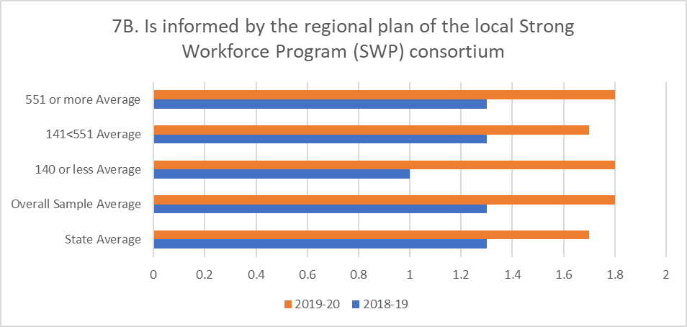

Table 7B.
Data Table for Figure 7B.
Question 7B | 2018–19 | 2019–20
State Average | 1.3 | 1.7
Overall Sample Average | 1.3 | 1.8
140 or less Average | 1 | 1.8
141<551 Average | 1.3 | 1.7
551 or more Average | 1.3 | 1.8
Figure 7B. is a horizontal bar chart that displays how LEAs answered the minimum eligibility requirement question “Is informed by the regional plan for the local SWP consortium.” Within the display, the average score is provided for 2018–19 and 2019–20 for LEAs who received CTEIG funds. LEAs with 551 or more ADA, scored 1.3 in 2018–19 and 1.8 in 2019–20. LEAs with over 141 and less than 550 ADA, scored 1.3 in 2018–19 and 1.7 in 2019–20. LEAs with 140 or less ADA scored 1 in 2018–19 and 1.8 in 2019–20. The Overall Sample population of 32 LEAs (10 percent) scored 1.3 in 2018–19 and 1.8 in 2019–20 and the State Average for all participating LEAs was 1.3 in 2018–19 and 1.7 in 2019–20.

Figure 8.
Leads to an industry recognized credential or certificate, or appropriate postsecondary education or training, employment, or postsecondary degree.
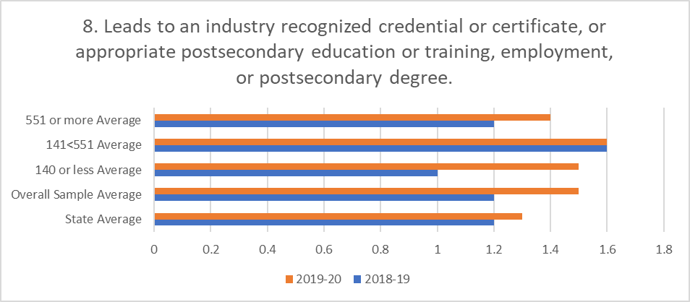
Figure 8. is a horizontal bar chart that displays how LEAs answered the minimum eligibility requirement question “Leads to an industry recognized credential or certificate, or appropriate postsecondary education or training, employment, or postsecondary degree.” Within the display, the average score is provided for 2018–19 and 2019–20 for LEAs who received CTEIG funds. LEAs with 551 or more ADA, scored 1.2 in 2018–19 and 1.4 in 2019–20. LEAs with over 141 and less than 550 ADA, scored 1.6 in 2018–19 and 1.6 in 2019–20. LEAs with 140 or less ADA scored 1 in 2018–19 and 1.5 in 2019–20. The Overall Sample population of 32 LEAs (10 percent) scored 1.2 in 2018–19 and 1.5 in 2019–20 and the State Average for all participating LEAs was 1.2 in 2018–19 and 1.3 in 2019–20.

Table 8.
Data Table for Figure 8.
Question 8 | 2018–19 | 2019–20
State Average | 1.2 | 1.3
Overall Sample Average | 1.2 | 1.5
140 or less Average | 1 | 1.5
141<551 Average | 1.6 | 1.6
551 or more Average | 1.2 | 1.4

Figure 9A.
CTE courses are staffed by skilled teachers or faculty.
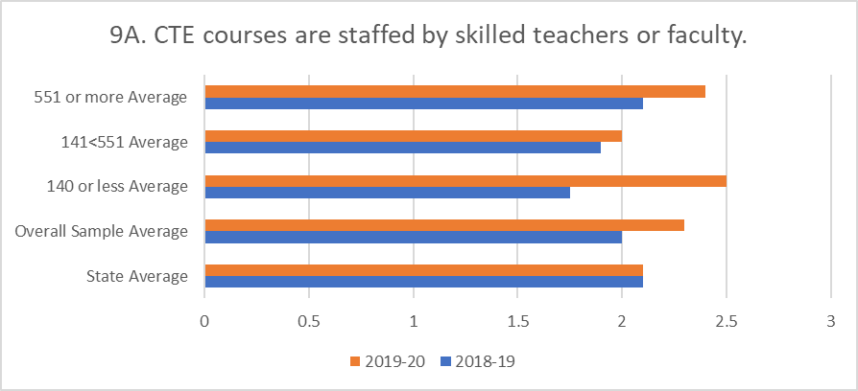
Figure 9A. is a horizontal bar chart that displays how LEAs answered the minimum eligibility requirement question “CTE courses are staffed by skilled teachers or faculty.” Within the display, the average score is provided for 2018–19 and 2019–20 for LEAs who received CTEIG funds. LEAs with 551 or more ADA, scored 2.1 in 2018–19 and 2.4 in 2019–20. LEAs with over 141 and less than 550 ADA, scored 1.9 in 2018–19 and 2 in 2019–20. LEAs with 140 or less ADA scored 1.8 in 2018–19 and 2.5 in 2019–20. The Overall Sample population of 32 LEAs (10 percent) scored 2 in 2018–19 and 2.3 in 2019–20 and the State Average for all participating LEAs was 2.1 in 2018–19 and 2.1 in 2019–20.

Table 9A.
Data Table for Figure 9A.
Question 9A | 2018–19 | 2019–20
State Average | 2.1 | 2.1
Overall Sample Average | 2 | 2.3
140 or less Average | 1.8 | 2.5
141<551 Average | 1.9 | 2
551 or more Average | 2.1 | 2.4

Figure 9B.
Dedicates resources for professional development for CTE pathway teachers, including educator externships with industry.
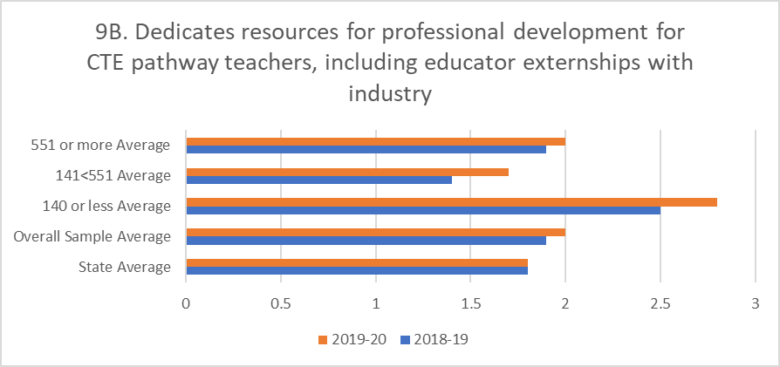
Figure 9B. is a horizontal bar chart that displays how LEAs answered the minimum eligibility requirement question “Dedicates resources for professional development for CTE pathway teachers, including educator externships with industry.” Within the display, the average score is provided for 2018–19 and 2019–20 for LEAs who received CTEIG funds. LEAs with 551 or more ADA, scored 1.9 in 2018–19 and 2 in 2019–20. LEAs with over 141 and less than 550 ADA, scored 1.4 in 2018–19 and 1.7 in 2019–20. LEAs with 140 or less ADA scored 2.5 in 2018–19 and 2.8 in 2019–20. The Overall Sample population of 32 LEAs (10 percent) scored 1.9 in 2018–19 and 2 in 2019–20 and the State Average for all participating LEAs was 1.8 in 2018–19 and 1.8 in 2019–20.

Table 9B.
Data Table for Figure 9B.
Question 9B | 2018–19 | 2019–20
State Average | 1.8 | 1.8
Overall Sample Average | 1.9 | 2
140 or less Average | 2.5 | 2.8
141<551 Average | 1.4 | 1.7
551 or more Average | 1.9 | 2

Figure 10.
Provides opportunities for pupils who are individuals with exceptional needs to participate in all programs.
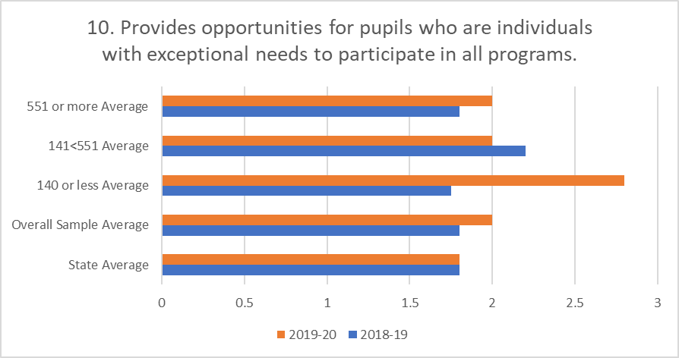
Figure 10. is a horizontal bar chart that displays how LEAs answered the minimum eligibility requirement question “Provides opportunities for pupils who are individuals with exceptional needs to participate in all programs.” Within the display, the average score is provided for 2018–19 and 2019–20 for LEAs who received CTEIG funds. LEAs with 551 or more ADA, scored 1.8 in 2018–19 and 2 in 2019–20. LEAs with over 141 and less than 550 ADA, scored 2.2 in 2018–19 and 2 in 2019–20. LEAs with 140 or less ADA scored 1.7 in 2018–19 and 2.8 in 2019–20. The Overall Sample population of 32 LEAs (10 percent) scored 1.8 in 2018–19 and 2 in 2019–20 and the State Average for all participating LEAs was 1.8 in 2018–19 and 1.8 in 2019–20.

Table 10.
Data Table for Figure 10.
Question 10 | 2018–19 | 2019–20
State Average | 1.8 | 1.8
Overall Sample Average | 1.8 | 2
140 or less Average | 1.7 | 2.8
141<551 Average | 2.2 | 2
551 or more Average | 1.8 | 2

Figure 11.
CTEIG Fiscal Year (FY) 2017–18 Actual Expenditures.
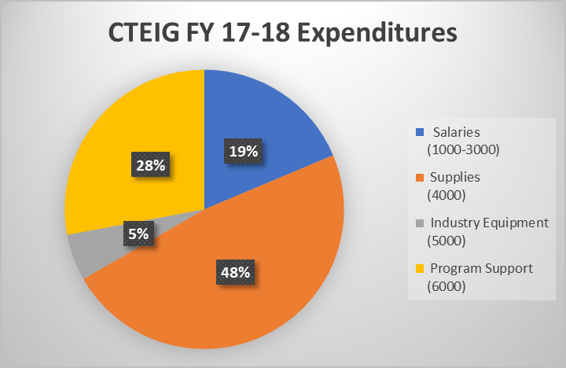
Figure 11. is a pie chart that displays how LEAs who received CTEIG, reported expending their funds during the 2017–18 year. Nineteen percent of funds were spent on salaries in budget object codes 1000–3000. Forty-eight percent of funds were spent on supplies in budget object code 4000. Five percent of funds were spent on industry equipment and twenty eight percent of funds were spent on program support.

Table 11.
Data Table for Figure 11.
Salaries  (1000–3000) | Supplies  (4000) | Industry Equipment  (5000) | Program Support  (6000) | 2017–18 Reported Expenditures  (1000–6000)
$6,555,785.46 | $16,848,132.93 | $1,889,047.99 | $9,803,215.80 | $35,096,182.18
19% | 48% | 5% | 28% | 100%

Figure 12.
CTEIG FY 2018–19 Actual Expenditures.
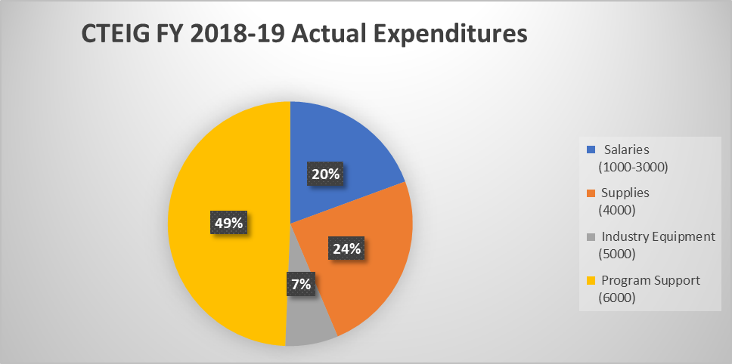
Figure 12. is a pie chart that displays how LEAs who received CTEIG, reported expending their funds during the 2018–19 year. Twenty percent of funds were spent on salaries in budget object codes 1000-3000. Twenty-four percent of funds were spent on supplies in budget object code 4000. Seven percent of funds were spent on industry equipment and forty-nine percent of funds were spent on program support.

Table 12.
Data Table for Figure 12.
Salaries  (1000–3000) | Supplies  (4000) | Industry Equipment  (5000) | Program Support  (6000) | 2018–19 Reported Expenditures  (1000–6000)
$6,064,587.65 | $7,594,250.00 | $2,184,535.00 | $15,437,292.00 | $31,280,664.65
20% | 24% | 7% | 49% | 100%

Figure 13.
2018–19 CTEIG Only Private For-Profit, Private Non-Profit and Public Institution.
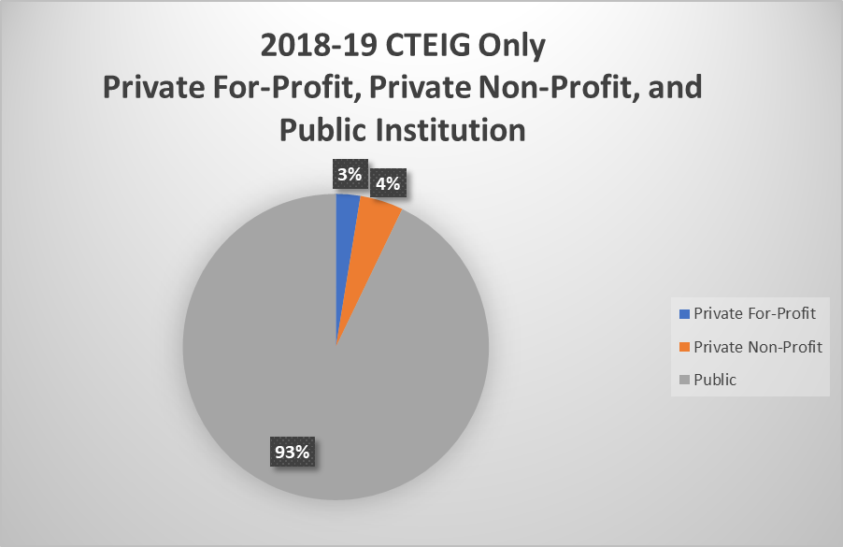
Figure 13 is a pie chart that displays the percentage of 2018–19 CTE completers from CTEIG recipient LEAs who reported attending private for-profit, private non-profit, and public institutions. Three percent of CTE completers reported attending private for-profit institutions, four percent of CTE completers reported attending private non-profit institutions, and ninety-three percent of CTE completers reported attending public institutions.

Table 13.
Data Table for Figure 13.
Private For-Profit | Private Non-Profit | Public | Total
164 | 290 | 5895 | 6349
2.6% | 4.6% | 92.8% | 100.0%

Figure 14.
2018–19 SWP Kindergarten through Grade Twelve (K–12) Only Private For-Profit, Private Non-Profit, or Public Institution.
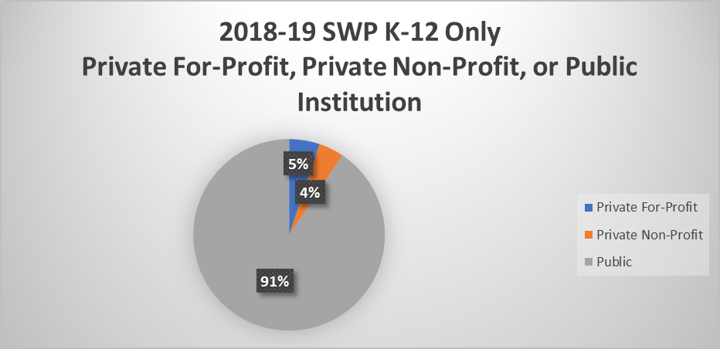
Figure 14 is a pie chart that displays the percentage of 2018–19 CTE completers from K–12 SWP recipient LEAs who reported attending private for-profit, private non-profit, and public institutions. Five percent of CTE completers reported attending private for-profit institutions, four percent of CTE completers reported attending private non-profit institutions, and ninety-one percent of CTE completers reported attending public institutions.

Table 14.
Data Table for Figure 14.
Private For-Profit | Private Non-Profit | Public | Total
79 | 65 | 1388 | 1532
5.2% | 4.2% | 90.6% | 100.0%

Figure 15.
2018–19 CTEIG and K–12 SWP Private For-Profit, Private Non-Profit, and Public Institutions.
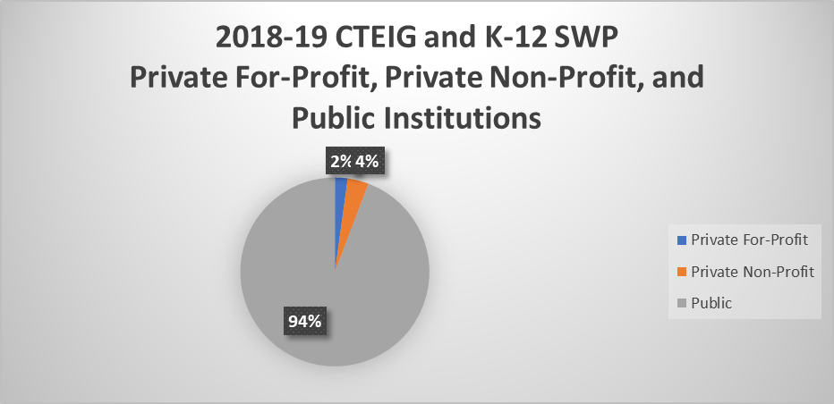
Figure 15 is a pie chart that displays the percentage of CTE completers at LEAs that received both CTEIG and K–12 SWP and who reported attending private for-profit, private non-profit, and public institutions. Two percent of CTE completers reported attending private for-profit institutions, four percent of CTE completers reported attending private non-profit institutions, and ninety-four percent of CTE completers reported attending public institutions.

Table 15.
Data Table for Figure 15.
Private For-Profit | Private Non-Profit | Public | Total
80 | 132 | 3440 | 3652
2.2% | 3.6% | 94.2% | 100.0%

Figure 16.
2018–19 CTEIG Only Industry Sector Employment.
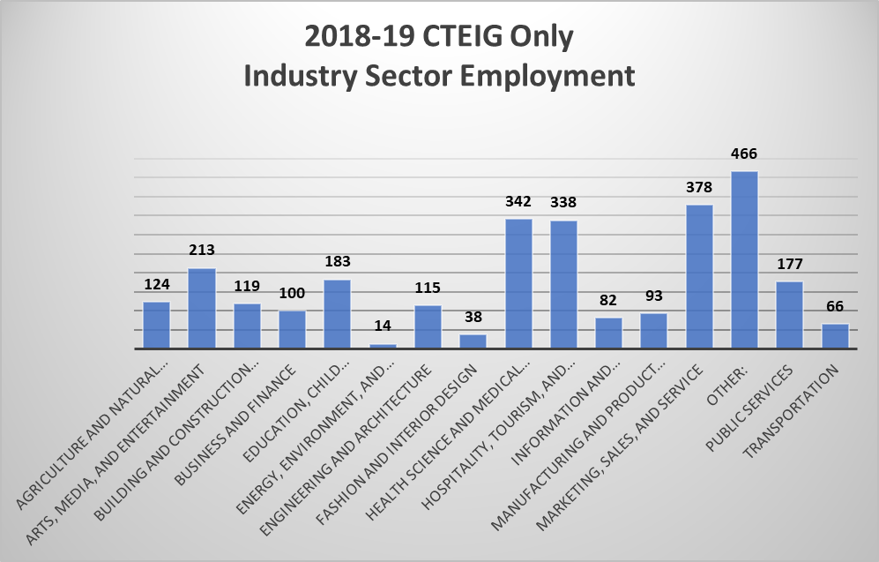
Figure 16 is a bar graph that shows the number of 2018–19 completers from LEAs who received CTEIG funds and who are currently employed in one of the 15 industry sectors including 124 in Agriculture and Natural Resources; 213 in Arts, Media, and Entertainment; 119 in Building and Construction Trades; 100 in Business and Finance; 183 in Education, Child Development, and Family Services; 14 in Energy, Environment, and Utilities; 115 in Engineering and Architecture; 38 in Fashion and Interior Design; 342 in Health Sciences and Medical Technologies; 338 in Hospitality, Tourism, and Recreation; 82 in Information and Communications Technologies; 93 in Manufacturing and Product Development; 378 in Marketing, Sales, and Services; 466 Other; 177 in Public Services; and 66 in Transportation.

Table 16.
Data Table for Figure 16.
Sector | Total
Agriculture and Natural Resources | 124
Arts, Media, and Entertainment | 213
Building and Construction Trades | 119
Business and Finance | 100
Education, Child Development, and Family Services | 183
Energy, Environment, and Utilities | 14
Engineering and Architecture | 115
Fashion and Interior Design | 38
Health Science and Medical Technology | 342
Hospitality, Tourism, and Recreation | 338
Information and Communication Technologies | 82
Manufacturing and Product Development | 93
Marketing, Sales, and Service | 378
Other | 466
Public Services | 177
Transportation | 66

Figure 17.
2018–19 SWP K–12 Only Industry Sector Employment.
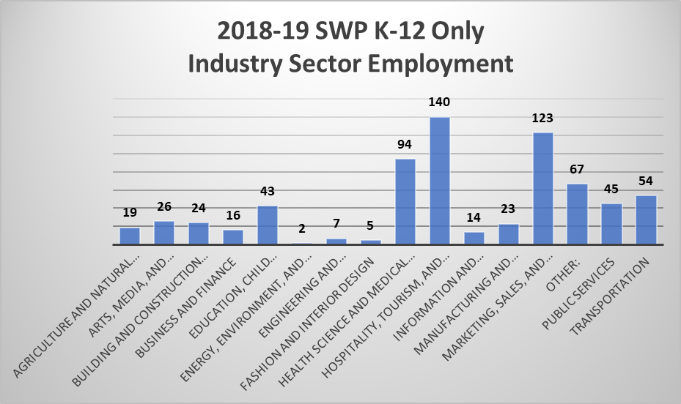
Figure 17 is a bar graph that shows the number of 2018–19 completers from LEAs that received K–12 SWP funds and who are currently employed in one of the 15 industry sectors including 19 in Agriculture and Natural Resources; 26 in Arts, Media, and Entertainment; 24 in Building and Construction Trades; 16 in Business and Finance; 43 in Education, Child Development, and Family Services; 2 in Energy, Environment, and Utilities; 7 in Engineering and Architecture; 5 in Fashion and Interior Design; 94 in Health Sciences and Medical Technologies; 140 in Hospitality, Tourism, and Recreation; 14 in Information and Communications Technologies; 23 in Manufacturing and Product Development; 123 in Marketing, Sales, and Services; 67 Other; 45 in Public Services; and 54 in Transportation.

Table 17.
Data Table for Figure 17.
Sector | Total
Agriculture and Natural Resources | 19
Arts, Media, and Entertainment | 26
Building and Construction Trades | 24
Business and Finance | 16
Education, Child Development, and Family Services | 43
Energy, Environment, and Utilities | 2
Engineering and Architecture | 7
Fashion and Interior Design | 5
Health Science and Medical Technology | 94
Hospitality, Tourism, and Recreation | 140
Information and Communication Technologies | 14
Manufacturing and Product Development | 23
Marketing, Sales, and Service | 123
Other | 67
Public Services | 45
Transportation | 54

Figure 18.
2018–19 CTEIG and K–12 Industry Sector Employment.
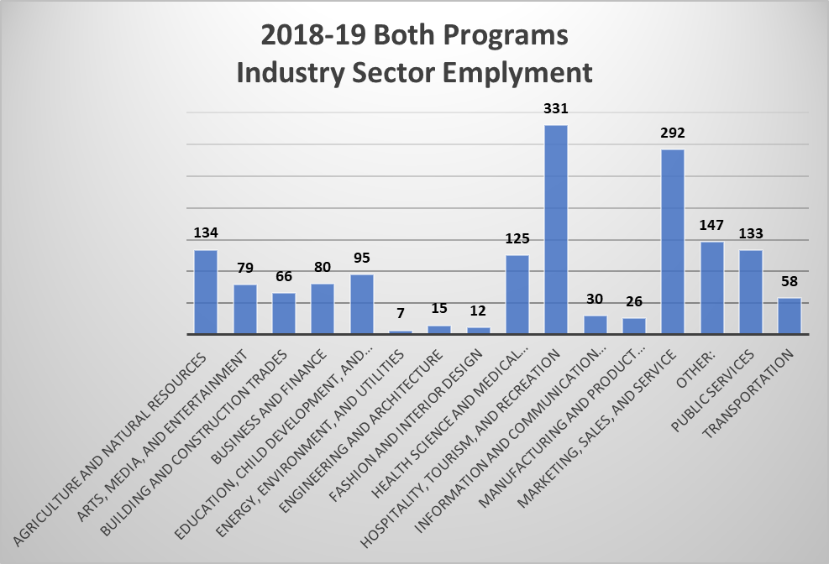
Figure 18. is a bar graph that shows the number of 2018–19 completers from LEAs that received both CTEIG and K–12 SWP funds and who are currently employed in one of the 15 industry sectors including 134 in Agriculture and Natural Resources; 79 in Arts, Media, and Entertainment; 66 in Building and Construction Trades; 80 in Business and Finance; 95 in Education, Child Development, and Family Services; 7 in Energy, Environment, and Utilities; 15 in Engineering and Architecture; 12 in Fashion and Interior Design; 125 in Health Sciences and Medical Technologies; 331 in Hospitality, Tourism, and Recreation; 30 in Information and Communications Technologies; 26 in Manufacturing and Product Development; 292 in Marketing, Sales, and Services; 147 Other; 133 in Public Services; and 58 in Transportation.

Table 18.
Data Table for Figure 18.
Sector | Total
Agriculture and Natural Resources | 134
Arts, Media, and Entertainment | 79
Building and Construction Trades | 66
Business and Finance | 80
Education, Child Development, and Family Services | 95
Energy, Environment, and Utilities | 7
Engineering and Architecture | 15
Fashion and Interior Design | 12
Health Science and Medical Technology | 125
Hospitality, Tourism, and Recreation | 331
Information and Communication Technologies | 30
Manufacturing and Product Development | 26
Marketing, Sales, and Service | 292
Other: | 147
Public Services | 133
Transportation | 58

Figure 19.
2018–19 CTEIG Only Certificate, Credential, License, or Technical Skill Attainment.
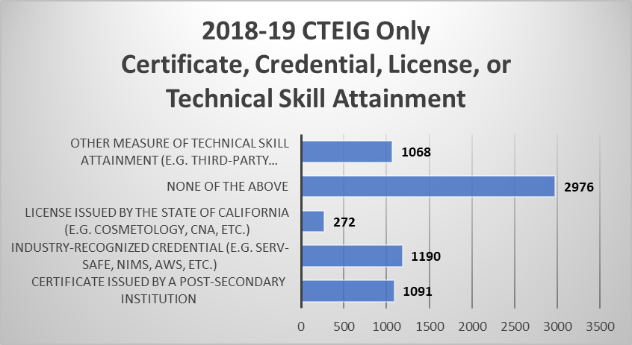
Figure 19. is a horizontal bar chart that shows the number of 2018–19 completers from LEAs that received CTEIG funds and their certificate, credential, license, or technical skill attainment. 1,068 completers obtained another measure of technical skill attainment (example, a third-party assessment); 2,976 obtained none of the above; 272 obtained a license issued by the State of California (example: Cosmetology, CNA, etc.); 1190 obtained an industry-recognized credential (example: ServSave, NIMS, AWS, etc.); and 1091 obtained a certificate issued by a post-secondary institution.

Table 19.
Data Table for Figure 19.
Certificate issued by a post-secondary institution | Industry-recognized credential (e.g. Serv-Safe, NIMS, AWS, etc.) | License issued by the State of California (e.g. Cosmetology, CNA, etc.) | None of the above | Other measure of technical skill attainment (e.g. third-party certification, NOCTI, Certiport, etc.)
1091 | 1190 | 272 | 2976 | 1068

Figure 20.
2018–19 SWP K–12 Only Credential, Certificate, License, or Technical Skill Attainment.
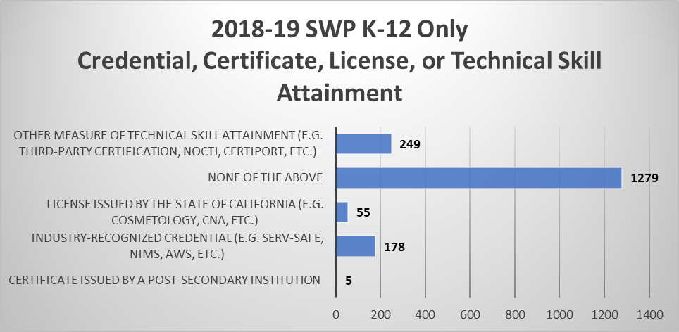
Figure 20. is a horizontal bar chart that shows the number of 2018–19 completers from LEAs that received K–12 SWP funds and their certificate, credential, license, or technical skill attainment. 248 completers obtained another measure of technical skill attainment (example, a third-party assessment); 1,279 obtained none of the above; 55 obtained a license issued by the State of California (example: Cosmetology, CNA, etc.); 178 obtained an industry-recognized credential (example: ServSave, NIMS, AWS, etc.); and 5 obtained a certificate issued by a post-secondary institution.

Table 20.
Data Table for Figure 20.
Certificate issued by a post-secondary institution | Industry-recognized credential (e.g. Serv-Safe, NIMS, AWS, etc.) | License issued by the State of California (e.g. Cosmetology, CNA, etc.) | None of the above | Other measure of technical skill attainment (e.g. third-party certification, NOCTI, Certiport, etc.)
5 | 178 | 55 | 1279 | 249

Figure 21.
2018–19 CTEIG and K–12 SWP Certificate, Credential, License, or Technical Skill Attainment.
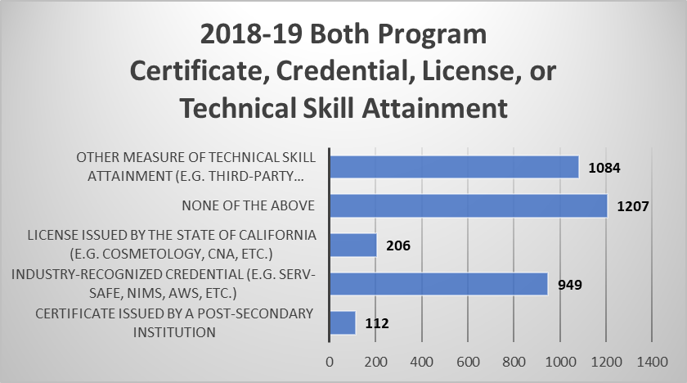
Figure 21. is a horizontal bar chart that shows the number of 2018–19 completers from LEAs that received both CTEIG and K–12 SWP funds and their certificate, credential, license, or technical skill attainment. 1,084 completers obtained another measure of technical skill attainment (example, a third-party assessment); 1,207 obtained none of the above; 206 obtained a license issued by the State of California (example: Cosmetology, CNA, etc.); 949 obtained an industry-recognized credential (example: ServSave, NIMS, AWS, etc.); and 112 obtained a certificate issued by a post-secondary institution.

Table 21.
Data Table for Figure 21.
Certificate issued by a post-secondary institution | Industry-recognized credential (e.g. Serv-Safe, NIMS, AWS, etc.) | License issued by the State of California (e.g. Cosmetology, CNA, etc.) | None of the above | Other measure of technical skill attainment (e.g. third-party certification, NOCTI, Certiport, etc.)
112 | 949 | 206 | 1207 | 1084

