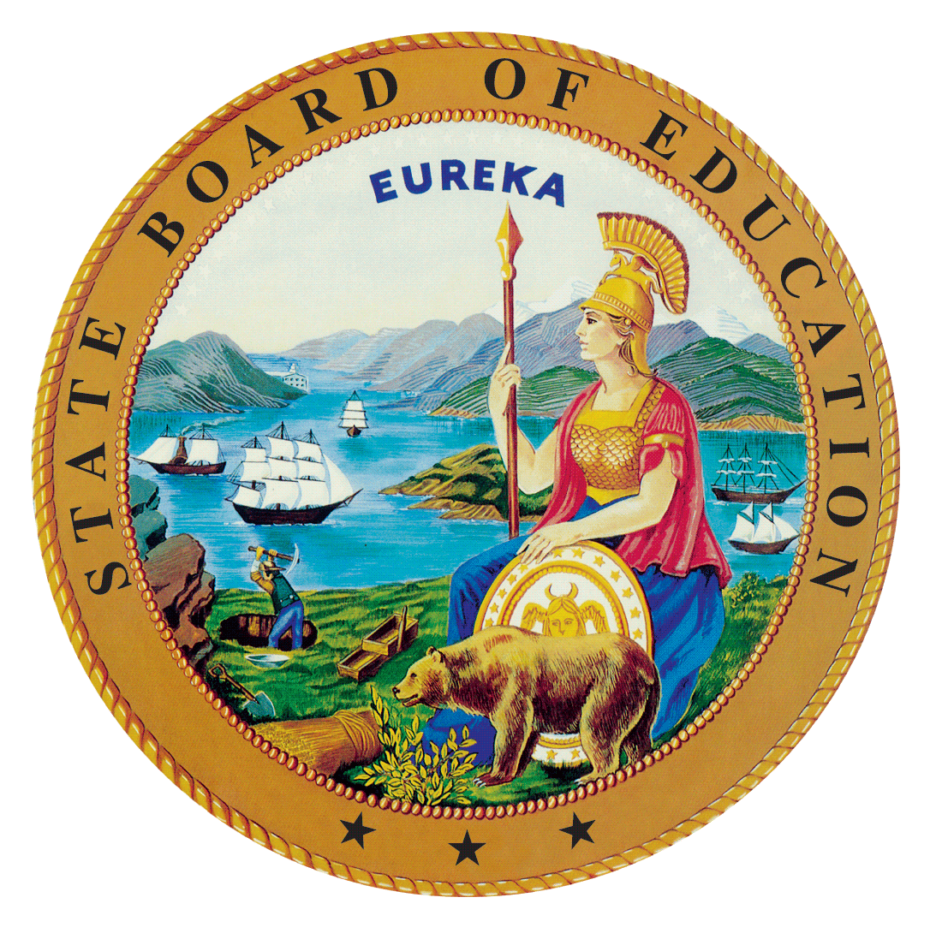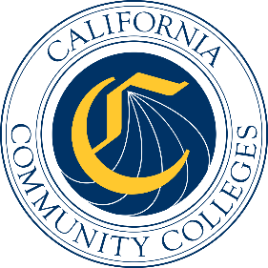

California Workforce Pathways
Joint Advisory Committee
September 25, 2020
Agenda Item 03
Posted by the California Department of Education

Subject
An Update on the California State Plan for Career Technical Education.

Type of Action
Information

Summary of the Issue(s)
The California State Team (CAST), consisting of core leadership of the State Board of Education (SBE), the California Department of Education (CDE), and the California Community Colleges Chancellor’s Office (CCCCO) was formed in October 2019 to oversee the development of the comprehensive California State Plan for Career Technical Education (CTE). At the July 2020 California Workforce Pathways Joint Advisory Committee (CWPJAC) meeting, the CAST presented a recommended approach to create a Strategic Plan/Call to Action in the development of the California State Plan for CTE. This proposed approach includes holding a series of study sessions to gather input from various stakeholders and practitioners.
Since the July 2020 CWPJAC meeting, the CAST considered the following in development of next steps: (a) approach and specific strategic areas of focus; (b) how to gather sources of inspiration for developing the California State Plan for CTE; and (c) creating an outline for the scope of work. Upon advice and guidance from CWPJAC members, a more detailed scope of work will be developed to produce a forward-looking document that becomes California’s Strategic Plan/Call to Action for CTE.

Recommendation
The CDE and the CCCCO staff recommend that the CWPJAC continue to provide feedback and guidance on the development of the California State Plan for CTE.

Brief History of Key Issues

Approach and Areas of Focus
The broad intent of the Strategic Plan/Call to Action approach for the California State Plan for CTE is to provide cohesion and direction to the current state, regional, and local level work through visionary and innovative approaches that are relevant for stakeholders, and particularly for students and employers as the system’s ultimate benefactors. The goal of the Strategic Plan/Call to Action is to lay out the State’s future vision for CTE, both in the short-term (i.e., in five years) and long-term (i.e., in ten years), using creative strategies while preserving intentionality of California’s student-centered approach.
In the immediate term, the Strategic Plan/Call to Action must also address critical needs and effort at improvement during the COVID-19 pandemic and after the pandemic has passed in order to maintain student learning and skills obtainment specifically relating to discussion around the Future of Work and future employability. During this time, career pathway programs have become more critical for helping to stabilize the economy and enable employers to hire workers with skills they need.
In the development of the State Plan for CTE, the scope of work has been organized into four key areas with equity and access being foundational threads throughout:
- Workforce supply that meets demand (industry interactions and partnerships, in-demand skills and clusters, etc.)
- Delivery (competency-based education, CTE online, experiential/work-based learning, apprenticeship, adult education, curriculum, etc.)
- Data that informs the investments (common outcomes, aligned data systems that captures cradle to career, etc.)
- Systems alignment (dual enrollment, teacher prep, teacher credentialing, pathways, etc.)
A remaining question is whether to weave the threads that connect access, equity, diversity, and inclusion throughout these four strategic areas or create a separate, fifth strategic area.

Sources of Inspiration
The CWPJAC’s Guiding Policy Principles to Support Student-Centered K–14+ Pathways and the 12 Essential Elements of a High-Quality College and Career Pathway are foundational to guide a student-centered approach. They feature topics such as online education; competency-based education; credential transparency; and facilitation of education and workforce transitions (from elementary to middle to high school to all segments of postsecondary education and training). Because students come with a diverse set of knowledge, skills, and abilities, the system must be ready to meet them at their level. Exploring these and other topics will set the stage for a forward-looking Strategic Plan/Call to Action that becomes the California State Plan for CTE.
A comprehensive California State Plan for CTE should fall within the larger context of State education and workforce development priorities and initiatives, as exemplified in the work surrounding the Future of Work and its focus on high road employment and training opportunities to create high quality jobs, use a job quality index as a way to intentionally address economic inequities and lift communities up, and build on worker demands. More information on the Future of Work Commission is available at https://www.labor.ca.gov/labor-and-workforce-development-agency/fowc/.
Another important resource are the citations within the Federal Strengthening Career and Technical Education for the 21st Century Act (Perkins V) State Plan, as well as input provided by stakeholders and public comment that are intended to be considered in the development of a California State Plan for CTE. These include:
- Continuing to align Perkins V accountability indicators to current state measures, and data collection methodology.
- Refining the definition of size, scope, and quality to take into account the many variations that exist within kindergarten through grade twelve local educational agencies and community colleges across California.
- Strengthening inter-segmental and inter-sectoral connections.
- Exploring options for teacher and faculty preparation, including considering how industry experience can support and strengthen college and career pathways, in partnership with staff of the California Commission on Teacher Credentialing as the options relate to preparing kindergarten through grade twelve educators.
- Addressing barriers and strategies to increase dual/concurrent enrollment opportunities.
- Considering ways to promote work-based learning within high-quality college and career pathways across diverse communities in California.
Even before the development of the federal Perkins V State Plan, the above list was under discussion for several years within the development of high-quality CTE programming, funded through state and federal funding sources. A goal of the Strategic Plan/Call to Action for CTE is to signal priority areas and efforts to achieve greater alignment and outcomes to the field.

Scope of Work Outline in Developing the California State Plan for CTE
More recent discussion among the CAST centered around the scope of work that needs to be developed in order to complete all the tasks necessary for producing the Strategic Plan/Call to Action. The CAST is seeking guidance from the CWPJAC with regard to a proposed draft scope of work. The draft scope of work includes:
- Revisiting comments made by the CWPJAC members during several reviews of the Federal Perkins V State Plan regarding issues that need further discussion when it came to developing the California State Plan for CTE.
- Reviewing feedback received from stakeholders and the public during the Federal Perkins V State Plan development on specific areas that needed to be clarified when the state pivoted towards developing the California State Plan for CTE.
- Identifying commitments made within the Federal Perkins V State Plan that would be addressed further during the development of the California State Plan for CTE, with the understanding that federal funds are supplementary to state efforts.
- Studying and reporting back information gathered on existing strategic initiatives in California, as well as in other states, in order to propose an aligned approach for delivering and improving CTE in California.
- Planning study session(s) for CWPJAC members on areas of focus that need to be addressed within the Strategic Plan/Call to Action.
- Writing and editing the Strategic Plan/Call to Action for CTE supported by input from the CAST.
Discussion by the CWPJAC on the above scope of work outline should enable the CAST to focus more clearly on the elements and next steps for developing the Strategic Plan/Call to action for CTE in California.

Summary of Previous California Workforce Pathways Joint Advisory Committee Discussion(s) and Action(s)
July 2020: The CAST presented a Strategic Plan/Call to Action approach to completing the California State Plan for CTE as a set of inter-related steps that require reviewing public and non-public documentation, as well as interaction with a wide swathe of stakeholders.

November 2019: The CWPJAC discussed the development of a comprehensive California State Plan for CTE along with an extended timeline beyond the Federal Perkins V State Plan submission to the U.S. Department of Education (ED). The CWPJAC advised staff to continue work on developing the comprehensive California State Plan for CTE.

October 2019: The CWPJAC reviewed, discussed, and provided initial input to a preliminary draft of the California State Plan for CTE. The CWPJAC directed staff to focus on the Federal Perkins V State Plan and present a draft federal application to the CWPJAC at its November 2019 meeting. The CWPJAC also reviewed and discussed an updated draft timeline of completed and future meetings for completing the Federal Perkins V State Plan.

September 2019: The CWPJAC reviewed a preliminary draft of the revisions to California’s State Plan for CTE, as well as an updated draft timeline.

July 2019: The SBE, CCCCO, and CDE staff together updated the draft timeline and planned activities for completing the revisions to California’s State Plan for CTE.

May 2019: The SBE, CCCCO, and CDE staff together introduced a draft timeline and planned activities for revising California’s State Plan for CTE.
March 2008: On March 12, 2008, the SBE unanimously approved the 2008–2012 California State Plan for Career Technical Education, as required by the Perkins IV, which had been previously approved by the Board of Governors on March 3, 2008. The Perkins IV State Plan was subsequently approved by the ED on July 1, 2008.

Fiscal Analysis (as allocated)
Not applicable.

Attachment(s)
None.

