California Workforce Pathways Joint Advisory Committee
cwpjac-sep20item04
Page 1 of 2
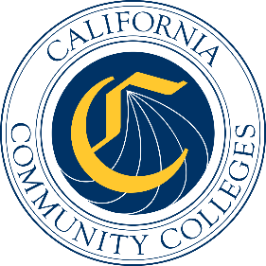

California Workforce Pathways
Joint Advisory Committee
September 25, 2020
Agenda Item 04
Posted by the California Department of Education

Subject
GENERAL PUBLIC COMMENT. Public comment is invited on any matter not included on the printed agenda.
Depending on the number of individuals wishing to address the CWPJAC, the presiding officer may establish specific time limits on presentations.

Type of Action
Information

Summary of the Issue(s)
This is a standing Agenda Item which allows the members of the public to address the CWPJAC on any matter that was not included on the printed September 25, 2020 meeting agenda.

Recommendation
Not applicable.

Brief History of Key Issues
Not applicable.

Summary of Previous California Workforce Pathways Joint Advisory Committee Discussion(s) and Action(s)
Not applicable.

Attachment(s)
None.

