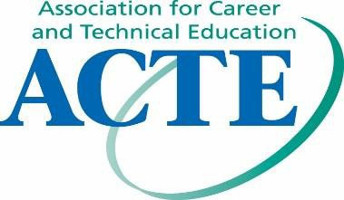
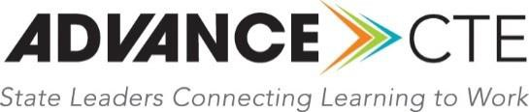

December 18, 2018
Director of the Information Collection Clearance Division
U.S. Department of Education
550 12th Street SW
PCP, Room 9088
Washington, DC 20202-0023
RE: Docket ID ED–2018-ICCD-0108
Dear Tomakie Washington:
On behalf of the Association for Career and Technical Education (ACTE), the nation’s largest not-for- profit association committed to the advancement of education that prepares youth and adults for career success, and Advance CTE, representing the state and territory leaders of our nation’s Career and Technical Education (CTE) system, we write to provide an addendum to our initial response, submitted on December 12, 2018 to the U.S. Department of Education’s request for comments on the Carl D. Perkins Career and Technical Education Act of 2006, as amended by the Strengthening Career and Technical Education for the 21st Century Act (Perkins V) Guide for the Submission of State Plans (Docket ID: ED-2018-ICCD-0108).
Plan Provisions
It has recently come to our attention that the structure of item G “Special Features of State Plan Submission (Check One)” (on page 11 of the PDF of the Draft State Plan Guide), is concerning to our memberships for three reasons:
- It suggests that checking one of the boxes ("WIOA Combined State Plan - Secondary and Postsecondary" or "WIOA Combined State Plan - Postsecondary Only”) is required. We recommend clarifying in table one on page four that this item is not require for states who elect to submit a one-year transition plan.
- This item implies that eligible agencies are required to submit a Combined State Plan. However, this is not the case, per Section 122(b)(2) of Perkins V. Therefore, we recommend including a checkbox for “Perkins V Single Plan.”
- The checkbox for “WIOA Combined State Plan - Postsecondary Only” suggests that a state has the option to submit a Perkins V State Plan for secondary only and a WIOA Combined State Plan for postsecondary only. We recommend removing this option because it is not authorized in statute, nor would it be beneficial to fostering the alignment across secondary and postsecondary that so many state and local leaders are working to foster through supporting high-quality programs of study through Perkins V. It should be clarified that a state cannot have two separate Perkins V state plans for secondary and postsecondary CTE, even if a state chooses to a combined state plan with WIOA. Under WIOA, the combined state plan is required to address both secondary and postsecondary CTE programs, and this is clarified on page 46 of the Required Elements for Submission of the Unified or Combined State Plan and Plan Modifications under the Workforce Innovation and Opportunity Act (OMB Control Number 1205- 0522), which states:
“(2) The State Plan must include information that describes the career and technical education activities to be assisted that are designed to meet or exceed the State adjusted levels of performance, including a description of—
- The career and technical education programs of study, that may be adopted by local educational agencies and postsecondary institutions to be offered as an option to students (and their parents as appropriate) when planning for and completing future coursework, for career and technical content areas that—
- Incorporate secondary education and postsecondary education elements;”
Therefore, to address the second and third concerns listed above regarding item G on page 11, we recommend that it be amended as follows:
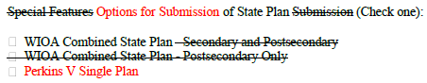
(Refer to the appendix for more information)
We hope the U.S. Department of Education’s Office of Career, Technical, and Adult Education (OCTAE) will consider this suggestion. Please feel free to contact Kathryn Zekus (kzekus@careertech.org), Advance CTE’s Senior Associate, Federal Policy, or Alisha Hyslop (ahyslop@acteonline.org), ACTE’s Director of Public Policy, should you have any questions about this addendum to our comments.
Sincerely,
Kimberly A. Green
Executive Director
Advance CTE
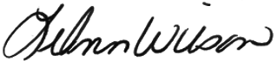
LeAnn Wilson
Executive Director
ACTE

Appendix
Note: This appendix section of this document has been added to provide long description to the amendment item on page 2. This is not part of the original letter sent by the Association for Career Technical Education (AdvanceCTE) to the United States Department of Education, dated December 18, 2018.
The following is the long description of the recommended amendment to Item G, Special Features of State Plan Submission. This is for comparison only and not intended as a fillable form.

Original/Current
Special Features of State Plan Submission (Check one):
- WIOA Combined State Plan - Secondary and Postsecondary
- WIOA Combined State Plan - Postsecondary Only

Proposed Amendment
Options for Submission of State Plan (Check one):
- WIOA Combined State Plan
- Perkins V Single Plan

