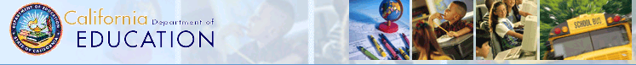

PERKINS DATA SYSTEM
General Information and Instructions
CDE 101 E-2

Prepared by:

Career and College Transition Division
California Department of Education (CDE)
January 2012
CONTENTS

Program Instructions 3
General Instructions 3

Reporting Requirements and Responsibilities 4

Definitions of CTE Terms 5
Student Definitions 5
Race and Ethnicity Definitions 7
Special Populations Definitions 8

Logging onto the System 10
Reporting Deadlines and System Options 11
Selecting CBEDS codes 12
Preloaded E-1 Data 13

Entering E-2 Data 14
Race and Ethnicity Data 14
Special Populations Data 15
Data Entry Values 16
Data Entry Examples 19
To Report Data for Special Populations 20
Saving Data 21
Upload Process 22
Final Data Submission 25

Reports 27

System Updates 29
Changing Passwords 29
Contact Information 30
Forgot Password …………… 32
Technical Setup 33
REPORT ON CAREER TECHNICAL EDUCATION (CTE) PLACEMENT

CDE 101 E-2

PROGRAM INSTRUCTIONS

The Report on CTE Placement, CDE 101 E-2, is designed to collect the student placement information mandated by the Carl D. Perkins Career and Technical Education Improvement Act of 2006 (Perkins IV) and Section 12053 of the California Education Code. Each local educational agency (LEA) participating in the Perkins IV funds is required to submit this annual report. LEAs participating in Section 131 and 132 consortia must submit individual reports. Regional Occupational Centers and Programs (ROCPs) must submit the report whether or not they are participating in the Perkins IV funds.

General Instructions

The CDE 101 E-2 data is submitted annually through the Perkins Data System. We are no longer using an electronic personal identification number (PIN). All Perkins IV participants were required to complete the registration when submitting the CDE 101 E-1 data. A unique username and password was created which can be retrieved by entering the e-mail that was provided when completing the “Contact Information.” You can obtain this password by selecting the “Forgot Password” option on the Logon page of the CDE 101 E-2 data system. Please see additional instructions on pages 25 - 30 for System Update Options. The Web-based program can be found on the California Department of Education (CDE) Perkins web page at http://www.cde.ca.gov/ci/ct/pk/.

Questions or Comments

Please submit your questions or comments to perkins@cde.ca.gov.

Reporting Requirements and Responsibilities

Data for the CDE 101 E-2 Report must be entered into the Perkins Data System by March 15. Agencies receiving Perkins funding and ROCPs must furnish placement information on students reported on the CDE 101 E-1 Report. Extensions will not be granted for the submission of accountability data. LEAs reporting zero twelfth grade concentrators on the CDE 101 E-1 will not be required to submit E-2 placement data.

NOTE: Agencies survey the students six months after graduation to collect post-graduation placement information and report these findings on the CDE 101 E-2 Data System. Districts and ROCPs should coordinate these efforts to avoid duplication of efforts and prevent surveying the students twice.

Enrollment Period: Report unduplicated race and ethnicity data on students enrolled in, or completing, CTE approved courses during the program year.

Unified and Union School Districts: Report only on secondary students completing CTE courses funded by the school district and CTE students enrolled in ROCP courses.

Adult Education: Report only on adults completing capstone CTE courses funded through Adult Education.

ROCPs: Report both on secondary and adult students completing CTE courses funded through the ROCP. ROCPs must provide separate reports for secondary and adult enrollments. (Please refer to paragraph below for explanation.)

County Offices (including Court and Community Schools): Report only on secondary students completing CTE courses in court and community schools administered by County Offices of Education.

Separate CDE 101 E-1 or E-2 Data Entry for Secondary and Adult Students: The United States Department of Education (ED) requires the CDE to identify and report secondary and adult ethnicity and special population data. To meet this requirement, ROCPs should report data on both the secondary and adult data. Union high school districts, unified school districts and county offices should report data on the secondary web page of the Perkins Data System, and Adult Education agencies should report data on the Adult web page of the Perkins Data System.

Definitions of CTE Terms

For reporting purposes, the CDE has developed the following definitions to describe students participating in CTE. Please apply these definitions when completing the forms:

CTE Program: Perkins IV defines a threshold level of vocational education as “a sequence of courses (which may include technical learning experiences) that provides individuals with the challenging academic and technical knowledge and skills the individuals need to prepare for further education and for careers in emerging and established professions and may lead to technical skill proficiency, a credential, a certificate, or a degree.” (sec. 3. [5])
Requirements of Sequences of Courses for CTE Programs assisted with Perkins IV funds 1) consist of not less than two full-year CTE courses with a combined duration of not less than 300 hours; 2) or a single, multiple-hour course which provides sequential units of instruction and has a duration of not less than 300 hours; 3) be coherent, meaning that the sequence may only include those CTE courses with objectives, and content that have a clear, and direct relationship to the occupation(s) or career targeted by the program; 4) include sufficient introductory and concentration CTE courses to provide students with the instruction necessary to develop the skill and knowledge levels required for employment and postsecondary education or training. (State Plan page 226.)

The number and duration of courses in the sequence of courses developed for each CTE program should be determined from the type and length of the instruction needed to provide students with the competencies (skills and understandings) required for career success and/or advanced education, or training for a specific industry. As a consequence, program sequences may vary in length. Though most are two to four semesters, or years, some may only be one year in duration. A number of ROCP and Adult Education CTE courses are single-year programs.

Student Definitions

A. Secondary Level

Participant: A secondary CTE participant is a student who has been enrolled in any CTE course.

Example: Any student who has been enrolled in a CTE course should be counted as a CTE Participant including all concentrators.

Concentrators: A secondary CTE concentrator is a student who has completed 50 percent of a planned program sequence (in hours or credits) in a state-recognized CTE sequence and is enrolled in the next course in that sequence, or has completed 50 percent of a single state-recognized multi-hour course and is enrolled in the second half of that course.

Example: In a sequence comprised of two or three courses, only students enrolled in the last course would be counted as concentrators. In a four course sequence, students enrolled in the third and fourth courses would be counted as concentrators. All concentrators would also be counted as participants.

Capstone Course: The last course in a planned sequence of CTE courses necessary for employment in an identified occupation. A student who completes this course may exit the program for employment or continue enrollment in the program to prepare for higher level employment or advanced education in the same career path.

B. Adult Level (Adult Schools and ROCPs)

Participant: An adult CTE participant is a student who has completed at least 20 hours of instruction in a CTE course that is at least 20 hours or more in duration.

Concentrator: An adult CTE concentrator is a student who has completed 50 percent of a planned program sequence (in hours or credits) in a state-recognized CTE sequence and is enrolled in the next course in that sequence, or has completed 50 percent of a single state-recognized multi-hour course and is enrolled in the second half of that course.

Capstone Course: Same as Secondary above

Tech Prep: Perkins IV, Title II, Section 203(c) defines “TECH PREP” as a program of study that (A) combines a minimum of two years of secondary education with a minimum of two years of post-secondary education in a non-duplicative sequential course of study; (B) integrates academic and CTE and utilizes work-based and work-site learning where appropriate and available; (C) provides technical preparation in a career field, including high skill, high wage, or high demand occupations; (D) builds student competence in technical skills and core academic subjects such as mathematics, science, reading, writing, communications, and workplace skills through applied, contextual academics, and integrated instruction in a sequence of courses; (E) leads to technical skill proficiency, an industry-recognized credential, a certificate, or a degree in a specific career; (F) leads to placement in appropriate employment or to further education; and (G) utilizes CTE programs of study to the extent practicable.

RACE AND ETHNICITY DEFINITIONS
The following categories and definitions are based on the October 30, 1997, “Revisions to the Standards for the Classification of Federal Data on Race and Ethnicity (Statistical Policy Directive No. 15)” issued by the Office of Management and Budget and can be found on their website at https://www.whitehouse.gov/omb/fedreg_1997standards. (Outside Source)
Race:

Hispanic or Latino: A person of Cuban, Mexican, Puerto Rican, South or Central American, or other Spanish culture or origin, regardless of race. The term, "Spanish origin," can be used in addition to "Hispanic or Latino."

Ethnicity:

American Indian or Alaskan Native: A person having origins in any of the original peoples of North and South America (including Central America), and who maintains cultural tribal affiliation or community attachment.

Asian: A person having origins in any of the original peoples of the Far East, Southeast Asia, or the Indian subcontinent, including, for example, Cambodia, China, India, Japan, Korea, Malaysia, Pakistan, the Philippine Islands, Thailand, and Vietnam.

Black or African American: A person having origins in any of the black racial groups of Africa. Terms such as "Haitian" or "Negro" can be used in addition to "Black or African American."

Native Hawaiian or Other Pacific Islander: A person having origins in any of the original peoples of Hawaii, Guam, Samoa, or other Pacific Islands." (The term "Native Hawaiian" does not include individuals who are native to the State of Hawaii by virtue of being born there.) In addition to Native Hawaiians, Guamanians, and Samoans, this category would include the following Pacific Islander groups reported in the 1990 census: Carolinian, Fijian, Kosraean, Melanesian, Micronesian, Northern Mariana Islander, Palauan, Papua New Guinean, Ponapean (Pohnpelan), Polynesian, Solomon Islander, Tahitian, Tarawa Islander, Tokelauan, Tongan, Trukese (Chuukese), and Yapese.

White: A person having origins in any of the original peoples of Europe, the Middle East, or North Africa.

Two or More Races: A person belonging to two or more racial groups.

Race and/or Ethnicity Unknown (Post-Secondary Only)

SPECIAL POPULATIONS DEFINITIONS

Economically disadvantaged: individuals from economically disadvantaged families, including foster children. (Sec. [3][29])This includes Board of Governor’s Grant, Pell Grant, Temporary Assistance for Needy Families, Workforce Investment Act, Supplemental Security Income, General/Public Assistance, Bureau of Indian Affairs, and other persons with income below the poverty level as defined by the 2008-2009 Income Eligibility Guidelines for Free and Reduced-Price Meals.

Individual with a disability: an individual with any disability (as defined in section 3 of the Americans with Disabilities Act of 1990 [Vol. 42 U.S.C. 12102] [Sec. 3(17)] and Individuals with Disabilities Education Act “97”)

Single parents: The term "single parents" includes single pregnant women. (Sec. [3][29])

Displaced homemaker: The term “displaced homemaker” means an individual who:
- (i) has worked primarily without remuneration to care for a home and family and for that reason has diminished marketable skills;
(ii) has been dependent on the income of another family member but is no longer supported by that income; or

(iii) is a parent whose youngest dependent child will become ineligible to receive assistance under part A of title IV of the Social Security Act (42 U.S.C. 601 et seq.) not later than two years after the date on which the parent applies for assistance under this title; and

- is unemployed or underemployed and is experiencing difficulty in obtaining or upgrading employment. (Sec. [3][10])

Note: By definition secondary students would not be counted as a Displaced homemaker.

Individual with limited English proficiency: a secondary school student, an adult, or an out-of-school youth, who has limited ability in speaking, reading, writing, or understanding the English language, and (A) whose native language is a language other than English; or (B) who lives in a family or community environment in which a language other than English is the dominant language. (Sec. [3][16])

Migrant: a person who needs to change from one residence to another residence in order to obtain seasonal employment, due to economic necessity. (34 Code of Federal Regulations (CFR) Part 200 - Federal Register/ Vol. 73, No. 146/ July 29, 2008/ Rules and Regulations)

Local Agency Performance-Level Targets: The State’s 2009-10 performance targets for the core indicators are based upon the statewide performance levels achieved during the 2007-08 program year. Subsequent year performance-level targets will be negotiated annually with the ED. The performance rates for these core indicators will be calculated by dividing the total number of CTE students scoring at or above proficient level by the total number of CTE students tested. (See tables on pages 54 – 62 [State Plan 313].)

Logging on to the system

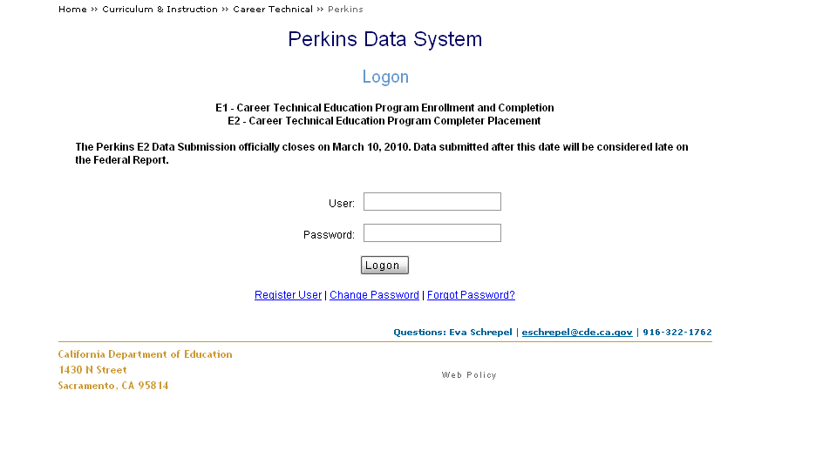

The Perkins Data System home page is located on the CDE Perkins web site at http://www2.cde.ca.gov/Perkins/logon.aspx

The homepage displays the system Logon where you must enter the User and Password created previously.

Click on the Change Password or Forgot Password to reset or retrieve your password information. (See pages 29 – 34 for instructions on System updates.)

Perkins Data System Users: Only one password and e-mail entry was allowed per agency and report type (i.e., secondary, adult, and ROCP) upon completion of the registration. This information was to be retained for future access to the database. Passwords are now created by the user and are not being issued by the CDE. Only those who have not completed the registration should be contacting CDE staff for assistance with the registration.

Reporting Deadlines and System Options



The Due Date identified on the Perkins Data System home page is the final reporting deadline: March 15.

This is the data that will be submitted to meet federal Perkins reporting requirements.

System Options have been added to provide the agencies with both E-1 and E-2 reports.

Data reported on the E-1 reports that is relevant to the E-2 reporting requirements has been pre-populated into the E-2 data system to assist the agencies and remain consistent with the previously reported data. The data system will allow you to view both E-1 and E-2 reports. E-1 data is currently available on a “Read Only” basis.
New Feature Update

LEAs now have the choice of two methods for completing the E-1:
- Electronic Upload, follow the instructions starting on page 30.
- Enter data directly, follow the instructions on this document.

3

Selecting California Basic Educational Data System (CBEDS) Course Codes
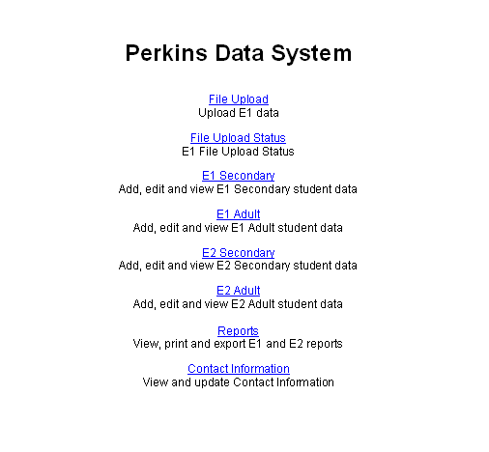

You will now have a list of the menu selections available for the agency.

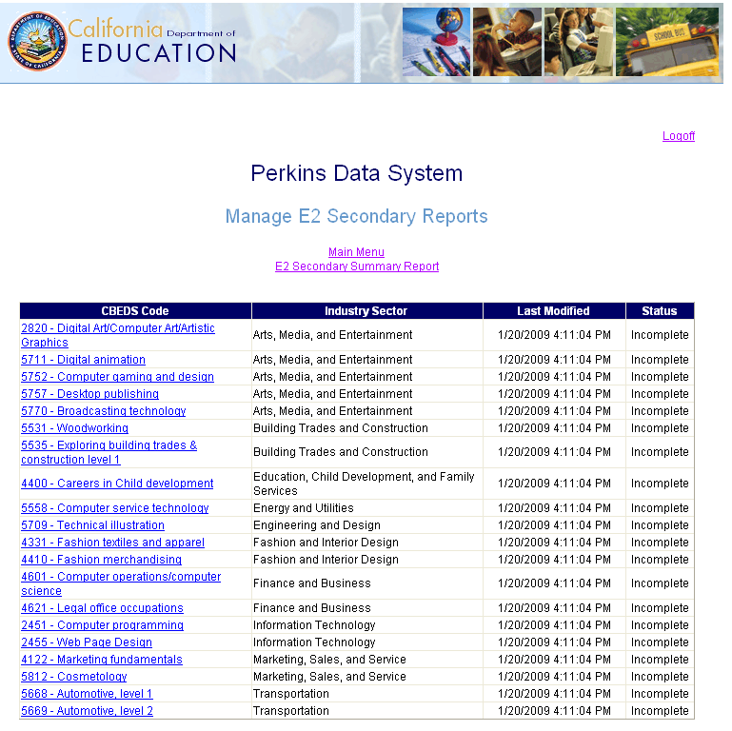

Click on E2 Secondary or E2 Adult to access a list of courses to report.

Click on the CBEDS code that you are completing the E-2 reports for.

NOTE: The E-2 report will only show those CBEDS codes with concentrators.

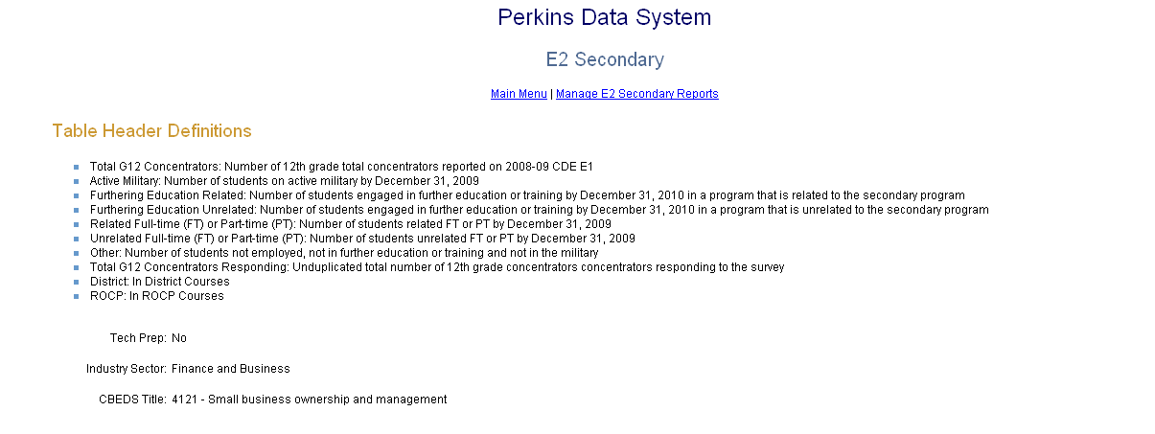
Preloaded E-1 Data

The CDE 101 E-2 is preloaded with the CBEDS Codes and twelfth grade concentrator data reported on the CDE 101 E-1. For Adult Education reporting the Adult Concentrators in a Capstone Course will be pre-loaded in each CBEDS Code.

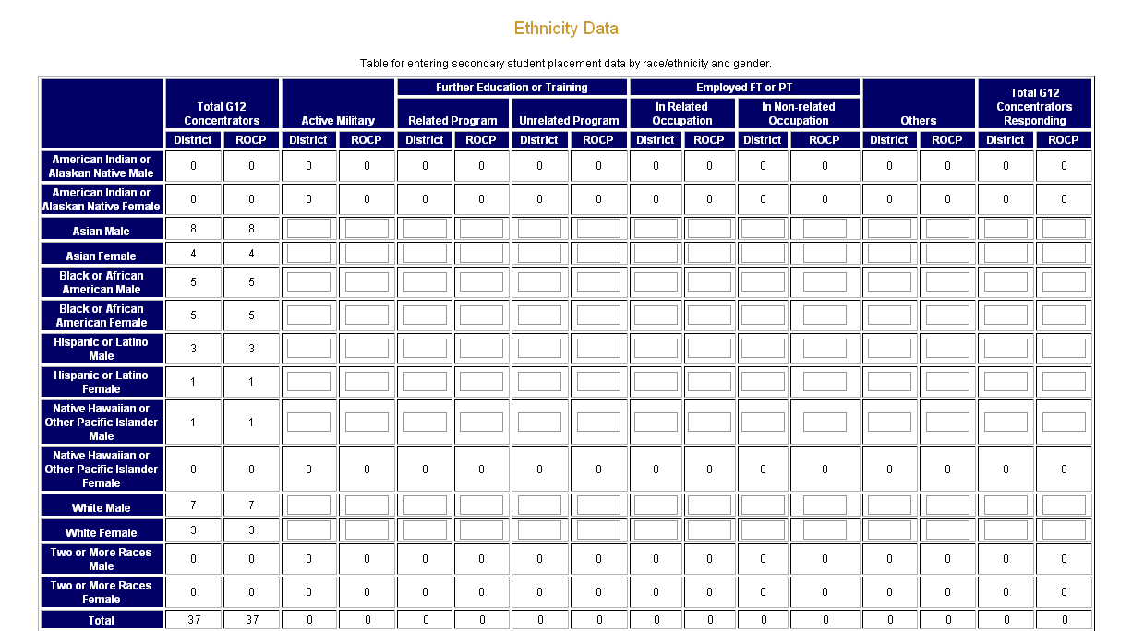

Complete only areas that have an empty data box.

After completing the form click the Next key to continue entering the Special Populations data.

The data being reported should reflect the information obtained from the follow-up survey sent to students that were reported in the CDE 101 E-1 report.

ENTERING E-2 DATA

Race and Ethnicity Data

Note: The Secondary Reports have two columns in every category requesting District and ROCP data. The E-1 report collected secondary data for students enrolled in courses in the District or enrolled in ROCP courses. The District column represents the students enrolled in District CTE courses. The ROCP column represents the number of District students enrolled in ROCP courses. While ROCPs will continue to report students enrolled in ROCP courses, we are utilizing this data to help the District account for their total number of twelfth grade concentrators.

Concentrators - Total number of unduplicated twelfth grade concentrators/adult concentrators in capstone reported on the CDE 101 E-1 for each Race/Ethnicity and Gender.

Active Military - The total reported number of students on active military duty by December 31st of the program year.

Further Education or Training - The total reported number of students engaged in further education or training by December 31 of the program year. This section is divided into two categories: Related Program reflects those students enrolled in education or training related to the CTE program in which the student was enrolled. Non-related Program reflects those students enrolled in education or training not related to the CTE program for.

Employed FT or PT – Is full-time (FT) or part-time (PT) employment data. This section is divided into two categories: Related Occupation reflects those students employed in an occupation related to the CTE program in which the student was enrolled. Non-related occupation reflects those students employed in an occupation not related to the CTE program.

Others – The total number of students not employed, not in further education, or training, and not in the military.

Total Concentrators Responding – The total unduplicated number of concentrators who responded to the survey.
Secondary Special Populations Data

Under Section 113 of Perkins IV the Special Population categories are required data breakout elements.
Data is based on total twelfth grade concentrators/adult concentrators in Capstone course reported on the CDE 101 E-1.

The special population categories are:
Total economically disadvantaged by gender
Total disabled by gender
Total single parent by gender
Total displaced homemaker (on Adult School Report only) by gender
Total limited English proficient by gender
Total migrant by gender

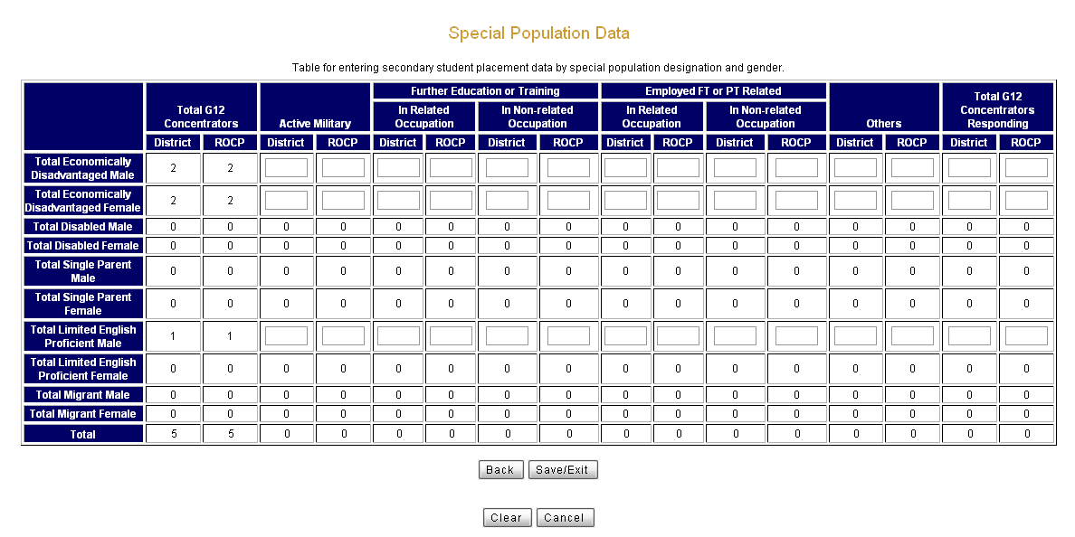

Complete only areas that have an empty data box.

After completing the form click the Save/Exit to complete the data submission for this CBEDS code.

Data can be reviewed and if information appears incorrect there are two options to correct this:
1) Select the Back to return to the Ethnicity Data or 2) select Clear to remove all data that was entered on this page only.

Data Entry Values

Each Special Population category contains data as submitted by the reporting agency on the CDE 101 E-1 report. The data preloaded in the Total Concentrators was obtained from the E-1 report and cannot be changed. The empty boxes in each column are fields that require a numeric value. The Total Concentrators Responding value is based on the feedback being submitted into the empty boxes on this report. Errors will appear if the correct values are not properly calculated. The following rules apply to each of the categories:

“Total Concentrators Responding” cannot be greater than “Total Concentrators.”
Example: The last column (outlined in the red box) cannot be greater than the first column (outlined in the black box) for each race/ethnicity and gender and Special Population Data.

Data Entry Values (Continued)
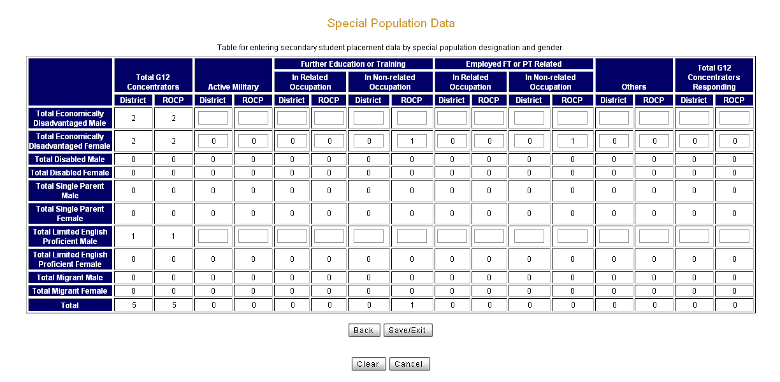

Sample of data that would result in an error.

The Total Concentrators Responding column (outlined in the red box) must have a value greater than or equal to the single highest value of the “Status” column on any race/ethnicity and gender row (outlined in the black box).

If a value of one were entered into Further Education or Training in Non-related Occupation and Employed In Non-related Occupation and a value of zero were entered into the Total Concentrators Responding in the row Total Economically Disadvantaged Female the results would yield an error message because the value of zero is less than the highest value entered in any of the other columns noted above. The value of the Total Concentrators Responding would need to be one or two which would correlate to the entries made in the “Status” columns. One could represent that the entry was duplicated and was data reported on the same individual. Two could represent two different individuals responding with their feedback falling into separate columns.

Data Entry Values (Continued)
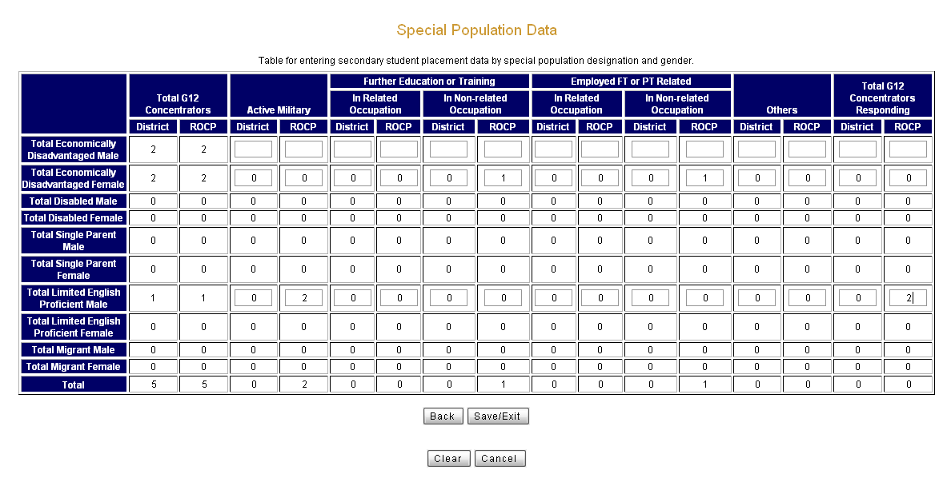

Sample of data that would result in an error.

The “status” columns cannot have a number greater than the sum of the values given in the Total G12 Concentrators.

An entry of two in the Active Military male column in the Total Limited English Proficient Male row would result in an error because that number is greater than the one reported in the Total G12 Concentrators.

Data Entry Examples

Question: How do I enter data for duplicated enrollment? Good question! Let’s examine the options in the example below:

Four students completed a CTE program in the school year and were reported in the CDE 101 E-1 report. These students were reported in the race/ethnicity category as Asain Female. A follow-up survey was sent out but only two of the four students responded. One of the students was on active military status as of December 31, both of the students were continuing their education at the local community college, one of the students reported being employed part-time, but only one in her field of study.

See red box for reporting this data for Race/Ethnicity:
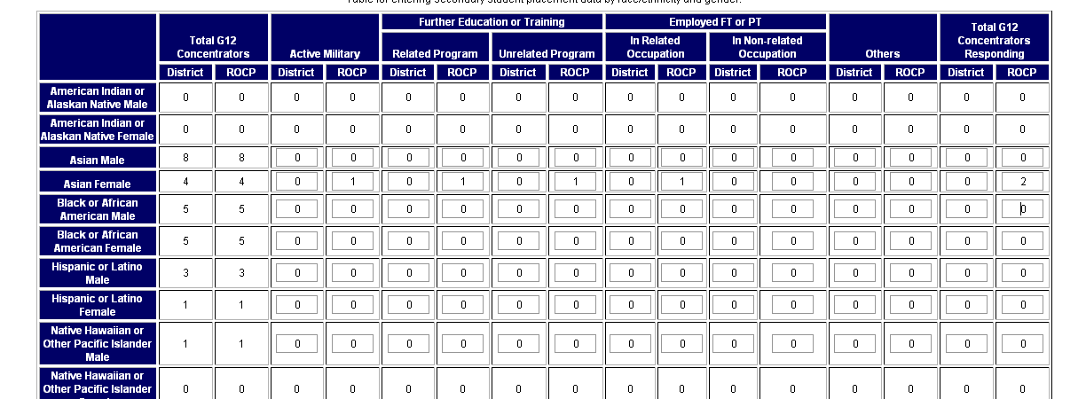

NOTE: The Perkins Data System automatically transfers Total G12 Concentrators reported on the CDE 101 E-1 report into the CDE 101 E-2. Data cannot be revised.
To Report Data for Special Populations:

In the example four students completed a CTE program in the school year and were reported in the CDE 101 E-1 report. These students were reported in the race/ethnicity category as Black or African American Female. A follow-up survey was sent out but only two of the four students responded. One of the students was on active military status as of December 31st, one was continuing their education at the local community college, both of the students reported being employed part-time, but only one in her field of study.

Two of the four students in this example was reported in the Totally Economically Disadvantaged Female row in the CDE 101 E-1. Once again the Perkins Data System automatically transfers Concentrators reported at E-1.

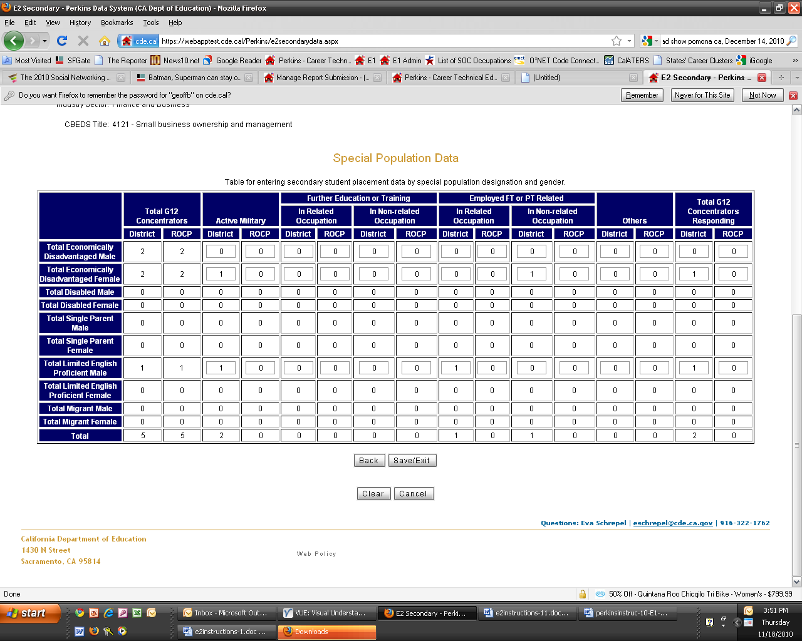
The survey indicated that one of the male Limited English Proficient students was on Active Military status and working part-time in a related occupation.

Saving Data

The Total row automatically totals each column
To return to the Ethnicity Data Table click on the Back key.

To cancel and clear the data submitted on this page only click the Clear key.

To save and submit all the data that has been entered for this CBEDS code click on the Submit key. You will return to the Manage E-2 Secondary Reports page with the list of reported CBEDS codes, where you will see “Complete” on the Status column.
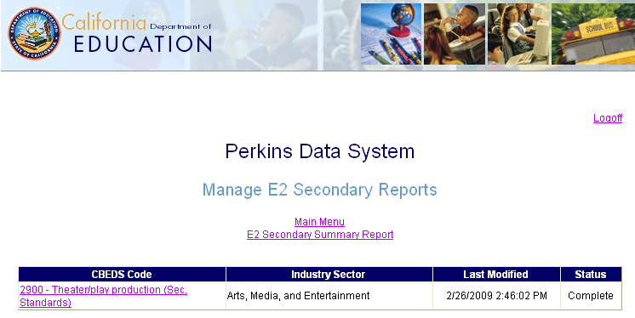

Upload Process

LEAs can now create a tab delimited text file that can be directly uploaded to the Perkins Data System. File specifications can be found at the CDE Perkins Web page at http://www.cde.ca.gov/ci/ct/pk/. Once the file is created follow the instructions below to upload the file.

1. Choose File Upload.
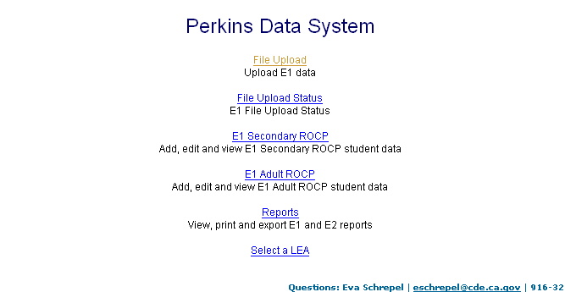

2. Select Adult or Secondary for LEA type.
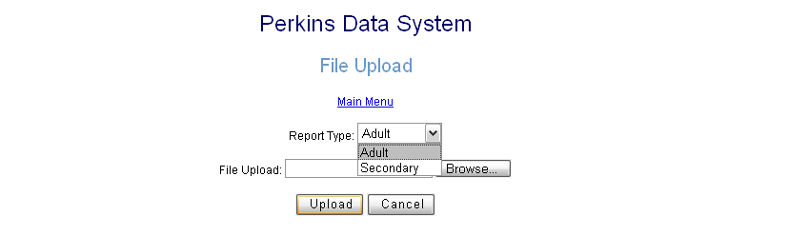

3. Browse to find the file created for upload.
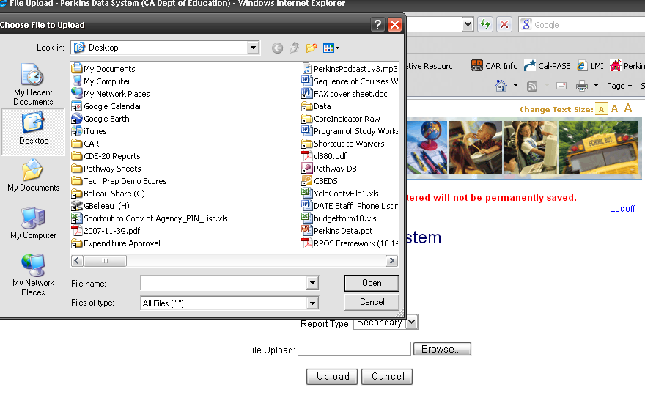

4. Upload text file.
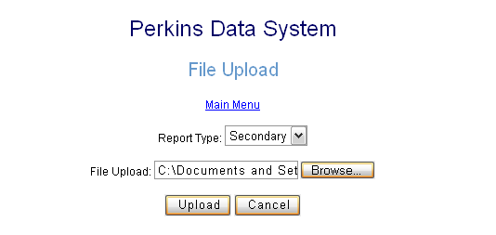

5. Check back the following day to see the file upload status.
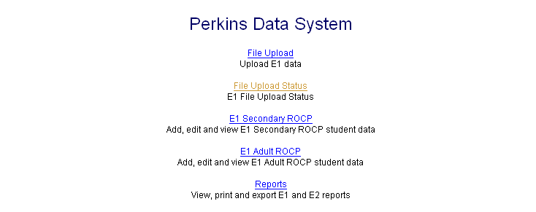

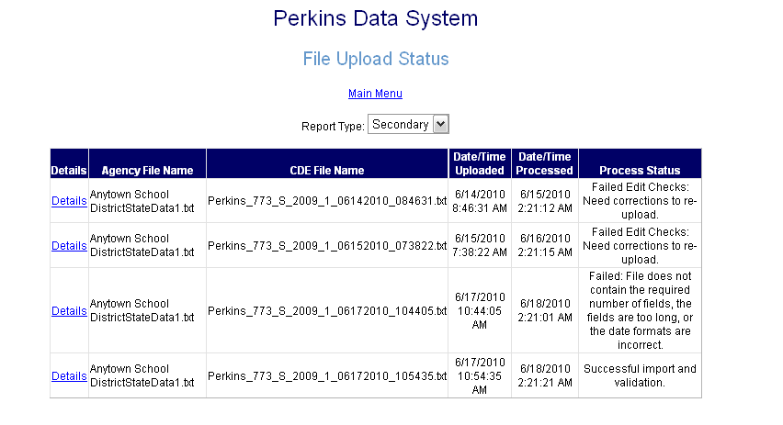
6. The following day the status will be available. If the file was unsuccessful, details will show the error status. Once a successful import was complete the data can be reviewed.

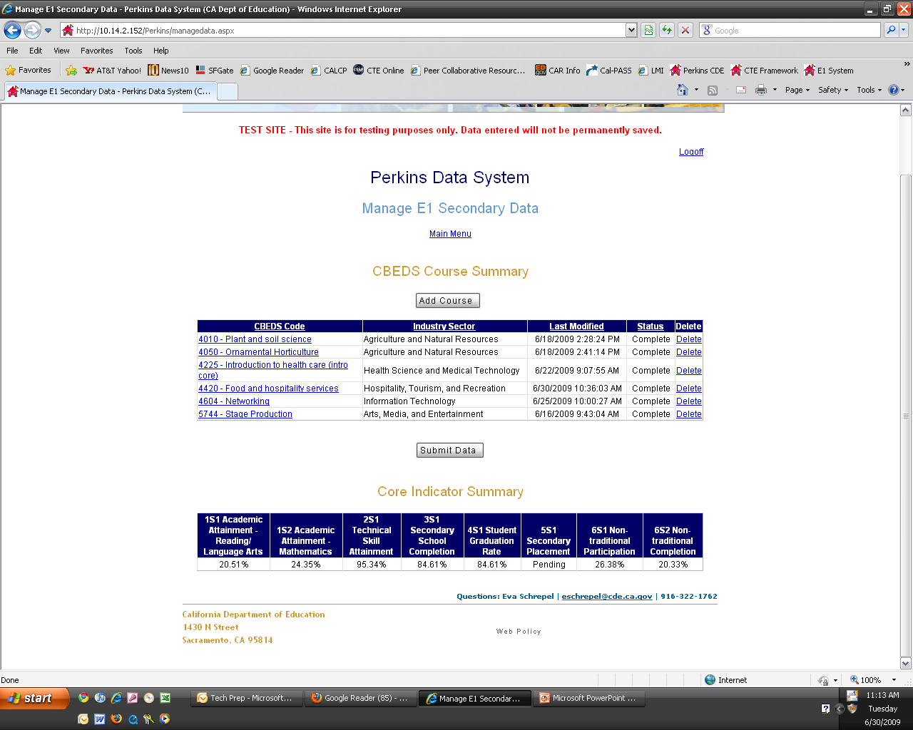
Final Data Submission

Once all data entry is complete, the final step is to submit the data to the CDE

Click Submit Data

Warning: Do not click Submit Data until all data entry is completed

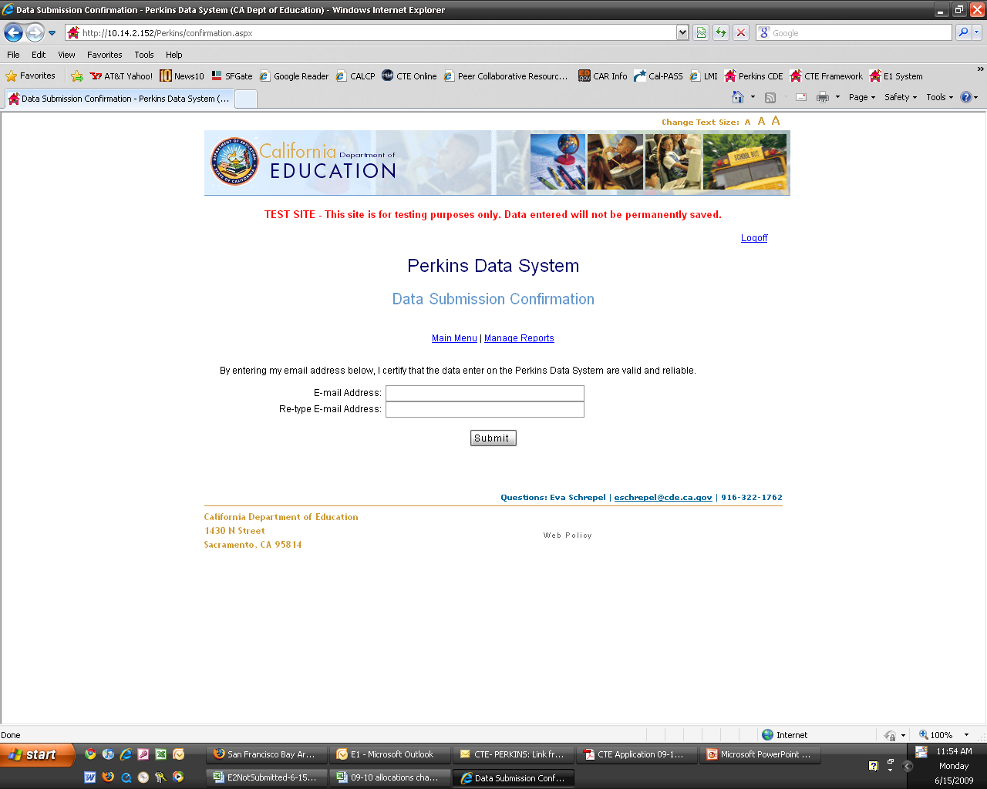

Note the Certification

Enter the E-mail address of CTE Coordinator Responsible for Accuracy of Perkins Data

Note: Once submitted the data is marked “read-only” and cannot be revised, if the submitted data needs to be revised and updated before March 10, please contact the CDE Perkins staff at perkins@cde.ca.gov or 916-324-5706.
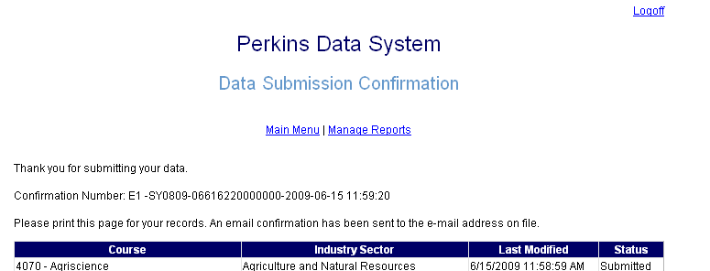

CONFIRMATION
From: Perkins [mailto:perkins@cde.ca.gov]
Sent: Monday, February 15, 2010 11:59 AM
To:
Subject: Perkins Data Submission – E2
Your data has been successfully submitted. If you have any questions please contact Eva Schrepel at eschrepel@cde.ca.gov.
Your confirmation number is E1 -SY0809-06616220000000-2009-02-15 11:59:20

An Email is sent to the Local Perkins Coordinator and the CDE as notification of the completion of the E-2 Process. This email should be retained on file at the LEA.

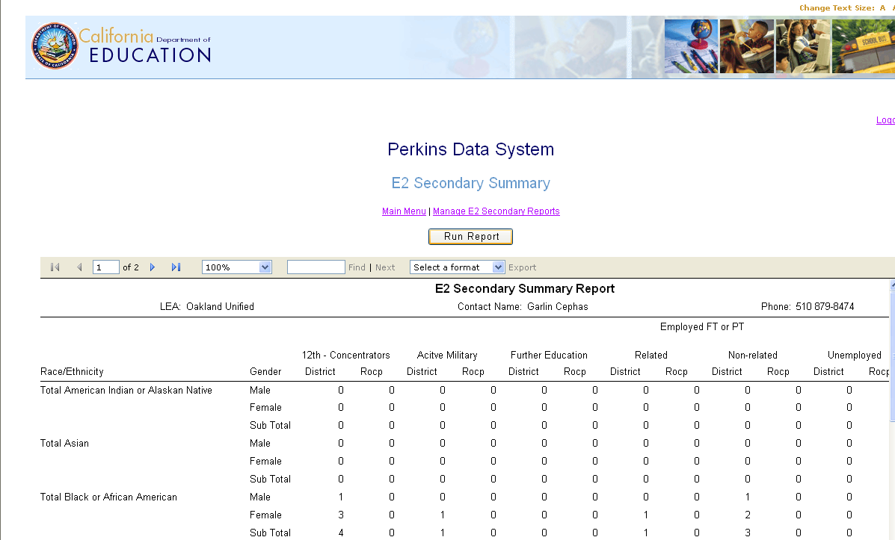
REPORTS

The Perkins Data System is now capable of generating paper reports or downloadable files that enable you to review or store reported data. These reports are available for both the E-1 and E-2 data. The E-1 data is a “Read Only” option. The E-2 data can be modified while the application is open; once the deadline date has arrived the reports will be made available on a “Read Only” option.

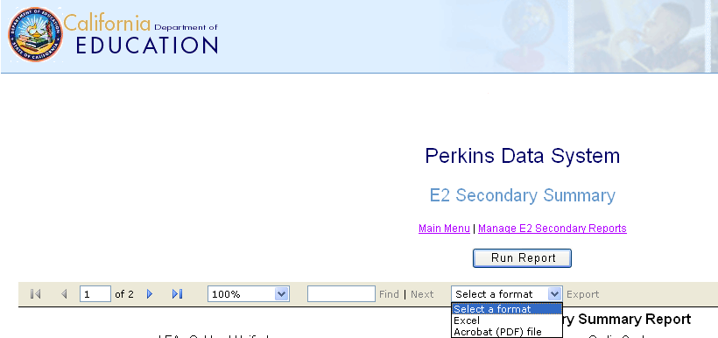
To print a report or export a file:

Select the down arrow next to the word Export. A dropdown menu will appear with the option to export the file in Excel or Acrobat (PDF) file.

Run the cursor over the word Export and a Microsoft message box with a downloadable file in the Excel or PDF option you selected will appear.

Reports (Continued)

The Perkins Data System will provide you the option to select a “Read Only” file for the E-1 data previously submitted and the current E-2 data report for the placement data being submitted.

Deadline for E-2 data is March 15.



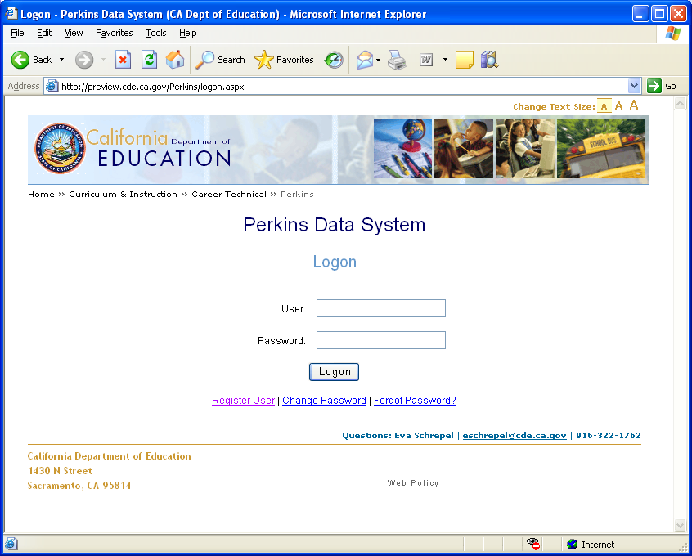
SYSTEM UPDATES

Changing Passwords

The Logon page of the Perkins Data System allows the user to maintain and update contact information.
To change your password select Change Password and complete the User name and Current Password information.

To return to the database select Main Menu.

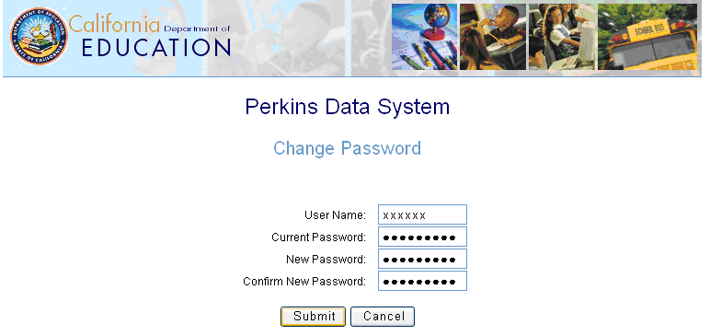


NOTE: You will need to have the current User Name and Password in order to “Change Password.”

Contact Information

Only one contact and e-mail can be used in the “Contact Information” fields. Those agencies that provide separate Adult and Secondary reports can select the “Secondary/Adult” Report Type. If you have separate contacts for the Adult and Secondary programs you can have each contact register individually by selecting the “Adult” OR “Secondary” – Report Types (see page 12). Please verify and update the contact information regularly. Fields displaying an asterisk sign (*) are Required Fields and must be completed.

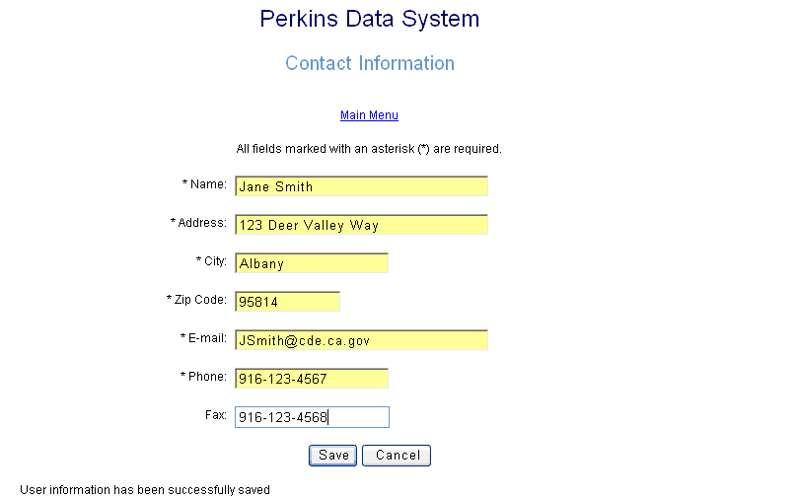
Only one E-mail field is allowed.

Please update the
E-mail field regularly to receive pertinent Perkins information.

The Save button overrides all contact information previously entered on this page.

Once you have Saved the contact Information click on Main Menu to return to the Perkins Data System.


Changing Contact Information

You will need to log on to the database
From the “Perkins Data System” you can select “Contact Information.”

Enter you current e-mail and click Change Password.

NOTE: You will need to have the current User Name and Password in order to Change “Contact Information.”

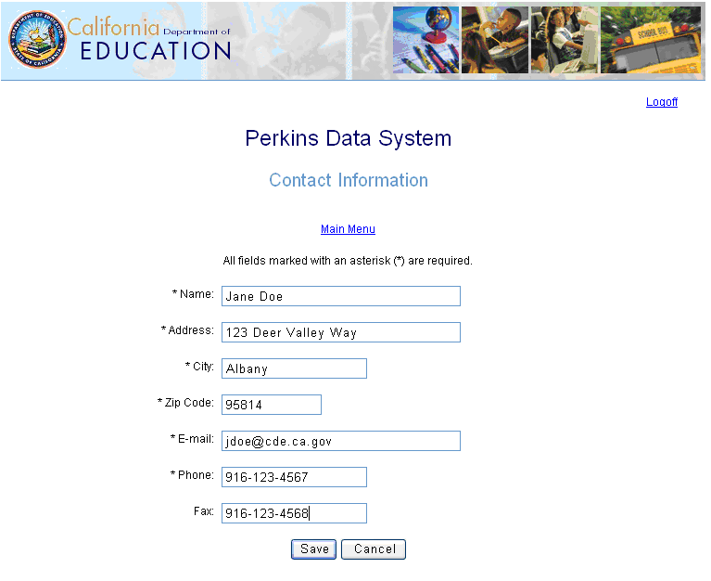
The Save button overrides all contact information previously entered on this page.

When complete you can select Main Menu to return to database.

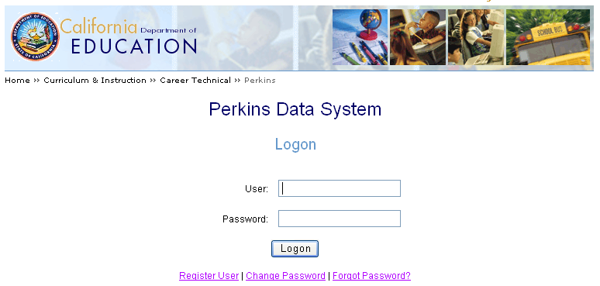
Forgot Password

From the Logon menu you can select the function “Forgot Password.”

Enter you current e-mail and click Send Password.

After you send the request a message will appear:

“Your password has been e-mailed to you. If you do not receive an e-mail in your inbox folder, please check your Junk Mail folder.”

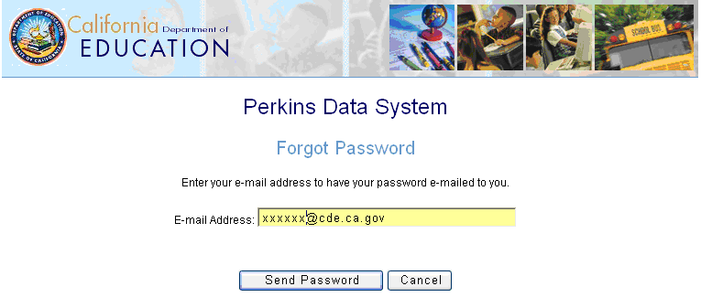
Select Main Menu to return to the database.

TECHNICAL SETUP

Problem: Records not saved

Solution: Modify Web browser setting

Some LEAs have experienced problems with their Internet settings. If you find that you have entered and saved a record (CBEDS code), but the next record you enter replaces the previous record, the settings in your Web browser are probably not set to check for a newer version of the stored pages. Please follow the directions below to change the settings in your Internet Options.

- Open Internet browser (This could be Microsoft Explorer or Netscape)
- Click on Tools
- Choose Internet Options
- Click on the General tab
- Click on Settings
- Choose the radio button “Every visit to the page”
- Click OK
- Click OK
- Close program to re-start with new setting

Problem: Perkins E-mail going to junk mail
Solution: Modify Junk Mail Handling

GroupWise

To manage the blocked senders list

- On the Tools menu, point to Junk Mail Handling, and then click Trust List.
- To add a new sender or domain to the list, click New. Enter perkins@cde.ca.gov in the dialog box and click OK.
- Click OK to apply rules that have been added or changed.

Outlook Express

To manage the blocked senders list

- On the Tools menu, click Options, and then select the Preferences tab, under E-mail, click Junk E-mail.
- Select the Safe Senders tab to add a new sender or domain to the list, click Add. Enter perkins@cde.ca.gov in the dialog box and click OK.
- Click Apply to complete the added email.

