Mathematics Framework
Adopted by the State Board of Education on July 12, 2023
Page 1 of 37

Mathematics Framework
Chapter 11: Technology and Distance Learning in the Teaching of Mathematics
Mathematics Framework Chapter 11: Technology and Distance Learning in the Teaching of Mathematics 1
Introduction 2
Purpose of Technology in Mathematics Learning 3
Technological Pedagogical Content Knowledge Framework 4
Principles for Technology Use in Mathematics Learning 6
Principle 1: Strategic Use of Technology in a Learning Environment Can Facilitate Powerful Learning of Mathematics 6
Principle 2: Support for Teachers of Mathematics Accompanies Use of Learning Technologies 13
Principle 3: Learning Technologies Are Accessible for All Students 15
Digital Learning 16
Common Definitions 19
Research-Based Distance Learning Principles 25
Ensuring Support for Distance Learning 29
Preparing Families and Staff for Distance Learning 29
Use of Common Tools 33
Identifying Success Criteria 34
Conclusion 36
Long Descriptions for Chapter 11 36

Introduction
Today, a host of technologies has the potential to support rich and deep mathematical learning for all students. Introducing students to technology is important in itself, given its increasingly integral role in our lives. However, this chapter emphasizes that using technology in the teaching of mathematics has one primary purpose: to support instructional objectives. The guidance in this chapter is thus intended to help educators facilitate interactive experiences that enrich students’ learning of the mathematics content and practice standards.
The chapter begins by outlining principles for technology use in math learning. Based on those principles, it recommends adopting technology only when accompanied by changes to teaching practices which make the technology an integral and sustained component of the instruction—that is, when accompanied by high quality, ongoing professional learning for teachers. Importantly, the chapter also discusses distance learning. A multitude of studies show that well-designed online or blended instruction can be as effective or more so than in-classroom learning alone. It thus describes features of effective distance learning and offers tips for success.

Purpose of Technology in Mathematics Learning
In keeping with the California Common Core State Standards for Mathematics (CA CCSSM), this framework describes the “learning of mathematics” in two aspects: the learning of grade-level content standards and the fostering of sound mathematical practices—that is, the productive habits of mind and habits of interaction embodied in the Standards for Mathematical Practice (SMPs). This chapter advocates for technology use that supports both aspects of mathematical learning. The first section describes the purpose of technology in the learning of mathematics, the second section introduces overarching principles meant to guide such technology use, and the third section provides general guidance for distance learning that is applicable but not limited to mathematics instruction. Additionally, to support schools in the effective implementation of technology to support learning, the California Digital Learning Integration and Standards Guidance (CA DLI&SG, CDE, 2021) provides strategies to build educator and system capacity. The standards guidance is intended to support teachers as they implement mathematics instruction. (See the Digital Learning section in this chapter for more information on the CA DLI&SG document.)
Technology use in the teaching of mathematics has one primary purpose: to facilitate interactive experiences that enrich the learning of both content standards and SMPs. Given the increasingly integral role that technology plays in commercial, societal, and cultural aims, the use of technology in educational settings likewise reflects the progress toward an informed and technologically skilled society. While introducing students to technology is certainly important in and of itself—and can even be a necessity (see the Distance Learning sections in this chapter)—it can be accomplished in service to the primary purpose described above. In other words, this chapter provides guidance on how technology use can best support mathematics instructional objectives, rather than adjusting instructional objectives to support the use of technology.

Technological Pedagogical Content Knowledge Framework
The Association for Mathematics Teacher Educators (AMTE) in 2009 published a framework for research and guidance on best practice in the use of technology in mathematics education. Technological pedagogical content knowledge (TPACK), based on the work of Mishra and Koehler (2006), is a specialized type of knowledge that enables educators to draw upon technological knowledge (knowledge of, and facility with, relevant technology), pedagogical knowledge (knowledge of teaching and learning strategies), and content knowledge (knowledge of mathematics) as they create meaningful learning experiences for students. In short, this knowledge is the synthesis of three areas of expertise for educators: technology, teaching, and mathematics. Thus, the guidance in this chapter is designed to establish and increase this type of knowledge. Figure 11.1 shows the relationships among technological knowledge, pedagogical knowledge, and content knowledge.
Figure 11.1: Technological Pedagogical Content Knowledge (TPACK) Model
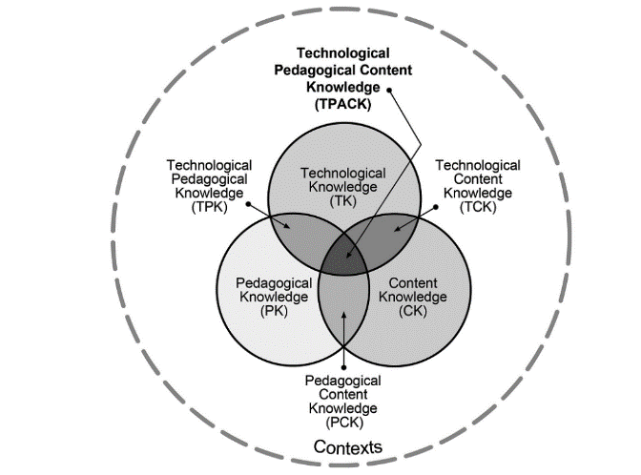
Long description of figure 11.1
Source: Koehler and Mishra, 2009.
According to the TPACK model, educators with robust technological pedagogical content knowledge are able to do the following:
- Incorporate knowledge of learner characteristics, orientation, and thinking to foster learning of mathematics with technology.
- Facilitate technology‐enriched mathematical experiences that foster creativity, develop conceptual understanding, and cultivate higher-order thinking skills.
- Promote mathematical discourse between and among instructors and learners in a technology‐enriched learning community.
- Use technology to support learner‐centered strategies that address the diverse needs of all learners of mathematics.
- Encourage learners to become responsible for and reflect upon their own technology‐enriched mathematics learning.
Although the behaviors seen above are characteristics of some educators in California, for many they are aspirational, especially for those in rural areas where access to and support for use of technology is more limited. Teachers, administrators, and district and county staff should work together to support the growth of the technological pedagogical content knowledge described in the behaviors above.

Principles for Technology Use in Mathematics Learning
The following principles are meant to guide effective incorporation of technology into the teaching of mathematics. This section addresses uses of technology that support mathematics learning specifically; uses of technology supporting remote learning in general are discussed in a later section. While technology use varies widely, these principles can serve as guideposts for all districts and schools as they consider utilizing various technologies to support learning.

Principle 1: Strategic Use of Technology in a Learning Environment Can Facilitate Powerful Learning of Mathematics
According to the National Council of Teachers of Mathematics (2015), the strategic use of technology in the teaching and learning of mathematics is the use of digital and physical tools by students and teachers in thoughtfully designed ways and at carefully determined times so that the capabilities of the technology enhance how students and educators learn, experience, communicate, and do mathematics. Strategic use of technology supports all students in their learning and is consistent with research on best practices in teaching and learning.
A technology-rich environment, when used strategically, can be a powerful tool for learning deeper mathematics. A technology-rich environment is one in which the technology serves a clearly defined pedagogical purpose (Zinger et al., 2017). In establishing a technology-rich environment for learners, three primary factors must be taken into account: access, usage, and skills (ITU, 2009). Access refers to the availability of technology for teachers and learners, usage refers to its prevalence in learning experiences, and skills refers to the knowledge level required, both for teachers and for students, to use the technology appropriately. In considering whether to use specific technology, each of these factors can help guide educators’ decisions. For example, if all students have access to a particular technology, and the teacher has the skills and support to enable learning that relies upon the technology, but future coursework relies upon different technology, then this difference in usage should be considered before adopting the technology.
By contrast, a technocentrist educational approach is one in which technology is considered both a means and an end (Zinger, Tate, and Warschauer, 2017). In other words, the aim of a technocentrist approach is to train learners in using technologies with the hope that learners will use new knowledge of technologies readily outside the classroom or in future learning situations. This approach, focused on technological learning rather than content-area learning, has been found to be ineffective in large-scale projects (Zinger et al., 2017).

Portrait of a Technology-Rich Setting
- All students have access to a particular technology intended to support specific mathematics content and practices. All families have access to appropriate technology and support to be an active part of the overall school community. (access)
- Teachers have knowledge about the pedagogical use of the technology—for example, through appropriate professional learning. (skills)
- The lesson, task, or activity relies upon the technology as an integral part of students’ interactions with the content. (usage)

National Council of Teachers of Mathematics Recommendations
According to the National Council of Teachers of Mathematics (NCTM), two types of technologies can support teachers in creating learning environments for students: content-specific mathematics technologies and content-neutral technologies (NCTM, 2015). Content-specific technologies support students in exploring and identifying mathematical concepts and relationships. These include computation/visualization programs, such as Desmos or GeoGebra, virtual manipulatives or games, and calculation. Content-neutral technologies, such as spreadsheets, word processors, and drawing programs, both online and offline, help students collaborate with peers and communicate work with teachers. Both content-specific and content-neutral technologies support students in learning mathematics content, practicing skills, and developing higher-order thinking skills such as visualizing, reasoning, and problem solving.
NCTM recommends the following guidance on the strategic use of technology:
- Mathematics constitutes the focus of instruction and drives the use of the technology. Teachers capitalize on the capabilities of technology to accomplish mathematics learning goals. As research has consistently pointed out (Reys and Arbaugh, 2001), calculator use does not hinder the learning of rich mathematics. It does hinder the learning of procedural mathematics, however, especially when that is believed to be the primary objective. In considering the use of technology, the belief that rote algorithms and procedural skills (which are easily replaced by calculators) are the most important mathematics to be learned must be reconsidered. Students learn to negotiate the use of technology in ways that facilitate larger aims only when they are given larger aims to accomplish with the technology.
- Strategic use does not imply continuous use. Teachers should carefully consider when and how often to rely upon technology in learning experiences. Although technology mediates a major portion of each day in distance learning environments (see the second half of this chapter), teachers in these situations should still be mindful of overreliance on certain forms of technology when other skills may need fostering. For example, students should, at times, draw lines on a coordinate grid on paper using a ruler instead of always using an online graphing system. This helps develop fine motor skills and encourages attending to precision (SMP.6) in a manner similar to drawing geometry shapes by hand. Or, in encouraging the development of number sense, teachers may wish to have students focus on mental math strategies such as “making ten” and composing or decomposing numbers. Pan balances encourage students’ ability to visualize maintaining balance by “disappearing” equal quantities from both sides of a balance as a valuable precursor to solving linear equations. When simply combining terms, supported by technology or not, without considering equations in their totality, students can lose sight of the larger aims of what they are doing much of the time. Teachers can support students by modeling deliberate use of technology only after a problem is first considered thoughtfully.
- Teachers can meaningfully connect the use of technology in classroom learning to the use of technology on state and local assessments. When technology use is interwoven with learning throughout the school year, students can familiarize themselves with methods of recording and capturing their thinking. This comfort can also inherently support students’ familiarity with the technological demands of the California Assessment for Student Progress and Performance (CAASPP). In distance learning environments, assessment often takes many more forms than it would if it culminated solely in computer-based exams. For example, students can view and compile portfolios of their work for a unit or quarter in the school’s learning management system and record a video reflecting on their progress. Formative assessment, both in face-to-face and remote learning situations, is a powerful driver for learning (see chapter 12).
The following sample task makes strategic use of technology and engages students in learning.

Sample Task: Rescue Rover (Mathematics II/Geometry)
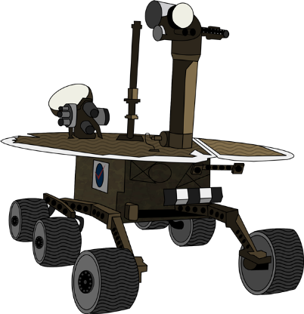
To teachers:
This activity promotes understanding of G-SRT-8, F-BF-1, A-REI-4, A-CED-1, 2, 3, and SMPs 1, 3, 4, and 5, as well as the Next Generation Science Standards and Science and Engineering Practices. The activity is designed for students working in heterogeneous teams of four members. Teachers should be mindful of students’ personalities and work habits when assigning them into groups in order to achieve effective cooperation and collaboration, and use individual discretion if frontloading additional scientific vocabulary, such as terms based in geology or science technology.
To students:
You and your team are working on a mission involving the remote collection of scientific data from the surface of Mars. Two active rovers, Dixie and Molly, are collecting soil samples, atmospheric data, and any evidence of past organic material.
[Incoming]: You suddenly receive a distress signal!
Dixie was moving around a rock outcropping and accidentally dislodged a boulder, pinning it against the rock face. Unfortunately, Dixie’s nuclear power supply is damaged and is emitting radiation with increasing intensity. This radiation will eventually melt Dixie’s internal wiring unless the team can remove the emergency release panel. Based on Dixie’s position, control center thinks the rock face is blocking access to the panel. The situation is truly dire for Dixie and its valuable data!
Fortunately, the other rover, Molly, could potentially reach Dixie in time to open the casing and remove the power supply using its robotic tool armature.
Your Team’s Tasks:
1. Determine the specific team goals for this situation.
2. Use the map below to list the information your team will need to help achieve these goals. (Note: Each pattern represents a different terrain on Mars)
3. There are two main terrains that Molly must traverse to reach Dixie. The first is fairly firm bedrock where Molly can average 20 kilometers/hour (km/hr). The second surface is rugged gravel and the rover will average only 10 km/hr. Work as a team to clearly plot out Molly’s path and determine the amount of time it will take to get Molly to Dixie. Remember, every minute counts!
Fairly Firm Bedrock Rugged Gravel
Legend: Each vertical and horizontal unit represents 10 km.
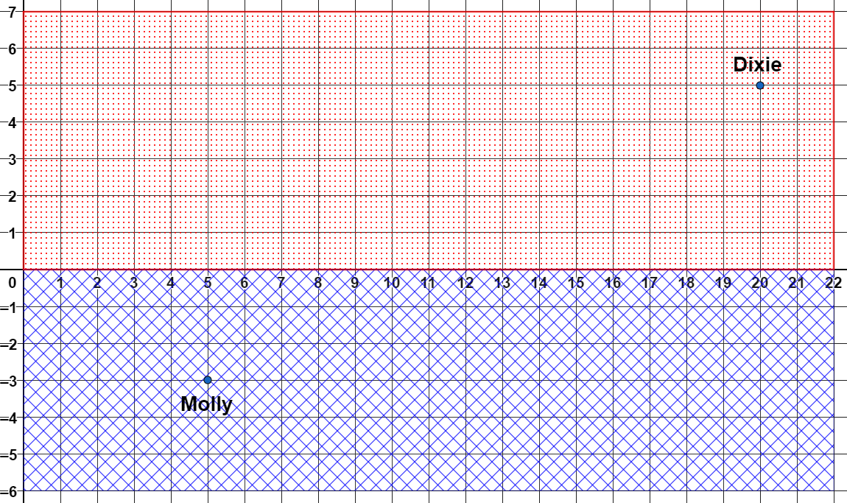
4. Answer the following questions, showing all your work and explaining your reasoning.
  - What is the least amount of time that it takes for Molly to reach Dixie? Explain the evidence that supports the shortest time duration that your team found.
  - Is the shortest distance a straight path between the two? Explain how you know.
  - Is the shortest distance always the fastest possible path? Explain your reasoning.
  - The control center asks your team to automate this process in case a future rover needs to reach another to perform a similar operation. Describe what parts of your solution process could be programmed. What parameters would there be?
Implementation:
After students unpack the problem and determine different points on the x-axis at which Molly crosses from one terrain to the other, there will be different time durations for the journey. To minimize the time, they must find the point on the border between terrains that gives the least time.
Technology Meets the Challenge:
Because calculating distances using the distance formula and dividing by Molly’s rate to find the time for that leg of the journey is tedious work by hand for each point chosen, students can divide this work among the team by having each member calculate the total time for a different point of their choosing. But what if there were three types of terrain, or five, or 10? The case for using technology to automate these processes is easily made at this point and is at the heart of NCTM’s first recommendation: Mathematics is the focus of instruction and drives the use of the technology. Teachers capitalize on the capabilities of technology to accomplish mathematics learning goals. Because optimizing for time involves some fairly complicated calculus, using technology can enable students to automate their processes and find the minimum distance.
One open-source software program that enables modeling of blended algebra and geometry problems is GeoGebra, which works in browsers and as an app. The teacher can encourage students to set up the diagram on GeoGebra, with points representing the locations of Molly and Dixie. They can then place a free point on the border and use the distance function to output the total distance. Using the algebra command lines, the time for the first “leg” (from Molly to the border point) can be programmed in as the quotient of the distance divided by Molly’s rate in the bedrock. Similarly, the time for the second “leg” (from the border point to Dixie) can be found. These times can then be totaled to find the total time, a figure that can be adjusted by grabbing and moving the border point along the border until the minimum time is found. The result is thousands of calculations in an instant! Students can discuss and explore variations on this design, such as different initial starting points for Molly and Dixie, various other terrains, different rates of travel, and elevation changes. In this way, students gain an understanding of the importance of the key mathematical relationships between time, distance, and speed since they must use these relationships in creating their model to answer questions.

Principle 2: Support for Teachers of Mathematics Accompanies Use of Learning Technologies
Supporting teachers in their pedagogical development is the most critical part of effecting positive change in students’ learning experiences. This chapter recommends the adoption of technology only when it is accompanied by changes to teaching practices that make the technology an integral and sustained component of the instruction and when ongoing support can be provided to teachers. In a nutshell, instructional purpose should drive the use of technology, not vice versa.
Administrators play a pivotal role in supporting teachers as they explore, adopt, and implement new technologies in their instructional practice. Introducing technology into students’ learning experiences requires consideration of a school’s mission, values, and budget as well as active communication among school and district personnel. Parents, caregivers, and families also represent a critical audience when considering technology awareness and education, especially with regards to distance learning. The following guidelines aim to inform administrators and policymakers in state, county, district, and school offices as they support teachers in strategic uses of technology:
- Adoption of technology occurs only when it is accompanied by changes to teaching practices that make the technology an integral and sustained component of the instruction and when ongoing support can be provided to teachers. Technologies can have short half-lives; restraint should be exercised in adoption of technologies popular in the moment.
- Time is provided to teachers to explore particular technologies to learn, reflect upon, and integrate technology into learning experiences for students. This is critical for all technology, as it is a hard lesson to have technology fail to work, or work improperly, at the point of students’ experiences with it. Delays, pauses, system updates, and the like can sabotage momentum in the flow of instruction.
- Technology support for teachers is ongoing and readily available. This support can take the form of workshops, peer collaboration, conference attendance, and virtual meetings. Of critical importance is that this time be provided and incentivized. In particular, the encouragement and support of peers is of great benefit as teachers expand their knowledge of strategic technology use.
- Effective professional development focused on the use of technology in mathematics learning is differentiated, reflecting the multitude of knowledge and comfort levels that teachers have with regards to technology. A successful plan for professional development recognizes that for teachers to learn to use technology in ways that enhance and increase student learning, they must go through “a process of entry, adoption, adaptation, appropriation, and invention as they navigate through the integration of technology in their classrooms” (Zinger et al., 2017, 586).
- To avoid overwhelming teachers, and in deference to the multitude of knowledge and comfort levels they have, training should focus on one tool or aspect of one system at a time. After teachers are given opportunities to implement the technology in their classes, further tools can be introduced (Zheng et al., 2014).
- Professional development includes specific criteria for teachers to rely upon as they select worthwhile applications, games, or other software that can accomplish learning objectives.
- Strategies that help support English learners while accessing tasks, such as identifying and clarifying terms used in the task (e.g., atmospheric data, organic material, and rock outcropping) are incorporated into professional development programs.

Principle 3: Learning Technologies Are Accessible for All Students
Technology use in mathematics classrooms must contribute to making the mathematics community more equitable. Thus, administrators and teachers must give special attention to issues of access when designing instructional uses of technology. In general, a key consideration is the “digital divide,” the gap in knowledge and skills between populations of students who have access to technology, usually through wealth and privilege, and those who do not. Reducing rather than widening the divide should be a product of well-designed uses of technology in schooling. For a particular technological tool, other considerations include:
- The linguistic or cultural assumptions embedded in the technological tool under consideration. Is the tool designed with a particular student profile in mind, thus disadvantaging students who don’t fit that profile? If so, another tool should be found or the existing tool modified to address these issues.
- Differences in prior exposure to related technology—perhaps necessitating different supports for different students. Appropriate and equitable supports must be provided to ensure equal access for all.
- Providing the necessary classroom materials for technology use, including both hardware and software.
- Providing initial and ongoing technology support that is readily available to students, even in rural and remote settings. Technology can be used as a vehicle to better understand the students, their interests, and other culturally relevant information as it relates to equity. For example, polling students can provide teachers with immediate information regarding their students’ interests, thus enabling teachers to vary activities, which can then engage the interests of more students. Surveys also provide an easy, anonymous way to conduct formative assessment (i.e., reading checks or gauging student comfort level with particular concepts).
- Allowing for widely varying levels of internet capabilities and connection speeds among students and their families, including limited device or internet availability or rural internet capabilities and potential outages/interruptions.
- Aligning technology use to create equitable learning experiences using assessment platform technology. For example, affording class time for students to become familiar with the Smarter Balanced interface and the kinds of resources used in the administration of the CAASPP (CDE, n.d.a).
The vignette Polygon Properties Puzzles offers a glimpse into a grade four classroom where the teacher is deliberate and selective in the use of technology. Her students apply mathematical practices (SMP.1, 3, 5, 6, 7) and show understanding of the properties of various polygons by illustrating polygons and defending their reasoning.
(Note: The following sections, aside from the Desmos snapshot, were primarily taken from the CA DLI&SG and the California Department of Education’s Distance Learning website.)

Digital Learning
Digital learning presents a unique set of challenges and opportunities for students, parents, teachers, and schools. Technology plays a vital role in facilitating meaningful learning of mathematics within a digital learning format. It is important to develop structures that continue to place students at the center of learning, while also being mindful of the varied contexts of at-home supports.
To support schools in the effective implementation of technology to support learning, the CA DLI&SG provides strategies to build educator and system capacity. The guide is based on foundational, research-based digital learning practices, including engaging in personal interaction, building classroom communities, promoting collaboration, incorporating authentic assessment, designing active learning activities, and cultivating student-centered opportunities to build agency.
The guide is organized into three sections. Section A presents six distinct areas of need. Addressing each area of need is essential to ensuring digital learning opportunities are effective and equitable. Sections B and C of the guide provide standards guidance for mathematics and English language arts/English language development by identifying and addressing critical areas of instructional focus.
- Section A
  - Chapter 1
    - Ensuring Equity and Access
    - Preparing and Supporting Teachers for Digital Teaching
    - Designing Meaningful Online and Blended Learning Experiences
  - Chapter 2
    - Assessing Students in Authentic Ways
  - Chapter 3
    - Infusing Social and Emotional Learning
    - Cultivating Educator and Student Well-being
- Section B
  - Chapters 4–9
    - Standards Guidance for Mathematics
- Section C
  - Chapters 10–16
    - Standards Guidance for English Language Arts, Literacy, and English Language Development
This guide incorporates vignettes and interviews featuring California educators throughout the chapters. These vignettes and interviews provide examples of topic-specific recommended strategies and resources for educators as they teach within and design digital learning environments.
Of particular relevance to this framework are chapters one through nine. The following provides a summary of the key concepts presented in these chapters.
Chapter 1 explores how to best ensure equity and access for all students, especially those who are affected by structural and institutional injustices during health and economic crises (PACE, 2020), including students with disabilities, students who are English learners, foster youth, and students experiencing homelessness (Repetto, Spitler, and Cox, 2018). Chapter one also includes a subsection on preparing and supporting teachers for digital teaching, as pedagogical approaches and strategies for online and hybrid environments are vastly different than those used in a traditional setting (Archambault and Kennedy, 2018). Therefore, effectively incorporating technology into learning experiences requires strategic professional learning (Kolb and Carter, 2020) that is ongoing, practice based, culturally relevant, content specific, and context specific. The final topic addressed in chapter one is designing meaningful online and blended learning experiences. This area provides practical guidance for educators who are designing online and hybrid learning experiences, including key considerations for aggregating time for synchronous and asynchronous learning.
Chapter 2 focuses on the importance of assessments in a digital environment. Specifically, the chapter focuses on suggestions for implementing formative, summative, interim, and diagnostic assessments in online and blended learning environments. These assessments are essential in determining the effectiveness of pedagogical strategies, understanding individual students’ needs and supports, and informing and individualizing instruction to accelerate learning.
Chapter 3 focuses on fostering healthy, equitable, and inclusive digital communities, including infusing social and emotional learning (SEL) and cultivating educator and student well-being. By emphasizing SEL and well-being, schools can create virtual learning environments that are safe and inclusive and that support equitable student outcomes.
Chapters 4–9 provide standards guidance for mathematics by addressing critical areas of instructional focus. The standards guidance is intended to support teachers as they implement mathematics instruction in online, blended, or in-person learning environments. The standards guidance is organized around the “big ideas” proposed in this framework, which seek to support teachers in moving to the teaching of meaningful mathematics and enabling students to develop an interconnected understanding of different concepts. Chapter 4 outlines additional suggestions for digital learning practices relevant to this content area, while chapter 5 introduces the standards guidance and highlights the importance of the content and the ways it is connected to other content and practices. Chapters 6–9 organize guidance for standards by grade level.
This section is adapted from the guidance in planning, implementation, and evaluation of online instruction from the California Department of Education (CDE) Distance Learning website (CDE, n.d.b).
While nothing will replace the invaluable connection developed through in-person teaching, there are best practices that local education agencies (LEAs) may consider to maximize instructional time. It is important that the time educators spend directly interacting with students be focused, planned, and designed to further student learning goals. Learners will need opportunities for guided learning with an educator, as well as opportunities to work with peers, families, and community members to apply their learning and practice their skills. This guidance is not all-encompassing as instructional time can be a nuanced area. These suggestions are recommended best practices and do not constitute legal advice or a legal service.

Common Definitions
The definitions below are designed to provide a common understanding of the various models of learning and their unique distinctions and to avoid the common error of applying terms interchangeably. It is important to note that not all distance learning requirements outlined in statute are included in this document. Readers should consider the CDE’s Frequently Asked Questions (CDE, n.d.c) and additional guidance documents as they plan for and engage in distance learning to ensure all requirements are met.
Distance Learning. Instruction in which the pupil and instructor are in different locations and pupils are under the general supervision of a certificated employee of the local educational agency (LEA). Distance learning may include but is not limited to all of the following:
- Interaction, instruction, and check-ins between teachers and pupils through the use of a computer or communications technology
- Video or audio instruction in which the primary mode of communication between the pupil and certificated employee is online interaction, instructional television, video, telecourses, or other instruction that relies on computer or communications technology
- The use of print materials incorporating assignments that are the subject of written or oral feedback (Education Code [EC] Section 43500[a])
Blended Learning. Combination of in-person and distance instruction.
The below terms are used throughout the document to discuss ways in which LEAs offer high-quality distance learning in accordance with EC Section 43503.
In-Person Instruction. Instruction under the immediate physical supervision and control of a certificated employee of the local educational agency while engaged in educational activities required of the pupil.
Synchronous Learning. Synchronous learning takes place in real time, with delivery of instruction and/or interaction with participants such as a live whole-class, small-group, or individual meeting via an online platform or in person when possible.
Asynchronous Learning. Asynchronous learning occurs without direct, simultaneous interaction of participants such as through videos featuring direct instruction of new content that students watch on their own time.
Time Value. Instructional time for distance learning is calculated based on the time value of synchronous and/or asynchronous assignments made by and certified by a certificated employee of the LEA. Time value for distance learning is different than time value used previously in independent study programs that include an evaluation of the time value of work product.
Distance learning assignments can include assigned instruction or activities delivered through synchronous or asynchronous means. Synchronous opportunities may include full-group instruction, peer interaction and collaboration, two-way communication, small-group breakouts, or individual office hours. The delivery method should match the purpose of the current learning outcome, corresponding task, and program placement (i.e., Language Acquisition Program). At times it may be appropriate for new content to be delivered asynchronously, utilizing synchronous time for peer interaction, small-group breakouts, or individual office hours. Inversely, at times content may require synchronous opportunities to include direct instruction on new content. All modes should provide students with a means of checking for understanding and progressing based on that understanding.
For linguistically and culturally diverse English learners, this means of checking for understanding should include opportunities to have oral conversations to elaborate on the language necessary to articulate what is understood and ask questions for clarifying what is not fully comprehended. For students with disabilities, instructional time may be determined by the Individualized Education Program (IEP) team, as instructional delivery should be appropriately adapted to the unique needs of the student. Additionally, instruction and activities should be aligned to learning objectives and goals specified in the IEP.
There is an opportunity for staff to develop integrated lessons to maximize instructional time. An example might include integrating science and math standards in a performance task. Educators will need to support the development of independent learning skills through modeling, scaffolding, student conferences, feedback, and reflection. Although family support is important, applied learning experiences should take into account that many families will not be able to provide extensive support. Families seeking to gain more knowledge about technology can be referred to the school’s or district’s parent center. These centers often provide classes or can refer parents to classes offered by an organization in their local community.
During time allotted for applied learning, it is important for an adult to be available for questions. Educators will need to be especially in tune with language needs and provide sufficient language scaffolds to ensure the student can participate fully in the development of content and the development of the necessary linguistic structures to meet the language demands of the lesson. Integrated English language development (ELD) is critical for English learners’ access to the material and should be an integral part of the lesson planning and delivery process in all subjects. Structures may need to be in place to provide support for students who may not have an English-speaking adult or family member to support applied learning. Consider using expanded learning staff or other staff from community-based organizations to support individual students or learning pods of students. Collaboration with families can be especially important when developing learning opportunities for students who are academically behind or students with disabilities, particularly students with extensive support needs. Gauging the needs of the family in supporting the student will be key to ensuring successful student outcomes. LEAs are encouraged to engage service providers and paraprofessionals in collaboratively supporting the students and family to ensure meaningful access to learning opportunities.
The ratio of synchronous and asynchronous time and the sequence of these chunks of instructional time will depend on the course structure, instructional methods, access to technology, student needs, and whether learning is taking place entirely online or if the class is using a blended model. As such, it is important to emphasize that these two types of instructional time do not need to be chunked or sequenced in any particular way. For example, a teacher may choose to have students spend an estimated 30 minutes independently reading a text to prepare for a 20-minute, teacher-facilitated synchronous discussion, followed by a 30-minute group research task, and then another 10-minute check-in discussion. Some English learner students may need materials in the primary language to support their independent learning. Families may need guidance, and it is best practice for teachers to model effective teaching practices, so families know how to support the student using these materials.
In the context of a multilingual program, instructional minutes in each language should be aligned to the percentage of minutes dedicated to that language based on the program design. For example, if 80 percent of the instructional minutes in a dual-language immersion program are dedicated to Spanish, then 80 percent of the 230 instructional minutes in a third-grade classroom should be dedicated to Spanish instruction and interaction.

Snapshot: Landing the Plane (Grade Eight)
This snapshot illustrates a use of technology to provide access for all students to sense-making mathematics, in remote or in-person settings.
During distance learning, Ms. Trejo and her eighth-grade students have less than half the synchronous learning time they had last year. She is planning strategically, trying to understand how best to use the time they are together and the time they are apart. She also values math that is conceptual and math that is learned through social interactions between students. The physical distance due to schools moving to online teaching and learning, and the tendency of computer-based mathematics to isolate students behind a monitor, puts both of those goals at risk. Ms. Trejo decides that a Desmos activity called “Land the Plane” should work as well in her current remote-instruction setting as it has in her past in-person instruction.
Using her classroom learning management system, she invites students to work asynchronously to “Land the Plane” (n.d.). The activity asks students to plot the linear equation of a plane so that it lands on a runway. Students can work on much of the activity by themselves because the activity gives them interpretive rather than evaluative feedback. Instead of seeing “right” or “wrong” as their feedback, students see the plane travel along the graph of whatever linear equation they plot. They learn from that feedback and try again.
Figure 11.2 Land the Plane
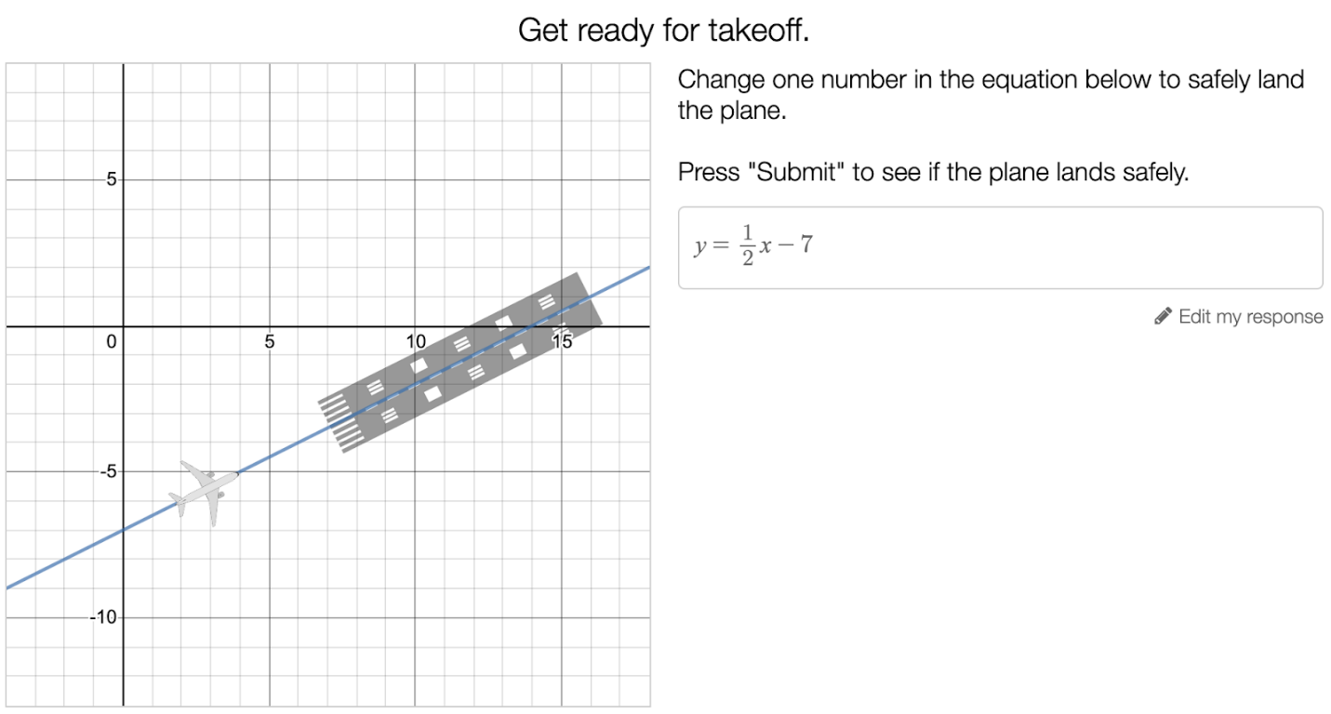
Long description of figure 11.2
During their limited synchronous time, Ms. Trejo focuses her and her class’s energy on some questions that computers cannot interpret or evaluate. In one case, students are presented with two hypothetical students’ linear equations and are asked to argue in favor of one. Ms. Trejo uses the Desmos snapshot tool to select and (anonymously) present unique student answers, and then invites students to discuss the strengths and weaknesses of those answers.
During this synchronous time, she also asks students to participate in the “Challenge Creator,” an activity where students create runway challenges for their classmates to solve.
Figure 11.3 Class Gallery for Land the Plane
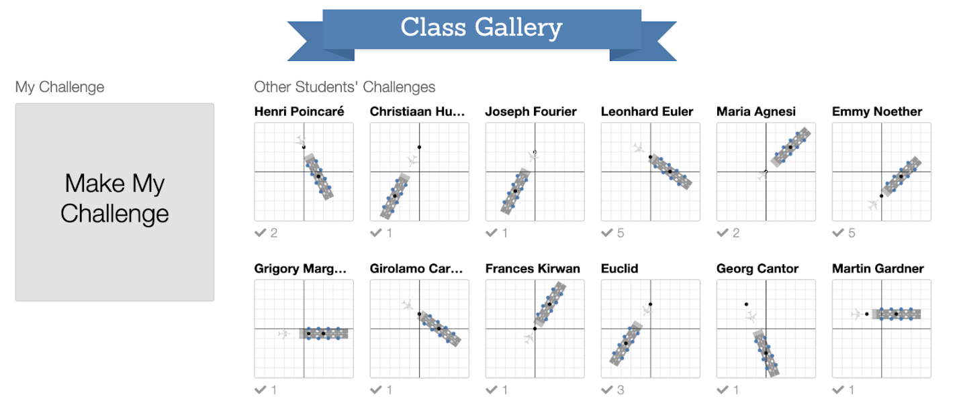
Long description of figure 11.3
Based on her understanding of her students, Ms. Trejo uses this activity to encourage discussion and debate among students over each other's challenges—and, sure enough, students debate in the chat which challenges were too easy, which seemed impossible, and how many tries they needed to solve the hardest ones, all while learning that they themselves can be authors of rich math questions, not just teachers and textbooks.
Distance learning has put many of Ms. Trejo’s pedagogical and mathematical goals at risk, but she has found digital tools that enhance, rather than undermine, her students’ mathematical connections and creativity.
(end snapshot)

Research-Based Distance Learning Principles
Research on effective distance and blended instruction can provide helpful principles for educators. It is useful to know that well-designed online or blended instruction can be as effective or more effective than in-classroom learning alone. While many worry that distance learning is necessarily less effective than in-person learning, many studies show that well-designed distance learning that has the following features is often more effective than traditional in-classroom learning alone (US Department of Education, 2010; see also Policy Analysis for California Education, 2020). Key elements include:
- A strategic combination of synchronous and asynchronous instruction. Combining synchronous activities where students meet regularly online (or in person) with their classmates and teachers with asynchronous activities where students think deeply and engage with the subject matter and other students independently are more effective than fully synchronous online courses.
Synchronous time should be set for reasonable amounts of time, punctuated with other activities to avoid attention fatigue. It can be used for short mini-lectures and for many kinds of student-to-student and student-to-teacher interaction as described below. Many students also benefit from synchronous individual or small-group support in addition to whole-group distance instruction.
Asynchronous time can provide an opportunity for students to gain exposure to concepts prior to engaging in synchronous time or as a follow up to dive more deeply into concepts that have been introduced through independent activities such as reading articles, watching videos or software-based presentations with voiceover, or completing modules online. Teachers can also use these asynchronous modules to provide targeted scaffolding or essential background information for those students in need of extra support in a particular area.
- Student control over how they engage with asynchronous instruction. Research shows that students do better when they can go at their own pace and on their own time, when they have some choice over the learning materials to use and the learning strategies that work best for them, and when materials are set up to enable them to engage deeply and critically with course content by managing how they use videos or print materials. As one successful online teacher explains:
Rather than assigning only worksheets or reading questions that can often lead to frustration and disengagement, offer students approaches that are universally designed so they can build and apply knowledge based on their interests and readiness levels. For example, provide a recorded lecture, two or three videos, and two readings about the topic. The students can listen or watch the lecture and then choose to complete a combination of the remaining content options. Provide links to reading assignments at different reading levels so that all students find a path to comprehension, with tools like Newsela, Rewordify, News in Levels, and more. Give two or three choices for completing a task, such as writing, recording a video, building a slide deck, using a game-based education platform to demonstrate math concepts, or historical and literary events, through building. Allow students to upload their work onto the classroom learning platform to share with peers. (For more information on universal design for learning, see chapter 2.)
- Frequent, direct, and meaningful interaction. The more interaction students have with other students, with their teachers, and with interactive content, the stronger the learning gains. In online learning environments where there is little student–student, student–instructor, and student–content interaction, students often become disengaged. Activities such as experiments, debates, data analysis, and groups solving challenging applications together can serve to synthesize and extend student knowledge. Students can interact with peers and the teacher in multiple formats. Whole-group and small-group discussion in synchronous instruction (e.g., in Zoom breakout rooms), chat rooms, and discussion boards that may be synchronous or asynchronous, and quick polls and votes followed by debate and discussion are all means to improve engagement and to create positive effects on learning gains, as are interactive materials.
- Collaborative learning opportunities. Opportunities for students to engage in interdependent cooperative learning are important and improve achievement. Teachers can structure learning opportunities that encourage collaboration by accommodating flexible grouping options for completing work and by setting class norms for collaborative activities. This includes group engagement in shared projects and presentations as well as smaller daily activities. Small groups can work on tasks together during synchronous time in breakout rooms and then return to share their ideas. Asynchronous tasks can also be structured to offer opportunities for students to collaborate and build learning together, such as through discussion boards and by providing peer feedback. Students can pursue projects in asynchronous time by being taught to set up their own collaboration in online platforms.
- Interactive materials. High-quality distance learning incorporates the use of interactive multimedia materials, typically during asynchronous learning. For example, fifth-grade science students who used a virtual web-based science lab, allowing them to conduct virtual experiments while teachers observed student work and gave feedback online, outperformed those who did an in-person science lab. Further, elementary special education students across five urban schools who used a web-based program supporting writing in action by prompting attention to the topical organization and structure of ideas during the planning and composing phases of writing outperformed those who had the same materials in hardcopy in the classroom (US Department of Education, 2010).
- Assessment through formative feedback, reflection, and revision. Formative assessment is very important in online and blended learning, and it promotes stronger learning when it provides feedback that allows students to reflect on and revise their work. For example, researchers found that students performed better when they used a formative online self-assessment strategy that gave them resources to explore when they answered an item incorrectly. Similarly, students who received quizzes that allowed them the opportunity for additional practice on item types that had been answered incorrectly did better over time than those who received quizzes identifying only right and wrong answers. Studies have found positive effects of a variety of reflection tools during online learning, ranging from questions asking students to reflect on their problem-solving activities to prompts for students to provide explanations regarding their work, student reflection exercises during and after online learning activities, and learning guidance systems that ask questions as students design studies or conduct other activities that support students’ thinking processes without offering direct answers (US Department of Education, 2010).
- Explicit teaching of self-management strategies. Students who receive instruction in self-regulation learning strategies perform better in online learning. Teachers can help students with tools that help them schedule their time, set goals, and evaluate their own work. They can also provide checklists that are readily available to students and parents that break out the steps for task completion to help them understand the scope of the work and the milestones they’ll accomplish along the way.

Ensuring Support for Distance Learning
As districts prepare for the start or restart of a distance learning program, it is important they consider ways to prepare families and staff for distance learning, the use of common tools, and the identification of success criteria. (See Figure 11.4) For students with disabilities, LEAs should plan for how IEPs can be executed in a distance learning environment. It is also important to establish the English Language Development (ELD) program expectations, schedules, and guidance as to how to make sure both designated and integrated ELD is provided consistently throughout all subjects.

Preparing Families and Staff for Distance Learning
To ensure that families and staff (including community partners where applicable) feel comfortable and prepared to engage in distance learning, it is important to solicit feedback to understand their experience in distance learning, if any, as well as to offer multiple opportunities to discuss expectations and engage with technology in a low-stakes setting. This engagement with families needs to occur in the language spoken in the home.
Figure 11.4 Considerations for Preparing Families and Staff for Distance Learning
Focus | Considerations
Understanding context | - Student Perspectives on Distance Learning (survey [in multiple languages] or focus groups)  - What did you like best about distance learning?  - What part of distance learning was the most challenging?  - If you could do one thing to improve distance learning, what would it be?  - Teacher Perspectives on Distance Learning (survey or focus groups)  - What worked well in distance learning over the spring?  - What were some of the biggest challenges?  - What do you need to be successful in distance learning in the fall?  - Were you able to support various types of student needs, including culturally and linguistically diverse English learners, students with disabilities, foster youth, socioeconomically disadvantaged youth, etc.?  - What strategies did you use to provide integrated and designated English language development (ELD)? Where do you need additional assistance?  - Family Perspectives on Distance Learning (survey [in multiple languages] or focus groups)  - What worked well with distance learning?  - What was the most difficult?  - How would you improve distance learning to better support your child?  - What support would you like/need as distance learning continues?  - Was the information provided in a language and manner accessible to you and your family?
During the initial opening/ reopening | - Considerations for Staff  - Offer professional development on a common digital platform by site. (See “Common Tools” below.)  - Support a common use of platforms. Example: If using Google Classroom, are all teachers logging homework in the same place?  - Ensure all staff are informed of students with disabilities (SWDs), current IEP and 504 accommodations, and if concerned who to contact to discuss supports needed in distance learning.  - Provide professional learning on integrated and designated ELD in the distance learning context and ensure that all staff are aware of the requirement that both integrated and designated ELD are provided to English learners.  - Provide professional learning on dual language instruction in the distance learning context and ensure that all staff are aware of the instructional minute requirements and plan for language use schedules to ensure language models continue as designed.  - Plan for a schedule of agreed-upon times of IEP meetings to ensure all team members are present.  - Collaborate with the IEP team to schedule services for students within the agreed-upon instructional minutes schedule.  - Considerations for Families/Students  - Over the course of a week, consider offering opportunities for 1:1 meetings or meetings in groups with families and students. It may be helpful to offer evening options for working family members. To the extent possible, ensure that interpreters are available for family members who speak languages other than English.  - Review the digital platform with the student and family.  - In transitioning to online learning, it is recommended that schools survey familial expertise with technology to better strategize support for their family as needed.  - Discuss the rhythm of learning that will be established: Where and when is work posted? How do they submit assignments?  - Ask families about the best form of communication and feedback loop.
Ongoing | - Considerations for Staff  - Offer tiered (ranging from beginning to mastering) professional development opportunities for staff to continue to build their capacity in areas to support distance learning such as learning platforms, engaging strategies, or tools and resources.  - Utilize staff meeting time to review success criteria, address emerging needs, celebrate successes, and identify areas for ongoing professional development.  - Establish a regular time for grade-level teams to collaborate in developing shared resources, review student work, and co-create lessons.  - Provide ongoing professional learning on integrated and designated ELD in the distance learning context and time for teachers to collaborate on addressing the needs of English learners (successes and next steps).  - Provide regular time for grade-level teams to collaborate with special education teams (i.e., Specialized Academic Instruction, Speech-Language Pathology, Occupational Therapy, and Adapted Physical Education) to discuss supports/challenges in the distance learning model and general education curriculum.  - Considerations for Families/Students  - Establish a regular time for families to receive support with technology as needed. Explore platforms that are available in languages other than English to ensure that families and students have access and that the home language is seen as an asset.  - Establish regular office hours for students to connect with their teachers and peers.  - To the extent possible, ensure that communications with families are translated and that translators are available for teachers to contact families who speak languages other than English.

Tips for Success
- Consider means of communication other than email, such as text messages, phone calls, or schoolwide communication systems. Survey data show that one in three families of English learners do not have an email address.
- Google and several text-messaging apps provide alternative phone numbers that link to your personal phone number so that it is kept private. Families calling the alternative phone number will connect to you directly. These services are typically free of charge. Several text messaging apps provide translation services for two-way translation (from English to the family’s preferred language and also translating their response back to English).
- Consider creating videos regarding how to access the digital platform for future viewing.
- Consider providing guidance in multiple languages, including video, written material, digital material, and technology platforms, apps, and others.

Use of Common Tools
Consistency across grade levels will support the success of students and families as they prepare to engage in distance learning. (See Figure 11.3.) Consistency also provides opportunities for teachers to marshal resources. For example, if teachers are all using the same high-quality curriculum, they might develop or curate videos for asynchronous learning and share them with colleagues. Consistent use of platforms allows families with multiple children to learn and offer support in a focused area. Similarly, students with multiple teachers will have space to focus on content as opposed to navigating multiple digital platforms for learning.
Figure 11.5: Considerations for Consistent Use of Common Digital Platform, Instructional Materials, and Assessments
Focus | Considerations
Common district-wide digital (learning management system) platform | - Select one common digital platform for appropriate grade spans (i.e., kindergarten and first grade may use a different platform than second grade and above).  - Ensure support is provided to teachers on how to use the platform in a consistent manner.  - Ensure support is provided to families on how to use the system and that this support is available in multiple languages.
Use of common high-quality instructional materials and resources | - Identify the district-adopted materials for each subject area.  - Ensure every teacher has access to the required curriculum, including ELD and special education.  - As a staff, use the categories of investigation identified in this framework (see chapters 6–8) for focus and planning in distance learning.  - As a staff, use the CA CCSSM to identify the new content introduced in each grade level for focus and planning.  - As a staff, use the ELA/ELD framework and the ELD standards to ensure that instructional materials include both integrated and designated ELD for English learners. Integrated ELD should be provided in all subject areas.  - As a staff, discuss multilingual program needs.  - Identify necessary supports to build staff, family, and student capacity around the curriculum that will be used. (See “Preparing Families and Staff for Distance Learning” above.)
Use of common diagnostic, formative, and summative assessments | - Administer a common grade-appropriate diagnostic assessment at the beginning of the year to establish a baseline for student learning.  - Plan for the administration of common assessments to use for grade-level collaboration, including assessments in other languages for multilingual programs and English language proficiency for ELD progress.  - Provide timely, personalized feedback to students on formative and summative assessments, including acknowledgment of the receipt of their work and a way for students to track their grades.  - Communicate to families and students their progress in learning, regularly ensuring translations when appropriate.

Identifying Success Criteria
It is important for districts to review the past and current local data in order to identify metrics for success in the distance learning setting. (See Figure 11.6.) For example, if an LEA previously saw high rates of chronic absenteeism for students with disabilities, a clear improvement outcome should be established with a plan to monitor participation rates for that student group. Improvement outcomes should include resources and supports to enhance connectivity, technology, and digital literacy for both students and families. Success criteria will clearly communicate the vision of the LEA regarding student performance and allow staff to monitor progress, celebrate success, and identify needs early.
Figure 11.6: Considerations for Identifying Success Metrics and Ensuring Commitment to Data Collection, Analysis, and Use
Focus | Considerations
Identify metrics to monitor progress in distance learning over time | - Identify anticipated student needs based on previous data and on formative assessments within the first month of school.  - Develop clear, consistent ways to solicit feedback from students, families, and staff in their home language and in a method accessible to them.  - Identify and develop common assessments at each grade level.  - Identify local data to review regularly, including specific data for student subgroups that are traditionally underserved.  - Consider external factors as they impact learning, such as power outages, evacuations, etc.
Data commitments | - Develop clear data commitments: When will assessments be given? Who will collect the information? Who will create data visuals that are easy to read?  - How are schools monitoring students’ progress and participation?  - What data needs to be collected to assess whether all learners are utilizing available resources?
Data analysis | - Review data on a regular basis with a team comprised of representative staff to support general education, including students with disabilities and English learners.  - Communicate data at staff meetings, including time to brainstorm the next steps.  - Establish a relationship between data outcomes and practices or strategies that were implemented.

Conclusion
Many technologies have the potential to support rich and deep mathematical learning for all students. Some provide contexts and representations of mathematical ideas (and tools for interacting with them) that help students deepen their understanding and their practice of mathematics. Others are not discipline specific but support student-centered pedagogy consistent with chapter two of this framework. As new technologies emerge, it is crucial that mathematical learning goals drive their use, that the tools support all learners, and that implementation be supported with high-quality professional learning opportunities for educators.

Long Descriptions for Chapter 11

Figure 11.1: Technological Pedagogical Content Knowledge Model
A three-circle Venn diagram. Technological Knowledge (TK), Content Knowledge (CK), and Pedagogical Knowledge (PK) overlap to create Pedagogical Content Knowledge (PCK), Technological Pedagogical Knowledge (TPK), Technological Content Knowledge (TCK), and Technological Pedagogical Content Knowledge (TPACK). Return to figure 11.1 graphic

Figure 11.2 Land the Plane
Coordinate plane with a line indicated, with equation y = 1/2x – 7. The line crosses the y-axis at (0,–7) and x-axis at (14,0). There is an airplane runway drawn on the line, extending from roughly (7,–4) to (16,1). Text on the right includes instructions: Change one number in the equation below to safely hold the plane. Press “Submit” to see if the plan lands safely. Return to figure 11.2 graphic

Figure 11.3 Class Gallery for Land the Plane
Desmos snapshot tool titled Class Gallery, Make My Challenge. “Other students’ challenges” are presented as twelve graphs containing proposed runways for aircraft at varying degrees. Graph 1: Henri Poincaré, includes a runway in quadrants I and IV. Graph 2: Christiaan Hu..., includes a runway in quadrant III. Graph 3: Joseph Fourier, includes a runway in quadrant II and III. Graph 4: Leonard Euler, includes a runway in quadrants I and IV. Graph 5: Maria Agnesi, includes a runway in quadrant I. Graph 6: Emmy Noether, includes a runway in quadrants IV and I. Graph 7: Grigory Marg..., includes a runway in quadrants III and IV. Graph 8: Girolamo Car..., includes a runway in quadrants I, II, and IV. Graph 9: Frances Kirwan, includes a runway in quadrant I. Graph 10: Euclid, includes a runway in quadrants II and III. Graph 11: Georg Cantor, includes a runway in quadrants III and IV. Graph 12: Martin Gardner, includes a runway in quadrants I and II. Return to figure 11.3 graphic
California Department of Education, October 2023

