Mathematics Framework
Adopted by the State Board of Education on July 12, 2023
Page 1 of 47

Mathematics Framework
Chapter 2: Teaching for Equity and Engagement

Mathematics Framework Chapter 2: Teaching for Equity and Engagement 1
Introduction 2
The Need for Greater Equity and Engagement 3
Three Dimensions of Systemic Change That Support Mathematics Instruction 7
An Assets-Based Approach to Instruction 7
Active Engagement Through Investigation and Connection 8
Cultural and Personal Relevance 9
Five Components of Equitable and Engaging Teaching for All Students 10
Component One: Plan Teaching Around Big Ideas 11
Component Two: Use Open, Engaging Tasks 16
Component Three: Teach Toward Social Justice 26
Component 4: Invite Student Questions and Conjectures 32
Component 5: Prioritize Reasoning and Justification 38
Conclusion 45
Additional Resources 45
Long Descriptions of Graphics for Chapter 2 46

Introduction
Improving mathematics access and outcomes in California requires that each classroom, transitional kindergarten through grade twelve (TK–12), is an equitable and engaging mathematics environment that supports all students. How a teacher creates and sustains that environment is the focus of this chapter. It expands on the five components of instructional design, introduced in chapter one, that encourage equitable outcomes and active student engagement: teaching big ideas; using open tasks; teaching toward social justice; supporting students’ questions and conjectures; and prioritizing reasoning and justification.
Instruction that incorporates these components can enable a diverse group of students to see themselves as mathematically capable individuals with curiosity and a love of learning that they will carry throughout their schooling.

The Need for Greater Equity and Engagement
All California teachers strive to ensure that every child has an equitable opportunity to succeed. But mathematics achievement data show that, on average, this effort is not resulting in the success we want for our students. Figure 2.1 below shows data from the California Assessment of Student Performance and Progress (CAASPP) test for the 2014–15 through 2021–22 school years for all students and selected sub-groups (American Indian or Alaska Native students, Asian students, Black or African American students, Filipino students, Hispanic or Latino students, Native Hawaiian or Pacific Islander students, White students, students of two or more races, economically disadvantaged students, English learners, students with disabilities, and foster youth). Across all tested grades, about a third (33.38 percent) of all students tested in 2021–22 met or exceeded the mathematics standard for their grade level—down from about 40 percent of students in the 2018–19 school year, before the start of the COVID-19 pandemic. The differences between White and Asian students and other student sub-groups shown in the figure are stark. Prior to the pandemic, except for White and Asian students, fewer than 30 percent of students in each sub-group met or exceeded the standard, and all groups lost ground between 2019 and 2022.
Figure 2.1 California Assessment of Student Performance and Progress: Percentage of Students Meeting or Exceeding Standards, Mathematics
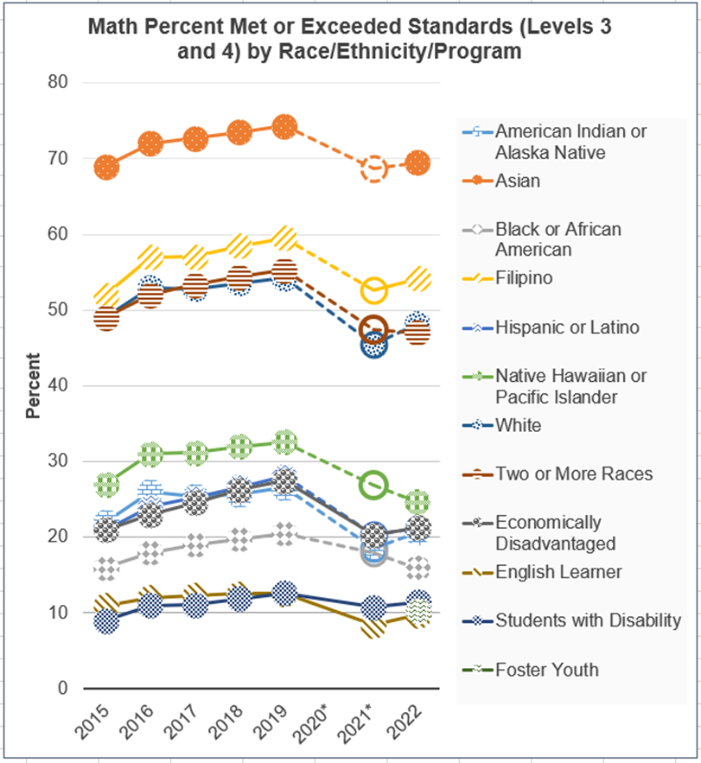
Group | 2015 | 2016 | 2017 | 2018 | 2019 | 2020* | 2021* | 2022
American Indian or Alaska Native | 22 | 26 | 25 | 26 | 27 | [blank] | 19 | 21
Asian | 69 | 72 | 73 | 74 | 74 | [blank] | 69 | 69
Black or African American | 16 | 18 | 19 | 20 | 21 | [blank] | 18 | 16
Filipino | 52 | 57 | 57 | 58 | 60 | [blank] | 53 | 54
Hispanic or Latino | 21 | 24 | 25 | 27 | 28 | [blank] | 20 | 21
Native Hawaiian or Pacific Islander | 27 | 31 | 31 | 32 | 33 | [blank] | 27 | 25
White | 49 | 53 | 53 | 54 | 54 | [blank] | 45 | 48
Two or More Races | 49 | 52 | 53 | 54 | 55 | [blank] | 47 | 47
Economically Disadvantaged | 21 | 23 | 25 | 26 | 27 | [blank] | 20 | 21
English Learner | 11 | 12 | 12 | 13 | 13 | [blank] | 8 | 10
Students with Disability | 9 | 11 | 11 | 12 | 13 | [blank] | 11 | 11
Foster Youth | [blank] | [blank] | [blank] | [blank] | [blank] | [blank] | [blank] | 10
Source: California Department of Education (CDE), n.d.a.
California high school graduation rates and the percentage of students meeting University of California/California State University (UC/CSU) requirements also show substantial differences among student sub-groups, as shown in figure 2.2. For example, whereas a majority of white and Asian students met the UC/CSU requirements in 2020-21, less than a quarter (23.98%) of graduating American Indian or Alaska Native students and only about one third of graduating African American (30.78%) and Hispanic or Latino (36.00%) students met the UC/CSU requirements. The data show that although there are graduation rate disparities among student groups, the disparities are wider with respect to UC/CSU eligibility, a finding that suggests that students' dramatically different in-school experiences have powerful implications for their future opportunities.
Figure 2.2 2021–22 Four-Year Adjusted Cohort Graduation Rate
Race/Ethnicity | Cohort Students | Cohort Graduation Rate | Percentage of Cohort Students Meeting UC/CSU Requirements
African American | 26,811 | 78.6% | 41.3%
American Indian or Alaska Native | 2,580 | 78.8% | 30.4%
Asian | 47,100 | 95.2% | 77.7%
Hispanic or Latino | 273,928 | 84.7% | 43.5%
White | 111,065 | 90.6% | 57.2%
Source: CDE, n.d.b.
At the higher education level, there are longstanding gaps among student groups in STEM enrollment and completion. While the number of female, Latino, and African American students enrolled in STEM fields in California’s public higher education system has grown over the past decade, a 2019 report found that “both nationally and in California, female and underrepresented minority (URM) students are underrepresented in STEM overall and are highly underrepresented in particular STEM fields, including engineering and computer science” (California Education Learning Lab, 2019, 2). The report found that in the UC system in 2016-17, African American students and Latino students accounted for only 1.3 percent and 15 percent, respectively, of bachelor’s degrees in STEM fields. In the CSU system, African Americans students accounted for only 2 percent and Latino students accounted for only 27 percent of bachelor’s degrees in STEM fields. (California Education Learning Lab, 2019).
This evidence makes clear that, on average across the state, the opportunities being provided and the approaches being employed in TK–12 classrooms, schools, and districts are not resulting in equitable student mathematics success. Across their TK–12 years, students in California and across the country experience differences in opportunities to learn associated with the quality of curriculum and teaching they encounter. These differences begin early and are too often related to racial and economic inequalities in school resources (Carpenter et al., 2014; Clements and Sarama, 2014; Turner and Celedón-Pattichis, 2011). These opportunity gaps impact student outcomes differentially (Carter and Welner, 2013; Conger et al., 2009; OECD, 2014; Goodman, 2019; Hanushek et al., 2019; Long et al., 2012; Reardon et al., 2018).
While circumstances outside of school influence equity and social mobility (Reardon, 2019), the National Council of Supervisors of Mathematics (NCSM) and its affiliate organization TODOS: Mathematics for All point to data showing that school systems play a role in helping to correct the current state of math education, increase equity, and ensure the highest quality mathematics teaching and learning (NCSM and TODOS, 2016). These mathematics leaders assert that equitable opportunities and outcomes for all students require systemic change. Educators at all levels need to take action to challenge deficit thinking, draw on—rather than exclude—students’ identities and cultural backgrounds, and create classrooms that foster active instead of passive learning experiences.
To support educators in taking such action, the sections below begin by addressing three dimensions of systemic change that are particularly important for effective mathematics instruction. The bulk of the chapter then details five components of instructional design that encourage equitable outcomes and active student engagement.

Three Dimensions of Systemic Change That Support Mathematics Instruction
Three dimensions of systemic change that are particularly important for effective mathematics instruction are: an assets-based approach to instruction; active student engagement through investigation and connection; and instruction that centers cultural and personal relevance, reflecting California’s diverse students. These practices undergird the discussion of the five components of equity and engagement that follows.

An Assets-Based Approach to Instruction
This framework asserts that California educators need opportunities to learn about, experiment with, and effectively use pedagogical approaches that recognize students’ assets. Educators need to build classroom environments where all students’ ideas are valued. Resources such as the Funds of Knowledge framework, developed by Moll et al. (1992), support teachers in learning ways to use students’ existing skills, experiences, and (cultural) practices as a knowledge/assets base on which to attach new instructional content and experiences.
Building a Culture of Access and Equity
“Creating, supporting, and sustaining a culture of access and equity requires being responsive to students' backgrounds, experiences, cultural perspectives, traditions, and knowledge when designing and implementing a mathematics program and assessing its effectiveness. Acknowledging and addressing factors that contribute to differential outcomes among groups of students are critical to ensuring that all students routinely have opportunities to experience high-quality mathematics instruction, learn challenging mathematics content, and receive the support necessary to be successful.
“Addressing equity and access includes both ensuring that all students attain mathematics proficiency and increasing the numbers of students from racial, ethnic, linguistic, gender, and socioeconomic groups who attain the highest levels of mathematics achievement.”
-National Council of Teachers of Mathematics (NCTM),2014a
While more research and empirical testing of assets-based pedagogies is needed (NCTM Research Committee, 2018), existing research suggests that using students’ funds of knowledge can help capture students’ imaginations and foster deeper understanding of domain knowledge (Lee, 2001; Rogoff, 2003). It can also help new learning “stick” (Hammond, 2021), increase student motivation, and perhaps support more equitable student achievement (Boykin and Noguera, 2011; NCTM Research Committee, 2018; Möller et al., 2020; Rivas-Drake et al., 2014). Given such evidence, the National Council of Teachers of Mathematics urges educators to move toward a culture of equity by enacting these pedagogies (see NCTM statement in box).

Active Engagement Through Investigation and Connection
In addition to an assets-based instructional approach, a longstanding body of research in the fields of education and psychology shows that students learn best through active engagement with mathematics and one another (Bransford et al., 2005; Freeman et al., 2014; Maaman et al., 2022; Wong et al., 2003). As discussed in chapter one, this framework highlights active engagement in classrooms by way of mathematical investigation and connection. Instructional design is guided by the why, how, and what of mathematics—for example, the three Drivers of Investigation encompass the “why” of math: to make sense of the world, predict what could happen, or impact the future. The tasks teachers design thus elicit students’ curiosity, leverage students’ knowledge, and provide motivation to engage deeply with authentic mathematics.
Research has produced a wealth of information showing that mathematics learning, understanding, and enjoyment comes from such active engagement with mathematical concepts––that is, when students are developing mathematical curiosity, asking their own questions, reasoning with others, and encountering mathematical ideas in multidimensional ways. This can occur through engagement with numbers but also through visuals, words, movement, and objects, and considering the connections between them (Boaler, 2019a; Cabana, Shreve, and Woodbury, 2014; Louie, 2017; Hand, 2014; Schoenfeld, 2002). The Universal Design for Learning (UDL) guidelines outline a multidimensional guide that benefits all students and can be particularly useful when applied to mathematics. (Later sections of this chapter elaborate on ways in which UDL can support equity and engagement.)
When students are engaged in meaningful, investigative experiences, they can come to view mathematics, and their own relationship to mathematics, far more positively. By contrast, when students sit in rows watching a teacher demonstrate methods before reproducing them in short exercise questions unconnected to real data or situations, the result can be mathematical disinterest or the perpetuation of the common perspective that mathematics is merely a sterile set of rules.
Students benefit from viewing mathematics as a vibrant, interconnected, beautiful, relevant, and creative set of ideas. As educators create opportunities for students to engage with and thrive in mathematics and value the different ways questions and problems can be approached and learned, many more students view themselves as belonging to the mathematics community (Boaler, 2016; Langer-Osuna, 2014; Walton et al., 2012). Such an approach prepares more students to think mathematically in their everyday lives and helps society develop many more students interested in and excited by Science, Technology, Engineering, and Mathematics (STEM) pathways.

Cultural and Personal Relevance
As noted above, California’s diverse student population brings to schools a broad range of interests, experiences, and cultural assets. Cultural and personal relevance is important for learning and also for creating mathematical communities that reflect California’s diversity. Educators can learn to notice, utilize, and value students’ identities, assets, and cultural resources to support learning for all students. Additionally, because culture and language can be intertwined, attending to cultural relevance may also enable teachers to attend to linguistic diversity – a key feature of California and relevant to the teaching and learning of mathematics (Moschkovitch, 1999, 2009, 2014).
This framework offers ideas for teaching in ways that create space for students with a wide range of social identities to access mathematical ideas and feel a sense of belonging to the mathematics community. A multitude of supports available to California teachers to ensure that the state’s large population of language learners and multilingual students can learn and thrive include many referenced in this framework: California’s English Language Development Standards (ELD Standards) (CDE, 2012), the California Department of Education’s advice for integrating the ELD Standards into mathematics teaching (CDE, 2021a), the principles of UDL (CAST, 2018), and the California Department of Education’s advice for asset-based pedagogies (CDE, 2021b.) Additional examples can be found in Darling’s (2019) framework, including ideas about strategically grouping students for language development, making work visual, and providing opportunities for pre-learning.

Five Components of Equitable and Engaging Teaching for All Students
California’s diverse classrooms include students from a wide range of differing backgrounds whose experiences in a mathematical practice or content area also vary widely. Moreover, across backgrounds, students learn in a wide variety of ways. How does a teacher create an equitable and engaging mathematics environment that supports all students to reach their academic potential?
The following sections describe five important components of classroom instruction that can meet the needs of students who are diverse in so many ways: 1) plan teaching around big ideas; 2) use open, engaging tasks; 3) teach toward social justice; 4) invite student questions and conjectures; 5) prioritize reasoning and justification.
Each component is based on research and supported by practice, and each is aligned with the three ideas shared above about moving toward instruction that is asset-based, supportive of students’ active investigation and connection-making, and culturally and personally relevant for students. The approaches presented here are aligned with other important resources, such as the Teaching for Robust Understanding (TRU) Framework (TRU Framework, 2018), NCTM’s Catalyzing Change series of books, as well as the Access and Equity: Promoting High Quality Access Series from NCTM. Relevant books include The Impact of Identity in K–8 Mathematics (by Julia Aguirre, Karen Mayfield and Danny B Martin), Teaching Math to Multilingual Students (by Kathryn Chavl and colleagues), and Teaching Math to English Learners (by Debra Coggins).

Component One: Plan Teaching Around Big Ideas
As discussed in chapter one, the first component of equitable, engaging teaching—planning teaching around big ideas—lays the groundwork for enacting the other four. Mathematics is a subject made up of important ideas and connections. Standards and textbooks tend to divide the subject into smaller topics, but it is important for teachers and students at each grade level to think about the big mathematical ideas and the connections between them (Nasir et al., 2014).
Planning teaching around big ideas is a way for teachers to engage students’ initial understandings and draw on their diverse assets, since students may engage with and demonstrate understanding of big ideas in different ways. By planning to teach the big ideas of mathematics and designing lessons that develop important content and mathematical practices, teachers are able to build on many ideas that arise from students during instruction, draw out students’ understandings, and help individuals and the class as a whole shape mathematical ideas into understandings that reflect the connected concepts and knowledge in the discipline (NASEM, 2000).
The big ideas approach to instruction contrasts with planning only around small, discrete, or disconnected topics in mathematics. Rather than seeking only to understand whether students can accurately demonstrate algorithmic proficiency on a single problem type, teachers hold a broader view of how students might demonstrate their mathematical knowledge and understanding. If students do not produce an expected algorithmic response, teachers look for the assets underlying their thinking, to build on what they do understand. Focusing only on small, discrete instructional topics may also limit students’ ability to connect an idea with their initial understanding, and thus may interfere with their ability to grasp new concepts and information or retain conceptual understanding (NASEM, 2000).
Although various big ideas are present in TK–12 mathematics, and many teachers may themselves envision different major themes in the standards, this framework sets forth the notion of big idea teaching in two important ways. First, instruction is designed to connect the why, the how, and the what of mathematics, as described in chapter one. The three Drivers of Investigation (DIs) address why the math at hand is relevant. The eight Standards for Mathematical Practice (SMPs) describe how students engage with mathematics. And the four Content Connections (CCs) describe what overarching topics and connections will be learned [see below for content big ideas]).
Secondly, instruction is guided by a focused set of big ideas, organized by grade level and CA CCSSM content standards. Created as part of the California Digital Learning Integration and Standards Guidance initiative (CDE, 2021c), these grade level big ideas, presented in subsequent chapters, are organized by Content Connections and include multiple CA CCSSM content standards, as illustrated for grade six in figures 2.3 and 2.4, below. Figure 2.3 is a network diagram of the big ideas (circular nodes) and the connections between them (line segments). Each network diagram is followed by a table such as figure 2.4 indicating the Content Connections and the relevant content standards for each big idea.
Figure 2.3 Grade Six Map of Big Ideas
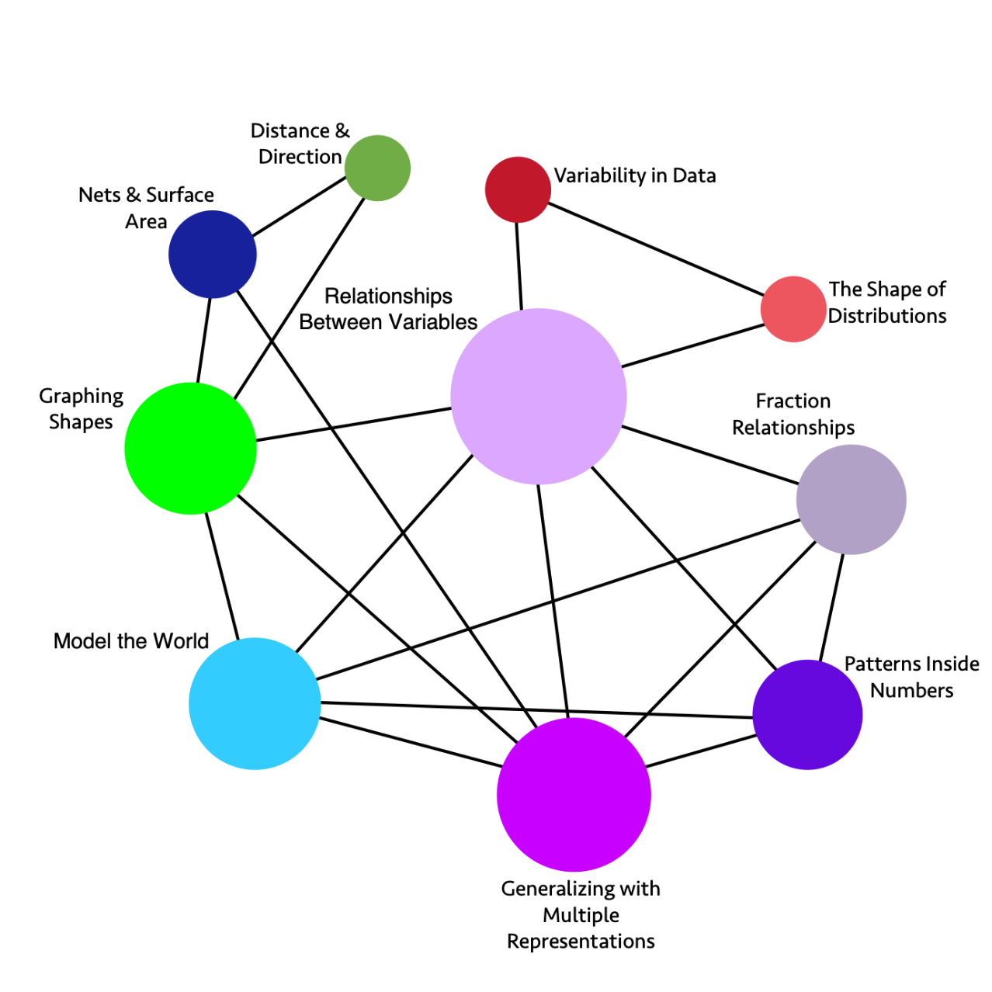
Long description of figure 2.3
Note: The sizes of the circles vary to give an indication of the relative importance of the topics. The connecting lines between circles show links among topics and suggest ways to design instruction so that multiple topics are addressed simultaneously.
Figure 2.4 Grade Six Content Connections, Big Ideas, and Standards
Content Connection | Big Idea | Grade 6 Standards
Reasoning with Data | Variability in Data | SP.1, SP.5, SP.4: Investigate real world data sources, ask questions of data, start to understand variability - within data sets and across different forms of data, consider different types of data, and represent data with different representations.
Reasoning with Data | The Shape of Distributions | SP.2, SP.3, SP.5: Consider the distribution of data sets - look at their shape and consider measures of center and variability to describe the data and the situation which is being investigated.
Exploring Changing Quantities | Fraction Relationships | NS.1, RP.1, RP.3: Understand fractions divided by fractions, thinking about them in different ways (e.g., how many 1/3 are inside 2/3?), considering the relationship between the numerator and denominator, using different strategies and visuals. Relate fractions to ratios and percentages.
Exploring Changing Quantities | Patterns inside Numbers | NS.4, RP.3: Consider how numbers are made up, exploring factors and multiples, visually and numerically.
Exploring Changing Quantities | Generalizing with Multiple Representations | EE.6, EE.2, EE.7, EE.3, EE.4, RP.1, RP.2, RP.3: Generalize from growth or decay patterns, leading to an understanding of variables. Understand that a variable can represent a changing quantity or an unknown number. Analyze a mathematical situation that can be seen and solved in different ways and that leads to multiple representations and equivalent expressions. Where appropriate in solving problems, use unit rates.
Exploring Changing Quantities | Relationships Between Variables | EE.9, EE.5, RP.1, RP.2, RP.3, NS.8, SP.1, SP.2: Use independent and dependent variables to represent how a situation changes over time, recognizing unit rates when it is a linear relationship. Illustrate the relationship using tables, 4 quadrant graphs and equations, and understand the relationships between the different representations and what each one communicates.
Taking Wholes Apart, Putting Parts Together | Model the World | NS.3, NS.2, NS.8, RP.1, RP.2, RP.3: Solve and model real world problems. Add, subtract, multiply, and divide multi-digit numbers and decimals, in real-world and mathematical problems - with sense making and understanding, using visual models and algorithms.
Taking Wholes Apart, Putting Parts Together  &  Discovering Shape and Space | Nets and Surface Area | EE.1, EE.2, G.4, G.1, G.2, G.3: Build and decompose 3-D figures using nets to find surface area. Represent volume and area as expressions involving whole number exponents.
Discovering Shape and Space | Distance and Direction | NS.5, NS.6, NS.7, G.1, G.2, G.3, G.4: Students experience absolute value on numbers lines and relate it to distance, describing relationships, such as order between numbers using inequality statements.
Discovering Shape and Space | Graphing Shapes | G.3, G.1, G.4, NS.8, EE.2: Use coordinates to represent the vertices of polygons, graph the shapes on the coordinate plane, and determine side lengths, perimeter, and area.
Teachers’ beliefs about mathematics influence how mathematics is taught and in turn, students’ perception of the discipline. Productive beliefs enable teachers to enact effective and equitable mathematics teaching practices (NCTM, 2020). As shown in figure 2.5, it can be productive to expose students to a range of strategies and approaches for problem solving, and those are more easily elicited when teachers organize instruction around big ideas. Doing so provides students with different points of access, based on their prior knowledge. It also helps teachers move beyond the unproductive notions that mathematical ideas and understandings should be sequentially organized in the same manner for all students or that algorithms that must be memorized.
Figure 2.5 Beliefs About Teaching and Learning Mathematics
Unproductive beliefs | Productive beliefs
Mathematics learning should focus primarily on practicing procedures and memorizing basic number combinations. | Mathematics learning should focus on developing understanding of concepts and procedures through problem solving, reasoning, and discourse.
Students need only to learn and use the same standard computational algorithms and the same prescribed methods to solve algebraic problems. | All students need to have a range of strategies and approaches from which to choose in solving problems, including, but not limited to, general methods, standard algorithms, and procedures.
Students can learn to apply mathematics only after they have mastered the basic skills. | Students can learn mathematics through exploring and solving contextual and mathematical problems.
Source: NCTM, 2014b.
Rather than focusing on specific procedures and memorization, instruction is more effective when teachers aim to develop understanding of bigger ideas and procedures. (See also the section below on open tasks). NCTM’s Principles to Action (NCTM, 2014b) posits that teachers should use big mathematical ideas to establish clear goals that guide lesson planning, instruction, and reflection. The goals help articulate the mathematics that students are learning (in a lesson, over a series of lessons, or throughout a unit). Teachers identify how the goals fit within a mathematics learning progression. They help students understand instructional goals and see how the current work contributes to their learning. Approached this way, big ideas help make learning progressions across grade levels clearer and support coherence of the curriculum within and across grade levels. Moreover, a focus on big ideas helps teachers identify and utilize the assets that learners bring to the classroom and helps students see how the range of their responses fit within a big idea.

Component Two: Use Open, Engaging Tasks
Besides linking numerous mathematics understandings into a coherent whole, the big ideas of mathematics provide a focus for student investigations (Charles, 2005)—the authentic activities, or projects that are the backbone of teaching the big ideas. Rather than being focused on one way of thinking or one right answer, student investigations rely on open tasks—that is, tasks that engage students in multidimensional exploration and investigation, drawing from their own knowledge and interests. Open tasks enable students to learn mathematics by meaningfully engaging in mathematical experiences that are visual, physical, and numerical and employ multiple representations and forms of expression (Foote and Lambert, 2011; Lambert and Sugita, 2016; Moschkovich, 1999; Boaler and LaMar, 2019). For example, students can be asked to design wheelchair ramps, plan a new school garden, or survey peers to find out how they have been impacted by distance learning.
Open tasks allow all students to work at levels that are appropriately challenging for them, within the content of their grade. By contrast, tasks that are closed ask narrow, focused questions that include only some students in the appropriate cognitive challenges. Teachers should aim to provide tasks that have a “low floor and a high ceiling,” meaning that any student can access the task but the task allows student to extend their thinking into a range of mathematical ideas (Boaler, 2016; Krainer, 1993).
The math task analysis framework from Stein and colleagues (2000) shown in figure 2.6 offers helpful descriptions of two types of narrow, low cognitive demand tasks—those that require only memorization or procedures without connections—and two types of open, high cognitive demand tasks—those in which students employ mathematical procedures with connections or do mathematics tasks. Too many students in California are not provided ample opportunities to consistently engage with open tasks that have high cognitive demand (The Education Trust, 2018). Yet closed tasks can still be useful to provide practice opportunities for students. Teachers should thus consider the frequency and manner in which they use closed tasks. And all tasks, regardless of their cognitive demand, should be offered based on the instructional goals.
Figure 2.6 The Task Analysis Guide
Lower-Level Demands | Higher-Level Demands
Memorization Tasks  - involve either reproducing previously learned facts, rules, formulae or definitions OR committing facts, rules, formulae or definitions to memory.  - cannot be solved using procedures because a procedure does not exist or because the time frame in which the task is being completed is too short to use a procedure.  - are not ambiguous. Such tasks involve exact reproduction of previously-seen material and what is to be reproduced is clearly and directly stated.  - have no connection to the concepts or meaning that underlie the facts, rules, formulae or definitions being learned or reproduced. | Procedures with Connections Tasks  - focus students’ attention on the use of procedures for the purpose of developing deeper levels of understanding of mathematical concepts and ideas.  - suggest pathways to follow (explicitly or implicitly) that are broad general procedures that have close connections to underlying conceptual ideas as opposed to narrow algorithms that are opaque with respect to underlying concepts.  - usually are represented in multiple ways (e.g., visual diagrams, , symbols, problem situations). Making connections among multiple representations helps to develop meaning.  - require some degree of cognitive effort. Although general procedures may be followed, they cannot be followed mindlessly. Students need to engage with the conceptual ideas that underlie the procedures in order to successfully complete the task and develop understanding.
Procedures Without Connection Tasks  - are algorithmic. Use of the procedure is either specifically called for or its use is evident based on prior instructions, experience, or placement of the task.  - require limited cognitive demand for successful completion. There is little ambiguity about what needs to be done and how to do it.  - have no connection to the concepts or meaning that underlie the procedure being used.  - are focused on producing correct answers rather than developing mathematical understanding.  - require no explanations or explanations that focuses solely on describing the procedure that was used. | Doing Mathematics Tasks  - require complex and non-algorithmic thinking (i.e., there is not a predictable, well-rehearsed approach or pathway explicitly suggested by the task, task instructions, or a work-out example).  - require students to explore and understand the nature of mathematical concepts, processes, or relationships.  - demand self-monitoring or self-regulation of one’s own cognitive processes.  - require students to access relevant knowledge and experiences and make appropriate use of them in working through the task.  - require students to analyze the task and actively examine task constraints that may limit possible solution strategies and solutions.  - require considerable cognitive effort and may involve some level of anxiety for the student due to the unpredictable nature of the solution process required.
Source: Stein et al., 2000
The following open task example, “Four 4s,” illustrates how an open task can support the development of big ideas, positive mathematical classroom norms, content standards, mathematical practices, and English language development. This task may be most useful for third and fourth graders, but it may also be meaningful for younger and older students.

An Open Task Example: Four 4s
Task Prompt: How many numbers can you create that have values between 1 and 20 using exactly four 4s and any operation?
Opportunities | Supported Standards
Opportunities for Mathematics Content Learning | Grade levels at which the task might be used, with (selected) mathematical big ideas and associated content standards:  - K – Being flexible within 10 (OA.1, OA.3)  - 1 – Equal Expressions (OA.1, OA.3), Tens and Ones (NBT.3)  - 2 – Skip Counting to 100 (NBT.3), Number Strategies (OA.1)  - 3 – Number Flexibility to 100 (OA.1, OA.3, NBT.3), Fractions as Relationships (NF.3)  - 4 – Fraction Flexibility (NF.3, NF.4, NF.5, OA.1), Multi-Digit Numbers (NBT 3)  - 5 – Fraction connections (NF.3, NF.4, NF.5, NBT.3)  - 6 – Generalizing with Multiple Representations (EE.6)
Opportunities for Mathematics Practices Learning | Standards for Mathematical Practice  - SMP.1 – Make sense of problems & persevere in solving them  - SMP.2 – Reason abstractly and quantitatively  - SMP.3 – Construct viable arguments & critique the reasoning of others
Opportunities for Language Development and Teacher Actions | ELD Standard Part 1 – Interacting in meaningful ways  - Collaborative (engagement in dialogue with others)  Teacher actions might include: allow time for struggle; ask:  - How could you get started on this problem?  - What does it mean that “any operation” is allowed?  - What does this symbol (parentheses, equal sign, fraction bar) mean to you?
Source: Youcubed, n.d.
Another popular example of how teachers can use open tasks is number talks. In a number talk, a teacher might ask the class of students to work out the answer to 18 × 5 mentally, then solicit the different answers that students may have found and write them on the board. After the different answers are collected teachers can ask if anyone would like to explain their thinking. Ideally, different students will share different ways of thinking about the problem, with visual, as well as numerical solutions. Chapter three provides further discussion of and resources for number talks. (For further guidance on implementing open tasks and on the teacher and student actions that might be demonstrated see NCTM’s Principles to Actions [2014]).
Open tasks support student engagement in mathematics in multiple ways, notably including the following three:
Open tasks can support access and flexible mathematical thinking. Open tasks have the potential to broaden access to mathematics because they are grounded in authentic and meaningful contexts—real life issues students actually wonder about—and thus provide multiple ways for students to begin thinking about the mathematics of the task. Students can engage with the mathematics through many different pathways and tools. Moreover, classroom discussions are enhanced by the range of strategies and perspectives that students offer. For example, when students discuss connections between direct modeling and more abstract reasoning strategies, students who may previously have relied on one strategy benefit. Those using direct modeling approaches might start to notice connections to more abstract ideas, helping them to think more flexibly and build understanding. Similarly, students utilizing more abstract strategies benefit from conceptually connecting those ideas to more concrete representations, drawings, or even other abstract approaches. With open tasks, teachers can take an assets-based approach to understand the mathematics that students bring to a task. The diversity of mathematical thinking that then arises in the classroom can support students’ conceptual understanding and strategic reasoning (National Research Council, 2001; Stein and Smith, 2018).
Open tasks can support teachers’ formative assessment. Open tasks provide teachers with opportunities to listen carefully, make sense of student thinking, and assess formatively as the lesson progresses. Teachers can thus make in-the-moment adjustments to support student learning and differentiate instruction. Such formative assessment begins with teachers selecting a rich task and anticipating how their individual students, with diverse mathematical strengths, might access and approach the task and how they might plan their instruction accordingly (Smith and Stein, 2018). (NCTM’s 2014 Principles to Actions offers guidance on how to select tasks and support student discussions around rich tasks.)
During the lesson, teachers can use classroom discourse to listen closely to students’ thinking (Cirillo and Langer-Osuna, 2018). They make use of the questions they have prepared in advance to support all students to learn the content. As surprises occur, teachers can also improvise additional questions and prompts that might support emerging understanding and enable students to communicate the mathematics more coherently. In short, teachers can be responsive to each students’ thinking, rather than evaluating students’ thinking along narrow dimensions of success. This creates opportunities to meet students where they are in their learning, the in-the-moment work of teaching (Munson, 2018).
(Chapter eleven provides further discussion of how the use of open tasks enables teachers to gather important information about students’ learning. Chapter twelve discusses California’s evolving comprehensive assessment system that support this framework’s vision of mathematics teaching and learning.)
Open tasks can support linguistically and culturally diverse learners, and learners with identified learning differences. Open tasks can enable students with a range of different learning and linguistic skills to demonstrate their initial thinking in various ways (i.e., numerically, symbolically, verbally, visually, or through physical action; Darling, 2019; CAST, 2018; Lambert and Sugita, 2016). They thereby support the alignment of instruction with the outcomes of the California ELD Standards and the UDL Guidelines.
To support participation of linguistically and culturally diverse English learners, teachers might listen for the mathematical ideas being expressed by students, noticing how students might draw on multiple language bases (i.e., translanguaging) or extra-linguistic communication, such as gesturing and using representation (Moschkovich, 1999, 2013). Teachers can thus attend to students’ mathematical ideas rather than focusing on correcting vocabulary and can listen carefully to know when to provide more substantial support for students at the Emerging level of English proficiency (Moschkovich, 2013). For example, the teacher could use revoicing to ensure that students understand a specific term under discussion (e.g., one-digit, two-digit). She could ask a direct question such as, “Mary said this is a two-digit number” as she points to a number. “Is this a two-digit number?” (Lagunoff et al., 2015). By revoicing and rephrasing students’ statements, the teacher allows the student the right to evaluate the correctness of the teacher’s interpretation. Revoicing also helps keep the discussion mathematical by reformulating the statement in ways closer to the standard mathematics discourse. For example, a teacher might say, “So I hear you say that this shape is not a triangle because it has four sides and triangles only have three sides. Is that right?”
While using open tasks, teachers can also support linguistically and culturally diverse language learners by strategically grouping students together for language development. During small group and whole class discussion, students have opportunities to participate as audience members for classmates’ presentations and explanations of their models and strategies. Through limited prompting and strategic support from the teacher, students determine whether their peers have used correct mathematical terminology when describing their processes. They also learn about ways their explanations could have been improved.
Effectively designing and implementing open tasks offers more ways for students to actively engage in mathematics and allows them to see how their perspectives and ideas can be assets in their own and their peers’ learning. As the UDL Guidelines shown in figure 2.7 show, open tasks offer students multiple ways to access the mathematical content (see also Lambert, 2020). Rachel Lambert and others have described strategies to support the participation of students with identified learning differences to share their thinking:
- Including paraprofessionals in the instruction allows students opportunities to rehearse and share their thinking in preparation for whole-class discussion (Baxter et al., 2005). This functions similarly to a think-pair-share completed prior to whole-class discussion.
- Creating a classroom culture where all students can and do readily access resources––like math notebooks, media apps and websites, and manipulatives––whenever they need them. Some students may use particular resources more often or for longer amounts of time than other students during whole class discussions and benefit from being able to draw on them as necessary (Foote and Lambert, 2011).
- Asking follow-up questions to set up the expectation and the support for students to be accountable to explaining their strategies. (Lambert and Sugita, 2016).
Instruction with open tasks can thus support differentiated learning, where progress is built upon students’ current understandings, allowing them to address any previously unfinished learning even as they advance their thinking in powerful ways. When teaching focuses on such inclusive approaches, progress for each student, not perfection, is the goal. Strategies that support students with identified learning differences ultimately create a positive learning environment for all students.
The vignette A Personalized Learning Approach demonstrates an open-ended task that all students can access and that extends to sufficient depth that all students remain challenged (that is, a “low floor, high ceiling” task).
Figure 2.7 Universal Design for Learning Guidelines
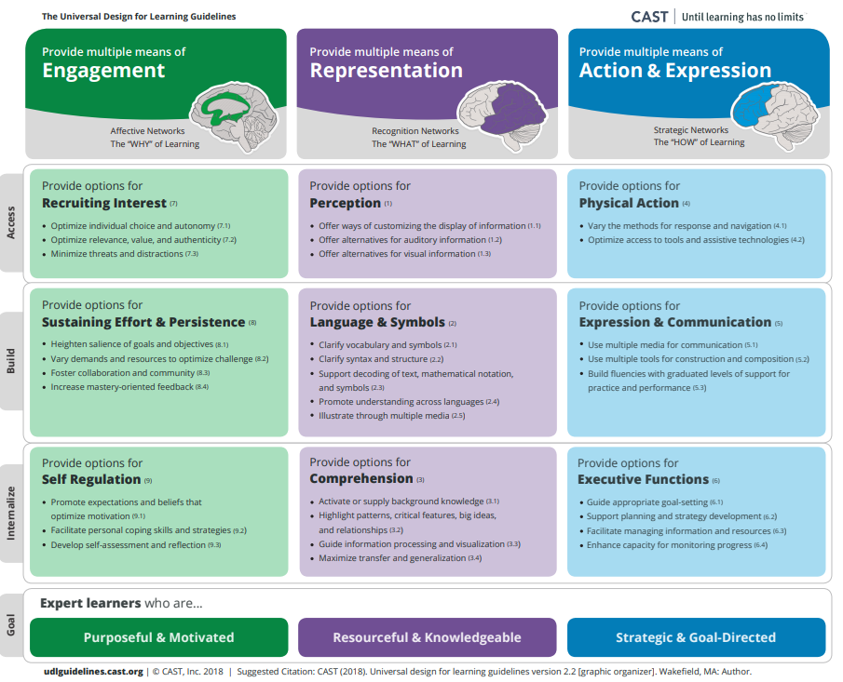
Long description of Universal Design for learning framework is available at https://udlguidelines.cast.org.

Component Three: Teach Toward Social Justice
Mathematics is a tool that can be used to both understand and impact the world. But too often students believe mathematics is not for them (Bishop, 2012; Darragh, 2015). Research shows that social and cultural contexts play a role in learners’ sense of belonging in mathematics classrooms. Additionally, learning environments enable or hinder whether and how students see themselves as doers of mathematics who believe that mathematics has a role in their lives (Lerman, 2000; Gutiérrez, 2013). Both mathematics educators and mathematics education researchers argue that teaching toward social justice can play an important role in shifting students’ perspectives on mathematics as well as their sense of belonging as mathematics thinkers (Xenofontos, 2019).
This framework discusses teaching toward social justice in two parts. First, it involves creating opportunities for students to both see themselves, as well as people from all backgrounds, as capable and successful doers of mathematics (Su, 2020). Second, teaching toward social justice urges educators to empower learners with tools to examine inequities and address important issues in their lives and communities through mathematics (Xenofontos et al., 2021; Goffney, Gutiérrez and Boston, 2018; Gutiérrez, 2009).
Creating opportunities for students to see themselves and others as mathematically competent. This concept is about building positive mathematical identities, beginning at the pre-kindergarten level. Teachers of young children use play to open opportunities for students to engage in non-routine problem solving, practice perseverance, and connect mathematical ideas (Chao and Jones, 2016, 17; Parks, 2015; Wager, 2013) Through activities centered around play, teachers can create spaces for children to see their backgrounds represented in mathematics. Young students can thereby develop powerful mathematical identities and critical mathematics agency in ways that honor and connect to their own family and cultural histories. For example, the Number Book Project (Esmonde and Caswell, 2010) invited a grade two student to share a poem with kindergarten students that was then used to create a classroom counting/number book for the kindergarten students. Teachers could use similar ideas to design engaging classroom activities.
Learning is not just a matter of gaining new knowledge—it is also about growth and identity development. As teachers introduce mathematics to students, they are helping them shape their sense of themselves as people who engage with numbers in the world (Langer-Osuna and Esmonde, 2017). Teaching mathematics through discussions and activities that broaden participation, lower the risks associated with contributing, and position students as thinkers and members of the classroom community are powerful ways to support students in seeing themselves as young mathematicians. Even in classrooms that utilize these approaches, however, stereotypes are often in play, impeding efforts to create robust, productive, and inclusive sense-making mathematics classroom communities (Langer-Osuna, 2011; Milner and Laughter, 2015; Shah, 2017). Teachers need to work consciously to counter racialized or gendered ideas about mathematics achievement (Joseph, Hailu, and Boston, 2017).
Teachers can begin with awareness that mathematics plays a role in the power structures and privileges that exist within our society and can support action and positive change. Teachers can support discussions that center mathematical reasoning rather than issues of status and bias by intentionally defining what it means to do and learn mathematics together in ways that include students’ languages, experiences, and interests. One way to do this is by emphasizing and welcoming students’ families into classroom discussions (González, Moll, and Amanti, 2006; Turner and Celedón-Pattichis, 2011; Moschkovich, 2013).
Teaching in culturally responsive ways that acknowledge and draw on students’ backgrounds, histories, and funds of knowledge enable students to feel a sense of belonging (Brady et al., 2020; Gonzalez, Moll, and Amanti, 2006; Hammond, 2020; Moll et al., 1992). Students see mathematics as a set of lenses on the world relevant to their own lives. Although there is overlap with multicultural education, the type of culturally responsive teaching envisioned here extends far beyond considerations of food, music, and folklore; it is foundational to helping students acknowledge, understand, and participate, both within the communities that they belong to and in the broader communities that they aspire to belong to. An eight-point framework for culturally responsive teaching developed by Muñiz (2019) aligns very closely with ideas of teaching toward social justice, including suggestions such as: reflect on one’s cultural lens; bring real-world issues into the classroom; and model high expectations for all students.
Culturally responsive teaching can be implemented in mathematics by exploring students’ lives and histories and designing and implementing curricula that center contributions that historically marginalized people have made to mathematics. Teachers can create opportunities for themselves and their students to share autobiographies as mathematics doers and learners, thereby creating spaces for students to participate as authors of their mathematical learning experiences.
Multicultural children’s literature can also be used to connect learning mathematics with students’ cultural experiences (Esmonde and Caswell, 2010; Leonard, Moore, and Brooks, 2013). For example, in The Great Migration: An American Story (Lawrence and Myers, 1995), young children explore quantity in terms of population shifts. In First Day in Grapes (Perez, 2002), a boy from a family of migrant workers uses his knowledge of mathematics to earn the respect of his peers. Drawing on The Black Snowman (Mendez, 1989), students can explore money problems through contexts linked to the African Diaspora. One Grain of Rice (Demi, 1997) offers students a context for exploring exponents and the importance of sharing food through the story of a peasant girl who tricks a king into giving her the royal storehouse’s entire supply of rice. Multicultural Mathematics Materials by Marina Krause (2000) also includes several games and activities that draw on Hopi and Navajo materials.
In the snapshot below, the teacher emphasizes the importance of communicating mathematical ideas and attending and responding to the mathematical ideas of others across languages. (Relevant big ideas and standards include DI1, CC3, SMP.3, 6; and 4.OA.4, 5.) This snapshot comes out of classroom research on the participation of linguistically and culturally diverse English learners in mathematical discussions (Turner et al., 2013). It documents an actual classroom experience. The teacher and students (grades four and five) are discussing multiplicative relations using a paper-folding task where students folded a piece of paper to make 24 equal parts. Note how the teacher and class members engage with Ernesto’s thinking about the mathematics in this task. Ernesto is an English learner. By focusing attention on his reasoning, the teacher is validating his status as a contributor to the mathematical discourse within the class.

Snapshot: Engaging with an English Learner’s Mathematical Thinking
Teacher: Ernesto, ¿nos dices cómo lo hiciste? (Ernesto, would you tell us how you solved it?)
Ernesto: Lo doblé cinco veces, a la misma (I folded it five times, the same way—) [Stands up to come to the front of the room]
Teacher: [Hands Ernesto a piece of paper to show his folds] A ver, escúchenlo. (Let’s see. Let’s listen to him.)
Ernesto: Lo doblé. cinco veces, igual. Así. (I folded it five times, equally. Like this.) [Folds paper five times in the same direction, using an accordion-like fold] [Unfolds paper] Y me da seis partes. (And it gives me six parts.)
Teacher: His idea is to fold it five times, five times, and you get six parts. Does anyone have something to say to Ernesto? What do you think of how he did that? Anybody agree? [pause] Anybody else do it that way?
Corinne: It’s different from ours, because he folded it five times to make six parts, and we—all three of us [the students who shared previously]—folded it in half, and [then] three times to make six parts.
Teacher: So, you noticed some way that Ernesto’s strategy is a little bit different.
Reflection: The classroom community could be relied on to translate for others, and the emphasis remained on positioning all learners as thinkers and as members of the same community. In doing so, students who historically are marginalized in mathematical discussions––in this case, English Learners—were positioned as contributors and thinkers alongside their English-speaking peers. Further, students from dominant cultures—in this case monolingual English speakers––had the opportunity to engage with the mathematical ideas of typically silent students, to take their ideas into consideration, and to build on and make connections to their mathematical thinking.
(end snapshot)
Empowering students with tools to examine inequities and address important issues in their lives and communities (Berry et al., 2020; Gutstein, 2003, 2006). In this second aspect of teaching for social justice, teachers use mathematics to analyze and discuss issues of fairness and justice and to make mathematics relevant and engaging to students. In an elementary school classroom this might include students studying counting and comparing to understand fairness in the context of current and historical events (Chao and Jones, 2016). For example, in the fifth-grade Water Project, mathematics helped students explore questions of justice by incorporating topics of volume, capacity, operations, and proportional reasoning as students explored their families’ access to and usage of water in developing countries (Esmonde and Caswell, 2010). Relatedly, teachers in Flint, Michigan, used the crisis of unsafe water in that city to connect a personally relevant and meaningful situation to their mathematics lessons (Plumb et al., 2017). The teachers asked, “How many water bottles does our class need each day?” and facilitated a mathematical exploration in which students estimated and calculated whether the number of water bottle donations reported in the news was sufficient to meet the needs of the school.
As further described in chapter five, teachers’ use of rich, open tasks that include opportunities for students to connect mathematics to their lives can also support the foundational development of data literacy, where students are asking investigative questions, collecting, considering, and analyzing data, and communicating findings (see also Franklin and Bargagliotti, 2020). When grappling with data, students can pose questions about issues that matter to them, ranging from water quality to such issues as cyber bullying, neighborhood resources, or sports and recreation. Data related to issues can draw not only from a range of mathematical ideas and student curiosities but also from a range of feelings about relevant, complex issues. A focus on complex feelings aligns with trauma-informed pedagogy, which highlights the importance of allowing students to identify and express their feelings as part of mathematics sense-making, and to allow students to address what they learn about their world by suggesting recommendations and taking action (Kokka, 2019).
Mathematics lessons that incorporate open tasks and the use of real-world data can thus create opportunities for teachers to find out about their students’ cultures, interests and experiences. At the same time, these lessons can provide contexts that help students understand mathematics as a tool for participating meaningfully in their communities and for seeing patterns that exist throughout the world. Meanwhile, as teachers gain knowledge about their students’ interests and cultures, they become better math teachers, able to choose, craft, and launch tasks that engage students with big ideas in meaningful and relevant ways (Aguirre, 2012; Ladson-Billings, 2009; Hammond, 2020).
Mathematics educators committed to social justice work provide curricular examples that equip students with a toolkit and mindset to identify and combat inequities with mathematics (Gutstein, 2006; Gutstein and Peterson, 2005; Moses and Cobb, 2001). Tasks have been developed to help students read and write the world with mathematics. First, students read the world by learning to use mathematics to highlight inequities. They then write the world—in other words, they learn to change it with mathematics (Gutstein, 2003; 2006). Note that these tasks correspond to Drivers of Investigation DI 1(making sense of the world), DI 2 (predicting what could happen), and DI3 (Impacting the future).
While the ideas of teaching toward social justice are not new, they are newly emphasized in this framework. One useful resource for teachers as they become familiar with these ideas is The Teaching Maths for Social Justice Network (TMSJN, n.d.). TMSJN provides information on approaches and how they might be related and used in tandem—e.g., integrating open tasks, assets-based instruction, and culturally relevant pedagogy—to support equitable mathematics classrooms.

Component 4: Invite Student Questions and Conjectures
Since open tasks about big ideas in mathematics foster curiosity, teachers can invite that curiosity by making space for students’ questions and conjectures. Students asking or posing mathematical questions is one of the most important yet neglected mathematical acts in classrooms—not questions to help move through a problem, but questions sparked by wonder and intrigue (Duckworth, 2006). For example, “What is half of infinity?” “Is zero even or odd?” “Does the pattern that describes the border of a square work if the shape is a pentagon?” Questions sparked by curiosity might sound like they’re pushing back on the ideas in play in the classroom, since students may begin questions with, “But what about…?” or “But didn’t you just say…?” But such questions should be valued and students given time to explore them. They are important in the service of creating active, curious mathematical thinkers.
Students given the opportunity to explore big ideas through open tasks become mathematically curious and are well primed to engage in another important act: making a conjecture. Most students in science classrooms know that a hypothesis is an idea that needs to be tested and proven. The mathematical equivalent of a hypothesis is a conjecture. When students are encouraged to come up with conjectures about mathematical ideas, and the conjectures are discussed and investigated by the class, students come to realize that mathematics is a subject that can be explored deeply and logically. It is through conjectures that curiosity and sense-making are nurtured.
Teachers invite student questions and conjectures when they teach by way of open, engaging tasks that focus on big ideas. The Drivers of Investigation, centered in this framework, are intended to spark students’ curiosity and prompt them to develop conjectures as they work on investigations with the goals of “making sense of the world,” “predicting what could happen,” and/or “impacting the future.” Encouraging questioning and conjecturing promotes critical and creative thinking. It also develops students’ sense of ownership of mathematical knowledge and understanding as teachers and students interrogate social positionings of who does mathematics. Students’ sense of ownership, nurtured through this approach, reflects the living practice of mathematics as a fluid endeavor wherein all persons are capable of questioning, creating, and owning mathematical knowledge.
Teachers, of course, can raise purposeful and productive questions as well, moving beyond questions that demand only simple recall or superficial explanation which sometimes dominate classroom conversation (Simpson et. al., 2014). To support students’ content development and to implement the SMPs, teachers should give careful attention to the types of questions they use. The goal is to use high quality, probing questions that empower students to deepen their understanding.
The Mathematics Assessment Project (MAP) offers a series of professional development modules (Mathematics Assessment Project, n.d.) that include Improving Learning through Questioning. This module provides guidance on how and why to use open-ended questions and provides examples such as, “What patterns can you see in this data?” or “Which method might be best to use here? Why?” Questions of this type take students beyond simple recall of known facts, instead calling for original thought and connections of concepts. MAP research has found that to draw students into mathematical conversations, questions must be designed to include all students and to elicit thinking and reasoning. Teachers should provide think time, support students to verbalize their thinking, avoid judging student responses, and pose follow-up questions that encourage students’ continued mathematical thinking. NCTM’s Principles to Actions (2014) offers further guidance on how teachers can pose purposeful questions to support mathematical reasoning and justification among students. Additionally, Chapin, O'Connor, and Anderson’s 2013 book, Talk Moves, provides multiple strategies teachers can employ to support students’ mathematical discussions, questions, and conjectures.
As teachers learn to engage in this practice, they might consider writing good questions down on a card and carrying it around during class for reference (back pocket questions). Or post questions on the wall as a reminder until they become automatic. Examples of good math questions can be found in books by Peter Sullivan and Marion Small. For example, in Sullivan’s Good Questions for Math Teaching (2002), he offers examples of good questions, organized by mathematical topics, that drive discussion, inquiry, and reasoning in math classrooms.
The following snapshot provides an example of how students created mathematical conjectures and how the teacher supported students’ active discussion of the conjectures.

Snapshot: Student Conjectures
A teacher presented fourth-grade students with a list of eight equations, noting that not all of them were true statements of equality. The students worked with partners to decide which were true and which were false and to explain how they knew.
2 × (3 × 4) = 8 × 3
4 × (10 + 2) = 40 + 2
5 × 8 = 10 × 4
6 × 8 = 12 × 4
9 + 6 = 10 + 5
9 - 6 = 10 - 5
9 × 6 = 10 × 5
Ryan and Anen worked together, and after a few minutes, the teacher could see that they were very excited. The teacher stopped by their workplace and, after listening to their explanation and posing a few challenges, invited them to describe their “magic” trick with multiplication to the class. At the front of the class, Anen wrote equation c, 5 × 8 = 10 × 4, on the board, and asked everyone to use a hand signal to show true or false. Almost all students indicated it is a true equation. Ryan asked the class about example d, 6 × 8 = 12 × 4. Again, the class agreed that it is true.
Anen and Ryan continued, saying that something special was going on, and they had a conjecture they think probably works all the time, but they want to be sure. They explained that in 5 × 8 = 10 × 4, they noticed “5” on the left side of the equation is half of the “10” on the right side, and the “8” on the left side is two times the “4” on the right side. So, they concluded, trying to use proper mathematical language, and pointing at the numbers as they spoke, “If you have factors like that where one first factor is half of the other first factor, and the second factor is twice as big as the other second factor, they’ll always be equal!”
The teacher called for the class to explore this conjecture and to see whether they could find a way to prove whether it is always true or not. Now the whole class was interested and trying to prove or disprove Ryan’s and Anen’s conjecture.
The teacher supported the discussion in several ways by:
- bringing the class together to listen according to class norms such as “everyone gets to speak” and “we listen carefully to each other’s ideas”
- encouraging the speakers to pause occasionally so that their classmates would have time to think and try out ideas
- asking students to repeat, revoice, or add on to each other’s statements
- re-stating Ryan’s and Anen’s explanations using precise mathematical terms
- checking with students who are learning English to ensure that they are both communicating with and supported by their partners during the student-led presentation
- calling for others in the class to express their own conjectures and challenges
- focusing students’ attention to Anen and Ryan’s explanations and questions
- posing questions to both the presenters and the other class members as the discussion progressed, such as:
  - why is this true?
  - will this always work?
  - does this work for other operations, or only for multiplication?
  - how can we know?
  - how are these numbers related?
(end snapshot)
In the above snapshot’s list of teacher supports, student peer revoicing was one of the strategies listed to encourage students’ questions and help students engage in mathematical discussion. Peer revoicing can encourage students to ask questions and help students engage in mathematical discussion. It is a “talk move” between two people where the contribution of the speaker is restated by the listener, who checks with the speaker to confirm understanding. It often includes a statement such as, “So I hear you say…” followed by a restatement of the speaker’s words and then a check for understanding such as “Is that right?”
Peer revoicing is a powerful routine for promoting shared understanding of mathematics as well as mutual recognition as young mathematicians. It structures the dialogue between the speaker and the listener in a way that ensures that the contributions build meaningfully upon each other. Teacher and peer revoicing can elevate the mathematical contributions of a student perceived as low-status (Cohen and Lotan, 1997; Cabana, Shreve, and Woodbury, 2014; LaMar, Leshin, and Boaler, 2020).
The following snapshot highlights how peer revoicing helped first graders take turns sharing, listening, and reasoning about one another’s math ideas. (Derived from Langer-Osuna, Trinkle, and Kwon’s research, 2019).

Snapshot: Peer Revoicing
Hope, a grade one teacher, introduces peer revoicing during a whole-class carpet discussion. She wants her young learners to practice a way of interacting that supports mutual attention and making sense of one another’s mathematical thinking (SMP.3, 5, 6). Using a large rekenrek, she models revoicing with a student partner. The student partner first states how many beads she sees on the rekenrek and how she knows (DI1, CC2; 1.OA.3, 6).
S: I see eight beads because there are five on the top and three on the bottom and that’s five, six, seven, eight.
T: So, I hear you say that you see eight beads because there are five beads on the top and three beads on the bottom and you counted up from five, six, seven, eight. and that’s how you knew there were eight. Is that right?
S: [nods head] Yup.
Hope then models the language used for the revoicing. “Let’s practice that” she says to her class. “I hear you say ‘mmmmm,’ is that right?”
The class repeats as a chorus, “I hear you say ‘mmmmm,’ is that right?”
Students then practice at the carpet with their partners, drawing on sentence frames taped onto the wall as needed and a class set of rekenreks before taking their rekenreks back to their tables for partner work.
At their table, students take turns representing numbers. Ana represents the number 10 and turns it toward her partner Sam. Sam counts the beads one by one and then states:
Sam: “I see a 10 because there are 1, 2, 3, 4, 5 on the top and 5 on the bottom.”
Ana: “So I hear you say, wait. Can you repeat?”
Sam: [giggles] I said I see a 10 because there are 5 on the top and 5 on the bottom and that makes 10.
Ana: “So I hear you saying that you see a 10 because there are 5 on the top and 5 on the bottom, is that right?”
Sam: “and that makes 10”
Ana: “and that makes 10. Is that right?”
Sam: Yes
Ana: Ok, my turn. You do a number now.
(end snapshot)
In addition to promoting active student questioning and reasoning, teacher and peer revoicing strategies actively aim to challenge deficit-oriented thinking because all students are empowered with making valuable contributions toward sense-making and learning.

Component 5: Prioritize Reasoning and Justification
Reasoning is at the heart of doing and learning mathematics. Through the acts of reasoning and justifying, more students can begin to see mathematics as a tool to ask questions about and make sense of their world, rather than as a static set of rules. When students have opportunities to reason and justify while engaging with open tasks, their engagement in math increases (Aguirre et al., 2013; Boaler and Staples, 2008) and they strengthen their identities as members of the mathematics community. Students’ mathematics achievement is also more likely to increase (Hiebert and Wearne, 1993; Stein and Lane, 1996) relative to that in classrooms that primarily use closed tasks requiring low levels of cognitive demand. Not least, students who are routinely prompted to reason about and justify their ideas build communication skills and learn to think flexibly and creatively—essential assets for twenty-first century employment (Mlodinow, 2018; Wolfram, 2020).
Unfortunately, many students don’t get to engage in deep reasoning while doing rich and open mathematics tasks. The Education Trust report Checking In (2018) describes middle school mathematics students’ limited opportunities to engage with rigorous tasks that require discussing and justifying their reasoning. Overall, only 9 percent of assignments had high cognitive demand, and the portion of assignments with low cognitive demand was higher in schools with more students experiencing poverty. Researchers have consistently documented that students in minoritized groups by race, socio-economic status, and first language are, disproportionally, not provided opportunities to engage in rigorous mathematical practices such as reasoning and justification (Oakes, 1999; Wilson and Urick, 2021).
The Opportunity Myth (TNTP, 2018) documented the experiences of over 30,000 students in grade six to twelve, finding that while 71 percent of students succeeded on their classroom assignments, only 17 percent demonstrated grade-level mastery on those assignments. The authors’ analysis found this result partly due to the procedural nature of the tasks used in classes. Tasks were not on grade level or involved low cognitive demand. Rarely did students have opportunities to discuss their reasoning and justify their mathematical thinking. Strikingly, 38 percent of the classrooms with no grade level assignments were predominantly students of color; only 12 percent were predominantly White students.
It is imperative to work toward more equitable mathematics teaching and learning. This framework builds on research suggesting that all students can reason deeply with and about mathematics and must be provided with opportunities to do so (Boaler and Staples, 2008; Bieda and Staples, 2020; Thanheiser and Sugimoto, 2022). Ensuring that all students have routine chances to engage in deep reasoning calls for two key conditions: teachers using effective teaching practices and classroom structures that promote student justification and reasoning.
Teachers using effective teaching practices. NCTM identifies teachers’ implementation of tasks that promote reasoning and problem solving as one of eight effective teaching practices (Catalyzing Change, NCTM, 2020). To incorporate reasoning into classroom instruction, teachers must start with productive beliefs about mathematics teaching and learning. Figure 2.8 expands on productive beliefs presented earlier in this chapter, focusing here on teachers facilitating tasks rather than providing information, students playing an active role in sense-making, and teachers challenging students to persevere and struggle productively to reason about and express their ideas (NCTM Principles to Action, 2014).
Figure 2.8 Beliefs About Teaching and Learning Mathematics (continued)
Unproductive beliefs | Productive beliefs
The role of the teacher is to tell students exactly what definitions, formulas, and rules they should know and demonstrate how to use this information to solve mathematics problems. | The role of the teacher is to engage students in tasks that promote reasoning and problem solving and facilitate discourse that moves students toward shared understanding of mathematics.
The role of the student is to memorize information that is presented and then use it to solve routine problems on homework, quizzes, and tests. | The role of the student is to be actively involved in making sense of mathematics tasks by using varied strategies and representations, justifying solutions, making connections to prior knowledge or familiar contexts and experiences, and considering the reasoning of others.
An effective teacher makes the mathematics easy for students by guiding them step by step through problem solving to ensure that they are not frustrated or confused. | An effective teacher provides students with appropriate challenge, encourages perseverance in solving problems, and supports productive struggle in learning mathematics.
Source: NCTM, 2014b.
As noted in the sections above, effective mathematics teaching requires that teachers recognize the out-of-school cultural practices of students as assets, not deficits, and incorporate those assets as instructional resources or tools. When teachers assume that cultural, linguistic, and community-based differences are assets, they open up possibilities for students to use their lived experiences as resources for reasoning and sense making.
Classroom structures that promote student justification and reasoning. Classrooms that use open tasks organized around big mathematical ideas and allow multiple entry points for students often share a similar structure designed to encourage students’ mathematical reasoning:
- The teacher launches a problem (or problem context) and uses participation structures to support equitable engagement (Featherstone et al., 2011).
- Students are allowed to individually process the questions being asked, understand the problem, and organize their thoughts prior to engaging in discussion.
- Students work through the problem in peer partnerships or small groups.
- The class gathers for whole-class discussion, reflection, and synthesis, referencing students’ solutions (Smith and Stein, 2018).
Students can explore mathematical questions, make conjectures, and reason about mathematics as they work in collaboration with peers during both small group and whole class discussions. Such discussions create opportunities for teachers and students to press other students about why they solved a problem in a particular way. This emphasis on justification—as a classroom practice—can support equitable outcomes because it gives students additional access to ways of making sense of mathematical concepts and procedures and provides time for students to make aspects of their thinking more explicit to themselves and others (National Academy of Sciences, 2018). Justification can aid in the development of more equitable student outcomes by making space for a broad range of student ideas to be brought into the classroom discussion.
Establishing classroom norms and routines can support students in attending to and making sense of their peers’ mathematical ideas and questions in ways that position one another’s thinking as worthy of taking into consideration (see also Cabana, Shreve, and Woodbury, 2014). Teachers must create norms and structures that enable all students to share and discuss ideas inclusively and draw students into mathematical conversations on an equal footing. An important message for students is the value of taking mathematical risks. Making mathematical errors and confusions public helps students make sense of them together, as a classroom of learners. A classroom that welcomes students’ unfinished thinking normalizes mathematical struggle as part of learning and positions all learners as belonging to the discipline of mathematics.
Issues of status, stereotypes, and peer relationships can get in the way of mathematical sense-making by biasing who participates, and in what ways, in the mathematical work at hand (Cohen and Lotan,1997; Esmonde and Langer-Osuna, 2011; Shah, 2017; LaMar, Leshin, and Boaler, 2020; Turner et al., 2013). Whole-class discussions at the close of a lesson provide opportunities to reflect on the impact of student partnerships and small-group work so that students increasingly internalize the expectations and learn the tools of inclusive, productive, shared mathematical work. Teachers might ask, “What went well in your partnerships today that we can learn from? What was difficult? What might we try tomorrow to be better partners?” Responses not only allow students an opportunity to express their thoughts like a mathematician, but the responses can provide valuable formative feedback for teachers to use when defining the next steps in the learning progression(s).
Structuring lessons to introduce questions first, allowing students time to consider how to approach the question, and incorporating student discussion and reasoning are distinct from the direct instruction approach. Direct instruction involves teaching students the methods and then providing opportunities to practice those methods. The two approaches are not mutually exclusive: there are appropriate times to incorporate direct instruction (Schwartz and Bransford, 1998; Deslauriers et al., 2019). For example, direct instruction may be especially useful when students need the methods to solve problems; they may be engaged and interested to learn the new methods being described (NCTM, 2014b).
Smith and Stein’s text, 5 Practices for Orchestrating Productive Mathematical Discussions (2018), offers a useful approach to planning and implementing tasks to support student reasoning. Chapin, O’Connor, and Anderson (2013) provide further support for teachers in supporting productive classroom discussions, considering the mathematics to talk about, and incorporating the moves that encourage productive discussions.
The snapshot below describes a high school classroom in which the teacher structured a lesson to actively engage students in reasoning needed to solve a problem. The big mathematical ideas and standards supported by the lesson are included at the end of the snapshot.

Snapshot: 36 Fences
Lori, a high school geometry teacher, introduces a problem to students at the start of a 90-minute class period. Lori explains that a farmer has 36 individual fence panels, each measuring one meter in length, and that the farmer wants to put them together to make the biggest possible area. Lori takes time to ask her students about their knowledge of farming, making reference to California’s role in the production of fruit, vegetables, and livestock. The students engage in an animated discussion about farms and the reasons a farmer may want a fenced area. While some of Lori’s long-term English learners show fluency with social/conversational English, she knows some will be challenged by forthcoming disciplinary literacy tasks. To support meaningful engagement in increasingly rigorous course work, she ensures that images of all regular and irregular shapes are posted and labeled on the board, along with an optional sentence frame, “The fence should be arranged in a [blank] shape because [blank].” These support instruction when Lori asks students what shapes they think the fences could be arranged to form.
Students suggest a rectangle, triangle, or square. With each response, Lori reinforces the word with the shape by pointing at the image of the shapes. When she asks, “How about a pentagon?” she reminds students of the optional sentence frame as they craft their response. Lori asks the students to think about this from the farmer’s perspective, and talk about it as mathematicians. Lori asks them whether they want to make irregular shapes allowable or not.
After some discussion, Lori asks the students to think about the biggest possible area that the fences can make. Some students begin by investigating different sizes of rectangles and squares, some plot graphs to investigate how areas change with different side lengths.
Susan works alone, investigating hexagons––she works out the area of a regular hexagon by dividing it into six triangles and she has drawn one of the triangles separately. She tells Lori that she knew that the angle at the top of each triangle must be 60 degrees, so she could draw the triangles exactly to scale using compasses and find the area by measuring the height.
Niko finds that the biggest area for a rectangle with perimeter 36 is a 9 x 9 square—which gives him the idea that shapes with equal sides may give bigger areas and he starts to think about equilateral triangles. Niko is about to draw an equilateral triangle when he gets distracted by Jaden who tells him to forget triangles, he has a conjecture that the shape with the largest area made of 36 fences is a 36-sided shape. Jaden suggests to Niko that he find the area of a 36-sided shape too and he leans across the table excitedly, explaining how to do this. He explains that you divide the 36-sided shape into triangles and all of the triangles must have a one-meter base. Niko joins in saying, “Yes, and their angles must be 10 degrees!” Jaden says, “Yes, and to work it out we need tangent ratios which the teacher has just explained to me.”
Jaden and Niko move closer together, incorporating ideas from trigonometry, to calculate the area.
As the class progresses many students start using trigonometry. Some students are shown the ideas by Lori, some by other students. The students are excited to learn about trig ratios since they enable them to go further in their investigations, they make sense to them in the context of a real problem, and they find the methods useful. In later activities the students revisit their knowledge of trigonometry and use them to solve other problems.
Opportunities for learning – Big Mathematical Ideas and California Mathematics Standards
- Geospatial Data (G-SRT.5, G-CO.12, G-MG.3)
- Triangle Problems (G-SRT.4, G-SRT.5, G-SRT.6, G-SRT.8, G-CO.12)
- Trig Explorations (G-SRT.5)
- Triangle Congruence (G-CO.12)
- Circle Relationships (G-CO.12)
- Transformation (G-CO.12)
- Geometric models (G-SRT.5, G-CO.12)
In this snapshot, students have an opportunity to meaningfully and actively engage in rich mathematical thinking. While some students worked alone, many students are both incorporating ideas from other students and contributing their own thinking. Through these actions, students are actively investigating and making connections across their own work while also seeing their own and others’ ideas as learning assets.
(end snapshot)

Conclusion
This chapter has detailed the five components of instructional design that encourage equitable outcomes and active student engagement: teaching big ideas, using open tasks, teaching toward social justice, supporting students’ questions and conjectures, and prioritizing reasoning and justification. Enacting these components requires that teachers broaden their perceptions of mathematics beyond methods and answers. The aim is to have students come to view mathematics as a subject that is about sense making and reasoning, to which they can contribute and belong. To achieve this, teachers need to create more opportunities for students to engage in intriguing, deep tasks that honor their ideas and thinking and draw on their backgrounds, interests, and experiences. Teachers pose purposeful questions and structure lessons to provide time for students to engage in mathematical reasoning through small and whole-group discussions. Such practices can enable all students to see themselves as mathematically capable learners with a curiosity and love of learning mathematics—capacities that will bolster them throughout their schooling.

Additional Resources
Teachers may be interested in the following vignettes, each of which provides a classroom example of practices discussed in this chapter.
Vignette: Productive Partnerships. To successfully launch tasks, teachers should discuss key contextual features and mathematical ideas, soliciting ideas from students to create shared language for anything that might be unfamiliar or confusing without reducing the cognitive demand of the task. Whole-class discussions during the launch are also important opportunities to support students in learning how to effectively and inclusively share ideas during small group work. This vignette describes an example of such a discussion in a fourth-grade classroom.
Vignette: Exploring Measurements and Family Stories. In this vignette a group of students explores their family’s immigration experiences through a measurement lesson on the topic of unit conversion, specifically between the US system and the metric system. Many of the students had experienced immigrating with their families to the US, knew relatives who had, or have family members living in other countries. Through map explorations and a series of discussions, students use and expand their math skills.
Vignette: Math Identity Rainbows. In Ms. Wong’s classroom in this vignette, students start to see mathematics as something that relates to their lives and that can work to empower individuals and communities. Tasks are not only deliberately designed to engage students in meaningful mathematics, but are also, at times, designed to support students in noticing that they are already important members of the mathematics classroom community.

Long Descriptions of Graphics for Chapter 2

Figure 2.3: Grade Six Map of Big Ideas
The graphic illustrates the connections and relationships of some sixth-grade mathematics concepts. Direct connections include:
- Variability in Data directly connects to: The Shape of Distributions, Relationships Between Variables
- The Shape of Distributions directly connects to: Relationships Between Variables, Variability in Data
- Fraction Relationships directly connects to: Patterns Inside Numbers, Generalizing with Multiple Representations, Model the World, Relationships Between Variables
- Patterns Inside Numbers directly connects to: Fraction Relationships, Generalizing with Multiple Representations, Model the World, Relationships Between Variables
- Generalizing with Multiple Representations directly connects to: Patterns Inside Numbers, Fraction Relationships, Model the World, Relationships Between Variables, Nets & Surface Area, Graphing Shapes
- Model the World directly connects to: Fraction Relationships, Relationships Between Variables, Patterns Inside Numbers, Generalizing with Multiple Representations, Graphing Shapes
- Graphing Shapes directly connects to: Model the World, Generalizing with Multiple Representations, Relationships Between Variables, Distance & Direction, Nets & Surface
- Nets & Surface directly connects to: Graphing Shapes, Generalizing with Multiple Representations, Distance & Direction
- Distance & Direction directly connects to: Graphing Shapes, Nets & Surface Area
- Relationships Between Variables directly connects to: Variability in Data, The Shape of Distributions, Fraction Relationships, Patterns Inside Numbers, Generalizing with Multiple Representations, Model the World, Graphing Shapes
Return to figure 2.3 graphic
California Department of Education, October 2023

Data for the 2019–20 school year are not available because statewide assessments were suspended during the first year of the pandemic. Data for the 2020–21 school year are for the subset of students who took the CAASPP assessment in that year. See https://www.cde.ca.gov/ta/tg/ca/documents/assessmentresultsguide21.docx for more information.

