California Department of Education  
August 2025

# PRISM Account Manager Support: How to Bulk Add Users

There are seven steps to bulk add users:

**Step 1:**

The Account Manager logs in to [PRISM California](https://www.prismcalifornia.org/home) to access the Bulk Add excel template.

**Step 2:**

In the Management tab, select the **User Management** dropdown.

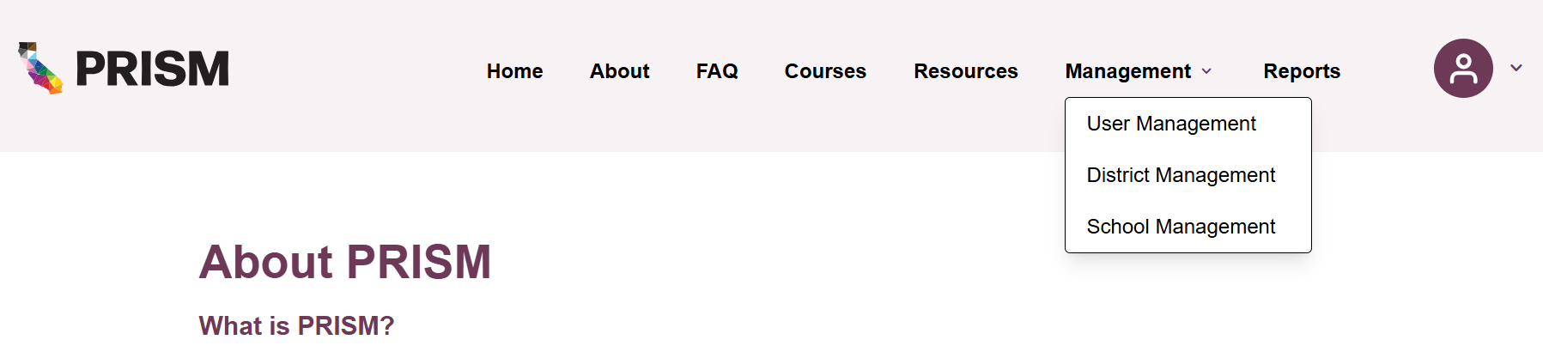

**Step 3:**

Select the **+Add User(s)** button on the right:

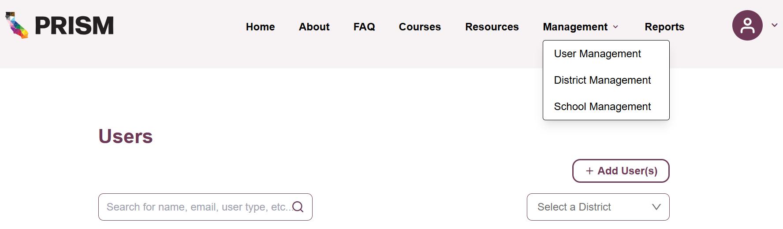

**Step 4:**

The two options are “Add User” or “Bulk Add User”. Choose the “**Bulk Add User”** tab:

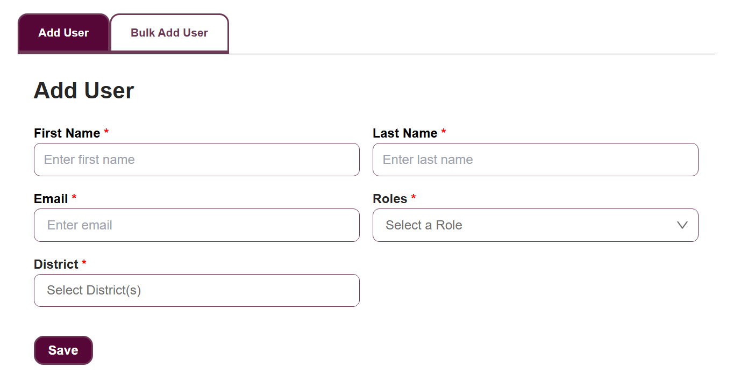

Note: If you want to add users individually, select the “Add User” tab instead.

**Step 5:**

When in the **Bulk Add User** tab, there is a link to **download the required file layout** for the necessary excel spreadsheet:

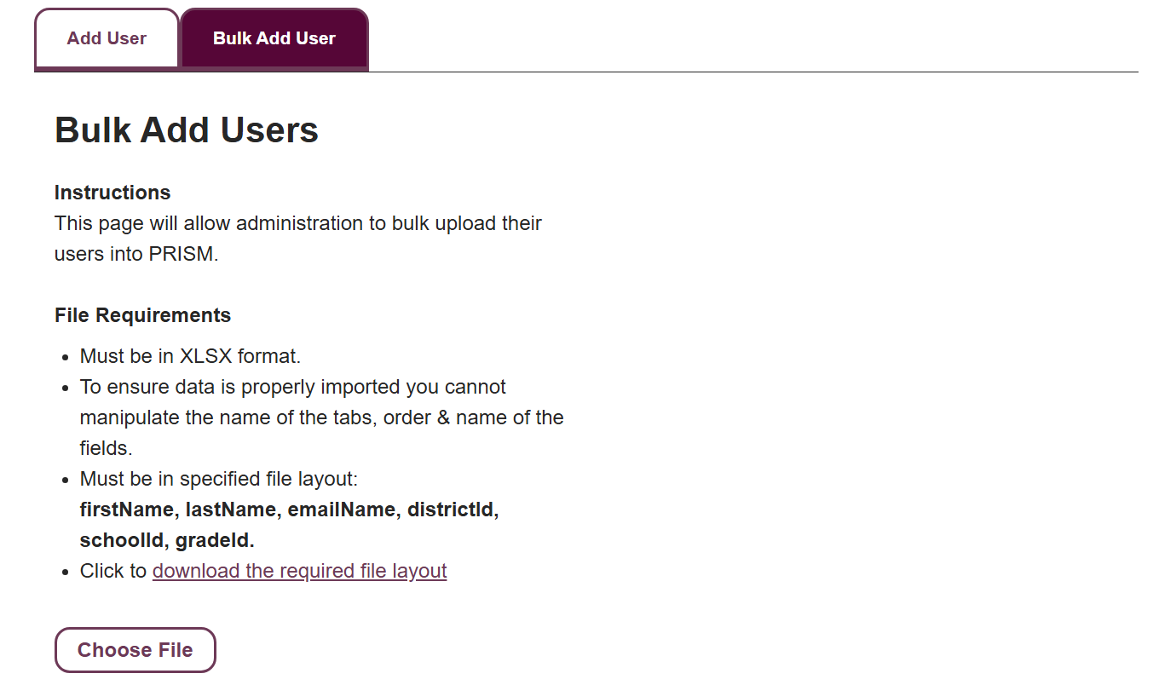

Note: The Bulk Add User page includes instructions stating that this feature allows administrators to upload users into PRISM. It also outlines the requirements, including that the spreadsheet must be in .xlsx format. To ensure the file is imported correctly, the tab name, the order and names of the fields, and the overall file layout must not be altered. For this reason, follow the specified layout. So, please do not change the format of the spreadsheet.

**Step 6:**

While in the excel spreadsheet, use the tabs at the bottom of the spreadsheet to access the required District ID and School ID:

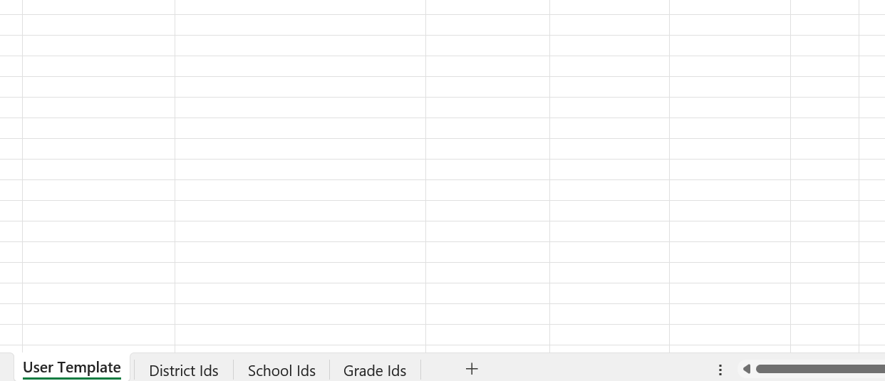

Note: If a user does not have an assigned school site, like a District Teacher on Special Assignment (TOSA), please select “District Office” for the corresponding column.

**Step 7:**

When the spreadsheet is complete, select **Choose File** at the bottom, and upload your saved excel spreadsheet:

