California Department of Education  
August 2025

# PRISM Account Manager Support: How to create an Account Manager

There are two options to create a new Account Manager:

## **Option I: Requesting a New Account Manager**

1. The LEA Superintendent emails PRISM@cde.ca.gov.

2. In the email, provide:

A. First name

B. Last name

C. Email address

D. County

E. District

## **Option II: Manually Adding an Account Manager**

1.If this is your first time accessing your account, activate it first by:

A. Opening the invitation email sent from PRISM. Superintendents received their initial email on July 1, 2025.

B. Clicking the provided link or go to [PRISM California](https://www.prismcalifornia.org/home).

C. Selecting “Forgot password?” to create a password and login.

2. If you have activated your account, follow the steps below to add another Account Manager:

A. Select the **Management** tab at the top, then select **+Add User(s)** on the right:

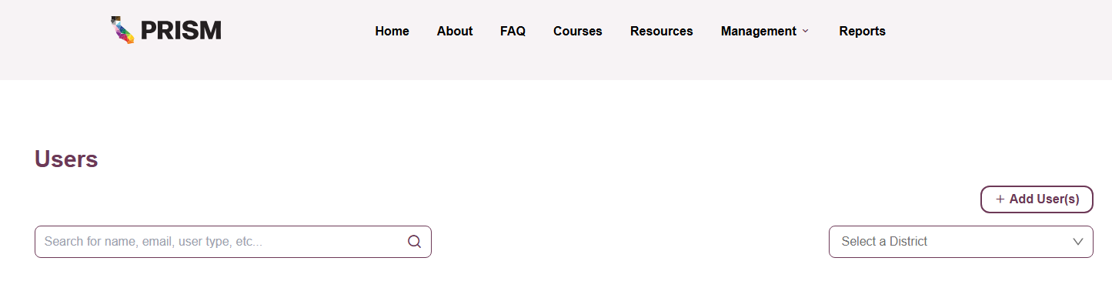

B. Select the **Account Manager** option in the **Roles** drop-down, input all information and save:

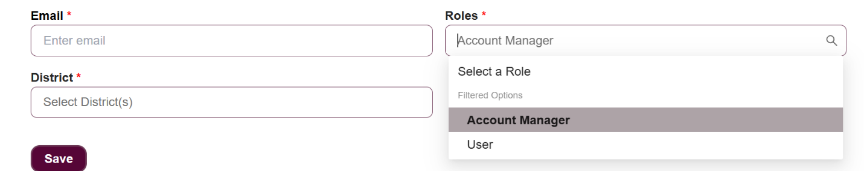

Note: An individual user from the LEA can be added, if “User” is selected as the role in the step above.