California Department of Education November, 2020

Accessing Data Publicly English Learner Data Available on the CDE Webpage

DataQuest
Reports English learner students can be found on DataQuest, the Department’s data reporting website.

DataQuest can be accessed at https://dq.cde.ca.gov/dataquest/

Instructions on accessing reports on English learner students on DataQuest are listed below.

Once on the DataQuest website, select the level to view the report such as “State” or “County.” As shown in Figure 1.
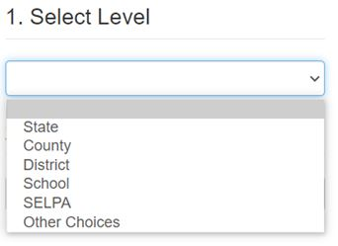
After selecting the level of the report, select the subject of the report such as “Enrollment Data” and “English Learner Data” and then select the “Submit” button. A detailed description of Figure 2 is available in Appendix A on page 6 of this document.
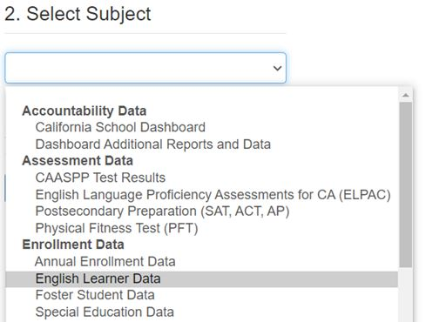

From here, select the school year for the report and then select the “Submit” button. As Shown in Figure 3 below.
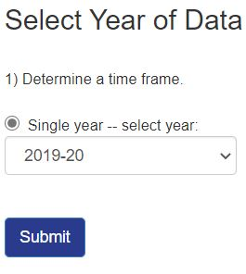

Once on the English Learner Data page, select the EL data report by selecting one of the report options and then select the “Submit” button. A detailed description of Figure 4 is available in Appendix A on page 6 of this document.
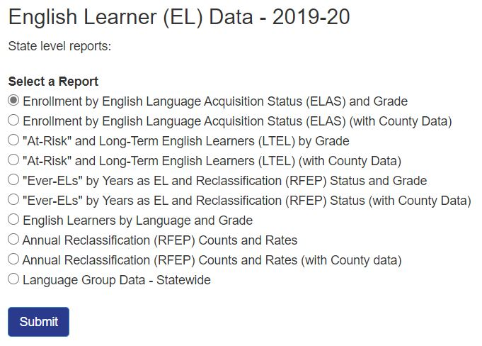

California School Dashboard
Figure 5:
Statewide accountability reports on English learner students can be found on the California School Dashboard (Dashboard), California’s educational accountability system. The Dashboard can be accessed at https://www.caschooldashboard.org/reports/ca/2018.

Instructions on accessing reports on English learner students on DataQuest are listed below.

Once on the Dashboard website, enter a school or district name for which to view outcome data.
Figure 6:

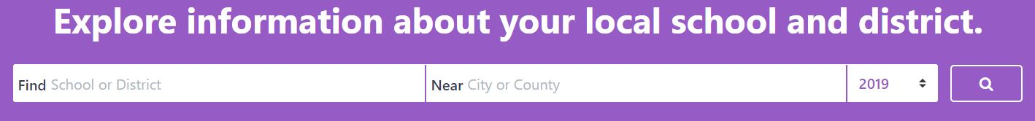

Then select the accountability report to view such as “Chronic Absenteeism” or “Suspension Rate.” As shown in Figure 7.

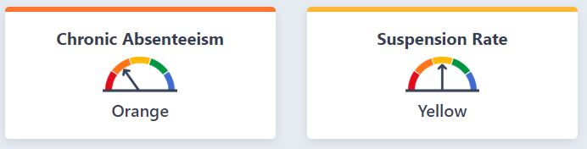
Once on the report landing page, more information for each indicator is displayed, including an “Equity Report” which provides the number of student groups at each of the performance colors (i.e., Red, Orange, Yellow, Green, and Blue). A detailed description of Figure 8 is available in Appendix A on page 6/7 of this document.

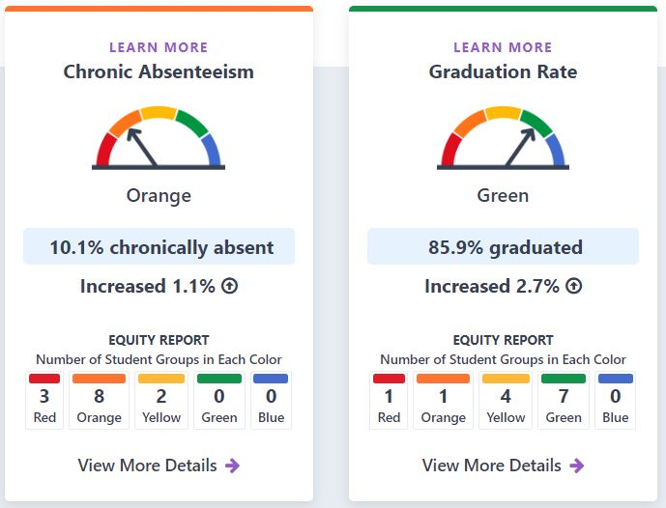

Select the “View More Details” option under the specific accountability card for more information.
Then scroll down below the “Student Group Details” section to view the statewide performance for each student group by performance color. A detailed description of Figure 9 is available in Appendix A on page 7 of this document.

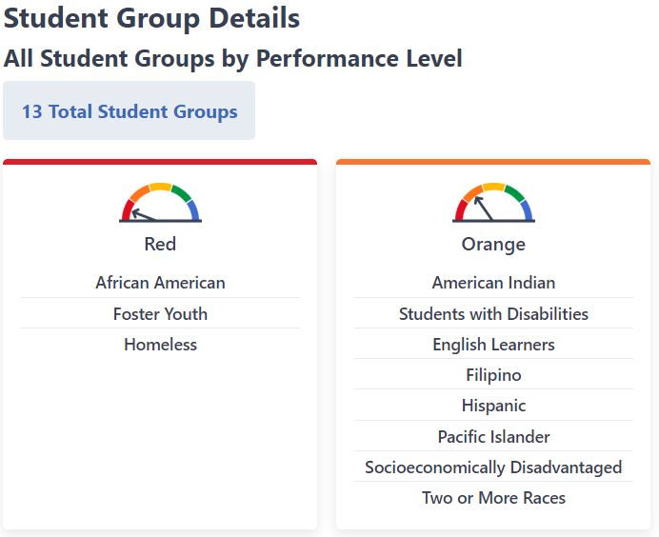

Then scroll down further below for the “Explore Groups by Performance Level” section to view the statewide performance for English learner students for the indicator selected. As shown in Figure 10.

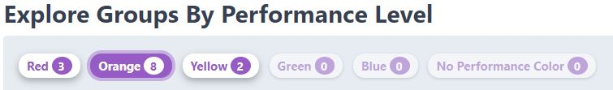

Select the performance color of the EL student group for more information on EL performance. A detailed description of Figure 11 is available in Appendix A on page 7/8 of this document.

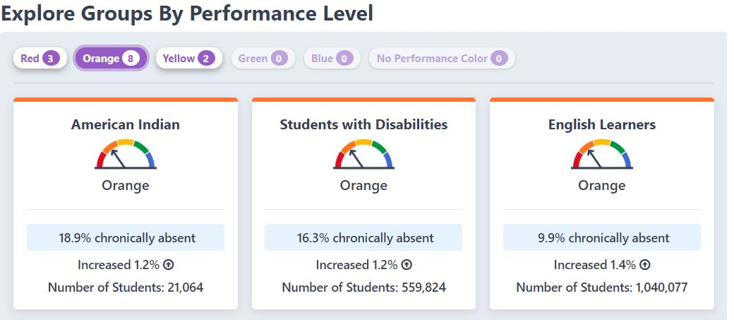

Appendix A – Descriptive Text for images.

Figure 2 – Descriptive Text
Image shows select subject with a dropdown of some available options:
Accountability Data
California School Dashboard
Dashboard Additional Reports and Data
Assessment Data
CAASPP Test Results
English Language Proficiency Assessments for CA (ELPAC)
Postsecondary Preparation (SAT, ACT, AP)
Physical Fitness Test (PFT)
Enrollment Data
Annual Enrollment Data
English Learner Data (Highlighted as an example of a selection to choose)
Foster Student Data
Special Education Data

Figure 4 – Descriptive Text
Image shows the Report Filters English Learner (EL) Data. State Level Reports:
Select a Report: (Shows available options to select from)

- Enrollment by English Language Acquisition Status (ELAS) and Grade
- Enrollment by English Language Acquisition Status (ELAS) (with County Data)
- “At-Risk” and Long-Term English Learners (LTEL) by Grade
- “At-Risk” and Long-Term English Learners (LTEL) (with County Data)
- “Ever-ELs” by Years as EL and Reclassification (RFEP) Status and Grade
- “Ever-ELs” by Years as EL and Reclassification (RFEP) Status (with County Data)
- English Learners by Language and Grade
- Annual Reclassification (RFEP) Counts and Rates
- Annual Reclassification (RFEP) Counts and Rates (with county data)
- Language Group Data – Statewide
Blue submit button shown in image.

Figure 8 – Descriptive Text

The image is of the 2019 Dashboard web page. Indicator In-Depth Display. Information Displayed is as below, from left to right:

- Learn More –Chronic Absenteeism
  - Gauge Indicator image pointing to Orange
  - 10.1% chronic absenteeism rate
  - Increased –1.1% (Arrow pointing up)
  - Equity Report –Number of Student Groups in Each Color • 3 –Red, 8 –Orange, 2-Yellow, 0 –Green, 0 –Blue
  - Select the “View More Details” option under the specific accountability card for more information.

- Learn More –Graduation Rate
  - Gauge Indicator image pointing to Orange
  - 85.9% graduation rate
  - Increased –2.7% (Arrow pointing up)
  - Equity Report –Number of Student Groups in Each Color • 1 –Red, 1 –Orange, 4-Yellow, 7 –Green, 0 –Blue
  - Select the “View More Details” option under the specific accountability card for more information.

Figure 9 – Descriptive Text
This image shows two examples of Student Group Details.
All Student Groups by Performance Level.
13 Student Groups:
Image on left shows: Gauge pointing to Red with three listed groups
African American
Foster Youth
Homeless
Image on right shows: Gauge pointing to Orange with 8 listed groups
American Indian
Students with Disabilities
English Learners
Filipino
Hispanic
Pacific Islanders
Socioeconomically Disadvantaged
Two or More races are in Orange.

Figure 11 – Descriptive Text
The image shows an example of Explore Groups By Performance Level:
There are three baseball like cards that detail the indicators. Within each indicator there is an opportunity to view additional data. Starting from left to right the indicators include the following:

- American Indian - Gauge Indicator arrow pointing to Orange
  - 18.9 percent chronically absent
  - Increased 1.2 percent
  - Number of Students 21,064

- Students with Disabilities - Gauge Indicator arrow pointing to Orange
  - 16.3 percent chronically absent
  - Increased 1.2 percent
  - Number of Students 559,824

- English Learners - Gauge Indicator arrow pointing to Orange
  - 9.9 percent chronically absent
  - Increased 1.4 percent
  - Number of Students 1,040,077

