Beyond Safe Havens Conference
California Department of Education
September 22, 2017

Keynote Speakers

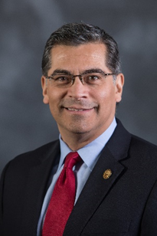
Attorney General, Xavier Becerra

The Honorable Attorney General Becerra is the 33rd Attorney General of California and the first Latino to hold the office in the history of the state. Mr. Becerra is the State’s chief law enforcement officer and has decades of experience serving the public through appointed and elected office where he has fought hard for working families, championed the economy and Social Security, and impacted the generation of jobs in health care, clean energy, technology, and entertainment.
Attorney General Becerra previously served 12 terms as a distinguished member of the U.S. House of Representatives and was a former Deputy Attorney General with the California Department of Justice. Born in Sacramento, he was the first in his family to receive a four-year degree, earning his bachelor of arts in economics, and later his Juris Doctorate at Stanford University. Mr. Becerra’s mother was born in Jalisco, Mexico and immigrated to the United States after marrying his father. He and his wife are the proud parents of three daughters.

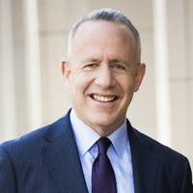
City of Sacramento Mayor, Darrell Steinberg

Darrell Steinberg is currently the Mayor of Sacramento and previously served as Senate President pro Tempore in the California Legislature. He is one of Sacramento’s most accomplished public servants, serving the Sacramento community for over 20 years in both houses of the Legislature. In 2010, he was awarded the John F. Kennedy Profile in Courage award in recognition of his leadership in bipartisan negotiations leading to the state’s fiscal recovery.

Mayor Steinberg, a relentless advocate for mental healthcare, authored Proposition 63, the Mental Health Services Act, creating a one billion-dollar system for dynamic mental health care in California. With a background in law and a Juris Doctorate from UC Davis Law School, he has led reform in criminal justice, insurance, and pensions and has focused on economic development, environmental sustainability, homelessness, and career technical education.

Mayor Steinberg’s vision, dream, and years of dedication recently became a reality at the launch of the Unity Center at the California Museum, celebrating the state’s diverse people, customs, and cultures.

Panelists

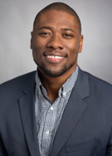
Ryan Smith, Executive Director, Education Trust-West

Executive Director of The Education Trust–West, a research and advocacy organization focused on educational justice and the high academic achievement of all California students, particularly those of color and living in poverty.


Fatima Avelica, Student, Academia Avance Charter School, Los Angeles

Since witnessing the detention of her father, Romulo Avelica, Fatima has become a national spokesperson and advocate for American immigrant families that are directly impacted by today’s broken immigration system. This recent experience has sparked an interest in the field of immigration as well as helping other families in the immigrant community.


Feliza I. Ortiz-Licon, Ed.D., Senior Director, Education Leadership Development, UnidosUS

Ms. Ortiz-Licon currently serves as the Senior Director of Education Leadership Development at UnidosUS (formerly National Council of La Raza), the largest national Latino civil rights and advocacy organization in the United States. This current position truly enhances her passion in advocating for underrepresented youth, reshaping the narrative and opportunities for Latinos and creating pathways to access higher education and post-secondary options.

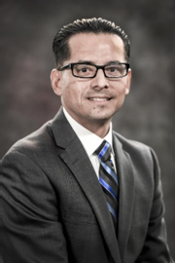
Jorge Aguilar, Superintendent, Sacramento City Unified School District (SCUSD)

Superintendent Aguilar leads the 13th largest school district in California. He has over 20 years of K-12 and higher education experience with a strong focus and background on issues of equity and student achievement. Mr. Aguilar has a proven track record using data to improve student outcomes, and is dedicated to the SCUSD Safe Haven Initiative and to supporting California Dreamers.


Jessie Ryan, Board Trustee, Sacramento City Unified School District (SCUSD)

Ms. Ryan is a product of public education and has led many advocacy efforts including the improvement of college opportunities and access for low-income students. Ms. Ryan is committed to protecting students and promoting tolerance. She was instrumental in crafting and implementing SCUSD’s Safe Haven Initiative and remains committed to serving all students.

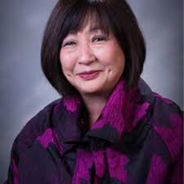
Karen Sakata, Superintendent, Contra Costa County Office of Education

Superintendent Sakata administers all County Office of Education programs and facilitates cooperation among schools, colleges, universities, government and community organizations. She is responsible for monitoring and approving all school district budgets. In addition, she serves as an advocate for education with the legislature and the public.

Moderator


Viviana Paez, News Anchor, Univision 19

Viviana Paez is a dynamic, vivacious news anchor and reporter for Univision 19 in Sacramento. Ms. Paez earned a master of arts in broadcast journalism at Miami University and has worked in the Spanish language news reporting profession in Florida and New Mexico. Ms. Paez was born in Barranquilla, Colombia and speaks Spanish, French, and English.

