Summer Food Service Program Claim for Reimbursement Instructions
July 2025

Nutrition Fiscal Services
Fiscal and Administrative Services Division
California Department of Education
This publication was produced by the Nutrition Fiscal Services (NFS) Unit of the Fiscal and Administrative Services Division (FASD), California Department of Education (CDE). NFS’ mailing address is 1430 N Street, Suite 2213, Sacramento, CA 95814. Comments regarding the content of this publication should be directed to Wesley Wong, Manager, NFS, FASD, 916-323-8355. For clarification on instructions, call 1-800-952-5609 and select Option #1.

Table of Contents
Summer Food Service Program Claim for Reimbursement Instructions July 2025 0
Introduction 2
Terminology and Definitions 3
Claim Submission Deadline Policy 5
Late Claims 5
Claiming Instructions for the SFSP 6
Monthly Reporting Through the CNIPS Website 6
A. Logging on to the CNIPS website 6
B. Creating a Monthly Claim in CNIPS 7
C. Certifying & Submitting a Monthly Claim 16
D. Creating an Adjusted Monthly Claim 16
E. Upload Claim Data Option 17
F. Additional information for Claim Preparers 19
Appendix A 22
Descriptive Text for Figures 22

Introduction
The Summer Food Service Program (SFSP) is a federally assisted meal program that was developed by the United States Department of Agriculture (USDA) and is administered by the California Department of Education (CDE). The SFSP was developed in order to provide nutritious meals in lower-income areas during the summer months to children who would normally be eligible for free and reduced-price meals during the regular school year. The CDE reimburses participating agencies (sponsors) meals times rates for the operational and administrative costs of providing meals.
Once approved to participate in the SFSP, each sponsor must submit a monthly Claim for Reimbursement to receive payment for meals served. Instructions are provided in this publication to assist the claim preparer. If the claim preparer has questions related to claim completion or payments, he or she may contact their assigned fiscal analyst at https://www.cde.ca.gov/fg/aa/nt/.
For specific program details please refer to the CDE Nutrition Services Division (NSD) web page at https://www.cde.ca.gov/ls/nu/sf/sfspinfo.asp or contact the field consultant for your sponsoring agency at 800-333-5675.

Terminology and Definitions
Actual Data - The reportable data for which the sponsor has supporting documentation at the time of claim submission. All data reported on the claim for reimbursement must be actual data.
Adjusted Claim - A revised claim for reimbursement the sponsor submits with changes in data subsequent to the submission of the sponsor’s original claim. Claims submitted subsequent to the submission of the original claim that are a result of an audit or administrative review are excluded from this category (see "audited claim").
Audited Claim - Corrections or changes made to a previously submitted claim as a result of the findings of an audit. These claim adjustments are entered by Nutrition Fiscal Services (NFS) staff and are considered final.
Cash Advance - Payment made in advance of the claim reimbursements to improve cash flow.
Claim for Reimbursement - A request for reimbursement submitted by a participating agency (sponsor) to the California Department of Education (CDE) for payment of reimbursable meals served.
Claim Month - The corresponding month during which meals were served and for which the sponsor is claiming reimbursement.
Claim Submission Deadline - The final date a claim may be accepted for consideration of payment is the sixtieth (60th) day following the last day of the claim month. The deadline is extended to the next business day when the 60th day is on a weekend or on a federal holiday.
CNIPS (Child Nutrition Information and Payment System) - The CDE's web-based system for administering the federal and state child nutrition programs.
FASD (Fiscal and Administrative Services Division) - A division of the CDE that provides accounting, budgeting, contracting, fiscal, and support services.
NFS (Nutrition Fiscal Services) - The unit within FASD responsible for processing nutrition claims for reimbursement. The NFS unit operates independent of the Nutrition Services Division.
NSD (Nutrition Services Division) - The division in the CDE that administers the United States Department of Agriculture (USDA) Food and Nutrition Service’s (FNS) Child Nutrition Programs and the Food Distribution Program in California.
Original Claim - The first claim for reimbursement submitted by a sponsor to the CDE for a particular month.
Sponsor - An agency or district that is approved to participate in the child nutrition programs.
State Agency - The state educational agency designated by the Governor or other appropriate executive or legislative authority of the state and approved by the USDA to administer nutrition programs in the state. The CDE is the state agency that administers the SFSP for California.
USDA (United States Department of Agriculture) - A government agency that works with the CDE to increase food security and reduce hunger by providing children and low-income people with access to food, a healthy diet, and nutrition education.

Claim Submission Deadline Policy
To be eligible for reimbursement, a claim preparer for each sponsor must submit a monthly claim for reimbursement that provides data in sufficient detail to justify the reimbursement claimed. The data must include, at a minimum, the number of meals served, and an authorized agent or district official of the sponsor must certify and submit the claim in the CNIPS.
All claims submitted must be certified by the authorized official to be considered a valid claim.
All original and upward adjusted claims resulting in a payment must be submitted by the sixtieth (60th) day following the last day of the month claimed to be considered for payment. The deadline is extended to the next business day when the 60th day is on a weekend or on a federal holiday. Claims submitted after the deadline cannot be processed, except as described in the section below, under, "Late Claims.”
Claims that are corrected must be re-certified and submitted after the correction is made and the claim is saved.
Claim Submission Deadlines for SFSP can be found on the following CDE web page:
https://www.cde.ca.gov/fg/aa/nt/sfspdeadlines.asp

Late Claims
There are two types of adjusted claims that can be accepted after the claim submission deadline:
- Claims containing changes to meal or eligibility data that result in no increase in reimbursement.
2. Downward adjusted claims. An adjusted claim must be submitted to correct an error that resulted in the sponsor being overpaid.
Upward adjusted claims that are submitted after the claim submission deadline and result in an increase in reimbursement cannot be processed. Upward adjusted claims submitted after the deadline will automatically be rejected for payment in the CNIPS and will not be processed unless the reasons for a late submission meet one or more of the criteria described at the following CDE web page:
https://www.cde.ca.gov/fg/aa/nt/sfspplateclms.asp

Claiming Instructions for the SFSP
These instructions were prepared for and are directed to sponsors’ claim preparers to help complete claims for reimbursement for the Summer Food Service Program (SFSP).
Sponsors should typically enter program information for one claim month only, with the option of including up to 10 operating days from the preceding or following month on a combined claim.
Per Code of Federal Regulations 7 CFR 225.6(h(3)(iii), non-congregate meals can only be offered in areas where congregate meals are not available. If a site is approved as a hybrid site that serves both congregate and non-congregate meals, a single meal type cannot be served as both congregate and non-congregate.
An error or omission on any of the following items may cause the claim to be rejected, resulting in delays in processing the sponsor’s claim and the receipt of reimbursement.

Monthly Reporting Through the CNIPS Website

A. Logging on to the CNIPS website
- You can access CNIPS from any computer connected to the Internet by opening your Internet browser and entering the URL (shown below) in the address line:
https://www.cnips.ca.gov/
TIP: You can add this URL to your browser’s “Favorites” list or create a shortcut to the website on your desktop for quicker access to the site. Refer to your browser or operating system help files for further information.

Figure 1: CNIPS Home Page Log On
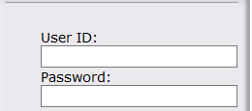
- In the Log On section (Fig. 1) enter your User ID and Password. (User ID and Password are case-sensitive, so be sure to use uppercase and lowercase letters if necessary.)
- Select Log On.
Note: If you do not have a User ID and Password, contact your SFSP County Specialist. The SFSP County Specialist directory is available in the CNIPS Download Forms section, Caseload SFSP or call 1-800-952-5609, option 2.

B. Creating a Monthly Claim in CNIPS
- Verify that the program year is correct for the claim you wish to create. To change the program year, select the year link in the CNIPS main menu bar and choose the appropriate year. (Fig. 2)
Note: The current program year is the default year if no other year has been selected.

Figure 2: Program Year Select
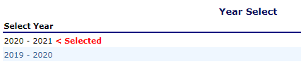
- Select the Claims link in the menu bar at the top of the CNIPS website page. (Fig. 3)

Figure 3: Selecting Claims
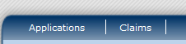
- Select Claim Entry located under Item. (Fig. 4)

Figure 4: Selecting Claim Entry
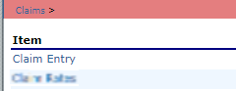
The Claim Entry function is used to enter, modify, and view claims for the Summer Food Service Program. In order to create a claim for a given month, an application must be in effect for the period and the month must be identified as an operating month in the sponsor’s site application(s).
- Select the month being claimed in the Claim Year Summary page. (Fig. 5)

Figure 5: Claim Year Summary Page
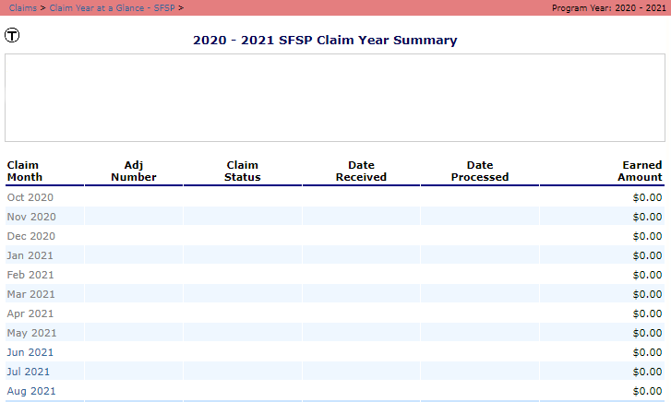
After selecting Claim Entry from the Claims menu, the SFSP Claim Year Summary for the selected year displays. This screen summarizes the Earned Amounts (the current value of the claim) and the Claim Status by month. Once the CDE has received the claim, the Date Received displays in the respective column. Once the CDE has processed the claim, the Date Processed appears in the respective column. The Adjustment Number column refers to the number of times the original claim has been modified (Modified claims must be re-processed by the CDE). Selecting a claim month will take you to the SFSP Claim Month Details screen.
- Select the Add Original Claim button. (Fig. 6)

Figure 6: Select Add Original Claim
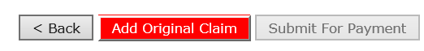
Claims can be added for any eligible month in the program year, as long as an application is in effect for that period. Once a claim has been completed and submitted without error, the CDE can process the claim and batch the claim for payment.
WARNING: An original claim cannot be submitted if the received date is more than 60 days since the last day of the previous claim month.
- Select the Add link under Actions next to the site you wish to create the claim for. (Fig. 7)

Figure 7: Select Add link for Site Level Claim
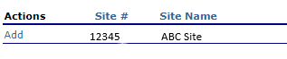
- Complete the General Information portion of the claim report for each site. Enter the required information in the Total Number of Days Food Served column. (Fig 8)
Complete the Meals Served to Children section by entering the reimbursable First Meals Served, Second Meals Served, and/or Camp Meals Served, for each approved meal type. (Fig. 8)
Note: If a site is approved for an Excessive Heat or Poor Air Quality waiver, include the waivered operating days under the “Total Number of Days Congregate Food Served” (even though the Excessive Heat and Poor Air Quality waiver allows you to serve in a Non-Congregate setting, USDA still counts those as congregate days).

Figure 8: SFSP Site Claim Report 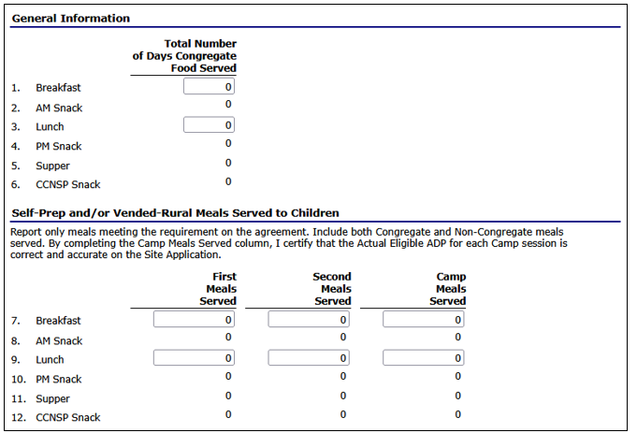
Long description for Figure 8 is available in Appendix A.
- The Rural Non-Congregate Meal Service section of the SFSP claim will only appear if a sponsor has sites approved for Rural Non-Congregate meal service. Please remember meal counts entered in this section of the claim should already be included in sections 7-12 shown in Fig. 8.
If a site is approved for Rural Non-Congregate meal service, complete the Rural Non-Congregate section for each site that is approved. Please use the information below to aid in completing this section. (Fig. 9)
  - Number of Non-Congregate Meals Served (First Column): This column represents the total number of Rural Non-Congregate meals served for the claim month.
  - Number of Days Non-Congregate Meals were Distributed (Second Column): This column represents the number of days in the month that meals are distributed via meal pick-up or meal delivery. If a Rural Non-Congregate site distributes five days’ worth of lunches every Monday, and there are four Mondays in the month, 4 would be entered in this column for lunches.
  - Number of Days Non-Congregate Meals were Provided (Third Column): represents the total number of days that meals were provided for in the month. In the same example above, since five lunches were distributed across four Mondays, 20 would be entered in this column for lunches.
Please note: Meals should always be claimed in the month they are distributed in. If a site distributes five days’ worth of meals on January 31st, all five meals would be claimed in January, even if they were intended for use in February.

Item 1. Breakfast
Enter the total number of Rural Non-Congregate breakfasts served during the month in the first column. On the second column, enter the total number of distribution days for the month. On the third column, enter the total number of days that breakfasts were provided for the entire month. (Fig. 9)

Item 2. AM Snack
Enter the total number of Rural Non-Congregate AM Snacks served during the month in the first column. On the second column, enter the total number of distribution days for the month. On the third column, enter the total number of days that AM Snacks were provided for the entire month. (Fig. 9)

Item 3. Lunch
Enter the total number of Rural Non-Congregate lunches served during the month in the first column. On the second column, enter the total number of distribution days for the month. On the third column, enter the total number of days that lunches were provided for the entire month. (Fig. 9)

Item 4. PM Snack
Enter the total number of Rural Non-Congregate PM Snacks served during the month in the first column. On the second column, enter the total number of distribution days for the month. On the third column, enter the total number of days that PM Snacks were provided for the entire month. (Fig. 9)

Item 5. Supper
Enter the total number of Rural Non-congregate suppers served during the month in the first column. On the second column, enter the total number of distribution days for the month. On the third column, enter the total number of days that suppers were provided for the entire month. (Fig. 9)

Figure 9: Rural Non-Congregate Meal Service
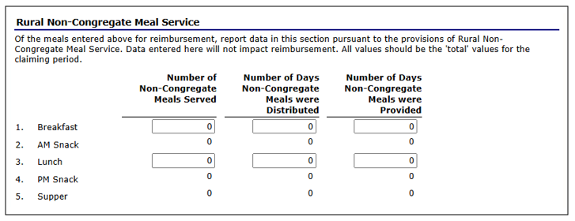
Long description for Figure 9 is available in Appendix A.
- The Excessive Heat or Poor Air Quality Waiver section of the SFSP claim will only appear if a sponsor has sites approved for Excessive Heat or Poor Air Quality waivers. Please remember operating days and meal counts entered in this section of the claim should already be included in sections 1-12 shown in Fig. 8.
If a site is approved for Excessive Heat or Poor Air Quality Waiver meal service, complete the Excessive Heat or Poor Air Quality Waiver section for each site that is approved. Please use the information below to aid in completing this section. (Fig. 10)

Item 1. Breakfast
Enter the total number of breakfasts served during the month in the first column. On the second column, enter the number of days breakfast was served for the month. (Fig. 10)

Item 2. AM Snack
Enter the total number of AM Snacks served during the month in the first column. On the second column, enter the total number of days that AM Snacks were served for the month. (Fig. 10)

Item 3. Lunch
Enter the total number of lunches served during the month in the first column. On the second column, enter the number of days lunch was served for the month. (Fig. 10)

Item 4. PM Snack
Enter the total number of PM Snacks served during the month in the first column. On the second column, enter the total number of days that PM Snacks were served for the month. (Fig. 10)

Item 5. Supper
Enter the total number of suppers served during the month in the first column. On the second column, enter the number of days supper was served for the month. (Fig. 10)

Item 6. Enter Specific dates that meals/snacks were taken off-site:
Enter the month and each day of the month that meals/snacks were taken off site. Please follow the date format below:
Example: 6/9, 6/10, 6/11, 6/12, 6/13.

Figure 10: Excessive Heat or Poor Air Quality Waiver
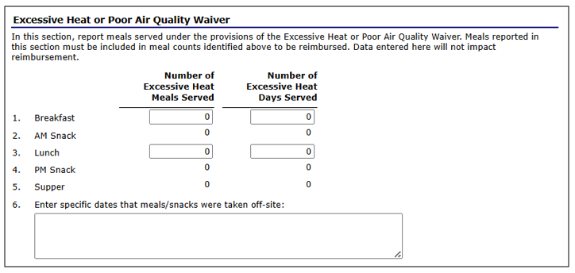
Long description for Figure 10 is available in Appendix A.
- Select Save followed by the Finish button. CNIPS takes you back to SFSP Claim Site List.
- Continue working on each site by following steps 7 through 10 until all intended site claims are reported.
- Once completed, select the Continue button at the bottom of the SFSP Claim Site List screen. (Fig. 11)

Figure 11: Continue Button
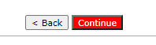
- Claim for Reimbursement – Sponsor Information screen will display. Complete the General Information section for inclusive dates of operation, number of participating sites, and total number of days of operation (Fig. 12), then select the Continue button.

Figure 12: General Information (Sponsor Level)
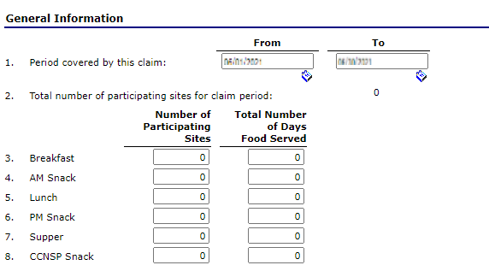
Long description for Figure 12 is available in Appendix A.

Item 1. Period covered by this claim (Fig. 12)
This information should cover activities during one claiming period. Sponsors providing food service for 10 days or less during a calendar month may combine that month’s claim with either the preceding month or the following month’s claim:
- If there are 10 operating days or less in the first month of operation, that month’s meal counts may be combined with the following month’s claim; and/or
- If there are 10 operating days or less in the following month of operation, that month’s meal counts may be combined with the preceding month’s claim.
- If there are 10 operating days or less in both the first month of operation and final month of operation, meal data for both months may be added to the full month’s claim.
- Claim data may not span more than three consecutive months.

Item 2. Total number of participating sites for this claim period (Fig. 12)
The total number of participating sites will be automatically populated in CNIPS.

Items 3-8. Number of Participating Sites (Fig. 12)
Enter the number of meal service sites next to the corresponding meal type. If a sponsor operates 1 site that serves breakfast, lunch, and supper, the claim preparer will enter a 1 in the field next to breakfast, lunch, and supper.

Items 3-8. Total Number of Days Food Served (Fig. 12)
Enter the number of meal service days next to each meal type served.

Items 9-14. Self-Prep and/or Vended-Rural Sponsors Only (Fig. 13)
- First Meals Served: Enter the number of meals served to children.
- Second Meals Served: Enter the number of second meals served to children.
- Camp Meals Served: Enter the number of camp meals served to children.
- Total Meals Served: This field will automatically calculate based on the number of meals served from the categories above.

Figure 13: Meals Served (Sponsor Level)
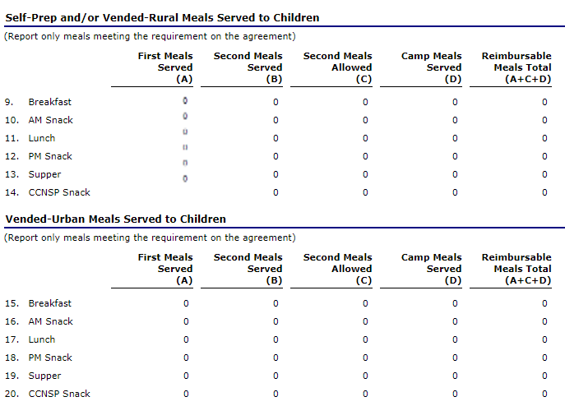
Long description for Figure 13 is available in Appendix A.

Items 15-20. Vended-Urban Sponsors Only (Fig. 13)
- First Meals Served: Enter the number of meals served to children.
- Second Meals Served: Enter the number of second meals served to children.
- Camp Meals Served: Enter the number of camp meals served to children.
- Total Meals Served: This field will automatically calculate based on the number of meals served from the categories above.
Note: Sponsors are reimbursed for second meals served up to two percent of the first meals served. CNIPS calculates the allowable seconds and displays the number on the claim summary screen. Camps are not eligible for reimbursement of second meals.

C. Certifying & Submitting a Monthly Claim
In order to successfully submit your claim, an authorized official must check the Certification box and select the Submit For Payment button. (Fig. 14)
Once you have submitted the claim, you will see a confirmation page. Select Finish to take you back to the claim month details page. When successfully submitted, the claim status will change from Pending to Accepted.

Figure 14: Certify & Submit Monthly Claim
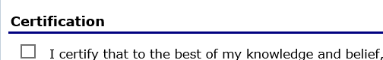
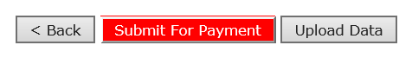

D. Creating an Adjusted Monthly Claim
Step 1 Follow Section B “Creating a Monthly Claim in CNIPS” steps 1 through 4.
Step 2 Select the Add Revision button. (Fig. 15)

Figure 15: Select Add Revision
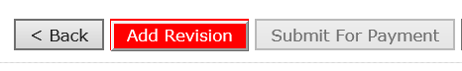
Step 3 Follow Section B steps 6 through 13.
Note: An adjusted claim for reimbursement completely replaces all the previously submitted data for the same claiming period. Therefore, when submitting an adjustment, the sponsor must report all data whether there has been a change or not.
WARNING: An original claim or upward adjusted claim cannot be submitted if the received date is more than 60-days from the last day of the claim month.

E. Upload Claim Data Option
Importing claim information from your Point of Sale (POS) system into the CNIPS is fast and easy. Importing the file saves the time and effort of keying in your claim data manually. The CNIPS can accept your agency’s site-specific data and aggregate it for claiming purposes. To import claim information into the CNIPS, your claim file must be formatted as fixed width ASCII text (txt file). Some sponsors may need to work with their POS vendor to develop a method of creating this file.
To import claim data in the CNIPS, follow these five simple steps:
- Create your claim file and save it; you can give the file any name that meets your needs.
- Log into the CNIPS and access the Claim Month Details screen for the selected claim month.
- Select the Upload Data button on the CNIPS screen to upload the file. (Fig. 14)
- When the File Open dialog box appears, navigate to the location where you save your claim files, and select the file you want to import.
- Select the Import button and the CNIPS will import and save your claim data.
After the file has been imported, the CNIPS will display a results screen that will advise you if any records need to be corrected. If there are errors in the data, you can either correct them manually in the CNIPS (just like you would with a claim you entered manually); or you can correct the errors in the POS claim file and re-import the entire corrected file. The file can be imported as many times as necessary. Until the claim is accepted, each new imported file will completely replace the prior claim information with the new claim information. Once the imported claim for the month is approved, subsequent imported files for the same month will result in the creation of a revised claim.

Figure 14: Upload Data button

To Upload Data
TIP: Only text (.txt) files can be uploaded.
- From the Claims menu, select Claim Entry.
The SFSP Claim Summary screen displays.
- Select the desired Claim Month.
The SFSP Claim Month Details screen displays.
- Select Upload Data. (Fig. 10)
The SFSP Claim Upload screen is displayed.
- Select Choose File.
The Choose File dialog box opens.
- Navigate to the location of the file you wish to upload in the dialog box.
Select the file.
- Select Open.
The path of the file is displayed in the Select File text box.
- Select Upload.
Once file has been uploaded without errors, a confirmation displays.
- Select Finish to return to the SFSP Claim Month Details screen.
For more information regarding uploading claim data, please see the SFSP Point of Service File Layout Specifications located in the CNIPS Applications tab within the Download Forms link or directly download the SFSP POS Specs Word document.

F. Additional information for Claim Preparers

To view a claim
- From the Claims menu, select Claim Entry.
The SFSP Claim Summary screen displays.
- Select the desired Claim Month.
The SFSP Claim Month Details screen displays.
- Under Claim Items, select Claim to the left of the claim you wish to view.
The SFSP Claim Site List screen displays.
- Under Actions, select View to the left of the claim site you wish to view.
The SFSP Site Claim Report screen displays.

To view a claim summary
You can view your claim information by selecting the Summary link. This screen will display the meals claimed, reimbursement rates, and the calculated amount. The Claim Summary allows you to view a summary of the month’s claim in an easy-to-read or print format. No modifications can be made from this page.
- From the Claims menu, select Claim Entry.
The SFSP Claim Summary screen displays.
- Select the desired Claim Month.
The SFSP Claim Month Details screen displays.
- Under Claim Items, select Summary to the left of the claim summary you wish to view. The SFSP Claim for Reimbursement Summary screen displays.

Claim Status Descriptions
Not Eligible - Site has an application for the program year but an application condition is preventing this site from being eligible to claim for the selected month. Examples include the site is not operating for the selected month or the application is not yet approved. This status appears on the Site Claim List screen only.
Incomplete - Claim has been created via the Add Original or Add Revision button, but the Save button was never selected. A claim in this status requires action on the part of your agency before it can be accepted.
Pending - The claim has been saved but has not been submitted and validated. This status also occurs when the claim was re-saved after a submit attempt. A claim in this status still needs to be certified and submitted by your agency before it can be accepted.
Error - A monthly claim has been submitted, and one or more site claims have an error. A claim in this status requires action on the part of your agency before it can be accepted.
Validated - The status of Validated is used to distinguish site level report records that are error-free. This status appears on the Site Claim List screen only. A claim in this status still needs to be certified and submitted by your agency before it can be accepted.
Accepted - Claim has been submitted and is ready to be processed.
Processed - Claim has been processed for payment

To delete a claim at the sponsor level
- From the Claims menu, select Claim Entry.
The SFSP Claim Year Summary screen displays.
- Select the desired Claim Month.
The SFSP Claim Month Details screen displays.
- Under Claim Items, select Claim to the left of the claim you wish to delete.
- Select Delete in the Edit menu in the upper-right corner.
- Select Delete.
A confirmation screen displays.
- Select Finish.
WARNING: Once the claim has been deleted, it is permanently removed from the application and cannot be restored. Use caution before deleting a claim.

To delete a claim at the site level
- From the Claims menu, select Claim Entry.
The Claim Year Summary screen displays.
- Select the desired Claim Month.
The Claim Month Details screen displays.
- Under Claim Items, select Claim to the left of the claim you wish to delete.
- Under Actions, select Delete for the corresponding site name.
- Select Delete in the Edit menu in the upper-right corner.
- Select Delete.
A confirmation screen displays.
- Select Finish.
WARNING: Once the claim has been deleted, it is permanently removed from the application and cannot be restored. Use caution before deleting a claim.

Appendix A

Descriptive Text for Figures

Figure 8: SFSP Site Claim Report
General Information section to enter the Total Number of Days Food Served for:
1. Breakfast, 2. AM Snack, 3. Lunch, 4. PM Snack, 5. Supper, 6. CCNSP Snack. The Total Number of Days Food Served should include Excessive Heat or Poor Air Quality waivered days.
Self-Prep and/or Vended-Rural Meals Served to Children section to enter the number of First Meals, Second Meals, and/or Camp Meals for: 7. Breakfast, 8. AM Snack, 9. Lunch, 10. PM Snack, 11. Supper, 12. CCNSP Snack.
Back to Figure 8.

Figure 9: Rural Non-Congregate Meal Service
General Information section to enter the Total Number of Non-Congregate Meals Served, Total Number of Days Non-Congregate Meals were Distributed, and Total Number of Days Non-Congregate Meals were Provided for the claim month for: 1. Breakfast, 2. AM Snack, 3. Lunch, 4. PM Snack, 5. Supper, 6. Enter specific dates that meals/snacks were distributed.
Back to Figure 9.

Figure 10: Excessive Heat or Poor Air Quality Waiver
General Information section to enter the Total Number of Excessive Heat Meals Served for: 1. Breakfast, 2. AM Snack, 3. Lunch, 4. PM Snack, 5. Supper, 6. Enter specific dates that meals/snacks were taken off-site.
Back to Figure 10.

Figure 12: General Information (Sponsor Level)
General Information section to enter the following: 1. Period covered by this claim (to and from dates), 2. Total number of participating sites and total number of days food served for the following meal types: 3. Breakfast, 4. AM Snack, 5. Lunch, 6. PM Snack, 7. Supper, 8. CCNSP Snack
Back to Figure 12.

Figure 13: Meals Served (Sponsor Level)
Sponsor Level Meals Served section to enter the number of First Meals Served (A), Second Meals Served (B), Second Meals Allowed (C), Camp Meals Served (D), and Reimbursable Meals Total (A+B+C) first for Self-Prep and/or Vended-Rural Meals, then for Vended-Urban Meals below.
Back to Figure 13.

