LEA ALTERNATIVES
FOR TRACKING DAILY PARTICIPATION
AND WEEKLY ENGAGEMENT FOR DISTANCE LEARNING
2020-21 School Year

California Department of Education
School Fiscal Services Division
October 2020
www.cde.ca.gov

For questions and assistance regarding the requirements of the CDE Template or an LEA alternative, email attendanceaccounting@cde.ca.gov.

Table of Contents
INTRODUCTION 3
DISTANCE LEARNING DOCUMENTATION AND RECORD KEEPING REQUIREMENTS 4
LEA ALTERNATIVES TO THE CDE TEMPLATE 5
Distance Learning Documentation – Illustration of LEA Options 6
Detail of LEA Options to the CDE Template 6
LEA Combinations 8
Combination A: Lesson Plan and Local SIS 8
Combination B: Local LMS and SIS 9
Combination C: LEA Created Template 10
Key Considerations in Developing LEA Processes 11
Instructional Assignment/Delivery Method, Assignment Tracking, and Instructional Time Certification 11
Attendance/Absence Documentation, Daily Participation Verification, and Certification 12
GLOSSARY OF TERMS 13
RESOURCES 14

INTRODUCTION
For the 2020-21 school year, local educational agencies (LEA) (https://www.cde.ca.gov/ci/cr/dl/distlearningfaqs.asp) providing instruction through distance learning in whole or part are subject to the provisions of the distance learning statutes (Education Code (EC) Section 43500, et. seq). Included within those provisions of law are requirements that the LEA document student attendance, daily participation, and weekly engagement, as well as certifying to the instructional time being assigned to students. As distance learning instruction is only applicable to the 2020-21 school year, the implementing statutes become inoperative on June 30, 2021. The California Department of Education (CDE) recognizes that implementing significant changes to the delivery of instruction to students along with additional recordkeeping requirements in a short span of time is tremendously challenging.
To that end, this document provides information on the various options available to meet distance learning recordkeeping requirements by modifying existing internal student information systems (SIS), learning management systems (LMS), or by creating a local process/system that includes all the required elements. The guidance does not constitute legal advice or a legal service.
A LEA’s wealth of experience with documenting student attendance and maintaining student records will assist with transitioning to these new requirements. Daily participation is akin to taking attendance and the weekly engagement record reflects most of the information already found in a teacher’s lesson plan and/or grade book. Much of the information needed for these records already exists, and for the 2020-21 school year may need to be captured and maintained a little differently than in prior school years. As LEAs evaluate how to meet the distance learning record keeping requirements, the following guiding questions should be considered:
- What do normal attendance, instruction, and assessment workflows look like?
- How would this option fit within normal workflows?
- What are the costs/benefits associated with this option versus others?
The CDE recognizes LEAs will work in partnership with their employees to ensure the process being used at the local level to capture this information is as efficient as possible, clearly understood, uses sound recordkeeping practices, and meets the requirements of the law. LEAs may want to consider pulling together a cross-functional team of staff that includes district administrators, site principals, attendance clerks, and classroom teachers to meet these goals. This will help ensure LEAs are successful during their annual external audit of these requirements and avoid any fiscal consequence to the LEA.
At the close of this document there is a glossary of helpful terms for reference, followed by a list of additional distance learning resources available on the CDE’s website including, frequently asked questions, the CDE’s Daily Participation and Weekly Engagement Tracking template (CDE Template), and additional information on implementing distance learning.

DISTANCE LEARNING DOCUMENTATION AND RECORD KEEPING REQUIREMENTS
As mentioned previously, many of the distance learning documentation requirements cover elements of attendance, participation, and student assignments for which LEAs already have a documentation process (e.g. SIS, LMS, lesson plan/grade book, etc.). Therefore, these requirements might most easily be accomplished by modifying local systems or processes. LEAs that choose to do so versus using the CDE Template should use the following checklist to ensure the modifications to local system/processes meet all the requirements below.
Check Box | Distance Learning Requirement | Statutory Reference | Summary of Requirement | Documentation Level
 | Instructional Assignment/ Delivery Method | 43504(e) | Documents synchronous or asynchronous instruction for each whole or partial day of distance learning, as part of the weekly engagement record. | Class
 | Assignment Tracking | 43504(e) | Documents assigned instruction, school work, and assessments assigned to meet each whole or partial day of distance learning instruction, as part of the weekly engagement record. | Class
 | Attendance/ Absence Documentation | 43504  (d)(1) and (f)(1) | Attendance and absences must be documented to facilitate reporting chronic absenteeism and meet compulsory education requirements. | Student
 | Daily Participation Documentation and Verification | 43504(d)(2), (e) | Daily participation may include, but is not limited to, evidence of participation in online activities, completion of assignments/assessments, contact with student, parents/guardians. Verifying participation is a requirement of the weekly engagement record. | Student
 | Instructional Time Certification | 43502(e)  43504(c) | Certification by LEA certificated staff to time value of assignments so that minimum instructional day and annual school year length requirements can be met. | May be certified at student, class, or grade level.

The above distance learning requirements, in addition to the LEA’s tiered reengagement strategies for students absent from distance learning, will be checked during the annual audit and have a fiscal consequence if not met. EC Section 43504(f)(2) requires an LEA to develop written procedures for tiered reengagement strategies for students that are absent from distance learning for more than three schooldays or 60 percent of the instructional days in a school week.
These requirements apply whether distance learning is provided in whole or for part of an instructional day and result in auditable records, which are maintained at the local level and not submitted to the CDE. It is important for LEAs to have a plan in place to collect and manage information from employees, including teachers that are documenting and maintaining these records, so that the information is available and easily attainable at the time of the annual audit.

LEA ALTERNATIVES TO THE CDE TEMPLATE
Ultimately it is up to an LEA to determine how to modify its current systems and processes to meet all the audited distance learning documentation requirements. One approach is to combine those elements that are student level documentation together and those that can be done at the class level together. The following illustration, table, and examples provide information to help an LEA with understanding the various approaches available to meet the requirements to document student attendance, daily participation, and weekly engagement, as well as certifying to the instructional time being assigned to students through distance learning instruction. The table does not provide an inclusive list of all the different combinations or methodologies available to a LEA, but rather the ones CDE expects would be the most common alternatives to using the CDE Template.
The examples and sample screenshots show how these options may work together to meet the distance learning documentation requirements. Each sample provides information on how to modify existing resources like SIS and LMS and/or lesson plans in order to meet the distance learning documentation requirements.

Distance Learning Documentation – Illustration of LEA Options
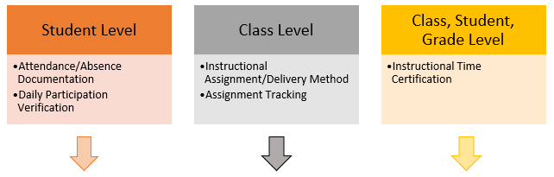

Detail of LEA Options to the CDE Template
(not an inclusive list)
Options | Attendance/Absence Documentation and Daily Participation Verification  EC Section 43504(d)(e)(f) | Instructional Assignment/Delivery Method and Assignment Tracking  EC Section 43504(e) | Instructional Time Certification  EC sections 43502(e) and 43504(c)
Level | Student | Class | May be certified at student, class, or grade level.
Combination A,  SIS + Lesson Plan/Grade Book | SIS captures the following:  - Document attendance and absences  - Document daily participation verification methodology  - Certification to the accuracy and correctness of the attendance record by an employee of the LEA that can attest to first-hand knowledge of the attendance. | Use teacher’s lesson plan and/or grade book to document students’ assignments and document in-person, synchronous, and/or asynchronous instruction for full or partial day. | Create a standalone certification document to be completed by a certificated employee of the LEA certifying to the time value of assignments.
Combination B,  SIS + LMS | Same as Combination A | Use LEA’s LMS, ensure comprehensive assignment tracking, document in-person, synchronous, and/or asynchronous instruction for full or partial day. | Incorporate certification into LMS or create a standalone certification document to be completed by a certificated employee of the LEA certifying to the time value of assignments.
Combination C,  LEA Created Template | LEA template captures the same elements as in 1-3 of Combination A. | LEA template captures the following data:  - Student assignment tracking  - In-person, synchronous, and/or asynchronous instruction for full or partial day. | Incorporate certification into LEA created template or create a standalone certification document to be completed by a certificated employee of the LEA certifying to the time value of assignments.
Combination D,  SIS for All Elements | Same as Combination A | Captures the same elements as in 1-2 of Combination C. | Incorporate certification into SIS.

LEA Combinations
The following visuals of Combination A thru C are meant to help a LEA with modifying existing local systems to meet these requirements. CDE identifies under each how the proposed combination meets the requirements and what modifications are needed to meet the distance learning documentation requirements. While a sample is not shown for Combination D, the other visuals can inform the needed modifications to use a SIS for all elements. Note: The content in the lesson plan and local LMS visuals are an example of documentation and are not intended to be exemplars of content. Additionally, it may be helpful to increase the percentage using the Zoom feature under the View ribbon for enhanced visibility.

Combination A: Lesson Plan and Local SIS
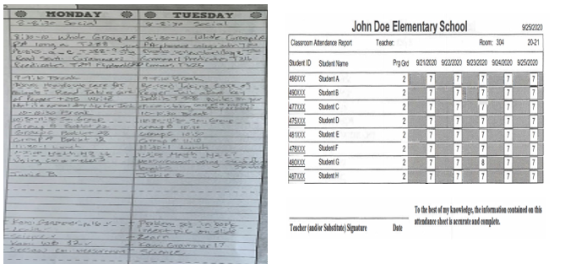
How does Combination A meet the requirements? | What modifications need to be added to Combination A to meet requirements?
LESSON PLAN  - Tracks class assignments | LESSON PLAN  - Modify to document in-person, synchronous, and/or asynchronous instruction for full or partial day.  - Create an instructional time certification document to be completed by a certificated employee of the LEA certifying to the time value of assignments.
LOCAL SIS  - Documents attendance and absences  - Documents daily participation and verification methodology*  - Certifies to accuracy and correctness of attendance | LOCAL SIS  The SIS in this example meets the student level documentation requirements shown on page 5.
*LOCAL SIS CODING: A – Absent & No Participation; 7 – Present in DL; 8 – Not present in DL but submitted work; 9 – Not present in DL, verified student participation in asynchronous assignment thru parent contact.

Combination B: Local LMS and SIS
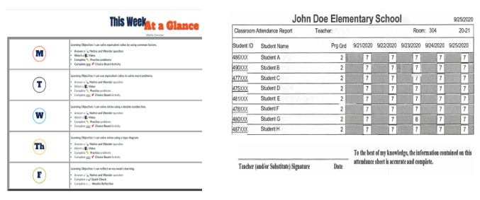
How does Combination B meet the requirements? | What modifications need to be added to Combination B to meet requirements?
LOCAL LMS  - Tracks class assignments | LOCAL LMS  - Modify to document in-person, synchronous, and/or asynchronous instruction for full or partial day.  - Create an instructional time certification document to be completed by a certificated employee of the LEA certifying to the time value of assignments or incorporate into LMS.
LOCAL SIS  - Documents attendance and absences  - Documents daily participation and verification methodology*  - Certifies to accuracy and correctness of attendance | LOCAL SIS  The SIS in this example meets the student level documentation requirements shown on page 5.
*LOCAL SIS CODING: A – Absent & No Participation; 7 – Present in DL; 8 – Not present in DL but submitted work; 9 – Not present in DL, verified student participation in asynchronous assignment thru parent contact.

Combination C: LEA Created Template
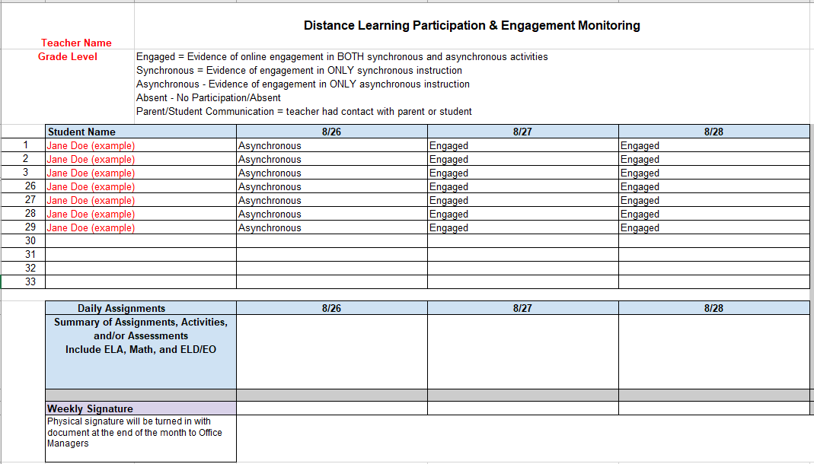
How does Combination C meet the requirements? | What modifications need to be added to Combination C to meet requirements?
- Tracks class assignments*  - Documents attendance and absences  - Documents daily participation and verification methodology | - Modify to document for each day the delivery of instruction methodology, in-person, synchronous, and/or asynchronous instruction for full or partial day.  - Modify the Weekly Signature to include certification language for attendance and instructional time.
*Instead of entering a summary of daily assignments, “See lesson plan/grade book.” is an option for an LEA.

Key Considerations in Developing LEA Processes
The following highlights the distance learning documentation requirement grouped by those that may be maintained at a class level versus those at a student level and identifies additional information an LEA should consider when creating a process to capture each of the necessary elements. Again, it will be important for LEAs to have a plan in place to collect and manage information from employees, including teachers that are documenting and maintaining these records, so that the information is available and easily attainable at the time of the annual audit.

Instructional Assignment/Delivery Method, Assignment Tracking, and Instructional Time Certification
- Instructional Assignment/Delivery Method: documents synchronous or asynchronous instruction for each whole or partial day of distance learning, as part of the weekly engagement record.
  - A class schedule may be used to meet the requirement to document in-person, synchronous, and or asynchronous instruction. LEAs that choose to use this method will still need to meet the assignment tracking or instructional time certification requirements.
  - If maintaining class level records in a departmentalized setting, multiple records will need to be combined across departmentalized subjects to show a full school day for a specific student.
- Assignment Tracking: documents assigned instruction, school work, and assessments assigned to meet each whole or partial day of distance learning instruction, as part of the weekly engagement record.
  - Assignment tracking may be done at the class level and is similar to a teacher’s lesson plan and/or grade book.
  - Sample work product is not required to be included in the daily participation and verification recordkeeping or in the weekly engagement record.
  - It is not necessary to list assignments that are included in any in-person portion of the instructional day in the weekly engagement record.
- Instructional Time Certification: certification by LEA certificated staff to time value of assignments so that minimum instructional day and annual school year length requirements can be met.
  - Statute does not prescribe the frequency of the certification to instructional time.
  - A supervising teacher may complete the instructional time certification. This option may be best suited for a departmentalized setting.
  - LEAs have the flexibility to use alternative certification language rather than what is on the CDE Template.
  - This certification may be completed by signing and scanning, by electronically signing a PDF, or through a signature application such as Docusign, as long as security measures are in place to protect confidential student information. For additional information refer to question 19 under the Attendance Accounting and Reporting header of CDE’s FAQ (https://www.cde.ca.gov/fg/aa/pa/pafaqs.asp).
- For audit purposes, this information will need to be combined with student level participation records to meet the statutory requirements.

Attendance/Absence Documentation, Daily Participation Verification, and Certification
- Attendance/Absence Documentation: attendance and absences must be documented to facilitate reporting chronic absenteeism, and meet compulsory education and audit requirements.
- Daily Participation Documentation and Verification: daily participation may include, but is not limited to, evidence of participation in online activities, completion of assignments/assessments, contact with student, parents/guardians.
  - Indicating the method used when verifying and documenting participation helps meet the daily participation verification requirement for the weekly engagement record. By collecting this information as part of attendance verification at the student level it allows the remaining elements of the weekly engagement record to be documented at a class level.
  - An LEA has discretion to determine the methods used to verify that students participated in at least some part of their assigned day when taking attendance and are not limited to those listed in statute. Other options include participation in synchronous online instruction, i.e. Zoom, participation in asynchronous assignments, etc.
- Documenting and verifying daily participation is done at the student level and is akin to and substantiates taking daily attendance.
- For audit purposes, this information will need to be combined with weekly engagement record at the class level and instructional time certification.
- Attendance Certification: the attendance/absence documentation must be certified by an employee of the LEA with firsthand knowledge of the student’s participation, at least every two school weeks under distance learning whether provided in whole or in a hybrid setting. Examples of employees that may have firsthand knowledge of student participation in assigned instruction, school work, and/or assessments include but may not be limited to teachers, paraprofessionals, and attendance clerks. This certification is different than instructional time certification, which must be completed by a certificated employee. LEAs that want to sign these records electronically must follow the electronic signature requirements discussed in question 19 under the Attendance Accounting and Reporting header of CDE’s FAQ (https://www.cde.ca.gov/fg/aa/pa/pafaqs.asp).

GLOSSARY OF TERMS
- Assignment: The instructional day for each student participating in distance learning is based on synchronous and/or asynchronous assignments, including assigned instruction (e.g. participating in a synchronous online lecture with the teacher, watching an asynchronous lecture, etc.), class discussion, school work, and assessments to meet the instructional day or portion of instructional day made by and certified to by a certificated employee of the LEA.
- Assignment Tracking: Documents assigned instruction, school work, and assessments assigned to meet each whole or partial day of distance learning instruction, as part of the weekly engagement record. If completing assignment tracking at a class level and a teacher is differentiating instruction for groups of students within the class by making separate assignments for each group, the assignment for each group should be indicated.
- Asynchronous: Asynchronous assignments and instruction occurs without direct, simultaneous interaction of participants.
- Full or Partial Day: A full instructional day is the length of the school day established by the local governing board, which is no less than the minimum number of instructional minutes for each grade level. Any amount of time that is less than the full instructional day is a partial day of instruction. A class period in a departmentalized setting may need to be treated as a day for the purpose of indicating the instructional delivery method. This does not mean that a period is the equivalent of a day for instructional time purposes. All students still need to be scheduled for the instructional minutes that apply to their grade span each day in order for a LEA to meet instructional time requirements.
- In-Person: In-person instruction is instruction delivered under the immediate physical supervision of a certificated employee of the LEA in which a student is enrolled.
- No Participation/Absent: The teacher or LEA employee is unable to verify that a student participated in at least some part of the assignments or assigned instruction that is included in the student’s school day. In a distance learning setting, if a student does not participate in at least some part of the assignments or assigned instruction that constitute their school day, that student would generate an absence for that day.
- Participation: Students that participate in any part of the instructional day are considered to be in attendance for that day. In distance learning, the instructional day is based on assignments, including assigned instruction made by and certified to by a certificated employee. Statute does not indicate a specific level of participation or amount of time students must be engaged in order to generate a day of attendance; that determination is at an LEA’s discretion. Since the distance learning instructional day is based on assignments, including assigned instruction, that are the equivalent of a school day, participation in any part of those assignments can result in attendance. Statute requires that participation be verified by an LEA and lists example means of participation such as evidence of participation in online activities, completion of assignments/assessments, and contact with student, parents/guardian. Statute does not limit the means of participation to those listed.
- Synchronous: Synchronous assignments and assigned instruction in distance learning takes place in real-time, with delivery of instruction and/or interaction with participants such as a live whole-class, small group, or individual meeting via an online platform.
The following terms are listed in EC Section 43504(d)(2) as types of daily participation. Daily participation is not limited to the terms listed below.
- Assigned Work/Assessment Completed: A student turns in any of their assigned work or completes an assessment that is included in the assigned day of distance learning or part of a day of distance learning, whether or not the student participates in any synchronous portion of the day. This would not include a homework assignment that is in addition to the synchronous and/or asynchronous assignments that constitute the instructional day for distance learning.
- Evidence of Participation in Online Activities: A teacher or LEA employee is able to verify that a student participated in assigned online instruction, school work, or assessments.
- Student or Parent/Guardian Contact: A teacher or LEA employee is able to verify through contact with a student or parent/guardian that the student participated in at least some part of the assignments or assigned instruction that is included in the student’s distance learning school day or distance learning portion of the school day.
- Other: Any other means an LEA has than those listed whereby a teacher or other LEA employee verifies student participation in their assigned distance learning school day or part of the distance learning school day.

RESOURCES
- CDE’s Combined Daily Participation and Weekly Engagement Template and User Guide
https://www.cde.ca.gov/fg/aa/pa/instructionaltime.asp
- 2020–21 Funding and Instructional Time FAQs
https://www.cde.ca.gov/fg/aa/pa/pafaqs.asp
- Distance Learning Frequently Asked Questions
https://www.cde.ca.gov/ci/cr/dl/distlearningfaqs.asp
- Distance Learning Instruction Planning Guidance
https://www.cde.ca.gov/ls/he/hn/guidanceplanning.asp
- CDE’s COVID-19 Web Page
https://www.cde.ca.gov/ls/he/hn/coronavirus.asp

