California Department of Education
Created 7/20/2023

HOW TO ZIP A FILE AND ATTACH TO AN EMAIL
For files that are larger than 20 mb, you may need to compress “zip” the file in order to attach it to an email. Please find directions below on the process to create a zip file and how to attach the file to an email.

Quick Reference
How to Zip a File or Files on a PC
How to Zip a File on a Mac
How to Zip Multiple Files and Folders on a Mac
How to Attach a Zip File to an Email

How to Zip a File or Files on a PC
- On your computer, locate the file or files that you want to zip.
- Right-click on the file or files, select “Send to” and then select "Compress (zipped) folder".
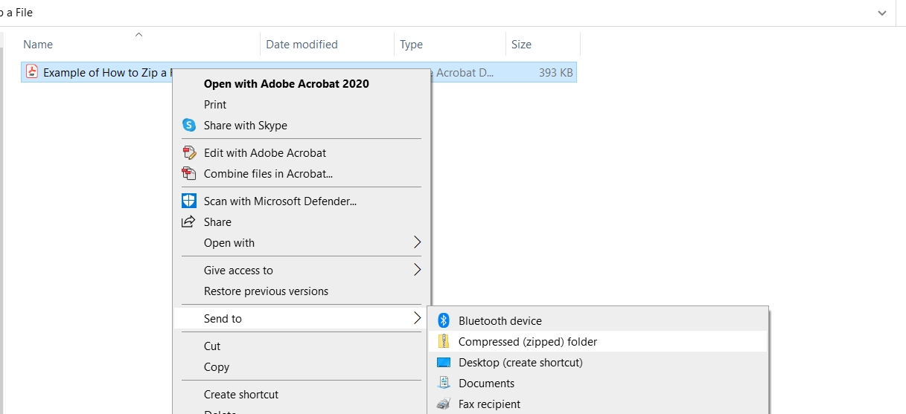

- A new zipped file will be created with the same name as the original file(s), but with a .zip extension.
- Name the folder with the following naming convention:
For an electronic submission of a Form J-13A, title the PDF by local education agency (LEA) name, J13A, fiscal year (FY) that the emergency ended, and incremental submission number XXX (for example: XYZJ13A2023_001 for an LEA’s first Form J-13A submission, XYZJ13A2023_002 for an LEA’s second submission, etc.).
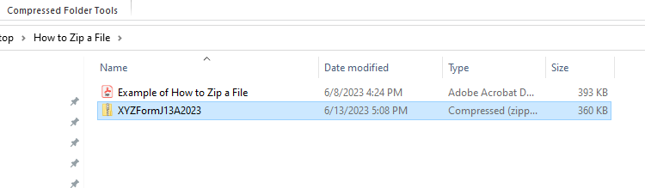

How to Zip a File on a Mac
- Open Finder and navigate to the file or folder you want to compress.
- Control-click or right-click the item and select Compress item name from the menu that opens.
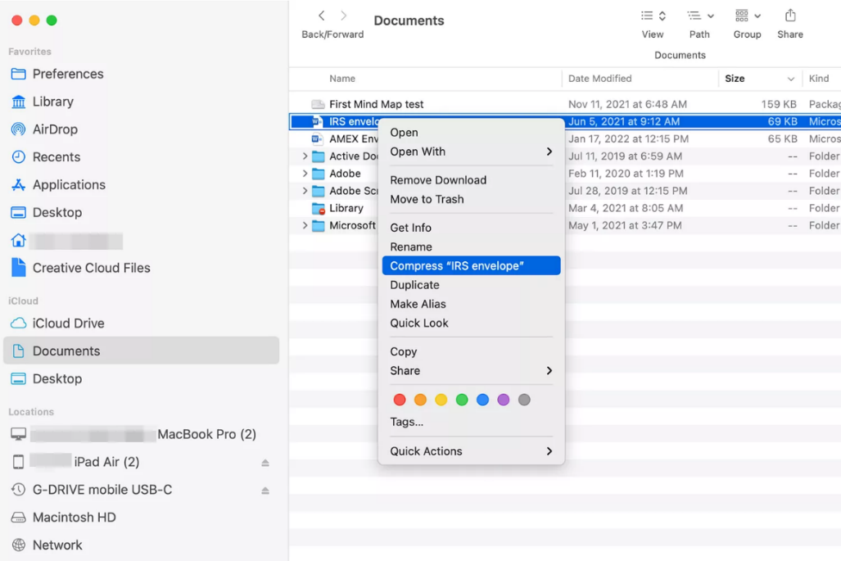
- Look for the compressed version of the file in the same location as the original file. It has the same name as the original file with a .zip extension.
- The Archive Utility zips the selected file and leaves the original file or folder intact.
- Name the folder with the following naming convention:
For an electronic submission of a Form J-13A, title the PDF by LEA name, J13A, FY that the emergency ended, and incremental submission number XXX (for example: XYZJ13A2023_001 for an LEA’s first Form J-13A submission, XYZJ13A2023_002 for an LEA’s second submission, etc.).

How to Zip Multiple Files and Folders on a Mac
Compressing multiple files and folders works similarly to compressing a single item. The main difference is the name of the zip file.
- Open the folder that contains the files or folders you want to compress.
- Select the items you want to include in the zipped file. Shift-click to select a range of files or command-click to select nonadjacent items.
- Right-click or control-click any one of the items and select Compress.
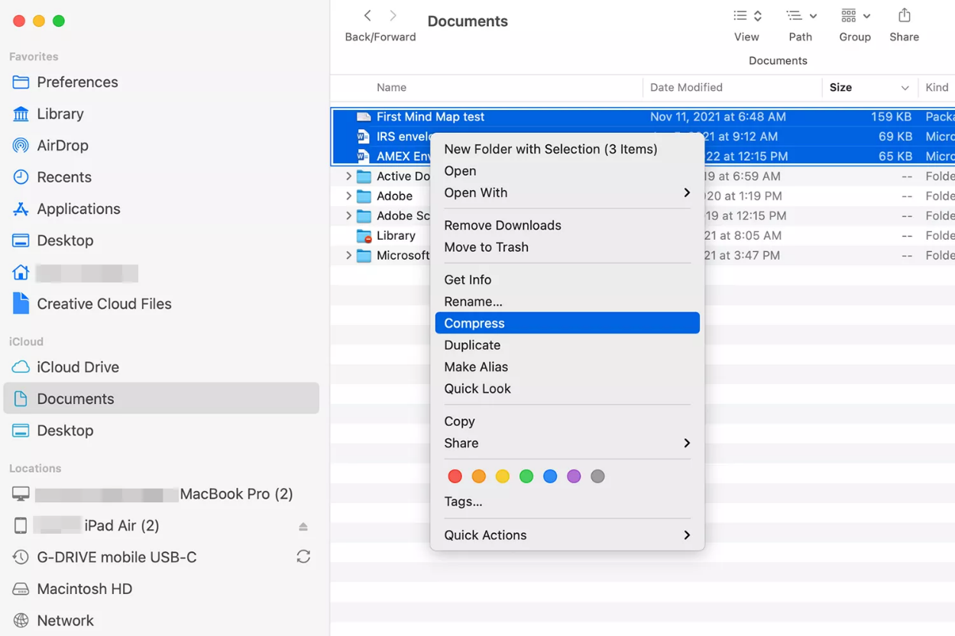
- Find the compressed items in a file called Archive.zip, which is in the same folder as the originals. If you already have an Archive.zip, a number is appended to the new archive's name: Archive 2.zip, Archive 3.zip, and so on.
- You may delete the word Archive and name the folder with the following naming convention:
For an electronic submission of a Form J-13A, title the PDF by LEA name, J13A, FY that the emergency ended, and incremental submission number XXX (for example: XYZJ13A2023_001 for an LEA’s first Form J-13A submission, XYZJ13A2023_002 for an LEA’s second submission, etc.).

How to Attach a Zip File to an Email
- Open your email client and compose a new email.
- In the body of the email, click on the "Attach files" button.
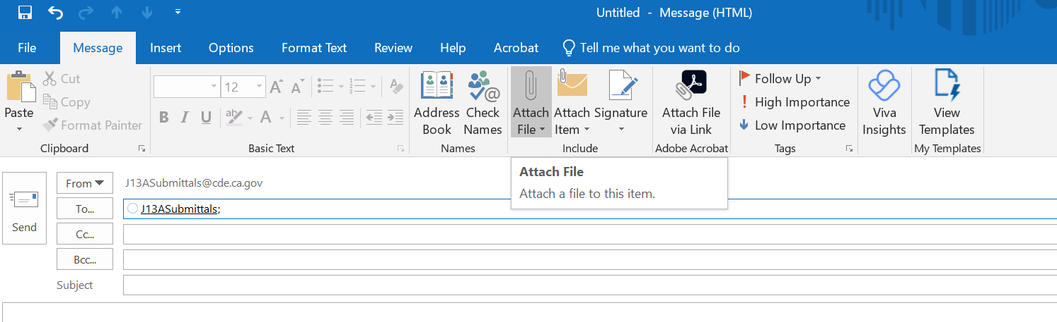
- Browse to the location of the zipped file and select it.
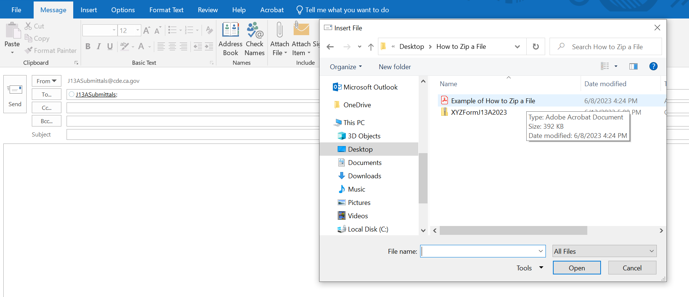

The zipped file will be attached to the email.
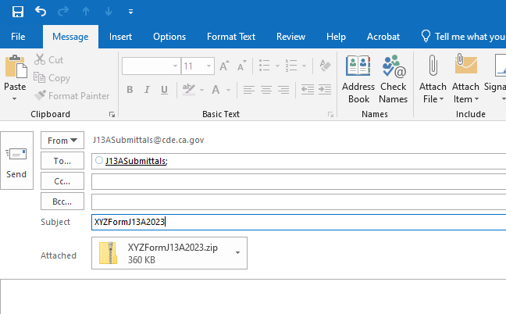
- Enter the recipient's email address, subject (i.e. XYZJ13A2023_001), and message, and then click on the "Send" button.
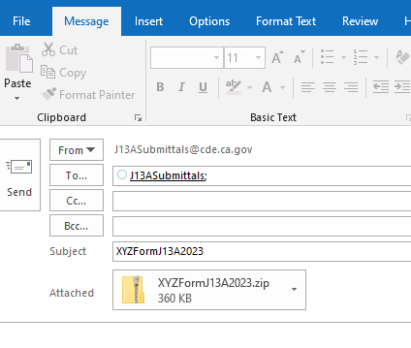
- If your file is still too large to attach to an email once you have zipped it, please contact attendanceaccounting@cde.ca.gov for assistance with the submission process.

