Standardized Account Code Structure (SACS) Web Financial Reporting System

SACS Web System User Guide
Version 2026
California Department of Education

July 2026

Table of Contents
Purpose 1
Quick Links 1
Mailing Address 2
Help Desk 2
Hardware and System Requirements 3
Supported Browsers 3
Windows 3
Mac 3
Recommended Screen Resolution 3
User Management 4
User Roles and Permissions 4
Entities 5
Login 6
User Account 7
Create a User Account 7
User Profile Page 8
Change SACS Web System Password 9
Change Email Address / Username 9
Opt-In to Beta Testing 10
Managing User Accounts 11
Create a New User Account 12
View Specific SACS Users 13
View All Locked User Accounts on the Users List 13
View All User Accounts with an Expired Password 14
View All Inactive Accounts for Your Specific Entity on the Users List 14
Reporting Process and Requirements 15
Reporting Process 15
Reporting Requirements/Due Dates 15
Budget Reports 15
Unaudited Actuals Reports 16
Interim Reports 17
Charter School Financial Reporting 20
Budget and Interim Reports 20
Unaudited Actuals Reports 20
Data Processing Sequence 23
Budget and Unaudited Actuals 24
Interim Reports 27
Internal Form Checks 30
Tips for Using the SACS Web System 31
Database Versus Form 31
Form Dependencies in the Technical Review Checklist 31
Automatic Form Tracking 31
Data Types 31
Data Entry 32
Navigation 33
Dashboard 33
Dataset Submissions List 35
New Draft button 36
Create a New Draft Dataset 36
Filter and Sorting Columns 37
Column Sort and Filter Icons 37
Sorting a Column 37
Filtering a Column 38
Dataset List Columns 38
Add or Remove Columns 38
Number of Rows 38
Resizing Columns 38
Column Descriptions 39
Copy and Share a Submission 41
Delete Submission 42
Comparing Two Dataset Submissions 42
Main Menu 47
Dashboard 47
Import Menu 47
Users Menu 47
Queues Menu 48
LEA Draft Dataset Approval 48
Edit Dataset 48
Dataset Approval 49
Oversight 50
Promote to CDE 51
Tools Menu 52
Single String Validation Tool 53
To Validate a SACS Account Code String: 54
Blank Forms 55
Fiscal Year Menu 56
User Profile Menu 56
Importing Datasets 59
Import - Other 59
Import - Official 62
Importing the Dataset 63
Single Import 63
Multiple Import 65
Importing Multiple Datasets 65
Import Options 66
Overwrite Datasets 66
Stop Import 67
Print or Export Import Results 67
Dataset Submissions 68
Data Submission Overview 68
Dataset Edit and Locking 68
Elements of the Submission Lock Feature 68
To Lock a Submission or Individual Form 69
To Unlock a Submission or Form 69
Locking Criteria Based on Form Dependencies. 69
Draft Datasets 70
Submission Datasets 70
Formal Submission Datasets 71
Resubmission Datasets 71
Recalled Dataset 72
Published Datasets 72
Opening a Submission 73
Table of Contents 74
Printing From the Table of Contents 75
User Data Input Review Screen 76
Data Review 77
Data Input 77
Data Deletion 78
Technical Review Checklists 80
Running TRCs 80
To Run the Technical Review: 80
Types of Technical Review Checks 81
Print Technical Review Checks 82
Technical Review Explanations 82
Understanding Explanations 82
Details of Checks 84
Print Technical Review Explanations 84
Forms 85
Printing Forms 85
Fund Forms 86
Budget and Unaudited Actual Fund Forms 87
Summary Statement 87
Fund Reconciliation 92
Revenue Detail 93
Expenditure Detail 93
Other Financing Sources/Uses Detail 93
Interim Fund Forms 93
Forms 01i Through 95i—Statement of Revenues, Expenditures, and Changes in Fund Balance. 93
General Fund[CSSF] (Form 01i) 94
Other Funds (Forms 08i Through 95i) 94
Fund Descriptions 94
Fund 01—General Fund [CSSF] 95
Fund 09—Charter Schools Special Revenue Fund 96
Fund 10—Special Education Pass-Through Fund 97
Fund 13—Cafeteria Special Revenue Fund 97
Fund 20—Special Reserve Fund for Postemployment Benefits 98
Fund 49—Capital Projects Fund for Blended Component Units 98
Fund 52—Debt Service Fund for Blended Component Units 99
Fund 61—Cafeteria Enterprise Fund 99
Fund 62—Charter Schools Enterprise Fund 100
Supplemental Forms 101
Budget & Unaudited Actual Supplemental Data Forms 102
Form A—Average Daily Attendance (Not Applicable for JPAs) 102
Form ASSET—Schedule of Capital Assets 110
Form CA—Unaudited Actuals Certification 111
Form CASH—Cashflow Worksheet 112
Form CAT—Schedule for Categorical 113
Form CB—Budget Certification 121
Form CC—Workers' Compensation Certification 122
Forms CEA/CEB—Current Expense Formula/Minimum Classroom Compensation 122
Form DEBT—Schedule of Long-Term Liabilities 126
Form ESMOE—Every Student Succeeds Act Maintenance of Effort 127
Form GANN—Appropriations Limit Calculations 133
School Districts 134
Form ICR—Indirect Cost Rate Worksheet 145
Form L—Lottery Report 150
Form MYP—Multiyear Projections-Budget 152
Form PCR—Program Cost Report 155
Form PCRAF—Program Cost Report Schedule of Allocation Factors 157
Form SEA—Special Education Revenue Allocations 158
Form SEAS—Special Education Revenue Allocations Setup 158
Forms SIAA/SIAB—Summary of Interfund Activities – Actuals/Budget 159
Interim Supplemental Data Forms 159
Form AI—Average Daily Attendance (Not Applicable for JPAs) 159
Form CASH—Cashflow Worksheet 159
Form CI—Certification of Interim Report 159
Form ESMOE—Every Student Succeeds Act Maintenance of Effort 160
Form ICR—Indirect Cost Rate Worksheet 160
Form MYPI—Multiyear Projections—Interim 161
Form MYPIO—Multiyear Projections—Interim, Other Funds 163
Form SIAI—Summary of Interfund Activities 165
Criteria And Standards 166
Assumptions for Budget Planning and Management 166
General Fund [CSSF]—Revenues 167
General Fund [CSSF]—Expenditures 168
Other Funds—Revenues, Expenditures, or Transfers 169
Data Sources for the Criteria and Standards Review 169
Extracted Data from Budget Year and Prior Year Actuals 170
Extracted Data—Interim Periods Only 170
Data Preloaded by CDE 170
Data Entered by LEA 170
Tips for Completing the Criteria and Standards Review 171
Form 01CS—Criteria and Standards Review—Budget 171
Overview of the Criteria and Standards Section—Budget 172
Overview of the Supplemental Information Section—Budget 182
Overview of the Additional Fiscal Indicators Section—Budget 187
Form 01CSI—Criteria and Standards Review—Interim (Not Applicable for End of Year Projections) 187
Overview of the Criteria and Standards, Supplemental Information, and Additional Fiscal Indicators—Interim 188
Technical Review Checks (TRCs) for the Criteria and Standards 196
Summarizing the Criteria and Standards Review 197
Components of Ending Fund Balance / Net Position (CEFB) 198
IFC Statuses 202
Reports 205
Program by Resource (PGM) Report 205
Determination of Major Funds 207
Government-Wide Reporting 207
Recommended Processing Sequence 208
Specialized Function Codes and Definitions Used in Conversion Entries and Government-Wide Reporting 208
Overview of Conversion Entries (Report ENTRY) 209
Detailed Instructions for Beginning Balance Entry (ENTRY: Begin Balance) 210
Detailed Instructions for Conversion Entries (ENTRY: Detail) 211
Government-Wide Conversion (Report CNVRT) 229
Government-Wide Statement of Net Position (Report GSNP) 234
Government-Wide Statement of Activities (Report GSA) 235
Special Education Maintenance of Effort Reports 236
Program Compliance Overview 236
Unaudited Actuals Period Reports 238
Interim Period Report 258
Charter Schools 260
References 265
Questions on Special Education MOE Reports and Requirements 265
Version History 266
View Version History 266
Restore Prior Versions 266
Exporting Datasets 267
Submission Data Export Screen 268
Exporting Data—Official 268
Exporting Data—Other 269
LEA Custom Information 270
Attachments 271
Attachment A—Forms and Reports in the SACS Web System 272
District Reporting 273
County Reporting 277
JPA Reporting 281
County Charter/District Charter School Reporting 284
Attachment B—SACS Import Module Specifications 288
Header Record Format 288
Detail Record Format 290
End-of-Dataset Record Format 290
Other Items To Consider When Programming the Extraction Programs 291
Attachment C—SACS Supplemental (Named Elements) Specifications 292
Attachment D—LEA Custom Info (Named Elements) Import Specifications 293
Attachment E—Form Dependencies 294
Budget Period 294
Unaudited Actuals Period 295
Interim Periods 295

Purpose
Welcome to the 2026 SACS Web System User Guide!
California local educational agencies (LEAs) are required to submit a series of financial reports and data to the California Department of Education (CDE). In 1997, a standardized account code structure (SACS) was developed and implemented over the next seven years by all LEAs. At the same time, the SACS Financial Reporting Software was developed to accommodate SACS accounting. The desktop software
was subsequently replaced by the SACS Web financial reporting system (SACS Web
System). The use of SACS and the SACS Web System helps facilitate consistency among LEAs in recording and reporting financial information. Specifically, the SACS Web System:
- Improves financial data collection, reporting, transmission, accuracy, and comparability;
- Reduces the administrative burden on LEAs in preparing required financial reports;
- Helps meet federal reporting guidelines;
- Ensures LEAs’ compliance with generally accepted accounting principles (GAAP) as prescribed by the Governmental Accounting Standards Board (GASB);
- Provides a framework to follow the flow of educational funds; and
- Provides better information for use by those interested in school finance.
Note: Instructions apply to LEAs, differences applicable to county offices of education (COEs) are indicated by italics.

Quick Links
Guidance for LEAs using SACS, a statewide, uniform financial reporting format; includes SACS query, valid combination tables, and other facts can be found at the CDE Guidance for SACS web page.
The CSAM provides the accounting policies and procedures that LEAs are required to follow, as well as guidance in implementing those policies and procedures can be found at the California School Accounting Manual (CSAM) web page, which include:
- Basis of accounting
- Revenue and expenditure recognition
- Fund types
- Types of transactions
- Methods of posting transactions, including adjusting entries
- Documentation required to substantiate certain transactions
- Year-end closing process, including the recording of accruals and deferrals
Advisories, bulletins, and letters related primarily to LEA accounting and reporting issues can be found at the CDE Correspondence web page.
SACS Web System - accessed via the CDE Financial Reporting web page. The direct link: SACS Web System

Mailing Address
School Fiscal Services Division
Office of Financial Accountability and Information Services
California Department of Education
1430 N Street, Suite 3800
Sacramento, CA 95814

Help Desk
The Help Desk Ticket screen can be accessed from the User Profile section in the top right corner. This screen will prepopulate with relevant system and user information and will allow a user to enter text and submit to CDE for review.

Hardware and System Requirements

Supported Browsers
Google Chrome is the only browser supported.
The SACS Web System may function on other browsers, such as Apple Safari, Microsoft Edge, and Mozilla Firefox; however, these browsers may encounter unexpected issues.
The system requirements for Google Chrome are listed below by Operating System.

Windows
To use Chrome browser on Windows, you will need:
- Windows 10 or later or Windows Server 2016 or later
- An Intel Pentium 4 processor or later that's SSE3 capable

Mac
To use Chrome browser on Mac, you will need:
- macOS 12 Monterey and up

Recommended Screen Resolution
The SACS Web System is best viewed on a widescreen monitor that displays a minimum of 1080p resolution (1920x1080). However, higher resolutions (3840x2160 or more) will reduce table scrolling and provide more screen space for submission and form columns.
Note: Devices that do not support the minimum 1080p resolution or are set to display below the recommended resolution will encounter issues with properly displaying the contents of the SACS Web System.

User Management
The SACS Web System requires individual user accounts to access the application. User accounts are established within the system using an email address as the username and creating a password. Each user account may be associated with multiple entities. Each entity may have one or more roles (See User Roles and Permissions).
The assignment of the Administration and User Management roles for the initial user at each LEA is done by the oversight entity for that LEA, in the following order:
- A CDE user assigns a COE user the roles of Administration and User Management.
- Each COE assigns a user at each school district, joint powers agency (JPA), and charter school under COE oversight the roles of Administration and User Management to manage accounts within that entity. Additional COE users may also be assigned the User Management role.
- Each school district assigns a user at each charter school under the district’s oversight the Administration and User Management roles.

- A user with User Management permissions for a specific entity is authorized to assign user roles within that entity or to those user/entities for which they have oversight. See Table 1 – SACS User Roles and Table 2 – SACS Entity Types for additional information.

User Roles and Permissions
User roles play a critical part in the SACS Web System to ensure system security and proper transition of the dataset submissions through the workflow process. User roles ensure dataset submissions, and the workflow are properly followed. Additionally, certain roles provide SACS Web System maintenance and security. The following table illustrates each user role, permissions, whether that role is part of the submission workflow, and which role grants access to permissions.
Table 1 - SACS User Roles
User Role | Permissions | Submission Workflow | How Do I Get this Role?
Edit Draft Dataset | Ability to edit draft datasets only | Yes | User Management
Edit Dataset | Ability to edit submission datasets associated with granted entities | Yes | User Management
Dataset Approval | Ability to promote a draft dataset to a submission dataset and to the oversight agency | Yes | User Management
Oversight | Ability to review and edit a submission for which the entity has oversight responsibilities | Yes | User Management
Certify/Promote to CDE | Ability to certify and submit unaudited actuals (UA) data to the CDE | Yes | CDE User Management
User Management | Ability to manage user accounts | No | User Management
Administration | Ability to create other Administration and User Management accounts | No | CDE User Management, User Management, or Administration

Entities
Entities are specific agencies involved with statutory financial reporting requirements and compliance reporting. Entities include school districts, charter schools, COEs, JPAs, Special Education Local Plan Areas (SELPAs), the State Board of Education (SBE), and CDE.
Each entity has specific roles that are applicable to its users. Each entity must have at least one user with the User Management role who may then assign other users within the entity the User Management role. The user with the User Management role administers all entity users and assign permissions according to need.
The table below illustrates each entity type, and the roles allowed for users of that particular entity.
Table 2 - SACS Entity Types
X = The role allowed for a particular entity.
Entity/Role | Edit Draft Dataset | Edit Dataset | Dataset Approval | Oversight | User Management | Administration | Certify/Promote to CDE
District | x | x | x | x | x | x | n/a
Charter School | x | x | x | n/a | x | x | n/a
COE | x | x | x | x | x | x | x
SELPA | x | x | x | x | x | x | n/a
JPA | x | x | x | x | x | x | n/a
SBE | x | x | x | x | x | x | n/a

Login
When a user logs in to the SACS Web System, the permissions available are based on the user’s assigned role(s) for the assigned entity and any entities under its oversight. Each role provides specific permissions within the application. For example:
A user with the Dataset Approval role for the Davis Joint Unified School District entity has the permission to promote (approve) a submission from Pending Internal Review state to the next state, New Dataset Submission, for a dataset submitted by a user within that school district, including any charter schools under the oversight of Davis Joint Unified School District.
or
A user with the User Management role for Yolo County Office of Education has the permission to assign the Oversight role to one or more users at the COE who then has access to the oversight queue for all of the school districts and charter schools in the county.

User Account
In order to perform any task in the SACS Web System, each user requires an individual user account. The entity’s user manager must assign the appropriate role to each user account. It is recommended that each entity establish user management policies that dictate how users are established, including how user roles and associated entities are requested and assigned.
Once a user has been granted the appropriate roles for each entity, functions such as importing submissions, editing submissions, promoting submissions and/or viewing submission details may be performed.
Every user can manage their user profile, including:
- Changing their password.
- Changing their email address/username.
- Indicating beta testing preference.

Create a User Account
- Contact the SACS Web System user with the User Management role for the specific entity to create a new account, including establishing the appropriate roles and associated entities.
- Once the user account is established, a Confirm Link email is sent to the new user to complete the login procedure; click the link in the email.
- Create a new password for the account by entering and confirming the password in the create password dialog box. The password strength must meet the following criteria to be considered strong:
- At least eight characters in length.
- Not be the same as email.
- At least one uppercase letter (A–Z).
- At least one lowercase letter (a–z).
- At least one number (0–9).
- At least one special character (! @ # $ ^ & * - = _ + ? ).
- Agree to the Terms of Service (this will be required each time a user logs in) by clicking the checkbox.
- Click the Login button.

User Profile Page
The Edit Profile page allows the User Management role to perform various actions, as listed below.
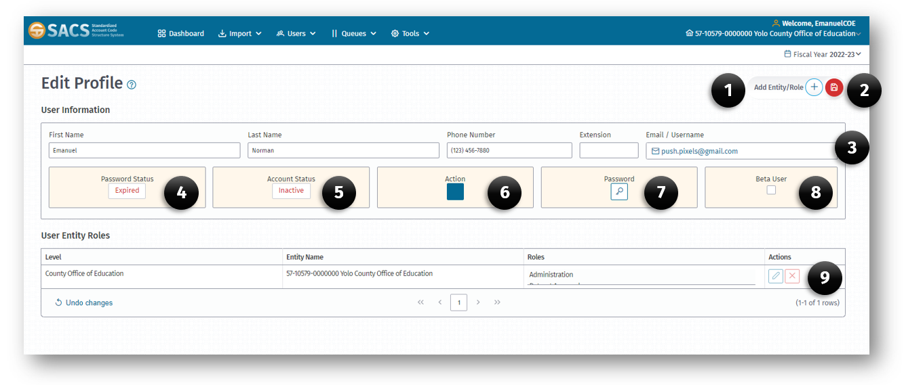
- Add Entity/Role button.
- Save Changes button (Only displays after changes are made).
- Email/Username field.
- Password Status indicator (Expired, Expires Soon, Active).
- Account Status indicator (Inactive, Active, Locked).
- Action button (Reinstate Account).
- Password Reset button.
- Beta User checkbox.
- User Entity Roles Action buttons (Edit, Remove).

Change SACS Web System Password
A user may change their password at any time, but at minimum every 90 days to ensure access to the SACS Web System. The user will receive a notification when logging in if their password will soon expire or has expired.
To change a password prior to the 90-day expiration date, the user shall:
  - Login to the SACS Web System using your existing credentials.
  - Click your User Profile, located on the right end of the Main Menu.
  - Select Edit Profile.
  - Click the Change Password button.
If the password has expired, the user may select the “I forgot my password” link on the system login page and enter the email address to receive an email with instructions on creating a new password.

Change Email Address / Username
The SACS Web System uses an individual’s email address to communicate with each user. The email address provides a unique login for each user, and identifies the assigned entity. The following steps can be used to change an email address or username.
  - Login into the SACS Web System using existing credentials.
  - Click User Profile, located on the right end of the Main Menu.
  - Select Edit Profile.
  - Click the Edit Email Address button next to the email/username.
  - Enter a new email address in the Email/Username field.
  - Click the Save button.
Note: Any changes to the page will trigger a Save Changes button into view next to the Add Entity/Role button.
  - The system will send an email to the new address confirming the change(s).

Opt-In to Beta Testing
The SACS Web System requires updates to keep current with technology or business processes. SACS Beta Testers are volunteers who agree to test application changes before the changes are released to all users.
To indicate interest in being a Beta Tester, a SACS Web user should follow the steps below:
- Log into the SACS Web System.
- Click User Profile, located on the right end of the Main Menu.
- Select Edit Profile.
- Click the Beta User checkbox.
- Click the Save button.

Managing User Accounts
Users with the User Management role may create new user accounts, add entities, grant user roles, and revoke roles when the user no longer needs access. The following list illustrates some of the capabilities the User Management user has and the tools available to manage accounts.
- Create a new user account.
- View specific SACS users.
- View all Locked and Inactive user accounts on the User List.
- View all Active accounts for your specific entity on the User List.
- Use the filter/sort feature to view specific accounts on the User List.
- Modify specific information on existing accounts.
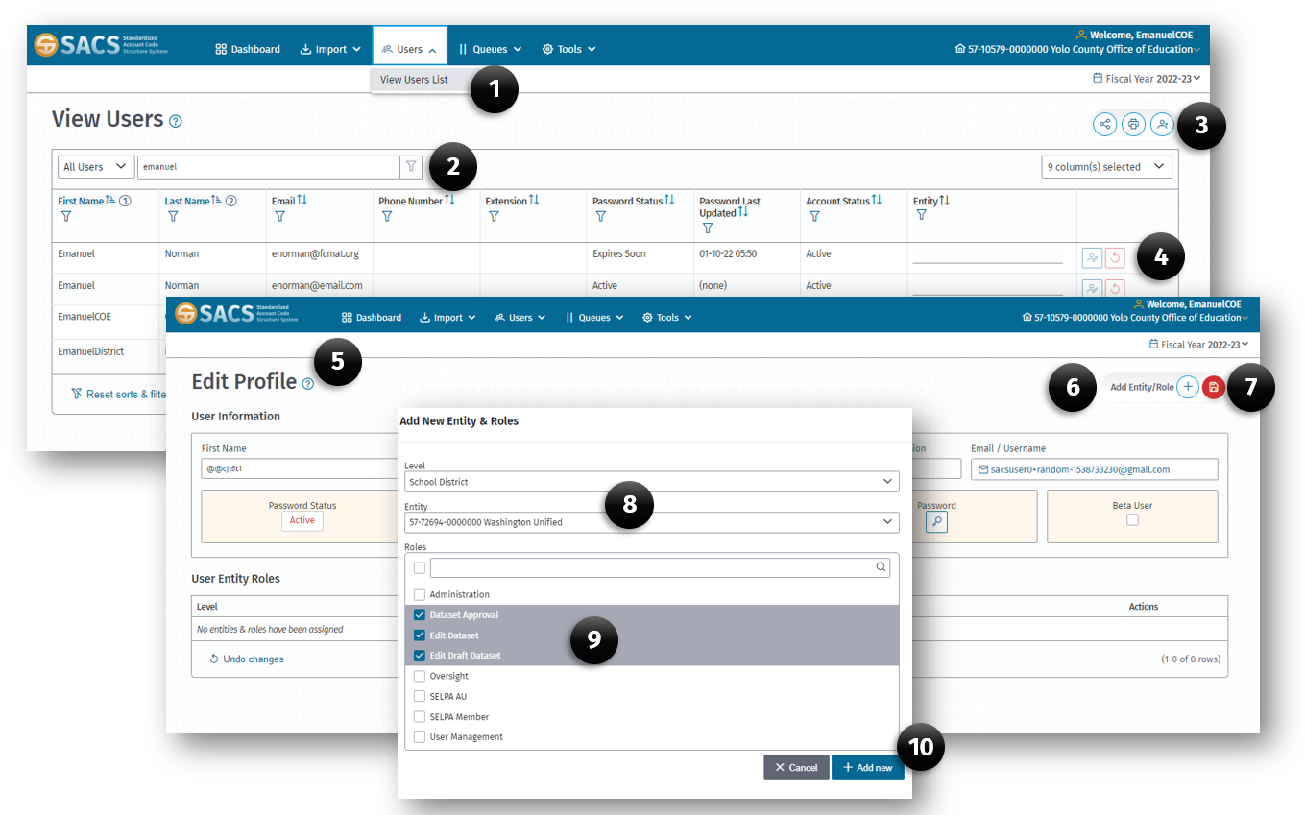

Create a New User Account
An individual with a SACS Web user account with a User Management role may assign users, following the steps listed below.
  - From the Main Menu, click the View Users List (1) option on the Users menu.
  - When the View Users page opens, click the New User (3) button.
  - In the New User Account screen, Enter the First Name, Last Name and Email Address for the new user.
  - Check the Terms of Agreement checkbox.
  - Click the Submit button to complete the account creation process.
  - The new user will receive an email link to complete the login process (set a password).
Note: the following steps to add entity and role to the new user account must be performed in order for the user to be able to access SACS Web System functionality.
  - Locate the new user using the filter list feature on the View Users List:
    - Click either the Filter icon on the First Name or Last Name column or the Global Filter (2) box.
    - Type the name of the new user.
Note: As the name is typed, the filter dynamically eliminates the records not meeting the criteria. When the user completes the name pattern, the resulting list is filtered to meet the criteria.
  - Click the Edit User (4) button on the corresponding row of the new user.
  - When the Edit Profile page opens, click the Add Entity/Role (6) button on the right top of the page.
  - In the Edit Entity & Roles dialog box, select:
    - The Level (8) (District, School, Charter).
    - The Entity (8) (specific school district).
    - Each desired Roles (9) the new user will need.
  - Click the Add Entity/Role (10) button to add the entity and roles to the new user account.
  - Click the Save (7) button to save all changes.
Note: If new entities or roles are added to a user’s account while the user is logged into SACS Web, the user will need to log out and then log back in for the changes to become available.

View Specific SACS Users
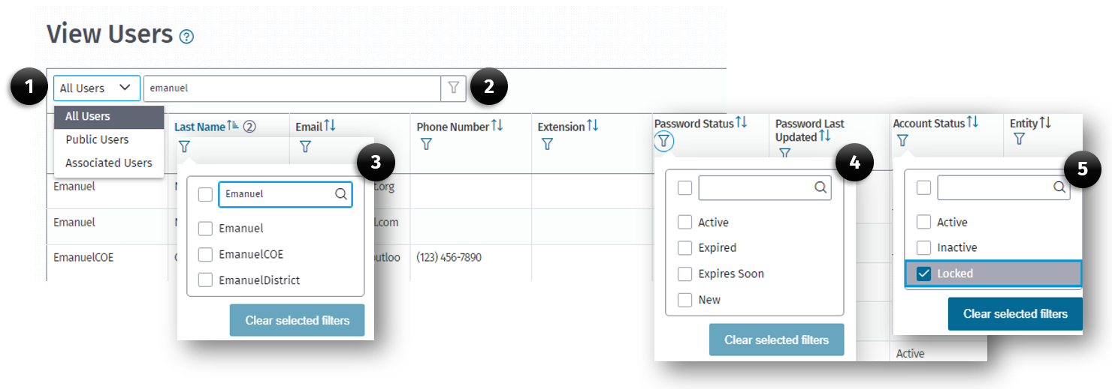
Use the filter feature on the User List to view specific users. The filter feature is dynamic. It filters as you enter criteria.
- From the Main Menu, click the View Users List option on the Users menu.
- When the View Users list opens, locate the user(s) by using the:
  - Filter box by typing the first or last name in the textbox.
  - Click the Filter (3) icon on the First Name or Last Name field.
  - Type the name of the user(s) in the Filter (2 or 3) dialog box.
  - Select the preferred user by checking the checkbox next to the name.
- The View Users list will display your criteria results.

View All Locked User Accounts on the Users List
A user with the User Management role may view a list of users who are Locked out because they attempted to log in with the incorrect password five times. To view these accounts:
- From the Main Menu, click the View Users List option on the Users menu.
- When the View Users page opens, use the filter icon in the Account Status (5) field to select the Locked option.
- The resulting users on the list shows locked accounts.
Note: From this list, a user’s account can be reinstated by clicking the Action button on the Edit Profile screen which sends a reset password email to the user.

View All User Accounts with an Expired Password
As a user with the User Management role, may view a list of users whose account passwords have Expired because they have not updated their passwords within 90 days. To view these accounts:
- From the Main Menu, click the View Users List option on the Users menu.
- When the View Users page opens, use the filter icon in the Password Status (4) field.
- Select Expired, Expires Soon or New options to locate users with a specific password status.
- The resulting list displays accounts with that specific account status.

View All Inactive Accounts for Your Specific Entity on the Users List
When a user does not log into their account for more than a year, the account is rendered inactive.
To view Inactive accounts:
- From the Main Menu, click the View Users List option on the Users menu.
- When the View Users page opens, use the filter icon in the Account Status (5) field.
- Select the Inactive option to locate users with that specific account status.
Note: From this list, a user’s account can be reinstated by clicking the Action button on the Edit Profile screen which sends a reset password email to the user.

Reporting Process and Requirements

Reporting Process
The SACS Web System reporting process begins with the LEA recording its financial transactions in the local financial system. The LEA transfers the information, either manually or electronically, from their financial system to the CDE SACS Web System. Additionally, the LEA manually enters certain supplemental information not already contained within their financial system (such as committed/assigned portions of ending fund balance).
The LEA reviews the data for accuracy and completeness according to the technical review specifications established by the CDE. Once the data has passed the technical review checks and the valid exceptions have been properly documented within the SACS Web System, reports are printed and signed by the LEA representative and presented to the LEA’s governing board.
The data is then submitted to the LEA's reviewing agency, the COE[CDE], using the SACS Web System workflow process. For unaudited actual submissions only, the COEs submit and certify data to the CDE. The reviewing agency's process of resolving exceptions varies by agency, but the process generally involves an interactive dialogue between the LEA and the reviewing agency.
Note: Instructions apply to LEAs, differences applicable to COEs are indicated by italics.

Reporting Requirements/Due Dates
The SACS Web System User Guide provides instructions for completing the budget, interim, and unaudited actuals reports. Below is a recap of the reporting requirements for each report type, including due dates, as specified in statute, and listed below. In accordance with Government Code Sections 6700, 6707, and 6803, if the due date falls on a Saturday, Sunday, or holiday, the reporting due date shall be the following workday. For year-specific due dates, refer to the Financial Reporting Calendars available on the CDE’s Financial Reporting web page. For a complete list of the specific forms required for each reporting process, please see Attachment A.
All forms that require a certification require an original signature. Per Government Code 16.5, electronic signatures are acceptable provided the LEA and oversight entity properly adopt and implement them. Designee signatures should only be used when indicated as allowable on the form. [For COEs only, scanned copies of originally signed budget or interim certification forms are acceptable.]

Budget Reports
School districts[COEs] and JPAs file their adopted budget and prior year's estimated actuals with their COE[CDE] (for charter schools refer to the Charter School Financial Reporting section).

What To File—Budget Adoption Documents
The following forms must be completed for a budget submission:
- Form 01—General Fund[County School Service Fund]—Statement of Revenues, Expenditures, and Changes in Fund Balance, including assumptions.
- Financial Statement (fund form) for every fund other than the General Fund[County School Service Fund] maintained by the LEA.
- Form A—Average Daily Attendance (not applicable for JPAs).
- Form CB—Certification of Budget Adoption (with original signatures).
- Form CC—Workers' Compensation Certification (with an original signature).
- Form 01CS—Criteria and Standards Review.
- Form CASH—Cashflow Worksheet.
- Form MYP—Multiyear Projections including assumptions.
- Technical Review Checklists (TRCs) for budget and actual data types, with all fatal exceptions cleared and valid warning exceptions explained.
- Any other applicable forms, as listed in Attachment A.
Due Date—July 1

Unaudited Actuals Reports
The unaudited actuals financial report represents the financial position and results of operations of the LEA for the concluded fiscal year and includes the most current board approved budget data.

What To File—Unaudited Actuals Financial Reports
For all LEAs, the following are required to be filed with the CDE via the COE (for charter schools refer to the Charter School Financial Reporting section). The COE must file all LEA submissions with the state via the SACS Web System and retain the signed certifications for the COE, districts, JPAs, and charter schools.
- Form CA—Certification with original signatures.
- One "Official" submission containing SACS unaudited actual data, prepared using the unaudited actuals period (not the budget period), which includes the most current board approved budget data.
- All required forms (see Attachment A for a list of the forms); and
- The unaudited actual data Technical Review Checklist with all fatal exceptions cleared and all warning exceptions explained.
Due Date—September 15, following the fiscal year of reporting
School district unaudited actuals financial reports are due to the COE.
Due Date—October 15, following the fiscal year of reporting
LEAs’ unaudited actuals financial reports are due to the CDE.

Submitting Unaudited Actual Data to the State
COEs must use the SACS Web System to file all LEAs' unaudited actual submissions with the state. The SACS Web System allows COEs to electronically certify the data and transmit the data files to the CDE. Before being permitted to submit to the CDE, COEs must submit the "Request for Unaudited Actuals Promoter Role" form to the CDE each year. This form is accessed and completed online by COEs through the Tools menu in the web application.
Notes:
- Unaudited actual submissions to the state must be Official unless the CDE has given the LEA permission, prior to submission, to submit a file containing pre-approved errors. A separate email explaining all fatal exceptions and the reason for not using the Official submission must be sent to the CDE at unauditedactuals@cde.ca.gov.
- Before electronically certifying data files, the COE is required to have on file the signed and completed certification, Form CA, for each LEA file being submitted. The original paper-copy certifications for the COE, districts, JPAs, and charter schools are retained by the COE and are not forwarded to the state.

Interim Reports
School district and JPA interim reports shall be approved by the district governing board and submitted to their COE (for charter schools refer to the Charter School Financial Reporting section).
Note:
For districts filing a qualified or negative certification, a copy of the Statement of Revenues, Expenditures, and Changes in Fund Balance (Form 01I) and the certification (Form CI) will also be sent by the COE to the CDE and the State Controller's Office (SCO).
COE interim reports shall be reviewed by the county board of education, approved by the county superintendent of schools, and submitted to the CDE.

What To File—First and Second Interim Reports
The following forms must be completed for an interim submission:
- Form CI—Certification with original signatures.
- Form AI—Average Daily Attendance (not applicable for JPAs).
- Form 01I—General Fund[County School Service Fund]—Statement of Revenues, Expenditures and Changes in Fund Balance including assumptions.
- Financial Statement (fund form) for every fund other than the General Fund projecting a negative fund balance.
- Form CASH—Cashflow Worksheet.
- Form MYPI—Multiyear Projections including assumptions.
- Form MYPIO—Multiyear Projections for every fund other than the General Fund[County School Service Fund] projecting a negative fund balance.
- Form 01CSI—Criteria and Standards Review.
- Technical Review Checklists for original budget and projected year totals data types, with all fatal exceptions cleared and valid warning exceptions explained.
- Any other applicable forms, as listed in Attachment A.
First and second interim reports are due to the reviewing agency within 45 days after the close of each interim period (October 31 and January 31). For year-specific due dates, refer to the Financial Reporting Calendars available on the CDE’s Financial Reporting web page.
COEs may change a district's certification and shall provide notice of that action to the governing board of the school district and to the CDE.
COEs must notify the CDE and the SCO of the type of certification filed by each district under their jurisdiction. Additionally, for those districts classified as qualified or negative, the COEs must include their comments on those certifications, including any action proposed or taken.

What To File—End of Year Projection Report (if required)
Pursuant to Education Code (EC) Section 42131(f)[1240.2], the governing board of each school district[COE] filing a qualified or negative certification for the second report required under EC Section 42130[1240], or classified as qualified or negative by the county superintendent of schools[State Superintendent of Public Instruction (State Superintendent)], shall provide to the county superintendent of schools[State Superintendent], the State Controller, and the State Superintendent no later than June 1, financial statement projections of the district's[COE's] fund and cash balances through June 30 for the period ending April 30.
Although statute does not require that these end of year projection reports be prepared in a format or on forms prescribed by the State Superintendent, interim reporting forms that serve this purpose are available within the SACS Web System by selecting the End of Year Projection reporting period. The following forms must be completed for an interim submission:
- Form AI—Average Daily Attendance (not applicable for JPAs).
- Form 01I—General Fund[County School Service Fund]—Statement of Revenues, Expenditures, and Changes in Fund Balance including assumptions.
- Financial Statement (fund form) for every fund other than General Fund projecting a negative fund balance.
- Form CASH—Cashflow Worksheet.
- Form MYPI—Multiyear Projections including assumptions.
- Form MYPIO—Multiyear Projections for any fund other than the General Fund[County School Service Fund] projecting a negative fund balance.
- Technical Review Checklists for original budget and projected year totals data types, with all fatal exceptions cleared and valid warning exceptions explained.
- Any other applicable forms, as listed in Attachment A.

Charter School Financial Reporting

Budget and Interim Reports
Charter schools are required by EC Section 47604.33 to submit budget and interim reports to their authorizing agency and to their county superintendent of schools. Although no particular format is required, the existing budget and interim forms in the SACS Web System are available for charter schools to use. The Charter School Unaudited Actuals Financial Report—Alternative Form (Alternative Form) is not available for budget and interim reports.
Due Dates (to the authorizing agency and to the county superintendent of schools)
Budget—On or before July 1
First Interim—On or before December 15
Second Interim—On or before March 15

Unaudited Actuals Reports
Charter schools are required by EC sections 42100 and 47604.33 to submit their year-end financial data (unaudited actuals financial reports) to the CDE via their authorizing agency, either in the SACS format or in the approved Alternative Form.
Charter schools reporting in the SACS format have several options for reporting their unaudited actual financial data in the SACS Web System to the CDE. The options are:

Reporting with the Authorizing Agency
Charter school SACS Web System financial data may be reported with the data from their authorizing agency in the authorizing agency's General Fund[County School Service Fund] (Fund 01), Charter Schools Special Revenue Fund (Fund 09), or Charter Schools Enterprise Fund (Fund 62) which allows accrual accounting for not-for-profit charter schools.

Reporting Separately from the Authorizing Agency
Charter school SACS Web System financial data may be reported by the charter school, separate from the authorizing agency, by using the charter school's county-district-school (CDS) code to access the applicable forms. Charter schools should report their data using either the Charter Alternative Form or the traditional SACS reporting forms. If using the traditional SACS forms, charters should use one of the following as their main operating fund: General Fund (Fund 01) or Charter Schools Enterprise Fund (Fund 62) which allows accrual accounting for not-for-profit charter schools. Charter schools using Fund 01 as their main operating fund may also report data in other funds, as appropriate.
Charter schools should use the same accounting model and basis of accounting for their unaudited actuals financial reporting to the CDE as they will use for their audited financial statements. Charter schools using the modified accrual basis of accounting for their audited statements (as school districts do), should use Fund 01 for unaudited actuals financial reporting. Charter schools using the accrual basis of accounting for their audited statements (as not-for-profit organizations typically do), should use Fund 62 for unaudited actuals financial reporting. For more information about governmental fund accounting and the differences between the accrual and modified accrual models, see Procedure 101 in the CSAM.
Regardless of which option for reporting charter school financial data in SACS is chosen, the data submitted for each charter school must be complete including beginning balances, revenues, expenditures, and ending balances.
- Charter school data reported in the authorizing agency's General Fund[County School Service Fund] will automatically be included in the calculation of the district's[COE's] reserve requirement in the Criteria and Standards Review form. However, if the district[COE] does not meet its reserve requirement because of the charter school data, the district[COE] may provide an explanation to the reviewing agency within the Criteria and Standards Review form that the Criteria and Standards Review form includes charter data.
- Charter school data included in the authorizing district's General Fund will be subject to the calculation of compliance with the classroom teacher salary percentage required by EC Section 41372. However, if a school district fails the calculation, an explanation that the failure is due to the inclusion of the charter school data can be provided within the TRC, if applicable. (This calculation does not apply to COEs.)
- Charter school data included in the authorizing agency's data will be included in the calculation of the indirect cost rate for the authorizing agency. The charter school may also use this rate. Charter school data reported separately from the authorizing agency will be used to calculate an indirect cost rate for use by the charter school.
Charter school data should not be duplicated in whole or in part in any other fund or format. In past years, some authorizing agencies have reported the authorizing agency's activities on behalf of a charter school in the Charter Schools Special Revenue Fund (Fund 09), when the charter school was separately reporting its own financial information, either in SACS or in the Alternative Form. The authorizing agency should use Fund 09 only for reporting a charter school's complete financial information. (More than one charter school may be reported in Fund 09 by an authorizing agency, but the information must be complete for each charter school.) Any activities on behalf of a charter school that are performed by the authorizing agency should be reported in the General Fund[County School Service Fund] (Fund 01) of the authorizing agency because these are the authorizing agency's activities, not the activities of the charter school.

Charter School Unaudited Actuals Financial Report Alternative Form
The Alternative Form is an option available for charter schools to prepare their unaudited actual financial reports using the SACS Web System. The Alternative Form is designed to include complete information for all funds of the charter school. If the charter school chooses to report unaudited actual financial data using the Alternative Form, the SACS Web version of the Alternative Form provided by the CDE must be used, and the data must be electronically submitted to the CDE via the COE.
For additional information regarding the Charter School Alternative Form, please see the Charter School Unaudited Actuals Financial Report Alternative Form User Guide available on the CDE Financial Reporting web page.

What To File—Unaudited Actuals Financial Reports
For all charter schools reporting separately in the SACS Web System using SACS forms, the following are required to be filed with the COE. The COE must retain the signed certification and electronically file all charter school submissions with the CDE.
- Form CA—Printed copy of Charter School Certification with original signatures.
- One "Official" SACS unaudited actual data submission prepared using the unaudited actuals period (not the budget period), which includes all required forms (see Attachment A for a list of required forms) and the unaudited actual data Technical Review Checklist with all fatal exceptions cleared and all warning exceptions explained.
Due Date—On or before September 15
Charter school unaudited actuals financial reports are due to the appropriate authorizing agency, which will submit the data to its COE.
Due Date—October 15
COEs review the charter schools’ unaudited actuals financial reports for accuracy and use the SACS Web System to electronically submit and certify the official unaudited actual data files to the CDE.

Submitting Unaudited Actual Data to the State
County offices of education must use the SACS Web System to file all LEAs' unaudited actual submissions with the state. The SACS Web System allows COEs to electronically certify the data and transmit the data files to the CDE. Before being permitted to submit to the CDE, COEs must submit the "Request for Unaudited Actuals Promoter Role" form to the CDE each year. This form is accessed and completed online by COEs through the Tools menu in the SACS Web System.
Notes:
- Unaudited actual submissions to the state must be done as Official unless the CDE has given the charter school permission, prior to submission, to submit a file containing pre-approved errors. A separate email explaining all fatal exceptions and the reason for not using the Official export must be sent to the CDE at sacsweb@cde.ca.gov.
- Before electronically certifying data files, the COE is required to have on file the signed and completed certification, Form CA, for each charter school file being submitted. The original paper-copy certification is retained by the COE and is not forwarded to the state.

Data Processing Sequence
All data input into the SACS Web System, either through the import process or manual entry, are stored in a database, enabling the system to extract directly from the database into each applicable form. General ledger and supplemental data is extracted into the fund, supplemental, and Criteria and Standards Review form, where applicable, limiting the amount of manual input to complete the forms.
Below is the recommended sequence for completing the reporting processes within the SACS Web System. While any order can be used, the following sequence will help to prevent the user from receiving technical review exception messages simply because certain data has not yet been entered and verified. Detailed descriptions of each of the tasks involved begin in the User Data Input Review section.
Notes:
- Please periodically check the SACS Financial Reporting web page: If any problems are found after a system release, CDE will list them on the web page or the SACS Web System dashboard and provide workaround instructions if applicable.
- This SACS Web User Guide is written primarily for the modified accrual basis of accounting used in governmental funds. Where the guide also addresses the accrual basis of accounting used in proprietary funds, fiduciary funds, and the government-wide statements, general references to ending fund balances should be interpreted as referring also to ending net position.

Budget and Unaudited Actuals
- Form A—To collect attendance data used in other forms and calculations within the SACS Web System. Complete, save, and print.
- Form CAT (unaudited actuals period only)—To calculate the year-end accruals for categoricals prior to reporting them in the general ledger.
- Import/User Data Input—Import general ledger budget and actual data from the LEA accounting system. Manually input, using the User Data Input Review screen, any general ledger data that is not maintained in the LEA accounting system. See the Importing Data section for details about automatic recalculations done after the import, reimport, and user data input processes.
- TRC-Import and TRC-General Ledger—Run the TRC-Import and TRC-General Ledger modules for budget and actual data to check the imported and manually entered general ledger data for valid SACS codes, combinations of codes, ending fund balances, interfund and intrafund balances, components of ending fund balances, and various other balances. Fatal exceptions must be corrected; warning exceptions must be corrected or, if the data is correct, must be explained; informational exceptions should be corrected or, if the data is correct, an explanation is optional but encouraged.
- General Ledger Data Corrections—Make general ledger data corrections, as necessary, in the LEA accounting system, and then reimport the applicable fund(s).
- Re-run TRC-Import and TRC-General Ledger to verify changes. See the Importing Data section for details about automatic recalculations done after the import, reimport, and user data input processes.
- Form PCRAF (unaudited actuals period only)—To provide allocation factors if there are expenditures in support functions with an undistributed goal.
- Form PCR (unaudited actuals period only).
- Forms CEA/CEB.
- Forms ASSET, DEBT, ICR, L, ESMOE, SEAS, and SEA, if applicable.
- Form GANN, if applicable (unaudited actuals period only).
- TRC-Supplemental—Run the TRC-Supplemental module, which checks for required supplemental forms (and Criteria and Standards Review form during the budget period) and conditions within those forms. Fatal exceptions must be corrected; warning exceptions must be corrected or, if the data is correct, must be explained.
- Supplemental Data Changes—Make supplemental data changes, as necessary, in the applicable supplemental forms. If it is necessary to make changes to, and subsequently reimport, general ledger data, see the next step for General Ledger Data Corrections. Re-run TRC-Supplemental to verify changes.
- General Ledger Data Corrections—Make general ledger data corrections, as necessary, in the LEA accounting system or in the Components of Ending Fund Balance/Net Position screen, and then reimport the applicable fund(s), if necessary. Re-run TRC-Import and TRC-General Ledger to verify changes. See the Importing Data section for details about automatic recalculations done after the import, reimport, and user data input processes.
- Components of Ending Fund Balance/Net Position—Within the Components of Ending Fund Balance/Net Position screen, enter or revise applicable components of ending fund balance/net position by resource. Re-run TRC-Import and TRC-General Ledger to verify changes. See the Importing Data section for details about automatic recalculations done after the import, reimport, and user data input processes.
- Form CA (unaudited actuals period only)—Unaudited Actuals Certification. Review the Summary of Unaudited Actual Data Submission worksheet to verify critical data elements.
- Fund Forms—When the general ledger data is finalized, open, review, and print fund forms as necessary. Save Form 01, most importantly during budget period, so applicable data will extract appropriately into Form 01CS and Form MYP.
- Form CASH (budget period only, if using the SACS format for cashflow analysis).
- Multiyear Projections (budget period only)—Complete, save, and print Form MYP if using the SACS form for multiyear projections. Form 01 and Form A must be completed and saved first.
- Criteria and Standards Review (budget period only)—Complete, save, and print the Criteria and Standards Review form (applicable for the General Fund[CSSF] only). Form 01, Form A, and Form MYP (if using the SACS MYP format) must be completed and saved before completing Form 01CS. COEs using Form MYP should open and save Form MYP after completing Form 01CS since data from Criterion 8 are used in Form MYP.
- TRC-Supplemental—Re-run TRC–Supplemental checks to verify that the Criteria and Standards Review form has been completed as required.
- Form CC (budget period only)—Workers' Compensation Certification.
- Form CB (budget period only)—Budget Certification. Review the Criteria and Standards Review Summary for any areas of potential concern for fiscal solvency.
- TRC-Export Validation—Run the TRC-Export Validation module, which checks for required forms, forms that have unbalanced or incomplete data, and forms that need to be opened and saved due to general ledger or supplemental data changes (dependencies). See Attachment E for information about clearing form dependencies.
- Technical Review Checklist, All—To verify all exceptions have been corrected, or explained where applicable.
- Table of Contents—Shows the fund and supplemental reports that contain data and have been saved. Upon selecting this form, the SACS Web System will automatically generate the contents based on the information in the database. View or print the Table of Contents to ensure all applicable forms are completed. For reference, compare the Table of Contents to Attachment A of this user guide. In addition, all fund, supplemental, and Criteria and Standards Review form can be printed from the Table of Contents window.
- Export—Export data using the Official option to retain a copy outside the SACS Web System for local needs, if applicable, and as a precaution against data loss.
Notes:
- Unaudited actual submissions to the state must be done as Official unless the CDE has given the LEA permission, prior to submission, to use the Other option. An email explaining all fatal exceptions and the reason for not providing an Official submission must be sent to the CDE at unauditedactuals@cde.ca.gov.
- The GASB Statement 34 government-wide conversion entries and reports and the Special Education Maintenance of Effort (SEMOE) reports should be completed after all of the above steps relating to fund reporting are completed.

Interim Reports
- Prior Period Data—Prior period data will automatically populate into relevant forms where necessary. An applicable submission must already exist in the SACS Web System for the appropriate Reporting Period or Fiscal year. Certain unaudited actual period data (e.g., data from forms ICR and ESMOE) will populate into interim period forms. There is no additional action required by the user. If an appropriate submission is not available in the SACS Web System, then the user may hand-enter the data.
- Supplemental Forms—Complete, save, and print supplemental forms AI and CASH (if using the SACS format for cashflow analysis).
- Import/User Data Input—Import general ledger Original Budget, Board Approved Operating Budget, Actuals to Date, and Projected Year Totals data, as applicable, from the LEA accounting system. Manually input, using the User Data Input Review screen, any general ledger data that is not maintained in the LEA accounting system.
- TRC-Import and TRC-General Ledger—Run the TRC-Import and TRC-General Ledger modules for each of the four types of interim data, to validate SACS codes and combinations of codes on the imported/input general ledger data and to check interfund, intrafund, and various other balances. Fatal exceptions must be corrected; warning exceptions must be corrected or, if the data is correct, must be explained; informational exceptions should be corrected or, if the data is correct, an explanation is optional but encouraged.
- General Ledger Data Corrections—Make general ledger data corrections, as necessary, in the LEA accounting system, then reimport the applicable fund(s).
Exception: Imported Projected Year Totals (PYT) data may be modified or deleted, or new PYT data may be added, in the User Data Input/Review screen. No other types of imported data can be added, modified, or deleted.
Re-run TRC-Import and TRC-General Ledger to verify changes. See the Importing Data section for details about automatic recalculations done after the import, reimport, and user data input processes.
- Components of Ending Fund Balance/Net Position—Within the Components of Ending Fund Balance/Net Position screen, enter or revise applicable components of ending fund balance/net position, by resource. Re-run TRC-Import and TRC-General Ledger to verify changes. See the Importing Data section for details about automatic recalculations done after the import, reimport, and user data input processes.
- Fund Forms—When the general ledger data is finalized (including the components of ending fund balance/net position), open, review, save, and print the applicable fund forms. Save Form 01I so applicable data will extract appropriately into the Multiyear Projections (Form MYPI) and Criteria and Standards Review (Form 01CSI) forms.
- Forms ICR and ESMOE, if applicable.
- Multiyear Projections—Complete, save, and print Form MYPI if using the SACS form for multiyear projections. Form 01I and Form AI must be completed and saved first. Also, complete and save Form MYPIO, if using the SACS MYP format, for each fund other than the general fund with a projected negative ending fund balance.
- Criteria and Standards Review—Complete, save, and print the Criteria and Standards Review form. Form 01I, Form AI, Form CASH (if using the SACS format for cashflow analysis), and Form MYPI (if using the SACS MYP format), must be completed and saved before completing Form 01CSI.
- TRC-Supplemental—Run the TRC-Supplemental module, which checks for required supplemental forms, the Criteria and Standards Review form, and for conditions within those forms. Fatal exceptions must be corrected; warning exceptions must be corrected or, if the data is correct, must be explained.
- Supplemental Data Changes—Make supplemental data changes, as necessary, in the applicable supplemental or Criteria and Standards Review form. If it is necessary to make changes to, and subsequently reimport, general ledger data, see the next step for General Ledger Data Corrections. Re-run TRC-Supplemental to verify changes.
- General Ledger Data Corrections—Make general ledger data corrections, as necessary, in the LEA accounting system or in the Components of Ending Fund Balance/Net Position screen, and then reimport the applicable fund(s), if necessary. Re-run TRC-Import and TRC-General Ledger to verify changes. See the Importing Data section for details about automatic recalculations done after the import, reimport, and user data input processes.
- Form CI—Interim Report Certification. Review the Criteria and Standards Review Summary for any areas of potential concern for fiscal solvency.
- TRC-Export Validation—Run the TRC-Export Validation module, which checks for required forms, forms that have unbalanced or incomplete data, and forms that need to be opened and saved due to general ledger or supplemental data changes (dependencies). See Attachment E, for information about clearing form dependencies.
- Technical Review Checklist, All—To verify all Exceptions have been corrected, or explained where applicable.
- Table of Contents—View or print the Table of Contents to ensure all applicable forms are completed. For reference, compare the Table of Contents to Attachment A of this user guide. In addition, all fund forms, supplemental forms, and the Criteria and Standards Review form can be printed from the Table of Contents window.
- Export—Export data using the Official option to retain a copy outside the SACS Web System for local needs, if applicable, and as a precaution against data loss.

Internal Form Checks
Internal form checks (IFCs), like technical review checks (TRCs), are used to check for accuracy, completeness, and validity of the data. IFCs, however, check data within the forms rather than outside of the forms. Unlike TRCs, IFCs are not visible unless there is a condition that triggers the IFC. In most cases, when an IFC condition exists, text will display in red on the screen and on the printed form identifying the area in the form that needs attention, and an exception will occur upon running the Export TRC.
Note: Forms may be closed with outstanding IFC conditions giving the user an opportunity to research and correct problems.
For additional information about IFCs see the IFC Statuses section in the Forms section.

Tips for Using the SACS Web System
The following sections provide guidelines to help users understand how data is contained and checked in the SACS Web System:

Database Versus Form
The SACS Web System is data based rather than form based. This means that the data is stored in one large database rather than in each individual form. The SACS Web System extracts the data from the database each time a form is opened. When data is changed either by import or manual input, each form that uses that data automatically reflects the change the next time the form is accessed.

Form Dependencies in the Technical Review Checklist
Forms that contain general ledger data or supplemental data from another form (form dependency) must be opened and saved when general ledger or supplemental data is changed. Any updated data is automatically extracted into a dependent form when it is opened. There is a technical review check to identify these occurrences. See Attachment E for a list of the form dependencies.

Automatic Form Tracking
The SACS Web System automatically displays the available forms based upon the current LEA and reporting period. For example, for a JPA, only those forms applicable to a JPA, based upon the reporting period, are available. See Attachment A for a complete list of forms.

Data Types
Data are tracked as one of three types in the SACS Web System:
- Imported—Data imported from LEA's accounting system. Once imported, general ledger data cannot be manually changed within the SACS Web System. Changes to imported data must be made in the source system and reimported into the SACS Web System.
Exceptions: Components of ending fund balance/net position data may be added or modified through the Components of Ending Fund Balance/Net Position screen. In addition, in the interim periods, imported Projected Year Totals general ledger data may be modified in the User Data Input/Review screen.
- Calculated—Calculations are made during import, in the User Data Input screen when changes are allowed, within the Components of Ending Fund Balance/Net Position, and within the forms. Calculated data cannot be modified directly; instead, the source data used in the calculations must be changed.
- Entered—General ledger or supplemental data keyed by the user. Entered data may be changed at any time. Calculations dependent on entered data are automatically changed when affected forms are opened and saved.

Data Entry
Data are entered using the following rules in the SACS Web System:
- No +/- Signs for Normal Balances
Values with normal balances do not display plus or minus signs. When a value is opposite of what is expected, it is displayed within parentheses. Exception: The accumulated depreciation contra-asset accounts (objects 9425, 9435, and 9445) are reported as debit accounts with their credit balances displayed as negatives. Please refer to the 2019 edition of the CSAM, Appendix B, for more information.
- Clear Cell Value—Entered Values
To clear an entered value, double click on the cell and press the Delete key on your keyboard. You may only clear values that have been entered.
- Clear Cell Value—Extracted Values
To clear a cell where its value is extracted but can be overwritten (e.g., the CASH and 01CS forms), you must enter a zero in the cell. If extracted cells are cleared by pressing the Delete key rather than entering zero, the original value may be re extracted when the form is opened, overwriting the deletions every time the form is reopened.
- Entering Cents; Rounding Cents
All dollar values display in the SACS Web System with two decimal places; whole numbers will automatically have .00 added to them. Numbers that have been rounded to the nearest dollar may be imported into the SACS Web System, but the data must still pass all the technical review checks, most of which have a $10 rounding allowance.
Note: If importing rounded numbers, please ensure the numbers were actually rounded and not simply truncated.

Navigation

Dashboard
Once a user logs into the SACS Web System, the user enters the home page, or Dashboard, from which a user may navigate through the Main Menu to the dataset Import page, Users list, dataset review Queues, Tools menu, and the Fiscal Year selection drop-down menu.
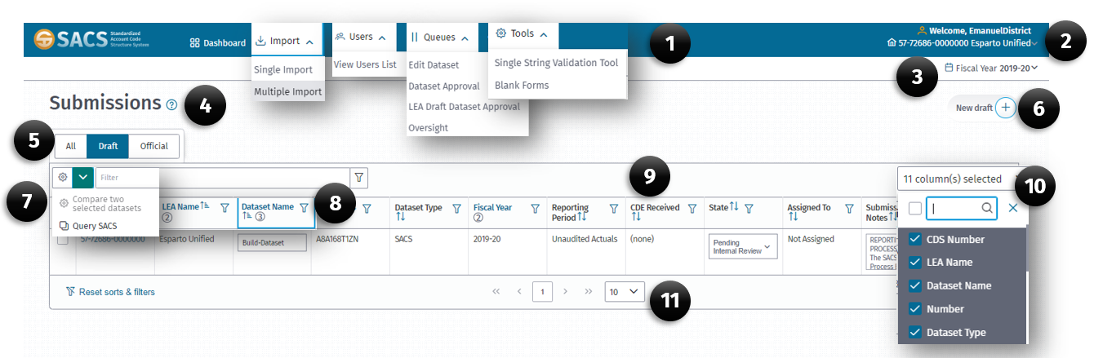
The Dashboard displays the
- Main Menu
- User Profile section
- Fiscal Year selector
- User Guide link
- Display Drafts/Official submissions selector
- New Draft button
- Compare Submission/Query SACS selector
- Column Filter/Sort icons
- Submission Columns
- Submission Column Show/Hide selector
- Submissions per Page selector
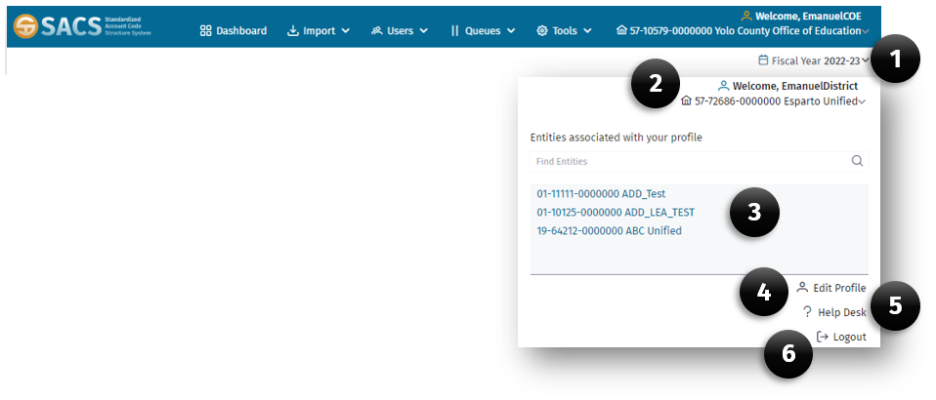
The User Profile section on the right of the Main Menu displays:
- Current Fiscal Year
- Current user and entity
- All entities associated with the current profile
- Edit Profile link
- Help Desk link
- Logout of the application link.
By default, the Dashboard displays the draft datasets. However, users may view Official, Draft or all datasets by selecting the appropriate option on the Drafts/Official submissions selector.

Dataset Submissions List
The Dataset Submissions List is located on the Dashboard, where the user may view all datasets associated with their profile. Each dataset displays on a separate row. The list, in default, displays up to ten datasets at a time.
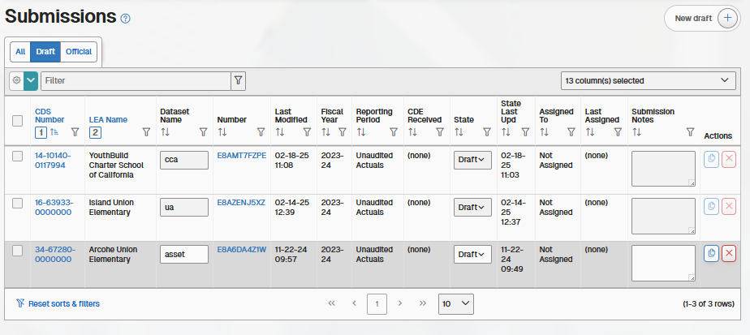
Above the Dataset Submissions List are three tabs that display different sets of datasets: All, Draft, and Official.
All: The All tab displays all the datasets available in the SACS Web System, both Draft datasets and Submission datasets. The tab displays all datasets available for the open reporting period for the selected fiscal year and entity. Access to the datasets is dependent on the user’s selected entity and associated roles.
Draft: This is the default tab for a user with Edit Draft Dataset role logging into the SACS Web system or selecting the Dashboard Top Navigation button. The tab displays all datasets that are in the Draft or Pending Internal Review states, as defined in the Dataset Submissions section of the User Guide. This includes new draft datasets that the user has currently imported/created, or copies of datasets that were shared with the user using the Send a Copy feature. The only time that a dataset no longer displays in this section is when a dataset is either promoted to a certain state or is deleted by the user. The tab displays the Draft datasets available for the open reporting periods for the selected fiscal year and entity. Users must have the Edit Draft Dataset role to access the datasets in this tab.
Official: The Official tab displays all Submission datasets that have been promoted from the Draft states and are in the New Dataset Submission state or higher, as defined in the Dataset Submissions section of the User Guide. The tab displays all Submission datasets available for the open reporting periods for the selected fiscal year and entity. Access to the datasets is dependent on the user’s selected entity and associated roles.
Note: Only the authorizing agency can see all their LEA submission status under their umbrella. All other LEAs can only see their own datasets.

New Draft button
The New Draft button allows the user to create a new empty dataset. The New Draft button is located on the top right side of the screen.

Create a New Draft Dataset
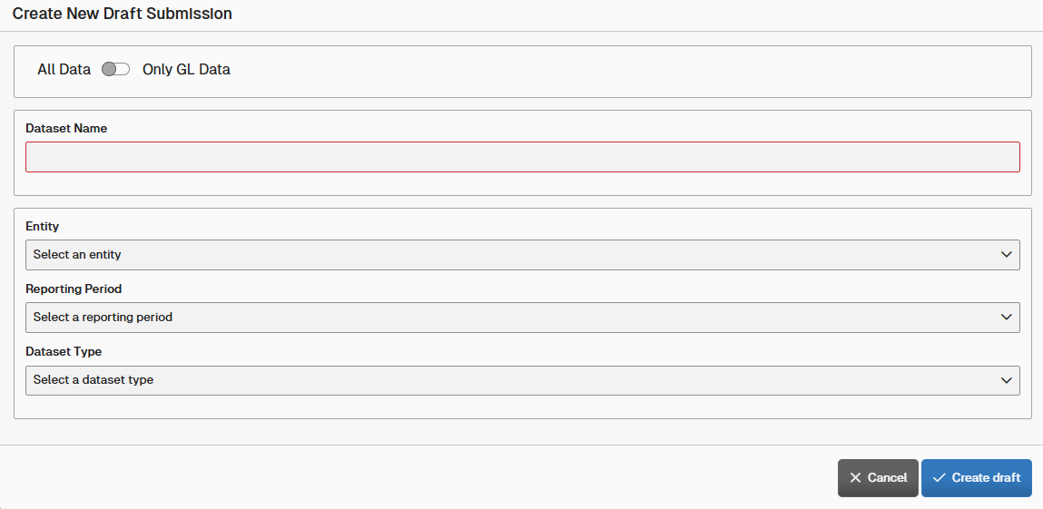
- From the Dashboard page (main page), click the New Draft + button.
- In the Create New Draft Submission dialog box enter a unique name for the dataset.
- Select the entity from the Entity drop-down list.
- Select the reporting period for the submission from the Reporting Period drop-down list.
- Select SACS or Charter Alternative from the Dataset Type drop-down list.
Note: The Charter Alternative option is only available if the entity is a charter school, and only applicable for the unaudited actuals reporting period.
- Click the Create Draft button.
Note: The new draft dataset will appear on the Dataset Submission List.

Filter and Sorting columns
Each column has a column name with the following components to filter and/or sort records:

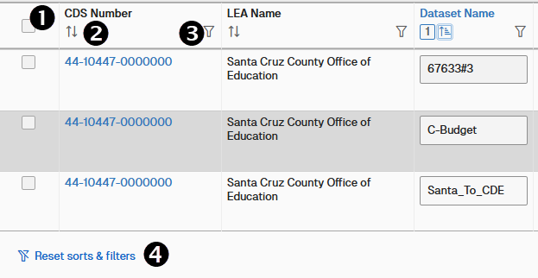

    - Column Name (Clicking this link sorts the list ascending or descending)
    - Sort Order icon (By using the CTRL + select, you can sort multiple columns)
    - Filter icon
    - Filter and Sort Reset link

Column Sort and Filter Icons
Each column in the Dataset Submission List has a series of icons that perform sort and filter operations of that column.

Sorting a Column
The Sort icon displays the current sort.
- Click the Sort (2) icon to sort the column in ascending order.
- Click the Sort (2) icon a second time to sort the column in descending order.
- When no sort is applied to the column, a neutral sort indicator is displayed.

Filtering a Column
The Filter icon displays a Filter dialog box which allows the user to either select records from the list or to type in a specific criterion to be used in the search parameter.
- Click the Filter icon (3) to open a filter dialog box.
- Type the search criteria in the Search box.
- As the pattern is typed, the filter dynamically eliminates the items not meeting the criteria.
- When the user completes the word pattern, the list is filtered to meet the criteria or:
- Select the record(s) in the list to be displayed.

Dataset List Columns
The Dataset Submissions list has up to 15 columns. Increase the width of displayed columns by reducing the number of columns. Each column has a sort and filter icon and a column name that may be used to sort the column in ascending or descend order. See the Sorting a Column and Filtering a Column section of this guide for more information on how to use those features.

Add or Remove Columns
- From the Dataset Submission List, click the Column Selector drop-down list box.
- Select or unselect each column to remove or add.
Note: The resulting list will update as checkboxes are selected or unselected.

Number of Rows
The number of rows function allows the user to determine the number of rows or datasets that is visible on a page.
Note: By default, 10 rows are displayed.

Resizing Columns
Column sizes may be manually resized using the sizing handles. To resize a column:
- Position your mouse pointer over the column border until you see the sizing pointer.
- While holding the left mouse button down, drag the mouse left or right until the desired size is achieved.

Column Descriptions
- CDS Number
The CDS Number column displays the entire CDS code for each dataset. Click the CDS code to access the dataset.
- LEA Name
The LEA Name column displays the name of the entity.
- Dataset Name
The Dataset Name column/field displays the unique name of the dataset that the user assigned.
- Number
The Number column displays identification numbers that are unique and associated with each individual dataset. Once a dataset has been created or imported into the SACS Web System, the number is generated. Click on the number to access the dataset.
- Dataset Type
The Dataset Type column/field displays “SACS” or “ALT” (Charter Alternative) depending on the reporting format user to prepare the submission. The Charter Alternative reporting format is available only to charter schools that report separately from their authorizing LEA.
- Last Modified
The Last Modified column/field displays the date a modification to the dataset was made.
- Last Modified By
The Last Modified By column/field displays name of the user who last modified the dataset.
- Fiscal Year
The Fiscal Year column/field displays the fiscal year the dataset represents.
- Reporting Period
The Reporting Period column/field displays the period the dataset represents (Budget, First Interim, Second Interim, End of Year Projection, or Unaudited Actuals).
- CDE Received
The CDE Received column/field displays the date the dataset was sent to CDE for review.
- State
The State column serves two purposes:
  - It displays or indicates the current state of the dataset. Original state is Draft.
  - It acts as an action button. The user may use the drop-down list box to promote or demote the dataset. Except for promoting a dataset from the Draft to Pending Internal Review state, state changes must be made via the appropriate queue.
- State Last Updated
The State Last Updated column displays the date the dataset state was last changed.
- Assigned To
The Assigned To column displays the name of the user assigned to the dataset. The Assigned To field may be updated when the dataset is accessed through a queue.
- Last Assigned
The Last Assigned column displays the date the Assigned To field was modified.
- Submission Notes
The Submission Notes column displays the note entered in the note field for the current dataset. Notes may be entered from the Dataset Submission List or through a queue.
  - To add a note to the submission:
- Click in the text box field and enter the text in freeform (maximum of 255 characters).
- Click out of the field to save the note. A message will appear at the top of the screen confirming the note has been successfully saved.
Note: This field is expandable by dragging the sizing handle on the lower right corner of the textbox.

Copy and Share a Submission
The Copy Submission button, in the Actions column, is available for each dataset. It may be used to create a copy of the selected dataset and share it with an authorized user if desired.
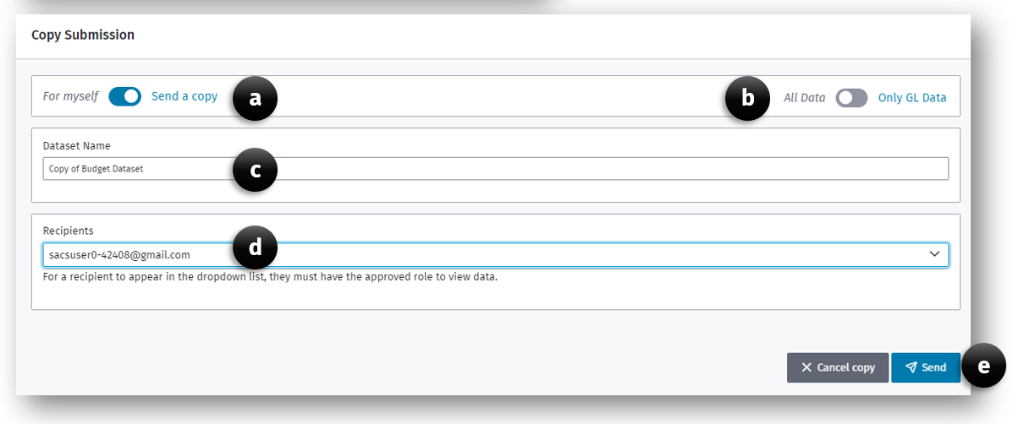
To copy or share a submission:
    - Click the Copy Submission button.
    - In the Copy Submission dialog box.
- Select the intended recipient of the dataset by selecting For myself or Send a copy option.
Note: If Send a copy is selected, the Recipients dropdown list will be active and list all approved recipients.
- Select the Only GL Data option if you only require the GL data to be copied.
Note: All notes and supplemental data will not be copied.
Note: The All Data or Only GL Data option is available only when the For myself option is selected.
- Enter a unique dataset name in the Dataset Name textbox.
- If Send a copy was selected, choose email from the Recipient dropdown list.
- Click the Copy Submission button to complete the copy or Send button if the submission will be shared with others.
Note: The copied submission will be located on the Draft dataset submission list.

Delete Submission
The Delete Submission button, in the Actions column, is available for each draft dataset. It may be used to delete a selected dataset. Note that datasets may be deleted only when they are in the Draft state.
To delete a dataset:
- Click the Delete Submission button.
- Click Yes or No to confirm whether you want to delete the submission.

Comparing Two Dataset Submissions
The Compare Two Dataset Submissions feature allows users to view and compare two datasets that are visible in the Submissions menu. Users can compare datasets originating from both different and same Fiscal Years, LEA type, Reporting Period, from the Draft, Submission, and Published Dataset Lists.
To compare two datasets:
- From the Dataset Submission List, select two datasets by clicking the dataset selector checkbox located on the first column left of the CDS number for the submission. Users can filter the columns on the Submission list to obtain datasets that are on separate pages, reporting periods, fiscal years, etc. to select the dataset they would like to compare.
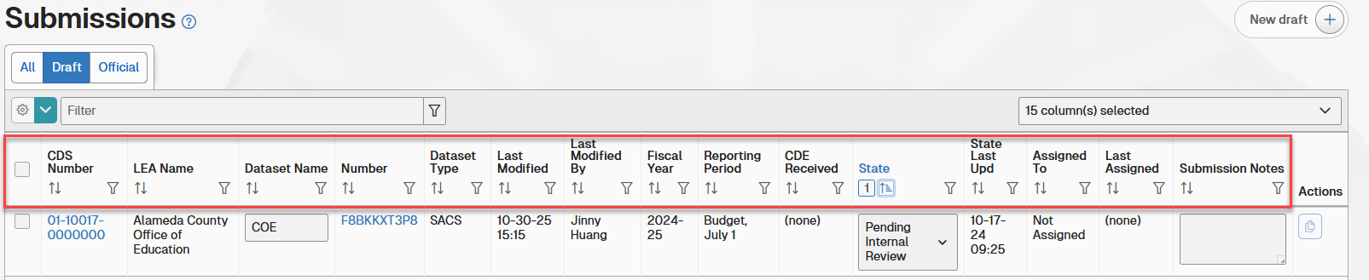

- Once the two datasets are checked, select the Compare two selected datasets button located above the check mark column in the cog dropdown menu.
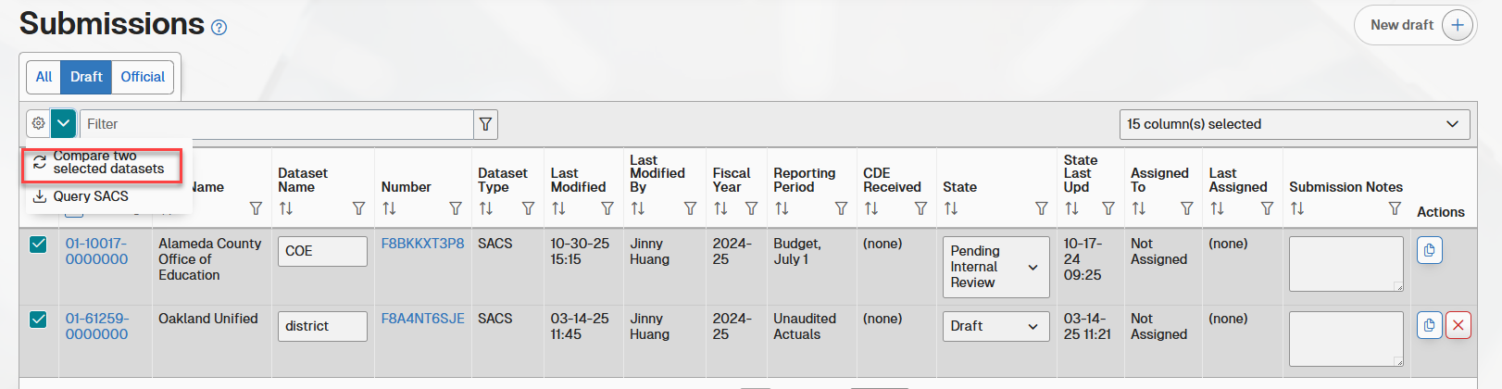
- On the Compare Dataset dialog box, select the Comparison Type:
a. GL Data
b. Supplemental Data
c. TRC Explanation Data
d. TRC Log Data
e. ALT Form Data
f. CASH Form Data
g. Fund Form Data
h. MYP Fund Data
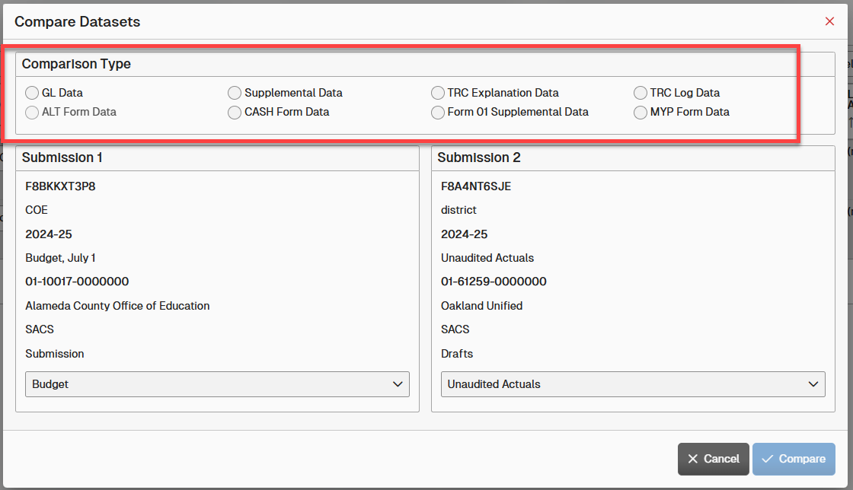

- If applicable, select the data type for submissions 1 and 2.
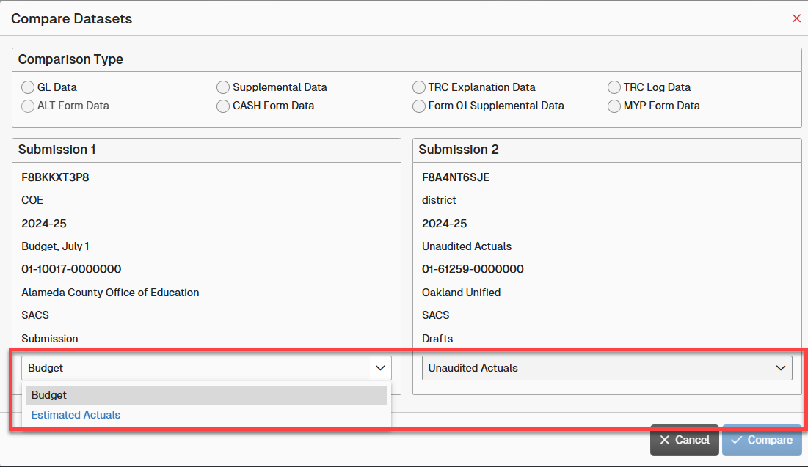

- After the Comparison Type and data type are selected, click the Compare button to see the results.
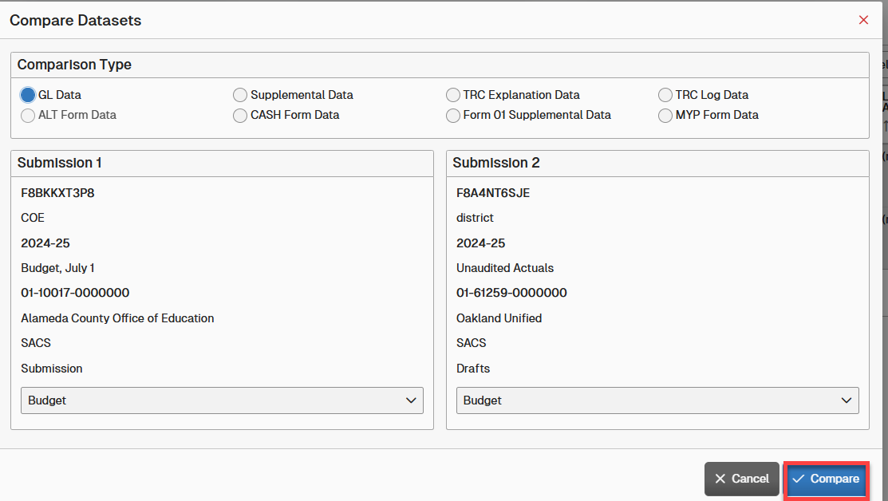

- When the appropriate Compare page opens, depending on the comparison type, it will display different results along with a different format:
a. GL Data: Displays all GL line data for the selected data type for both submissions. Matched GL lines are alongside each other, while mismatched will not be next to each other. Note: This only applies for the GL line itself, not the value data. The value data does not affect whether the lines are matching or not.
b. Supplemental Data: Displays all Supplemental line data for the selected data type for both submissions. Matched Supplemental lines are alongside each other, while mismatched will not be next to each other. Note: This only applies for the Supplemental line itself, not the value data. The value data does not affect whether the lines are matching or not.
c. TRC Explanation Data: This displays all unexplained and explained warning TRCs.
d. TRC Log Data: Displays all warning and fail TRCs, regardless of severity or status, i.e. whether the TRC has passed or failed.
e. ALT Form Data: Only applies to Unaudited Actuals reporting period Alternative Form submissions. Displays all Alternative Form data.
f. CASH Form Data: This displays all supplemental data related to form CASH. This selection can only be used when there is CASH supplemental data in at least one dataset.
g. Fund Form Data: The report only has Fund 01 and 01I supplemental data. No other fund form or supplemental data will be displayed here. Fund 01 needs to be saved in the submission prior to running the report.
h. MYP Form Data: This displays all supplemental data related to form MYP/MYPI. This selection only is able to be used when there is MYP/MYPI supplemental data in at least one dataset.

Main Menu
The Main Menu is located on the top of each page within the SACS Web System. When pages or forms are open, a Back button is accessible to allow the user to return to the previous screen.

Dashboard
The Dashboard menu item, when selected, returns the user to the Home Page or the Dashboard view. The Dashboard is the default view of the SACS Web System.

Import Menu
The Import menu displays two menu options:
    - Single Import – This option allows the user to import a single dataset (file with .dat, .txt, .csv extensions) into the SACS Web System from the user’s financial system. The application requires the dataset to be the same fiscal year as the one selected in the Fiscal Year menu.
    - Multiple Import – This option allows the user to import up to five datasets at the same time. Each dataset must have a unique name.

Users Menu
The Users menu allows the user to view a list of all user accounts. This list can be filtered by All Users, Public Users (users with an account that have not been assigned an entity and role), Associated Users, or by a search criterion. An entity user with the User Management role may use this screen to manage the associated entities and roles of that entity’s users.
Refer to the User Management section for detailed information about viewing, establishing, and managing SACS Web System.

Queues Menu
The Queues menu provides users with a unique set of views for different stages of the submission workflow. The submission workflow allows a user to promote a submission to the next step, or state, or demote a submission to the previous state, if necessary. During each workflow step, with the exception of the Draft state, the submission is visible on a specific queue.
A user’s assigned roles determine available queues. Only those queues are viewable by the user in the Queue drop-down menu. When the user clicks a specific queue, a list of submissions that meet the queue criteria is displayed. The user may then promote or demote one or more of those submissions to the next or previous state in the workflow.
The following sections describe the workflow states and LEAs and reporting periods applicable to each queue.

LEA Draft Dataset Approval
An LEA user with the Dataset Approval role may access the LEA Draft Dataset Approval queue. This queue displays a list of the draft datasets in the user’s entity with a state of Pending Internal Review. Draft datasets may be reviewed and promoted as a dataset submission.
Reporting Period | Charter | District | JPA | COE
B,I1,I2,I3,A | Pending Internal Review | Pending Internal Review | Pending Internal Review | Pending Internal Review

Edit Dataset
An LEA user with the Edit Dataset role may access the Edit Dataset queue. This queue displays a list of datasets in the user’s entity with a state of:
- New Dataset Submission
- Data Entry
- Update Dataset
Reporting Period | Charter | District | JPA | COE
B,I1,I2,I3,A | New Dataset Submission | New Dataset Submission | New Dataset Submission | New Dataset Submission
B,I1,I2,I3,A | Data Entry | Data Entry | Data Entry | Data Entry
B,I1,I2,I3,A | Update Dataset | Update Dataset | Update Dataset | Update Dataset

Dataset Approval
An LEA user with the Dataset Approval role may access the Dataset Approval queue. This queue displays a list of datasets in the user’s entity with a state of:
- New Dataset Submission
- Data Entry
- Update Dataset
- Active Submission Returned
Reporting Period | Charter | District | JPA | COE
B,I1,I2,I3,A | New Dataset Submission | New Dataset Submission | New Dataset Submission | New Dataset Submission
B,I1,I2,I3,A | Data Entry | Data Entry | Data Entry | Data Entry
B,I1,I2,I3,A | Update Dataset | Update Dataset | Update Dataset | Update Dataset
B,I1,I2,I3 | n/a | Active Submission Returned | n/a | Active Submission Returned

Oversight
An LEA user with the Oversight role may access the Oversight queue. This queue displays a list of datasets in the user’s entity with a state of:
- Promote to 1st Level LEA Review
- Promote to 2nd Level COE Review
- LEA Oversight Review Completed
- LEA Published
Reporting Period | Charter | District | JPA | COE
B,I1,I2,I3,A | n/a | Promote to 1st Level LEA Review | n/a | Promote to 1st Level LEA Review
B,I1,I2,I3,A | n/a | n/a | n/a | Promote to 2nd Level COE Review
B,I1,I2,I3 | n/a | n/a | n/a | LEA Oversight Review Completed
B,I1,I2 | n/a | n/a | n/a | LEA Published

Promote to CDE
An LEA user with the Certify/Promote to CDE role may access the Promote to CDE queue. This queue is only available for a limited time during the Unaudited Actuals reporting period process. This queue displays a list of datasets in the user’s entity with a state of:
- Pending CDE Authorization
- In CDE Review
- Active Submission Returned
- Resubmission Required
- Published
Reporting Period | Charter | District | SBE | JPA | COE
A | n/a | n/a | Pending CDE Authorization | n/a | Pending CDE Authorization
A | n/a | n/a | In CDE Review | n/a | In CDE Review
A | n/a | n/a | Active Submission Returned | n/a | Active Submission Returned
A | n/a | n/a | Resubmission  Required | n/a | Resubmission Required
A | n/a | n/a | Published | n/a | Published

Tools Menu
The Tools menu provides LEA users with entity-specific SACS tools. The table below indicates which tools are available to which entity types.
Tool | COE | District | JPA | Charter
Financial Reporting Calendars | X | X | X | X
COE Software Contacts | X | X | X | X
Single String Validation Tool | X | X | X | X
Batch Operations | X | X | X | X
Blank Forms | X | X | X | X
Request for UA Promoter Role | X | N/A | N/A | N/A
Charter Schools Financial Reporting Status | X | N/A | N/A | N/A
Check Submission Status | X | N/A | N/A | N/A
Reports | X | X | X | X

Financial Reporting Calendars
A new tab will open that takes the user to the CDE’s current Fiscal Calendars web page that contains information on apportionments, budget, interim, and year-end financial reporting calendars.

COE Software Contact Information List
Provides LEAs with a list of COE staff who should be able to provide assistance either by phone or email for answering question regarding the SACS Software System or help with user accounts.
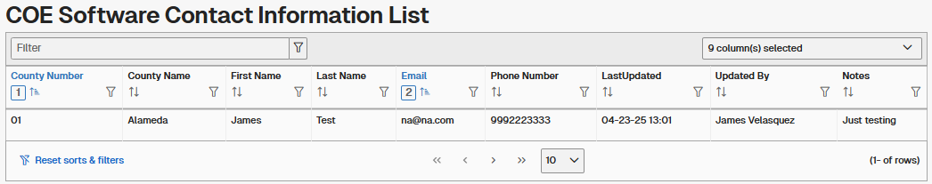
COE contact information is entered by the CDE and every county should have at least one contact person.

Single String Validation Tool
The Single String Validation tool provides an LEA user the ability to enter a 19-digit
SACS account code string to have the system verify whether it is a valid for the current
fiscal year and entity.

If the account code string contains code combination errors, the system returns the
invalid combinations allowing the user can revise accordingly. Note that only valid state
defined codes, per the CSAM, should be used in the tool. Use of locally defined account
codes will result in validation errors.

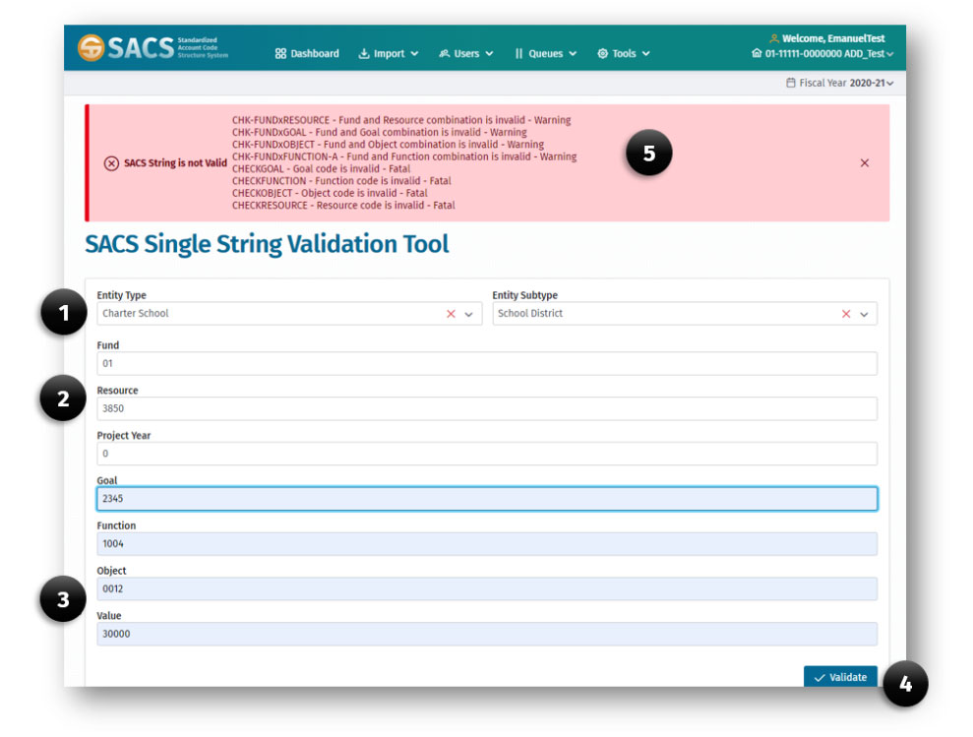

To Validate a SACS Account Code String:
- Select the Entity Type from the drop-down list.
Note: If the Entity Type is Charter School, an Entity Subtype must be selected. Select School District or County in the drop-down list.

- Enter a value for each SACS account code field, e.g., Fund, Resource and Project Year.

- Enter the Goal, Function, Object codes and a dollar amount in the Value field, which cannot be zero.

- Click the Validate button.

- If the string is invalid, an error message will display with an explanation of the individual code, e.g., Resource, or code combination, e.g., Resource and Object, error.
Note: For further information regarding SACS valid code combinations, please refer to the CSAM.

Batch Operations
The Batch Operations tool allows users to monitor the Query SACS function.
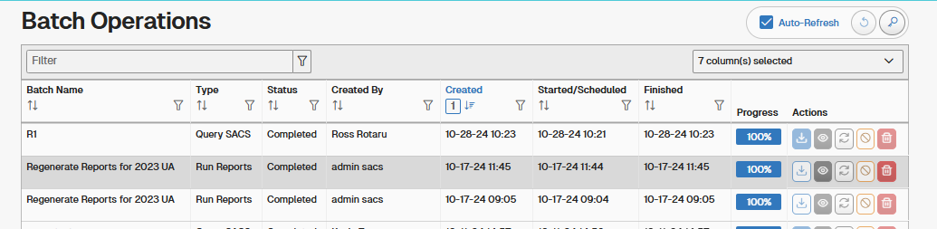
The Auto-Refresh operation will refresh the browser window so that the progress of a batch operation can be monitored with having to refresh the browser window manually. The Batch Operations columns are as follows:
- Batch Name – Name of the batch operation given when it is first started.
- Type – the type of batch operation running.
- Status – The batch status will be In Progress, Completed, or Failed.
- Created By – Name of user who started the batch operation.
- Created – Date and time that the batch process was started.
- Finished – Date and time that the batch process was completed.
- Progress – A thermometer style progress monitor.
- Actions – Options that can be completed for a batch process, from left to right:
  - Download File – Download the data generated as an Excel spreadsheet.
  - View Log – The log generated by the process.
  - Re-run Batch Operation – Used if an operation is stopped before completing or if it fails.
  - Cancel – Used to cancel a currently running operation.
  - Delete – Deletes a batch operation and removes it from the list.

Blank Forms
The Blank Forms tool allows a user to view a blank version of fund forms, supplemental forms, Criteria and Standards Review, Components of Ending Fund Balance/Net Position (CEFB), reports and Table of Contents. All forms can be exported in an Acrobat Portable Document Format (.pdf) or exported to Excel.
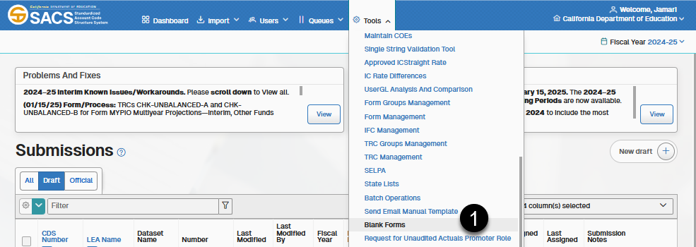

Printing or Exporting a Blank Form
- Select the Blank Forms option under the Tools menu.
- Select the Fiscal Year of the form.
- Select the Entity Type (District, Charter School, etc.).
  - If Charter School, select Charter Type.
- Select the Reporting Period.
- Select Dataset Type.
- Select the form Group (CEFB, Funds, Supplementals).
- Select the Form.
- Click the Start button.
- When the form appears, click the Export or Print button.
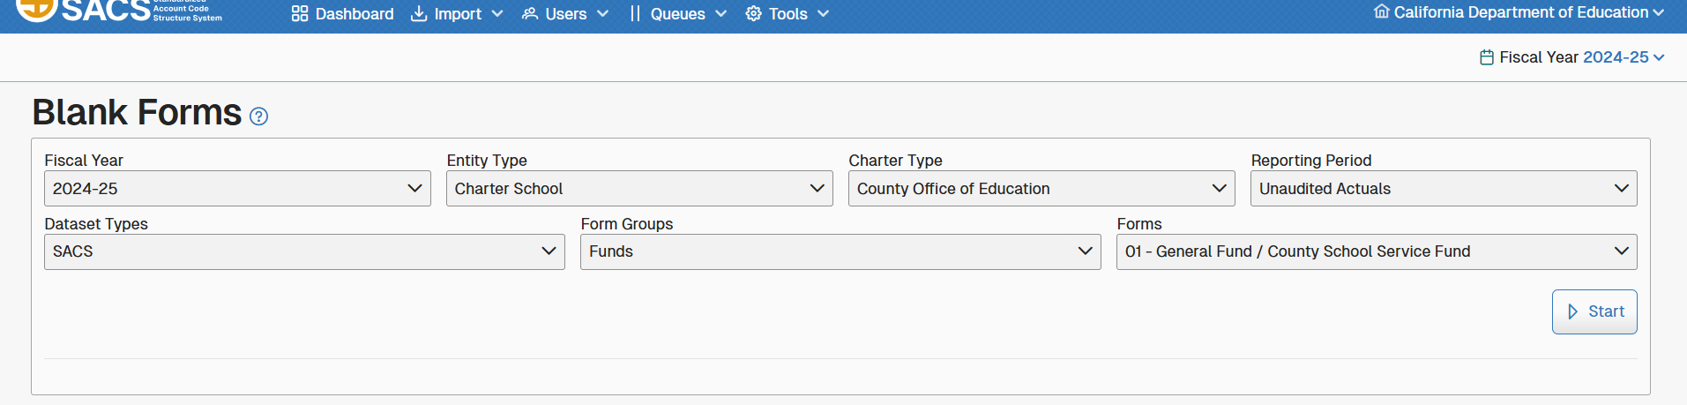

Fiscal Year Menu
The Fiscal Year menu allows a user to select the relevant fiscal year for a specific task. To upload a dataset, the fiscal year must be the same as the year displayed in the Fiscal Year menu.
Users may access prior year datasets by selecting the appropriate fiscal year.

User Profile Menu
The User Profile menu located on the right of the Main Menu is also an indicator to show:
- The user currently logged into the application.
- The current year (selected by the Fiscal Year menu option).
- The current entity which displays the entity’s name and CDS code
- A drop-down menu showing all entities associated with the current user.
Additional menu items include the Edit Profile menu item to allow the user to edit contact information, add or remove entities and roles as well as the Logout menu item.

Request for Unaudited Actuals Promoter Role Form
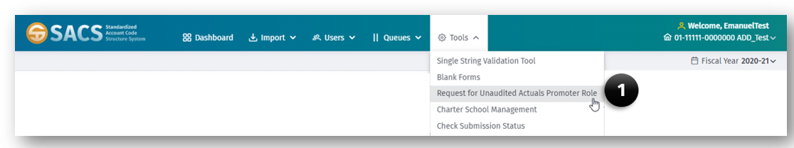
This tool provides COE level users the ability to request from CDE the role of Certify/Promote UA submissions to CDE. This authorization is valid for one fiscal year.

To Request the UA Promoter Role
- Select the Unaudited Actuals Promoter Role Form option under the Tools menu.
- Complete the County Superintendent Information section of the form.
- Complete the Chief Business Official Information section of the form.
- Complete the Superintendent/Designee Name section of the form.
- Click the Save button.

Charter Schools Financial Reporting Status
This is available to COEs during the UA reporting period to identify how charter schools will report their UA submissions. Instructions on filling out this form will be sent directly to COEs prior to the start of the UA data collection.

Check Submission Status
Allows COEs to track UA submissions after promoting them to the CDE. Important columns to note are:
- State – The state will be either blank (submission not yet promoted), In CDE Review, or Published.
- CDE Received – Date and time that a submission was promoted to the CDE.
- Certification Acknowledged – Date when the COE acknowledges on the Promote To CDE queue that the signed certificates have been received by the COE.

Reports
This tool allows users to select from up to six reports. All users have access to the following reports:
- Entity Look Up (50100)
- State by Entities and Roles (34700)
- State by Roles and Entities (34800)
Users with either the Administrator or User Management roles also have access to the following reports:
- All Users at Selected Entity (34100)
- Beta Testers by CDS (34200)
Selected Roles in Selected CDS Code (34600)

Importing Datasets
Datasets created by the reporting entity's financial system can be incorporated into SACS Web System by using the Import function. To import a dataset, the dataset must meet the SACS Web System data file specifications found in Attachment B.
Note: The import function accepts a dataset when the dataset and the options selected in the import dialog box match, as follows:
- Reporting period
- Fiscal year
- Entity, e.g., COE or district
The functionality of Import is listed below:

Import - Other
Use the Other option for importing data which is either exported from an LEA’s financial system or exported from the SACS Web System. When data is imported using the Other option, the SACS Web System performs various checks and calculations, depending on the reporting period and type of data:
Checks and Calculations | Reporting Period | Data Type
Ending fund balances/net position (Object 979Z) are recalculated.  Ending fund balances/net position (net beginning fund balances/net position plus revenues and other sources minus expenditures/expenses and other uses) are calculated as Object 979Z by fund and resource.  Object 979Z equals the sum of nonspendable, restricted, committed, assigned, and unassigned fund balances (objects 9700–9790) for all funds except funds 61 through 95. For funds 61 through 95, Object 979Z equals the sum of net investment in capital assets (Object 9796), restricted net position (Object 9797), and unrestricted net position (Object 9790). | All | All
Zero amounts are ignored.  Zero amounts are ignored to prevent receiving fatal account code and combination technical review check exceptions for them. | All | All
Assets, deferred outflows of resources, liabilities, and deferred inflows of resources (Objects  9100–9699) are ignored.  Assets, deferred outflows of resources, liabilities, and deferred inflows of resources are ignored during import and cannot be input. Therefore, amounts reported as nonspendable for Revolving Cash, Stores, and Prepaid Expenditures are not compared to the asset amounts or modified by the SACS Web System. Although not required, assets, deferred outflows of resources, liabilities, and deferred inflows of resources are allowed for estimated/unaudited actual data. | All | Budget/  All Interim
Other Commitments (Object 9760) and Other Assignments (Object 9780) are recalculated.  When Other Commitments and/or Other Assignments are detailed and saved in the Components of Ending Fund Balance/Net Position screen, general ledger amounts for objects 9760 and/or 9780 are recalculated by fund and resource. | All | All, except  Interim period  Actuals to Date
Budgeted beginning fund balances/net position (Object 9791) are recalculated.  Budgeted beginning fund balances/net position (Object 9791) are recalculated to equal the actual ending fund balances/net position by fund and resource.  Note: When estimated/unaudited actual ending fund balances/net position exist for any fund, budgeted beginning fund balances/net position are recalculated for all funds. | Budget/ Unaudited Actuals | Budget
Nonspendable amounts are compared to asset amounts.  Amounts reported as nonspendable for Revolving Cash (Object 9711), Stores (Object 9712), and Prepaid Expenditures (Object 9713) are compared to their respective asset amounts (objects 9130, 9320, and 9330, respectively) during system recalculations and, where different, are changed to equal the asset amounts even when the asset amounts are zero.  When there are asset amounts (objects 9130, 9320, and 9330) reported but there are no corresponding nonspendable amounts, the SACS Web System creates the respective nonspendable amounts (objects 9711, 9712, and 9713, respectively).  Note: When there are no amounts reported in assets for Revolving Cash (Object 9130), Stores (Object 9320) and Prepaid Expenditures (Object 9330):  - Their respective nonspendable amounts (objects 9711, 9712, and 9713) remain unchanged during system recalculations for estimated actual data.  - Their respective nonspendable amounts (objects 9711, 9712, and 9713) are deleted during system recalculations for unaudited actuals data. | Budget/ Unaudited Actuals | Estimated/ Unaudited Actuals

Import - Official
The Import Official option is used to import data previously exported using the Export Official option from the SACS Web System. Unlike the Import Other option, recalculations are not performed; however, the appropriate technical review checks for any given reporting period must be run before an official export can be made of the officially imported data.

Importing the Dataset
The SACS Import feature allows LEA users with either Edit Dataset or the Edit Draft Dataset role to import a single or multiple datasets for a particular reporting period.
Note: The import function accepts a dataset when the dataset data and the options selected in the import dialog box match as follows:
- Reporting period
- Fiscal year
- Entity, e.g., county, district
The Import menu item displays two menu options, Single Import and Multiple Import.

Single Import
This option allows the user to import a single dataset into the SACS Web System from the user’s financial software for data entry, review, and approval. The user must select a dataset with the same fiscal year as the Fiscal Year selected in the Fiscal Year menu.
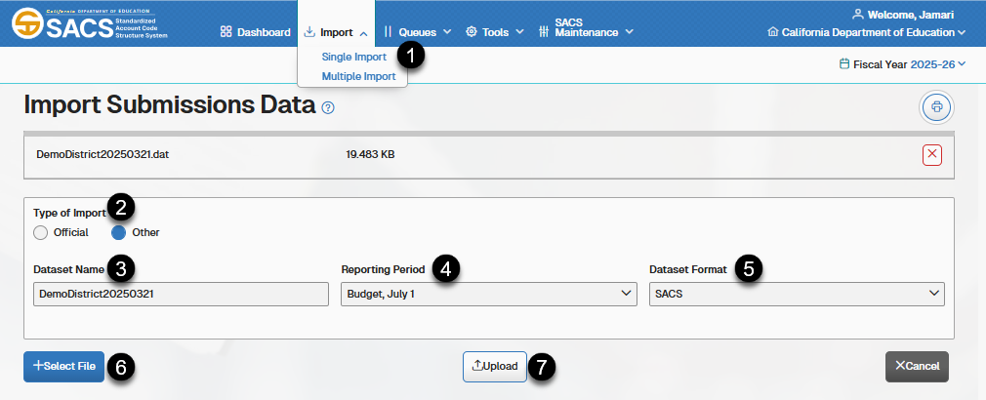
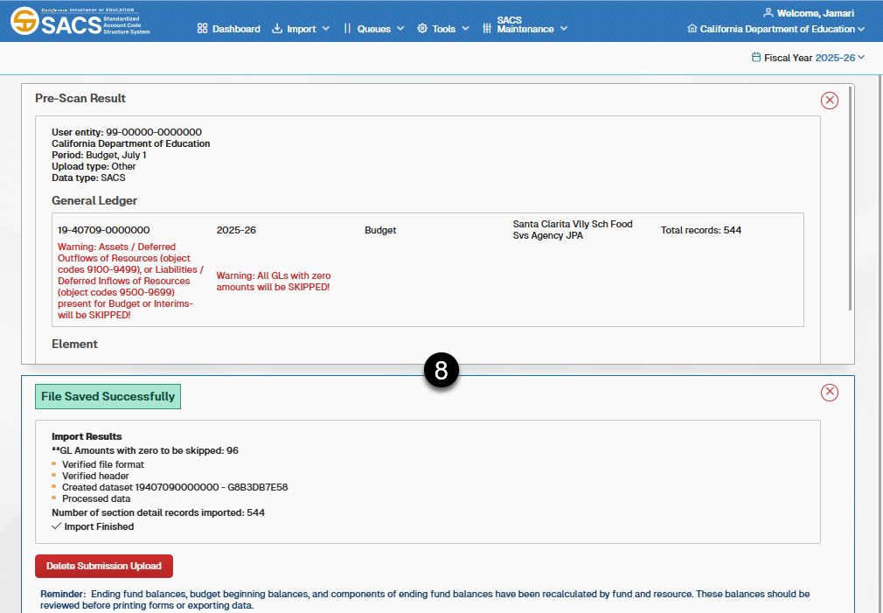
- Select the Single Import option on the Import menu.
- Select either Official or Other as the Type of Import.
- Enter a name for the dataset in the Dataset Name text box.
- Select the reporting period from the Reporting Period drop-down list box.
- Select SACS or Charter Alternative as the Dataset Format from the drop-down list.
- Click the + Select File button to locate and select a dataset to import.
- Click the Upload button to complete the import process.
- Note: When the import process ends, the system displays the import result log at the top of the page.

Multiple Import
This option allows a user to import up to five datasets.
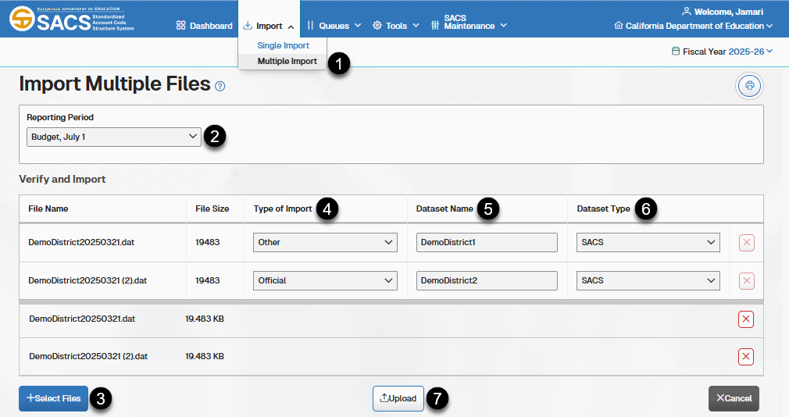
Importing Multiple Datasets
- Select the Multiple Import option on the Import menu.
- Select a Reporting Period from the drop-down list box.
- Click the + Select Files button to select datasets located on your computer.
- For each dataset, select either Official or Other as the Type of Import from the drop-down list box.
- Enter a unique dataset name in the Dataset Name text box. Each dataset must have a unique name.
- Select SACS or Charter Alternative as the Dataset Type from the drop-down list.
- Click the Upload button to upload each data file for processing into SACS.

Import Options

Overwrite Datasets
The Overwrite Dataset feature allows a user to replace all or part of existing data within a specific dataset.
When a user is working within a dataset and chooses import all or part of the data from another file, the Delete All Data option deletes all data associated with the CDS Number for the selected dataset including GL, Supplemental and Explanation data, Fiscal Year, Reporting Period, and Type of Data.
When a user imports data using the Delete Only option, the system deletes only those forms already existing in the system (funds, supplementals, etc.) that are being imported.
Note: Options are based on selecting the Type of Import: Other or Official. Selecting Official allows only the Delete All data overwrite option. Selecting Other will provide the user with the option to overwrite only the forms being imported or Delete All data.
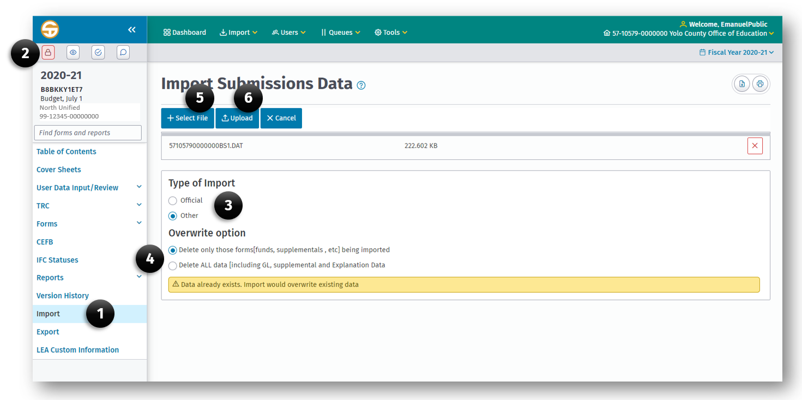
To Overwrite Part or All Data in a Dataset:
- Click the Import menu item on the left navigation bar in the current submission.
- Lock the submission by clicking the Lock Submission button.
- Select Official or Other to identify the Type of Import to be used.
- Select the Type of Import/Overwrite by selecting either:
  - Delete only those forms (funds, supplementals, etc.) being imported.
  - Delete ALL data (including GL, supplemental and Explanation Data).
- Click the + Select File button to select the dataset to be used.
- Click the Upload button to complete the import process.

Stop Import
A user may stop the import process at any time by clicking the Cancel button.
Note: The data import will not be committed until the entire process completes.

Print or Export Import Results
To print the import results:
- To print to PDF, click the Print button.
- To export to Excel, click the Export button.

Dataset Submissions

Data Submission Overview
This data submission and review workflow module provides SACS Web System users with an end-to-end financial data submission process. Some transition and state changes for data submissions are included with some system-automated or approval-based changes.
Workflow functionality is role-based. Authorized users may view and manage relevant workflow items. Multiple users may work with the same data file at the same time. They may not, however, edit the same form simultaneously. As part of the workflow process, users and reviewers may comment and request corrections to a data submission.
Workflow functionality includes charter school reporting. A charter school may report using either the SACS format or Charter Alternative format. Reviewing agencies of charter schools may monitor submission progress.

Dataset Edit and Locking
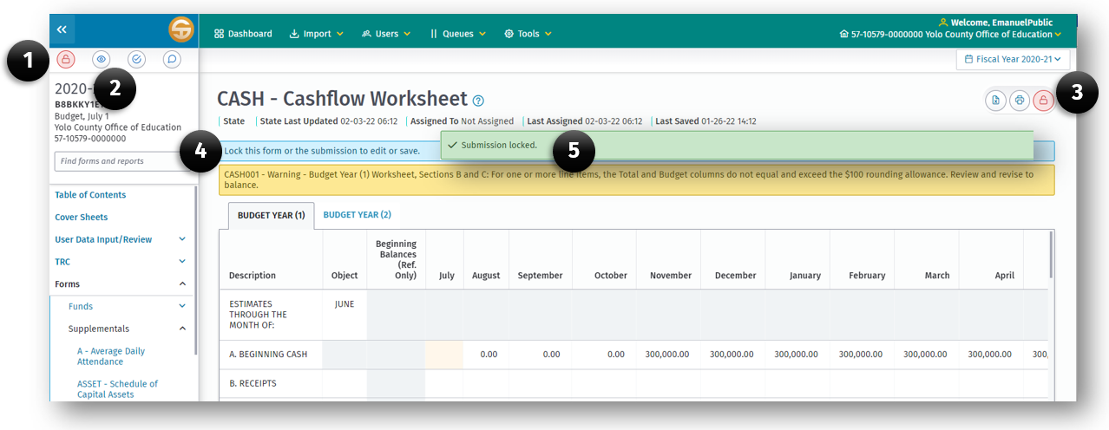When a user is a member of an entity and has the role of Edit Dataset or Edit Draft Dataset, the SACS Web system allows modification of a dataset submission. Additionally, the user must lock the form or entire submission prior to editing. When the submission is locked by another user, only a user with the Administration or User Manager role can remove the lock.

Elements of the Submission Lock Feature
- Lock Submission button.
- View Current Locks button.
- Lock Current Form button.
- Notification of to whom and what form a lock is applied.
- Notification of submission lock.

To Lock a Submission or Individual Form
- Open the submission by clicking the submission link on the Dashboard Submission list.
- On the User Data Input Review screen click the Lock Submission button (1) or the Lock Current Form button (3).
- A notification (5) will be displayed if the lock was successful.

To Unlock a Submission or Form
- Go to the User Data Input Review screen or the form that is locked and press the appropriate lock button (1) or (3) to unlock the submission form.
- Click the View Current Locks button (2).
- In the notification (4) click the remove lock button for each form or submission.
Note: A user can unlock their own submission locks only. But a user with the User Management and/or Administration role can unlock another user’s locked submission.

Locking Criteria Based on Form Dependencies
*Locking a form will also prevent other forms from being locked if part of a dependency chain
Left Navigation Pane | Locking Requirements
Table of Contents | No Locking Requirements
User Data Input/Review | Submission wide locking required
TRC | Submission wide locking required
Forms | Form* or Submission wide locking required
CEFB | Submission wide locking required
IFC Statuses | No Locking Requirements
Reports | Form* or Submission wide locking required
Version History | No Locking Requirements
Import | Submission wide locking required
Export | No Locking Requirements
LEA Custom Information | No Locking Requirements

Draft Datasets
- Draft datasets are defined as datasets in the following states:
  - Draft
  - Pending Internal Review
- Draft Datasets are visible on the Draft dataset list only for the user who created the datasets.
- Datasets in the Pending Internal Review state are visible to LEA users with the Dataset Approval role, on the Draft Dataset Approval queue.
- LEA users may have a maximum of five draft datasets for a selected fiscal year and specific entity.
- Datasets can only be deleted when in the Draft state.

Submission Datasets
Submission datasets are datasets that are exclusive to the entity and visible on the Dashboard for any entity user the with Edit Dataset or Dataset Approval role. Submission datasets are datasets in the following states:
  - New Dataset Submission
  - Data Entry
  - Update Dataset
  - Promote to CDE Review
  - Promote to 1st Level LEA Review
  - Promote to 2nd Level COE Review
  - LEA Oversight Review Completed
  - Pending CDE Authorization
- The New Dataset Submission state is the initial state in which other users within the entity may edit forms, import data, and enter data elements.
- The Data Entry state is used to edit forms, import data, and to allow manual entry of data elements, as well as run validations and make corrections.
- The Update Dataset state is reflected when oversight returns a dataset for corrections.
- The Promote to CDE Review state is used by COEs and single district county school districts to submit the budget and interim datasets and COEs to submit county, district, JPA, and charter school unaudited actuals datasets to CDE. The submission is locked for data edits by the submitter.
- The Promote to 1st Level LEA Review state is used when the dataset has been sent to the 1st level of Oversight to review the submission and approve or reject the submission. The submission is locked for data edits by the submitter.
- The Promote to 2nd Level COE Review is used to provide an additional review level for Charter Schools Authorized by Districts submissions. The submission is locked for data edits by 1st Level reviewers.
- The LEA Oversight Review Complete state is reflected for submissions (that are in reporting period Budget or Interim 1 – 3) that have been approved by Oversight. The system locks the submission, preventing edits.
- The Pending CDE Authorization state is used to move the submission in the UA reporting period to the CDE workflow for CDE review and approval.

Formal Submission Datasets
Formal submission datasets are defined as datasets that have been promoted to the CDE. Formal submissions will be displayed in the “In CDE Review” state.

Resubmission Datasets
After an LEA submits a formal dataset submission, they may need to revise and resubmit a new dataset to replace the formal dataset version that was submitted to the CDE. When a new draft dataset that is created for resubmission and promoted through the LEA workflow process, use a dataset name that clearly identifies it as a resubmission.
- Resubmission datasets are defined as datasets in the following states:
  - Resubmission
  - Resubmission Required
  - Submission Replaced
  - Resubmission Rejected
- Only one active LEA submission is allowed in their entity wide submission area.
- When the resubmission is at the Promote to CDE Review status, the system recognizes the dataset as a resubmission (since there was a previous formal submission for the entity). SACS automatically sets the resubmitted dataset to the Resubmission status and CDE is alerted by email.
- CDE will stop further review of the original dataset and determine whether the resubmitted dataset will replace the original submission.
- The status of the original dataset is changed to Submission Replaced if a resubmission is accepted as a replacement by the CDE and then an email is automatically sent to the LEA.
- If the submission is rejected, the state for resubmitted dataset is changed to Resubmission Rejected and email is triggered to LEA and the original dataset will continue through the review process.
- If CDE rejects a submission, CDE will return the submission to the LEA and set the status to Resubmission Required.

Recalled Dataset
A COE or SBE oversight user may email CDE to request a recall for a submission in CDE review for a given entity, fiscal year and reporting period. The CDE may return the submission to the LEA by setting the state to Active Submission Returned. The submission then goes back through the LEA workflow process for corrections.
- Recalled dataset are defined as datasets in the following state:
  - Active Submission Returned
Datasets not in the Published states (Published or CDE Published) may be changed to the Active Submission Returned state and the CDE Received field is set to null.

Published Datasets
After oversight review is complete for datasets, the dataset will be published within the system. Published datasets are defined as datasets in the following states:
  - Published
  - LEA Published
  - CDE Published
The published datasets are separately available to the public in the SACS Data Viewer website. The accompanying web page with information and instructions is the SACS Data Viewer - Financial web page.

Opening a Submission
- From the Dashboard page, click the submission (1) link (CDS number in the CDS Number column).
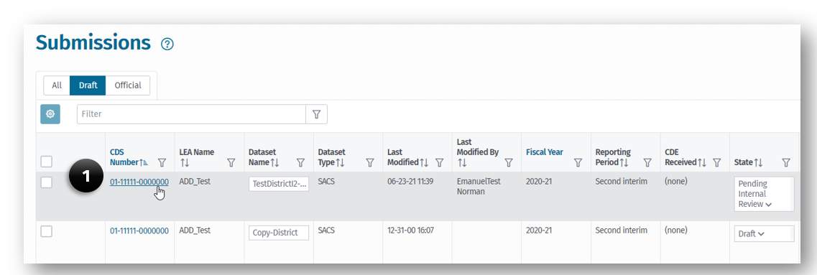
- The submission opens to the User Data / Input Review screen.
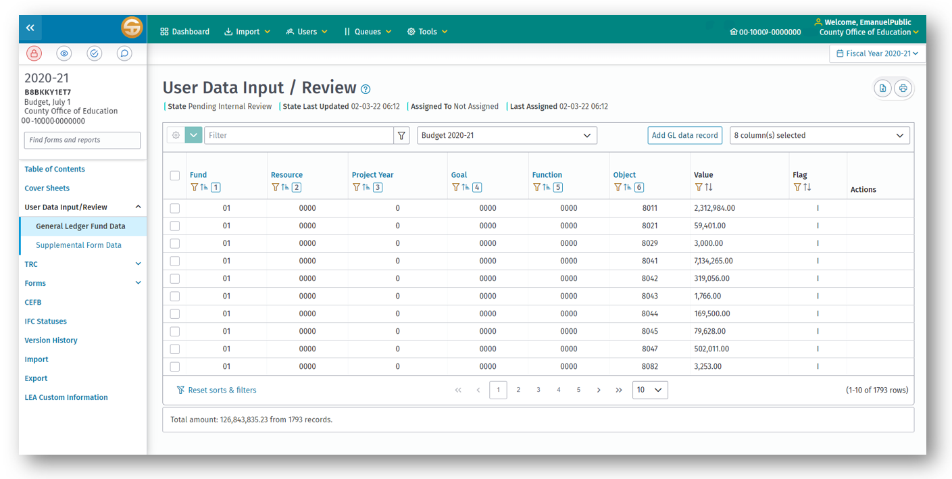

Table of Contents
The Table of Contents form displays high-level views of forms of a submission that contain data. It allows a user to identify which forms have data and what type of data it is (GL data vs Supplemental data).
The Table of Contents is accessed under the submission detail screen in the left Navigation Pane. It displays a list of forms available for the selected LEA type and reporting period. It is automatically created by the system when the form is opened.
G, S, and GS are used to identify the type of data contained in the form. A "G" displays when general ledger data is either input or imported into the SACS Web System, whether or not the applicable form is opened. An "S" displays when a supplemental form is opened and saved, whether or not data is entered in the form. (Exception: For funds, the "S" means that the fund form is saved, and that supplemental data exist for it.) "GS" displays when both types of data apply to the form.
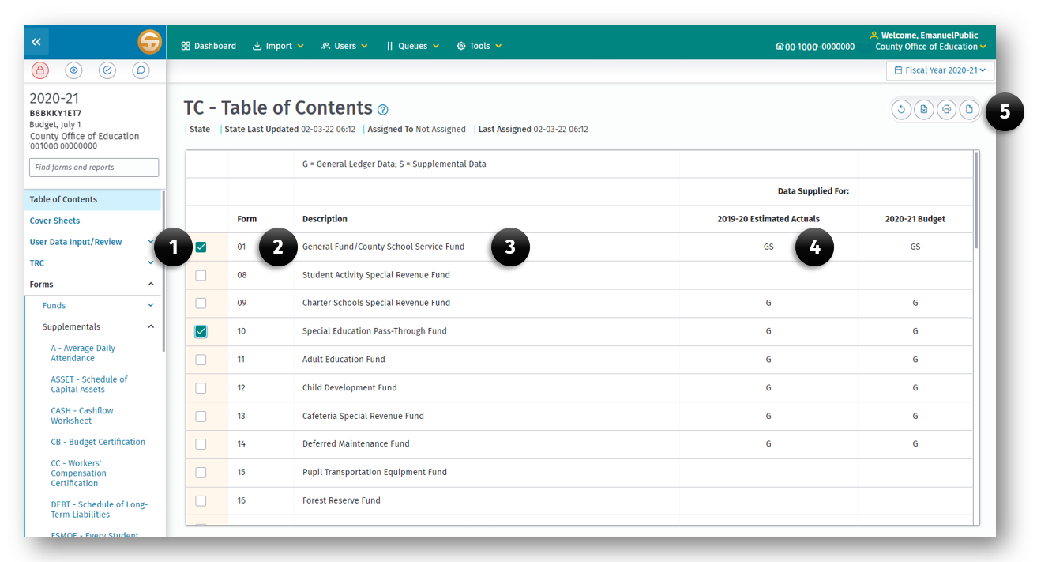
The Table of Contents Form displays each form in rows in the submission and the components of each form in columns to include:
- The form selection checkbox for selecting a form to print.
- The form number.
- The form name.
- The data indicator.
G = General Ledger data found in the form.
S = Supplemental data found in the form.
GS = Both General Ledger and Supplemental data found in the form.
- The Print and Export buttons.

Printing From the Table of Contents
The Table of Contents allows a user to select one (or multiple) forms to print at once.
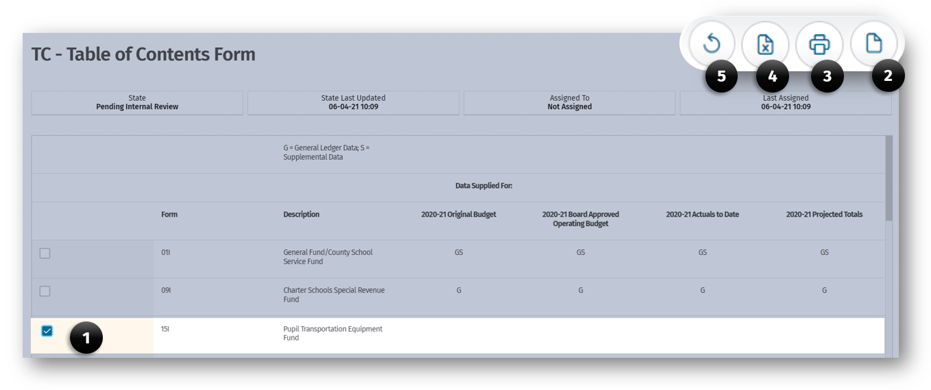To print selected rows or the entire Table of Contents:
- Select one or more rows (or none to print all forms).
- Click the Print Selected Forms (2) button to print the selected form or:
- Click the Print (3) button to print the Table of Contents Form.
- Click the Export to Excel (4) button to export the Table of Contents Form as an Excel spreadsheet.
- Click the Clear (5) button to clear all checked rows from the Table of Contents Form.

User Data Input Review Screen
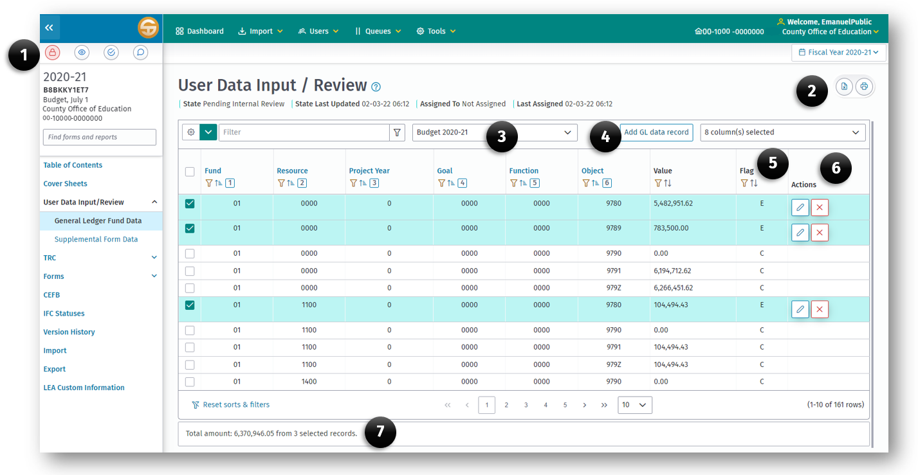
The User Data Input Review Screen feature provides authorized users the ability to view (including filter/sort, print) GL and Supplemental data associated with a draft or submission dataset. Elements of the User Data / Input Review Screen include:
- Submission Control (1) buttons.
- Print and Export (2) buttons.
- Data type (3) selector.
- Add GL data record (4) button.
- Record Flag (5) column:
  - Note: Flag set by system with following values:
    - I - when record was imported.
    - E - when record was added manually using the User Data Input Review Screen or when record was added using form CEFB.
    - C - when record was calculated/created by the system.
    - When a dataset is exported containing records with a flag of E or C and then reimported, the original flags of E or C keep their value; they are not changed to I.
- Record Action (6) buttons:
  - Edit Record button
  - Delete Record button
- Cumulative Total (7) display

Data Review
In addition to viewing the general ledger and supplemental data on the User Data Input/Review screen, from this screen a user may total selected records and print either all or a portion of the selected rows.

Totaling Records
To total records, select the particular records to be totaled by clicking each record checkbox. The Total may be viewed on the bottom of the screen. This is useful when a user wants to balance a particular account—for example, ending fund balance. To do so, filter the records by object 979Z (by clicking on the Object column filter icon), then enter 979Z.

Printing Records
A user may print the entire list of general ledger fund data records, an individual record, or a group of records. To print the entire list, click on the Print button. To print an individual record, select the record(s) you wish to print, and then click the Print button. To print a group of records, select the desired group individually, or by filters, then click print.

Sorting Records
General ledger fund data is automatically sorted by fund, resource, project year, goal, function, and object. Supplemental data is automatically sorted by data element name. A user may re-sort the data by clicking on the heading above the column(s) by which you wish to sort. For example, clicking on the Object heading will apply a sort order to the data in order of object code; clicking on Function, then Fund, sorts the data by function in each fund. To return to the original sort order, click “Reset Sorts & Filters” located at the bottom of the screen.

Data Input

Add a Record
General ledger data may be entered for any fund where imported data for that fund do not already exist in the database. Exception: General ledger data for Projected Year Totals data during interim reporting periods may be added even when imported Projected Year Totals data exist.
To add general ledger data:
- Lock the submission by clicking the Lock Submission button
- Click the Add GL Data Record button at the top of the screen and a pop-up window provides the fields to be entered.
  - Use the Tab key to move from one field to the next.
  - For negative values, use the "-" sign before the number.
- When all fields have been entered, press Enter or click OK.
  - Note that the SACS Web System allows one record per unique SACS account code string.

Edit a Record
When general ledger data is entered rather than imported, the flag in the last column of the User Data Input/Review screen equals "E" and the data may be modified, except for amounts entered through the Components of Ending Fund Balance/Net Position screen; those amounts must be modified in the Components of Ending Fund Balance/Net Position screen.
- Click on the Edit Record button at the bottom of the screen.
  - The pop-up window displays the record and allow changes to be made.
  - Use the Tab key to move from one field to the next.
- When all fields have been modified, press Enter or click OK.
  - Imported data (Flag equals "I") may not be modified except for Projected Year Totals data during the interim periods.
  - Calculated data (Flag equals "C") cannot be modified directly; instead, the source data used in the calculations must be changed.

Data Deletion

Delete a Record
This selection is used to delete a single general ledger fund record when it is manually entered; single records of imported general ledger data may not be deleted.
Exception: Single records of imported general ledger data for the Projected Year Totals data during interim reporting periods may be deleted.

Delete By Fund Group
This selection is used to delete all records of general ledger data for a fund; there may be a combination of entered, imported, and calculated data.
To delete all records for a specific fund, select a record of the fund, then click on the Delete by Fund Group option under the Delete Modes button. The fund name will display with a delete verification message. Click Yes, to delete all records within the selected fund for the type of data selected.

Delete Form Group
This selection is used to delete all records of supplemental data for a supplemental form. Individual records of a supplemental form may not be deleted. To delete all records for a specific supplemental form, select any record of the form, then click on the Delete Form Group option under the Delete Modes button. The form name will display with a delete verification message. Click Yes to delete records within the selected supplemental form, for the type of data selected.

Technical Review Checklists
Part of the financial reporting process requires a technical review of the data, including verification that entries exist, agree, and are consistent across all funds and forms. These checks are called the Technical Review Checklist (TRC) and are done from the Technical Review option of the TRC menu within a submission. While all TRCs may be run at any time, it is best to complete this in stages since different sections of the TRCs are dependent on different data being available. For additional information, see the Data Processing Sequence section.

Running TRCs
Prior to submission approval at the local level, the user must run a TRC for each data type. The data is checked according to state-defined specifications. After the TRCs have run, a report of each check and an explanation of the errors are available to be reviewed, exported, or printed.
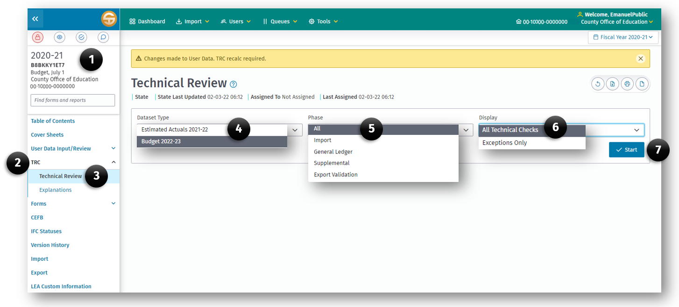

To Run the Technical Review:
- Open a Submission (1) dataset from the Dashboard.
- Click TRC (2) on the left Navigation Menu.
- Click the Technical Review (3) sub option.
- Select a Dataset Type (4).
Note: The TRCs must be run separately for each data type. The TRCs applied to the data, and their severity, are based on the LEA type, reporting period and data type.
- Select the Phase (5) of TRCs to be run:
- All—Import, General Ledger, Supplemental, and Export checks. This is the default.
- Import—Checks for valid accounts and balances.
- General Ledger—Checks for interfund, intrafund, and various other types of account balancing.
- Supplemental—Checks for completion of appropriate forms and validates supplemental and general ledger data.
- Export Validation—Verifies form requirements and dependencies. See Attachment E for a list of form dependencies.
Note: For charter schools, all Import and General Ledger checks are available to validate general ledger data, using both the county and district account codes and combinations. Applicable Supplemental and Export checks are available as well.
- Select the Display (6) option for the technical review check results;
- All Technical Checks – this is the default.
- Exceptions Only, including explained exceptions.
- Click the Start (7) button to run the TRC.

Types of Technical Review Checks
Following is a table of the types of checks and related requirements:
Code | Name | Description
F | Fatal | Data must be corrected; an explanation is not allowed.
W/WC | Warning/Warning with Calculation | When data is not correct, correct it; when data is correct, an explanation is required.
O | Informational | When data is not correct, correct it; when data is correct, an explanation is optional.

Print Technical Review Checks
A user may print TRCs when investigating or correcting exceptions, and for documentation purposes. Click the Print button to print the entire TRC as it is displayed on the screen.

Technical Review Explanations

Understanding Explanations
The TRC Explanations screen is used to review the TRC status and for keying narratives for valid TRC exceptions. Select the Explanations option on the TRC menu within a submission to review the TRC status.
The first step in clearing an exception is to determine whether the check is applicable to the agency. If so, and if the data is verified as correct, the LEA must provide an explanation of the details supporting the exception. The explanation must be specific and as detailed as possible; explanations such as “Will be fixed next year,” “OK,” or “Don’t know” are not sufficient. While the checks are written as detailed as possible, when an item does not apply to the LEA, it is acceptable to state so in the explanation. The explanations provide the reviewer of the report the information necessary to complete the review.
When an exception is explained, and then subsequently corrected, the TRC automatically deletes the explanation when the TRC is run again.

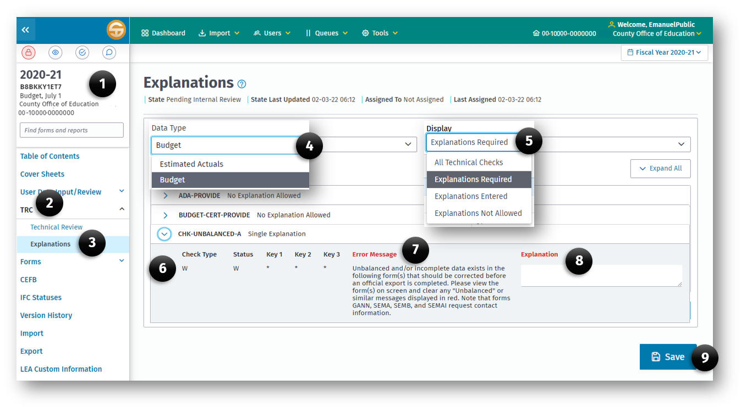
To provide an explanation for a TRC:
- Open a Submission dataset from the Dashboard.
- Click TRC on the left Navigation Menu.
- Click the Explanations option.
- Select the Dataset Type.
- Select which TRCs to Display - When the Explanations Required option is selected, only those exceptions where an explanation is required or optional will be displayed. Passed, fatal, and explained TRCs do not display.
- Click the TRC in the Explanation List.
- Review the TRC error message in the Selected Technical Check box at the bottom of the list.
- Enter a narrative explaining why the exception should be considered appropriate.
- Click the Save button to save the explanation.
Caution: TRC Fatal (F) exceptions that are not corrected and TRC Warning exceptions (W/WC) that are not corrected or explained prevent the SACS Web System from completing an official export.

Details of Checks
Check Type – The check type categorizes the severity of the check and is directly associated with the check itself; it is not dependent on the LEA’s data. The check type does not change and is not an indication of whether the check has passed.
Status – The status field indicates the current status of the check and is directly dependent on the LEA’s data or explanations. When a Fatal or Warning check fails, the check type indicator also displays as the status until it is corrected or explained. All checks must contain a status of Passed or Explained before an Official submission can occur. Informational checks are automatically assigned a status of Passed.
P – Passed
No exception exists, it is an Informational check that automatically passed, or an exception has been corrected.
E – Explained
An explanation is provided for a nonfatal exception. Explanations should not be entered for incorrect data. Incorrect data must be corrected.
Key1, Key2, Key3
The key fields provide information. When combined with the error message, they may help users identify the accounting information to be reviewed.

Print Technical Review Explanations
Use the Print button to print displayed explanation(s).

Forms

Printing Forms
Printing forms may be done at any time. Click the print button (1) while viewing the form. Some forms may have additional options such as Orientation, or What to Print, in the Print Preview (2) dialog box where a user may choose to print the entire form including all tabs.
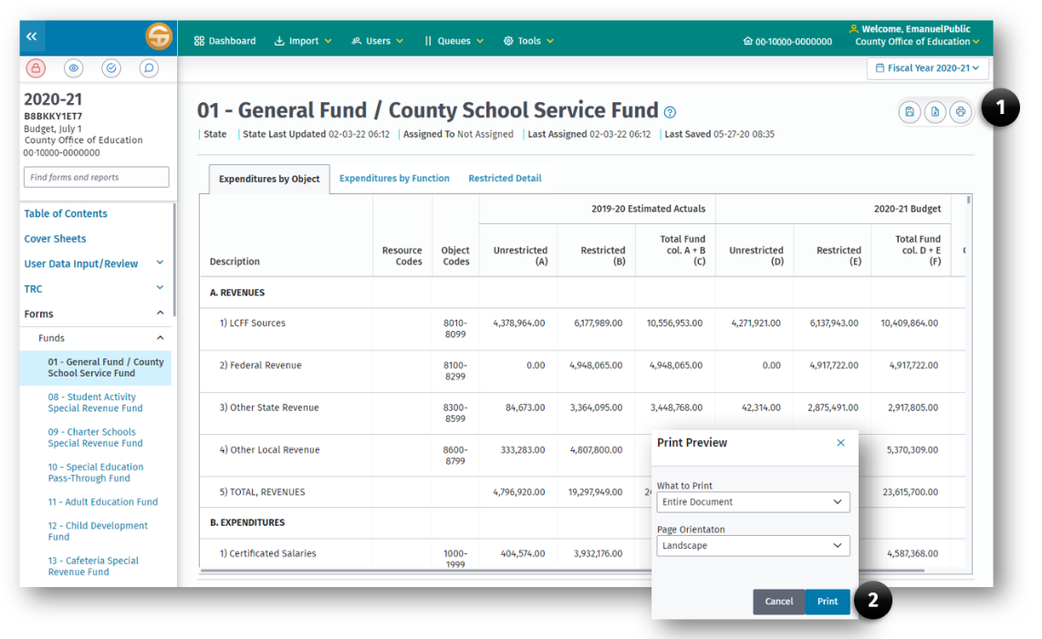

Fund Forms
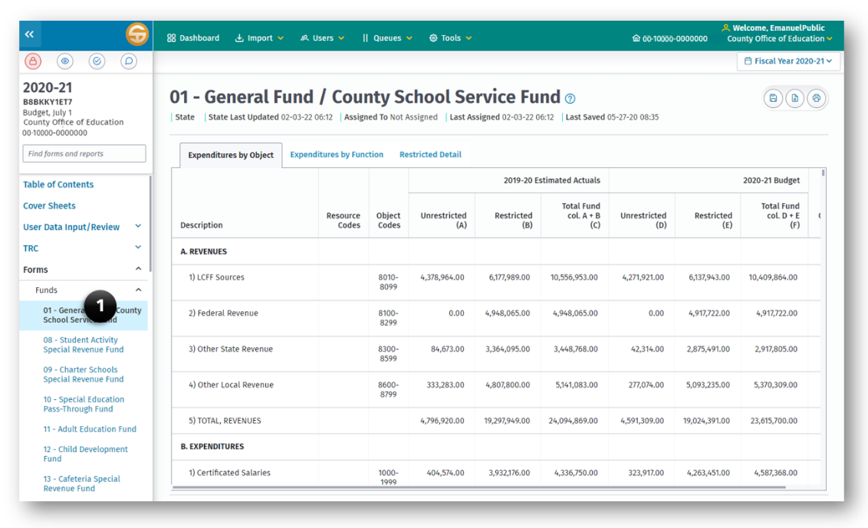
Fund forms may be accessed from a submission using the left navigation panel by clicking on (1) Forms > Funds. The available forms are based on the reporting period and LEA type. For a complete list of forms, see Attachment A.
Upon opening, the general ledger data previously imported or manually entered in the User Data Input/Review screen, and any amounts detailed in the Components of Ending Fund Balance/Net Position screen, will be extracted from the database directly into the form; this extraction process can take a few minutes. The data may be viewed and the form printed from this screen; however, general ledger data cannot be entered, changed, or deleted from this screen.
Some fields on the fund forms are shaded to indicate that data in these fields are not appropriate. The CDE encourages LEAs to review any data displaying in shaded cells to determine whether they are recorded correctly. The individual data records for these amounts display in one or more of the import technical review checks for valid account code combinations. If the LEA believes the data is correct, the LEA should provide a narrative in the TRC explanation to support the use of the accounts. This will assist the CDE in evaluating whether a change in valid account combinations is warranted.
Notes:
- During the budget and interim periods, the General Fund[County School Service Fund (CSSF)] forms (Forms 01/01I) must be opened and saved in order for the data to be pulled into the Criteria and Standards Review and Multiyear Projections forms 01CS, 01CSI, MYP, and MYPI.
- This guide is written primarily for the modified accrual basis of accounting used in governmental funds. Where the guide also addresses the accrual basis of accounting used in proprietary funds, fiduciary funds, and the government-wide statements, general references to beginning and ending fund balances should be interpreted as referring also to beginning and ending net position, and general references to expenditures should be interpreted as referring also to expenses.

Budget and Unaudited Actual Fund Forms
There are three different displays in the budget and unaudited actual fund forms:
- Expenditures by Object—Displays summarized and detailed revenues, expenditures, and other financing sources and uses by major object in the operating statements and includes year end balances in the fund reconciliation.
- Expenditures by Function—Contains the same data as expenditures by object; however, the expenditures section is displayed by major function rather than object and is only summarized.
- Restricted Detail—Displays detail of restricted balances by resource.
The fund forms display both actual and budget data.

Summary Statement
Following is a detailed description of the information presented in the summarized data of the Expenditures by Object and the Expenditures by Function formats, known as the Summary Statement:

Revenues: Section A
Displays operating revenues that are of a recurring or ongoing nature and likely to be received year after year. Does not include interfund transfers or non-recurring sources (revenues), such as proceeds from the sale of sites.

Expenditures: Section B
Displays operating expenditures that are of a recurring or ongoing nature and likely to be expended year after year. Does not include interfund transfers or non-recurring uses of revenues (expenditures), such as transfers from lapsed or reorganized districts.

Excess (Deficiency) of Revenues Over Expenditures Before Other Financing Sources and Uses: Section C
Compares operating revenues and expenditures, indicates whether revenues and expenditures are balanced, and highlights any deficit in operations. Creates a first line of focus on the ongoing financial health of the fund.

Other Financing Sources/Uses: Section D
Displays all interfund transfers plus other sources and uses. The other sources/uses are generally of a non-recurring nature and are not likely to be received or expended year after year, such as site sale proceeds (source) and transfers from lapsed or reorganized LEAs (use). Provides information on the amount of unrestricted General Fund[CSSF] revenues needed to subsidize restricted programs.

Net Increase (Decrease) in Fund Balance: Section E
Displays the net change in the fund balance as a result of all activities. Does not include the beginning fund balance (prior year's ending fund balance).

Fund Balance, Reserves: Section F
Displays the beginning fund balance, ending fund balance, and reserves.
Beginning Balance—As of July 1: F1a
The estimated/unaudited actual beginning balance must agree with the prior year unaudited actual ending balance as previously reported to the CDE. For the budget year, the SACS Web System automatically calculates the beginning balance based on the amount calculated for the unaudited actual ending balance.
The Technical Review Checklist will check to ensure that the LEA's "July 1" beginning balances agree with the prior year unaudited actual ending balances, by fund and resource.
Adjustments: F1b & F1d
A prior period adjustment applies to a correction of an error in the financial statements of a prior period or a restatement of the beginning balance when a change in accounting principle cannot be applied retroactively. Prior period adjustments or restatements are only applicable to the unaudited actual section of the report.
Ending Balance, June 30: F2
The estimated/unaudited actual ending fund balance (EFB) displayed on the fund form is calculated based on the data extracted into the form from the dataset’s general ledger data. If invalid object codes or fund by object combination codes (which are both fatal in the Technical Review Checks) exist in the dataset’s general ledger data, they will not display on the fund form, and the EFB on the fund form will not equal the EFB in the dataset’s general ledger data or the budget beginning fund balance (which is calculated from the estimated/unaudited actual EFB in the dataset’s general ledger data). For example, when Object 4100 is used in Fund 71, there is no place on the fund form for it to post so it is not included in the EFB calculation on the fund form, but it is used in the dataset’s general ledger EFB calculation. This type of exception must be corrected by changing the invalid codes in the source of the data (i.e., the LEA's accounting system).

Components of Ending Fund Balance—For All Funds Except Funds 61 Through 95
Nonspendable Fund Balance: F2a (Objects 9710–9719)
Displays the amounts that are not in spendable form, either because they will never convert to cash (such as prepaid items) or must remain intact pursuant to legal or contractual requirements (such as the principal of a permanent endowment).
- Nonspendable Revolving Cash (Object 9711)—the portion of fund balance reflecting the value of the revolving cash account.
- Nonspendable Stores (Object 9712)—the portion of fund balance reflecting the value of stores.
- Nonspendable Prepaid Items (Object 9713)—the portion of fund balance reflecting the value of prepaid items.
- All Other nonspendable Assets (Object 9719)—the portion of fund balance reflecting the value of nonspendable assets not specified above. For example, this object is used for the legal reserve required for Certificates of Participation, the long-term portion of notes receivable, or the principal of a permanent endowment.
Actual data reported in the asset accounts for Revolving Cash Account (Object 9130), Stores (Object 9320), and Prepaid Expenditures (Object 9330) is compared to amounts reported in the nonspendable Fund Balance for Revolving Cash (Object 9711), Stores (Object 9712), and Prepaid Items (Object 9713) accounts, respectively. If the amounts do not agree by fund and resource, the SACS Web System recalculates the amounts reported in the nonspendable accounts to equal the asset amounts.
Restricted Fund Balance: F2b (Objects 9730–9749)
Displays the amounts subject to externally imposed and legally enforceable constraints.
- Restricted Balance (Object 9740)—the portion of fund balance representing resources subject to externally imposed and legally enforceable constraints imposed either by external resource providers, e.g., grantors or creditors, or by law through constitutional provisions or enabling legislation. Examples include unspent balances of restricted state and federal grants, and unspent proceeds of general obligation bonds. All positive balances of SACS restricted resources 2000 through 9999 are reported using Object 9740.
Committed Fund Balance: F2c (Objects 9750–9769)
Displays the amounts of resources whose use is constrained by limitations self-imposed by the LEA through formal action of its highest level of decision-making authority. The constraints can be modified or removed only through the same process by which they were imposed. The action imposing the constraint must be made by the end of the reporting period. The actual amounts may be determined at a later date, prior to the issuance of the financial statements.
- Stabilization Arrangements (Object 9750)—the portion of fund balance set aside pursuant to a stabilization arrangement more formal than the reserve for economic uncertainties recommended by the Criteria and Standards for fiscal solvency or other minimum fund balance policy. The level of constraint must meet the criteria to be reported as committed, and the circumstances in which the resources are used must be specific and nonroutine. The formal action imposing the constraint should identify and describe in sufficient detail the circumstances in which the amounts may be used. Minimum fund balance policies and other stabilization arrangements that do not meet the criteria to be reported as committed are reported as unassigned. Also see Reserve for Economic Uncertainties (Object 9789).
- Other Commitments (Object 9760)—the portion of fund balance representing commitments other than stabilization arrangements.
Assigned Fund Balance: F2d (Objects 9770–9788)
Displays the amounts of resources that are intended to be used for specific purposes but for which the constraints do not meet the criteria to be reported as restricted or committed. Intent may be established either by the LEA’s highest level of decision-making authority or by a designated body or official. Constraints giving rise to assigned fund balance may be imposed at any time before the financial statements are issued, and may be modified or removed by a process less formal than is required for committed fund balance. In governmental fund types other than the general fund, this is the residual fund balance classification.
- Other Assignments (Object 9780)—the portion of fund balance representing assignments.
Unassigned Fund Balance: F2e (Objects 9789–9790)
Displays the amounts not classified as nonspendable, restricted, committed, or assigned.
- Reserve for Economic Uncertainties (Object 9789)—the portion of unassigned fund balance set aside pursuant to a minimum fund balance policy. This amount includes the reserve recommended by the Criteria and Standards for fiscal solvency, as well as additional reserve amounts established pursuant to local policy. Object 9789 is available in Fund 01 and Fund 17.
- Unassigned/Unappropriated (Object 9790)
- In the General Fund[CSSF], residual fund balance in excess of amounts reported in the nonspendable, restricted, committed, or assigned fund balance classifications and net of Object 9789, Reserve for Economic Uncertainties.
- In all governmental funds including the general fund, the excess of nonspendable, restricted, and committed fund balance over total fund balance (deficits). Assigned amounts must be reduced or eliminated if a deficit exists.
Components of Ending Net Position—For funds 61 through 95
Since funds 61 through 95 use accrual accounting, components of ending fund balance are not appropriately reported for them. Two objects are established to allow components of net position to be reported correctly. The two object codes are:
- Net Investment in Capital Assets (Object 9796)
- Restricted Net Position (Object 9797)
Net Investment in Capital Assets: F2a (Object 9796)
Displays the amount of capital assets, net of accumulated depreciation, reduced by the outstanding debt directly related to the capital assets.
Restricted Net Position: F2b (Object 9797)
Displays the amount of restricted net position.
Unrestricted Net Position: F2c (Object 9790)
Displays the amount not required to be reported in the other components of net position.

Fund Reconciliation
Displays the fund's assets, deferred outflows, liabilities, deferred inflows, and fund balance at the end of the fiscal year, for actual data only. Budget information does not display, as asset and liability accounts do not apply for budget data. Data is required for unaudited actuals only (optional for estimated actuals).
Note: Even though the Fund Reconciliation section (Assets, Deferred Outflows of Resources, Liabilities, Deferred Inflows of Resources, and Fund Equity) is optional for estimated actuals in the budget period, the page will print whether the LEA wishes to present it or not. We suggest that those LEAs who do not wish to present it replace the page with a blank that says, "This page intentionally left blank." No Technical Review Checks are applied to this section in the budget period.
Assets: Section G
Displays the general ledger assets as of the end of the fiscal year. Total Assets (Line G10) plus Total Deferred Outflows (Line H2) must equal Total Liabilities (Line I6) plus Total Deferred Inflows (Line J2) plus Fund Equity (Line K).
Deferred Outflows of Resources: Section H
Displays the general ledger deferred outflows as of the end of the fiscal year.
Liabilities: Section I
Displays the general ledger liabilities as of the end of the fiscal year.
Deferred Inflows of Resources: Section J
Displays the general ledger deferred inflows as of the end of the fiscal year.
Fund Equity: Section K
Displays the Fund Balance as of the end of the fiscal year. Fund Equity (Line K) must agree with the Ending Balance reported on Line F2 of the Fund Balance, Reserves section for unaudited actuals.

Revenue Detail
(Expenditures by Object format only)
This section presents the revenue detail for the fund.

Expenditure Detail
(Expenditures by Object format only)
This section presents the expenditure detail for the fund.

Other Financing Sources/Uses Detail
(Expenditures by Object format only)
This section presents the interfund transfers and other sources/uses for the fund.
Note: Because of the level of detail on the General Fund[CSSF] forms (Form 01) for districts and COEs, the font is much smaller for these reports. Changing the printing orientation from portrait to landscape will increase the font size. Be aware, however, that it may also change the form format and/or page breaks, as well as increase the number of pages for the report.

Interim Fund Forms

Forms 01i Through 95i—Statement of Revenues, Expenditures, and Changes in Fund Balance.
The General Fund[CSSF] and any other funds projecting a negative fund balance are required for the interim periods.
Description of data types used in the interim periods:
- Original Budget is the current year budget adopted on or before July 1, or the revised budget of an LEA whose original July 1 budget was disapproved by its reviewing agency. (See Note under Importing Data, Import of Budget Period Data for Interim Use.)
- Board Approved Operating Budget is the latest approved operating budget. If the governing board has not approved any amendments to the budget, the Board Approved Operating Budget will be the same as the Original Budget.
- Actuals to Date represents the actual revenue received and expenditures paid as of the close of the interim reporting period.
Note: The system automatically recalculates fund balances (Object 979Z) by resource after any import or input of fund data. The recalculated results are stored in the dataset’s general ledger data along with the imported or input fund data, with a flag of "C" to indicate it is calculated data. The recalculations are performed for all budget and actual data types, including the Actuals to Date data type. However, fund balance calculations are generally not meaningful for Actuals to Date data. Therefore, the fund balance section of the Interim fund forms is shaded for the Actuals to Date column; Actuals to Date data is not accessible in the Components of Ending Fund Balance/Net Position screen; and the Resource x Object technical review check ignores objects 9700–9799, except for Object 9791, for Actuals to Date data.
- Projected Year Totals represents the total projected revenue, expenditures, and other activities for the entire year. It includes all required year-end accruals of revenues and expenditures.

General Fund[CSSF] (Form 01i)
There are four worksheets in the General Fund/CSSF interim report:
- Unrestricted – Data for resources 0000 through 1999 are displayed in the Unrestricted worksheet.
- Restricted – data for resources 2000 through 9999 are displayed in the Restricted worksheet.
- Combined Unrestricted/Restricted – The Unrestricted and Restricted worksheets are summed in the Unrestricted/Restricted worksheet,
- Restricted Detail – Detail of restricted balances by resource are displayed in the Restricted Detail worksheet.
Note: Form 01I must be opened and saved for the data to be pulled into the criteria and standards review and multiyear projections forms 01CSI and MYPI.

Other Funds (Forms 08i Through 95i)
Unlike the General Fund[CSSF] interim report, the interim reports for other funds only have combined unrestricted/restricted and restricted detail data. Interim reports must be completed for any fund projected to end the current year with a negative fund balance.

Fund Descriptions
The following information is provided as an augmentation to the information in the CSAM. If a fund is not discussed here, there is no information/clarification in addition to what is in CSAM. Please refer to CSAM for specific descriptions and directions regarding the funds.

Fund 01—General Fund[CSSF]
The following information relates to the General Fund. All reports referenced in the following sections are from the Principal Apportionment Data Collection.
Objects 8010–8019
Resource 0000
Principal Apportionment
All LEAs shall report current year Local Control Funding Formula (LCFF) State Aid in Object 8011. Report current year Education Protection Account entitlement in Object 8012. Report prior year adjustments or corrections to LCFF State Aid, including the Education Protection Account entitlement, in Object 8019. This represents amounts received but not previously accrued for prior year apportionments.
- Object 8011 should be based on the following Principal Apportionment funding exhibits:
School Districts—State Aid portion of the School District LCFF Calculation; plus School District Basic Aid Choice Calculation; plus School District Basic Aid Court-Ordered Voluntary Pupil Transfer Calculation Report; plus School District Basic Aid Supplement Funding (Charter).
Charter Schools—State aid portion of Charter School LCFF Calculation.
County Offices of Education—State aid portion of County LCFF Calculation.
Objects 8021–8079
Resource 0000
Tax Relief Subventions, County and District Taxes
Report the proceeds of levies that count toward the LCFF calculation.
Objects 8080–8089
Resource 0000
Miscellaneous Funds
- Report Royalties and Bonuses in Object 8081 and Other In-Lieu Taxes in Object 8082.
- The Non-LCFF Adjustment (Object 8089) represents a transfer of 50 percent of the amount in revenue objects 8081–8082 from LCFF Sources to Other Local Income. Make this entry by decreasing (debiting) revenue Object 8089 and increasing (crediting) revenue Object 8691. Amounts should agree with those reported in the School district Local Revenue report.

Other State Revenue
Objects 8311–8319
Resource 6500
Special Education Master Plan, Other State Apportionment
Report the current year Special Education entitlement in Resource 6500, Object 8311. Report prior year adjustments/corrections to the Special Education entitlement in Resource 6500, Object 8319.
Due to the funding model under Assembly Bill 602 (Chapter 854, Statutes of 1997), most SELPAs are electing to have the SELPA Administrative Unit (AU) receive the special education apportionments. Refer to CSAM Procedure 755 for accounting guidelines for SELPA AUs and their participating member LEAs.

Fund 09—Charter Schools Special Revenue Fund
The Charter Schools Special Revenue Fund, Fund 09, exists as an option to separately report the activities of LEA-operated charter schools outside of the authorizing LEA's general fund[CSSF]. Note that activities performed by an authorizing LEA on behalf of a charter school, such as the receipt and subsequent pass-through of charter school funds, should be reported in the General Fund[CSSF] (Fund 01) of the authorizing LEA because these are activities of the authorizing LEA, not the activities of the charter school. The following information relates to the Charter Schools Special Revenue Fund:
Object 8011
Resource 0000
State Aid—Current Year
Record LCFF State Aid for charter schools.
Object 8019
Resource 0000
State Aid—Prior Years
Report prior year adjustments or corrections to LCFF State Aid or the Education Protection Account entitlement. This represents amounts received but not previously accrued for prior year apportionments.

Fund 10—Special Education Pass-Through Fund
The Special Education Pass-Through Fund, Fund 10, is required for all Special Education Local Plan Area (SELPA) Administrative Units (AUs) that receive special education pass-through revenues and that have administrative involvement in allocating and distributing those revenues to other member LEAs.
This fund is used only for pass-through revenues. Special education pass-through revenues are those revenues received by the AU on behalf of the SELPA for distribution to other member LEAs in accordance with the local plan.
Special Education revenues that are not passed through to other member LEAs, but rather are retained for use by the AU in accordance with the local plan, are not accounted for in this fund. Those revenues and the related expenditures are operational in nature and are properly accounted for in the AU’s own general fund.

Fund 13—Cafeteria Special Revenue Fund
The following information relates to the Cafeteria Special Revenue Fund:
Expenditures
Cafeteria Program Expenditures
Cafeteria program expenditures that are initially charged against the General Fund[CSSF] shall be included in appropriate resource, function, and object of expenditure classifications.
The General Fund[CSSF] may be reimbursed at any time in the current fiscal year from the Cafeteria Special Revenue Fund for these expenditures by crediting the expenditure in the General Fund[CSSF] and charging the expenditure in the Cafeteria Special Revenue Fund.
Object 5750
Object 7350
Transfers of Direct Costs—Interfund
and
Transfers of Indirect Costs—Interfund
Use to transfer direct and indirect charges from the General Fund[CSSF] to the Cafeteria Special Revenue Fund.
- Education Code 38101 emphasizes that a district[COE] cannot charge a food service program more than once for expenditures for the same service. If a food service program is being charged for a service as a direct cost, the district[COE] shall not allocate that cost as a direct support cost or indirect cost. In addition, indirect costs shall be limited to the lesser of the district's[COE's] indirect cost rate as approved by the CDE or the statewide average indirect cost rate for statewide average indirect cost rate for food service programs is posted on the CDE Indirect Cost Rates (ICR) web page.

Fund 20—Special Reserve Fund for Postemployment Benefits
This optional fund may be used to account for amounts LEAs have earmarked for retiree benefits but have not contributed irrevocably to a retiree benefit plan. It works exactly like Fund 17, Special Reserve Fund for Other Than Capital Outlay Projects, in that LEAs may transfer earmarked amounts to Fund 20, but must transfer them back to the General Fund[CSSF] for expenditure. For additional information on this fund, refer to CSAM Procedure 305.

Fund 49—Capital Projects Fund for Blended Component Units
This fund is used for the collection of data from Mello-Roos Community Facilities Districts and similar entities that are considered blended component units of the LEA to ensure that statewide costs for educational facilities are accurately reflected in statewide reports, eliminate the need of LEAs to exclude Mello-Roos data before reporting to CDE, and also expedite LEAs conversion for government-wide reporting under GASB Statement 34.

Fund 52—Debt Service Fund for Blended Component Units
In conjunction with Fund 49, Capital Project Fund for Blended Component Units, this debt service fund is used to account for the collection of money for current debt service for community facility districts and other similar entities.

Fund 61—Cafeteria Enterprise Fund
The following information relates to the Cafeteria Enterprise Fund:
Expenses
Cafeteria Program Expenses
Cafeteria program expenses which are initially charged against the General Fund[CSSF] shall be included in appropriate resource, function, and object of expenditure classifications.
The General Fund[CSSF] may be reimbursed at any time in the current fiscal year from the Cafeteria Enterprise Fund for these expenditures by crediting the expense in the General Fund[CSSF] and charging the expense in the Cafeteria Enterprise Fund.
Object 5750
Object 7350
Transfers of Direct Costs—Interfund
and
Transfers of Indirect Costs—Interfund
Use to transfer direct and indirect charges from the General Fund[CSSF] to the Cafeteria Enterprise Fund.
- Education Code 38101 emphasizes that a district[COE] cannot charge a food service program more than once for expenditures for the same service. If a food service program is being charged for a service as a direct cost, the district[COE] shall not allocate that cost as a direct support cost or indirect cost. In addition, indirect costs shall be limited to the lesser of the district's[COE's] indirect cost rate as approved by the CDE or the statewide average indirect cost rate for food service programs. The statewide average indirect cost rate for food service programs is posted on the CDE Indirect Cost Rates (ICR) web page.

Fund 62—Charter Schools Enterprise Fund
The Charter Schools Enterprise Fund, Fund 62, may be used to account for the activities of LEA-operated not-for-profit public benefit charter schools that use the accrual basis of accounting. It may also be used to account for the activities of separately operated not-for-profit public benefit charter schools that report separately from their authorizing LEAs. Since fund accounting is inconsistent with accrual accounting, in this case Fund 62 serves not as a fund but as a means to collect financial data needed for submission of reports to CDE.
Object 8011
Resource 0000
State Aid—Current Year
Record LCFF State Aid for charter schools.
Object 8019
Resource 0000
State Aid—Prior Years
Report prior year adjustments or corrections to LCFF State Aid or the Education Protection Account entitlement. This represents amounts received but not previously accrued for prior year apportionments.

Supplemental Forms
The supplemental data forms are accessed under the Forms menu option from the Left Navigation Menu within the submission and are available based on the LEA type and reporting period. The supplemental data forms are designed to provide required certifications, permit entry of specific information relating to certain programs, and demonstrate compliance with particular requirements.
Supplemental forms are required, optional or not applicable based on the current reporting period, LEA type, and the rules required to submit data for the form. This is represented by Appendix A - Form Reporting Period Matrix.
Since similarities exist among the forms, listed below are general pointers to enhance the report processing. Unlike fund data, supplemental data can be entered, modified, or deleted directly in the reports that allow data entry.
- Entering Data

Fields shaded tan allow key entry. To record an entry, press the Enter or Tab key. Pressing the Enter key does not cause the cursor to move to another field. Pressing the Tab key moves the cursor horizontally, then vertically, to the next entry field. Both methods bypass any extracted, calculated, or locked fields. The arrow keys move the cursor to the next or previous field (entry, imported, calculated, or locked fields) in the form.
- Entering Cents
Most dollar values display in the SACS Web System with two decimal places; whole numbers will automatically have .00 added to them.
- Inserting/Editing Data
Clicking on a field allows the entry to be edited but does not replace the existing data.
- Typeover
Double clicking on a field allows new data to be entered to replace the existing data. This is the typeover mode.
- Deleting Data—Entered Values
Double clicking on a field and pressing the Delete key clears data in that field.
Caution: Do not use the space bar to clear an entry; it causes problems in the dataset and errors in the TRC.
- Deleting Data—Extracted Values
To clear a cell where the value is extracted but can be overwritten (for example, the CASH form), enter a zero. If extracted cells are cleared by pressing the Delete key rather than entering zero, the original value may be re-extracted when the form is re-opened, overwriting the deletion every time the form is re-opened.
- Computations
The SACS Web System automatically recalculates the forms with input fields on-screen whenever a user changes the information in a cell and moves to another cell.
- Negative Amounts
Press the “-“ key before entering a negative number.
The following supplemental data forms are fully extracted from the dataset’s general ledger data (similar to the fund forms) and/or supplemental data, and need only be opened, reviewed, and printed if desired:
- Program Cost Report (Form PCR)
- Summary of Interfund Activities – Actuals (Form SIAA)/Budget (Form SIAB)/Interim (Form SIAI)
Note: As with the fund forms, invalid account codes in the LEA financial system export may result in unexpected results in supplemental data forms containing extracted general ledger data. Clear all fatal import and general ledger technical review checks before completing the supplemental data forms.

Budget & Unaudited Actual Supplemental Data Forms

Form A—Average Daily Attendance (Not Applicable for JPAs)
The Average Daily Attendance (ADA) form is used to report attendance for the Second and Annual attendance reporting periods as well as funded ADA, used to determine the LCFF entitlement.
- The Second Principal attendance period, designated as P-2, is the attendance count for all full school months during the period from July 1 through the last school month that ends on or before April 15 of the fiscal year. It is used by the CDE to calculate the P-2 Apportionment, certified in June of every fiscal year.
- The Annual attendance period, designated as Annual, is the attendance count for all full school months during the period from July 1 through June 30 of the fiscal year, and is used by the CDE in combination with P-2 data to compute the Annual Apportionment, certified in the February of the subsequent fiscal year.
Form A data is key entered and should correspond to the data reported in the applicable data entry screens of the Principal Apportionment Data Collection (PADC) web application and Principal Apportionment funding exhibits, published by the CDE for each Principal Apportionment certification.
Form A contains three separate worksheets (tabs) for use in reporting School District ADA, County Office ADA, and Charter School ADA.

Tab A─School District ADA
Line A1 - Total District Regular ADA
Line A1 is for ADA served by the school district and reported by the district on the Attendance School District data entry screen of the PADC. For school districts in which all schools have been converted to charter schools, any reference to Attendance School District below should be replaced with Attendance Charter School – All Charter District.
- In the columns marked “P-2 ADA,” enter the actual or estimated ADA, as applicable, that would be reported in the Total column of Line A-6 of the Attendance School District data entry screen of the PADC for the P-2, or P-2 Corrected reporting period.
- In the columns marked “Annual ADA,” enter the actual or estimated ADA, as applicable, that would be reported in the Total column of Line A-6 of the Attendance School District data entry screen of the PADC for the Annual reporting period.
- For Funded ADA, refer to the School District ADA funding exhibit, Line F-3, excluding lines E-2 and E-3, or the applicable sections of the LCFF Calculator by Fiscal Crisis Management Assistance Team (FCMAT). Do not include District Funded County Program ADA; this ADA is reported separately on Lines A5a-A5f.
Note that funded ADA is based on either P-2 or Annual ADA for each ADA category. Regular ADA that includes Opportunity Classes, Home and Hospital, Special Day Class and Continuation Education is equal to the greater of current year ADA, prior year ADA, or the average ADA of the three most recent prior year. The remainder of the ADA is funded based on reported ADA for the fiscal year.
Line A2 - Total Basic Aid Choice/Court Ordered Voluntary Pupil Transfer Regular ADA
- In the columns marked “P-2 ADA,” enter the actual or estimated ADA that would be reported in the Total column of Line A-6 of the Attendance Basic Aid Choice/Court Ordered Voluntary Pupils Transfer data entry screen of the PADC for the P-2, or P-2 Corrected reporting period.
- In the columns marked “Annual ADA,” enter the actual or estimated ADA that would be reported in the Total column of Line A-6 of the Attendance Basic Aid Choice/Court Ordered Voluntary Pupils Transfer data entry screen of the PADC for the Annual reporting period.
- For Funded ADA, refer to Line E-5 of the School District Basic Aid Choice Calculation funding exhibit, or the applicable sections of the LCFF Calculator by FCMAT. Regular ADA that includes Opportunity Classes, Home and Hospital, Special Day Class and Continuation Education is funded as of P-2. The remainder of the ADA is funded based on Annual ADA.
Line A3 - Total Basic Aid Open Enrollment Regular ADA
Basic Aid Open Enrollment funding is inactive; no ADA should be reported on Line A3.

Lines A5a-A5f – District Funded County Program ADA
These lines represent the ADA for students that are residents of the district, attend programs of education that are district funded but county operated, and do not meet the requirements for funding under the COE Alternative Education Grant.
COEs report this ADA in the Attendance District Funded County Programs screen of the PADC. The ADA reported by the COEs can be found on the School District Transfer of Funds for County Served District Funded ADA funding exhibit. Final funding for the year is based on either P-2 or Annual ADA, as specified by applicable statues. To estimate funded ADA, school districts may coordinate with the COEs providing services and use the LCFF Calculator by FCMAT, or analogous calculation tool.

Line A7 – Adults in Correctional Facilities
Enter the ADA from Line A-1 of the Adults in Correctional Facilities data entry screen for applicable periods.

Line A8 – Charter School ADA
This line does not allow key entry. Use Tab C, Charter School ADA, to report ADA for charter schools that report their SACS financial data in the authorizing LEA’s Fund 01, 09, or 62.

Tab B—County Office ADA

Lines B1a-B1c – County Program Alternative Education Grant ADA
These lines represent the ADA for students attending juvenile court schools operated by the county office of education, and students that attend other schools operated by the county office, such as the County Community Schools or special education classes and centers, who are enrolled pursuant to EC Section 2574(c)(4)(A).
- In the columns marked “P-2 ADA,” enter the actual or estimated ADA, as applicable, that would be reported in the Total column of the applicable lines of the Attendance COE data entry screen of the PADC for the P-2, or P-2 Corrected reporting period.
- In the columns marked “Annual ADA,” enter the actual or estimated ADA, as applicable, that would be reported in the Total column of the applicable lines of the Attendance COE data entry screen of the PADC for the Annual reporting period.
- For Funded ADA, refer to the County Alternative Education Grant ADA exhibit, Line C-1, or the applicable sections of the LCFF Calculator by FCMAT.
Note that, beginning with 2023–24 fiscal year, funded ADA is equal to the greater of current year ADA, prior year ADA, or the average ADA of the three most recent prior year, reported as of the Annual or Annual Corrected period.

Lines B2a-B2f – District Funded County Program ADA
These lines represent the ADA for students attending programs funded through their districts of residence, operated by the county office of education, that do not meet the requirements for funding under the COE Alternative Education Grant. This ADA is the combined total for all applicable districts of residence. The county office would also not report this ADA on Tab A, School District ADA. Tab A is completed by each district of residence to report its own District Funded County Program ADA.
- In the columns marked “P-2 ADA,” enter the actual or estimated ADA, as applicable, that would be reported in the Total column of the applicable lines on the Summary tab of the Attendance District Funded County Programs data entry screen of the PADC for the P-2, or P-2 Corrected reporting period.
- In the columns marked “Annual ADA,” enter the actual or estimated ADA, as applicable, that would be reported in the Total column of the applicable lines on the Summary tab of the Attendance District Funded County Programs data entry screen of the PADC for the Annual reporting period.
- Funded ADA for Lines B2a, B2b, B2e, and B2f is equal to P-2 ADA. Funded ADA for Lines B2c and B2d is equal to Annual ADA.

Line B4 – Adults in Correctional Facilities
Enter the ADA from Line A-1 of the Adults in Correctional Facilities data entry screen for applicable periods.

Line B5 – County Operations Grant ADA
The County Operations Grant ADA total is compiled by the Principal Apportionment Office and is displayed in the County Operations Grant funding exhibit.

Line B6 – Charter School ADA
This line does not allow key entry. Use Tab C, Charter School ADA, to report ADA for charter schools that report their SACS financial data in the authorizing LEA’s Fund 01, 09, or 62.

Tab C—Charter School ADA
This tab is used to enter ADA for either of the following:
1) Charter schools reporting in SACS separately from their authorizing LEAs use this tab exclusively to enter their own ADA.
2) Districts and county offices of education use this tab in conjunction with the School District tab or County Office ADA tab to enter ADA for charter schools that report their financial data in the district or county office’s Funds 01, 09, or 62.
As necessitated for ADA extraction into the district Criteria and Standards, and district form MYP, the Charter School worksheet of Form A is divided into two separate sections. Only charter school ADA corresponding to SACS financial data reported in Fund 01 should be entered into the first section. Charter school ADA corresponding to SACS financial data reported in Fund 09 or Fund 62 should be entered into the second section.

Charter School ADA Corresponding to SACS Financial Data Reported in Fund 01:

Line C1 – Total Charter School Regular ADA
- In the columns marked “P-2 ADA,” enter the actual or estimated ADA, as applicable, that would be reported in the Total column of Line J-5 of the Attendance Charter School data entry screen of the PADC for the P-2, or P-2 Corrected reporting period.
- In the columns marked “Annual ADA,” enter the actual or estimated ADA, as applicable, that would be reported in the Total column of Line J-5 of the Attendance Charter School data entry screen of the PADC for the Annual reporting period.
- Charter School Regular funded ADA is determined by a combination of P-2 and Annual ADA, adjusted for compliance with funding determinations made to nonclassroom-based ADA and prorated for any days below the required minimum number of school days. Funded ADA is available on the Charter School ADA funding exhibit, Line E-5, or the applicable sections of the LCFF Calculator by FCMAT.

Lines C2a-C2c – Charter School County Program Alternative Education ADA
These lines represent the ADA for students in charter-operated juvenile court schools and students in other county programs operated by charter schools, who are enrolled pursuant to EC Section 2574(c)(4)(A). The ADA is funded through the county office.
- In the columns marked “P-2 ADA,” enter the actual or estimated ADA, as applicable, that would be reported in the Total column for Lines D-1 through D-3 for all tracks in the Attendance County Program Charter School data entry screen of the PADC for the P-2, or P-2 Corrected reporting period.
- In the columns marked “Annual ADA,” enter the actual or estimated ADA, as applicable, that would be reported in the Total column for Lines D-1 through D-3 for all tracks in the Attendance County Program Charter School data entry screen of the PADC for the Annual reporting period.
- Charter School County Program Alternative Education funded ADA is equal to Annual ADA, adjusted for compliance with funding determinations made to nonclassroom-based ADA and prorated for any days below the required minimum number of school days. Funded ADA is available on the Charter School ADA funding exhibit, Lines K-6, L-6, and M-6, or the applicable sections of the LCFF Calculator by FCMAT.

Lines C3a-C3e – Charter School Funded County Program ADA
These lines represent the ADA that does not meet the requirements for funding under the COE Alternative Education Grant for charter school students attending county programs. This ADA is funded through the charter school.
- In the columns marked “P-2 ADA,” enter the actual or estimated ADA, as applicable, that would be reported in the Total column for Lines P-1 through P-5 for all tracks in the Attendance County Program Charter School data entry screen of the PADC for the P-2, or P-2 Corrected reporting period.
- In the columns marked “Annual ADA,” enter the actual or estimated ADA, as applicable, that would be reported in the Total column for Lines P-1 through P-5 for all tracks in the Attendance County Program Charter School data entry screen of the PADC for the Annual reporting period.
- Charter School Funded County Program funded ADA is determined by a combination of P-2 and Annual ADA, adjusted for compliance with funding determinations made to nonclassroom-based ADA and prorated for any days below the required minimum number of school days.
- Funded ADA for Lines C3a, C3b, and C3e is equal to P-2 ADA. Funded ADA for Lines C3c and C3d is equal to Annual ADA.

Charter School ADA Corresponding to SACS Financial Data Reported in Fund 09 or Fund 62:

Line C5 – Total Charter School Regular ADA
- In the columns marked “P-2 ADA,” enter the actual or estimated ADA, as applicable, that would be reported in the Total column of Line J-5 of the Attendance Charter School data entry screen of the PADC for the P-2, or P-2 Corrected reporting period.
- In the columns marked “Annual ADA,” enter the actual or estimated ADA, as applicable, that would be reported in the Total column of Line J-5 of the Attendance Charter School data entry screen of the PADC for the Annual reporting period.
- Charter School Regular funded ADA is determined by a combination of P-2 and Annual ADA, adjusted for compliance with funding determinations made to nonclassroom-based ADA and prorated for any days below the required minimum number of school days. Funded ADA is available on the Charter School ADA funding exhibit, Line E-5, or the applicable sections of the LCFF Calculator by FCMAT.

Lines C6a-C6c – Charter School County Program Alternative Education ADA
These lines represent the ADA for students in charter-operated juvenile court schools and students in other county programs operated by charter schools, who are enrolled pursuant to EC Section 2574(c)(4)(A). The ADA is funded through the county office.
- In the columns marked “P-2 ADA,” enter the actual or estimated ADA, as applicable, that would be reported in the Total column for Lines D-1 through D-3 for all tracks in the Attendance County Program Charter School data entry screen of the PADC for the P-2, or P-2 Corrected reporting period.
- In the columns marked “Annual ADA,” enter the actual or estimated ADA, as applicable, that would be reported in the Total column for Lines D-1 through D-3 for all tracks in the Attendance County Program Charter School data entry screen of the PADC for the Annual reporting period.
- Charter School County Program Alternative Education funded ADA is equal to Annual ADA, adjusted for compliance with funding determinations made to nonclassroom-based ADA and prorated for any days below the required minimum number of school days. Funded ADA is available on the Charter School ADA funding exhibit, Lines K-6, L-6, and M-6, or the applicable sections of the LCFF Calculator by FCMAT.

Lines C7a-C7e – Charter School Funded County Program ADA
These lines represent the ADA that does not meet the requirements for funding under the COE Alternative Education Grant for charter school students attending county programs funded through the charter school.
- In the columns marked “P-2 ADA,” enter the actual or estimated ADA, as applicable, that would be reported in the Total column for Lines P-1 through P-5 for all tracks in the Attendance County Program Charter School data entry screen of the PADC for the P-2, or P-2 Corrected reporting period.
- In the columns marked “Annual ADA,” enter the actual or estimated ADA, as applicable, that would be reported in the Total column for Lines P-1 through P-5 for all tracks in the Attendance County Program Charter School data entry screen of the PADC for the Annual reporting period.
- Charter School Funded County Program funded ADA is determined by a combination of P-2 and Annual ADA, adjusted for compliance with funding determinations made to nonclassroom-based ADA and prorated for any days below the required minimum number of school days.
- Funded ADA for Lines C3a, C3b, and C3e is equal to P-2 ADA. Funded ADA for Lines C3c and C3d is equal to Annual ADA.

Form ASSET—Schedule of Capital Assets
Form ASSET is used to report changes in the balances of capital assets and accumulated depreciation for the fiscal year. This form closely resembles the note disclosure for capital assets required by GASB Statement 34. It is divided into two sections: Governmental Activities and Business-Type Activities. Capital assets used in general governmental activities accounted for in governmental funds are reported in the Governmental Activities section. Capital assets used in business-type activities accounted for in enterprise funds are reported in the Business-Type Activities section. Each of these sections is further divided into capital assets that are not being depreciated, and capital assets that are being depreciated.
The schedule of capital assets is completed using extracted, entered, and calculated data. The columns on this form are completed as follows:

Unaudited Balance July 1
Capital asset ending balances reported in Form ASSET in the prior year are prepopulated in the Unaudited Balance July 1 (beginning balance) column. If capital assets were not reported in Form ASSET in the prior year and, therefore, zeros appear in the beginning balance column, report any beginning balances in the Audit Adjustments/Restatements column. Beginning balances for accumulated depreciation and amortization are input as negative numbers.
Manual input is not allowed in this beginning balance column.

Audit Adjustments/Restatements Column
Adjustments or restatements that increase the unaudited July 1 balances of capital assets are input as positive numbers. Adjustments or restatements that decrease the unaudited July 1 balances of capital assets are input as negative numbers.
Adjustments or restatements that increase the unaudited July 1 balances of accumulated depreciation and amortization are input as negative numbers. Adjustments or restatements that decrease the unaudited July 1 balances of accumulated depreciation and amortization are input as positive numbers.

Audited Balance July 1
Amounts are calculated beginning with Unaudited Balance July 1, plus Audit Adjustments/Restatements.

Increases Column
Increases in capital assets are input as positive numbers. Increases in accumulated depreciation and amortization are input as negative numbers. Amounts in the Increases column are added to the amounts in the Audited Balance July 1 column to arrive at the Ending Balance June 30 column.
For example, the cost of equipment acquired during the fiscal year is recorded as a positive number on the line for Capital Assets Being Depreciated: Equipment, in the Increases column. The increase to accumulated depreciation on equipment for the fiscal year is recorded as a negative number on the line for Accumulated Depreciation for Equipment, in the Increases column.

Decreases Column
Decreases in capital assets are input as positive numbers. Decreases in accumulated depreciation and amortization are input as negative numbers. The amounts in the Decreases column are subtracted from the amounts in the Audited Balance July 1 column to arrive at the Ending Balance June 30 column.
For example, the original cost of equipment that is sold or otherwise disposed of is removed from the aggregate balance of equipment and is recorded as a positive number on the line for Capital Assets Being Depreciated: Equipment, in the Decreases column. The accumulated depreciation associated with the equipment disposed of is removed from the aggregate accumulated depreciation balance for equipment and is recorded as a negative number on the line for Accumulated Depreciation for Equipment, in the Decreases column.

Ending Balance June 30
Amounts are calculated beginning with the Audited Balance July 1, plus Increases, minus Decreases.
Amounts in the Ending Balance June 30 column should be verified to ensure that adjustments, increases, and decreases to capital assets have been input correctly and that ending balances agree to asset schedules and financial statements. Ending balances are saved by CDE and used for external data reporting purposes and are extracted into the subsequent year's Form ASSET as beginning balances.

Form CA—Unaudited Actuals Certification
Form CA is the official signature page for the unaudited actuals report submission. For JPAs only, it includes a section to request an indirect cost rate. If JPAs do not indicate whether or not an indirect cost rate is requested, an exception will display upon running the TRC.
In addition to the certification page, Form CA also has a page titled Summary of Unaudited Actual Data Submission (not applicable for charter schools). It provides a summary of critical data elements that may have fiscal implications on the next year's apportionments or recovery of indirect costs. Please verify the accuracy of this data prior to filing the unaudited actuals financial reports.

Form CASH—Cashflow Worksheet
All LEAs are required to submit, along with their budget and interim reports, a cashflow analysis of their General Fund[CSSF] for the current fiscal year. Although submitting a cashflow analysis is required, the use of Form CASH is not. LEAs may choose to use their own cashflow worksheet form upon approval by their reviewing agency.
Form CASH provides monthly detail by major object category of the receipt and disbursement transactions for the General Fund[CSSF]. For the budget cashflow worksheet, estimated receipts and disbursements from July 1 through June 30 are reported. For the first interim cashflow worksheet, the actual receipts and disbursements from July 1 through October 31 are reported and the remaining months are estimated through the end of the fiscal year. For the second interim cashflow worksheet, the actual receipts and disbursements from July 1 through January 31 are reported and the remaining months are estimated through the end of the fiscal year.
By including accruals and adjustments in the totals, current year revenues and expenditures by major object category on the cashflow worksheet, generally, should agree with the total projected revenues and expenditures for the General Fund[CSSF] for the same major object categories.
To complete this report, start with the “Budget Year (1)” tab:
- Enter the month that represents the actual cash activities, except in the Budget period where the month of June is hardcoded.
- Enter the Beginning Balances in Section D (Balance Sheet Items). This column is informational or reference only and is not included in the calculations for the Total column.
- Enter the beginning cash balance for the month of July in Section A. Based on the data entered, the beginning cash balances for subsequent months will be automatically calculated.
- Enter the appropriate amounts in sections B (Receipts), C (Disbursements), and D (Balance Sheet Items) for each month. Sections E (Net Increase/Decrease) and F (Ending Cash) are automatically calculated, with Ending Cash extracted to Beginning Cash in the next month.
- Enter the appropriate amounts in the Accruals and Adjustments columns. The Adjustments column is for any non-cash differences, other than year-end accruals, between cash transactions and amounts budgeted.
- Fund 01 Projected Year Total GL data (Budget Year for budget period) will extract into the Budget column if Fund 01 data exists. If Fund 01 data does not exist, Fund 62 data will extract into the Budget column. The extracted amounts should agree with the projected revenues and expenditures for the General Fund[CSSF], or as applicable for Fund 62.
- Upon closing the form, a warning internal form check will prompt the user if one or more line items in the Total and Budget columns are not equal in sections B and C, and the difference exceeds the $100 rounding allowance.
For LEAs that elect to continue their cashflow projections into the subsequent year, enter the appropriate amounts using the “Budget Year (2)” tab.
- The ending cash balance at June from the “Budget Year (1)” tab will extract into the beginning cash balance in the “Budget Year (2)” tab.
- Enter the appropriate amounts in sections B (Receipts), C (Disbursements), and D (Balance Sheet Items) for each month. Sections E (Net Increase/Decrease) and F (Ending Cash) are automatically calculated, with Ending Cash extracted to Beginning Cash in the next month.
- Enter the appropriate amounts in the Accruals and Adjustments columns.
Note: The amounts entered in the Budget Period will carry forward to the First Interim, amounts in the First Interim will carry forward to the Second Interim, and amounts in the Second Interim will carry forward to the End of Year Projection Report. To override any cells in the First Interim, Second Interim, or End of Year Projection reports, enter the new amounts directly into the applicable cells, including 0.00. Simply deleting a value and not replacing with another value or zero will cause the original value to be re-extracted every time the form is reopened.

Technical Review Check (TRC) for Form CASH
There is a fatal CHK-DEPENDENCY TRC to alert the user if data that impact the form has been changed since the form was last opened and saved. Form CASH is dependent on GL data from Fund 01 and (if Fund 01 does not exist) from Fund 62. The TRC may display the dependency for both funds 01 and 62.

Form CAT—Schedule for Categorical
Form CAT is an optional form designed to assist in the determination of the correct amount of unused grant award (carryover), accounts payable, accounts receivable, unearned revenue, and/or restricted ending balance at the end of the fiscal year for all federal, state, and local categorical programs for which the LEA is responsible, regardless of the funding source.
The CAT form allows for the addition of multiple columns via the buttons above each column.
1. The left arrow button shifts the column to the left from its current position.
2. The plus sign button creates a new column to the right.
3. The “x” button deletes the column.
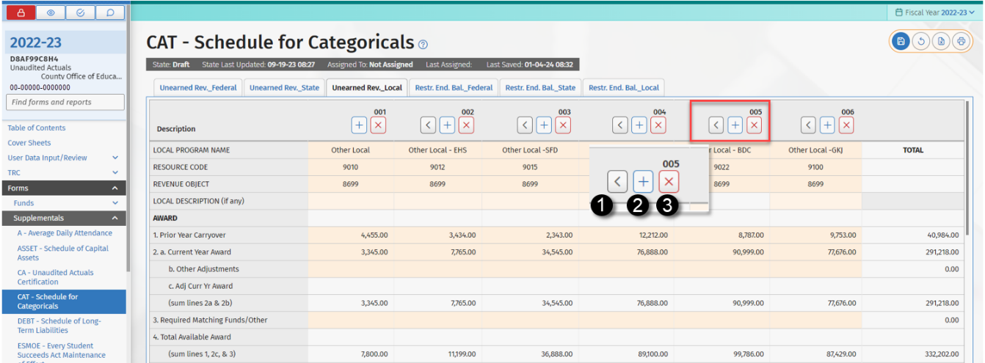
Information on whether a particular state or federal program administered by the CDE is accounted for as subject to deferral of unearned revenue (U) or subject to restricted ending balance (F) is available through the SACS Query, located on the CDE Standardized Account Code Structure (SACS) web page.
Select either the Program Cost Account (PCA) Number Query or SACS Resource Code Query and enter the desired search criteria to access program information from the SACS Query database.

Categorical Programs Subject to Deferral of Unearned Revenues
Categorical programs are classified as subject to deferral of unearned revenues when their revenue is earned at the time qualifying expenditures are made. In general, an expenditure is the prime factor for determining grant eligibility and revenue is recognized when the qualifying expenditure is made. Revenue received but not expended by the end of the fiscal year must be reported as unearned revenue.
The following rules apply to accounting for these programs:
- The revenue is initially recognized when cash is received.
- At the end of the year, when the total revenues received exceed the total donor-authorized expenditures, the difference is recorded as unearned revenue. Unearned revenue is revenue that has been received but has not been earned. The total expenditures used in this calculation may not exceed the program award.
- At the end of the year, when the total revenues received are less than the total donor-authorized expenditures, the difference is recorded as an accounts receivable. The total expenditures used in this calculation may not exceed the program award.
- Unused program award revenue (carryover) is the difference between the total program award and the total donor-authorized expenditures for the year. The amount of any unused program award revenue (carryover) is not recorded in the books but is added to the amount of the program award for the subsequent year to determine the total revenue available. The unused program award revenue should not be recorded as an accounts receivable because it is not earned.

Column Headings
Provide for each program the official name of the program, the five-digit number (federal programs only) from the Assistance Listings (formerly, Catalog of Federal Domestic Assistance), the resource code used to record the program, the revenue object, and the local description of the program, if any.

Award

Line 1 - Prior Year Carryover
Report the amount of the prior year's unused award, which may be expended in the current year. Include any adjustments made to the prior year's award. This amount includes any unearned revenue deferred from the prior year.

Line 2a - Current Year Award
Report the amount of the current year's award. This amount should agree with the award letter or document from the grantor agency.

Line 2b - Transferability Every Student Succeeds Act (ESSA) (Object 8990) (For Federally Funded Programs Subject to Deferral of Unearned Revenues Only)
Report transfers of federal funds made using Object 8990, Contributions from Restricted Revenues, pursuant to Section 5103(b) of Part A of Title V of the Elementary and Secondary Education Act (ESEA), as amended by the ESSA.

Lines 2b State/2b Local/2c Federal - Other Adjustments
Report any other adjustments made to the grant award.

Lines 2c State/2c Local/2d Federal - Adjusted Current Year Award
For State and Local Programs, the sum of the Current Year Award (Line Local 2a) plus Other Adjustments (Line 2b). For federal programs, the sum of the Current Year Award (Line 2a) plus Transferability (Line 2b) plus Other Adjustments (Line 2c).

Line 3 - Required Matching Funds/Other
Report the amount of any required matching funds as indicated in the award letter or document. When there is no match required, enter zero. Exclude "in-kind" matching. Report other income such as interest earned by and restricted to specific programs. Exclude contributions made using Object 8980, Contributions from Unrestricted Revenues.

Line 4 - Total Available Award

Federal
The sum of the Prior Year Carryover (Line 1) plus the Adjusted Current Year Award (Line 2d) plus the Required Matching Funds/Other (Line 3). This amount represents the total available to be spent this year.

State/Local
The sum of the Prior Year Carryover (Line 1) plus the Adjusted Current Year Award (Line 2c) plus the Required Matching Funds/Other (Line 3). This amount represents the total available to be spent this year.

Revenues

Line 5 - Unearned Revenue Deferred from Prior Year
Report the amount of unearned revenue recorded in the prior year.

Line 6 - Cash Received in Current Year
Report the amount of cash received during the current year. Include transfers made using Object 8990; exclude transfers made using Object 8980. Include the amount of any cash received from the prior year's award that was not recorded as an account receivable in the prior year. When adjustments were made to the current year's revenue accounts as a result of prior year's accounts receivable and accounts payable, report these amounts too.

Line 7 - Contributed Matching Funds
Report the amount of matching funds contributed by the LEA. Exclude "in-kind" matching.

Line 8 - Total Available
The sum of the Unearned Revenue Deferred from Prior Year (Line 5) plus the Cash Received in Current Year (Line 6) plus the Contributed Matching Funds (Line 7).

Expenditures

Line 9 - Donor-Authorized Expenditures
Report the sum of the direct, direct support, and indirect costs approved by the grantor agency; include expenditures of required matching funds. The Donor-Authorized Expenditures may not exceed the Total Available Award (Line 4).

Line 10 - Non Donor-Authorized Expenditures
Report expenditures not authorized by the grantor agency, e.g., expenditures in excess of the available award amount (encroachment). LEAs should record a contribution to restricted programs using Object 8980, Contributions from Unrestricted Revenues, equal to their non donor-authorized expenditures.

Line 11 - Total Expenditures
The sum of the Donor-Authorized Expenditures (Line 9) plus the Non Donor-Authorized Expenditures (Line 10).

Line 12 - Amounts Included on Line 6 Above for Prior Year Adjustments
Report the amount of the adjustments made to the current year's revenue accounts as a result of prior year's accounts receivable and accounts payable on this line. These adjustments should be reported as the opposite of the adjustments made on Line 6. For example, when a negative adjustment of $200 is reported on Line 6 for an adjustment for prior year's accounts receivable, this line should show a positive adjustment of $200.

Line 13 - Calculation of Unearned Revenue or Accounts Payable, and Accounts Receivable Amounts
The sum of Line 8 minus Line 9 plus Line 12. Report this amount on Line 13a, 13b, or 13c, as applicable.
- Line 13a - When the computed amount on Line 13 is positive and the program allows for unused funds to be retained and used in the next year, report the amount on Line 13a, Unearned Revenue. The unearned revenue is the amount of categorical funds, received as of June 30, but have not been spent and, therefore, have not been earned.
- Line 13b - When the computed amount on Line 13 is positive and the program does not allow unused funds to be retained and used in the next year, report the amount on Line 13b, Accounts Payable. This amount is owed back to the grantor agency.
- Line 13c - When the computed amount on Line 13 is negative, report the amount on Line 13c, Accounts Receivable. This is the amount of revenue earned but not received from the grantor agency.

Line 14 - Unused Grant Award Calculation
The sum of the Total Available Award (Line 4) minus Donor-Authorized Expenditures (Line 9). This represents the amount of the current year's award which has not been spent. Report this amount on Line 14 if carryover is allowed.

Line 15 - If Carryover Is Allowed, Enter Line 14 Amount Here
When carryover is allowed, enter the amount from Line 14; add this amount to the award for the next year to determine the total available award. When the award does not allow the unused funds to be carried over to the next year, enter zero. LEAs should use this information in preparing the next year's budget.

Line 16 - Reconciliation of Revenue
The sum of Line 5 plus Line 6, minus lines 13a and 13b, plus Line 13c. This line should agree with the revenue reported on the financial statements for this program. Revenue includes program revenue, Object 8990 transfers, and interest earnings.

Categorical Programs Subject to Restricted Ending Balances
Categorical programs are classified as Subject to Restricted Ending Balances when their revenue is earned at the time the funds are apportioned to the LEA. These categorical programs are generally entitlements based on an allocation formula. These programs are restricted, but more in form than in substance. Only a failure on the part of the LEA to comply with regulations causes a forfeiture of the funds. Any program funds not expended before the end of the year must be reported as Restricted Ending Balance.
The following rules apply to accounting for these programs:
- The revenue is recognized when cash is received.
- The amount of any revenue that has not been received by June 30, but is expected to be received by September 30, should be accrued as an accounts receivable.
- At the end of the year, any program funds that have not been expended are recorded as restricted ending balance. This is done because restrictions remain on the type of expenditures that can be made from the revenues; therefore, the balance for this program must be separated from the other balances available for general use.
Column Headings
Provide for each program the official name of the program, the five-digit number (federal programs only) from the Assistance Listings (formerly, Catalog of Federal Domestic Assistance), the resource code used to record the program, the revenue object, and the local description of the program, if any.

Award

Line 1 - Prior Year Restricted Ending Balance
Report the restricted ending balance for this award as reported last year. Include adjustments made to the prior year's award.

Line 2a - Current Year Award
Report the amount of the current year's award. This amount should agree with the award letter or document from the grantor agency.

Line 2b - Other Adjustments
Report any other adjustments made to the award.

Line 2c - Adjusted Current Year Award
The sum of the Current Year Award (Line 2a) plus Other Adjustments (Line 2b).

Line 3 - Required Matching Funds/Other
Report the amount of required matching funds as indicated in the award letter or document. When there is no required match, enter zero. Exclude "in-kind" matching. Report other income such as interest earned by and restricted to specific programs.

Line 4 - Total Available Award

Federal
The sum of the Prior Year Restricted Ending Balance (Line 1) plus the Adjusted Current Year Award (Line 2c) plus the Required Matching Funds/Other (Line 3). This amount represents the total available to be spent this year.

State/Local
The sum of the Adjusted Prior Year Restricted Ending Balance (Line 1) plus the Adjusted Current Year Award (Line 2c) plus the Required Matching Funds/Other (Line 3). This amount represents the total available to be spent this year.

Revenues

Line 5 - Cash Received in Current Year
Report the amount of the current year's award received. Include in this amount adjustments to the current year's revenue account as a result of the prior year's accounts receivable.

Line 6 - Amounts Included on Line 5 for Prior Year Adjustments
Report the amount of the adjustments made to the current year's revenue accounts as a result of the prior year's accounts receivable on this line. These adjustments should be reported as the opposite of the adjustments made on Line 5. For example, when a negative adjustment of $200 was reported on Line 5 for an adjustment for prior year's accounts receivable, this line should show a positive adjustment of $200.

Line 7a - Accounts Receivable
The sum of Line 2c minus Line 5 minus Line 6. This is the amount of the award for the current year that has not been received from the donor agency.

Line 7b - Noncurrent Accounts Receivable
Report the portion of Line 7a that is Noncurrent Accounts Receivable and is not expected to be received by September 30. Do not make an entry to your books for the Noncurrent Accounts Receivable.

Line 7c - Current Accounts Receivable
The sum of Line 7a minus 7b. This represents the Current Accounts Receivable portion of the award for the current year that is expected to be received by September 30. An entry should be made to your books for the Current Accounts Receivable.

Line 8 - Contributed Matching Funds
Report the amount of matching funds contributed by the LEA. Exclude "in-kind" matching.

Line 9 - Total Available
The sum of the Cash Received in Current Year (Line 5) plus the Current Accounts Receivable (Line 7c) plus the Contributed Matching Funds (Line 8). This line should agree with the total revenue reported for this categorical program on the financial statements.

Expenditures

Line 10 - Donor-Authorized Expenditures
Report the sum of the direct, direct support, and indirect costs as approved by the grantor agency; include expenditures of required matching funds. The Donor-Authorized Expenditures may not exceed the Total Available Award (Line 4).

Line 11 - Non Donor-Authorized Expenditures
Report any expenditure not authorized by the grantor agency, e.g., expenditures in excess of the available award amount (encroachment). Districts[COEs] should record a contribution to restricted programs using Object 8980, Contributions from Unrestricted Revenues, equal to their non donor-authorized expenditures.

Line 12 - Total Expenditures
The sum of the Donor-Authorized Expenditures (Line 10) plus the Non Donor-Authorized Expenditures (Line 11).

Line 13 - Restricted Ending Balance—Current Year
The sum of the Total Available Award (Line 4) minus the Donor-Authorized Expenditures (Line 10). This represents the amount of the award that has not been spent, and in most cases will agree with the ending balance reported on the financial statements for this program. When Noncurrent Accounts Receivable (Line 7b) exists, subtract that amount from the restricted ending balance calculated on this line to arrive at the ending balance reported on the financial statements. Note that prior year adjustments may necessitate an additional contribution to the restricted programs or a reverse contribution to the unrestricted programs.

Form CB—Budget Certification
Form CB is the official signature page for the budget report submission. It includes a Criteria and Standards Review Summary that recaps the Criteria and Standards, Supplemental Information, and Additional Fiscal Indicator items from the Criteria and Standards Review (Form 01CS). The Met/Not Met and No/Yes indicators in Form CB are automatically completed based on information in Form 01CS.
Criteria and Standards that are “Not Met” and supplemental information and additional fiscal indicators that are “Yes” may indicate areas of potential concern for fiscal solvency purposes and should be carefully reviewed.

Form CC—Workers' Compensation Certification
The Workers' Compensation Certification, Form CC, provides information about workers' compensation claims for self-insured school districts[COEs]. Form CC must be completed, signed, and included in the budget report submission whether or not the LEA provides this benefit.
The governing board[county board of education] shall certify to the county superintendent of schools[State Superintendent] the amount of liabilities actuarially determined and amount of total liabilities reserved in the budget (EC Section 42141).
Separate categories are available for those school districts[COEs] that are members of a workers' compensation JPA. Select the category that is most appropriate for the LEA.

Forms CEA/CEB—Current Expense Formula/Minimum Classroom Compensation
The Current Expense Formula/Minimum Classroom Compensation, Form CEA/CEB, is used for the following purposes:
- To report the current expense of education (EDP 365).

- To allow COEs to determine whether the district complies with EC Section 41372, Apportionments for the Payment of Salaries of Classroom Teachers, which requires that elementary, unified, and high school districts expend at least 60, 55, and 50 percent respectively, of their current cost of education for classroom teacher and aide salaries, plus associated benefits. EC Section 41374 provides for certain school districts with individual class sessions below a certain number of pupils to be exempt from the EC Section 41372 requirements. (Enter an "X" on Line 16 of the Form CEA/CEB when the district is exempt.)
The system will automatically generate all sections of this form except optional fields in Part I, Column 4b and Part II, Line 13b (see below for entering data on these lines).

Part I—Current Expense Formula
Column 1 Total Expense for the Year
The SACS Web System extracts the data for the total expense for the year from the general ledger Fund 01 data.
Column 2 Reductions (for Current Expense of Education calculation)
The SACS Web System extracts the unduplicated expenditures in the following goals, functions, and objects to be excluded from the Current Expense of Education amount pursuant to EC Section 41372:
- Nonagency (goals 7100–7199)

- Community Services (Goal 8100)

- Food Services (Function 3700)

- Fringe Benefits for Retired Persons (objects 3701–3702)

- Facilities Acquisition and Construction (Function 8500)
Notes:
In addition to fringe benefits for already-retired employees, objects 3701 and 3702 may include certain allocated costs for past unfunded liabilities relating to active employees (see definitions in CSAM). All costs reported in objects 3701 and 3702 are excluded from the calculation of minimum classroom compensation.

Maintenance Assessment District expenditures are considered to be part of the Community Services goal.
Column 3 Current Expense of Education
The SACS Web System calculates the Current Expense of Education (EDP 365) by subtracting expenditures identified in Column 2 from the Total Expense for Year in Column 1.
Columns 4a and 4b Reductions for the Minimum Classroom Compensation Calculation
Certain expenditures are excluded from the Current Expense of Education for the Minimum Classroom Compensation Calculation. School districts have an option to proceed with the reductions extracted by the SACS Web System from the GL data in Column 4a or enter the reduction amounts manually in Column 4b.
Column 4a Reductions (Extracted)
- Expenditures for transportation (Function 3600)

- Lottery expenditures (Resource 1100)

- Amounts paid to nonpublic schools for the education of special education students (Function 1180)

- Expenditures for programs which do not allow teacher salary expenditures.

- Expenditures for programs that require disbursement of the funds without regard to the requirements of EC Section 41372.

- Categorical programs and grants designated for activities of a specialized nature that specify something other than hiring classroom teachers or aides.
Following is a complete list of SACS codes extracted as “reductions” in Column 4a:
- SACS resources 1100, 3316, 3326, 3327, 3372, 3386, 3515, 3724, 4123, 4124, 5035, 5314, 5316, 5370, 5460, 5465, 5652, 6010, 6030, 6126, 6140, 6230, 6300, 6355, 6385, 6386, 6392, 7010, 7027, 7028, 7085, 7124, 7126, 7236, 7388, 7410, 8210,

- SACS functions 1180, 3600.
Column 4b Reductions (Overrides Column 4a)
School districts may elect to report the reductions manually in Column 4b if the extracted data in Column 4a do not include all of the reductions deemed applicable by the school district. Such reductions are limited to categorical aid received from the federal or state government that did not incur teacher salaries. The amounts reported in Column 4b override the reductions automatically extracted by the system in Column 4a. Therefore, any additional amounts determined as applicable by the school district should be added to the system extracted amounts in Column 4a and reported in Column 4b as the combined total of the reductions to Minimum Classroom Compensation calculation.
Note: If an amount (even zero) is entered in any row of Column 4b, or on Line 13b (see Part II below), the SACS Web System switches from using the values in Column 4a/Line13a to using only the values in Column 4b/Line 13b; it does not use a combination of the two.
Expenditures of the Restricted Maintenance Account (RMA) (Ongoing and Major Maintenance Account, Resource 8150) should not be excluded in Form CEA. They are not "amount[s] expended from categorical aid received from the federal or state government which funds were granted for expenditures in a program not incurring any teacher salary expenditures or requiring disbursement of the funds without regard to the requirements of [EC Section 41372]."
The RMA exists to demonstrate compliance with the requirement that LEAs that receive School Facility Program (SFP) funding administered by the Office of Public School Construction of the Department of General Services must dedicate a certain percentage of their operating budgets toward facility maintenance. Moneys contributed to this account are not federal or state categorical aid. (Note that Resource 8150 is a local resource, not a state or federal resource.) Said another way, were it not necessary to demonstrate compliance with SFP regulations, the expenditures in the RMA account would be charged to an unrestricted resource.

Part II—Minimum Classroom Compensation
The SACS Web System will generate all information except for the optional field Line 13b.
- Line 13b: Report the salaries and benefits of teachers and instructional aides that were deducted in Column 4b (see note above in Column 4b text).
Note: If an amount (even zero) is entered in any row of Column 4b, or on Line 13b, the SACS Web System switches from using the values in Column 4a/Line 13a to using only the values in Column 4b/Line 13b; it does not use a combination of the two.
- A warning internal form check alerts users to review line 13b if no amount is entered when an amount is entered in Part I, Column 4b, Reductions (Overrides).

Part III—Deficiency Amount
Using information from Form CEA/CEB Parts I and II, Part III indicates if a school district has met the minimum classroom compensation percentage required under EC Section 41372. This information will also show on Form CA, Unaudited Actuals Certification, on the page titled Summary of Unaudited Actual Data Submission.
- If the percentage is met, Line 5 will be zero.
- If the percentage is not met, and the district has not indicated they are exempt from the requirement, Line 5 will be the deficiency amount. In addition, an exception will be reported in the Technical Review Checklist.
- If the district has indicated they are exempt from the requirement by marking “X” on Line 16, Line 5 will show "exempt."

Part IV—Explanation for Amounts Entered in Part I, Column 4b
This section must be completed if an amount is entered in Part I, Column 4b, Reductions (Overrides). A fatal internal form check will generate if the required explanation is not provided.

Form DEBT—Schedule of Long-Term Liabilities
Form DEBT is used to report changes in the balances of long-term liabilities for the fiscal year. This form closely resembles the note disclosure for long-term liabilities required by GASB Statement 34. It is divided into two sections: Governmental Activities and Business-Type Activities. Liabilities relating to general governmental activities accounted for in governmental funds are reported in the Governmental Activities section. Liabilities relating to business-type activities accounted for in enterprise funds are reported in the Business-Type Activities section.
The schedule of long-term liabilities is completed using a combination of extracted, entered, and calculated data. The columns on this form are completed as follows:

Unaudited Balance July 1
Long-term liability ending balances reported in Form DEBT in the prior year are prepopulated in the Unaudited Balance July 1 (beginning balance) column. If long-term liabilities were not reported in Form DEBT in the prior year, and, therefore, zeros appear in the beginning balance column, report any beginning balances in the Audit Adjustments/Restatements column. Data entry is not allowed in the beginning balance column.

Audit Adjustments/Restatements Column
Adjustments or restatements that increase the unaudited July 1 balances of long-term liabilities are input as positive numbers. Adjustments or restatements that decrease the unaudited July 1 balances of long-term liabilities are input as negative numbers.

Audited Balance July 1
Amounts are calculated beginning with Unaudited Balance July 1, plus Audit Adjustments/Restatements.

Increases Column
Increases in the amounts of long-term liabilities are input as positive numbers. The amounts in the Increases column are added to the amounts in the Audited Balance July 1 column to arrive at the Ending Balance June 30 column.
For example, the amount of general obligation bonds issued during the fiscal year is recorded on the line for General Obligation Bonds Payable, in the Increases column.

Decreases Column
Decreases in the amounts of long-term liabilities are input as positive numbers. The amounts in the Decreases column are subtracted from the amounts in the Audited Balance July 1 column to arrive at the Ending Balance June 30 column.
For example, the amount of general obligation bond principal payments made during the fiscal year decreases the balance of bonds payable, and is recorded on the line for General Obligation Bonds Payable, in the Decreases column.

Ending Balance June 30
Amounts are calculated beginning with Audited Balance July 1, plus Increases, minus Decreases.
Amounts in the Ending Balance June 30 column should be verified to ensure that adjustments, increases, and decreases to long-term liabilities have been input correctly and that ending balances agree to debt schedules and financial statements. Ending balances are saved by CDE and used for external data reporting purposes and are extracted into the subsequent year's Form DEBT as beginning balances.
Note that liabilities relating to postemployment benefits other than pensions (OPEB) are reported in two places in the SACS Web system. The Total/Net OPEB Liability in Form DEBT should tie to the amount reported on the Government-wide Statement of Net Position. It should be expected to match the total/net OPEB liabilities reported in the Criteria and Standards Review.

Amounts Due Within One Year
Amounts of long-term liabilities due within one year are input as positive numbers. The amounts in this column represent the portion of the long-term liabilities reported in the Ending Balance June 30 column that are payable in the next fiscal year. The amount reported as due within one year should not exceed the ending balance of the associated liability. If it does exceed the ending balance, “At least one Amount Due exceeds Ending Balance” will appear in red on the screen and will also appear on the printed report. Upon closing the form, a message will display requesting that the data be input or corrected as appropriate. If the condition is not cleared, a TRC exception will occur the next time the Export TRCs are run.

Form ESMOE—Every Student Succeeds Act Maintenance of Effort
This form compiles the expenditures to be used in determining whether the LEA met the maintenance of effort requirement under the Elementary and Secondary Education Act (ESEA), as reauthorized by the “Every Student Succeeds Act (ESSA)”. It is required for LEAs that received funding under covered programs, as indicated by having revenue account balances for applicable resource codes.
This form must be completed and saved during the unaudited actuals period, when applicable, or a Fatal exception will display in the supplemental technical review checks. In all other periods, this form is optional and is provided for planning purposes only. For the unaudited actuals period, Form ESMOE extracts unaudited actual data. For the budget and interim periods, Form ESMOE extracts estimated actual and projected year totals data, respectively.
This version of the User Guide provides general instructions and fiscal year specific information for completing reports for 2025–26 unaudited actuals, 2026–27 budget and interim periods.

MOE Requirement
The ESEA, as reauthorized by ESSA, provides that an LEA may receive funds under a covered program for any fiscal year only when the state educational agency finds that its state and local funded expenditures for free public education in the preceding fiscal year is not less than 90 percent of those in the second preceding fiscal year, in the aggregate or on a per capita expenditure basis (20 United State Code [USC] 7901; ESEA Sec. 8521). This is to ensure that funds under covered programs are used to provide services that are in addition to the regular services provided by the LEA to participating students. Under certain circumstances, an LEA may obtain a waiver. The MOE test is done at the LEA level.

Failure to Meet MOE
Absent a waiver, an LEA’s failure to meet the MOE requirement applicable to a particular funding year may result in a reduction of allocations under the covered programs for that year. The list of covered programs may be found in Section 8101(11) of the ESEA. CDE will reduce the allocations in the exact proportion by which the LEA failed to meet the MOE requirement by falling below 90 percent of both the combined fiscal effort per student and aggregate expenditures, using the measure most favorable to the LEA, if such LEA has also failed to meet such requirement for one or more of the five immediately preceding fiscal years (20 USC 7901; ESEA Sec. 8521(b)(1)). This reduction is equal to the allocation amount times a "deficiency" percentage based on aggregate expenditures or per capita expenditures, whichever is less. The deficiency percentage is equal to the amount in the preceding year that is below the required level of effort, i.e., 90 percent of the second preceding year's aggregate expenditures or per capita expenditures, divided by that required level of effort.
If the actual aggregate and per capita expenditures for a particular year do not meet the required level of effort, they shall not be used as the basis for determining MOE in subsequent years; the basis will be the required level of effort for that year.
Note: Form ESMOE provides the LEA a preliminary determination as to whether it met the MOE requirement for a particular funding year. The target date for completion of the official MOE test done by CDE is April 30 of the fiscal year prior to the funding year to which the test applies. LEAs that fail the test are normally notified by July that their funding for covered programs for the fiscal year beginning in July will be reduced as described above. As such, the MOE test for funding year 2026–27, comparing 2024–25 expenditures with those for 2023–24, are completed by April 30, 2026. LEAs that fail that test are notified of the result by July 31, 2026, and their funding for covered programs for 2026–27 are reduced accordingly.

Completing Form ESMOE
The amounts in sections I, II, and III are usually extracted and calculated; manual entry is only allowed for lines I.C9 and I.D2 when applicable. In Section IV, manual entry is allowed for any base expenditure adjustment to the extracted data in Section III. Detail below reflects the unaudited actuals period which compares 2025–26 expenditures to 2024–25 expenditures. Interim periods compare projected 2026–27 expenditures with 2025–26 unaudited actuals expenditures.

Section I—Expenditures

Lines A, B and C1–C8 - 2025–26 Expenditures—Total and Exclusions
These amounts are extracted from the unaudited actual general ledger data, for the funds, goals, functions, and objects as indicated on the form.
Line A is the total state, local, and federal expenditures for the LEA.
Lines B and C1 through C7 are excluded from the total expenditures shown on Line A, since they are not for free public education for MOE calculation purposes, as provided under 34 Code of Federal Regulations (CFR) Section 299.5.
Line C8 - Tuition, a revenue account, is deducted from the total expenditures on Line A to account for the reduction of expenditures resulting from tuition reimbursement. This line also includes amounts received by COEs from districts for district students in programs operated by the county office.

Line C9 - Supplemental Expenditures for Presidentially Declared Disaster
Enter on Line C9 any expenditures resulting from a Presidentially declared disaster included in the total expenditures on Line A but not included on lines B, C1-C8, D1, or D2. These are not subject to MOE, as prescribed under 34 CFR Section 299.5.

Lines D1-D2 - Additional MOE Expenditures
Line D1 is extracted and is the difference between the cafeteria fund expenditures and revenues, representing any deficit spending in the cafeteria program. Net expenditures to cover deficits for food services are part of the expenditures subject to MOE.
Enter on Line D2 any expenditures to cover deficits for student body activities, which are also part of the expenditures subject to MOE.

Line E - Total Expenditures Subject to MOE
This line is the total expenditures subject to MOE and will be the base in determining if the LEA maintained the required level of expenditures on an aggregate expenditures basis (90 percent of Line E). It is important to note that in order to perform the MOE calculation, this number cannot be negative. If a negative amount is calculated for this line, a warning will appear at the top of the page.

Section II—Expenditures Per ADA

Line A- Average Daily Attendance
This is the total elementary and high school, including charter schools, ADA for the 2025–26 Annual Report, extracted from Form A, Average Daily Attendance. For budget periods, ADA is extracted from the Estimated Annual ADA column of Form A. For interim periods, Annual ADA is not available on Form AI, so ADA is extracted from the Estimated P-2 Report ADA Projected Year Totals column (District) or Form AI Estimated Funded ADA Projected Year Totals column (County). Because manual adjustment may be required to accurately reflect estimated Annual ADA, this extracted ADA number may be overwritten.

Line B - Expenditures Per ADA
This is the per capita expenditures for MOE purposes, arrived at by dividing Total Expenditures Subject to MOE (Line I.E) by Average Daily Attendance (Line II.A). It is the base in determining if the LEA maintained the 90 percent required level of expenditures on a per capita basis.

Section III—MOE Calculation
This calculation determines whether the LEA met the MOE requirement. This is a preliminary determination only, as the final determination is made by the CDE based on the SACS data submitted by the LEAs, which are subject to CDE review.

Line A - Line A, Base Expenditures
For the budget and unaudited actuals periods, the total (aggregate) and total per ADA (per capita) base expenditures are preloaded from the official CDE prior year MOE calculation. Note that for submissions in the Budget period, preloaded base figures are preliminary because the official CDE calculation may not be complete; amounts are provided for planning purposes only and may be overwritten, if necessary.
For interim periods (all LEAs), base expenditures are extracted and preloaded from the prior year (2025–26) unaudited actuals period form (Section III, Line C). These amounts may be overwritten, if necessary.
LEAs who failed the MOE requirement:
The required effort for 2025–26 is 90 percent of the MOE expenditures for 2024–25. The exception to this rule is when the LEA does not meet its required effort in the prior year (2024–25). In this instance, the LEA’s 2025–26 base expenditure amount is 90 percent of the preceding prior year (2023–24) expenditure amount (or required expenditure amount when the LEA also failed MOE in 2023–24). Please note that data preloaded from the official CDE calculation for county and district budget and unaudited actuals periods reflects the adjusted base expenditure amount for LEAs that failed the prior year MOE calculation. However, for interim period calculations (projecting the estimated outcome of the MOE calculation for the 2026–27 unaudited actuals period), LEAs must manually make adjustments to their preloaded base expenditure amounts when they failed the MOE calculation in 2025–26. Interim preloaded amounts are extracted directly from the previous appropriate preliminary calculation; therefore adjustments have not been made to reset the base to the required expenditure level. LEAs must utilize Section IV to adjust their Base Expenditures (Line III.A). The Adjusted Base Expenditures on Line III.A2 should equal 90 percent of the 2024–25 aggregate and per ADA expenditures.

Line A1 - Adjustments to Base Expenditures
This amount is from Section IV and is for adjustments to the LEA's total or per ADA base expenditures for LEAs who fail the prior year MOE requirement. See Section IV instructions for an explanation of how this line should be utilized.

Line A2 - Adjusted Base Expenditures
This is the sum of lines A and A1, and is the amount on which the total and per capita 2025–26 required effort is based.

Line D - MOE Deficiency Amount, if Any, Expressed in Total and Per ADA Expenditures
This is the difference between Line B, required effort, and Line C, current year expenditures, for total expenditures and per capita. When one or both columns show a zero, the MOE requirement is met; when both are positive (Line C is less than Line B), the current year expenditures are less than the required fiscal effort, and the MOE requirement is not met.

Line E - MOE Determination
This line shows a message that indicates whether the MOE is met, or when the MOE calculation is incomplete. When the message is that the MOE calculation is incomplete, this indicates that data required to calculate the MOE deficiency amount on Line III.D is absent. When general ledger data has been imported and Form A is completed, it may be necessary to make adjustments in Section IV to complete the data.

Line F - MOE Deficiency Percentage, When MOE Not Met; Otherwise Zero
These are calculated amounts and the percentages by which the LEA failed to meet the MOE in 2025–26. When an LEA failed the MOE requirement comparing the 2025–26 expenditures with the required effort for that year, the amount of funding for MOE covered programs for 2027–28 may be reduced by the lower of the total expenditures or per ADA deficiency percentage shown on this line, subject to CDE review.

Section IV—Detail of Adjustments to Base Expenditures
List in this section adjustments to the LEA's base expenditures. This section is used for interim periods by LEAs who failed the MOE requirement in the preceding year and need to use their second preceding year's expenditure data as their base expenditures. To make an adjustment, enter the exact amounts that display on Line III.A as negative numbers on the first adjustment line in Section IV so Line III.A2 equals zero. Then, add a line in Section IV and, using your 2024–25 Form ESMOE for reference, enter 90 percent of the final total expenditure amount into the Total Expenditures column and enter 90 percent of the final total expenditures per ADA amount into the Expenditures Per ADA column.
A description of adjustments must be provided for validation purposes. For the unaudited actuals period, an internal form check prompts users to enter the description of adjustments in the Expenditure Adjustment column or the ADA Adjustment column. Users may close the form without fixing the condition, but the reason for the adjustment must be provided to complete an official export.
After completing this form, click Save and close the window. This will prevent a Fatal exception in the TRCs.

Form GANN—Appropriations Limit Calculations
In November 1979, California voters approved Proposition 4, an initiative that added Article XIII B to the California Constitution. This constitutional amendment, popularly known as the Gann Initiative, placed limits on the growth of expenditures for publicly funded programs. Division 9 of Title 1, beginning with Section 7900 of the Government Code, was then added to law to specify the process for calculating state and local government appropriation limits and appropriations subject to limitation under Article XIII B of the Constitution. These constitutional and statutory sections explain and define the appropriations limit and appropriations subject to limitation as they apply to state and local governments and require that each entity of government formally "adopt" its appropriations limit for a given fiscal year.
In addition, EC sections 1629 and 42132 specify that by September 15 (districts) and October 15 (COEs) of each year, the governing boards of the LEA shall adopt a resolution identifying their estimated appropriations limits for the current year and their actual appropriations limit for the preceding year. The documentation supporting the adoption resolution shall be made available to the public. It is not necessary to submit a copy of the board resolution adopting the appropriations limit to the CDE.
For further information or any questions about the Gann program, please contact the CDE Government Affairs Division at gann@cde.ca.gov.
Form GANN was implemented to assist LEAs in meeting their constitutional and statutory obligations under the Gann Initiative to calculate appropriation limits and appropriations subject to limitation. Districts and county offices of education must include their completed Form GANN with their officially exported unaudited actual submission.
Upon opening Form GANN, applicable general ledger, attendance, and revenue data are extracted into the form. The general ledger account codes and specific forms from which data are extracted are noted on the form. In addition, applicable prior year Gann data as reported in the prior year's Form GANN will be preloaded into the form. Once the extractions are completed, only a few items remain to be keyed into the form.
Adjustment columns are available to make any necessary corrections to preloaded or extracted data, for compliance with Gann reporting requirements. All adjustments must be explained in the bottom section of Form GANN, and documentation supporting the adjustments kept in the LEA’s files along with a copy of this year's Form GANN.
A fatal internal form check will prompt users to enter an explanation if data exists in the Adjustments column. Users will be able to close the form without fixing the condition, but the explanation must be provided to complete an Official export.
The first set of columns on Form GANN calculate the appropriations limit and appropriations subject to the limit for the year of reporting (actuals), and the second set of columns calculate the subsequent year’s preliminary appropriations limit and that year's appropriations subject to the limit (budget). The references in the columns such as "202x–2x Actual" or "202x–2x Budget" refer to columns on the source documents (Form A) or the type of general ledger data (actual or budget) being extracted into Form GANN.

School Districts

Section A—Prior Year Data

Lines 1 and 2 - Final Prior Year Appropriations Limit and Prior Year Gann ADA
Lines A1 and A2 in the Extracted Data column of the actuals data section are preloaded from prior year’s Form GANN. If any data is incorrect or missing, please contact the Office of Financial Accountability and Information Services at sacsinfo@cde.ca.gov.
If prior year ADA or any revenue items included in the Gann calculation, as shown on prior year’s Form GANN is adjusted after the LEA submitted its prior year unaudited actuals to CDE, the LEA must recalculate the limit and report the adjustments on the current Form GANN as follows:
- Using a local copy of the previous year’s Form GANN, enter the ADA or revenue adjustments and save the form.
- Take the Adjusted Appropriations Limit on D11 and compare it to the original Prior Year Appropriations Limit as shown on Line A1, Extracted Data column of the current Form GANN.
- Report the difference in the limit on Line A1 in the Adjustments column of the current Form GANN and provide an explanation for the adjustment at the bottom of the form. The resulting amount in Entered Data/Totals column on current Form GANN should match Line D11 of the revised prior year’s Form GANN.
- If the prior year’s limit adjustment is due to ADA adjustment, report the adjustment only on Line A2 of the current Form GANN.
- Retain a copy of the previous year’s recalculations for audit purposes.
Lines A1 and A2 in the Extracted Data column of the budget year data section are extracted from the actuals data section of the current Form GANN, Lines D11 and B3.

Lines 3-6 - Adjustments to Prior Year Limit
Lines 3-6 represent adjustments to the prior year limit, as follows:
If completing Form GANN with | In the actuals column, report | In the budget column, report
2024–25 unaudited actuals | Adjustments to the 2023–24 Gann limit | Adjustments to the 2024–25 Gann limit
2025–26 unaudited actuals | Adjustments to the 2024–25 Gann limit | Adjustments to the 2025–26 Gann limit
2026–27 unaudited actuals | Adjustments to the 2025–26 Gann limit | Adjustments to the 2026–27 Gann limit
On Line A3, enter the amount of adjustments to prior years’ appropriations limits to reflect district lapses, reorganizations, and transfers of responsibility where a transfer of appropriations limit authority occurred between the district and another LEA that is not in direct proportion to the ADA transferred.
On Line A4, enter the amount of any voter approved increases to the prior year’s appropriations limit. Increases are usually associated with the approval of a parcel tax or some other increase in tax revenues and are only valid for four years, at which time the appropriations limit must be adjusted downward to the level it would have been had the increases not been approved.
On Line A5, enter the effect of the lapse of a voter approved increase to the prior year’s appropriations limit. This amount will be subtracted from lines A3 and A4 to calculate the total adjustments to the appropriations limits for both years on Line A6.

Line 7 - Adjustments to Prior Year ADA
On Line A7, enter the adjustments to the prior year ADA resulting from district lapses, reorganizations, and other transfers, only when an adjustment to the district's appropriations limit is entered on Line A3 above.

Section B—Current Year Gann ADA

Lines 1-3 - Current Year P-2 ADA (From Form A)
Total K-12 ADA and Total Charter Schools ADA from the Unaudited Actuals P-2 ADA and Budget Estimated P-2 ADA columns of Form A are extracted into the respective Extracted Data columns. Only the ADA for charter schools reporting financial data in the authorizing school district’s Funds 01, 09 and 62 is extracted into Form GANN. Adjustments to those amounts may be entered into the Adjustments columns to meet Gann reporting requirements but must be explained in detail on the bottom of Form GANN.

Section C—Current Year Local Proceeds of Taxes / State Aid Received

Lines 1-16 - Taxes and Subventions (From Funds 01, 09, and 62)
General Fund, Charter Schools Special Revenue Fund, and Charter Schools Enterprise Fund data for unaudited actuals year and budget year is extracted into the respective Extracted Data columns. Adjustments to those amounts can be entered into the Adjustments columns to meet Gann reporting requirements but must be explained in detail on the bottom of Form GANN.
Line C13, Other Non-Ad Valorem Taxes—When necessary, enter an amount in the Adjustments column to adjust the extracted amount to account for tax revenues (excluding voter approved debt service taxes) that are subject to the appropriations limit. Non-tax amounts should not be included here. Enter an explanation on the bottom of Form GANN.
Line C14, Penalties and Interest from Delinquent Non-LCFF Taxes—When necessary, enter an amount in the Adjustments column to adjust the extracted amount to account for those penalties and interest for the above taxes. Do not include penalties and interest on other local taxes or revenues (e.g., penalties and interest on debt service taxes). Enter an explanation on the bottom of Form GANN.
Line C15, Transfers to Charter Schools in Lieu of Property Taxes (Object 8096). The adjustment for Transfers to Charter Schools in Lieu of Property Taxes (negative in virtually all districts) was eliminated beginning in 2016–17. The reason for the change is that the previous treatment of the in-lieu transfers did not capture taxes that were transferred to charter schools that report separately in SACS or that report their financial data on the Charter School Alternative form. These tax funds are subject to the appropriations limit requirements and should not be excluded from the calculations.

Lines 17-18 - Other Local Revenues (From Funds 01, 09, and 62)
General Fund, Charter Schools Special Revenue Fund, and Charter Schools Enterprise Fund data for unaudited actuals year and budget year is extracted into the respective Extracted Data columns. Adjustments to those amounts can be entered into the Adjustments columns to meet Gann reporting requirements but must be explained in detail on the bottom of Form GANN.

Lines 19-23 - Excluded Appropriations
Lines C19 through C22 require manual input, with the exception of C19c. Include appropriations made directly or indirectly from local proceeds of taxes reported on lines C18 and D7b, or from state aid received reported on Line C26.
On Line C19a, enter expenditures in funds 01, 09, and 62, objects 3301 and 3302, for federally mandated Medicare. Do not include employer contributions to Medicare that are not mandated by the federal government, such as those resulting from negotiated employee contracts or other decisions by the LEA. Do not include contributions for Old-Age, Survivors, and Disability Insurance (OASDI) or for alternative retirement plans. If no federally mandated Medicare contributions are made, enter zero. If no amount is entered on this line, a warning message will display above the line and in a message box upon closing the form.
On Line C19b, enter expenditures for any qualified capital outlay projects, which is defined as fixed assets (including land and construction) with a useful life of 10 or more years and a value which equals or exceeds one hundred thousand dollars ($100,000). Only include expenditures that are made from local proceeds of taxes reported on lines C18 and D7b, or from state aid received reported on Line C26.
On Line C19c, data is preloaded with data extracted from a district's general ledger for Fund 01, Resource 8150, Objects 8900-8999. If necessary, enter an amount in the Adjustments column to adjust the extracted amount to only account for deposits made from local proceeds of taxes reported on lines C18 and D7b, or from state aid received reported on Line C26, into a routine restricted maintenance account. Enter an explanation on the bottom of Form GANN.
On Line C20, enter the amounts that represent expenditures required by the Americans with Disabilities Act federal law that are not reimbursed by federal, state, or other sources and which are made from local proceeds of taxes reported on lines C18 and D7b, or from state aid received reported on Line C26.
On Line C21, enter the amounts that represent expenditures required by court order for desegregation costs for which the district has not received reimbursement from the state and which are made from local proceeds of taxes reported on lines C18 and D7b, or from state aid received reported on Line C26 (for court orders imposed on or after November 6, 1979).
On Line C22, enter the amounts that represent other expenditures required by court or federal mandates imposed on or after November 6, 1979, that are not reimbursed by the state or other sources and which are made from local proceeds of taxes reported on lines C18 and D7b, or from state aid received reported on Line C26.

Lines 24-26 - State Aid Received (From Funds 01, 09, and 62)
General Fund, Charter Schools Special Revenue Fund, and Charter Schools Enterprise Fund data for unaudited actuals year and budget year is extracted into the respective Extracted Data columns. Adjustments to those amounts may be entered into the Adjustments columns to meet Gann reporting requirements but must be explained in detail on the bottom of Form GANN.
Line C24 includes LCFF funding received via the Principal Apportionment (Object 8011), plus funding from the Education Protection Account (Object 8012) provided pursuant to Section 36 of Article XIII of the California Constitution.
Line C25, LCFF State Aid-Prior Years (Object 8019). Included on this line are prior year adjustments/corrections to LCFF State Aid.

Lines 27-28 - Data for Interest Calculation (From Funds 01, 09, and 62)
General Fund, Charter Schools Special Revenue Fund, and Charter Schools Enterprise Fund data for unaudited actuals year and budget year is extracted into the respective Extracted Data columns to calculate the amount of interest that is to be counted in the LEA's appropriations limit. Adjustments to those amounts can be entered into the Adjustments columns to meet Gann reporting requirements but must be explained in detail on the bottom of Form GANN.

Section D—Appropriations Limit Calculations
This section requires no extractions or entered data; it is calculated based on the data in sections A, B, and C.
Lines 1-4 - Preliminary Appropriations Limit equals the revised prior year appropriations limit times the inflation factor (based on price factor published by the Department of Finance) times the program population adjustment (change in ADA factor).
Lines 5-9d - Appropriations Subject to the Limit equals the district's local revenues plus state subventions less excluded appropriations. Note that the calculation for Line 7a Interest Counting in Local Limit is (Line C28 divided by [Lines C27 minus C28] times [Lines D5 plus D6c]). This is a partial formula. The full formula considers if C28 is 0 and returns a 0. Then, if C28 is not 0, but C27 is 0, it returns C28. Otherwise, it returns the lesser of C28 or (Lines C28 divided by [C27 minus C28] times [D5 plus D6c]).
Line 10 - Adjustments to the Limit Per Government Code Section 7902.1
If there is an amount greater than zero in this field (i.e., the district’s appropriations subject to the limit exceed the preliminary appropriations limit), the district’s limit has increased. If there is an amount less than zero in this field (i.e., the district’s preliminary appropriations limit exceeded the appropriations subject to the limit), the district’s limit has decreased.

Gann Contact Information
The Gann Contact Person and the Contact Email Address must be completed in order to do an Official export. If the contact information is not completed, a message box stating such will display upon closing the form. In addition, the export technical review check GANN-PROVIDE will not pass.

County Offices of Education

Section A—Prior Year Data

Lines 1-5 - Prior Year Appropriations Limit and Prior Year Gann ADA
Lines A1 through A5 in the Extracted Data column of the actuals data section are preloaded from prior year’s Form GANN. If any data is incorrect or missing, please contact the Office of Financial Accountability and Information Services at sacsinfo@cde.ca.gov.
If prior year ADA or any revenue items included in the Gann calculation, as shown on prior year’s Form GANN is adjusted after the COE submitted its prior year unaudited actuals to CDE, the COE must recalculate the limit and report the adjustments on the current Form GANN as follows:
- Using a local copy of the previous year’s Form GANN, enter the ADA or revenue adjustments and save the form.
- Take the Adjusted Appropriations Limit on Line D16 and compare it to the original Prior Year Appropriations Limit as shown on Line A3, Extracted Data column of the current Form GANN.
- Report the difference in the limit on Line A3 in the Adjustments column of the current Form GANN and provide an explanation for the adjustment at the bottom of the form. The resulting amount in Entered Data/Totals column on current Form GANN should match Line D16 of the revised prior year’s Form GANN.
- If the prior year’s limit adjustment is due to ADA adjustment, report the adjustment only on Lines A4 and/or A5 of the current Form GANN. Lines A4 and A5 should add up to total countywide ADA excluding district charters. When they do not add up, the numbers must be adjusted.
- Retain a copy of the previous year’s recalculations for audit purposes.
Line A1 in the Extracted Data columns are equal to A3 (the prior year final appropriations limit) times the percentage the LCFF Alternative Education Grant is to the total of the LCFF Alternative Education plus Operations Grants, but not to exceed the LCFF Alternative Education Grant. The percentage is calculated using A6 and A7.
Line A2 in the Extracted Data column is equal to the difference between lines A3 and A1.
Lines A3, A4, and A5 in the Extracted Data column of the budget year data section are extracted from the actuals data section of the current Form GANN, Lines D16, B3, and B4.
There was a change in 2016–17 in the calculation of the portion of the appropriations limit attributable to direct services to students versus the portion attributable to other services. The purpose of the change is to readjust the split between the categories to mirror the actual split occurring in LCFF calculations.

Lines 6-7 - Prior Year LCFF
Line A6 in the actuals column is preloaded from the prior year Annual County Office of Education LCFF Calculation Exhibit, line A-28.
Line A6 in the budget column is extracted from Line A6 in the actuals column COEs have the option to override this entry with a projected PY Annual LCFF Alternative Education Grant amount. To override the entry, enter the new amount directly into the cell, including 0.00. Deleting a value may cause that value to be re-extracted every time the form is reopened. When a negative amount is entered, a message will display in Line A6 and in a message box upon closing the form.
Line A7 in the actuals column is preloaded from the prior year Annual County Office of Education LCFF Calculation Exhibit, line A-1.
Line A7 in the budget column is extracted from Line A7 in the actuals column COEs have the option to override this entry with a projected PY Annual LCFF Operations Grant amount. To override this entry, enter the new amount directly in the cell; Deleting a value may cause that value to be re-extracted every time the form is reopened. When a zero or negative amount is entered, a message will display in Line A7 and in a message box upon closing the form.

Lines 8-13 - Adjustments to Prior Year Limit
Lines 8-13 represent adjustments to the prior year limit, as follows.
If completing Form GANN with | In the actuals column, report | In the budget column, report
2024–25 unaudited actuals | Adjustments to the 2023–24 Gann limit | Adjustments to the 2024–25 Gann limit
2025–26 unaudited actuals | Adjustments to the 2024–25 Gann limit | Adjustments to the 2025–26 Gann limit
2026–27 unaudited actuals | Adjustments to the 2025–26 Gann limit | Adjustments to the 2026–27 Gann limit
On Line A8, enter the amount of adjustments to prior years' appropriations limits where a transfer of appropriations limit authority occurred between the county office and another LEA that is not in direct proportion to the ADA transferred.
On Line A9, enter the amount of voter approved increases to the prior year’s appropriations limit. Increases are usually associated with the approval of a parcel tax or some other increase in tax revenues and are only valid for four years, at which time the appropriations limit must be adjusted downward to the level it would have been had the increases not been approved.
On Line A10, enter the effect of the lapse of a voter approved increase to the prior year’s appropriations limit. This amount is subtracted from lines A8 and A9 to calculate the total adjustments to the appropriations limits for both years on Line A11.
Line A12, Extracted Data column, prorates the total adjustments (Line A11) according to the ratio of the "program" portion of the limit to the total appropriations limit. For example, when the "program" portion is 40 percent of the total limit and the COE has $100,000 in total adjustments, the adjustment to the program portion is $40,000. When this is not correct (e.g., if the COE’s parcel tax and limit increase were 100 percent for the program portion of the COE’s expenses), enter amounts in the Adjustments columns to arrive at the correct values in the Entered Data/Totals columns and provide an explanation on the bottom of Form GANN.
Line A13 is the difference between lines A11 and A12 and is the remainder of the adjustments that pertain to the "other services" portion of the COE’s total appropriations limit.
Note: Lines A12 and A13 may be used to adjust the distribution of the COE’s appropriations limit in the case of a county office that did not have "program" ADA in 1978–79 and, therefore, did not have a "program" limit amount, but has since implemented one or more county programs.

Lines 14-15 Adjustments to Prior Year ADA
On Line A14, enter the "program" portion of the adjustments to the prior year ADA resulting from reorganizations and other transfers, or for creating a base program ADA amount as described on Line A12 above, when there is an amount on Line A8 or Line A12.
On Line A15, enter the "other services" portion of the adjustments to the prior year ADA resulting from reorganizations and other transfers, when an adjustment to the appropriations limit is entered on Line A8.

Section B—Current Year Gann ADA

Lines 1-3 - Current Year Program ADA (From Form A)
ADA from the Unaudited Actuals Annual ADA and Budget Estimated Annual ADA columns of Form A are extracted into the respective Extracted Data columns. Adjustments to those amounts may be entered into the Adjustments columns to meet Gann reporting requirements but must be explained in detail on the bottom of Form GANN.

Line 4 - Current Year District ADA (From Districts' Form GANN)
Enter in the respective columns the sum of the values on Line B3 of Form GANN for districts in the county. If no amount is entered in this line, a warning message displays above the line and in a message box upon closing the form.

Section C—Current Year Local Proceeds of Taxes / State Aid Received

Lines 1-17 - Taxes and Subventions (From Funds 01, 09, and 62)
County School Services Fund, Charter Schools Special Revenue Fund, and Charter Schools Enterprise Fund data for unaudited actuals year and budget year is extracted into the respective Extracted Data columns. Adjustments to those amounts can be entered into the Adjustments columns to meet Gann reporting requirements but must be explained in detail on the bottom of Form GANN.
Line C10, Receipts from County Board of Supervisors—When necessary, enter an amount in the Adjustments column to include any miscellaneous local revenues. Enter an explanation on the bottom of Form GANN.
Line C14, Other Non-Ad Valorem Taxes—When necessary, enter an amount in the Adjustments column to adjust the extracted amount to only account for tax revenues (excluding voter approved debt service taxes) that are subject to the appropriations limit. Non-tax amounts must not be included here. Enter an explanation on the bottom of Form GANN.
Line C15, Penalties and Interest from Delinquent Non-LCFF Taxes—When necessary, enter an amount in the Adjustments column to adjust the extracted amount to only account for those penalties and interest for the above taxes. Do not include penalties and interest on other local taxes or revenues (e.g., penalties and interest on debt service taxes). Enter an explanation on the bottom of Form GANN.
Line C16, Transfers to Charter Schools in Lieu of Property Taxes (Object 8096). The adjustment for Transfers to Charter Schools in Lieu of Property Taxes (positive in all affected COEs) was eliminated beginning in 2016–17. The reason for the change is that the previous treatment of the In-Lieu transfers did not capture taxes that were transferred to charter schools that report separately in SACS or that report their financial data on the Charter School Alternative form. These tax funds are subject to the appropriations limit requirements and should be included in district calculations and excluded from COE calculations to avoid double counting.

Lines 18-19 - Other Local Revenues (From Funds 01, 09, and 62)
County School Services Fund, Charter Schools Special Revenue Fund, and Charter Schools Enterprise Fund data for unaudited actuals year and budget year is extracted into the respective Extracted Data columns. Adjustments to those amounts can be entered into the Adjustments columns to meet Gann reporting requirements but must be explained in detail on the bottom of Form GANN.

Lines 20-24 - Excluded Appropriations
Lines C20a through C23 require manual input. Include appropriations made directly or indirectly from local proceeds of taxes reported on lines C19 and D12b, or from state aid received reported on Line C27.
On Line C20a, enter expenditures in funds 01, 09, and 62, objects 3301 and 3302, for federally mandated Medicare. Do not include employer contributions to Medicare that are not mandated by the federal government, such as those resulting from negotiated employee contracts or other decisions by the LEA. Do not include contributions for OASDI or for alternative retirement plans. When no federally mandated Medicare contributions are made, enter zero. If no amount is entered on this line, a warning message will display above the line and in a message box upon closing the form.
On Line C20b, enter expenditures for any qualified capital outlay projects, which is defined as fixed assets (including land and construction) with a useful life of 10 or more years and a value which equals or exceeds one hundred thousand dollars ($100,000). Only include expenditures that are made from local proceeds of taxes reported on lines C19 and D12b, or from state aid received reported on Line C27.
On Line C21, enter the amounts that represent expenditures required by the Americans with Disabilities Act federal law that are not reimbursed by federal, state, or other sources and which are made from local proceeds of taxes reported on lines C19 and D12b, or from state aid received reported on Line C27.
On Line C22, enter the amounts that represent expenditures required by a court order for desegregation costs for which the county office has not received reimbursement from the state and which are made from local proceeds of taxes reported on lines C19 and D12b, or from state aid received reported on Line C27 (for court orders imposed on or after November 6, 1979).
On Line C23, enter the amounts that represent other expenditures required by court or federal mandates imposed on or after November 6, 1979, that are not reimbursed by the state or other sources and which are made from local proceeds of taxes reported on lines C19 and D12b, or from state aid received reported on Line C27.

Lines 25-27 State Aid Received (From Funds 01, 09, and 62)
Line C25 is the LCFF current year funds received via the Principal Apportionment (Object 8011). It also includes State Aid funding from the Education Protection Account (Object 8012 provided pursuant to Section 36 of Article XIII of the California Constitution.
Line C26, LCFF State Aid-Prior Years (Object 8019). Included on this line are prior year adjustments/corrections to LCFF State Aid.

Lines 28-29 - Data for Interest Calculation (From Funds 01, 09, and 62)
County School Services Fund, Charter Schools Special Revenue Fund, and Charter Schools Enterprise Fund data for unaudited actuals year and budget year is extracted into the respective Extracted Data columns to calculate the amount of interest that is to be counted in the LEA's appropriations limit. Adjustments to those amounts may be entered into the Adjustments columns to meet Gann reporting requirements but must be explained in detail on the bottom of Form GANN.

Section D—Appropriations Limit Calculations
This section requires no extractions or entered data; it is calculated based on the data in sections A, B, and C.
Lines 1-9 - Preliminary Appropriations Limit equals the revised prior year program limit times the inflation factor (based on price factor published by the Department of Finance) times the program population adjustment (change in ADA factor) plus the preliminary other services limit.
Note: A warning will appear if D7, which represents the year over year change in total district ADA, calculates a change of 15% or greater (increase or decrease). Please confirm the entries for Lines A5, A15, B4. The total district ADA should be reported as the sum of the values on Line B3 of Form GANN for districts in the county for the respective year. These Lines do not refer to the ADA of the COE.
Lines 10-14d - Appropriations Subject to the Limit equals the COE's local revenues plus state subventions less excluded appropriations. Note that the calculation for Line 12a Interest Counting in Local Limit is (Lines C29 divided by [C28 minus C29] times [D10 plus D11a]). This is a partial formula. The full formula considers if C29 is 0 and returns a 0. Then, if C29 is not 0, but C28 is 0, it returns C29. Otherwise, it returns the lesser of C29 or (Lines C29 divided by [C28 minus C29] times [D10 plus D11a]).
Line 15 - Adjustments to the Limit Per Government Code Section 7902.1
If there is an amount greater than zero in this field (i.e., the COE’s appropriations subject to the limit exceed the COE’s preliminary appropriations limit), the limit has increased. If there is an amount less than zero in this field (i.e., the COE’s preliminary appropriations limit exceeded the COE’s appropriations subject to the limit), the limit has decreased.

Gann Contact Information
The Gann Contact Person and the Contact Email Address must be completed in order to do an Official export. If the contact information is not completed, a message box displays upon closing the form. In addition, the export technical review check GANN-PROVIDE will not pass.

Form ICR—Indirect Cost Rate Worksheet
The Indirect Cost Rate Worksheet, Form ICR, calculates a proposed restricted, fixed with carry forward type of indirect cost rate for LEAs to use in recovering indirect costs from federal and state programs. The rate calculated from one year, once approved, is used to recover indirect costs in the second subsequent year.
Form ICR contains three types of information: general ledger data used to determine the indirect (numerator) and base (denominator) costs; first and second prior year indirect cost data used in the carry-forward adjustment; and supplemental data. For the required unaudited actuals period, Form ICR extracts unaudited actual data. For the optional budget and interim periods, Form ICR extracts estimated actual and projected year totals data, respectively.

Part I—General Administrative Share of Plant Services Costs
Form ICR identifies, in a standardized manner, the portion of plant services costs (maintenance and operations costs and facilities rents and leases costs) attributable to general administration using the percentage of salaries and benefits relating to general administration, including contracted general administrative positions not paid through payroll, as proxy for the percentage of square footage occupied by general administration.
Line A2a LEAs should enter any costs incurred for general administrative positions performing services on site but paid through a contract rather than through payroll.
Line A2b LEAs reporting costs on Line A2a must provide a description of each general administrative position paid through a contract.
If a description is not provided for costs entered on Line A2a, the message "Description required" will appear in red on the screen and on the printed report. In addition, for the unaudited actuals period only: Upon closing the form, a message will display requesting that the description be entered. If the condition is not cleared, a technical review check (TRC) exception will occur the next time the export TRC is run.

Part II—Adjustments for Employment Separation Costs
Line A LEAs may enter any normal separation costs for state or federal restricted programs that were charged to an unrestricted resource (0000–1999) in funds 01, 09, or 62 with functions 1000–6999 or 8100–8400. Once entered, these costs are removed from base costs and added to the indirect cost pool in Part III of Form ICR.
Line B LEAs must indicate the amount of abnormal and mass separation costs charged to unrestricted resources (0000–1999) in funds 01, 09, or 62 with functions 7200–7700. If none, enter zero. This information is used to move the costs from the indirect cost pool to base costs in Part III of Form ICR.
If Line B is left blank, the message "Entry required" will appear in red on the screen and on the printed report. In addition, for the unaudited actuals period only: Upon closing the form, a message will display requesting that the data be entered. If the condition is not cleared, a TRC exception will occur the next time the export TRC is run.
Please refer to CSAM Procedure 655 for guidance on employment separation costs.

Part III—Indirect Cost Rate Calculation
The majority of data needed to calculate the indirect cost rate is automatically pulled from general ledger data. The carry-forward adjustment needed on Line A9 to calculate the fixed-with-carry-forward indirect cost rate is calculated in Part IV.
The data extracted into parts I, III, and IV cannot be manually adjusted. If corrections are needed to the general ledger data, they must be made to the "source" data and then reimported into the SACS Web System. If the preloaded prior year information in Part IV appears to be incorrect, please contact CDE at 916-322-1770 or sacsinfo@cde.ca.gov.

Part IV—Carry-forward Adjustment
Line A Indirect costs incurred in the current year are displayed on Line A for use in Line C.
Line B1 The carry-forward adjustment from the second prior year Form ICR (Part III, Line A9) is preloaded for use in Line C.
Line B2 If any portion of a negative carry-forward adjustment from a prior year was deferred, it is preloaded for use on Line C. Line B2 can be manually adjusted for the budget period.
Line C1 If the amount of indirect costs recoverable in the current year, net of carry-forward adjustments reported on Line B1 and Line B2, was less than the indirect costs incurred in the current year, the calculated under-recovery is displayed on Line C1.
Line C2 If the amount of indirect costs recoverable in the current year, net of carry-forward adjustments reported on Line B1 and Line B2, was greater than the indirect costs incurred in the current year, the calculated over-recovery is displayed on Line C2. The carry-forward adjustment for over-recovery is limited by using either the approved rate times current year base costs or, if the highest rate actually used to recover costs from any program was less than the approved rate, the highest rate used times current year base costs. Rates used to recover costs from programs are displayed in Exhibit A.
Line D The carry-forward adjustment calculated on Line C1 (if positive) or Line C2 (if negative) is displayed. If the carry-forward adjustment on Line D is positive, it is displayed on Line F and in Part III, Line A9.
Line E If Line D is positive, Line E is not applicable and all rows are locked. If the carry-forward adjustment on Line D is negative, and if the negative carry-forward adjustment would cause the proposed rate to be negative or would reduce the rate at which the LEA could recover indirect costs to such an extent that the LEA would sustain significant fiscal harm, the LEA may request that the carry-forward adjustment be allocated over more than one year. The LEA can select Option 1 (the default), Option 2, or Option 3 to request that all, one-half, or one-third of the negative carry-forward adjustment be applied in the current year calculation with the remainder deferred to the following year. The deferred portion will be preloaded on Line B2 in the following year. If Line D in the following year is negative, the LEA can again request that the negative carry-forward adjustment be allocated over more than one year. For the unaudited actuals period only, if the ICR is negative, an internal form check will prompt the LEA to select an option that will eliminate or minimize the negative ICR to the extent possible.
Line F The net difference between Line D and any amount deferred by selecting Option 2 or Option 3 is displayed on Line F. This carry-forward adjustment amount is used in Part III, Line A9.

Exhibit A—Indirect Cost Rates Charged to Programs
Exhibit A displays the approved indirect cost rate and the highest rate used to charge indirect costs to any program, including an advisory message (for the unaudited actuals period only) if the highest rate used was greater than the approved rate. It also displays the detail for each program in which indirect costs were charged, by fund and resource, showing eligible costs, indirect costs charged, and the effective indirect cost rate used. If the highest rate used was less than the approved rate, the carry-forward adjustment calculation in Part IV, Line C2 uses the highest rate used. Otherwise, the calculation uses the approved rate.

Reasonableness of the Indirect Cost Percentage
The SACS Web System performs a number of technical review checks on the indirect cost data, including a check to see if the indirect cost percentage is within a typical range.
Note: The check that looks to see if the percentage is within a typical range looks at indirect cost data before the carry-forward adjustment is made. For most LEAs, regardless of their size or type, when general administrative costs in functions 7200–7700 are coded correctly, the percentage of indirect costs before the carry-forward adjustment will fall between two percent and nine percent. Rates above or below these levels do occur, but, if they occur, extra review is performed through the technical review check to ensure the accuracy of the underlying data.
Following is a list of common problem areas that directly affect the indirect cost rate:
- Functions 7200–7600, Other General Administration. Functions 7200–7600 are for agency-wide general administrative services, yet they have a tendency to be overused as a "catch-all" for things that may have an administrative feel but should be identified to particular areas. Costs charged to functions 7200–7600 should be evaluated to ensure they fit the definition of an LEA-wide general administrative cost as stated in CSAM.
- Function 7700, Centralized Data Processing. Function 7700 by definition is for agency-wide data processing costs. Data processing costs that support instructional programs (i.e., computers in the classroom, instructional computer labs, instructional networks, library computers, etc.) should be charged to an instruction function (1000) or instruction-related function (2420) rather than Function 7700.
- Object 5800, Professional/Consulting Services and Operating Expenditures, with Function 7200. Similar to the first bullet listed, the coding combination of Function 7200 with Object 5800 is sometimes overused for items that have an administrative feel but that belong in other functions, usually Function 7100 (Board and Superintendent), Function 2100 (Instructional Supervision and Administration), or Function 2700 (School Administration).
- Costs for legal and elections. Per the Chart of Accounts in CSAM, these costs should typically be charged to Function 7100, Board and Superintendent.
- Objects 37XX, OPEB. Expenditures for postemployment benefits other than pensions (OPEB) should be charged in accordance with CSAM Procedure 785. They may not be lump sum charged to Function 7200, Other General Administration.
- Object 5900, Communications. Communication costs (e.g., cell phones, cable, and Internet services) generally should be charged to Function 2700, School Administration, or Function 7200, Other General Administration. However, these costs may follow the function of the user if the charges can be directly documented, such as by identification on the monthly statement(s). For example, Internet fees that are part of classroom instruction may be charged to Function 1000, Instruction.
- Cost distributions in lieu of time accounting. If one person performs multiple tasks covering both instruction-related and general administration duties, and time accounting is not available to determine the actual salary split, CSAM allows for a number of standard splits:
- Clerical/support duties in small districts. In small school districts where the county office of education provides for most of the district's fiscal services, the majority of the services provided by district clerical/support staff tend to be more typical of those of a school secretary (e.g., preparing school purchase orders, collecting time sheets for payroll, school attendance reporting, monitoring school budgets) and the position may be charged 70 percent to Function 2700, School Administration, and 30 percent to Function 7200, Other General Administration.
- Assistant superintendents for instruction. The costs of assistant superintendents for instruction or equivalent positions having first-line responsibility for instructional administration and for participation in district/county policy may charge their costs as 50 percent to Function 2100, Instructional Supervision and Administration, and 50 percent to Function 7200, Other General Administration.
For further information on function or object codes, see Section 300, Chart of Accounts and Appendix D, Function Codes for Common Activities, in CSAM. For further information on standard salary splits, see Procedure 905, Documenting Salaries and Wages. For further information on indirect costs, see Procedure 915, Indirect Cost Rate.
Charter Management Organization Fees.
Charter Management Organization (CMO) fees paid for charter school oversight should also be charged, in part, to those function(s) that best reflect the activity, such as Function 2100, Instructional Supervision & Administration, Function 2700, School Administration or Functions 3000-3999, Pupil Services and not lump sum charged to Function 7200, Other General Administration.

Form L—Lottery Report
CDE is required by Control Section 24.60 of the Budget Act to annually prepare a report to the Governor and the California State Legislature regarding expenditures of lottery funds. To provide the most accurate data for the report to the Governor and the Legislature, the Lottery Report is required from LEAs receiving and/or expending state lottery revenues.
All lottery revenues must be separately accounted for pursuant to Government Code Section 8880.5(k), and are usually expended in Resource 1100, Lottery: Unrestricted, and/or Resource 6300, Lottery: Instructional Materials. However, some LEAs may wish to contribute from Resource 1100, Lottery: Unrestricted, into other restricted resources. When this is done, then expenditures must be manually added in the second column of the Lottery Report. Note that Object 8980, Contributions from Unrestricted Resources, is limited to a debit in Resource 1100, allowing a contribution out of that resource. Use of objects 8980 or 8990 is not allowed with Resource 6300.
Upon selecting Form L from the Supplemental Forms menu, the SACS Web System automatically extracts all the necessary data to complete the Lottery Report, unless contributions have been made from Resource 1100, Lottery: Unrestricted, to other resources. When contributions are not been made, the form needs to be opened, saved, and then closed only. When contributions are made, enter data into the second column of the form to identify how those contributions were expended.
First Column—Lottery: Unrestricted (Resource 1100)
The SACS Web System automatically extracts the beginning balance, revenues, and expenditures from the general ledger data for Resource 1100, Lottery: Unrestricted, from all funds into the first column. Note that interfund transfers are not extracted into the form. Unrestricted lottery money to be expended in other funds may either be first contributed to Resource 0000, Unrestricted, using Object 8980 and then transferred to another fund and resource using the applicable interfund transfer object (7611–7619), or it may be transferred to another fund and expended in the Lottery resource.
Second Column—Transferred to Other Resources for Expenditure
The second column is used to manually record the contributions from Resource 1100, Lottery: Unrestricted, and the related expenditures. If there have been no contributions made to other resources (first column of Line A6) and there is no beginning balance (second column of Line A1), no entry is required and, in fact, no entry should be made in this column. Amounts should be entered in the expenditures section of this column only if contributions have been made from unrestricted lottery dollars (Line A6) or if there is a beginning balance remaining from a prior year contribution.
If there have been contributions from Resource 1100 into other resources, the contributions and related expenditures must be added manually to this column. The resulting ending balance in this column should not be negative. If there is a negative ending balance, a message will display on the screen in red and a message will display upon closing the form. See the Unbalanced Conditions section below for additional information. If a contribution has been made, but the related expenditures have not been entered in Form L, a supplemental technical review exception will be generated.
The SACS Web System automatically extracts the beginning balance (Line A1) from the prior year Form L ending balance that was preloaded into the system, if applicable. If all or part of any beginning balance has been expended in the current fiscal year, the related expenditures must be added manually to this column.
Note: No entry should be made to the second column of Line A4, Transfers from Funds of Lapsed/Reorganized LEAs (Object 8965), unless the district has a balance in a resource, transferred from a lapsed or reorganized district, which includes an unexpended contribution of unrestricted state lottery funds. If applicable, this amount should agree with any prior year ending balance in the second column of the lapsed or reorganized district(s) transferred to this district.
Third Column—Lottery Instructional Materials (Resource 6300)
The SACS Web System automatically extracts the beginning balance, revenues, and expenditures from the general ledger data for Resource 6300, Lottery: Instructional Materials, from all funds, into the third column. Note that Resource 6300 dollars cannot be contributed to other resources. Also note that many of the cells in this column have been shaded, indicating that expenditures in those areas may not be appropriate for the purchase of instructional materials. However, for those cases where expenditures may be appropriate, data provided will extract into the shaded cells. With the passage of Senate Bill 820 (Chapter 110, Statutes of 2020), lottery funds for instructional materials may now be used to purchase laptop computers and devices that provide internet access for use by pupils, teachers, and faculty as a learning resource.
Fourth Column—Totals
The fourth column calculates the sums of the first through third columns. These totals will be used for CDE's report to the Governor and the state legislature.

Unbalanced Conditions or Information Not Provided
When any of the following conditions exist in Form L, upon closing the form a message box displays and identifies the unbalanced or missing item(s). Also, upon running the export technical review checks, an exception will display when the conditions exist.
- Line A6, Contributions from Unrestricted Resources, in the Totals column does not equal zero. The extracted data in the first column and the entered data in the second column on Line A6 must net to zero. This will generate a fatal TRC exception that must be corrected by modifying the manually entered data.
- Line C, Ending Balance, in the second column is negative. Total Expenditures (Line B12) must not exceed Total Available (Line A7). This will generate a fatal TRC exception that must be corrected by modifying the manually entered data.
- Line C, Ending Balance, does not equal Line A7, Total Available, minus Line B12, Total Expenditures, in one or more columns. Amounts for invalid codes or combinations will not extract into the form. Correct import technical review exceptions. This will generate a warning TRC exception so that the general ledger data may be corrected and re-extracted into the form when the form is reopened.
- Section D, Comments. When data exists in shaded cells for Resource 6300, the following messages displays; and a fatal TRC exception is generated, when no comments are entered:
Upon closing the form, a message will display “Amounts exist in shaded cells for Resource 6300. Review appropriateness and explain in Comments section.”
In addition, a message will display on the form in the Comments section: “Explanation needed for amounts in shaded cells for Resource 6300.”

Form MYP—Multiyear Projections-Budget
LEAs are required to submit, along with their budgets, multiyear (current and two subsequent fiscal years) projections for their General Fund[County School Service Fund]. Form MYP is available for use by all LEAs as an optional form. When Form MYP is used, applicable data from Form MYP extracts into the Criteria and Standards Review form (Form 01CS), reducing the amount of data entry into Form 01CS.
Note: Do not save Form MYP if the LEA did not key data into it. Doing so will prevent the LEA from entering multiyear projection data in the Criteria and Standards Review, Form 01CS.
An LEA may use its own multiyear projection form with the approval of its reviewing agency. The multiyear projections must, at a minimum, include separate projections for the unrestricted and restricted components of the General Fund[County School Service Fund], as well as a combined total. Also, the form must include the percent change between the budget year and first subsequent fiscal year, and the percent change between the first and second subsequent fiscal years.
To minimize the number of manual entries, the SACS Web System extracts data from other forms into Form MYP. For a proper extraction to occur, the following forms must be completed and saved prior to working on Form MYP:
Districts: Form 01 and Form A
COEs: Form 01 and Form A
JPAs: Form 01
Form MYP is composed of three worksheets: 1) unrestricted, 2) restricted, and 3) combined unrestricted/restricted (for JPAs there is only the combined unrestricted/restricted worksheet). After completing the unrestricted and restricted worksheets, the combined unrestricted/restricted worksheet is automatically completed except for a few items in Section F, Recommended Reserves.

Unrestricted and Restricted Worksheets
Form MYP includes five columns, A through E:
Column A Column A reflects the base year for the MYP, which is the current year. The SACS Web System automatically extracts budget data from the General Fund[County School Service Fund] form (Form 01) and County Operations Grant attendance data from Form A for COEs.
Columns B & D Column B represents the percent change between the current and first subsequent fiscal years. The percentages are automatically calculated based on the amounts in Column A and the amounts entered in Column C.
Column D represents the percent change between the first and second subsequent fiscal years. The percentages are automatically calculated based on the amounts entered in columns C and E.
Columns C & E Columns C and E represent the projections for the first and second subsequent fiscal years. For each of the two subsequent fiscal years, input the projected unrestricted and restricted revenue and expenditure amounts except for the certificated and classified expenditures which, along with ending fund balances, are automatically carried forward from the preceding fiscal year column. Also, enter the components of ending fund balance for each of the two subsequent fiscal years.
Internal form checks are built into the form. The following messages may appear on the screen and on the printed form: “Cannot be negative; revise,” “Cannot be positive; revise,” “Negative; revise assignments,” and “Positive; revise components.” Upon closing the form, a message box will identify the condition, and the applicable warning or fatal exception will display upon running the export TRCs.
Section F As noted on the form, provide the assumptions used to develop the projections for the first and second subsequent fiscal years. Include an explanation for adjustments projected on lines B1d, B2d, and B10. If projections are entered on any of these lines and an explanation is not entered in this section, a message will display in red on the screen and on the printed form. Upon closing the form, a message box will identify this condition, and a fatal exception will display upon running the export TRCs.

Unrestricted/Restricted (Combined) Worksheet
The unrestricted/restricted worksheet automatically combines data from the unrestricted and restricted worksheets. However, Section F, Recommended Reserves, requires manual input, in addition to extracted Form 01 and Form 17 data, to calculate the available reserves.
An Administrative Unit of a Special Education Local Plan Area (SELPA) that reports revenues in the Special Education Pass-Through Fund (Form 10) has the option to exclude or not to exclude these revenues from the calculation of its recommended reserve level.
- If the LEA chooses to exclude the pass-through funds distributed to SELPA members in the calculation of its recommended reserve level, the appropriate response is a “yes” and the SACS Web System does not add the extracted information from Form 10 in Section F, Line 3b.
- If the LEA chooses not to exclude the pass-through funds distributed to SELPA members in the calculation of its recommended reserve level, the appropriate response is a “no” and the SACS Web System adds the extracted information from Form 10 in Section F, Line 3b. The LEA must enter the projected pass-through funds distributed to SELPA members into the first and second subsequent fiscal years. If no projections are made, “Data input required” will appear for the corresponding IFC on the screen and on the printed form. Upon closing the form, a message box will identify this condition, and a warning exception will display upon running the export TRCs.
JPAs must enter negative restricted ending balances projected in any resource(s) for the two subsequent fiscal years. A 0.00 entry is permissible. When positive instead of negative numbers are entered, "Cannot be positive; revise" will appear on the screen and on the printed form. Upon closing the form, a message box will identify the condition, and a fatal exception will display upon running the export TRCs.
Additional data entry varies depending on the type of LEA:
Districts: Special Education Local Plan Area (SELPA) pass-through information (a Yes/No response, SELPA member names, and two subsequent fiscal years of pass-through data) and two subsequent fiscal years of ADA must be manually entered. When you are not the SELPA Administrative Unit (AU), a “yes” response is appropriate.
COEs: SELPA pass-through information (as described for districts) must be manually entered. When you are not the SELPA Administrative Unit (AU), a “yes” response is appropriate.
JPAs: Current and two subsequent fiscal years of ADA must be manually entered, when applicable.
Section G (JPAs only)
As noted on the form, provide the assumptions used to develop the projections for the first and second subsequent fiscal years. Include an explanation for any expenditure adjustments projected on lines B1d, B2d, and B10. If projections are entered on any of these lines and an explanation is not entered in this section, a message displays on the screen and on the printed form. Upon closing the form a message box will identify this condition, and a fatal exception will display upon running the export TRCs.

Form PCR—Program Cost Report
The Program Cost Report, Form PCR, is based on the goal field and calculates, in a standardized manner, funds 01, 09, and 62 total costs by program (refer to Procedure 910, Program Cost Accounting in CSAM). Form PCR is fully automated and does not allow manual entry of data. Data pulled into the form is extracted from both the LEA's general ledger data and SACS Web System generated "Object PCRA" adjusting entries created from Form PCRAF data.
Form PCR displays data by goal and consists of the Program Cost Report and four supporting schedules:
- The Program Cost Report (PCR) summarizes direct (e.g., direct-charged and allocated) and central administration costs by goal. It also displays as "Other Costs" those expenditures with functions not already picked up in the specific goal lines.
- Schedule of Direct Charged Costs (DCC) details the costs of instruction, ancillary service, and community service functions, which must always be direct-charged to a goal, and also any support function costs that have been direct-charged to a goal.
- Schedule of Allocated Support Costs (AC) details Undistributed costs (goals 0000 and 9000) allocated to specific goals based on allocation factors (see Form PCRAF for allocation factors).
- Schedule of Central Administration Costs (CAC) calculates the ratio used to distribute central administration costs in Column 4 of Form PCR. This ratio is similar to, but not exactly the same as, an indirect cost rate (see Form ICR for the indirect cost rate calculation).
- Schedule of Other Costs (OC) displays the costs direct-charged to functions 3700 (Food Services), 6000 (Enterprise), 8500 (Facilities Acquisition and Construction), and 9000–9999 (Other Outgo).
Five technical review checks relate to Form PCR data:
- CHK-FUNDxFUNCTION-A: Checks goal by function combinations to verify that expenditures in the function ranges of 1000s, 4000s, and 5000s are associated with specific goals.
- CHK-GOALxFUNCTION-B: Checks goal and function combinations to verify that expenditures in functions 7200–7700 are associated with appropriate goals.
- PCRAF-UNDISTRIBUTED: Verifies that allocation factors have been entered in Form PCRAF for support functions with costs in Undistributed goals 0000 and 9000.
- PCR-ALLOC-NO-DIRECT: Identifies goals that have allocated costs but contain no direct costs.
- PCR-GF-EXPENDITURES: Determines whether the total costs in Form PCR agree with total funds 01, 09, and 62 general ledger expenditures.
If the expenditures in Form PCR do not balance to the general ledger data, completing the following checklist should bring them into balance:
- Has Form PCRAF been completed and saved? Allocation factors must be provided for all Form PCRAF columns that have costs on Line A.
- Have all technical review checks with a Fatal exception been corrected? Fatal exceptions for invalid codes, goal by function combinations, or function by object combinations, must be corrected in order for Form PCR to balance.

Form PCRAF—Program Cost Report Schedule of Allocation Factors
The Program Cost Report Schedule of Allocation Factors, Form PCRAF, is used to distribute – or allocate – among program goals those funds 01, 09, and 62 expenditures that, in addition to having a support function, have an "Undistributed" goal (0000 and 9000).
When opened, Form PCRAF automatically extracts into Line A any Undistributed general ledger expenditures that must be allocated to program goals. Allocation factors are needed for columns with amounts on Line A. If there are costs on Line A, Form PCRAF must be completed and saved before Form PCR is considered complete (i.e., undistributed costs in goals 0000 and 9000 must be allocated to specific goals before Form PCR will balance to total funds 01, 09, and 62 expenditures).
When completing Form PCRAF, enter allocation factors— Full Time Equivalent (FTE) Teachers, Classroom Units (CUs), or Pupils Transported (PTs)— for all columns that have amounts on Line A. For information on how to calculate allocation factors, refer to Procedure 910, Program Cost Accounting in CSAM.
Items of note in Form PCRAF include:
- Complete counts of allocation factors are required unless specific guidelines are met. For each column with costs on Line A, complete counts of allocation factors (FTEs, CUs, or PTs) must be entered unless documentation exists to substantiate why the factors are being excluded. For example, if an LEA has six programs, allocation factors must be entered for all six programs unless documentation shows why the factor is being excluded. This is because if support costs have not already been direct-charged to a goal and they are being distributed using the allocation method, the support costs should be split proportionately among all programs of the LEA.
- Some LEAs direct-charge their instruction and instruction-related programs for nearly all of a particular support cost and the only portion left in goals 0000 and 9000 is that applicable to the central administrative offices. When this occurs, so that the remaining costs are allocated proportionately among all of the LEA's goals, enter complete allocation factor counts for the column that corresponds with the support cost. For example, an LEA direct-charges its programs for plant maintenance and operations and the only costs left in Function 8100, Plant Maintenance and Operations, with Goal 0000, are those applicable to the central administrative offices. For the Plant Maintenance and Operations column on Form PCRAF, the LEA would enter complete CU allocation factors for all of its programs so that the remaining Function 8100 costs are spread proportionately among its programs.
Once allocation factors (FTEs, CU, PTs) have been entered and Form PCRAF has been saved, opening and saving Form PCR prompts the SACS Web System to create "Object PCRA" adjusting entries that allocate goals 0000 and 9000 costs to specific goals by crediting (reducing) goals 0000 and 9000 and debiting (increasing) the goals where allocation factors were entered. A summary of costs allocated to various goals can be seen in Form PCR, Schedule of Allocated Support Costs (AC).

Form SEA—Special Education Revenue Allocations
The Special Education Revenue Allocations form, Form SEA, is an optional form for reporting and budgeting special education revenues of a special education local plan area (SELPA) and the allocations to the SELPA members. The LEA that is the Administrative Unit (AU) of the SELPA can use this, or another format of its choice, to provide information on the special education revenues and SELPA member allocations.
Before opening Form SEA for completion, open Form SEAS (Special Education Revenue Allocations Setup) to make a SELPA selection, and then save the data and close the form. (Note that for an LEA that is the AU for multiple SELPAs, the SELPA ID selection in Form SEAS must be made for each different SELPA report being completed.) After the SELPA selection is made in Form SEAS, when Form SEA is opened, the SELPA name will automatically display at the top of the form and the SELPA members' names will automatically display in Section II, Allocation to SELPA Members. If Form SEA is opened without making a SELPA selection in Form SEAS, (??) will display for the SELPA name and a "Do NOT Save – SELPA not set" message will display in red on the screen.
There is no extraction of data in this form; it is all key entry.

Section I
Report the total special education revenues for the SELPA, by source.

Section II
Report the total special education revenues allocated to each SELPA member listed in Section II.
The total revenues reported in Section I must equal the total allocations reported in Section II, or an “unbalanced” message will appear in red on the screen, on the printed form, and in a message box upon closing the form. In addition, the export technical review checklist will display an exception.

Form SEAS—Special Education Revenue Allocations Setup
Form SEAS is used to select which SELPA to be used in Form SEA and Special Education MOE reports (i.e., reports SEMA, SEMAI, and SEMB). It must be completed before using Form SEA or the Special Education MOE reports.
Upon opening the form, the system will automatically display, at the bottom of the screen, the SELPA(s) associated with the LEA. To select a SELPA, type in the Selected SELPA box the applicable two-digit identification code from the list, then save and close the form. There is no other key entry allowed in this form.
The date in the date approved (from Form SEA) box is automatically filled out after entering the allocation plan approval date into the SEA form and saving that form. This is one way of knowing which SELPA SEA forms have been completed.

Forms SIAA/SIAB—Summary of Interfund Activities – Actuals/Budget
The Summary of Interfund Activities, Forms SIAA/SIAB, is for reconciling the interfund activities of the LEA. Upon selecting the form, the SACS Web System automatically generates this report. The Technical Review will check for any imbalance of interfund activities.

Interim Supplemental Data Forms

Form AI—Average Daily Attendance (not applicable for JPAs)
Form AI contains three separate worksheets (tabs) for use in reporting School District ADA, County Office of Education ADA, and Charter School ADA.
Estimated Funded ADA (Original Budget) represents the ADA used as a basis for LCFF funding for the original budget adopted by July 1 for the current fiscal year.
Estimated Funded ADA (Board Approved Operating Budget) represents the ADA used as a basis for LCFF funding for the current approved operating budget for the current fiscal year.
Estimated P-2 Report ADA (Projected Year Totals) represents the current year's estimated Second Period Report of Attendance (P-2 ADA). In previous years, this column was used only if the district was projecting declining enrollment. It is now required in the interim period because the data is used in Form 01CSI.
Estimated Funded ADA (Projected Year Totals) represents the ADA projected to be used as a basis for LCFF funding for the current fiscal year.

Form CASH—Cashflow Worksheet
Form CASH is required for the budget and interim periods. Refer to the Budget Form CASH for information on completing this form.

Form CI—Certification of Interim Report
The Certification of Interim Report is the official signature page for the interim report submission and includes a Criteria and Standards Review Summary that recaps the Criteria and Standards, Supplemental Information, and Additional Fiscal Indicator items from the Interim Criteria and Standards Review (Form 01CSI). The Met/Not Met and No/Yes indicators in Form CI are automatically completed based on information in Form 01CSI.
Criteria and Standards that are “Not Met” and supplemental information and additional fiscal indicators that are “Yes” may indicate areas of potential concern and should be carefully reviewed.
One of the following three certifications must be designated by the school district[COE] when certifying to their fiscal stability on the first and second interim reports (financial certification is not applicable to end of year projection reports).
Positive: Based upon current projections, the school district[COE], will meet its financial obligations for the current fiscal year and subsequent two fiscal years.
Qualified: Based upon current projections, the school district[COE] may not meet its financial obligations for the current fiscal year or subsequent two fiscal years.
Negative: Based upon current projections, the school district[COE] will not meet its financial obligations for the remainder of the current fiscal year or for the subsequent fiscal year.
To select the certification type (required for the first and second interim reports), click on the button next to the paragraph that describes your financial condition. LEA shall obtain appropriate signatures in a format adopted by the LEA and approved by the oversight entity.
The reviewing agency will confirm or reclassify the interim certifications. COEs are responsible for reviewing interim certifications for school districts and JPAs within their jurisdiction and are required to report to the State Controller and State Superintendent indicating the type of certification filed by each district. The CDE is responsible for reviewing interim certifications for COEs and school districts for which the county board of education also serves as the district governing board.

Form ESMOE—Every Student Succeeds Act Maintenance of Effort
The Every Student Succeeds Act Maintenance of Effort form (Form ESMOE) is optional for interim periods. Refer to Form ESMOE for additional information.

Form ICR—Indirect Cost Rate Worksheet
The Indirect Cost Rate Worksheet is optional for interim periods. Refer to the Form ICR for additional information.

Form MYPI—Multiyear Projections—Interim
LEAs are required to submit, along with their interim reports, multiyear (current and two subsequent fiscal years) projections for their General Fund[County School Service Fund]. Form MYPI is available for use by all LEAs as an optional form. However, if Form MYPI is used, applicable data from Form MYPI will extract into the Criteria and Standards Review form (Form 01CSI), reducing the amount of data entry into Form 01CSI.
Note: Do not save Form MYPI if the LEA did not key data into it. Doing so will prevent the LEA from entering multiyear projection data in the Criteria and Standards Review, Form 01CSI.
An LEA can use its own multiyear projection form with the approval of its reviewing agency. The multiyear projections must, at a minimum, include separate projections for the unrestricted and restricted components of the General Fund[County School Service Fund], as well as a combined total. The form must also include the percent change between the budget year and first subsequent fiscal year, and the percent change between the first and second subsequent fiscal years.
To minimize the number of manual entries, the SACS Web System will extract data from other forms into Form MYPI. For a proper extraction to occur, the following forms must be completed and saved prior to working on Form MYPI:
Districts: Form 01I and Form AI
COEs: Form 01I and Form AI
JPAs: Form 01I
Form MYPI is composed of three worksheets: 1) unrestricted, 2) restricted, and 3) combined unrestricted/restricted (for JPAs there is only the combined unrestricted/restricted worksheet). After completing the unrestricted and restricted worksheets, the combined unrestricted/restricted worksheet will be automatically completed except for a few items in Section F, Recommended Reserves.

Unrestricted and Restricted Worksheets
Form MYPI includes five columns, A through E:
Column A Column A reflects the base year for the MYPI, which is the current year. The SACS Web System will automatically extract interim projections (projected year totals data) from the General Fund[County School Service Fund] form (Form 01I) and County Operations Grant attendance data from Form AI for counties.
Columns B & D Column B represents the percent change between the current and first subsequent fiscal years. The percentages are automatically calculated based on the amounts in Column A and the amounts entered in Column C.
Column D represents the percent change between the first and second subsequent fiscal years. The percentages are automatically calculated based on the amounts entered in columns C and E.
Columns C & E Columns C and E represent the projections for the first and second subsequent fiscal years. For each of the two subsequent fiscal years, input the projected unrestricted and restricted revenue and expenditure amounts except for the certificated and classified expenditures which, along with ending fund balances, are automatically carried forward from the preceding fiscal year column. Also enter the components of ending fund balance for each of the two subsequent fiscal years.
Internal form checks have been built into the form. The following are messages that may appear in red on the screen and on the printed form: “Cannot be negative; revise,” “Cannot be positive; revise,” “Negative; revise assignments,” and “Positive; revise components.”
Upon closing the form, a message box will identify the condition, and the applicable warning or fatal exception will display upon running the export TRCs.
Section F As noted on the form, provide the assumptions used to develop the projections for the first and second subsequent fiscal years. Further, LEA must include an explanation for any adjustments projected on lines B1d, B2d, and B10. If projections are entered on any of these lines and an explanation is not entered in this section, a message will display in red on the screen and on the printed form. Upon closing the form, a message box will identify this condition, and a fatal exception will display upon running the export TRCs.

Unrestricted/Restricted (Combined) Worksheet
The unrestricted/restricted worksheet automatically combines data from the unrestricted and restricted worksheets. However, Section F, Recommended Reserves, requires manual input, in addition to extracted Form 01I and Form 17I data, to calculate the available reserves.
An Administrative Unit of a Special Education Local Plan Area (SELPA) that reports revenues in the Special Education Pass-Through Fund (Form 10I) will have the option to exclude or not to exclude these revenues from the calculation of its recommended reserve level.
- If the LEA chooses to exclude the pass-through funds distributed to SELPA members in the calculation of its recommended reserve level, the appropriate response is a “yes” and the SACS Web System will not add the extracted information from Form 10I in Section F, Line 3b.
- If the LEA chooses not to exclude the pass-through funds distributed to SELPA members in the calculation of its recommended reserve level, the appropriate response is a “no” and the SACS Web System will add the extracted information from Form 10I in Section F, Line 3b. The LEA must enter the projected pass-through funds distributed to SELPA members into the first and second subsequent fiscal years. If no projections are made, “Data input required” will appear in red on the screen and on the printed form. Upon closing the form a message box will identify this condition, and a warning exception will display upon running the export TRCs.
JPAs must enter any negative restricted ending balances projected in any resource(s) for the two subsequent fiscal years. A 0.00 entry is permissible. If positive instead of negative numbers are entered, "Cannot be positive; revise" will appear in red on the screen and on the printed form. Upon closing the form, a message box will identify the condition, and a fatal exception will display upon running the export TRCs.
Additional data entry will vary depending on the type of LEA:
Districts: Special Education Local Plan Area (SELPA) pass-through information (a Yes/No response, SELPA member names, and two subsequent fiscal years of pass-through data) and two subsequent fiscal years of ADA must be manually entered. If the LEA are not the SELPA Administrative Unit (AU), a “yes” response is appropriate.
COEs: SELPA pass-through information (as described for districts) must be manually entered. If the LEA are not the SELPA Administrative Unit (AU), a “yes” response is appropriate.
JPAs: Current and two subsequent fiscal years of ADA must be manually entered, if applicable.
Section G As noted on the form, provide the assumptions used to develop the
(JPAs only) projections for the first and second subsequent fiscal years. Further, LEA must include an explanation for any expenditure adjustments projected on lines B1d, B2d, and B10. If projections are entered on any of these lines and an explanation is not entered in this section, a message will display in red on the screen and on the printed form. Upon closing the form a message box will identify this condition, and a fatal exception will display upon running the export TRCs.

Form MYPIO—Multiyear Projections—Interim, Other Funds
Pursuant to the criteria and standards, LEAs are required to submit, along with their interim reports, multiyear (current and two subsequent fiscal years) projections for any fund that has a projected negative ending fund balance. Form MYPIO is available for use by all LEAs (except for charter schools) as an optional form. An LEA can use its own multiyear projection form with the approval of its reviewing agency.
Form MYPIO is available in the Supplemental Forms menu. After Form MYPIO is selected from the menu, a list of funds (other than the General Fund[County School Service Fund]), for which there is general ledger data, will appear. To create a multiyear projection, select the applicable fund from the list. Only one fund can be selected at a time.
Form MYPIO includes five columns, A through E:
Column A Column A reflects projected year totals for the current year, which is the base year for the multiyear projection. The SACS Web System will automatically extract projected year totals data from the general ledger for the selected fund.
Columns B & D Column B represents the percent change between the current and first subsequent fiscal years. The percentages are automatically calculated based on the amounts in Column A and the amounts entered in Column C.
Column D represents the percent change between the first and second subsequent fiscal years. The percentages are automatically calculated based on the amounts entered in columns C and E.
Columns C & E Columns C and E represent the projections for the first and second subsequent fiscal years. For each of the two subsequent fiscal years, input the projected revenue and expenditure amounts. Also enter the components of ending fund balance for each of the two subsequent fiscal years.
Internal form checks have been built into the form. The following are messages that may appear in red on the screen and on the printed form: “Cannot be negative; revise,” and “Negative; revise assignments.” Upon closing the form a message box will identify this condition, and the applicable warning or fatal exception will display upon running the export TRCs.
Section E As noted on the form, provide the assumptions used to develop the projections for the first and second subsequent fiscal years. Include an explanation for any expenditure adjustments projected on Line B10. Further, plans for how and when the negative ending fund balance will be addressed should be provided in this section.

Form SIAI—Summary of Interfund Activities
The Summary of Interfund Activities, Form SIAI, is for reconciling the interfund activities of the district[COE]. Upon selecting the form, the SACS Web System will automatically generate this report. The Technical Review will check for any imbalance of interfund activities.

Criteria And Standards
LEAs are required (EC Section 33129) to use the Criteria and Standards adopted by the State Board of Education (SBE) in developing their budgets and managing their expenditures. In addition, Criteria and Standards are used to monitor the fiscal stability of LEAs. After all other forms have been prepared and the data is validated through the Technical Review Checklist, the Criteria and Standards Review form (Form 01CS for budgets and Form 01CSI for interims) must be completed. Form 01CS (01CSI) is accessed from the Forms menu option on the left Navigation pane and automatically opens upon selecting Criteria and Standards.
The Criteria and Standards Review form has three sections: Criteria and Standards, Supplemental Information, and Additional Fiscal Indicators. There are ten criteria and standards, ten supplemental information items (nine in the interim periods), and nine additional fiscal indicators. For COEs, there is the same number of supplemental information items, but there are only eight criteria and standards and eight additional fiscal indicators. All three sections must be completed; only general fund[CSSF] data must be included unless otherwise indicated on the form. Where possible, data is extracted and preloaded from various sources into the Criteria and Standards Review form. Some data must be manually input.

Assumptions for Budget Planning and Management
School districts and COEs prepare their budget and interim reports based on the latest available assumptions. The CDE strongly encourages districts and COEs to document and include those assumptions in the budget and interim packages submitted for approval. Further, the reviewing agency may require this information as it is crucial in assessing the reasonableness and viability of the budgets and the LEA’s fiscal stability. It allows the reviewing agencies to better understand the budget and interim reports and to make more informed determinations as to whether they are in compliance with the state-adopted Criteria and Standards for fiscal solvency. At a minimum, the following assumptions must be identified and included in the budget and interim packages. Additionally, individual reviewing agencies may require more specific, or slightly different, information.
Note: The following assumptions are geared toward budget preparation. Interim report assumptions must cover similar information with a focus on explaining material differences in the items between the current and prior periods.

General Fund[CSSF]—Revenues

Local Control Funding Formula (LCFF)
- Identify reasons for significant changes in population (ADA and enrollment) and plans for addressing the fiscal impact on the budget.
- Identify significant changes in funding level not explained by changes in population or by cost-of-living adjustment (COLA).
- Explain how ADA or enrollment projections were determined for the budget year, including the methodology or basis used for the projections (e.g., cohort survival, actual count).
- Identify major changes to components of the LCFF revenue calculation.

Federal Revenues
- Identify significant changes in federal grants/entitlements and whether they are included in the budget prior to or only upon approval by the federal agency.

State Lottery Revenues
- Identify lottery amounts per ADA for the unrestricted and restricted (Proposition 20) apportionments.

Other State Revenues
- Identify COLA and growth changes budgeted for the major state categorical programs. Explain significant changes over the prior year not explained by growth or COLA changes.
- Identify COLA and growth changes and excess costs budgeted for special education programs. Explain significant changes over the prior year not explained by growth or COLA changes.

Local Revenues
- Identify the cash balances, interest rates, and method used to budget interest earnings.
- Identify Tax Revenue Anticipation Notes (TRANs), including the issue amount, costs, repayment schedule, and arbitrage.
- Identify significant changes in other local revenues, such as leases, rentals, etc., over the prior year.

One-Time Unrestricted Revenues
- Identify significant one-time unrestricted revenue sources.

General Fund[CSSF]—Expenditures

Certificated and Classified Salary Costs
- Identify the number of budgeted positions and significant changes from the prior year in the projected number of employees due to changes in population, staffing ratio changes, or other changes due to contract amendments.
- Identify projected changes in the salary schedule used in the budget. Explain significant changes in salary costs not explained by changes in step and column and COLA.
- Identify changes related to the costs of step and column adjustments, attrition, and significant changes resulting from collective bargaining agreements.

Employee Benefit Costs
- Identify rates budgeted for statutory benefits (State Teacher Retirement System (STRS), Public Employees’ Retirement System (PERS), Social Security, Medicare, Unemployment Insurance, and Workers’ Compensation).
- Identify rate of change and the employer/employee share of annual cost for health and welfare benefits included in the budget. Identify significant differences not explained by normal rate increases in premiums.
- Identify component costs of the health and welfare benefit packages for existing and retired employees. When plans are self-funded, identify funding method (pay-as-you-go or actuarial).
- Identify the costs associated with a golden handshake or other retirement package and include in multiyear projections.

Other Significant Expenditures
- Identify significant one-time expenditures (prior year carryovers, capital outlay, or facility improvements).
- Identify significant long-term debt obligations (certificates of participation, lease-purchase agreements, and other bond obligations) including the source of those funds.
- Identify other significant cost increases that will impact the budget.
- Identify and explain reasons and terms of major transfers between funds.

Net Change in the Unrestricted General Fund[CSSF] Balance
- Identify significant unrestricted deficit spending. Identify the causes and determine whether deficits are ongoing or due to one-time events. When ongoing, identify any plans and timelines for mitigating and eliminating the deficits.

Components of Ending Fund Balance
- Identify and explain major changes in the components of ending general fund[CSSF] balance over the prior year.
- Identify reasons and timelines for major assignments and commitments of ending general fund[CSSF] balances.
- Explain the assigned and committed components of the ending fund balance.

Other Funds—Revenues, Expenditures, or Transfers

Changes in Revenues, Expenditures, or Transfers
- Explain significant differences from the prior year in revenues, expenditures, or transfers. Identify significant deficit spending and whether deficits are ongoing or due to one-time events. When ongoing, identify plans for mitigating or eliminating the deficit.
- Identify reasons and timelines for major assignments and commitments of ending fund balances.

Data Sources for the Criteria and Standards Review
To ensure accuracy in the Criteria and Standards Review form, prior to completion of Form 01CS (01CSI), general ledger data must be imported or key entered in the User Data Input/Review screen, the general fund[CSSF] Form 01(01I) must be opened and saved, and key supplemental forms must be completed.

Extracted Data from Budget Year and Prior Year Actuals
- Revenues, expenditures, and fund balances from general ledger data and from Form 01 (01I) data (save Form 01 (01I) after importing or key entering Fund 01)
- Average daily attendance data from Form A (AI)
- Subsequent years’ data from Form MYP (MYPI), when used by the LEA
- Cash balance from Form CASH, when used by the LEA

Extracted Data—Interim Periods Only
- Budget Adoption Data—The interim Criteria and Standards Review form for the first interim extracts budget adoption data, if available. The budget adoption dataset must be in a non-draft state.
- Unaudited Actual Data—The interim Criteria and Standards Review forms populates with unaudited actual data from the prior fiscal year, if available. The unaudited actual dataset must be in a non-draft state.
- First Interim Data— The interim Criteria and Standards Review form for second interim extracts first interim data, if available, for comparison to second interim data. The first interim dataset must be in a non-draft state.

Data Preloaded by CDE
- General ledger (funds 01, 10, and 17) and average daily attendance (Form A) data from prior years’ unaudited actual submissions for second and third prior years. (When prior year data is not reported, or is reported incorrectly, resulting in criteria not being met, explanations must be included for each applicable criterion.)
- Enrollment data from California Longitudinal Pupil Achievement Data System (CALPADS) for second and third prior years.

Data Entered by LEA
Throughout the Criteria and Standards Review form, instructions at the beginning of each item identify which data must be manually entered.

Tips for Completing the Criteria and Standards Review
- In the Criteria and Standards Review form, general fund[CSSF] data is extracted from the general ledger data and from the saved Form 01 (01I). Therefore, in addition to importing general fund[CSSF] data, Form 01 (01I) must be opened and saved before completing the Criteria and Standards Review form.
Note: Since fund data is extracted from general ledger data, as well as from Form 01 (01I), invalid codes and combinations may cause the extracted data to differ from the data displayed in the funds. CDE recommends that invalid codes and combinations be corrected prior to completing the Criteria and Standards Review form. Run the Import technical review checks to identify invalid codes and combinations.
- After opening the Criteria and Standards Review form for the first time (at which time the SACS Web System extracts data preloaded by CDE, plus fund and supplemental data), user may wish to print the form to use as a tool for gathering data to complete it.
- To make data entry and moving around in the form easier refer to the Tips for Using the SACS Web System section of this user guide. CDE recommends using the Tab key to move throughout the form.
Caution: Please read each item in the Criteria and Standards Review form carefully. The type of data gathered, such as Funded ADA or P-2 ADA, may change from question to question.
- Detailed explanations are required within the Criteria and Standards Review form when the criterion is not met or supplemental information items indicate a need for additional information.
Note: The status of each criterion and applicable supplemental information items default to Not Met until applicable data is imported, saved, and/or entered. Enter a zero in any of the cells that are not applicable.
- After completing the applicable sections and providing required explanations, such as for criteria with a Not Met status, save and print the form before closing.

Form 01CS—Criteria and Standards Review—Budget
The budget certification (Form CB) indicates that the budget is developed using the state-adopted Criteria and Standards, and that the budget includes the expenditures necessary to implement the Local Control and Accountability Plan (LCAP) or annual updates to the LCAP effective for the budget year. The certification and a copy of the complete Criteria and Standards Review form must accompany the budget when it is submitted to the school district’s[COE’s] governing board for adoption. After the budget has been adopted, the county superintendent of schools [State Superintendent] conducts a review of each budget as follows:
- Examines the adopted budget to determine whether it complies with the Criteria and Standards. The county superintendent of schools [State Superintendent] shall identify technical corrections that must be made to bring the budget into compliance with the Criteria and Standards.
- Determine whether the adopted budget allows the school district[COE] to meet its financial obligations during the fiscal year and is consistent with a financial plan that enables the school district[COE] to satisfy its multiyear financial commitments.

Overview of the Criteria and Standards Section—Budget

Criterion 1—Average Daily Attendance (ADA) (not applicable for JPAs)
Projected funded [projected County Operations Grant] average daily attendance (ADA) is not overestimated in the first prior fiscal year or in two or more of the previous three fiscal years by more than the percentage level determined by the P-2[county operations grant] ADA of the LEA.
Additional ADA standard for COEs: Projected funded ADA for county operated programs for the budget or two subsequent fiscal years is not increased from the historical average from the three prior years by more than two percent each year.

Overview
This standard compares funded ADA estimated in the July 1 adopted budget (original budget) to the actual funded ADA reported for each of the previous three fiscal years.

Purpose
The historical accuracy of projected funded ADA is measured to determine the reasonableness and reliability of the estimated ADA and resulting funding projections that are built into the current and two subsequent fiscal years’ budgets.

Source of Data
Budgeted funded ADA must be manually entered for each of the three prior fiscal years, using the ADA reported on the Form A (lines A4 and C4) [Form A, Line B5] that was filed with each year’s adopted budget. For the budget year, the ADA reported on Form A is automatically extracted. [For the budget year, the ADA reported on Form A for various county operated programs are automatically extracted. When Form MYP is used, County Operations Grant ADA is extracted for the two subsequent fiscal years; projected ADA for each program, including County Operations Grant ADA when no Form MYP exists, must be manually entered for each of the two subsequent fiscal years.]
Actual funded ADA is preloaded by the CDE from the second and third prior years’ unaudited actual submissions and extracted from Form A for the first prior year.
If the authorizing LEAs includes charter school financial data in their own reporting (the LEA's funds 01, 09, or 62), only the ADA corresponding to charter school financial data reported in the LEA's Fund 01 is extracted from Form A.

Criterion 2—Enrollment (not applicable for COEs or JPAs)
Projected enrollment is not overestimated in the first prior fiscal year or in two or more of the previous three fiscal years by more than the percentage level determined by the P-2 ADA of the district.

Overview
This standard compares the projected enrollment used as a basis in building ADA for the July 1 adopted budget in each of the previous three fiscal years, to the enrollment certified as part of the Fall 1 submission to CALPADS in those three fiscal years.

Purpose
The historical accuracy of enrollment projections is measured to determine the reasonableness and reliability of the enrollment and ADA that is built into the current and two subsequent fiscal years’ budgets.

Source of Data
Budgeted enrollment must be manually entered for all years, using the projected enrollment data that was reported in the July 1 adopted budgets for those years.
Actual enrollment for the second and third prior fiscal years is preloaded by CDE from the certified Fall 1 CALPADS submission, as displayed in DataQuest. This data may be overwritten to exclude enrollment of charter schools that report separately from the district, or to exclude enrollment corresponding to charter school financial data reported in the district’s funds 09 and 62. District’s actual enrollment data preloaded in the district regular lines include both district regular and charter school enrollment. Districts must adjust the district regular enrollment lines and the charter school enrollment lines accordingly. Due to timing of the reporting period being enabled, the actual enrollment data for the first prior fiscal year will not be available for preloading and must be manually entered.

Criterion 3—ADA to Enrollment (not applicable for COEs or JPAs)
Projected second period (P-2) ADA to enrollment ratio for the budget year or two subsequent fiscal years has not increased from the historical average ratio from the three prior fiscal years by more than one half of one percent.

Overview
This standard compares the ratio of P-2 ADA to enrollment used for each of the budget and two subsequent fiscal years, to the historical average ratio from the previous three fiscal years plus one half of one percent. For example, when the average ratio for the prior three fiscal years was 95.5 percent, the standard is 96.0 percent (95.5 plus 0.5).

Purpose
Generally, school districts have consistent ADA to enrollment ratios over time. Because ADA is typically built from enrollment projections, and accurate ADA estimates are an integral part of a well-built budget, this criterion indicates reasonableness and reliability of the budgeted/projected ADA and enrollment; variances outside the standard may indicate over/underestimated ADA or enrollment.

Source of Data
Manual input is not needed for the budget and three prior years. Enrollment data is linked from Criterion 2. P-2 ADA is preloaded by CDE from the second and third prior years’ unaudited actuals and extracted from Form A for the first prior and budget years.
If the authorizing LEAs includes charter school financial data in their own reporting (the LEA's funds 01, 09, or 62), only the ADA corresponding to charter school financial data reported in the LEA's Fund 01 is extracted from Form A.
Criterion 4[Criterion 2]—Local Control Funding Formula (LCFF) Revenue (not applicable for JPAs)
Projected LCFF revenue for the budget year or two subsequent fiscal years has not changed from the prior fiscal year by more than the change in population, plus cost-of-living adjustment (COLA), plus or minus one percent.
For basic aid school districts [excess property tax COEs], projected LCFF revenue has not changed from the prior fiscal year by more than the percent change in property tax revenues plus or minus one percent.
For school districts receiving Necessary Small School allowance, projected LCFF revenue has not changed from the prior fiscal year by more than the district’s COLA, plus or minus one percent.

Overview
This standard compares the projected percentage change in LCFF revenue to the total projected percentage change in population plus funding level for each of the budget and two subsequent fiscal years.

Purpose
This standard measures the reasonableness of the LCFF revenue projections for the budget and two subsequent fiscal years and identifies those with a variance that is greater than would be expected for just population changes and funding level changes.

Source of Data
For basic aid school districts [excess property tax/minimum state aid COEs], local property tax revenues projected for each of the two subsequent fiscal years must be manually entered. Prior year and budget year amounts are automatically extracted from Form 01, object codes 8021–8089.
The projected LCFF revenue for each of the two subsequent fiscal years must be manually entered. Prior year and budget year amounts are automatically extracted from general ledger.
The SACS Web System requires a user to select one of the three standards (LCFF revenue, basic aid [excess property tax/minimum state aid], and necessary small school [districts only]) used for this criterion. Regardless of the standard selected, criterion 4A1[2A-1] must be completed to obtain the total change in population and funding level.

Criterion 5[Criterion 3]—Salaries and Benefits
Projected ratio of total unrestricted salaries and benefits to total unrestricted general fund expenditures for the budget year or two subsequent fiscal years has not changed from the historical average ratio from the three prior fiscal years by more than the greater of three percent or the district’s required reserves percentage. [The projected total salaries and benefits for any of the budget year or two subsequent fiscal years has not changed from the prior fiscal year amount by more than the change in funded COLA plus or minus five percent.]

Overview
This standard determines, for each of the budget and two subsequent fiscal years, the ratio of salaries and benefits to total expenditures, and then it compares the ratios to the district’s historical average ratio which are adjusted by that year’s reserve standard percentage or three percent, whichever is greatest. [This standard compares the change in total salaries and benefits against the change in funding level plus or minus five percent for each of the budget and two subsequent fiscal years.]

Purpose
This standard measures the reasonableness of projected unrestricted salaries and benefits when compared to total unrestricted general fund expenditures [changes in total salaries and wages when compared to changes in funding] for the budget and two subsequent fiscal years. When salaries and benefits are growing at a faster rate than total expenditures[funding], significant pressure is put on the remaining budget to provide for the increased cost of salaries and benefits. Assumptions for changes in funding level, salary increases, health and welfare benefits increase, step and column adjustments, and staffing adjustments due to population changes must be taken into consideration when reviewing this criterion.

Source of Data
Manual input is not needed for the budget year or for the three prior fiscal years used to determine the historical average ratio. The expenditures for the budget and first prior fiscal years are extracted from Form 01 while the expenditures for the second and third prior fiscal years are preloaded by CDE from the prior years’ unaudited actual submissions.
For the two subsequent fiscal years, when Form MYP exists, the projected salaries and benefits and total expenditures are extracted; otherwise, the data must be manually entered.

Criterion 6[Criterion 4]—Other Revenues and Expenditures
Projected operating revenues (including federal, other state, and other local) or expenditures (including books and supplies, and services and other operating), for the budget year or two subsequent fiscal years, have not changed from the prior fiscal year amount by more than the percentage change in population and the funded COLA [percentage change in funded COLA] plus or minus ten percent.
For each major object category, changes that exceed the percentage change in population and the funded COLA [percentage change in funded COLA] plus or minus five percent must be explained.

Overview
This standard measures the amount of change by major object revenue and expenditure category, and by the sum of these major object revenue and expenditure categories, for each of the budget and two subsequent fiscal years.
Following are the major object revenue and expenditure categories evaluated in this criterion:
Revenue
Federal Revenue (Objects 8100–8299)
Other State Revenue (Objects 8300–8599)
Other Local Revenue (Objects 8600–8799)
Expenditure
Books and Supplies (Objects 4000–4999)
Services and Other Operating Expenditures (Objects 5000–5999)

Purpose
This standard measures the consistency from one year to the next of operating revenues and expenditures. While changes are to be expected, it is also reasonable to expect the amount of change to be close to that of the change in population plus funding level. Changes that exceed this by more than five percent must be explained.
The standard also measures the total percentage change in operating revenues and in expenditures. When either change is more than ten percent different than the change in population plus funding level, then the standard is not met. In this case, explanations are automatically linked with explanations provided for the major object comparison.

Source of Data
For the budget and first prior years, the operating revenues and expenditures are automatically extracted from general ledger data. When Form MYP exists, data for the two subsequent fiscal years is extracted; otherwise, the projections must be manually entered for each major revenue and expenditure object category.

Criterion 7[Criterion 5]—Facilities Maintenance
Confirm that the annual contributions for facilities maintenance funding are not less than the amounts required pursuant to EC Section 17070.75 (Ongoing and Major Maintenance/Restricted Maintenance Account), when applicable, and that the district[county office] is providing adequately to preserve the functionality of its facilities for their normal life in accordance with EC sections 52060(d)(1) and 17002(d)(1).

Overview
This standard compares, for those LEAs subject to the requirement, the amount budgeted for contribution to the ongoing and major maintenance account against the minimum amount required by law.

Purpose
This standard determines whether the district[COE] is setting aside adequate funds to maintain its facilities to the extent provided in statute. If not, this could indicate future deterioration of facilities and could jeopardize future resources of the LEA.

Source of Data
Budgeted contributions per EC Section 17070.75(b)(2)(A) for the ongoing and major maintenance/restricted maintenance account (OMMA/RMA) is automatically extracted from general ledger data (Fund 01, Resource 8150, objects 8900–8999).
The required OMMA/RMA contribution for school districts is calculated using three percent of total expenditures and other financing uses (Fund 01, objects 1000–7999. Statutes exclude the following resource codes from the total general fund expenditures calculation: 3212, 3213, 3214, 3216, 3218, 3219, 3225, 3226, 3227, 3228, 5316, 5632, 5633, 5634, 7027, and 7690. For school districts designated as the administrative unit of a Special Education Local Plan Area (SELPA), and that choose to exclude the special education pass-through revenues, the total expenditures and other financing uses are automatically adjusted to exclude the distribution of revenues that are passed through to participating members of the SELPA (Fund 10, objects 7211–7213 and 7221–7223, resources 3300–3499, 6500–6540 and 6546).
For COEs, when determining the minimum OMMA/RMA contribution, three percent is applied to total unrestricted expenditures and other financing uses (Fund 01, resources 0000–1999, objects 1000–7999).

Criterion 8[Criterion 6]—Deficit Spending
Unrestricted deficit spending (total unrestricted expenditures and other financing uses is greater than total unrestricted revenues and other financing sources) as a percentage of total unrestricted expenditures and other financing uses, has not exceeded one-third of the district’s[COE’s] available reserves as a percentage of total expenditures and other financing uses in two of the three prior fiscal years.
Note that the standard contains specific guidelines for calculating available reserves, including that general fund[CSSF] negative balances in restricted resources decreases the amount of available reserves and that for SELPA administrative units special education pass-through funds may be excluded from the amount of total expenditures.

Overview
This standard compares the percentage of deficit spending against a standard that is based on one-third of each year’s available reserves percentage for each of the three prior fiscal years.

Purpose
The historical deficit spending trends from previous years may be used to determine the reasonableness and reliability of the current budget. A pattern of ongoing sizable deficits, if not addressed, results in depleting reserves below the state recommended level and may jeopardize the financial solvency of a school district[COE].

Source of Data
General ledger, Form 01, and Form 17 data is preloaded by CDE from the unaudited actual submissions for the second and third prior fiscal years and are extracted from the budget period for the first prior and budget fiscal years.

Criterion 9[Criterion 7]—Fund and Cash Balances
Criterion 9A[Criterion 7A]—Fund Balance
Budgeted beginning unrestricted general fund[CSSF] balance has not been overestimated in two out of the three prior fiscal years by a percentage level that is based on a district’s average daily attendance [a COE’s total expenditures and other financing uses, including special education pass-through, when applicable].

Overview
This standard compares the estimated beginning unrestricted general fund[CSSF] balance reported in the July 1 adopted budget (original budget) against the actual beginning unrestricted general fund[CSSF] balance for each of the three prior fiscal years.

Purpose
This standard measures the historical accuracy of the budgeted beginning unrestricted general fund[CSSF] balance to determine the reasonableness and reliability of the current and projected years’ beginning fund balances. An accurate beginning fund balance is critical in determining how much is available to budget for expenditures; overestimating the beginning fund balance could result in either deficit spending or mid-year budget reductions.

Source of Data
The budgeted beginning unrestricted general fund[CSSF] balances reported in the original budgets (Form 01, Line F1e) for the three prior fiscal years must be manually entered. These balances include audit adjustments or restatements reported in Form 01 as filed with the July 1 adopted (original) budget.
The actual beginning unrestricted general fund[CSSF] balances for the second and third prior fiscal years are preloaded by CDE from the Form 01 that was filed with the unaudited actual submissions. The beginning unrestricted fund balance for the first prior fiscal year is extracted from the budget period Form 01.
For COEs, when Form MYP exists, the name of the SELPA(s) for which the LEA is designated as an administrative unit is automatically extracted, along with the amounts of special education pass-through funds for the two subsequent fiscal years. When Form MYP does not exist, the data must be manually entered, when applicable.
Criterion 9B[Criterion 7B]–Cash Balance
Projected general fund[CSSF] cash balance will be positive at the end of the current fiscal year.
Overview
This standard determines if the general fund[CSSF] cash balance will be positive at the end of the current fiscal year.
Purpose
This standard measures whether the district[COE] is maintaining a positive cash balance at the end of the current fiscal year to ensure that the general fund[CSSF] is solvent and is able to satisfy its current year financial obligations.
Source of Data
Extracts Budget, Form CASH, when available, otherwise entered

Criterion 10[Criterion 8]—Reserves
Available reserves for the budget year or two subsequent fiscal years are not less than an amount based on the percentage level or base dollar amount as determined by the district’s average daily attendance [the COE’s total expenditures and other financing uses, including special education pass-through funds, when applicable] multiplied by the LEA’s total expenditures and other financing uses.
Note that this standard contains specific guidelines for calculating available reserves, including that general fund[CSSF] negative balances in restricted resources decrease the amount of available reserves and that for SELPA administrative units special education pass-through funds may be excluded from the amount of total expenditures.

Overview
The standard compares the amount of budgeted reserves (less any Fund 01 negative ending balances in restricted resources) against the minimum reserve amounts required by the standard for the budget and two subsequent fiscal years.

Purpose
This standard determines whether the district[COE] meets the minimum reserve amounts as defined by the Criteria and Standards. Inadequate reserves is a major area of concern and may indicate a budget that is not approvable or a budget that could be subject to intervention or assistance by the reviewing agency, as provided by law.
Items of note concerning the reserve amounts:
- Reserve for Economic Uncertainties (Object 9789), a major component of the reserves, is an amount set aside expressly for major unforeseen events that would otherwise jeopardize the budget plan. Such a reserve is not for expenditures that are known or can be anticipated.
- Fund balances in restricted resources (2000–9999) cannot be considered as available to meet the reserve standard. Further, negative balances in restricted resources will decrease the amount of available reserves as calculated by the standard.

Source of Data
For the budget year, total general fund[CSSF] expenditures and other financing uses (including special education pass-through funds) and budgeted reserves are extracted from general ledger data.
For the two subsequent fiscal years, if Form MYP exists, total general fund[CSSF] expenditures and other financing uses (including special education pass-through funds) and budgeted reserves are extracted. When Form MYP does not exist, the data must be manually entered, including the name of the SELPA(s) for which the district is designated as an administrative unit.

Overview of the Supplemental Information Section—Budget

S1—Contingent Liabilities
Identify known or contingent liabilities (e.g., financial or program audits, litigation, state compliance reviews) that may impact the budget.

S2—Use of One-Time Revenues for Ongoing Expenditures
Identify ongoing general fund[CSSF] expenditures in the budget in excess of one percent of the total general fund[CSSF] expenditures that are funded with one-time resources in the budget year. Explain how the one-time resources will be replaced to continue funding the ongoing expenditures in the following fiscal years.

S3—Use of Ongoing Revenues for One-Time Expenditures
Identify any large non-recurring general fund[CSSF] expenditures that are funded with ongoing general fund[CSSF] revenues.

S4—Contingent Revenues
Identify projected revenues for the budget year and two subsequent fiscal years that are contingent on reauthorization by the local government, special legislation, or other definitive act (e.g., parcel taxes, forest reserves). When these revenues are dedicated for ongoing expenses, explain how the revenues will be replaced or the expenditures reduced.

Purpose of S1 Through S4
The purpose of these supplemental information items is to identify and disclose:
- known or contingent liabilities
- lapsing revenues that are funding ongoing activities
- ongoing revenues currently funding one-time activities, thus freeing up available resources
- revenues included in the budget that are contingent on reauthorization
These items may materially impact the district’s[COE’s] current or two subsequent fiscal years’ budgets.

Source of Data for S1 Through S4
Yes or No buttons must be clicked for each of the above supplemental information items. For each item that has been answered with Yes, additional information must be entered manually in a written narrative form.

S5—Contributions
Identify projected contributions from unrestricted resources in the general fund[CSSF] to restricted resources in the general fund[CSSF] for the budget year and two subsequent fiscal years. Provide an explanation when contributions have changed from the prior fiscal year amounts by more than $20,000 and more than ten percent. The explanation must include whether contributions are ongoing or one-time in nature.
Identify projected transfers to or from the general fund[CSSF] to cover operating deficits in either the general fund[CSSF] or any other fund for the budget year and two subsequent fiscal years. Provide an explanation when transfers have changed from the prior fiscal year amounts by more than $20,000 and more than ten percent. The explanation must include whether transfers are ongoing or one-time in nature.
Estimate the impact of any capital projects on the general fund[CSSF] operational budget.

Purpose
This item identifies general fund[CSSF] pressures, i.e., any programs, funds, or capital projects budgets that are out of balance and may need to be supported by the district’s[COE’s] general fund[CSSF] operating budget, for any of the budget or two subsequent fiscal years.

Source of Data
Projected contributions from unrestricted general fund[CSSF] programs to restricted general fund[CSSF] programs must be manually entered for the two subsequent fiscal years. For the first prior and budget years, the projected contributions are automatically extracted from general ledger data.
Interfund transfers (both to and from the general fund[CSSF]) used to cover operating deficits are extracted from Form MYP Unrestricted/Restricted worksheet, when Form MYP exists. When Form MYP does not exist, data must be manually entered for the two subsequent fiscal years. For the first prior and budget years, the interfund transfers are automatically extracted from general ledger data.
Click the appropriate Yes or No button to indicate whether there are capital projects that may impact the general fund[CSSF] operational budget. When Yes, additional information on the capital project(s) and the estimated fiscal impact to the general fund[CSSF] must be manually provided.

S6—Long-Term Commitments
Identify all existing and new multiyear commitments and their annual required payments for the budget year and two subsequent fiscal years. Include multiyear commitments, multiyear debt agreements, and new programs or contracts that result in long-term obligations.
Explain how any increase in annual payments will be funded. Also explain how any decrease to funding sources used to pay long-term commitments will be replaced.

Purpose
The purpose of this item is to disclose all long-term commitments, identify their funding sources, and explain any potential pressures on the general fund[CSSF].

Source of Data
All long-term commitment information must be entered manually.
The SACS Web System provides six lines to list long-term commitments. When more than six commitments are being reported, an option is to combine like commitments to condense the information onto the six lines, and then list the individual commitments in the assumptions.

S7—Unfunded Liabilities
Estimate the unfunded liability for postemployment benefits other than pensions (OPEB) based on an actuarial valuation, when required, or other method; identify or estimate the actuarially determined contribution (when available); and indicate how the obligation is funded (pay-as-you-go, amortized over a specific period, etc.).
Estimate the unfunded liability for self-insurance programs such as workers’ compensation based on an actuarial valuation, when required, or other method; identify or estimate the required contribution; and indicate how the obligation is funded (level of risk retained, funding approach, etc.).

Purpose
The purpose of this item is to disclose unfunded liabilities that may materially impact the district’s[COE’s] current or two subsequent fiscal years’ budgets.

Source of Data
All data is manually input to describe the OPEB and other self-insurance programs, including method(s) of annually funding the programs and the estimated or actuarial value of the accrued liability for the programs.
Note that the amounts reported in this section must tie to the Schedules of Required Supplementary Information in the notes to the financial statements.

S8—Status of Labor Agreements
Analyze the status of all employee labor agreements. Identify new labor agreements, as well as new commitments provided as part of previously ratified multiyear agreements; and include contracts, including administrator contracts (and including compensation). For new agreements, indicate the date of the required board meeting. Compare the increase in new commitments to the projected increase in ongoing revenues and explain how these commitments will be funded in future years.

Purpose
The purpose of this item is to analyze the status of labor negotiations to estimate labor costs and their potential impact on the district’s[COE’s] current or two subsequent fiscal years’ budgets, and to determine the reasonableness of the salaries and benefits expenditures that are projected for the current and two subsequent fiscal years’ budgets.

Source of Data
All data for labor agreements must be manually entered.
For certificated and classified agreements: Include the number of full-time equivalent employees, information on health and welfare benefits, prior year settlement items, step and column adjustments, and attrition information. When negotiations are settled, include information regarding the certification by the superintendent and chief business official and applicable budget revisions adopted to fund the settlement. Include specific details of the settlement unless the public disclosure documents prepared pursuant to Government Code Section 3547.5 were filed with the reviewing agency. When negotiations are not settled, include information on what it would cost for a one percent salary raise, and tentative salary schedule amounts that were included in the budget. For management/supervisor/confidential agreements: Include the number of fulltime equivalent employees, information on health and welfare benefits, step and column adjustments, and cost of any other benefits provided. Enter details for settled agreements. When agreements are not settled, include information on what it would cost for a one percent salary raise, and tentative salary schedule amounts included in the budget.

S9—Local Control and Accountability Plan (LCAP)
Confirm that the governing board of the school district[COE] adopted an LCAP or an update to the LCAP effective for the budget year.

Purpose
The purpose of this item is to verify compliance with the requirement that the budget shall not be adopted or approved before an LCAP or an update to the LCAP effective for the budget year is adopted and approved.

Source of Data
Either the Yes or No button must be clicked to provide the appropriate response and the adoption date must be manually entered.

S10—Local Control and Accountability Plan (LCAP) Expenditures
Confirm that the school district’s[COE’s] budget includes the expenditures necessary to implement the LCAP or annual update to the LCAP.

Purpose
The purpose of this item is to verify compliance with the requirement that a budget that does not include expenditures necessary to implement the local control and accountability plan and any annual update to the local control and accountability plan that is effective for the budget year may not be adopted or approved.

Source of Data
Either the Yes or No button must be clicked to provide the appropriate response.

Overview of the Additional Fiscal Indicators Section—Budget
A1—Negative Cash Flow
A2—Independent Position Control
A3—Declining Enrollment (not applicable for JPAs)
A4—New Charter Schools Impacting District Enrollment [County Office ADA] (not applicable for JPAs)
A5—Salary Increases Exceed COLA
A6—Uncapped Health Benefits
A7—Independent Financial System (not applicable for county offices)
A8[A7]—Fiscal Distress Reports
A9[A8]—Change of CBO or Superintendent (Financial Official or Director for JPAs)

Purpose
To provide reviewing agencies with additional information on which to evaluate fiscal solvency, and to provide state policy makers with information to evaluate statewide issues and trends. Note that a Yes answer to any single indicator does not necessarily suggest a cause for concern but may alert the reviewing agency to the need for additional review.

Source of Data
Click the appropriate Yes or No button for items, except for Item A3. Additional fiscal indicator A3 is automatically extracted from information in the Budget Enrollment column of Criterion 2[County Operations Grant ADA column of Criterion 1].

Form 01CSI—Criteria and Standards Review—Interim (Not Applicable for End of Year Projections)
In accordance with EC Section 42131[1240], school districts[COEs] are required to conduct a minimum of two interim reviews of their budgets during the fiscal year. The Criteria and Standards Review form used for first and second interim reporting is similar in format to that used in the budget process, but the applicable Criteria and Standards vary.
COEs are responsible for reviewing interim certifications for school districts and JPAs within their jurisdiction and are required to report to the State Controller and State Superintendent indicating the type of certification (positive, qualified, negative) filed by each district. The CDE is responsible for reviewing interim certifications for COEs and school districts for which the county board of education also serves as the district governing board. The reviewing agency will confirm or reclassify the interim certifications.

Overview of the Criteria and Standards, Supplemental Information, and Additional Fiscal Indicators—Interim
Because of the many similarities between the Criteria and Standards for the budget and interim periods, this section summarizes the interim standards and data sources. Additional information, including the purpose for each item and additional data detail, is available in the budget period section, Form 01CS—Criteria and Standards Review—Budget.
Note: The interim Criteria and Standards Review form for the first interim extracts budget adoption data, when available. The dataset must be in a non-draft state.
Criterion 1—Average Daily Attendance (ADA) (not applicable for JPAs)
Projected funded [projected County Operations Grant] average daily attendance (ADA) for the current fiscal year or two subsequent fiscal years, has not changed by more than two percent since the previous reporting period.
Projected funded ADA for county operated programs has not changed for any of the current fiscal year or two subsequent fiscal years by more than two percent since the previous reporting period.

Source of Data—First Interim
Extracts Budget Adoption, when available, otherwise entered.
Extracts First Interim, Form AI
Enter ADA for the two subsequent fiscal years.
COEs: Extracts First Interim, Form MYPI, when available, otherwise entered.

Source of Data—Second Interim
Extracts First Interim, when available, otherwise entered.
Extracts Second Interim, Form AI
Enter ADA for the two subsequent fiscal years.
COEs: Extracts Second Interim, Form MYPI, when available, otherwise entered.
Criterion 2—Enrollment (not applicable for COEs or JPAs)
Projected enrollment for the current fiscal year or two subsequent fiscal years has not changed by more than two percent since the previous reporting period.

Source of Data—First Interim
Extracts Budget Adoption, when available, otherwise entered.
Enter CALPADS/Projected enrollment.

Source of Data—Second Interim
Extracts First Interim, when available, otherwise entered.
Enter CALPADS/Projected enrollment.
Criterion 3—ADA to Enrollment (not applicable for COEs or JPAs)
Projected second period (P-2) average daily attendance (ADA) to enrollment ratio for any of the current fiscal year or two subsequent fiscal years has not increased from the historical average ratio from the three prior fiscal years by more than one half of one percent (0.5%).

Source of Data—First Interim
Preloads third and second prior year Unaudited Actuals.
Extracts first prior year Unaudited Actuals, when available, otherwise entered.
Extracts Budget Adoption, when available, otherwise entered.
Extracts First Interim, Form AI.
Links from Criterion 2.

Source of Data—Second Interim
Preloads third and second prior year Unaudited Actuals.
Extracts first prior year Unaudited Actuals, when available, otherwise entered.
Extracts First Interim, when available, otherwise entered.
Extracts Second Interim, Form AI.
Links from Criterion 2.
Criterion 4[Criterion 2]—Local Control Funding Formula (LCFF) Revenue (not applicable for JPAs)
Projected LCFF revenue for any of the current fiscal year or two subsequent fiscal years has not changed by more than two percent since the previous reporting period.

Source of Data—First Interim
Extracts Budget Adoption, when available, otherwise entered.
Extracts First Interim, Fund 01I.
Enter projected year totals for the two subsequent fiscal years.

Source of Data—Second Interim
Extracts First Interim, when available, otherwise entered.
Extracts Second Interim, Fund 01I.
Enter projected year totals for the two subsequent fiscal years.

Criterion 5[Criterion 3]—Salaries and Benefits
Projected ratio of total unrestricted salaries and benefits to total unrestricted general fund[CSSF] expenditures for the current fiscal year or two subsequent fiscal years has not changed from the historical average ratio from the three prior fiscal years by more than the greater of three percent or the district’s required reserves percentage.
Projected total salaries and benefits for the current fiscal year or two subsequent fiscal years has not changed by more than five percent since the previous reporting period.

Source of Data—First Interim
Preloads third and second prior year Unaudited Actuals.
Extracts first prior year Unaudited Actuals, when available, otherwise entered.
Extracts First Interim, Form 01I.
Extracts First Interim, Form MYPI, when available, otherwise entered.
COEs: Extracts Budget Adoption, when available, otherwise entered.

Source of Data—Second Interim
Preloads third and second prior year Unaudited Actuals.
Extracts first prior year Unaudited Actuals, when available, otherwise entered.
Extracts Second Interim, Form 01I.
Extracts Second Interim, Form MYPI, when available, otherwise entered.
COEs: Extracts First Interim, when available, otherwise entered.

Criterion 6[Criterion 4]—Other Revenues and Expenditures
Projected operating revenues (including federal, other state, and other local) or expenditures (including books and supplies, and services and other operating) for the current fiscal year or two subsequent fiscal years, have not changed by more than five percent since the previous reporting period.
Changes that exceed five percent in any major object category must be explained.

Source of Data—First Interim
Extracts Budget Adoption, when available, otherwise entered.
Extracts First Interim, Fund 01I.
Extracts First Interim, Form MYPI, when available, otherwise entered.

Source of Data—Second Interim
Extracts First Interim, when available, otherwise entered.
Extracts Second Interim, Fund 01I.
Extracts Second Interim, Form MYPI, when available, otherwise entered.

Criterion 7[Criterion 5]—Facilities Maintenance
Identify changes that have occurred since the previous reporting period in the projected contributions for facilities maintenance funding as required pursuant to Education Code Section 17070.75 (Ongoing and Major Maintenance Account), or in how the district[county office] is providing to preserve the functionality of its facilities for their normal life in accordance with Education Code sections 52060(d)(1) and 17002(d)(1).

Source of Data—First Interim
Extracts Budget Adoption, when available, otherwise entered (extracted data may be overwritten).
Extracts First Interim, Fund 01I.

Source of Data—Second Interim
Extracts First Interim, when available, otherwise entered (extracted data may be overwritten).
Extracts Second Interim, Fund 01I.

Criterion 8[Criterion 6]—Deficit Spending
Unrestricted deficit spending (total unrestricted expenditures and other financing uses is greater than total unrestricted revenues and other financing sources) as a percentage of total unrestricted expenditures and other financing uses, has not exceeded one-third of the district’s[county office’s] available reserves as a percentage of total expenditures and other financing uses in any of the current fiscal year or two subsequent fiscal years.

Source of Data—First Interim
Links from Criterion 10[8].
Extracts First Interim, Form 01I.
Extracts First Interim, Form MYPI, when available, otherwise entered.

Source of Data—Second Interim
Links from Criterion 10[8].
Extracts Second Interim, Form 01I.
Extracts Second Interim, Form MYPI, when available, otherwise entered.

Criterion 9A[Criterion 7A]—Fund Balance
Projected general fund[CSSF] balances are positive at the end of the current fiscal year and two subsequent fiscal years.

Source of Data—First Interim
Extracts First Interim, Form 01I.
Extracts First Interim, Form MYPI, when available, otherwise entered.

Source of Data—Second Interim
Extracts Second Interim, Form 01I.
Extracts Second Interim, Form MYPI, when available, otherwise entered.

Criterion 9B[Criterion 7B]—Cash Balance
Projected general fund[CSSF] cash balance is positive at the end of the current fiscal year.

Source of Data—First Interim
Extracts First Interim, Form CASH, when available, otherwise entered.

Source of Data—Second Interim
Extracts Second Interim, Form CASH, when available, otherwise entered.

Criterion 10[Criterion 8]—Reserves
Available reserves for any of the current fiscal year or two subsequent fiscal years are not less than standard percentage levels or amounts as applied to total expenditures and other financing uses.

Source of Data—First Interim
Extracts First Interim, Form MYPI, when available, otherwise entered.
Extracts First Interim, Form 01I.
Extracts First Interim, Fund 17I, if available.
COEs: Links from Criterion 6 and 8, if applicable.

Source of Data—Second Interim
Extracts Second Interim, Form MYPI, when available, otherwise entered.
Extracts Second Interim, Form 01I.
Extracts Second Interim, Fund 17I, if available.
COEs: Links from Criterion 6 and 8, if applicable.

Supplemental Information S1—Contingent Liabilities
Does the LEA have known or contingent liabilities (e.g., financial or program audits, litigation, state compliance reviews) that have occurred since the previous reporting period that may impact the budget?

Source of Data—First and Second Interims
Click button for Yes/No.

Supplemental Information S2—Use of One-time Revenues for Ongoing Expenditures
Does the LEA have ongoing general fund[CSSF] expenditures funded with onetime revenues that have changed since the previous reporting period by more than five percent?

Source of Data—First and Second Interims
Click button for Yes/No.

Supplemental Information S3—Temporary Interfund Borrowings
Does the LEA have projected temporary borrowings between funds? (Refer to Education Code Section 42603).

Source of Data—First and Second Interims
Click button for Yes/No.

Supplemental Information S4—Contingent Revenues
Does the LEA have projected revenues for the current fiscal year or either of the two subsequent fiscal years contingent on reauthorization by the local government, special legislation, or other definitive act (e.g., parcel taxes, forest reserves)?

Source of Data—First and Second Interims
Click button for Yes/No.

Supplemental Information S5—Contributions and Transfers
Contributions from unrestricted resources in the general fund[CSSF] to restricted resources in the general fund[CSSF], or transfers into or out of the general fund[CSSF] to cover operating deficits in either the general fund[CSSF] or any other fund, for the current fiscal year and two subsequent fiscal years, have not changed by more than $20,000 and more than five percent since the previous reporting period. Further, identify capital project cost overruns that have occurred since the previous reporting period that may impact the budget.

Source of Data for Contributions—First Interim
Extracts Budget Adoption, when available, otherwise entered.
Extracts First Interim, Fund 01I, current year contributions.
Enter data for first and second subsequent fiscal years.
Click button for Yes/No.

Source of Data for Contributions—Second Interim
Extracts First Interim, when available, otherwise entered.
Extracts Second Interim, Fund 01I, current year contributions.
Enter data for first and second subsequent fiscal years.
Click button for Yes/No.

Source of Data for Transfers—First Interim
Extracts Budget Adoption, when available, otherwise entered.
Extracts First Interim, Fund 01I, current year transfers.
Extracts First Interim, Form MYPI, when available, otherwise entered for the two subsequent fiscal years.

Source of Data for Transfers—Second Interim
Extracts First Interim, when available, otherwise entered.
Extracts Second Interim, Fund 01I, current year transfers.
Extracts Second Interim, Form MYPI, when available, otherwise entered for the two subsequent fiscal years.

Supplemental Information S6—Long-term Commitments
Identify all existing and new multiyear commitments (including multiyear debt agreements and new programs or contracts that result in long-term obligations) and their annual required payment for the current fiscal year and two subsequent fiscal years. Explain how any increase in annual payments will be funded. Also, explain how any decrease to funding sources used to pay long-term commitments will be replaced.

Source of Data—First Interim
Extracts Budget Adoption, when available, otherwise entered (extracted data may be overwritten).
Click button for Yes/No.

Source of Data—Second Interim
Extracts First Interim, if available, otherwise entered (extracted data may be overwritten).
Click button for Yes/No.

Supplemental Information S7—Unfunded Liabilities
Identify any changes in estimates for unfunded liabilities (postemployment benefits other than pensions and self-insurance programs) since the previous reporting period and indicate whether the changes are the result of a new actuarial valuation. An internal form check message, “Data must be entered,” appears until all numeric fields have been completed. A 0.00 entry is permissible.

Source of Data—First Interim
Extracts Budget Adoption, when available, otherwise entered.
Click button for Yes/No.
Enter First Interim liability data, when applicable.

Source of Data—Second Interim
Extracts First Interim, when available, otherwise entered.
Click button for Yes/No.
Enter Second Interim liability data, when applicable.

Supplemental Information S8—Status of Labor Agreements
Enter the number of full-time-equivalent (FTE) positions for the prior year, budget year, and first and second subsequent years. An internal form check message, “Data must be entered for all years” will appear until all the fields have been completed.
Analyze the status of all employee labor agreements. Identify new labor agreements that have been ratified since the previous reporting period, as well as new commitments provided as part of previously ratified multiyear agreements; include all contracts, administrator contracts and compensation. For new agreements, indicate the date of the required board meeting. Compare the increase in new commitments to the projected increase in ongoing revenues and explain how these commitments will be funded in future fiscal years.

Source of Data—First Interim
Click button (Yes/No/NA) showing status of negotiations for the certificated, classified, and management.
Enter labor agreement data, when applicable.

Source of Data—Second Interim
Click button (Yes/No/NA) showing status of negotiations for the certificated, classified, and management.
Enter labor agreement data, when applicable.

Supplemental Information S9—Status of Other Funds
Analyze the status of other funds that may have negative fund balances at the end of the current fiscal year. When a fund has a projected negative fund balance, prepare an interim report and multiyear projection for that fund. Explain plans for how and when the negative fund balance will be addressed.

Purpose
The purpose of this item is to identify the potential impact on the district’s[COE’s] fiscal solvency of any other funds that may have negative balances at the end of the current fiscal year. Include with the interim report and multiyear projection the reasons for the negative fund balance(s) and plans for how and when the problem(s) will be corrected.

Source of Data—First and Second Interim
Click button for Yes/No.
Enter fund information, when applicable.

Additional Fiscal Indicators—A1 Through A9[A8]

Source of Data—First and Second Interim
A1 is extracted; all others have buttons to click for Yes/No.

Technical Review Checks (TRCs) for the Criteria and Standards
There are two fatal supplemental TRCs (warning checks for JPAs) to ensure that all three sections of the Criteria and Standards Review form (Form 01CS[01CSI]) are properly completed. In addition, a fatal “unbalanced” data check alerts the user when certain data in the form is unbalanced or incorrect and a fatal dependency check alerts the user when data that impact the form has changed since the form was last opened and saved.
The supplemental TRCs are:
CS-Yes-No—Checks for missing Yes/No answers in the supplemental information and additional fiscal indicators sections of the Criteria and Standards Review form (Form 01CS[01CSI]). Most supplemental information items, and all fiscal indicator items, require a Yes/No response.
CS-Explanations—Checks the Criteria and Standards Review form (Form 01CS[01CSI]) for missing explanations where criteria have not been met or supplemental information items have been answered Yes. An explanation for any criterion that does not meet its standard must be provided and generally any supplemental information item identified as applicable must also be explained.

Summarizing the Criteria and Standards Review
For each of the criteria and standards, supplemental information items, and additional fiscal indicators, the SACS Web System determines, based on the information provided whether the standards/items have been met (indicated as Met or Not Met) or are outside of allowable limits or what might be considered desirable conditions (indicated as Yes or No). These results are then summarized on the certification form (Form CB[CI]) for information and review.

Components of Ending Fund Balance / Net Position (CEFB)
The Components of Ending Fund Balance/Net Position screen is accessed on the left navigation pane in a submission. The format of the screen display and printed forms depend on the type of fund being reported.
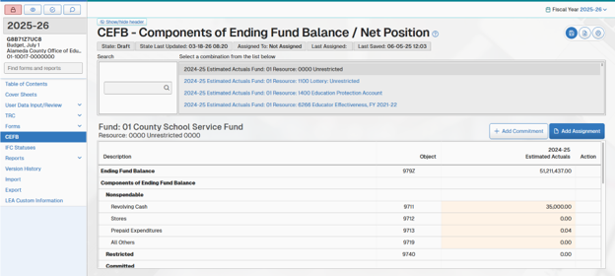
For governmental funds (funds 01–57), the Components of Ending Fund Balance/Net Position screen displays the title “Components of Ending Fund Balance.” It provides for nonspendable, restricted, committed, assigned, and unassigned components of the ending fund balance to be changed or added, and for multiple commitments and assignments within a resource to be individually defined.
- For proprietary and applicable fiduciary funds (funds 61–95), the Components of Ending Fund Balance/Net Position screen displays the title “Components of Ending Net Position.” It provides for net investments in capital assets and restricted net position to be changed.
A list of the resources reported in the data is displayed by data type, then by fund. Resource x Fund combinations with zero ending fund balance/net position are not displayed. During budget and unaudited actuals periods, the actual data type is listed first, followed by budget. During interim periods, budget data types are listed first, followed by projected year totals; actuals to date data type is not applicable here.
Changes made in the Components of Ending Fund Balance/Net Position screen are posted as general ledger data in the submission, replacing any existing values previously imported or entered for those objects.
Valid code combinations (resource with object) are not checked when amounts are entered in the Components of Ending Fund Balance/Net Position screen; valid code combinations are checked during the Import phase of the TRC.
Governmental Funds (Funds 01–57)—Input is allowed as follows:
- Nonspendable Amounts (objects 9710–9719)
Budget, interim, and estimated actuals data:
Changes can be made to all nonspendable amounts.
Unaudited actual data:
Changes can only be made to nonspendable for All Others, Object 9719.
- Restricted Amounts (objects 9730–9749)
Unrestricted resources, all data types:
Not applicable for unrestricted resources. No amount can be input.
Restricted resources, all data types:
Restricted Balance (Object 9740) is a calculated amount and will be recalculated to reflect changes made to components. No amount can be input. The calculated amount can be positive or zero.

- Committed Amounts (objects 9750–9769)
Unrestricted resources, all data types:
Changes can be made to all committed amounts and multiple commitments can be individually defined (see below for details).

Restricted resources, all data types:
Not applicable for restricted resources. No amount can be input.

- Assigned Amounts (objects 9770–9788)
Unrestricted resources, all data types:
Changes can be made to all assigned amounts and multiple assignments can be individually defined (see below for details).
Restricted resources, all data types:
Not applicable for restricted resources. No amount can be input.
- Unassigned/ Unappropriated Amounts (objects 9789–9790)
Unrestricted resources, all data types:
Changes can be made to Reserve for Economic Uncertainties (Object 9789).
For unrestricted resources, Unassigned/ Unappropriated (Object 9790) is a calculated amount and will be recalculated to reflect changes made to components. No amount can be input. The calculated amount can be positive, zero, or negative.
Restricted resources, all data types:
Reserve for Economic Uncertainties (Object 9789) is not applicable for restricted resources.
For restricted resources, Unassigned/ Unappropriated (Object 9790) is a calculated amount and will be recalculated to reflect changes made to components. No amount can be input. The calculated amount can be zero or negative.
For imported or entered estimated/unaudited actual general ledger data, amounts reported as nonspendable for Revolving Cash, Stores, and Prepaid Expenditures are compared to their respective asset amounts during system recalculations and, where different, are changed to equal the asset amounts, even when the asset amounts are zero. (Because assets, deferred outflows of resources, liabilities, and deferred inflows of resources are ignored during import of budget and interim general ledger data types, and data entry for these accounts is not allowed, amounts reported as nonspendable for Revolving Cash, Stores, and Prepaid Expenditures are not compared to the asset amounts or modified by the SACS Web System.)
Detail of multiple commitments or assignments within a resource can be individually defined within Object 9760, Other Commitments, or Object 9780, Other Assignments, by clicking on the Add Commitment or Add Assignment button respectively. A new line will be created in the Committed or Assigned section under Other Commitments or Other Assignments. Enter the commitment or assignment title, press Tab, then enter the amount. Multiple commitments or assignments may be added in this manner. Any value existing in Object 9760 or Object 9780 for fund and resource will be replaced with the total of all Other Commitments or Assignments entered for that fund and resource. To delete an entered Other Commitment or Other Assignment, click on the entry to be deleted, then click on the Delete Row button to the right of the entry and confirm that the entry should be deleted.
If general ledger data is reimported after commitments or assignments have been defined in the Components of Ending Fund Balance/Net Position screen, general ledger amounts for Object 9760, Other Commitments; Object 9780, Other Assignments; and Object 9790, Unassigned/Unappropriated Fund Balance, will be automatically recalculated by fund and resource to match the amounts defined in the Components of Ending Fund Balance/Net Position screen.
Data entered on this screen will display on the applicable fund form. If commitments or assignments are added for any resource within a fund using the Add Commitments or Add Assignments feature, this feature must be used for every resource within that fund that has an amount in Object 9760 or Object 9780 in the dataset to ensure the detailed commitments or assignments appearing on the fund form by resource agree with the total Other Commitments or Other Assignments for the entire fund.
Proprietary and Applicable Fiduciary Funds (Funds 61–95)—Input is allowed as follows:
- Net Investment in Capital Assets (Object 9796)
Changes can be made.
- Restricted Net Position (Object 9797)
Changes can be made.
- Unrestricted Net Position (Object 9790)
Unrestricted Net Position is a calculated amount and will be recalculated to reflect changes made to components. No amount can be input.
There are six technical review checks run during the general ledger phase relating to CEFB data:
- CEFB-POSITIVE: Components of Ending Fund Balance/Net Position (objects 9700–9789, 9796, and 9797), whether imported or entered on the Components of Ending Fund Balance/Net Position screen, are checked individually for negative balances, by fund and resource.
- EXCESS-ASSIGN-REU: Amounts reported in Other Assignments (Object 9780) and/or Reserve for Economic Uncertainties (Object 9789) are checked to ensure that they do not create a negative amount in Unassigned/Unappropriated (Object 9790) by fund and resource, for all funds except 61 through 95.
- UNASSIGNED-NEGATIVE: Checks to ensure Unassigned/Unappropriated balance (Object 9790) is zero or negative, by resource, in all funds except the general fund and funds 61 through 95.
- RS-NET-POSITION-ZERO: Restricted Net Position (Object 9797), in Unrestricted Resources, is checked to ensure they are zero, by resource, in funds 61 through 95.
- UNR-NET-POSITION-NEG: Checks to ensure amounts reported in Unrestricted Net Position (Object 9790) in Restricted Resources are zero or negative by resource, in funds 61 through 95.
- CEFB=FD-EQUITY: This check runs only at Unaudited Actuals period for Unaudited Actuals data type only. Checks to ensure Components of Ending Fund Balance/Net Position (objects 9710–9790, 9796, and 9797) agree with Fund Equity (Assets [objects 9100–9489] plus Deferred Outflows of Resources [objects 9490–9499] minus Liabilities [objects 9500–9689] minus Deferred Inflows of Resources [objects 9690–9699]).

IFC Statuses
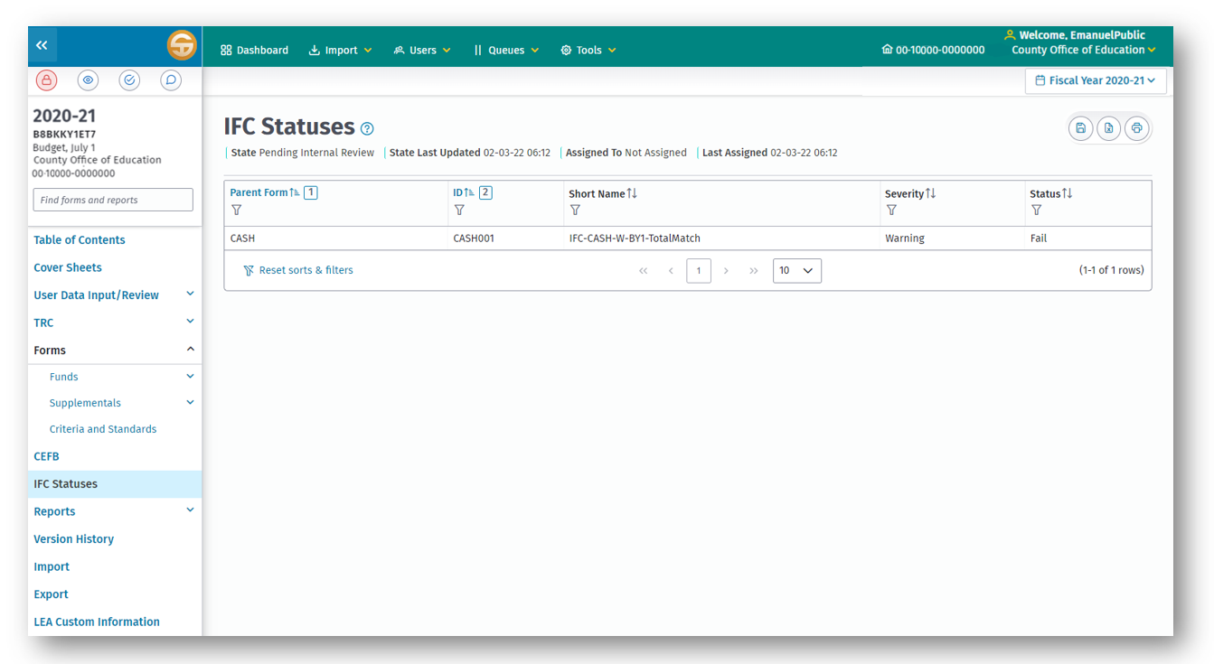
The IFC statuses screen may be accessed on the left navigation panel of the submission detail screen. Internal form checks (IFCs), similar to TRCs, are used to check for accuracy, completeness, and validity of the data, but IFCs are done within the forms rather than outside of the forms like the TRCs. Unlike TRCs, IFCs are not visible unless there is a condition that triggers the IFC. In most cases, when an IFC condition exists and is not passing, text will display on the screen identifying the area in the form that needs attention, and an exception will occur upon running the Export TRC.
Note: Forms can be closed with outstanding IFC conditions, allowing the user to research and correct the problems.
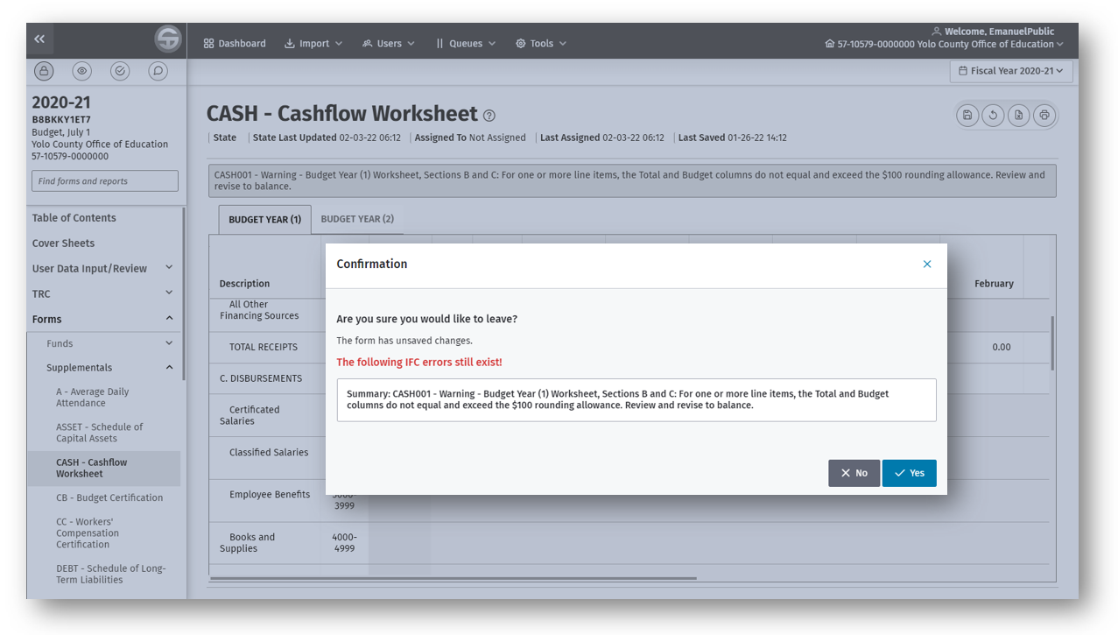
Upon exiting a form with an IFC condition, a message box displays with details about the condition.
The warning TRC is CHK-UNBALANCED-A, for which the condition must be corrected in the form or, when the data is correct, the TRC exception must be explained. The fatal TRC is CHK-UNBALANCED-B, for which the condition must be corrected in the form to clear the TRC and to complete an official export of the data.
Listed below are the forms that contain internal form checks and the TRCs within which the IFC exceptions will display. Note that some forms have both warning and fatal checks and may, therefore, appear within both TRCs.
CHK-UNBALANCED-A (Warning)
Form CASH
Form CEA
Form CEB
Form GANN
Form L
Forms MYP/MYPI/MYPIO
Form SEA
Reports SEMA/SEMB/SEMAI
CHK-UNBALANCED-B (Fatal)
Forms 01CS/01CSI
Form CEA
Form CEB
Form DEBT
Form ESMOE
Form GANN
Form ICR
Form L
Forms MYP/MYPI/MYPIO
Reports SEMA/SEMB/SEMAI
Also, IFCs exist in form SEAS, and government-wide reports CNVRT, ENTRY, and GSNP; however, they are informational only and do not generate either of the above TRC exceptions.

Reports
The Reports menu, accessible in the submission view, left navigation menu, provides the user with various reports in addition to and separate from the forms required for state reporting. The intent of providing these additional reports is to reduce the administrative reporting burden on LEAs and to eliminate duplication of effort for financial reporting to CDE program staff by automating reports to the extent possible. The available reports are based on the current reporting period.

Program by Resource (PGM) Report
The Program by Resource report provides financial data, for the program resource(s) selected by the user, in formats typically requested by CDE program staff. For each combination of fund, resource, and project year selected, the SACS Web System generates four different versions of a report that detail the amount available for expenditure, the expenditures, the difference between the amount available and the expenditures, and the percentage of eligible expenditures spent on indirect costs. The four versions of the Program by Resource report differ only in the way that expenditures are presented.
The Amount Available section is presented by object, the same way in all four versions of the report: Beginning balances, revenues by type, other financing sources and contributions, and unearned revenue.
The Expenditures section is presented differently in each version of the report:
- In the Object Summary version, expenditures are presented at a summarized level by object.
- In the Object Detail version, expenditures are presented at a more detailed level by object, with some objects further divided between instructional and noninstructional functions.
- In the Function Summary version, expenditures are presented at a summarized level by function.
- In the Function Detail version, expenditures are presented at a more detailed level by function.
The Balance (Total Available minus Total Expenditures and Other Financing Uses) is presented the same way in all four versions of the report. It is the calculated difference between the Total Available and the Total Expenditures and Other Financing Uses displayed in the report.
Indirect costs as a percentage of eligible expenditures are presented the same way in all four versions of the report: Eligible expenditures, indirect costs, and indirect costs divided by eligible expenditures.
The data for these reports is extracted from general ledger (GL) data and is calculated within the report. The only data entry allowed is to identify the "expenditures through" date shown on the report. This date can be entered, revised, or deleted on the first worksheet. It will automatically be copied from there to the other three worksheets.
The report is available only for Actuals data. It is not available for Budget data. The type of Actuals data used in the report depends on the reporting period:
- Budget Periods: Estimated Actuals data is used in the report.
- Interim Periods: Actuals to Date data is used in the report.
- Unaudited Actuals Period: Unaudited Actuals data is used in the report.
To generate Report PGM, navigate towards the left navigation menu, locate the Reports menu and select Reports. In the dropdown menu, select PGM – Program by Resource Report. All resources, by fund and project year, for which GL data exists, will be displayed at the top of the screen. The LEA may include one or more fund/resource/project year records in the report. The checkboxes next to each fund/resource/project year record can be used to select specific records. Additionally, the user can select all records by selecting the checkbox in the top left of the report. In the resulting report, the data for all the records included in the report will be combined and the records included in the report will be listed at the top of the report. To view each of the different versions of the report, click on the corresponding tab at the top of the table.
Notes:
- Per CSAM Procedure 315, the Project Year code, where needed, applies to revenues and expenditures but its use is optional for balance sheet accounts. Therefore, if revenues or expenditures within the GL data are reported by project year but beginning balances are not, and if not all project years for a given resource are selected for inclusion in the report, the calculated balance within the report (Total Available minus Total Expenditures and Other Financing Uses) may not agree to the calculated balance within the GL data for the resource as a whole (Object 979Z).
- The balances on the two versions of the report by object may differ from the balances on the two versions of the report by function if invalid account code combinations exist in the data. Any differences will be resolved when all import technical review exceptions are cleared.

Determination of Major Funds
The Determination of Major Funds (Form DTERM) report identifies which funds must be reported as major funds in the audited financial statements by comparing the assets, deferred outflows of resources, liabilities, deferred inflows of resources, revenues, and expenditures for governmental and enterprise funds to determine which funds meet the ten percent and five percent criteria defined in Governmental Accounting Standards Board (GASB) Statement 34.
To generate this report, click on DTERM - Determination of Major Funds on the Reports menu. All data for this report is extracted using the fund and object code ranges shown on the report. No key entry is required or permitted. To include additional fund as a major fund in the government-wide financial statements, the LEA should advise their auditor.

Government-Wide Reporting
Government-wide reporting is accessed under the Reports menu option from the left navigation panel within a submission and contains the following reports:
- CNVRT – Government-wide Conversion (CNVRT),
- ENTRY – Conversion Entries (ENTRY),
- GSA – Government-wide Statement of Activities and Reconciliation of Fund Statements (GSA), and
- GSNP – Government-wide Statement of Net Position and Reconciliation of Fund Statements (GSNP).
These reports include the conversion entries and worksheets necessary to convert from individual governmental funds to government-wide activities, and to prepare the Statement of Activities and Statement of Net Position required by GASB statements 34 and 63.
Government-wide conversion entries and reports should be prepared only after the funds are closed. Fund accounting must be correct for conversion entries to work properly. Conversion entries are not designed to correct accounting errors within the funds.

Recommended Processing Sequence
The following paragraphs describe the government-wide reporting options and functionality in their recommended processing sequence.
Note: Certain worksheets must be saved, closed, and reopened in order for related worksheets to extract linked data properly. This guide indicates where this is so. If subsequent changes are made to worksheets prepared early in the recommended processing sequence, worksheets prepared later in the recommended processing sequence must be opened and saved.

Specialized Function Codes and Definitions Used in Conversion Entries and Government-Wide Reporting
Certain specialized function codes and account descriptions are used for automation of conversion entries and government-wide reporting. These specialized codes and account descriptions have no application outside of the SACS Web System and should not be used for any other purpose. LEAs should continue to use the standard account codes as defined in the CSAM in their daily accounting.
Where specialized function codes appear in conversion entries, they are italicized to highlight their specialized use.
- Functions 1000–1999 are summarized to Function 1000, Instruction.
- Function 2420 is summarized to Function 2420, Instructional Library, Media and Technology.
- Function 2700 is summarized to Function 2700, School Site Administration.
- Functions 2100–2999 except 2420 and 2700 are summarized to Function 2100, Instructional Supervision and Administration.
- Function 3600 is summarized to Function 3600, Home-to-School Transportation.
- Function 3700 is summarized to Function 3700, Food Services.
- Functions 3000–3999 except 3600 and 3700 are summarized to Function 3900, All Other Pupil Services.
- Functions 4000–4999 are summarized to Function 4000, Ancillary Services.
- Functions 5000–5999 are summarized to Function 5000, Community Services.
- Functions 6000–6999 are summarized to Function 6000, Enterprise Activities.
- Function 7700 is summarized to Function 7700, Centralized Data Processing.
- Functions 7000–7999, except 7700, are summarized to Function 7200, All Other General Administration.
- Function 8500 is summarized to Function 8500, Facilities Acquisition and Construction.
- Functions 8000–8999 except 8500 are summarized to Function 8100, Plant Services.
- Function 9100, objects 7431 through 7439, except 7434 and 7438, are summarized to Function 9101, Debt Service - Principal.
- Function 9100, objects 7434 and 7438, are summarized to Function 9102, Debt Service - Interest.
- Function 9100, objects 5800 and 7699, are summarized to Function 9103, Debt Service - Issue Costs and Discounts.
- Function 9200, objects 7110 through 7299, are summarized to Function 9200, Transfers Between Agencies.
- Function 9300, objects 7611–7629, are summarized to Function 9300, Interfund Transfers.
- Function 9300, objects 1000–7999, except 5800, 7110–7199, 7611–7629,
7431–7439 and 7699, are summarized to Function 9000, Other Outgo.
- Function 0000, Object 6900, is summarized to Function 0000, Depreciation (Unallocated).
- Function 0000, Object 6910 and 6920, is summarized to Function 0000, Amortization (Unallocated).

Overview of Conversion Entries (Report ENTRY)
The Conversion Entries workbook comprises five worksheets. To access these worksheets, on the Reports menu, click on Conversion Entries, and then select each worksheet by its tab.
- Begin Balance (Beginning Balance): This worksheet is used to include the July 1 beginning balances of Capital Assets, Deferred Outflows of Resources, Long-term Liabilities, and Deferred Inflows of Resources relating to governmental activities in the government-wide consolidation. A detailed discussion of the beginning balance entry is provided below. The beginning balance entry is extracted automatically to the Fund Consolidation worksheet (see below).
This entry is required each year at least until such time as CDE collects government-wide data from all LEAs and can preload prior year balances into the SACS Web System.
- Detail (Conversion Entry Detail): This worksheet is used for development of supporting detail, or workpapers, for each of the possible conversion entries. To the extent possible, general ledger (GL) data is extracted and a proposed default conversion entry is provided based on assumptions defined for each entry. User adjustments are allowed for most default entries. Where GL data is not extracted and a default entry is not provided, user input is required to create the entry. A detailed discussion of each conversion entry is provided below.
Conversion entries from the Detail worksheet post automatically to the Conversion Entry Summary worksheet (see below).
- CE001 Data by Fnc: This worksheet displays the data extracted for the first conversion entry, CE001, summarized and sorted by function. This worksheet is provided for user reference and analysis. No key entry is required or permitted. A detailed discussion of Conversion Entry CE001 is provided below.
- CE001 Data by Obj: This worksheet displays the data extracted for the first conversion entry, CE001, summarized and sorted by object. This worksheet is provided for user reference and analysis. No key entry is required or permitted. A detailed discussion of Conversion Entry CE001 is provided below.
- Summary (Conversion Entry Summary): This worksheet summarizes the conversion entries developed in the Conversion Entry Detail worksheet and presents them in standard journal entry format. No key entry is required or permitted. Entries in the Conversion Entry Summary post automatically to the Conversion Worksheet (see below).

Detailed Instructions for Beginning Balance Entry (ENTRY: Begin Balance)

Entry: Beginning Balance
The purpose of this entry is to include in the government-wide statements the LEA’s beginning balances for capital assets, accumulated depreciation/amortization, deferred outflows of resources, long-term liabilities, and deferred inflows of resources relating to governmental activities as of July 1 of the year for which the LEA is reporting. Balances in these accounts relating to business-type activities are already reported in proprietary funds and are not included in this entry. Current liabilities already reported in governmental funds are not included in this entry.
Capital Assets and Accumulated Depreciation/Amortization. The appropriate conversion entry is to debit capital asset accounts and credit accumulated depreciation/amortization accounts for the July 1 balances of capital assets and accumulated depreciation/amortization.
Deferred Outflows of Resources – pensions only. The appropriate conversion entry is to debit deferred outflows of resources for the July 1 balances of deferred outflows of resources relating to pensions.
Deferred Outflows of Resources – OPEB only. The appropriate conversion entry is to debit deferred outflows of resources for the July 1 balances of deferred outflows of resources relating to OPEB.
Deferred Outflows of Resources – other. The appropriate conversion entry is to debit deferred outflows of resources for the July 1 balances of deferred outflows of resources relating to governmental activities (excluding pensions and OPEB), that are not already reported in governmental funds. Unamortized deferred losses on debt refundings from prior years are included in this account.
Long-term Liabilities. The appropriate conversion entry is to debit prepaid expense for unamortized debt issue costs for prepaid debt insurance, credit liability accounts for the July 1 balances of long-term liabilities, and debit or credit liability accounts for unamortized debt issue discount or premium. Accreted interest on deep-discount or capital appreciation bonds as of July 1 is included in the beginning balance of the bonds.
Deferred Inflows of Resources – pensions only. The appropriate conversion entry is to credit deferred inflows of resources for the July 1 balances of deferred inflows of resources relating to pensions.
Deferred Inflows of Resources – OPEB Only. The appropriate conversion entry is to credit deferred inflows of resources for the July 1 balances of deferred inflows of resources relating to OPEB.
Deferred Inflows of Resources – other. The appropriate conversion entry is to credit deferred inflows of resources for the July 1 balances of deferred inflows of resources relating to governmental activities (excluding pensions and OPEB), that are not already reported in governmental funds. Unamortized deferred gains on debt refundings from prior years are included in this account.
No data is extracted for this entry.
The SACS Web System will automatically calculate and post the net of the debits and credits to beginning net position.

Detailed Instructions for Conversion Entries (ENTRY: Detail)
The purpose of conversion entries is to consolidate governmental fund data and convert it from the current financial resources measurement focus and the modified accrual basis of accounting to the economic resources measurement focus and the accrual basis of accounting.
In the consolidation and conversion process, the fund, resource, and goal identities of transactions are largely ignored. Generally, only function (for expenditures) and object (for revenues, assets, and liabilities) remain meaningful. Resource codes are used only where it is necessary to distinguish program revenues from general revenues. In this case resource range 2000–9999 is used to distinguish program revenues, and resource range 0000–1999 is used to distinguish general revenues.
Government-wide conversion entries and reports should be prepared only after fund accounting is complete and the funds are closed. Fund accounting must be correct for conversion entries to work properly. Conversion entries are not designed to correct accounting errors within the funds.
To the extent possible, general ledger (GL) data is extracted and a proposed default conversion entry is provided based on assumptions defined for each entry. User adjustments are allowed for most default entries. Where it is not possible to extract GL data and provide a default entry, user input is required to create the entry.
For each entry, data extracted from the GL is displayed in the Extracted Data column. The proposed default conversion entry is displayed in the Default Conversion of Extracted Data column. In most entries, users may adjust the proposed default conversion entry in the User Adjustments column. The Default Conversion of Extracted Data column and the User Adjustments column are combined and displayed in the final Conversion Entry column. User input is allowed only in the User Adjustments column; all other columns are locked.
An “unbalanced” message will display for any entry in which debits do not equal credits in the final Conversion Entry column. For example, occasionally a default conversion entry will be out of balance due to rounding of extracted data. The user must then adjust for the rounding difference in the User Adjustment column to eliminate the unbalanced condition in the final conversion entry.
The SACS Web System contains twenty-eight defined conversion entries. It is likely that most LEAs will not need all twenty-eight of the conversion entries.

Entry CE001: Capital Outlay Expenditures
The purpose of this entry is to eliminate amounts reported as capital outlay expenditures in governmental funds for acquisition or construction of capital assets, and to instead report these amounts as increases to capital asset accounts on the statement of net position.
In the governmental funds, capital outlay expenditures were debits to assorted functions. To eliminate the expenditures, the functions in which they were reported must be credited, and capital asset accounts must be debited.
Data relating to capital outlay expenditures is extracted from governmental funds 01 through 57, objects 6000–6999, all functions, plus Function 8500, objects
1000–5999 and 7000–7999.
Because of the large volume of GL data extracted for this entry, the extracted data is displayed in two separate worksheets rather than in the Extracted Data column. In the worksheet titled CE001 Data by Fnc, the extracted data is sorted, subtotaled, and displayed by function. In the worksheet titled CE001 Data by Obj, the extracted data is sorted, subtotaled, and displayed by object. The extracted data is provided for user review and analysis. No key entry is required or permitted.
The default conversion entry uses the following assumptions:
- Object 9410 is debited for expenditures reported in Object 6100.
- Object 9420 is debited for expenditures reported in Object 6170.
- Object 9430 is debited for expenditures reported in Object 6200 plus expenditures reported in Function 8500, objects 1000–5999 and 7000–7999.
- Object 9440 is debited for expenditures reported in objects 6300, 6400, and 6500.
- Object 9460 is debited for expenditures reported in Object 6600.
- Object 9470 is debited for expenditures reported in Object 6700.
- The functions to which capital outlay expenditures were charged in the funds are credited.
Users may adjust the proposed default conversion entry in the User Adjustments column.
Example: A typical example of a user adjustment to the default conversion entry would be to capitalize as Work in Progress, rather than as Buildings, any expenditures relating to buildings that were not actually completed as of the end of the period. The default entry debits the capital asset account for Buildings for all expenditures for buildings and improvements. The user would adjust the default entry by crediting Buildings and debiting Work in Progress instead.
Note: Function 8500 is locked to prevent user adjustments because residual costs in Function 8500 are not allowed. Function 8500 does not appear on the statement of activities because project costs are normally capitalized and reported on the statement of net position. If a user has properly reported capitalizable project costs in Function 8500 in the funds but wishes to expense certain costs in the year incurred rather than depreciating them over time, the user would adjust the default entry by crediting Buildings and debiting the appropriate function (typically the function that will utilize the asset(s) being expensed).
It is not uncommon for Entry CE001 to be out of balance due to rounding of the extracted data. In that event, an “unbalanced” message will display. The user must adjust for the rounding difference in the User Adjustment column to eliminate the unbalanced condition in the final conversion entry.

Entry CE002: Debt Service Expenditures
The purpose of this entry is to eliminate amounts reported as debt service expenditures in governmental funds for repayment of the principal portion of long-term debt, and instead report decreases to long-term liability accounts on the statement of net position.
In the governmental funds, debt service expenditures were debits to the Debt Service function. To eliminate the expenditures, the Debt Service function must be credited, and long-term liability accounts must be debited.
Data relating to debt service expenditures is extracted from governmental funds 01 through 57, objects 7432, 7433, 7435, 7436, and 7439, Function 9100.
The default conversion entry uses the following assumptions:
- Object 9662 is debited for expenditures reported in Object 7432.
- Object 9661 is debited for expenditures reported in Object 7433.
- Object 9669 is debited for expenditures reported in objects 7435, 7436, and 7439.
Users may adjust the proposed default conversion entry in the User Adjustments column.
Example: A typical example of a user adjustment to the default conversion entry would be to correct the long-term debt account that should be reduced as a result of debt service expenditures. The default entry debits Other General Long-Term Debt for any expenditures recorded in Object 7439, Other Debt Service - Principal. The user might adjust the default entry by crediting Other General Long-Term Debt and debiting Leases Payable instead.

Entry CE003: Debt Issuance
The purpose of this entry is to eliminate amounts reported in governmental funds as Other Financing Sources for proceeds of long-term debt; amounts reported as Other Financing Sources or Uses for issuance premium or discount; and amounts reported as expenditures for debt issue costs for prepaid debt insurance, and instead report liabilities, prepaid expenses, and deferred outflows of resources or deferred inflows of resources relating to gain or loss on debt refunding, on the statement of net position.
Proceeds of long-term debt: In the governmental funds, debt proceeds were reported as credits to Other Financing Sources. To eliminate them, Other Financing Sources must be debited and a long-term liability account must be credited instead.
Debt issuance discount: If the debt was issued at a discount, in the governmental funds the issue discount was reported as a debit to Other Financing Uses. To eliminate it, Other Financing Uses must be credited and the related long-term liability account must be debited instead.
Debt issuance premium: If the debt was issued at a premium, in the governmental funds the issue premium was reported as a credit to Other Financing Sources. To eliminate it, Other Financing Sources must be debited and the related liability account must be credited instead.
Debt issue costs (for prepaid debt insurance only): In the governmental funds, debt issue costs were reported as debits to the Debt Service function. To eliminate the portion of issue costs for prepaid insurance, the Debt Service function must be credited and the prepaid expense account must be debited instead.
Data relating to debt issuance is extracted from governmental funds 01 through 57, objects 5400, 5450, and 7699, Function 9100; and objects 8931, 8951, 8961, 8971, 8972, 8973, and 8979.
The default conversion entry uses the following assumptions:
- Object 9330 is debited for issue costs reported in objects 5400 and 5450.
- Object 9669 is credited for proceeds reported in objects 8931 and 8961 and for premium reported in Object 8979.
- Object 9669 is debited for issue discount reported in Object 7699.
- Object 9660 is credited for proceeds reported in Object 8974.
- Object 9661 is credited for proceeds reported in Object 8951.
- Object 9666 is credited for proceeds reported in Object 8971.
- Object 9667 is credited for proceeds reported in Object 8972.
- Object 9668 is credited for proceeds reported in Object 8973.
Users may adjust the proposed default conversion entry in the User Adjustments column.
Examples: A typical example of a user adjustment to the default conversion entry would be to correct the long-term debt account to which the issue premium or discount applies. The default entry debits or credits Other General Long-Term Debt for issue premium or discount. The user might adjust the default entry by debiting or crediting Other General Long-Term Debt, and debiting or crediting General Obligation Bonds Payable instead.
Another example of a user adjustment to the default conversion entry would be if the LEA had issued new debt to refund previously issued debt. The LEA would need to adjust the default entry to report a deferred gain or loss for the difference between the reacquisition price of the refunded debt and the net carrying value of the refunded debt. The user would either debit deferred outflows of resources and credit the related liability (if the reacquisition price of the refunded debt was greater than the net carrying value of the refunded debt), or credit deferred inflows of resources and debit the related liability (if the reacquisition price of the refunded debt was less than the net carrying value of the refunded debt).

Entry CE004: Donated and Contributed Capital Assets
The purpose of this entry is to recognize donated or contributed capital assets. These are not reported in governmental funds because they do not involve inflows or outflows of current financial resources, but they should be reported in the government-wide statement of net position at their market value on the date of donation or contribution.
No data is extracted for this entry.
The appropriate conversion entry is to debit a capital asset account and credit general revenue or program revenue. Users may input the necessary amounts in the User Adjustments column.

Entry CE005: Disposal of Capital Assets
The purpose of this entry is to reflect disposals of capital assets in the government-wide statement of net position, and to report only any gain or loss from such disposals in the government-wide statement of activities.
Disposals may occur through sale, trade-in, or scrap. In the governmental funds, any proceeds from disposals of capital assets were reported as credits to revenue or Other Financing Sources. To adjust or eliminate them, revenue or Other Financing Sources must be debited, a capital asset account must be credited, and accumulated depreciation must be debited.
Losses on disposals of capital assets should be reported in the General Administration function, not in the function that utilized the asset. However, insignificant losses can be adjusted through the current year depreciation expense instead.
Data potentially relating to proceeds from the disposal of capital assets is extracted from governmental funds 01 through 57, objects 8631 and 8953. The extracted data is displayed, but no default conversion entry is provided because user analysis is required.
The appropriate conversion entry is to eliminate the carrying value of the capital asset that was disposed of by debiting accumulated depreciation and crediting the capital asset account. Any gain is reported as income. Any loss is reported in the General Administration function. It will usually be necessary to adjust or eliminate amounts reported in the funds as proceeds from the disposal. Users may input the necessary amounts in the User Adjustments column.

Entry CE006: Earned but Unavailable Revenues
The purpose of this entry is to recognize revenues that were earned in the current period, but that were not recognized in governmental funds because they were not "available" for purposes of the modified accrual basis of accounting.
No data is extracted for this entry.
In the governmental funds, earned but unavailable revenue is accrued as a receivable and the unavailable portion is deferred until the period in which it becomes available. The appropriate conversion entry is to debit deferred inflows of resources and credit either program revenue or general revenue. Users may input the necessary amounts in the User Adjustments column.
Note that for LEAs, earned but unavailable revenues are rare. A unique example was that portion of the 2001 Special Education Mandate Settlement that LEAs were legally guaranteed to receive, but in increments over a ten-year period. Traditional mandate reimbursements are not recorded as receivables in governmental funds, so are not included in this entry.

Entry CE007: Elimination of Revenues Relating to Prior Periods
The purpose of this entry is to eliminate certain revenues and unavailable revenues that were recognized in the government-wide statements in a prior period, but that were reported in governmental funds in the current period.
No data is extracted for this entry.
In the governmental funds, previously unavailable revenue that becomes available in the current period is recognized as revenue. Previously unavailable revenue that remains unavailable continues to be reported as deferred inflows of resources. The appropriate conversion entry is to debit either revenue or deferred inflows of resources and credit net position. Users may input the necessary revenue and deferred inflows of resources amounts in the User Adjustments column. The SACS Web System will automatically calculate and post the balance to Object 979Z, Net Position.

Entry CE008: Liability for Unmatured Interest on Long-Term Debt
The purpose of this entry is to recognize unmatured interest on long-term debt. Unmatured interest on long-term debt is not recognized in governmental funds until the period when it is due.
No data is extracted for this entry.
The appropriate conversion entry is to debit the debt service function and credit either accounts payable or, in the case of deep-discount or capital appreciation bonds, the debt itself. Users may input the necessary amounts in the User Adjustments column.

Entry CE009: Liability for Compensated Absences
The purpose of this entry is to recognize the change in liabilities for compensated absences. Liabilities for compensated absences are accrued in governmental funds only to the extent of amounts that have come due as of June 30, because the remainder is not normally expected to be liquidated with current financial resources.
No data is extracted for this entry.
The appropriate conversion entry is to debit (for increases) or credit (for decreases) the applicable functions, and debit or credit Object 9665, Compensated Absences, for the net change. Users may input the necessary amounts in the User Adjustments column.

Entry CE010: Expenditures Relating to Prior Periods
The purpose of this entry is to eliminate expenditures reported in governmental funds that related to a prior period, that were not recognized in governmental funds in the prior period under the modified accrual basis of accounting because they did not involve the use of current financial resources. Typical examples are interest on long-term debt that matured and was paid in the current period, payments on structured legal settlements or revenue repayment plans, and payments on retirement incentives financed over time.
No data is extracted for this entry.
The appropriate conversion entry is to debit long-term debt or net position, as appropriate, and credit the functions in which the expenditures were reported. Users may input the necessary amounts in the User Adjustments column.

Entry CE011: Adjustments to Work in Progress
The purpose of this entry is to adjust the Work in Progress account for previously capitalized costs of projects that were still in progress at the end of the prior fiscal year but have since been completed; or, more rarely, to write off previously capitalized costs of projects that will not be completed.
No data is extracted for this entry.
The appropriate conversion entry for projects that have been completed is to debit capital asset accounts and credit the Work in Progress account. The appropriate conversion entry for projects that will not be completed is to debit the General Administration function (where project planning costs would have been reported had they not been capitalized) and credit the Work in Progress account. Users may input the necessary amounts in the User Adjustments column.

Entry CE012: Depreciation
The purpose of this entry is to recognize the current year expense for depreciation of capital assets used in governmental activities, and to adjust the related contra-asset accounts for accumulated depreciation. Very rarely, this entry would also be used to recognize the permanent impairment of capital assets.
No data is extracted for this entry.
The appropriate conversion entry is to debit each function in which depreciation was incurred or in which permanent impairment should be recognized, and credit accumulated depreciation. Users may input the necessary amounts in the User Adjustments column.
If amounts recognized for permanent impairments are significant, it may be appropriate to manually reclassify them from an expense of a function to a special or extraordinary item on the statement of activities.

Entry CE013: Amortization
The purpose of this entry is to recognize the current year amortization of debt issue premiums or discounts, deferred gain or loss on debt refunding, and debt issue costs for prepaid debt insurance relating to past issuance of long-term debt.
No data is extracted for this entry.
The appropriate conversion entry for amortization of premiums is to debit the long-term liability and credit the Debt Service function. The appropriate conversion entry for amortization of discounts is to debit the Debt Service function and credit the long-term liability. The appropriate conversion entry for amortization of a deferred loss on debt is to debit the Debt Service function and credit deferred outflows of resources. The appropriate conversion entry for amortization of a deferred gain on debt refunding is to debit deferred inflows of resources and credit the Debt Service function. The appropriate conversion entry for amortization of debt issue costs for prepaid debt insurance is to debit the Debt Service function and credit the prepaid expense account. Users may input the necessary amounts in the User Adjustments column.

Entry CE014: Incorporation of Assets, Deferred Outflows of Resources, Liabilities, and Deferred Inflows of Resources of Internal Service Funds
The purpose of this entry is to incorporate the assets, deferred outflows of resources, liabilities, and deferred inflows of resources of internal service funds with the assets, deferred outflows of resources, liabilities, and deferred inflows of resources of governmental funds for government-wide reporting. Internal service funds are presumed to primarily benefit governmental activities, so their assets, deferred outflows of resources, liabilities, and deferred inflows of resources are reported in the governmental activities column on the government-wide statements.
Internal service fund assets, deferred inflows of resources, liabilities, and deferred outflows of resources are extracted from funds 66 through 68, objects 9110–9499 and objects 9500–9699.
The default conversion entry is:
- Debit objects 9110–9489 for assets.
- Debit Object 9490 for deferred outflows of resources - other.
- Credit objects 9500–9689 for liabilities.
- Credit Object 9690 for deferred inflows of resources - other.
- Debit or credit Net Position for the difference.
User adjustments to this default conversion entry are allowed only to enter deferred outflows of resources relating to pensions and OPEB, and deferred inflows of resources relating to pensions and OPEB, to distinguish them from deferred outflows and inflows of resources not relating to pensions and OPEB.
Note: Any current year change in net position for internal service funds must be accounted for in Entry CE015, Entry CE016, or both.

Entry CE015: Elimination of Internal Service Funds Profit or Loss Generated Within the LEA
The purpose of this entry is to eliminate any profit or loss in internal service funds resulting from internal activity within the LEA. Internal service funds are presumed to operate on a break-even basis for the benefit of the participating governmental activities or functions. To eliminate any redundancy in reporting government-wide revenues and expenditures, any profit or loss from internal service fund operations within the LEA needs to be allocated back to the functions that were overcharged or undercharged for the services provided. This is done using a look-back approach based on the proportionate participation of each function.
As an example, assume that an internal service fund provided liability insurance coverage to the following participating (benefiting) functions:
Participating Function | Proportionate Participation
General Administration | 75%
Pupil Transportation | 15
Food Services | 10
Total | 100%
Assume that the internal service fund generated a profit from internal activities of $1,000. Using a look-back approach, the costs reported for the participating functions should be reduced as follows:
Participating Function | Proportionate Reduction of Costs
General Administration | 75% × $1,000 = $ 750
Pupil Transportation | 15 × 1,000 = 150
Food Services | 10 × 1,000 = 100
Total | 100% × $1,000 = $1,000
No data is extracted for this entry.
The appropriate conversion entry is to debit or credit expenditures in the participating functions, and debit or credit net position for the total. Users may input the necessary amounts in the User Adjustments column. The SACS Web System will automatically calculate and post the balance to Object 979Z, Net Position.
Note: Any current year change in net position for internal service funds must be accounted for in Entry CE015, Entry CE016, or both.

Entry CE016: Incorporation of Internal Service Fund External Activities and Interfund Transfers
The purpose of this entry is to include that portion of internal service fund revenues, expenditures, and profit or loss generated by transactions with parties outside the LEA, plus any interfund transfers within the LEA. Internal service funds are presumed to primarily benefit governmental activities, so any profits or losses from activities outside the LEA are reported in the governmental activities column on the government-wide statements.
Data relating to interfund transfers of internal service funds is extracted from internal service funds 66 through 68, Object 7619, Function 9300, and Object 8919.
The default conversion entry for interfund transfers is:
- Debit Object 7619, Function 9300 for interfund transfers out.
- Credit Object 8919 for interfund transfers in.
- Debit or credit Net Position for the difference.
The appropriate conversion entry for revenues, expenditures, and net profit generated by parties outside the LEA is to debit expenditures and credit either program revenues or general revenues for the appropriate amounts. Users may input the necessary amounts in the User Adjustments column. The SACS Web System will automatically calculate and post the balance to Object 979Z, Net Position.
Note: Any current year change in net position for internal service funds must be accounted for in Entry CE015, Entry CE016, or both.

Entry CE017: Reclassification of Interfund Transfers Involving Fiduciary Funds
Note: Entry CE017 must be completed if applicable, and the ENTRY workbook saved, closed, and reopened, before preparing Entry CE019.
The purpose of this entry is to reclassify interfund transfers involving fiduciary funds as transactions with external parties, rather than as internal transactions. Due to the nature of fiduciary funds, interfund transfers between governmental funds and fiduciary funds are not appropriate.
Interfund transfers out are debits and interfund transfers in are credits. To reclassify those involving fiduciary funds, Other Outgo - Interfund Transfers must be credited and Other Outgo - All Other Transfers Out must be debited. Other Sources - Interfund Transfers must be debited and Other Transfers In From All Others must be credited.
Data potentially relating to interfund transfers involving fiduciary funds is extracted from all funds, Object 7619, Function 9300, and Object 8919. Data for the Governmental, Proprietary, and Fiduciary Fund categories is displayed separately. Within the Proprietary Funds category, the enterprise and internal service fund types are displayed separately.
The default conversion entry uses the following assumptions:
- In the Governmental Funds section, Object 7619, Other Outgo - Interfund Transfers is credited and Object 7299, Other Outgo - All Other Transfers Out is debited for the amount reported in the Fiduciary Fund section, Object 8919.
- In the Governmental Funds section, Object 8919, Other Authorized Interfund Transfers In is debited and Object 8799, Other Transfers In From All Others is credited for the amount reported in the Fiduciary Funds section, Object 7619.
- Corresponding entries are made in the Fiduciary Funds section.
- If no amounts are extracted in the Fiduciary Funds section, no entry is necessary.
Users may adjust the proposed default conversion entry in the User Adjustments column in the Governmental Funds and Proprietary Funds sections. The default conversion in the Fiduciary Funds section may not be adjusted.

Entry CE018: Reclassification of Interfund Balances Involving Fiduciary Funds
Note: Entry CE018 must be completed if applicable, and the ENTRY workbook saved, closed, and reopened, before preparing Entry CE020.
The purpose of this entry is to reclassify interfund balances involving fiduciary funds as balances due to or from external parties. Due to the nature of fiduciary funds, interfund balances between governmental funds and fiduciary funds may not be appropriate.
Interfund receivables are debits and interfund payables are credits. To reclassify those involving fiduciary funds, Due From Other Funds must be credited and Accounts Receivable debited, and Due To Other Funds must be debited and Accounts Payable credited.
Data relating to interfund balances is extracted from all funds, objects 9310 and 9610. Data for the Governmental, Proprietary, and Fiduciary Fund categories is displayed separately. Within the Proprietary Funds category, the enterprise and internal service fund types are displayed separately.
The default conversion entry uses the following assumptions:
- In the Governmental Funds section, Object 9310 is credited and Object 9200 is debited for the amount reported in the Fiduciary Fund section, Object 9610.
- In the Governmental Funds section, Object 9610 is debited and Object 9500 is credited for the amount reported in the Fiduciary Funds section, Object 9310.
- Corresponding entries are made in the Fiduciary Funds section.
- If no amounts are extracted in the Fiduciary Funds section, no entry is necessary.
Users may adjust the proposed default conversion entry in the User Adjustments column in the Governmental Funds and Proprietary Funds sections. The default conversion in the Fiduciary Funds section may not be adjusted.

Entry CE019: Elimination of Internal Transfers
Note: Entry CE017 must be completed if applicable, and the ENTRY workbook saved, closed, and reopened, before preparing Entry CE019.
The purpose of this entry is to eliminate interfund transfers among the governmental and internal service funds consolidated in the government-wide statements to eliminate the "grossing up" effect of the LEA's transactions with itself. Interfund transactions between governmental or internal service funds and enterprise funds should not be eliminated.
Interfund transfers in are credits and interfund transfers out are debits. To eliminate them, interfund transfers in must be debited and interfund transfers out must be credited.
Data relating to interfund transfers is extracted from all funds, objects 7611–7619, Function 9300, net of Conversion Entry CE017; and objects 8911–8919, net of Conversion Entry CE017. Data for the Governmental, Proprietary, and Fiduciary Fund categories is displayed separately. Within the Proprietary Funds category, the enterprise and internal service fund types are displayed separately.
The default conversion entry uses the following assumptions:
- In the Governmental and Internal Service Funds sections, objects
7611–7615 are credited and objects 8911–8916 are debited for the amounts extracted.
- In the Governmental Funds section, objects 7616 and 7619 are credited for the amounts extracted minus the amounts extracted in the Enterprise Funds section, objects 8916 and 8919.
- In the Governmental Funds section, Object 8919 is debited for the amount extracted minus the amount extracted in the Enterprise Funds section, Object 7619.
User adjustments to this default conversion entry are allowed in the Governmental and Internal Service Funds sections.

Entry CE020: Elimination of Internal Balances
Note: Entry CE018 must be completed if applicable, and the ENTRY workbook saved, closed, and reopened, before preparing Entry CE020.
The purpose of this entry is to eliminate interfund balances among the governmental and internal service funds consolidated in the government-wide statements, to eliminate the "grossing up" effect of the LEA's balances to and from itself. Interfund balances between governmental or internal service funds and enterprise funds should not be eliminated.
Balances due from other funds are debits and balances due to other funds are credits. To eliminate them, Due From Other Funds must be credited and Due To Other Funds must be debited.
Data relating to interfund balances is extracted from all funds, objects 9310 and 9610 net of Conversion Entry CE018, and is displayed separately for each category of funds (Governmental Funds, Proprietary Funds, and Fiduciary Funds).
The default conversion entry uses the following assumptions:
- In the Governmental Funds section, Object 9310 is credited for the amount extracted minus the amount extracted in the Proprietary Funds section, Object 9610.
- In the Governmental Funds section, Object 9610 is debited for the amount extracted minus the amount extracted in the Proprietary Funds section, Object 9310 net of CE017.
User adjustments to this default conversion entry are not allowed.

Entry CE021: Total/Net Other Postemployment Benefits (OPEB) Liability and OPEB Expense
The purpose of this entry is to adjust for the change in total/net OPEB liability not accrued in governmental funds because they are not normally expected to be liquidated with current financial resources, and to recognize OPEB expense, deferred outflows of resources relating to OPEB, and deferred inflows of resources relating to OPEB.
No data is extracted for this entry.
The appropriate conversion entry is to debit OPEB expenses by function for the period; and to debit or credit deferred outflows of resources, deferred inflows of resource, and total/net OPEB liability to adjust for the changes in the balances of these OPEB accounts since the prior period. Expenses by function should be reported in proportion to the LEA’s OPEB expenditures by function. The proportion of the LEA’s OPEB expenditures can be derived from the data extracted in conversion entry CE026.
Note: For LEAs that self-insure for OPEB, since the self-insurance fund is reported on the accrual basis, any total/net OPEB liability, OPEB expense, deferred outflows of resources relating to OPEB, and deferred inflows of resources relating to OPEB will have already been accrued and this conversion entry will not be necessary.

Entry CE022: Other Liabilities Not Normally Liquidated With Current Financial Resources
The purpose of this entry is to accrue expenses and liabilities for obligations incurred during the year that will not be liquidated with current financial resources (other than obligations for compensated absences, long-term debt, OPEB, and pensions, which are addressed in separate conversion entries). Examples include special termination benefits such as retirement incentives financed over time, structured legal settlements, and revenue overpayments that will be repaid over several years.
No data is extracted for this entry.
The appropriate conversion entry is to debit the functions or revenue accounts in which the obligations were incurred, and credit Object 9669, Other General Long-Term Debt. Users may input the necessary amounts in the User Adjustments column.

Entry CE023: Employer’s Net Pension Liability and Pension Expense
The purpose of this entry is to adjust for the LEA’s share of the change in net pension liabilities, not accrued in governmental funds because they are not normally expected to be liquidated with current financial resources, and to recognize the LEA’s share of pension expense, deferred outflows of resources relating to pensions, and deferred inflows of resources relating to pensions, as reported by the pension plan(s).
No data is extracted for this entry.
The appropriate conversion entry is to debit expenses by function for the LEA’s share of pension expense for the period; and to debit or credit deferred outflows of resources, deferred inflows of resources, and net pension liability to adjust for the LEA’s share of the changes in the balances of these pension plan accounts since the prior period. Expenses by function should be reported in proportion to the LEA’s employer contributions to pensions by function. The proportion of the LEA’s contributions can be derived from the data extracted in conversion entry CE024.

Entry CE024: Employer Pension Contributions Made Subsequent to Measurement Date
The purpose of this entry is to adjust for employer pension contributions made by the LEA subsequent to the pension plan measurement date.
In the governmental funds, employer pension contributions were debits to assorted functions. To eliminate the expenditures, the functions in which they were reported must be credited, and Deferred Outflows of Resources must be debited.
Data relating to employer pension contributions is extracted from governmental funds 01 through 57, objects 3100–3299, all functions (except Function 8500). Data relating to the on-behalf contributions made by the state to the state teachers’ retirement system is not extracted.
Users may adjust the proposed default conversion entry in the User Adjustments column.
An example of a user adjustment to the default conversion entry would be if any amount of the LEA’s contributions subsequent to the pension plan measurement date were to satisfy a contribution receivable recognized by the pension plan prior to the end of the current measurement period. For California LEAs, it is unlikely that this adjustment will be needed.

Entry CE025: State’s Share of Pension Expense – Special Funding Situation
The purpose of this entry is to record pension expense for State support of pensions in a “special funding situation” as defined in Governmental Accounting Standards Board (GASB) Statement 68. Pension expense is recognized for the portion of the State’s proportionate share of collective pension expense that is associated with the LEA, net of the state’s on-behalf contribution already recognized in the LEA’s governmental funds pursuant to GASB Statement 85. Revenue is recognized in an amount equal to the net pension expense stated above.
No data is extracted for this entry.
The appropriate conversion entry is to debit expenses by function and credit program revenue. Expenses by function should be reported in proportion to the LEA’s employer contributions to pensions by function. The proportion of the LEA’s contributions can be derived from the data extracted in conversion entry CE024. Users may input the necessary amounts in the User Adjustments column.

Entry CE026: Employer OPEB Expenditures Made Subsequent to Measurement Date
The purpose of this entry is to adjust for employer OPEB expenditures made by the LEA subsequent to the total/net OPEB liability measurement date and before the end of the reporting period.
In the governmental funds, employer OPEB expenditures were debits to assorted functions. To eliminate the expenditures, the functions in which they were reported must be credited, and Deferred Outflows of Resources relating to OPEB must be debited.
Data relating to employer OPEB expenditures is extracted from governmental funds 01 through 57, objects 3700–3799, all functions (except Function 8500).
Users may adjust the proposed default conversion entry in the User Adjustments column.

Entry CE027: Amortization of Lease Assets and Subscription Assets
The purpose of this entry is to recognize the current year expense for amortization of lease assets and subscription assets used in governmental activities, and to adjust the related contra-asset accounts for accumulated amortization.
No data is extracted for this entry.
The appropriate conversion entry is to debit each function in which amortization was incurred or in which permanent impairment should be recognized, and credit accumulated amortization. Users may input the necessary amounts in the User Adjustments column.

Entry CE028: Lease/Subscription Modification and Termination
The purpose of this entry is to record adjustments due to lease or subscription modification or at the end of lease/subscription term.
No data is extracted for this entry.

Government-Wide Conversion (Report CNVRT)
The Government-wide Conversion workbook comprises four worksheets. To access these worksheets, on the Reports menu, click on Government-wide Conversion, and then select each worksheet by its tab.
- Fund Consolidation: This worksheet consolidates the assets, deferred outflows of resources, liabilities, deferred inflows of resources, general revenues and program revenues, expenditures, and other financing sources and uses of governmental funds, plus the beginning balances of capital assets, deferred outflows of resources, long-term liabilities, and deferred inflows of resources from Beginning Balance entry, into one trial balance.
The extraction criteria for each row are displayed in the Resource, Function, and Object columns. All data in this worksheet is extracted from GL fund data or Beginning Balance entry. No key entry is required or permitted. The consolidated trial balance data posts automatically to the Conversion Worksheet (see below).
- Conversion Worksheet: This worksheet combines the consolidated trial balances of governmental funds, capital assets, deferred outflows of resources, long-term liabilities, and deferred inflows of resources as presented in the Fund Consolidation with the conversion entries developed in the Conversion Entry Detail worksheet, to produce the figures to be reported on the Statement of Net Position and the Statement of Activities.
All data in this worksheet is linked from the Fund Consolidation or extracted from the Conversion Entry Summary. Amounts displayed in the Entry Amounts column can be traced to the conversion entries cited in the Entry Numbers column. No key entry is required or permitted except in the Other Worksheet Adjustments column (see below).
The user should review the Conversion Worksheet carefully. In particular, the user should ensure that no data exists in shaded cells, as these will not pull to the government-wide statements.
Conversion Worksheet totals post automatically to the Statement of Activities and the Statement of Net Position (see below).
Cautionary notes regarding the Other Worksheet Adjustments column: This column is provided as a temporary workaround to allow the user to make any entry or adjustment, not provided for in Conversion Entries CE001 through CE028, necessary to convert the governmental fund data from the current financial resources measurement focus and the modified accrual basis of accounting to the economic resources measurement focus and the accrual basis of accounting; or to eliminate redundancy resulting from interfund activity within consolidated governmental funds. This column should not be used to correct accounting errors in the funds.
Any use of the Other Worksheet Adjustments column should be reported to CDE for consideration as a change order to the conversion entries.
Amounts entered into the Other Worksheet Adjustments column pull through to the government-wide statements, but do not pull through to the reconciliations of the government-wide statements to the governmental fund statements (see below).
- Program Revenue Detail: This worksheet identifies the program revenues by function to be reported on the statement of activities in the Charges for Services, Operating Grants and Contributions, and Capital Grants and Contributions columns for governmental activities and for business-type activities.
Program revenue data is extracted from GL data, conversion entries, and the conversion worksheet. The extraction of program revenue uses the criteria displayed in the resource and object columns on the Conversion Worksheet. In extracting program revenues, contributions and transfers in objects 8091–8096, 8098–8099, and 8980–8998 are ignored.
Program revenues are initially identified to the functions that generated them using the methodology and default assumptions described below. Users may adjust the default identification of revenues to functions if the default does not accurately represent the functions that generated the revenues.
The Program Revenue Detail worksheet is divided into six sections:
- Charges for Services: Governmental Activities
- Operating Grants and Contributions: Governmental Activities
- Capital Grants and Contributions: Governmental Activities
- Charges for Services: Business-type Activities
- Operating Grants and Contributions: Business-type Activities
- Capital Grants and Contributions: Business-type Activities
Generally, the governmental activities and business-type activities sections function similarly. Program revenues to be reported as Charges for Services or Operating Grants and Contributions are initially allocated to functions based on the pattern of expenditures by function within each resource in which program revenues occur. In governmental activities, program revenues to be reported as Capital Grants and Contributions are initially allocated to the Instruction function. In business-type activities, program revenues to be reported as Capital Grants and Contributions are initially allocated to the Enterprise function.
In the sections for Charges for Services and Operating Grants and Contributions, program revenues extracted from GL data are displayed by resource at the left. To the right, five rows of information are displayed for each resource:
- The Expenditures by Function row displays expenditures extracted from GL data for that resource, by function.
- The Percentage of Total row expresses the expenditures by function as percentages of the total expenditures in the resource.
- The Default Revenues by Function row calculates the initial allocation of program revenues to functions by multiplying the program revenue for the resource by the percentage in the Percentage of Total row.
- The User Adjustments row allows the user to adjust the identification of program revenues by function if the default does not accurately represent the function(s) that generated the revenues. For example, a grant might have expenditures in several functions, but the user may feel that the grant revenue was actually generated by only one of these functions. The user would enter an adjustment to decrease the revenue identified to the inappropriate functions, and increase the amount of revenue identified to the appropriate function.
- The Adjusted Revenues by Function row sums the amounts in the Default Revenues by Function and User Adjustments rows.
The sections for Capital Grants and Contributions function similarly to the preceding sections, except:
- The Expenditures by Function row is not used.
- The Percentage of Total row is not used.
- The Default Revenues by Function row initially allocates all of the program revenue to the Instruction function for governmental activities, and to the Enterprise function for business-type activities.
- The User Adjustments row allows the user to adjust the identification of program revenues by function if the default does not accurately represent the function(s) that generated the revenues. For example, a capital grant to build a school should be reported as program revenue of the Instruction function, but a capital grant to build a library should be reported as program revenue of the Library function.
- The Adjusted Revenues by Function row sums the amounts in the Default Revenues by Function and User Adjustments rows.
Users may adjust the default identification of program revenues by function in the User Adjustments rows. All other rows are locked.
At the bottom of the sections for governmental activities, three final rows are displayed:
- The Subtotal by Function row displays Adjusted Revenue by Function subtotals for each column.
- The User Identification of Conversion Entries, Adjustments, and Rounding Differences by Function row allows the user to manually attribute to functions any program revenue amounts from conversion entries; from worksheet adjustments affecting program revenues; or from rounding differences between the program revenues by function on this worksheet and the program revenues reported on the Conversion Worksheet. If any of these amounts exist, the combined amount will display in the Total column and an “unbalanced” message will display to the left. The user must distribute the amount from the Total column among the appropriate functions.
- The Adjusted [type of program revenue] by Function row sums the amounts in the preceding two rows for each column. If the Total column does not agree to the Conversion Worksheet, an “unbalanced” message will display to the left.
At the bottom of the sections for business-type activities, only one final row is displayed:
- The Adjusted [type of program revenue] by Function row displays Adjusted Revenue by Function totals for each column.
User adjustments are required to clear any of the following conditions:
- If program revenues exist in a resource but there were no expenditures in that resource to use as a basis for allocation of revenues by function, the message, "Default not possible; user adjustment required" will display on the Default Revenues by Function row. The user must manually identify the function(s) that generated the program revenue, and enter the appropriate amounts of the program revenue in the columns for the appropriate functions.
- If program revenue is initially identified on the Default Revenue by Function row to Function 8500, Facilities Acquisition and Construction, an adjustment will automatically be entered in the Function 8500 column on the User Adjustments row to clear it. The message, "Unbalanced; user adjustment required" will display on the Adjusted Revenues by Function row. The user must enter an offsetting adjustment in another more appropriate function. Program revenues cannot be reported for Function 8500 because the Facilities Acquisition and Construction function does not appear on the Statement of Activities.
- If there is any discrepancy, due to rounding or unbalanced user adjustments, between the Adjusted Revenues by Function for each resource displayed in the Total column at the right, and the program revenues for each resource displayed in the Program Revenues by Resource column at the left, the message, "Unbalanced; user adjustment required" will display on the Adjusted Revenues by Function row. The user must enter an adjustment in the User Adjustments row to balance the revenues by function to the total program revenues.
- If conversion entries or manual worksheet adjustments involving program revenues exist, or if there is any discrepancy due to rounding between total program revenues by function for all resources and total program revenues on the conversion worksheet, the user must identify the functions that are affected and distribute the amount from the Total column among the appropriate columns for the functions.
The user must clear all Unbalanced and User Adjustment Required conditions in order for amounts to pull through correctly to the government-wide statements.
When the CNVRT workbook is saved, closed, and reopened, the Program Revenue Detail worksheet totals post automatically to the Program Revenue Summary (below).
- Program Revenue Summary: This worksheet summarizes and displays by resource the program revenues to be reported by function on the statement of activities. When the CNVRT workbook is saved, closed, and reopened, all data is extracted from the Adjusted Revenues by Function rows from the Program Revenue Detail worksheet. User adjustment is not allowed. Any “unbalanced” messages in the Program Revenue Summary must be cleared in the Program Revenue Detail. Program Revenue Summary totals post automatically to the Statement of Activities (see below).

Government-Wide Statement of Net Position (Report GSNP)
The Government-wide Statement of Net Position workbook comprises two worksheets. To access these worksheets, on the Reports menu, click on Government-wide Statement of Net Position, and then select each worksheet by its tab.
- Statement of Net Position: This is the Statement of Net Position required by GASB statements 34 and 63. All data is extracted, either from the Statement of Net Position column of the Conversion Worksheet (for governmental activities) or from GL data (for business-type activities), except for the following two items for which key entry is required:
- Identification of long-term liabilities due within one year and due in more than one year. An “unbalanced” message will display until these amounts are entered.
- Identification of net investment invested in capital assets; restricted for capital projects; restricted for debt service; restricted for educational programs; restricted for other purposes (expendable and nonexpendable); and unrestricted. An “unbalanced” message will display until these amounts are entered.
  - GSNP Reconciliation: This is the required reconciliation between the governmental fund balances reported on the fund statements and the net position reported on the government-wide statement of net position. All data is extracted from GL data or conversion entries. No key entry is required or permitted.
The user should review the reconciliation to ensure that "Total fund balances, governmental funds" ties to the governmental fund balances and that "Total net position, governmental activities" ties to the statement of net position. It may be necessary to manually adjust for minor differences due to rounding before including the reconciliation in the final financial statements.
Note that in the Statement of Net Position, the Governmental Activities column includes the assets, deferred outflows of resources, liabilities, and deferred inflows of resources of internal service funds, which are non-governmental funds. Therefore, assets, deferred outflows of resources, liabilities, and deferred inflows of resources displayed as reconciling items on the GSNP Reconciliation will differ in amount from the assets, deferred outflows of resources, liabilities, and deferred inflows of resources reported on the Statement of Net Position by any amounts relating to internal service funds.
Note: Amounts entered manually in the Other Worksheet Adjustments column of the Conversion Worksheet do not pull through to this reconciliation, and require manual adjustment.

Government-Wide Statement of Activities (Report GSA)
The Government-wide Statement of Activities workbook comprises two worksheets. To access these worksheets, on the Reports menu, click on Government-wide Statement of Activities, and then select each worksheet by its tab.
- Statement of Activities: This is the Statement of Activities required by GASB Statement 34. All data is extracted from the Statement of Activities column of the Conversion Worksheet, the Program Revenue Summary, or GL data. No key entry is required or permitted.
- GSA Reconciliation: This is the required reconciliation between the change in fund balances reported on the governmental fund statements and the change in net position reported on the government-wide statement of activities. All data is extracted from GL data or conversion entries. No key entry is required; key entry is permitted only to enter the description of expenditures relating to prior periods.
The user should review the reconciliation to ensure that "Total change in fund balances, governmental funds" ties to the changes in governmental fund balances and that "Changes in net position of governmental activities" ties to the statement of activities. It may be necessary to manually adjust for minor differences due to rounding before including the reconciliation in the final financial statements.
Note: Amounts entered manually in the Other Worksheet Adjustments column of the Conversion Worksheet do not pull through to this reconciliation and require manual adjustment.

Special Education Maintenance of Effort Reports
These reports contain the worksheets necessary to determine compliance with the special education maintenance of effort (MOE) requirement. They are located at the left navigation pane under Reports. There are two reports for the unaudited actuals period: SEMA, Special Education MOE—Actual vs. Actual Comparison and SEMB, Special Education MOE—Budget vs. Actual Comparison, and one report for the interim periods: SEMAI, Special Education MOE— Projected vs. Actual Comparison.
This version of the User Guide provides general instructions and fiscal year specific information for completing reports for 2025–26 unaudited actuals and 2026–27 interim periods.

Program Compliance Overview
The Special Education Maintenance of Effort (SEMOE) reports are used to determine if a local educational agency (LEA) met the maintenance of effort required by the federal Individuals with Disabilities Education Act (IDEA) and implementing regulations. In summary, an LEA may not reduce the amount of state and local, or local only funds that it spends for the education of students with disabilities below the amount it spent for the comparison year. The comparison year is the year in which the LEA met MOE using the same method. There are two components to the LEA MOE requirement – the eligibility standard and the compliance standard.
The eligibility standard requires that, except in specified situations, in order to find an LEA eligible for IDEA Part B funds for the upcoming fiscal year, the LEA should have budgeted for the education of students with disabilities at least the same amount of state and local, or local only funds, as it actually spent for the education of students with disabilities during the most recent year for which information is available per 34 Code of Federal Regulations Section 300.203(a).
The compliance standard requires that, except in specified situations, an LEA should not reduce the level of expenditures for the education of students with disabilities made from state and local, or local only funds, below the level of those expenditures from the same source for the comparison year per 34 Code of Federal Regulations Section 300.203(b).
The federal Subsequent Years rule requires that the level of effort an LEA must meet in the year after it fails to maintain effort is the level of effort that would have been required in the absence of that failure and not the LEA’s actual reduced level of expenditures in the year in which it failed to maintain effort per 34 Code of Federal Regulations Section 300.203(c).
An LEA may use the following four methods to meet both the eligibility and compliance standards:
- Combined state and local expenditures;
- Combined state and local expenditures on a per capita basis;
- Local expenditures only;
- Local expenditures only on a per capita basis.
The 2025–26 unaudited actuals reporting period in the SACS Web System contains Report SEMA comparing the 2025–26 actual expenditures with the comparison year’s actual expenditures. It also contains Report SEMB comparing the 2026–27 budget with the comparison year’s actual expenditures, less the Program Cost Report Allocations.
- The form SEMA is to determine whether an LEA meets the federal compliance test for the LEA MOE. Failure on the part of an LEA to meet the LEA MOE compliance test results in the CDE invoicing the LEA for the amount of the failure. The LEA will have to pay the invoice from a non-federal fund source from the current fiscal year.
- The form SEMB is to determine whether an LEA meets the federal eligibility test for the LEA MOE. Failure on the part of an LEA to meet the LEA MOE eligibility requirement results in the CDE withholding IDEA funds that the LEA is entitled to receive on the basis of the IDEA subgrant to LEA calculations.
- The Subsequent Years Tracking (SYT) worksheet is used to determine if the LEA is comparing the actual expenditures of the SEMA and the budgeted expenditures of the SEMB to the appropriate comparison year for each of the four methods back to FY 2011–12, which is the base year for the LEA MOE calculations. Per the IDEA, an LEA may meet the compliance standard using any one of four methods: (1) state and local aggregate expenditures, (2) state and local per capita, (3) local only aggregate expenditures and (4) local only per capita. The comparison year for determining if an LEA meets the compliance standard is the last year the LEA met MOE using the same method and might vary depending on each method. The LEA is required to submit the SYT worksheet with the SEMA and SEMB reports. Please contact your SELPA AU for a copy of the most recent SYT worksheet. When completing this worksheet, the Program Cost Report Allocations (PCRA) may be found in Report SEMA, LE-CY worksheet, within the Total Expenditures section, regardless of which fiscal year is used as the comparison year.
For questions about the federal Subsequent Year Rule and the SYT worksheet, please contact Alexa Slater at aslater@cde.ca.gov.
The requirements discussed here also apply to charter schools. Please refer charter school SEMOE reporting procedures for additional information.
To assist LEAs and SELPAs in monitoring their MOE compliance during the year, the SACS Web System also includes an MOE reporting feature for the interim periods. The 2026–27 interim report, SEMAI, Special Education MOE—Projected vs. Actual Comparison, compares the special education 2026–27 projected expenditures with the comparison year actual expenditures to determine if the required level of fiscal effort will be met at the end of the year. The interim MOE report is not required to be submitted to the CDE. Please refer to SEMAI reports for additional information.

Unaudited Actuals Period Reports
There are two special education MOE reports in this reporting period: 2025–26 Actual vs. Actual Comparison (SEMA) and 2026–27 Budget vs. Actual Comparison (SEMB). Each of these reports consists of four worksheets: three prepared by each member LEA and one prepared by the administrative unit (AU) of a SELPA that has two or more members. (Single-agency SELPAs need only to complete the three LEA worksheets.) Details of these worksheets are shown in the following table:

A. SEMA – Special Education MOE – 2025–26 Actual vs. Actual Comparison: LEA Worksheets
Worksheet Name | Description
1. 2025–26 Expenditures by LEA (LE-CY) | Expenditures extracted from general ledger data; unduplicated pupil count, as of October 1, 2025, manually entered.
2. 2024–25 Expenditures by LEA (LE-PY) | Manual entries, based on 2024–25 Report SEMA and 2025–26 Unaudited Actual data.
3. LEA Maintenance of Effort Calculation (LMC-A) | Section 1 and Section 2 data manually entered; Section 3 figures extracted from LE-CY worksheet, and manually entered.

A. SEMA – Special Education MOE – 2025–26 Actual vs. Actual Comparison: SELPA Worksheet
Worksheet Name | Description
1. 2025–26 Expenditures by SELPA (SE-CY) | Data imported via SELPA workflow and/or manual entries, posted from LE-CY worksheets of SELPA members.

B. SEMB – Special Education MOE – 2026–27 Budget vs. Actual Comparison: LEA Worksheets
Worksheet Name | Description
1. 2026–27 Budget by LEA (LB-B) | Budget figures extracted from general ledger data; best estimate for October 2026 unduplicated pupil count manually entered.
2. 2025–26 Expenditures by LEA (LE-B) | Expenditures extracted from general ledger data; unduplicated pupil count, as of October 1, 2025, manually entered.
3. LEA Maintenance of Effort Calculation (LMC-B) | Section 1 and Section 2 data manually entered; Section 3 figures extracted from LB-B worksheet, and manually entered.

B. SEMB – Special Education MOE – 2026–27 Budget vs. Actual Comparison: SELPA Worksheet
Worksheet Name | Description
1. 2026–27 Budget by SELPA (SB-B) | Data imported via SELPA workflow and/or manual entries, posted from LB-B worksheets of SELPA members.

Overview of Reporting Process and Requirements for Both SEMA and SEMB
- LEA completes the three LEA worksheets for the report being done.
- If LEA is a member of a multi-agency SELPA, LEA submits the worksheets to the SELPA AU.
- If LEA is a single-agency SELPA, LEA submits the worksheets to the CDE.
- SELPA AU completes the three LEA worksheets for its own MOE data for the report being done.
- SELPA AU prepares the SELPA worksheet based on the SELPA members’ LEA worksheets to compile the SELPA figures for current year expenditures.
- SELPA AU submits one SELPA worksheet (SEMA: worksheet SE-CY; SEMB: worksheet SB-B) and the three LEA worksheets from each member LEA to the CDE (SEMA: worksheets LE-CY, LE-PY, and LMC-A; SEMB: worksheets LB-B, LE-B, AND LMC-B).

SELPA Workflow
The SACS Web System allows SELPA Member LEAs to send SEMOE data from the SEMA/SEMB/SEMAI reports to their SELPA AU, in cases where the COE of the same county is a SELPA AU. When the SELPA Member selects the top right “Not ready for review” button of their report, the icon changes from an “X” to a “√ ” indicating that the data is now “Ready for review”. The system automatically sends an email notification to the SELPA AU that alerts them that they have SELPA Member data for review. The SELPA AU accesses the data from their own draft dataset and can choose to accept or reject the submitted data. For this SELPA workflow, the SELPA Member user should be assigned the “SELPA Member” role and the SELPA AU user should be assigned the “SELPA AU” role.
Note: The SEMOE data includes the following worksheets only for the SELPA workflow:
- SEMA report - LEA Exps CY worksheet
- SEMB report - LEA Budget worksheet
- SEMAI report - LEA Projected worksheet

Due Dates
The reports are due as follows:
Report SEMA
Due to SELPA AU: September 15, 2026: LEA worksheets from member LEAs
Due to CDE: November 16, 2026: SELPA worksheet, and LEA worksheets from member LEAs
Report SEMB
Due to SELPA AU: September 15, 2026: LEA worksheets from member LEAs
Due to CDE: November 16, 2026: SELPA worksheet, and LEA worksheets from member LEAs

Subsequent Year Tracking Worksheet
Due to SELPA AU: September 15, 2026
Due to CDE: November 16, 2026
Note: While it is advisable to complete the SEMA and SEMB reports before submitting the SACS unaudited actual data to the CDE, they are not required reports for that submission and must be submitted separately as noted below.

Reports Due to CDE
Reports should be submitted in electronic Acrobat® Portable Document Format (PDF) by the above due dates.
The electronic reports in PDF should be sent to spedfiscalprogrpts@cde.ca.gov. Please include the name of the SELPA in the subject line of the email.

Initial Procedures Before Completing the SEMA and SEMB Reports
Select the SELPA for which the MOE report is being done:
- Open Form SEAS from the Forms/Supplementals menu, and enter the 2-character code of the applicable SELPA from the displayed list.
- Click Save, and then Close the Form SEAS window. (See the Special Education Revenue Allocation Setup [SEAS] section for additional instructions in completing Form SEAS.)
Notes:
  - After completing Form SEAS, the name of the SELPA selected in that form will automatically display on the SELPA name line in the LEA Maintenance of Effort Calculation worksheet and in all of the SELPA worksheets. Also, the names of the LEAs that belong to the selected SELPA will automatically display in individual columns in the Expenditures by SELPA and Budget by SELPA worksheets.
  - If Form SEAS is not filled out and saved, (??) will display for the SELPA name in the applicable worksheets. In addition, the Expenditures and Budget worksheets will not display columns for SELPA members; only the Adjustments and Total columns will display.
  - It is important that Form SEAS be completed or updated before completing Report SEMA or SEMB. All information (such as, comparison year information and contact information) entered in the LEA MOE Calc worksheet and SELPA worksheet of Report SEMA or SEMB will be lost when Form SEAS is completed or updated after the completion of Report SEMA or SEMB.

Completing Report SEMA
In the left navigation panel, click Reports, then select SEMA-Special Education MOE—Actual vs. Actual Comparison. This will open the workbook, with the first of the four worksheets showing. A tab for each of the worksheets displays at the top of the screen. To open a different worksheet, click on the corresponding tab.

The worksheets are completed as follows:

2025–26 Expenditures by LEA (LE-CY)
Unduplicated Pupil Count: Enter the California Longitudinal Pupil Achievement Data System (CALPADS) special education unduplicated pupil count as of October 1, 2025. A warning message will display when closing the report if the information is not entered.
Total Expenditures: All special education expenditures are extracted from the general ledger data for the funds, resources, goals, and objects as indicated on the report. No manual entry is needed in this section other than for any adjustments to the extracted amounts.
Federal Expenditures: Special education expenditures paid from federal sources are extracted from the general ledger data for the funds, resources, goals, and objects as indicated on the report. No manual entry is needed in this section other than for any adjustments as described below.
The Object 8980 amount extracted represents total contributions from unrestricted revenues to federal resources for the special education program. Since the expenditures paid from these contributions are included in the "TOTAL (federal expenditures) BEFORE OBJECT 8980," an amount equivalent to the contributions is deducted from that total to arrive at the net expenditures paid from federal sources. The same Object 8980 amount is added to the STATE AND LOCAL EXPENDITURES, and to the LOCAL EXPENDITURES.
State and Local Expenditures: Special education expenditures paid from state and local sources are extracted from the general ledger data for the funds, resources, goals, and objects as indicated on the report. No manual entry is needed in this section other than for any adjustments as described below.
The total Contributions from Unrestricted Revenues, Object 8980, credited to federal resources, as shown in the FEDERAL EXPENDITURES section, is added here.
Local Only Expenditures: Special education expenditures paid from local sources only are extracted from the general ledger data for the funds, resources, goals, and objects as indicated on the report. No manual entry is needed in this section other than for any adjustments as described below.
Contributions from Unrestricted Revenues, Object 8980, credited to federal resources, as shown in the FEDERAL EXPENDITURES section, and Contributions from Unrestricted Revenues, Object 8980, credited to state resources are also included here.
Adjustments Column: Enter any adjustments (deductions and additions are allowed) to the numbers automatically extracted, in order to arrive at the correct total expenditures for special education MOE calculation purposes. Fully explain on a separate page any amounts shown in the Adjustments column, and attach that to the reports submitted to the SELPA AU or the CDE. Maintain supporting documentation, which should be available upon request from the SELPA AU or the CDE.
Note: When making adjustments, ensure that the total/net adjustments in the Total Expenditures section is equal to the sum of the adjustments in the Federal Expenditures and State And Local Expenditures sections. If these amounts do not equal, an “unbalanced” message will display in red on the screen and on the printed report for both the LE-CY and LMC-A worksheets. Upon closing the report, a message box will identify the unbalanced item(s).

2024–25 Expenditures by LEA (LE-PY)
This worksheet is manually filled out to calculate the 2024–25 (prior year's) special education expenditures that may be used in the actual vs. actual comparison. If adjustments to the prior year's special education expenditures were made in 2025–26 after the submission of the SACS 2024–25 unaudited actual data to the CDE, the 2024–25 special education expenditures to be used in this year's comparison may not be the same as the 2024–25 special education expenditures amount used in the prior year's actual vs. actual comparison (SEMA). Adjustments to that amount must be made to make the 2024–25 expenditures used in this year's actual vs. actual comparison comparable to those for the 2025–26 expenditures.
The sources for the numbers to be input in this report are: 1) the prior year's SEMA Report, 2024–25 Expenditures by LEA (LE-CY), and 2) 2025–26 unaudited actual general ledger data.
Section A, State and Local, and Section B, Local Only – 2024–25 Expenditures: The descriptions below apply to both Section A and Section B, with the Section A column used for amounts affecting or pertaining to state and local expenditures, and the Section B column, for those affecting or pertaining to local expenditures only.
Line 1 Total Costs
Enter the total costs shown in the 2024–25 Report SEMA, 2024–25 Expenditures by LEA (LE-CY) worksheet, submitted last year to the CDE or SELPA AU. Enter in Section A the amount in the Total Costs line, Total column, in the State and Local Expenditures section of that worksheet, and in Section B, the amount in the Local Expenditures section.
Line 2 Audit Adjustments
Enter any audit adjustments to the 2024–25 special education expenditures made after the closing of the books for that fiscal year, not included on Line 1. The adjustment amount will be part of Object 9793, Audit Adjustments, in the 2025–26 unaudited actual general ledger data.
Line 3 Restatements
Enter any restatements of the 2025–26 beginning fund balances made in 2025–26 that affected the 2024–25 special education expenditures, as reflected in Object 9795, Other Restatements, for the funds and resources as indicated on the report if that restatement is not included on Line 1.
Line 4 Other Adjustments
Enter any other adjustments being made this year, not included on Line 1. Describe the adjustments in the space provided on the worksheet.
Line 5 2024–25 Adjusted Expenditures
These are automatically calculated and represent the total adjusted 2024–25 combined state and local expenditures (Section A column) and local expenditures (Section B column), which will be compared with the 2025–26 expenditures.

Section C – Unduplicated Pupil Count:
Line 1 Enter the unduplicated pupil count reported in the 2024–25 Report SEMA, 2024–25 Expenditures by LEA (LE-CY) worksheet in last year's actual vs. actual MOE report. This would be the unduplicated pupil count for October 2024.
Line 2 Enter any adjustments in the October 2024 unduplicated pupil count made after the submission of the LE-CY worksheet last year, to reflect the correct count this year.
Line 3 This is automatically calculated and represents the total, adjusted unduplicated pupil count for 2024–25.

LEA Maintenance of Effort Calculation (LMC-A)
This worksheet is used to determine if the LEA maintained the level of fiscal effort required for 2025–26.
Per the IDEA, an LEA may meet the compliance standard using any one of four methods: (1) state and local aggregate expenditures, (2) state and local per capita, (3) local only aggregate expenditures and (4) local only per capita. The Subsequent Years Tracking (SYT) worksheet is used to determine the comparison year the LEA must use for 2025–26 for each of the four methods. The comparison year for determining if an LEA meets the compliance standard is the last year the LEA met MOE using the same method and might vary depending on each method. The LEA is required to submit the SYT worksheet with the SEMA and SEMB reports. Please contact your SELPA AU for a copy of the most recent SYT worksheet. When completing this worksheet, the Program Cost Report Allocations (PCRA) may be found in Report SEMA, LE-CY worksheet, within the Total Expenditures section, regardless of which fiscal year is used as the comparison year.
Section 1: Complete Section 1 if the LEA determines that a reduction in expenditures was due to transactions exempt from the MOE requirement (REF: 34 CFR Section 300.204). These are:
- The voluntary departure, by retirement or otherwise, or departure for just cause, of special education or related services personnel.
- A decrease in the enrollment of students with disabilities.
- The termination of the obligation of the agency to provide a program of special education to a particular student with a disability that is an exceptionally costly program, as determined by the State Educational Agency, because the student:
- Has left the jurisdiction of the agency;
- Has reached the age at which the obligation of the agency to provide FAPE (free and appropriate public education) to the student has terminated; or
- No longer needs the program of special education.
- The termination of costly expenditures for long-term purchases, such as the acquisition of equipment or the construction of school facilities.
- The assumption of cost by the high cost fund operated by the SEA under 34 CFR Section 300.704(c).
Enter in the respective lines of Section 1 the amounts resulting from any of these events. The SACS Web System will automatically add the amounts and carry the total exempt reductions to Section 3.
Note: If the LEA completes Section 1, the LEA must complete the LEA Maintenance of Effort Exemption Worksheet. The worksheet is to be used to calculate and describe the allowable exceptions (exemptions) that were reported by the LEA in Section 1. The LEA must submit this worksheet to the CDE with the LMC-A worksheet. If the LEA has any questions, please contact Alexa Slater at aslater@cde.ca.gov.

Section 2: “50 Percent Rule”
Note: Only LEAs that have a “meets requirement” compliance determination under IDEA, Section 613(a) and that are not found significantly disproportionate for the current year are eligible to use this option to reduce their MOE requirement.
Complete this section if a reduction in expenditures could be offset by up to 50 percent of an increase in IDEA Part B Section 611 funding in 2025–26. An increase in the IDEA Part B Section 619 preschool funding is not taken into consideration. Under federal law and regulations, an LEA may reduce its required MOE by not more than 50 percent of the increase, minus the amount of Part B funds the LEA chooses to use for early intervening services (EIS). The LEA must use an amount of state or local funds equal to the reduction in the required level of expenditures used in this section, to carry out activities that could be supported with funds under the Elementary and Secondary Education Act of 1965 (ESEA), regardless of whether the LEA is using funds under the ESEA for those activities (IDEA of 2004, Section 613(a)(2)(C)).
Note: ESEA includes Title I, Impact Aid, and other ESEA programs. Impact Aid is considered general aid to the recipient school districts; these districts may use the funds in whatever manner they choose in accordance with their local and State requirements. LEAs typically use Impact Aid for a wide variety of expenditures including the salaries of teachers and teacher aides; purchasing textbooks, computers, and other equipment; after-school programs and remedial tutoring; advanced placement classes; and special enrichment programs. For more information see “Impact Aid Program Overview”.
IDEA contains a provision which permits LEAs to use up to 15 percent of their Part B funds, both Section 611 and Section 619 combined, for any fiscal year to implement EIS. Expending IDEA funds for EIS activities has a direct and substantial impact on an LEA’s ability to reduce its MOE requirement through the 50 percent rule. See examples below, in scenario 1 and 2, for details.
Enter in the appropriate lines the total IDEA Part B Section 611 funding received and accrued during 2025–26 (current year funding line) and 2024–25 (prior year funding line). The SACS Web System calculates the increase, if any, and 50 percent of that amount.
Enter in the appropriate line the total IDEA Part B Section 619 funding received and accrued during 2025–26 (current year line). The SACS Web System calculates 15 percent of Part B funding, the maximum amount available for EIS.
Scenario 1: The maximum amount that the LEA may set aside for EIS is greater than the maximum “50 percent reduction” amount.
Enter in the appropriate line the amount, or $0 if not applicable, set aside for EIS. This amount is limited to the maximum amount available for EIS. The SACS Web System calculates the amount available for reduction of the MOE requirement.

Example
Description | Amount
Prior Year's Allocation | $900,000
Current Year's Allocation | $1,000,000
Increase | $100,000
Maximum Available for MOE Reduction (50% of Increase) | $50,000
Maximum Available for EIS (15% of Current Year’s Allocation) | $150,000
If the LEA chooses to set aside $150,000 for EIS, it may not reduce its MOE (MOE maximum $50,000 less $150,000 for EIS means $0 can be used for MOE).
If the LEA chooses to set aside $100,000 for EIS, it may not reduce its MOE (MOE maximum $50,000 less $100,000 for EIS means $0 can be used for MOE).
If the LEA chooses to set aside $50,000 for EIS, it may not reduce its MOE (MOE maximum $50,000 less $50,000 for EIS means $0 can be used for MOE).
If the LEA chooses to set aside $30,000 for EIS, it may reduce its MOE by $20,000 (MOE maximum $50,000 less $30,000 for EIS means $20,000 can be used for MOE).
If the LEA chooses to set aside $0 for EIS, it may reduce its MOE by $50,000 (MOE maximum $50,000 less $0 for EIS means $50,000 can be used for MOE).
Enter in the State and Local column and, if applicable, in the Local Only column, the portion of the available amount being used to reduce the MOE requirement. This amount is limited to the calculated available amount for reduction of the MOE requirement.
Scenario 2: The maximum amount that the LEA may set aside for EIS is less than the maximum “50 percent reduction” amount.
Enter in the appropriate line the amount, or $0 if not applicable, used to reduce the MOE requirement. The SACS Web System calculates the amount available to set aside for EIS.

Example
Description | Amount
Prior Year's Allocation | $1,000,000
Current Year's Allocation | $2,000,000
Increase | $1,000,000
Maximum Available for MOE Reduction (50% of Increase) | $500,000
Maximum Available for EIS (15% of Current Year’s Allocation) | $300,000
If the LEA chooses to use no funds for MOE, it may set aside $300,000 for EIS (EIS maximum $300,000 less $0 means $300,000 for EIS).
If the LEA chooses to use $100,000 for MOE, it may set aside $200,000 for EIS (EIS maximum $300,000 less $100,000 means $200,000 for EIS).
If the LEA chooses to use $150,000 for MOE, it may set aside $150,000 for EIS (EIS maximum $300,000 less $150,000 means $150,000 for EIS).
If the LEA chooses to use $300,000 for MOE, it may not set aside anything for EIS (EIS maximum $300,000 less $300,000 means $0 for EIS).
If the LEA chooses to use $500,000 for MOE, it may not set aside anything for EIS (EIS maximum $300,000 less $500,000 means $0 for EIS).
Enter in the State and Local column and, if applicable, in the Local Only column, the portion of the amount being used to reduce the MOE requirement. This amount is limited to the available amount shown above.
Note: If the LEA completes Section 2, the LEA must list the activities (which are authorized under the ESEA) paid with the freed up funds at the bottom of the Section 2.
Section 3, Part A––Combined State and Local Expenditures Method: This comparison method determines if the LEA met the MOE requirement based on combined state and local expenditures.
Test 1: Amounts will be extracted or calculated in Column A. Based on the most recent year that the LEA met the MOE compliance requirement using the actual vs. actual method based on state and local expenditures, input the fiscal year in the column heading in Column B. Then input the total special education expenditures paid from state and local sources, and MOE adjustments resulting from audit adjustments, restatements, and/or other adjustments. Column C is the difference between the two years’ combined state and local expenditures.
Test 2: The FY 2025–26 column data will be extracted. Based on the most recent year that the LEA met the MOE compliance requirement using the actual vs. actual method based on per capita state and local expenditures, input the fiscal year in the column heading in Column B. Then input the total special education expenditures paid from state and local sources; MOE adjustments resulting from audit adjustments, restatements; and/or other adjustments, and special education unduplicated pupil count. Column C is the difference between the two years’ combined state and local expenditures, in total and per capita.
If one or both of the differences in Column C for the Section 3.Test 1 (if applicable) or Test 2 are positive, the LEA met the MOE compliance requirement.
Section 3, Part B––Local Expenditures Only Method: This comparison method determines if the LEA met the MOE requirement based on local expenditures only.
Test 3: Amounts will be extracted or calculated in Column A. Based on the most recent year that the LEA met the compliance requirement using the actual vs. actual method based on local expenditures only, input the fiscal year in the column heading in Column B. Then input the total special education expenditures paid from local sources only, and MOE adjustments resulting from audit adjustments, restatements, and/or other adjustments. Column C is the difference between the two years’ local expenditures only.
Test 4: The FY 2025–26 column data will be extracted. Based on the most recent year that the LEA met the MOE compliance requirement using the actual vs. actual method based on per capita local expenditures, input the fiscal year in the column heading in Column B. Then input the total special education expenditures paid from local sources only; MOE adjustments resulting from audit adjustments restatements; and/or other adjustments, and the special education unduplicated pupil count. Column C is the difference between the two years’ local expenditures, in total and per capita.
If one or both of the differences in Column C for the Section 3.Test 3 (if applicable) or Test 4 are positive, the LEA met the MOE compliance requirement.
Contact Person: Enter in the appropriate lines the name of the LEA contact person for this report and that person's title, telephone number, and email address. A warning message will display when closing the report if the information is not entered.
The following report is prepared if the SELPA is a multi-agency SELPA.

2025–26 Expenditures by SELPA (SE-CY)
Data imported via SELPA workflow and/or manual entries. Enter in the respective LEA columns (including one for the SELPA AU) the total 2025–26 expenditures by object and the October 2025 unduplicated pupil count reported in the SELPA members' 2025–26 Expenditures by LEA (LE-CY) worksheets.
Enter in the Adjustments column any additions to or deductions from the amounts reported by the member LEAs, as necessary. Provide detailed explanations for the adjustments on a separate page, which should be submitted with this worksheet. Supporting documentation must be maintained, and should be available upon request from the CDE.

Completing Report SEMB
In the left navigation panel, click Reports, then select SEMB-Special Education MOE—Budget vs. Actual Comparison. This will open the workbook, with the first of the four worksheets showing. A tab for each of the worksheets displays at the top of the screen. To open a different worksheet, click on the corresponding tab.
The worksheets are completed as follows:

2026–27 Budget by LEA (LB-B)
The amounts in this worksheet are extracted from the 2026–27 budget amounts input/imported to the unaudited actuals reporting period in the SACS Web System. The elements of the budgeted expenditures in this worksheet are similar to those found in the 2025–26 Expenditures by LEA (LE-CY) for the SEMA report, except that they pertain to budgeted amounts rather than to actual expenditures, and do not include Object PCRA, Program Cost Report Allocations. (There is no PCRA calculation for the budget data.)
Use the latest approved 2026–27 budget, if different from the original budget, so that the MOE calculation reflects the latest available information. Use the Adjustments column to make necessary adjustments to the extracted amounts.
Enter the best estimate of CALPADS unduplicated pupil count for October 2026. Keep supporting documentation for how the estimate was determined; CDE may follow up if the figures are significantly different from the October 2025 pupil count. A warning message will display when closing the report if the information is not entered.

2025–26 Expenditures by LEA (LE-B)
This worksheet is the same as the 2025–26 Expenditures by LEA (LE-CY) in Report SEMA, except for the treatment of Object PCRA, Program Cost Report Allocations. Although the amount for this object code is shown in the LE-B worksheet, it is not included in the TOTAL COSTS because there is no comparable budget data. It is shown as a non-add item so the amount will be available for next year's reports.
Review the 2025–26 Expenditures by LEA (LE-CY) in Report SEMA for additional information on completing this worksheet.
Note: Similar to LE-CY, adjustments in the Total Expenditures section must equal the sum of the adjustments in the Federal Expenditures and State And Local Expenditures sections or an “unbalanced” message will display.

LEA Maintenance of Effort Calculation (LMC-B)
This worksheet is used to determine if the LEA's 2026–27 budget meets the required level of fiscal effort.
Per the IDEA, an LEA may meet the compliance standard using any one of four methods: (1) state and local aggregate expenditures, (2) state and local per capita, (3) local only aggregate expenditures and (4) local only per capita. The Subsequent Years Tracking (SYT) worksheet is used to determine the comparison year the LEA must use for 2026–27 for each of the four methods. The comparison year for determining if an LEA meets the compliance standard is the last year the LEA met MOE using the same method and might vary depending on each method. The LEA is required to submit the SYT worksheet with the SEMA and SEMB reports. Please contact your SELPA AU for a copy of the most recent SYT worksheet. When completing this worksheet, the Program Cost Report Allocations (PCRA) may be found in Report SEMA, LE-CY worksheet, within the Total Expenditures section, regardless of which fiscal year is used as the comparison year.
Section 1: Complete Section 1 if your LEA determines that a reduction in expenditures was due to transactions exempt from the MOE requirement (REF: 34 CFR Section 300.204). These are:
- The voluntary departure, by retirement or otherwise, or departure for just cause, of special education or related services personnel.
- A decrease in the enrollment of students with disabilities.
- The termination of the obligation of the agency to provide a program of special education to a particular student with a disability that is an exceptionally costly program, as determined by the State Educational Agency, because the student:
- Has left the jurisdiction of the agency;
- Has reached the age at which the obligation of the agency to provide FAPE (free and appropriate public education) to the student has terminated; or
- No longer needs the program of special education.
- The termination of costly expenditures for long-term purchases, such as the acquisition of equipment or the construction of school facilities.
- The assumption of cost by the high cost fund operated by the SEA under 34 CFR Section 300.704(c).
Enter in the respective lines of Section 1 the amounts resulting from any of these events. The SACS Web System will automatically add the amounts and carry the total exempt reductions to Section 3.
Note: If the LEA completes Section 1, the LEA must complete the LEA Maintenance of Effort Exemption Worksheet. The worksheet is to be used to calculate and describe the allowable exceptions (exemptions) that were reported by the LEA in Section 1. The LEA must submit this worksheet to the CDE with the LMC-B worksheet. If the LEA has any questions please contact Alexa Slater at aslater@cde.ca.gov.

SECTION 2: “50 Percent Rule”
Note: Only LEAs that have a “meets requirement” compliance determination under IDEA, Section 613(a) and that are not found significantly disproportionate for the current year are eligible to use this option to reduce their MOE requirement.
Complete this section if a reduction in expenditures could be offset by up to 50 percent of an increase in IDEA Part B Section 611 funding in 2026–27. An increase in the IDEA Part B Section 619 preschool funding is not taken into consideration. Under federal law and regulations, an LEA may reduce its required MOE by not more than 50 percent of the increase, minus the amount of Part B funds the LEA chooses to use for EIS. The LEA must use an amount of state or local funds equal to the reduction in the required level of expenditures used in this section, to carry out activities that could be supported with funds under ESEA, regardless of whether the LEA is using funds under the ESEA for those activities (IDEA of 2004, Section 613(a)(2)(C)).
Note: ESEA includes Title I, Impact Aid, and other ESEA programs. Impact Aid is considered general aid to the recipient school districts; these districts may use the funds in whatever manner they choose in accordance with their local and State requirements. LEAs typically use Impact Aid for a wide variety of expenditures including the salaries of teachers and teacher aides; purchasing textbooks, computers, and other equipment; after-school programs and remedial tutoring; advanced placement classes; and special enrichment programs. For more information see “Impact Aid Program Overview”:
This contains a provision which permits LEAs to use up to 15 percent of their Part B funds, both Section 611 and Section 619 combined, for any fiscal year to implement EIS. Expending IDEA funds for EIS activities has a direct and substantial impact on an LEA’s ability to reduce its MOE requirement through the 50 percent rule. See examples below, in scenario 1 and 2, for details.
Enter in the appropriate lines the total IDEA Part B Section 611 funding for 2026–27 (current year funding line) and 2025–26 (prior year funding line). The SACS Web System calculates the increase, if any, and 50 percent of that amount.
Enter in the appropriate line the total IDEA Part B Section 619 funding for 2026–27 (current year funding line). The SACS Web System calculates 15 percent of Part B Funding, the maximum amount available for EIS.
Scenario 1: The maximum amount that the LEA may set aside for EIS is greater than the maximum “50 percent reduction” amount.
Enter in the appropriate line the amount, or $0 if not applicable, set aside for EIS. This amount is limited to the maximum amount available for EIS. The SACS Web System calculates the amount available for reduction of the MOE requirement.

Example
Description | Amount
Prior Year's Allocation | $900,000
Current Year's Allocation | $1,000,000
Increase | $100,000
Maximum Available for MOE Reduction (50% of Increase) | $50,000
Maximum Available for EIS (15% of Current Year’s Allocation) | $150,000
If the LEA chooses to set aside $150,000 for EIS, it may not reduce its MOE (MOE maximum $50,000 less $150,000 for EIS means $0 can be used for MOE).
If the LEA chooses to set aside $100,000 for EIS, it may not reduce its MOE (MOE maximum $50,000 less $100,000 for EIS means $0 can be used for MOE).
If the LEA chooses to set aside $50,000 for EIS, it may not reduce its MOE (MOE maximum $50,000 less $50,000 for EIS means $0 can be used for MOE).
If the LEA chooses to set aside $30,000 for EIS, it may reduce its MOE by $20,000 (MOE maximum $50,000 less $30,000 for EIS means $20,000 can be used for MOE).
If the LEA chooses to set aside $0 for EIS, it may reduce its MOE by $50,000 (MOE maximum $50,000 less $0 for EIS means $50,000 can be used for MOE).
Enter in the State and Local column and, if applicable, in the Local Only column, the portion of the available amount being used to reduce the MOE requirement. This amount is limited to the calculated available amount for reduction of the MOE requirement.
Scenario 2: The maximum amount that the LEA may set aside for EIS is less than the maximum “50 percent reduction” amount.
Enter in the appropriate line the amount, or $0 if not applicable, used to reduce the MOE requirement. The SACS Web System calculates the amount available to set aside for EIS.

Example
Description | Amount
Prior Year's Allocation | $1,000,000
Current Year's Allocation | $2,000,000
Increase | $1,000,000
Maximum Available for MOE Reduction (50% of Increase) | $500,000
Maximum Available for EIS (15% of Current Year’s Allocation) | $300,000
If the LEA chooses to use no funds for MOE, it may set aside $300,000 for EIS (EIS maximum $300,000 less $0 means $300,000 for EIS).
If the LEA chooses to use $100,000 for MOE, it may set aside $200,000 for EIS (EIS maximum $300,000 less $100,000 means $200,000 for EIS).
If the LEA chooses to use $150,000 for MOE, it may set aside $150,000 for EIS (EIS maximum $300,000 less $150,000 means $150,000 for EIS).
If the LEA chooses to use $300,000 for MOE, it may not set aside anything for EIS (EIS maximum $300,000 less $300,000 means $0 for EIS).
If the LEA chooses to use $500,000 for MOE, it may not set aside anything for EIS (EIS maximum $300,000 less $500,000 means $0 for EIS).
Enter in the State and Local column and, if applicable, in the Local Only column, the portion of the amount being used to reduce the MOE requirement. This amount is limited to the available amount shown above.
Note: If the LEA completes Section 2, the LEA must list the activities (which are authorized under the ESEA) paid with the freed up funds at the bottom of the Section 2.
Section 3, Part A––Combined State and Local Expenditures Method: This comparison method determines if the LEA met the MOE requirement based on combined state and local expenditures.
Test 1: Amounts will be extracted or calculated in Column A. Based on the most recent year that the LEA met the MOE compliance requirement using the actual vs. actual method based on state and local expenditures, input the fiscal year in the column heading in Column B. Then input the total special education expenditures paid from state and local sources, and MOE adjustments resulting from audit adjustments, restatements, and/or PCRA adjustments. Column C is the difference between the two years’ combined state and local expenditures.
Test 2: The FY 2026–27 column data will be extracted. Based on the most recent year that the LEA met the MOE compliance requirement using the actual vs. actual method based on per capita state and local expenditures, input the fiscal year in the column heading in Column B. Then input the total special education expenditures paid from state and local sources; MOE adjustments resulting from audit adjustments, restatements, and/or PCRA adjustments; and special education unduplicated pupil count. Column C is the difference between the two years’ combined state and local expenditures, in total and per capita.
If one or both of the differences in Column C for the Section 3.Test 1 (if applicable) or Test 2 are positive, the LEA met the MOE eligibility requirement.
Section 3, Part B––Local Expenditures Only Method: This comparison method determines if the LEA met the MOE requirement based on local expenditures only.
Test 3: Amounts will be extracted or calculated in Column A. Based on the most recent year that the LEA met the compliance requirement using the actual vs. actual method based on local expenditures only, input the fiscal year in the column heading in Column B. Then input the total special education expenditures paid from local sources only, and MOE adjustments resulting from audit adjustments, restatements, and/or other adjustments. Column C is the difference between the two years’ local expenditures only.
Test 4: The FY 2026–27 column data will be extracted. Based on the most recent year that the LEA met the MOE compliance requirement using the actual vs. actual method based on per capita local expenditures, input the fiscal year in the column heading in Column B. Then input the total special education expenditures paid from local sources only; MOE adjustments resulting from audit adjustments, restatements, and/or other adjustments; and the special education unduplicated pupil count. Column C is the difference between the two years’ local expenditures, in total and per capita.
If one or both of the differences in Column C for the Section 3.Test 3 (if applicable) or Test 4 are positive, the LEA met the MOE eligibility requirement.
Contact Person: Enter in the appropriate lines the name of the contact person for this report and that person's title, telephone number, and email address. A warning message will display when closing the report if the information is not entered.
The following report is prepared if the SELPA is a multi-agency SELPA.

2026–27 Budget by SELPA (SB-B)
Data imported via SELPA workflow and/or manual entries. Enter in the respective LEA columns (including one for the SELPA AU) the 2026–27 budget by object and the October 2026 (estimated) unduplicated pupil count reported in the SELPA members' 2026–27 Budget by LEA (LB-B) worksheets.
Enter in the Adjustments column any additions to or deductions from the amounts reported by the member LEAs, as necessary. Provide detailed explanations for the adjustments on a separate page, which should be submitted with this worksheet. Supporting documentation must be maintained, and should be available upon request from the CDE.

Interim Period Report
The Special Education MOE—Projected vs. Actual Comparison report (Report SEMAI) may be used during the fiscal year to check if the LEA is meeting the level of fiscal effort required for 2026–27, based on the projected expenditures as of an interim date. This is not a required report. The LEA SEMAI worksheets, used to monitor an LEA's MOE compliance, do not have to be submitted to the SELPA AU or CDE, although a multi-agency SELPA AU wanting to check if the SELPA-wide projected expenditures are meeting its MOE requirement can request interim LEA reports from its members. The SELPA AU will then use the SELPA SEMAI worksheets to monitor SELPA-wide compliance.
Report SEMAI consists of four worksheets: three prepared by the member LEA to extract the expenditure figures, to input the LEA's unduplicated pupil count, and to determine if it met the MOE requirement; and one prepared by the administrative unit (AU) of a multi-agency SELPA, to compile the SELPA-wide figures to determine MOE compliance. The worksheets are shown in the following table:

LEA Worksheets:
Worksheet Name | Source of Figures
1. 2026–27 Projected Expenditures by LEA (LP-I) | Projected expenditures extracted from general ledger data; best estimate for October 2026 unduplicated pupil count manually entered.
2. 2025–26 Expenditures by LEA (LA-I) | Expenditures extracted from general ledger data; unduplicated pupil count, as of October 1, 2025, manually entered.
3. LEA Maintenance of Effort Calculation (LMC-I) | Section 1 and Section 2 data manually entered; Section 3 figures extracted from LP-I worksheet, and manually entered.

SELPA Worksheet:
Worksheet Name | Source of Figures
1. 2026–27 Projected Expenditures by SELPA (SP-I) | Data imported via SELPA workflow and/or manual entries, posted from LP-I worksheets of SELPA members.
Prior to completing this report, select one of the interim reporting periods and then select the applicable SELPA. Review the Initial Procedures Before Completing the SEMA and SEMB Reports section for additional information.

Completing Report SEMAI
In the left navigation panel of the selected interim reporting period, click Reports, then select SEMAI-Special Education MOE— Projected vs. Actual Comparison. This will open the workbook with the first of the four worksheets showing. A tab for each of the worksheets displays at the top of the screen. To open a different worksheet, click on the corresponding tab.
The worksheets are completed as follows:

2026–27 Projected Expenditures by LEA (LP-I)
The line items in this worksheet are similar to those found in the 2026–27 Budget by LEA (LB-B) worksheet in Report SEMB.
The 2026–27 Projected Totals are extracted from general ledger data. Use the Adjustments column to make adjustments to those amounts in order to reflect correct projected expenditures that are not yet recorded in the general ledger data.
Enter the best estimate of CALPADS unduplicated pupil count for October 2026. A warning message will display when closing the report if the information is not entered.

2025–26 Actual Expenditures by LEA (LA-I)
The line items in this worksheet are the same as those in the 2025–26 Expenditures by LEA (LE-B) worksheet in Report SEMB. Review the 2025–26 Expenditures by LEA (LE-B) worksheet section for additional information. 2025–26 unaudited actual general ledger data from the unaudited actuals reporting period can be extracted into this worksheet by selecting from the drop down "List UA Submissions" in the top right arrow button. Complete this worksheet in the same manner as described in that section.

LEA Maintenance of Effort Calculation (LMC-I)
This worksheet is used to determine if the LEA's 2026–27 projected expenditures are meeting the required level of fiscal effort.
This worksheet is completed similarly to the LEA Maintenance of Effort Calculation (LMC-B) in Report SEMB. Review the LEA Maintenance of Effort Calculation (LMC-B) section for additional information.

2026–27 Projected Expenditures by SELPA (SP-I)
This worksheet can be completed by a multi-agency SELPA if its member LEAs submitted their LEA SEMAI worksheets to it. There is no requirement for LEAs to submit SEMAI reports to the SELPA AU; that is a local decision.
This worksheet is completed similarly to the SELPA worksheet for the SEMB Report. Review the SELPA worksheet section for additional information.

Charter Schools
Charter schools are subject to the same special education MOE requirements. The MOE requirements section can be reviewed for additional information. They will submit SEMOE or similar reports either to their SELPA administrative unit (AU) or to their authorizing LEA, according to the chart below. The reporting will depend on whether a charter school, pursuant to EC Section 47641, is participating as an LEA in a special education plan approved by the State Board of Education, or is deemed a public school of the LEA that granted the charter. The reporting will also be affected by whether the charter school's financial data is included in the authorizing LEA's unaudited actual SACS reports or reported separately, and whether a charter school that is reporting separately from the authorizing LEA is using SACS or the Charter School Alternative Form.
Reporting will be done as follows:
- If the charter school is part of the authorizing LEA for special education purposes and:
  - Charter school data is included in authorizing LEA's unaudited actual SACS submission to CDE then:
Charter School | Authorizing LEA | SELPA AU
No SEMOE or similar reports are needed from the charter school; its special education expenditures are already included in the LEA's expenditures. | Because the expenditures extracted into the LEA's SEMOE reports already include the charter school's special education expenditures, no separate expenditure information is required. However, a list of the charter schools included in the LEA's data should be prepared and submitted to the SELPA AU (or the CDE). | SELPA AU does not show the charter school separately in the SELPA worksheet, since the charter school's expenditures are already included in the LEA's SEMOE reports, and the LEA is reported as a SELPA member. However, a list of charter schools included in the LEAs' data should be prepared and submitted to the CDE.
  - Otherwise if the charter school is reporting its financial data to CDE, separate from its authorizing LEA then:
Charter School | Authorizing LEA | SELPA AU
Charter school prepares SEMOE or similar reports as described in 2.a. or 2.b. below, depending on whether it is using the SACS Web System or the Charter School Alternative Form, and submits them to its authorizing LEA. | LEA manually inputs charter school special education expenditures in the Adjustments columns/line in the LEA worksheets, and explains the adjustments.  If more than one charter school is included in the Adjustments columns/line, a list of charter schools included should be prepared and submitted to the SELPA AU or the CDE. | Same as in 1.a.
- If the charter school is participating as an LEA in the SELPA and:
  - Charter school is reporting its financial data to CDE in SACS, separate from its authorizing LEA then:
Charter School | Authorizing LEA | SELPA AU
Charter school prepares SEMOE reports from the SACS Web System, as described in the reports sections above, and submits them to its SELPA AU. | Authorizing LEA does not include the charter school's special education expenditures in its SEMOE reports. | SELPA AU includes the charter school in the applicable SELPA worksheet (SE-CY in the SEMA report, and SB-B in the SEMB report) as another SELPA member. It inputs the school's expenditures in separate columns designated for the school if they are displayed in the worksheet (after completing Form SEAS), or in the Adjustments columns/line if not (see Note after this table).  A list of charter schools included in the Adjustments columns/line should be prepared and submitted to the CDE.
  - Or if the charter school is reporting in the Charter School Alternative Form (separate from its authorizing LEA) then:
Charter School | Authorizing LEA | SELPA AU
Charter school manually prepares hard copies of, or reports similar to, the SACS Web System SEMOE worksheets required of LEAs (three each for SEMA and SEMB), modified as explained below, and submits them to the SELPA AU.  The manually-prepared 2025–26 Expenditures by LEA (in the SEMA and the SEMB) and  2026–27 Budget by LEA (in the SEMB) should show the same object codes, but not necessarily the goal codes, as shown in the SACS Web System version of those worksheets, for total expenditures, federal expenditures, combined state and local expenditures, and local expenditures. If hard copies of the SEMOE reports are used, the goals columns in the two worksheets are not required. | Same as in 2.a. | Same as in 2.a.
  - Otherwise if the charter school data is included in authorizing LEA's unaudited actual SACS submission to CDE then:
Charter School | Authorizing LEA | SELPA AU
Charter school (or the district, since the charter school is part of the district for financial reporting purposes and is included in the district's unaudited actuals) prepares the SEMOE reports for the charter school, as described in 2.b. above. | LEA deletes the charter school's special education expenditures from the SEMOE report. Show these as deductions in the Adjustments columns/line of the affected worksheets (LE-CY and LE-PY in the SEMA report, and LB-B and LE-B in the SEMB report), and explain on a separate page.  If more than one charter school is included in the Adjustments columns/line, a list of the charter schools included should be prepared and submitted to the SELPA AU or the CDE with the LEA reports. | SELPA AU includes the charter school in the applicable SELPA worksheet as another SELPA member, as described in 2.a. above.  SELPA AU should ensure that the authorizing LEA's MOE reports do not include the expenditures pertaining to the charter school.

References
- 20 United States Code, Section 1413
- 34 Code of Federal Regulations, sections 300.202; 300.203; 300.204; and 300.205

Questions on Special Education MOE Reports and Requirements
- For program questions: Alexa Slater, Education Fiscal Services Consultant, CDE Special Education Division, 916-322-0581, aslater@cde.ca.gov.
- For accounting and SACS Web System questions: CDE School Fiscal Services Division, Office of Financial Accountability & Information Services by phone at 916-322-1770 or by email at sacsinfo@cde.ca.gov.

Version History
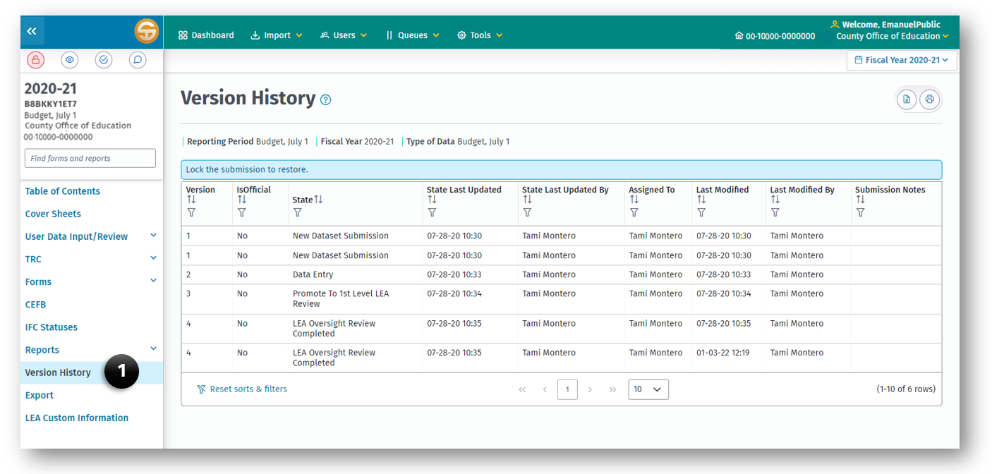
The Submission Version History and Restore feature provides LEA users the ability to view submission version history and the ability to restore prior versions. The version history records a new version when the submission dataset changes states. The version history starts recording with the New Dataset Submission state, when the submission dataset gets promoted to the Data Entry state.

View Version History
Users are able to view the version history in their submissions applicable to their roles and permissions.
An LEA user with the role of Edit Dataset, Dataset Approval, Oversight, or Administration may view history for a submission dataset when it has been promoted past the state New Dataset Submission.

Restore Prior Versions
The system provides an authorized user a method to restore prior versions on the Submission Version History screen.
An LEA user with the Administration role can restore the submission dataset to a previous state, as long as the submission dataset is in an editable state that the user can access and lock.

Exporting Datasets
The Export module allows a user to create two types of export files: Official or Other.
Official — Run an Official export to create data files for submission to the reviewing agency, or to make a copy of your files as a precaution against loss. During the official export process, final validation of the data by automatically running all TRCs is completed.
Other — Run an “Other” export to create a data file to share with someone else, or to make a copy of your files as a precaution against loss. This feature does not run the TRCs and must not be used to submit your data to the CDE.
Note: The files created with either export option are named with the LEA's 14-digit CDS code, "ccdddddsssssss" where "cc" is the 2-digit county code, "ddddd" is the 5-digit district code, and "sssssss" is the 7-digit school code.
When the LEA is not a charter school, the school code will be "0000000." Additionally, the export file names end with "reporting period" identifiers to provide for easy identification of file contents and to help prevent overwriting data files from different periods (i.e., overwriting a budget reporting period file with an unaudited actuals or interim reporting period file), as well as the fiscal year and the file’s unique license plate number.
For example, an export file named "49706150000000_BS1 2026–27_D8A5U87U5FALT" indicates that it contains 2026–27 July 1 Budget data for 49-70615-0000000, Bellevue Union Elementary School District. (See the following chart for reporting period identifiers.)
"Reporting Period" Identifiers Used in  Export File Names | Reporting Period From Which the  Export File Was Created
BS1 | July 1 Budget
A | Unaudited Actuals
I1 | First Interim
I2 | Second Interim
I3 | End of Year Projection
Export files (both Official and Other) contain all general ledger and supplemental data for the reporting period, for the LEA(s) selected.

Submission Data Export Screen
The Export feature system allows a user to export the active SACS submission dataset as Official (if the TRCs passed) or Other export data file.

Exporting Data—Official
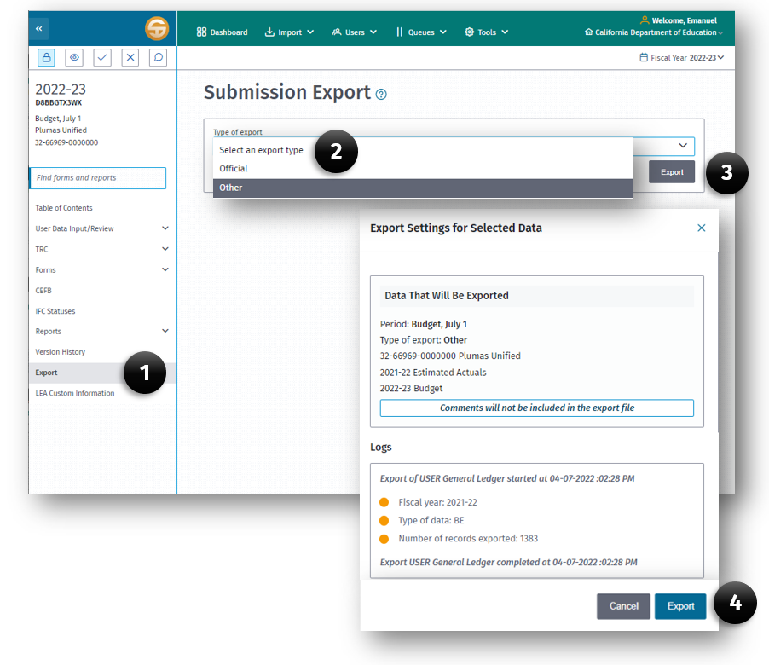
To perform an Official export:
- Click the Export link on the left Navigation pane.
- Select Official (if a TRC has run and passed) or Other in the Type of Export field.
- Click the Export button.
- Click Export on the information dialog box which illustrates what will be exported.
During the Official export process, the SACS Web System runs the TRC for the applicable data types to ensure the data is ready for an Official export. (See the table below for the data types applicable to each reporting period's official export.) If the TRCs fail, the export process aborts, and the Export Log displays the names of the exceptions for each applicable data type that prevents the official export from occurring. The user is directed to the TRC Explanations screen to review outstanding failed checks. All outstanding exceptions must be corrected or explained before an Official export can occur.
When Officially Exporting Data  From This Reporting Period | These Types of Data  Must Pass the TRC
July 1 Budget | Budget and Estimated Actuals
Unaudited Actuals | Unaudited Actuals*
First/Second Interims/End of Year Projection | Original Budget* and Projected Year Totals*

*Although budget data during unaudited actuals period, and board approved budget and actuals to date data during the interim periods, are not checked for Official export, CDE strongly recommend all fatal exceptions are corrected and warning exceptions are corrected or explained for these types of data.

Exporting Data—Other
To perform an Other export:
- Click the Export link on the left Navigation pane.
- Select Other in the Type of Export field.
- Click the Export button.
- Click Export on the information dialog box which illustrates what will be exported.
After the data is exported, the exported .dat file may be used to import the data by following the "Import—Other" directions in the Importing Data section of this user guide.

LEA Custom Information
This feature allows the user to display the LEA Custom Information supplied by their financial system extract file and brought into the LEA element table within the SACS Web System during the Import process. The LEA Custom Information screen provides information regarding conditions in the financial data import source.
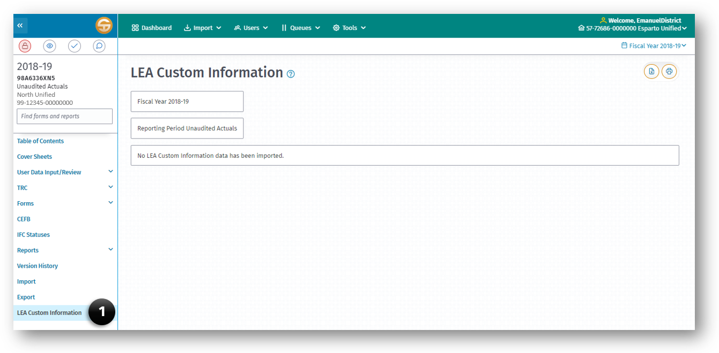
The following is an example of imported information:
- Fiscal Year and Data Type
- Data Discrepancy Errors
- Reporting Period Budget
- Data Source Actuals

Attachments
Attachment A—Forms and Reports in the SACS Web System
Attachment B—SACS Import Module Specifications
Attachment C—SACS Supplemental (Named Elements) Specifications
Attachment D—LEA Custom Info (Named Elements) Import Specifications
Attachment E—Form Dependencies

Attachment A—Forms and Reports in the SACS Web System
The Attachment A tables identify which forms, either fund, report, or supplemental, use data that is extracted directly from user imported general ledger data and/or hand keyed into the form. Each of the four tables (district, COE, JPA, and charter) identifies only applicable forms for each LEA type, and also informs the user as to which forms are optional or required for a specific reporting period, Budget, Unaudited Actual or Interim.
The following key is used within each table:
- G – General Ledger Data
- P – Preloaded Data from Prior Year
- S – Supplemental Data
- R – Required
- R* – Required, if Applicable
- O – Optional
- O* – Optional SACS Format; Required Data
- O** – Optional SACS Format; Required, if Applicable
- n/a – Not Available/Applicable

District Reporting
Funds & Forms | Description | Extracted | Keyed | Budget | Unaudited Actuals | Interim
CEFB | Components of Ending Fund Balance/Net Position | GS | GS | O | O | O
01 | General Fund/County School Service Fund | GS | n/a | R | R | n/a
01I | General Fund/County School Service Fund | GS | n/a | n/a | n/a | R
08 | Student Activity Special Revenue Fund | GS | n/a | R* | R* | n/a
08I | Student Activity Special Revenue Fund | GS | n/a | n/a | n/a | R*
09 | Charter Schools Special Revenue Fund | GS | n/a | R* | R* | n/a
09I | Charter Schools Special Revenue Fund | GS | n/a | n/a | n/a | R*
10 | Special Education Pass-Through Fund | GS | n/a | R* | R* | n/a
10I | Special Education Pass-Through Fund | GS | n/a | n/a | n/a | R*
11 | Adult Education Fund | GS | n/a | R* | R* | n/a
11I | Adult Education Fund | GS | n/a | n/a | n/a | R*
12 | Child Development Fund | GS | n/a | R* | R* | n/a
12I | Child Development Fund | GS | n/a | n/a | n/a | R*
13 | Cafeteria Special Revenue Fund | GS | n/a | R* | R* | n/a
13I | Cafeteria Special Revenue Fund | GS | n/a | n/a | n/a | R*
14 | Deferred Maintenance Fund | GS | n/a | R* | R* | n/a
14I | Deferred Maintenance Fund | GS | n/a | n/a | n/a | R*
15 | Pupil Transportation Equipment Fund | GS | n/a | R* | R* | n/a
15I | Pupil Transportation Equipment Fund | GS | n/a | n/a | n/a | R*
17 | Special Reserve Fund for Other Than Capital Outlay Projects | GS | n/a | R* | R* | n/a
17I | Special Reserve Fund for Other Than Capital Outlay Projects | GS | n/a | n/a | n/a | R*
18 | School Bus Emissions Reduction Fund | GS | n/a | R* | R* | n/a
18I | School Bus Emissions Reduction Fund | GS | n/a | n/a | n/a | R*
19 | Foundation Special Revenue Fund | GS | n/a | R* | R* | n/a
19I | Foundation Special Revenue Fund | GS | n/a | n/a | n/a | R*
20 | Special Reserve Fund for Postemployment Benefits | GS | n/a | R* | R* | n/a
20I | Special Reserve Fund for Postemployment Benefits | GS | n/a | n/a | n/a | R*
21 | Building Fund | GS | n/a | R* | R* | n/a
21I | Building Fund | GS | n/a | n/a | n/a | R*
25 | Capital Facilities Fund | GS | n/a | R* | R* | n/a
25I | Capital Facilities Fund | GS | n/a | n/a | n/a | R*
30 | State School Building Lease-Purchase Fund | GS | n/a | R* | R* | n/a
30I | State School Building Lease-Purchase Fund | GS | n/a | n/a | n/a | R*
35 | County School Facilities Fund | GS | n/a | R* | R* | n/a
35I | County School Facilities Fund | GS | n/a | n/a | n/a | R*
40 | Special Reserve Fund for Capital Outlay Projects | GS | n/a | R* | R* | n/a
40I | Special Reserve Fund for Capital Outlay Projects | GS | n/a | n/a | n/a | R*
49 | Capital Project Fund for Blended Component Units | GS | n/a | R* | R* | n/a
49I | Capital Project Fund for Blended Component Units | GS | n/a | n/a | n/a | R*
51 | Bond Interest and Redemption Fund | G | n/a | R* | R* | n/a
51I | Bond Interest and Redemption Fund | G | n/a | n/a | n/a | R*
52 | Debt Service Fund for Blended Component Units | G | n/a | R* | R* | n/a
52I | Debt Service Fund for Blended Component Units | G | n/a | n/a | n/a | R*
53 | Tax Override Fund | G | n/a | R* | R* | n/a
53I | Tax Override Fund | G | n/a | n/a | n/a | R*
56 | Debt Service Fund | G | n/a | R* | R* | n/a
56I | Debt Service Fund | G | n/a | n/a | n/a | R*
57 | Foundation Permanent Fund | GS | n/a | R* | R* | n/a
57I | Foundation Permanent Fund | GS | n/a | n/a | n/a | R*
61 | Cafeteria Enterprise Fund | GS | n/a | R* | R* | n/a
61I | Cafeteria Enterprise Fund | GS | n/a | n/a | n/a | R*
62 | Charter Schools Enterprise Fund | GS | n/a | R* | R* | n/a
62I | Charter Schools Enterprise Fund | GS | n/a | n/a | n/a | R*
63 | Other Enterprise Fund | GS | n/a | R* | R* | n/a
63I | Other Enterprise Fund | GS | n/a | n/a | n/a | R*
66 | Warehouse Revolving Fund | G | n/a | R* | R* | n/a
66I | Warehouse Revolving Fund | G | n/a | n/a | n/a | R*
67 | Self-Insurance Fund | GS | n/a | R* | R* | n/a
67I | Self-Insurance Fund | GS | n/a | n/a | n/a | R*
71 | Retiree Benefit Fund | GS | n/a | R* | R* | n/a
71I | Retiree Benefit Fund | GS | n/a | n/a | n/a | R*
73 | Foundation Private-Purpose Trust Fund | GS | n/a | R* | R* | n/a
73I | Foundation Private-Purpose Trust Fund | GS | n/a | n/a | n/a | R*
76 | Warrant/Pass-Through Fund | GS | n/a | R* | R* | n/a
76I | Warrant/Pass-Through Fund | GS | n/a | n/a | n/a | R*
95 | Student Body Fund | GS | n/a | R* | R* | n/a
95I | Student Body Fund | GS | n/a | n/a | n/a | R*
01CS | Criteria and Standards Review | GPS | S | R | n/a | n/a
01CSI | Criteria and Standards Review (Form 01CSI and Form CI are not applicable for End of Year Projections) | GPS | S | n/a | n/a | R
A | Average Daily Attendance | n/a | S | R | R | n/a
AI | Average Daily Attendance | n/a | S | n/a | n/a | R
ASSET | Schedule of Capital Assets | P | S | O | R* | n/a
CA | Unaudited Actuals Certification | S | S | n/a | R | n/a
CASH | Cashflow Worksheet | n/a | S | O* | n/a | O*
CAT | Schedule for Categoricals | n/a | S | n/a | O | n/a
CB | Budget Certification | S | S | R | n/a | n/a
CC | Workers' Compensation Certification | n/a | S | R | n/a | n/a
CEA | Current Expense Formula/Minimum Classroom Compensation – Actuals | G | S | O | R | n/a
CEB | Current Expense Formula/Minimum Classroom Compensation – Budget | G | S | O | n/a | n/a
CI | Interim Certification (Form 01CSI and Form CI are not applicable for End of Year Projections) | S | S | n/a | n/a | R
DEBT | Schedule of Long-Term Liabilities | P | S | O | R* | n/a
ESMOE | Every Student Succeeds Act Maintenance of Effort | GPS | S | O | R* | O
GANN | Appropriations Limit Calculations | GPS | S | n/a | R | n/a
ICR | Indirect Cost Rate Worksheet | GP | S | O | R | O
L | Lottery Report | GP | S | O | R* | n/a
MYP | Multiyear Projections – General Fund | GS | S | O* | n/a | n/a
MYPI | Multiyear Projections – General Fund | GS | S | n/a | n/a | O*
MYPIO | Multiyear Projections – Other Funds | G | S | n/a | n/a | O**
PCR | Program Cost Report | G | n/a | n/a | R | n/a
PCRAF | Program Cost Report – Allocation Factors | G | S | n/a | R* | n/a
SEA | Special Education Revenue Allocations | P | S | O | O | n/a
SEAS | Special Education Revenue Allocations Setup | P | S | O | O | O
SIAA | Summary of Interfund Activities – Actuals | G | n/a | O | O | n/a
SIAB | Summary of Interfund Activities – Budget | G | n/a | O | n/a | n/a
SIAI | Summary of Interfund Activities – Projected Year Totals | G | n/a | n/a | n/a | O
TC | Table of Contents | n/a | n/a | O | O | n/a
TCI | Table of Contents | n/a | n/a | n/a | n/a | O
PGM | Program by Resource | G | S | O | O | O
CNVRT | Government-wide Conversion | GS | S | n/a | O | n/a
DTERM | Determination of Major Funds | G | n/a | n/a | O | n/a
ENTRY | Conversion Entries | G | S | n/a | O | n/a
GSA | Government-wide Statement of Activities and Reconciliation of Fund Statements | GS | n/a | n/a | O | n/a
GSNP | Government-wide Statement of Net Position and Reconciliation of Fund Statements | GS | S | n/a | O | n/a
SEMA | Actual vs. Actual MOE Calculation | GS | S | n/a | O | n/a
SEMAI | Actual vs. Actual MOE Calculation | GS | S | n/a | n/a | O
SEMB | Budget vs. Actual MOE Calculation | GS | S | n/a | O | n/a

County Reporting
Funds & Forms | Description | Extracted | Keyed | Budget | Unaudited Actuals | Interim
CEFB | Components of Ending Fund Balance/Net Position | GS | GS | O | O | O
01 | General Fund/County School Service Fund | GS | n/a | R | R | n/a
01I | General Fund/County School Service Fund | GS | n/a | n/a | n/a | R
08 | Student Activity Special Revenue Fund | GS | n/a | R* | R* | n/a
08I | Student Activity Special Revenue Fund | GS | n/a | n/a | n/a | R*
09 | Charter Schools Special Revenue Fund | GS | n/a | R* | R* | n/a
09I | Charter Schools Special Revenue Fund | GS | n/a | n/a | n/a | R*
10 | Special Education Pass-Through Fund | GS | n/a | R* | R* | n/a
10I | Special Education Pass-Through Fund | GS | n/a | n/a | n/a | R*
11 | Adult Education Fund | GS | n/a | R* | R* | n/a
11I | Adult Education Fund | GS | n/a | n/a | n/a | R*
12 | Child Development Fund | GS | n/a | R* | R* | n/a
12I | Child Development Fund | GS | n/a | n/a | n/a | R*
13 | Cafeteria Special Revenue Fund | GS | n/a | R* | R* | n/a
13I | Cafeteria Special Revenue Fund | GS | n/a | n/a | n/a | R*
14 | Deferred Maintenance Fund | GS | n/a | R* | R* | n/a
14I | Deferred Maintenance Fund | GS | n/a | n/a | n/a | R*
15 | Pupil Transportation Equipment Fund | GS | n/a | R* | R* | n/a
15I | Pupil Transportation Equipment Fund | GS | n/a | n/a | n/a | R*
16 | Forest Reserve Fund | GS | n/a | R* | R* | n/a
16I | Forest Reserve Fund | GS | n/a | n/a | n/a | R*
17 | Special Reserve Fund for Other Than Capital Outlay Projects | GS | n/a | R* | R* | n/a
17I | Special Reserve Fund for Other Than Capital Outlay Projects | GS | n/a | n/a | n/a | R*
18 | School Bus Emissions Reduction Fund | GS | n/a | R* | R* | n/a
18I | School Bus Emissions Reduction Fund | GS | n/a | n/a | n/a | R*
19 | Foundation Special Revenue Fund | GS | n/a | R* | R* | n/a
19I | Foundation Special Revenue Fund | GS | n/a | n/a | n/a | R*
20 | Special Reserve Fund for Postemployment Benefits | GS | n/a | R* | R* | n/a
20I | Special Reserve Fund for Postemployment Benefits | GS | n/a | n/a | n/a | R*
21 | Building Fund | GS | n/a | R* | R* | n/a
21I | Building Fund | GS | n/a | n/a | n/a | R*
25 | Capital Facilities Fund | GS | n/a | R* | R* | n/a
25I | Capital Facilities Fund | GS | n/a | n/a | n/a | R*
30 | State School Building Lease-Purchase Fund | GS | n/a | R* | R* | n/a
30I | State School Building Lease-Purchase Fund | GS | n/a | n/a | n/a | R*
35 | County School Facilities Fund | GS | n/a | R* | R* | n/a
35I | County School Facilities Fund | GS | n/a | n/a | n/a | R*
40 | Special Reserve Fund for Capital Outlay Projects | GS | n/a | R* | R* | n/a
40I | Special Reserve Fund for Capital Outlay Projects | GS | n/a | n/a | n/a | R*
53 | Tax Override Fund | G | n/a | R* | R* | n/a
53I | Tax Override Fund | G | n/a | n/a | n/a | R*
56 | Debt Service Fund | G | n/a | R* | R* | n/a
56I | Debt Service Fund | G | n/a | n/a | n/a | R*
57 | Foundation Permanent Fund | GS | n/a | R* | R* | n/a
57I | Foundation Permanent Fund | GS | n/a | n/a | n/a | R*
61 | Cafeteria Enterprise Fund | GS | n/a | R* | R* | n/a
61I | Cafeteria Enterprise Fund | GS | n/a | n/a | n/a | R*
62 | Charter Schools Enterprise Fund | GS | n/a | R* | R* | n/a
62I | Charter Schools Enterprise Fund | GS | n/a | n/a | n/a | R*
63 | Other Enterprise Fund | GS | n/a | R* | R* | n/a
63I | Other Enterprise Fund | GS | n/a | n/a | n/a | R*
66 | Warehouse Revolving Fund | G | n/a | R* | R* | n/a
66I | Warehouse Revolving Fund | G | n/a | n/a | n/a | R*
67 | Self-Insurance Fund | GS | n/a | R* | R* | n/a
67I | Self-Insurance Fund | GS | n/a | n/a | n/a | R*
71 | Retiree Benefit Fund | GS | n/a | R* | R* | n/a
71I | Retiree Benefit Fund | GS | n/a | n/a | n/a | R*
73 | Foundation Private-Purpose Trust Fund | GS | n/a | R* | R* | n/a
73I | Foundation Private-Purpose Trust Fund | GS | n/a | n/a | n/a | R*
76 | Warrant/Pass-Through Fund | GS | n/a | R* | R* | n/a
76I | Warrant/Pass-Through Fund | GS | n/a | n/a | n/a | R*
95 | Student Body Fund | GS | n/a | R* | R* | n/a
95I | Student Body Fund | GS | n/a | n/a | n/a | R*
01CS | Criteria and Standards Review | GPS | S | R | n/a | n/a
01CSI | Criteria and Standards Review (Form 01CSI and Form CI are not applicable for End of Year Projections) | GPS | S | n/a | n/a | R
A | Average Daily Attendance | n/a | S | R | R | n/a
AI | Average Daily Attendance | n/a | S | n/a | n/a | R
ASSET | Schedule of Capital Assets | P | S | O | R* | n/a
CA | Unaudited Actuals Certification | S | S | n/a | R | n/a
CASH | Cashflow Worksheet | n/a | S | O* | n/a | O*
CAT | Schedule for Categoricals | n/a | S | n/a | O | n/a
CB | Budget Certification | S | S | R | n/a | n/a
CC | Workers' Compensation Certification | n/a | S | R | n/a | n/a
CI | Interim Certification (Form 01CSI and Form CI are not applicable for End of Year Projections) | S | S | n/a | n/a | R
DEBT | Schedule of Long-Term Liabilities | P | S | O | R* | n/a
ESMOE | Every Student Succeeds Act Maintenance of Effort | GPS | S | O | R* | O
GANN | Appropriations Limit Calculations | GPS | S | n/a | R | n/a
ICR | Indirect Cost Rate Worksheet | GP | S | O | R | O
L | Lottery Report | GP | S | O | R* | n/a
MYP | Multiyear Projections – General Fund | GS | S | O* | n/a | n/a
MYPI | Multiyear Projections – General Fund | GS | S | n/a | n/a | O*
MYPIO | Multiyear Projections – Other Funds | G | S | n/a | n/a | O**
PCR | Program Cost Report | G | n/a | n/a | R | n/a
PCRAF | Program Cost Report – Allocation Factors | G | S | n/a | R* | n/a
SEA | Special Education Revenue Allocations | P | S | O | O | n/a
SEAS | Special Education Revenue Allocations Setup | P | S | O | O | O
SIAA | Summary of Interfund Activities – Actuals | G | n/a | O | O | n/a
SIAB | Summary of Interfund Activities – Budget | G | n/a | O | n/a | n/a
SIAI | Summary of Interfund Activities – Projected Year Totals | G | n/a | n/a | n/a | O
TC | Table of Contents | n/a | n/a | O | O | n/a
TCI | Table of Contents | n/a | n/a | n/a | n/a | O
PGM | Program by Resource | G | S | O | O | O
CNVRT | Government-wide Conversion | GS | S | n/a | O | n/a
DTERM | Determination of Major Funds | G | n/a | n/a | O | n/a
ENTRY | Conversion Entries | G | S | n/a | O | n/a
GSA | Government-wide Statement of Activities and Reconciliation of Fund Statements | GS | n/a | n/a | O | n/a
GSNP | Government-wide Statement of Net Position and Reconciliation of Fund Statements | GS | S | n/a | O | n/a
SEMA | Actual vs. Actual MOE Calculation | GS | S | n/a | O | n/a
SEMAI | Actual vs. Actual MOE Calculation | GS | S | n/a | n/a | O
SEMB | Budget vs. Actual MOE Calculation | GS | S | n/a | O | n/a

JPA Reporting
Funds & Forms | Description | Extracted | Keyed | Budget | Unaudited Actuals | Interim
CEFB | Components of Ending Fund Balance/Net Position | GS | GS | O | O | O
01 | General Fund/County School Service Fund | GS | n/a | R | R | n/a
01I | General Fund/County School Service Fund | GS | n/a | n/a | n/a | R
08 | Student Activity Special Revenue Fund | GS | n/a | R* | R* | n/a
08I | Student Activity Special Revenue Fund | GS | n/a | n/a | n/a | R*
10 | Special Education Pass-Through Fund | GS | n/a | R* | R* | n/a
10I | Special Education Pass-Through Fund | GS | n/a | n/a | n/a | R*
11 | Adult Education Fund | GS | n/a | R* | R* | n/a
11I | Adult Education Fund | GS | n/a | n/a | n/a | R*
12 | Child Development Fund | GS | n/a | R* | R* | n/a
12I | Child Development Fund | GS | n/a | n/a | n/a | O
13 | Cafeteria Special Revenue Fund | GS | n/a | R* | R* | n/a
13I | Cafeteria Special Revenue Fund | GS | n/a | n/a | n/a | R*
14 | Deferred Maintenance Fund | GS | n/a | R* | R* | n/a
14I | Deferred Maintenance Fund | GS | n/a | n/a | n/a | R*
15 | Pupil Transportation Equipment Fund | GS | n/a | R* | R* | n/a
15I | Pupil Transportation Equipment Fund | GS | n/a | n/a | n/a | R*
17 | Special Reserve Fund for Other Than Capital Outlay Projects | GS | n/a | R* | R* | n/a
17I | Special Reserve Fund for Other Than Capital Outlay Projects | GS | n/a | n/a | n/a | R*
18 | School Bus Emissions Reduction Fund | GS | n/a | R* | R* | n/a
18I | School Bus Emissions Reduction Fund | GS | n/a | n/a | n/a | R*
20 | Special Reserve Fund for Postemployment Benefits | GS | n/a | R* | R* | n/a
20I | Special Reserve Fund for Postemployment Benefits | GS | n/a | n/a | n/a | R*
21 | Building Fund | GS | n/a | R* | R* | n/a
21I | Building Fund | GS | n/a | n/a | n/a | R*
35 | County School Facilities Fund | GS | n/a | R* | R* | n/a
35I | County School Facilities Fund | GS | n/a | n/a | n/a | R*
40 | Special Reserve Fund for Capital Outlay Projects | GS | n/a | R* | R* | n/a
40I | Special Reserve Fund for Capital Outlay Projects | GS | n/a | n/a | n/a | R*
61 | Cafeteria Enterprise Fund | GS | n/a | R* | R* | n/a
61I | Cafeteria Enterprise Fund | GS | n/a | n/a | n/a | R*
67 | Self-Insurance Fund | GS | n/a | R* | R* | n/a
67I | Self-Insurance Fund | GS | n/a | n/a | n/a | R*
71 | Retiree Benefit Fund | GS | n/a | R* | R* | n/a
71I | Retiree Benefit Fund | GS | n/a | n/a | n/a | R*
76 | Warrant/Pass-Through Fund | GS | n/a | R* | R* | n/a
76I | Warrant/Pass-Through Fund | GS | n/a | n/a | n/a | R*
95 | Student Body Fund | GS | n/a | R* | R* | n/a
95I | Student Body Fund | GS | n/a | n/a | n/a | R*
01CS | Criteria and Standards Review | GPS | S | R | n/a | n/a
01CSI | Criteria and Standards Review (Form 01CSI and Form CI are not applicable for End of Year Projections) | GPS | S | n/a | n/a | R
ASSET | Schedule of Capital Assets | P | S | O | R* | n/a
CA | Unaudited Actuals Certification | S | S | n/a | R | n/a
CASH | Cashflow Worksheet | n/a | S | O* | n/a | O*
CAT | Schedule for Categoricals | n/a | S | n/a | O | n/a
CB | Budget Certification | S | S | R | n/a | n/a
CC | Workers' Compensation Certification | n/a | S | R | n/a | n/a
CI | Interim Certification (Form 01CSI and Form CI are not applicable for End of Year Projections) | S | S | n/a | n/a | R
DEBT | Schedule of Long-Term Liabilities | P | S | O | R* | n/a
ICR | Indirect Cost Rate Worksheet | GP | S | O | O | O
MYP | Multiyear Projections – General Fund | GS | S | O* | n/a | n/a
MYPI | Multiyear Projections – General Fund | GS | S | n/a | n/a | O*
MYPIO | Multiyear Projections – Other Funds | G | S | n/a | n/a | O**
PCR | Program Cost Report | G | n/a | n/a | R | n/a
PCRAF | Program Cost Report – Allocation Factors | G | S | n/a | R* | n/a
SEA | Special Education Revenue Allocations | P | S | O | O | n/a
SEAS | Special Education Revenue Allocations Setup | P | S | O | O | O
SIAA | Summary of Interfund Activities – Actuals | G | n/a | O | O | n/a
SIAB | Summary of Interfund Activities – Budget | G | n/a | O | n/a | n/a
SIAI | Summary of Interfund Activities – Projected Year Totals | G | n/a | n/a | n/a | O
TC | Table of Contents | n/a | n/a | O | O | n/a
TCI | Table of Contents | n/a | n/a | n/a | n/a | O
PGM | Program by Resource | G | S | O | O | O
CNVRT | Government-wide Conversion | GS | S | n/a | O | n/a
DTERM | Determination of Major Funds | G | n/a | n/a | O | n/a
ENTRY | Conversion Entries | G | S | n/a | O | n/a
GSA | Government-wide Statement of Activities and Reconciliation of Fund Statements | GS | n/a | n/a | O | n/a
GSNP | Government-wide Statement of Net Position and Reconciliation of Fund Statements | GS | S | n/a | O | n/a
SEMA | Actual vs. Actual MOE Calculation | GS | S | n/a | O | n/a
SEMAI | Actual vs. Actual MOE Calculation | GS | S | n/a | n/a | O
SEMB | Budget vs. Actual MOE Calculation | GS | S | n/a | O | n/a

County Charter/District Charter School Reporting
Funds & Forms | Description | Extracted | Keyed | Budget | Unaudited Actuals | Interim
CEFB | Components of Ending Fund Balance/Net Position | GS | GS | O | O | O
01 | General Fund/County School Service Fund | GS | n/a | O | R* | n/a
01I | General Fund/County School Service Fund | GS | n/a | n/a | n/a | O
08 | Student Activity Special Revenue Fund | GS | n/a | O | R* | n/a
08I | Student Activity Special Revenue Fund | GS | n/a | n/a | n/a | O
11 | Adult Education Fund | GS | n/a | O | R* | n/a
11I | Adult Education Fund | GS | n/a | n/a | n/a | O
12 | Child Development Fund | GS | n/a | O | R* | n/a
12I | Child Development Fund | GS | n/a | n/a | n/a | O
13 | Cafeteria Special Revenue Fund | GS | n/a | O | R* | n/a
13I | Cafeteria Special Revenue Fund | GS | n/a | n/a | n/a | O
14 | Deferred Maintenance Fund | GS | n/a | O | R* | n/a
14I | Deferred Maintenance Fund | GS | n/a | n/a | n/a | O
15 | Pupil Transportation Equipment Fund | GS | n/a | O | R* | n/a
15I | Pupil Transportation Equipment Fund | GS | n/a | n/a | n/a | O
17 | Special Reserve Fund for Other Than Capital Outlay Projects | GS | n/a | O | R* | n/a
17I | Special Reserve Fund for Other Than Capital Outlay Projects | GS | n/a | n/a | n/a | O
18 | School Bus Emissions Reduction Fund | GS | n/a | O | R* | n/a
18I | School Bus Emissions Reduction Fund | GS | n/a | n/a | n/a | O
19 | Foundation Special Revenue Fund | GS | n/a | O | R* | n/a
19I | Foundation Special Revenue Fund | GS | n/a | n/a | n/a | O
20 | Special Reserve Fund for Postemployment Benefits | GS | n/a | O | R* | n/a
20I | Special Reserve Fund for Postemployment Benefits | GS | n/a | n/a | n/a | O
21 | Building Fund | GS | n/a | O | R* | n/a
21I | Building Fund | GS | n/a | n/a | n/a | O
25 | Capital Facilities Fund | GS | n/a | O | R* | n/a
25I | Capital Facilities Fund | GS | n/a | n/a | n/a | O
30 | State School Building Lease-Purchase Fund | GS | n/a | O | R* | n/a
30I | State School Building Lease-Purchase Fund | GS | n/a | n/a | n/a | O
35 | County School Facilities Fund | GS | n/a | O | R* | n/a
35I | County School Facilities Fund | GS | n/a | n/a | n/a | O
40 | Special Reserve Fund for Capital Outlay Projects | GS | n/a | O | R* | n/a
40I | Special Reserve Fund for Capital Outlay Projects | GS | n/a | n/a | n/a | O
49 | Capital Project Fund for Blended Component Units | GS | n/a | O | R* | n/a
49I | Capital Project Fund for Blended Component Units | GS | n/a | n/a | n/a | O
51 | Bond Interest and Redemption Fund | G | n/a | O | R* | n/a
51I | Bond Interest and Redemption Fund | G | n/a | n/a | n/a | O
52 | Debt Service Fund for Blended Component Units | G | n/a | O | R* | n/a
52I | Debt Service Fund for Blended Component Units | G | n/a | n/a | n/a | O
53 | Tax Override Fund | G | n/a | O | R* | n/a
53I | Tax Override Fund | G | n/a | n/a | n/a | O
56 | Debt Service Fund | G | n/a | O | R* | n/a
56I | Debt Service Fund | G | n/a | n/a | n/a | O
57 | Foundation Permanent Fund | GS | n/a | O | R* | n/a
57I | Foundation Permanent Fund | GS | n/a | n/a | n/a | O
61 | Cafeteria Enterprise Fund | GS | n/a | O | R* | n/a
61I | Cafeteria Enterprise Fund | GS | n/a | n/a | n/a | O
62 | Charter Schools Enterprise Fund | GS | n/a | O | R* | n/a
62I | Charter Schools Enterprise Fund | GS | n/a | n/a | n/a | O
63 | Other Enterprise Fund | GS | n/a | O | R* | n/a
63I | Other Enterprise Fund | GS | n/a | n/a | n/a | O
66 | Warehouse Revolving Fund | G | n/a | O | R* | n/a
66I | Warehouse Revolving Fund | G | n/a | n/a | n/a | O
67 | Self-Insurance Fund | GS | n/a | O | R* | n/a
67I | Self-Insurance Fund | GS | n/a | n/a | n/a | O
71 | Retiree Benefit Fund | GS | n/a | O | R* | n/a
71I | Retiree Benefit Fund | GS | n/a | n/a | n/a | O
73 | Foundation Private-Purpose Trust Fund | GS | n/a | O | R* | n/a
73I | Foundation Private-Purpose Trust Fund | GS | n/a | n/a | n/a | O
76 | Warrant/Pass-Through Fund | GS | n/a | O | R* | n/a
76I | Warrant/Pass-Through Fund | GS | n/a | n/a | n/a | O
95 | Student Body Fund | GS | n/a | O | R* | n/a
95I | Student Body Fund | GS | n/a | n/a | n/a | O
A | Average Daily Attendance | n/a | S | O | O | n/a
AI | Average Daily Attendance | n/a | S | n/a | n/a | O
ASSET | Schedule of Capital Assets | P | S | O | R* | n/a
CA | Unaudited Actuals Certification | S | S | n/a | R | n/a
CASH | Cashflow Worksheet | n/a | S | O* | n/a | O
CAT | Schedule for Categoricals | n/a | S | n/a | O | n/a
CB | Budget Certification | S | S | O | n/a | n/a
CI | Interim Certification | S | S | n/a | n/a | O
DEBT | Schedule of Long-Term Liabilities | P | S | O | R* | n/a
ESMOE | Every Student Succeeds Act Maintenance of Effort | GPS | S | O | R* | O
ICR | Indirect Cost Rate Worksheet | GP | S | O | R | O
L | Lottery Report | GP | S | O | R* | n/a
PCR | Program Cost Report | G | n/a | n/a | R | n/a
PCRAF | Program Cost Report – Allocation Factors | G | S | n/a | R* | n/a
SEAS | Special Education Revenue Allocations Setup | P | S | O | O | O
SIAA | Summary of Interfund Activities – Actuals | G | n/a | O | O | n/a
SIAB | Summary of Interfund Activities – Budget | G | n/a | O | n/a | n/a
SIAI | Summary of Interfund Activities – Projected Year Totals | G | n/a | n/a | n/a | O
TC | Table of Contents | n/a | n/a | O | O | n/a
TCI | Table of Contents | n/a | n/a | n/a | n/a | O
PGM | Program by Resource | G | S | O | O | O
CNVRT | Government-wide Conversion | GS | S | n/a | O | n/a
DTERM | Determination of Major Funds | G | n/a | n/a | O | n/a
ENTRY | Conversion Entries | G | S | n/a | O | n/a
GSA | Government-wide Statement of Activities and Reconciliation of Fund Statements | GS | n/a | n/a | O | n/a
GSNP | Government-wide Statement of Net Position and Reconciliation of Fund Statements | GS | S | n/a | O | n/a
SEMA | Actual vs. Actual MOE Calculation | GS | S | n/a | O | n/a
SEMAI | Actual vs. Actual MOE Calculation | GS | S | n/a | n/a | O
SEMB | Budget vs. Actual MOE Calculation | GS | S | n/a | O | n/a

Attachment B—SACS Import Module Specifications
The purpose of the Import module is to take user data in an electronic format and reformat it so that it may be processed through the SACS Web System which allows LEAs to meet financial reporting obligations using a modernized and efficient manner.
When exporting files from a local LEA Financial System for import into the SACS Web System, the file format is as follows: an ASCII DOS, comma delimited text file (file cannot be binary) with three types of records—a header record, transaction (detail) records, and an end of dataset (EOD) record. No special file name needs to be used; the SACS Web System will accept any correctly formatted file.
The structure of the file will be:
Header1
Detail1
EOD1
Header2
Detail2
EOD2
Headern
Detailn
EODn

Header Record Format
The header record will have this format:
"fiscal year","14-digit CDS code", "reporting period identifier", "column code identifier"
Example: "202X–2X","01100170000000","BS1","BE"
Note: The 14-digit CDS code is a unique code assigned to each LEA by the CDE. When the county-district 7-digit code is used by an LEA, the SACS Web System import routine automatically appends the CDS code with 7 zeros to complete the 14-digit code.
The reporting period identifier corresponds to the following financial reporting periods:
BS1 – Budget, July 1
A – Unaudited actuals
I1 – First interim
I2 – Second interim
I3 – End of year projection
The column code identifies which type of data the file contains. The column code identifier corresponds to the following types of financial data contained in the file:
BB – Budget
BE – Estimated actuals
BA – Unaudited actuals
IO – Original budget
IB – Board approved operating budget
IA – Actuals to date
IP – Projected totals
This table shows the allowable combinations for reporting period and column code identifiers.
Reporting Period Identifiers | Column Code  Identifiers
BS1 | BB; BE
A | BB; BA
I1 | IO; IB; IA; IP
I2 | IO; IB; IA; IP
I3 | IO; IB; IA; IP

Detail Record Format
The detail records will have this format:
"19-digit SACS code", "amount"
Example: "0133261500184003801","12345"
The 19-digit SACS account code comprises these elements:
Fund 2 characters
Resource 4 characters
Project Year 1 character
Program Goal 4 characters
Function 4 characters
Object 4 characters
Amount up to 15 characters
(Allowable range: -99,999,999,999.99 to +99,999,999,999.99. Plus and minus signs count as one character; periods count as one character; commas are only shown here for ease of reading.)

End-of-Dataset Record Format
The end-of-dataset record has this format:
"-1","EOD","14-digit CDS code”, “reporting period identifier”, “column code identifier", "count of detail records"
Example: "-1","EOD","01100170000000","BS1","BE","5361"

Sample Records
The following shows sample records for the 202Y–2Y budget process (BS1) with 3,567 budget (BB) transaction records and 5,361 estimated actual (BE) transaction records:
"202X–2X","01100170000000","BS1","BE"
"0133261500184003101","9563266"
"0133261500184003801","998"
"0133261500184003802","12345"
"0133261500184004200","47863"
"-1","EOD","01100170000000","BS1","BE","5361"
"202Y–2Y","01100170000000","BS1","BB"
"0133261500184003101","1039586"
"0133261500184003801","10039"
"0133261500184003802","257689"
"0133261500184004200","56987"
"-1","EOD","01100170000000","BS1","BB","3567"

Other Items To Consider When Programming the Extraction Programs
Normal balances must be reported in positive numbers; abnormal balances are reported as negative numbers. EXCEPTION: The accumulated depreciation contra-asset accounts (objects 9425, 9435, and 9445) are debit accounts and require that credit balances be reported as negatives.
The following types of accounts must not be included in the file for import to the SACS Web System:
Budgetary Accounts Objects 9800–9839
Control Accounts Objects 9840–9899
Nonoperating Accounts Objects 9910–9979
Records with zero amounts
For the budget and interim reporting periods, budget data for assets, deferred outflows of resources, liabilities, and deferred inflows of resources (objects 9100–9699) is ignored during import and cannot be input. Although not required, estimated actual data for assets, deferred outflows of resources, liabilities, and deferred inflows out resources is allowed.
For further information please refer to the CSAM. It describes the use of optional and locally defined codes and the requirements for "rolling up" the general ledger data to the level specified by CDE for the purpose of transmitting data.

Attachment C—SACS Supplemental (Named Elements) Specifications
The supplemental data specifications are identical to the general ledger data specifications contained in Attachment B, with the following exceptions:
- The header contains one additional field at the end of the record, which must have the value "ELEMENT."
For example:
"202X–2X","01100170000000","BS1","BE","ELEMENT"
- The first field of a detail record contains a data name instead of a SACS account.
For example:
"A.TOTAL.DISTRICT.ADA.FD","1039586"
Supplemental data may be contained within the same file as the general ledger data.

Attachment D—LEA Custom Info (Named Elements) Import Specifications
The LEA Custom Info screen, accessed in the left Navigation Pane, displays LEA custom information supplied by the extract file and brought into the LEA element table in the SACS Web System during the Import process. This information is for LEA use and is not part of state requirements.
The LEA Custom Info provides information regarding conditions in the financial data import source. The following is an example of information that an LEA may provide in this screen:
Reporting Period Budget
Fiscal Year & Data Type 202X–2X Estimated Actuals
Data Source Actuals From: FCS
Data Discrepancy Error: Fu01 9712 <> 9320
The LEA Custom Info specifications are identical to the general ledger specifications contained in Attachment C, with the following exceptions:
- The header contains one additional field at the end of the record which must have the value "ELEMENT."
For example:
"202X–2X","01100170000000","BS1","BE","ELEMENT"
- The detail record first field contains LEA.
For example:
"LEA.BUDGET STATUS","BLANK"
LEA Custom Info data may be contained in the same file as the general ledger or supplemental data.

Attachment E—Form Dependencies
Many of the forms in the SACS Web System are dependent on data from other forms (supplemental data) and/or funds (general ledger data). The dependent forms must be opened and saved to re-extract the most current data any time relevant general ledger (GL) or supplemental data is changed. When dependent forms are not opened and saved after relevant general ledger or supplemental data are changed, the dependent forms are inaccurate. The technical review checklist identifies such occurrences via the fatal export check CHK-DEPENDENCY. The check does not allow an official export of the data until the dependent forms are opened and saved.
The following tables list all of the dependent forms and the general ledger ("Funds") or supplemental ("Forms") data upon which they are dependent. When funds or forms listed in the "Dependent on" columns are changed, the applicable "Dependent Forms" must be opened and saved. To avoid a cyclical CHK-DEPENDENCY exception, the dependent forms must be opened and saved in the order listed in the "Dependent Forms" column.

Budget Period
Dependent Forms  (save these forms in this order) | Dependent on Forms | Dependent on Funds (GL)
01 | n/a | 01
CASH | n/a | 01, 62
CEA | n/a | 01
CEB | n/a | 01
MYP | 01, A | 10, 17
01CS | 01, A, MYP | All applicable funds
CB | 01CS | n/a

Unaudited Actuals Period
Dependent Forms  (save these forms in this order) | Dependent on Forms |  | Dependent on Funds (GL)
01 | n/a | 01
CEA | n/a | 01
ESMOE | A | 01, 09, 13, 61, 62
GANN | A | 01, 09, 62
ICR | n/a | 01, 08, 09, 11, 12, 13, 19, 57, 61, 62
L | n/a | All funds
PCRAF | n/a | 01, 09, 62
PCR | PCRAF | 01, 09, 11, 12, 13, 19, 57, 61, 62
CA | CEA, GANN, ICR, ESMOE | n/a
SEMA | PCR | 01, 09, 62
SEMB | PCR | 01, 09, 62

Interim Periods
Dependent Forms  (save these forms in this order) | Dependent on Forms | Dependent on Funds (GL)
01I | n/a | 01
CASH | n/a | 01, 62
MYPI | 01I, AI | 10, 17
MYPIO | n/a | All applicable funds except 01
01CSI | 01I, AI, CASH, MYPI | All applicable funds
CI | 01CSI | n/a
SEMAI | n/a | 01, 09, 62

LEAs may use their own cashflow worksheet, with the approval of their reviewing agency, as long as it provides a monthly cashflow projected through the end of the fiscal year.
LEAs may use their own multiyear projection format, with the approval of their reviewing agency, as long as it provides current and at least two subsequent fiscal years; separately projects unrestricted resources, restricted resources, and combined total resources; and shows the percent change between years.
LEAs may use their own cashflow worksheet, with the approval of their reviewing agency, as long as it provides a monthly cashflow projected through the end of the fiscal year.
LEAs may use their own multiyear projection format, with the approval of their reviewing agency, as long as it provides current and two subsequent fiscal years; separately projects unrestricted resources, restricted resources, and combined total resources; and shows the percent change between years.
LEAs may use their own multiyear projection format, with the approval of their reviewing agency, as long as it provides current and two subsequent fiscal years and shows the percent change between years.
LEAs may use their own cashflow worksheet, with the approval of their reviewing agency, as long as it provides a monthly cashflow projected through the end of the fiscal year.
LEAs may use their own multiyear projection format, with the approval of their reviewing agency, as long as it provides current and two subsequent fiscal years and separately projects unrestricted resources, restricted resources, and combined total resources.
LEAs may use their own multiyear projection format, with the approval of their reviewing agency, as long as it provides current and two subsequent fiscal years.
“Administrative involvement” is defined in Governmental Accounting Standards Board Statement 24 and in the California School Accounting Manual, Procedure 750.

