
Fiscal Year 2013-14
Principal Apportionment
Data Collection and Tax Software
Version 13.01

Installation GUIDE

California Department of Education
School Fiscal Services Division
1430 N Street
Sacramento, CA 95814
Prepared: March 24, 2014
Table of Contents
1.0 Introduction 1
1.1 Document Conventions 1
1.2 System Requirements 2
2.0 Software Installation 3
2.1 Downloading and Installing the Software from the Internet 3
2.1.1 Downloading from Internet Explorer 3
2.1.2 Installing the Software 3
2.1.3 Setting Compatibility Mode 9

Table of Figures
Figure 1: InstallShield Wizard Window 4
Figure 2: Windows Installer Window 4
Figure 3: Welcome Window 5
Figure 4: Customer Information Window 5
Figure 5: Destination Folder Program Window 6
Figure 6: Database Folder Program Window 6
Figure 7: Install Program Window 7
Figure 8: Installation Progress Window 7
Figure 9: Installation Completed Successfully Window 8
Figure 10: Principal Apportionment Data Collection Software Shortcut 9
Figure 11: Compatibility Mode Window 9

Introduction
This document is the Installation Guide for the California Department of Education Principal Apportionment Software, and it covers installation of the Data Collection and Tax software packages. Understanding basic Windows functions and procedures, such as clicking, double clicking, right clicking, etc., will assist you in installing and using the software.
This Installation Guide is designed to be common to the Tax Software which can be downloaded separately, and the Principal Apportionment Data Collection Software which includes the Tax Software within it. The steps involved with installing the two separate packages are the same, with the exception of the self-extracting executable download and install. For example, the Data Collection Software begins with padc2013vxxx.exe file, and the Tax Software begins with the tax2013vxxx.exe file.
Note: If you install the Principal Apportionment Data Collection Software package, it is not necessary to separately install the Tax Software package. County offices should install the Principal Apportionment Data Collection Software package. County auditors should install the Tax Software package. School districts and charter schools should install the Principal Apportionment Data Collection Software package to submit attendance-related data to their county office.
For instructions on using the Software, please refer to the Principal Apportionment Data Collection Software User Guide or the Data Reporting Instruction Manual which can be found at http://www.cde.ca.gov/fg/sf/pa/.

Document Conventions
This document uses the following conventions to describe functions and procedures in the software:
Window Names | The names of windows, screens, and dialogue boxes use title case, such as:  Save As window  User Information screen
Commands | Commands are operations you must follow in order to perform certain functions in the software. Bold face font is used, such as:  Select Print from the File menu  Click the OK button
Image Names | Images, or pictures, are described as Figures and use Italic face font, such as:  Figure 1: Diagram of the data process.
Important Notes | Notes include important statements regarding steps you may need to take. They are highlighted in gray, with a black border on the top and bottom, such as:  Note: Important note here

System Requirements
The installation of the Principal Apportionment Software requires approximately 20-40 MB of hard disk space on Windows based PCs.

Software Installation
This section describes software installation in Windows from the Internet.

Downloading and Installing the Software from the Internet
The latest versions of the Software are available on the Internet at http://www.cde.ca.gov/fg/sf/pa.
Note: Depending on the browser used, the downloading instructions may be different than described below.

Downloading from Internet Explorer
- Navigate to http://www.cde.ca.gov/fg/sf/pa.
- Click on the padc2013v1301.exe file.
Note: To download the Data Collection Software click on the appropriate links, then the padc2013v1301.exe file, respectively. The various setup windows and dialog boxes will be specific to the software you are installing.
- A dialog box will display asking if you want to run or save the file.
- If you want to run the file, select Run and the installation process will begin.
- If you want to save the file, select Save to save the file to the default folder or select Save As to save the file to a specific folder. (For example, you might save your file to the Desktop so you may quickly find it.)
Note: Be sure you have closed all other applications.

Installing the Software
- Locate the downloaded file (ex. padc2013v1301.exe) and double-click on it to start the installation process.
- The InstallShield Wizard window displays (Figure 1).
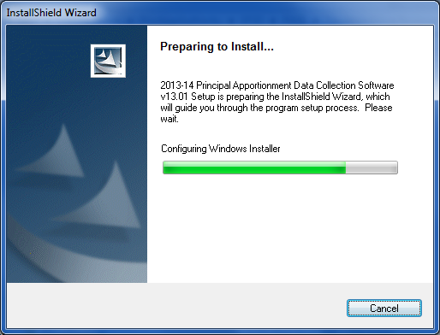
Figure 1: InstallShield Wizard Window
- The Windows Installer window displays (Figure 2).
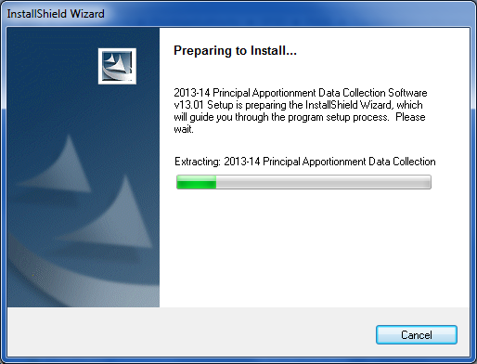
Figure 2: Windows Installer Window
- The Welcome window displays (Figure 3).
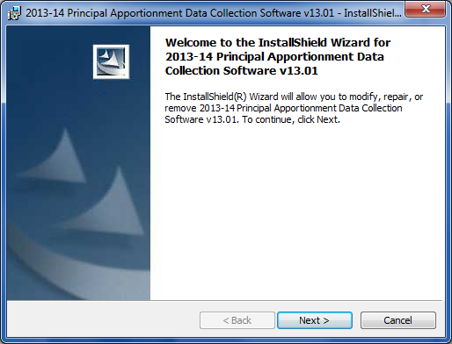
Figure 3: Welcome Window
- Click the Next button. The Customer Information window displays (Figure 4).
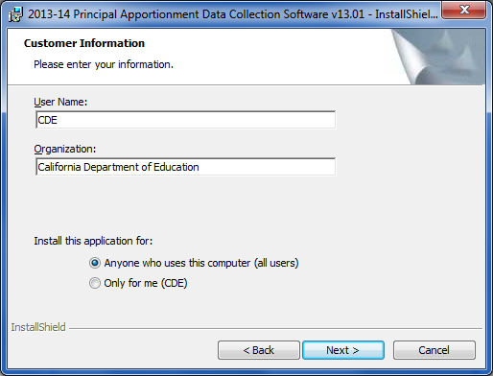
Figure 4: Customer Information Window
- Click the Next button. The Destination Folder Program window displays (Figure 5).
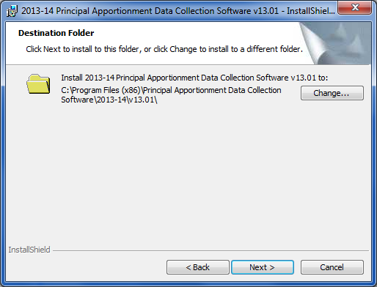
Figure 5: Destination Folder Program Window

- Click the Next button. The Database Folder Program window displays (Figure 6).
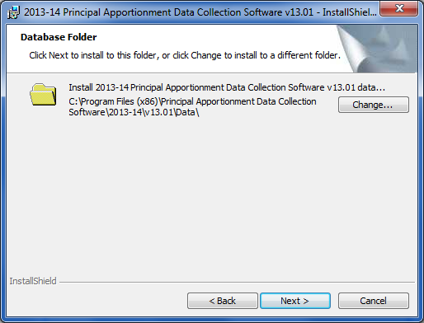
Figure 6: Database Folder Program Window
- Click the Next button. The Ready to Install the Program window displays (Figure 7).
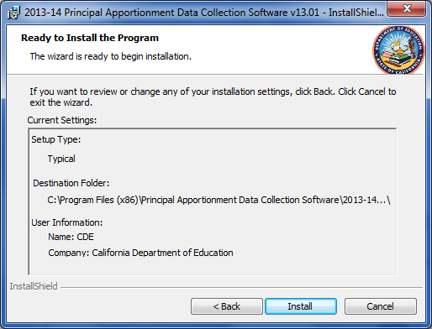
Figure 7: Install Program Window
- Click Install. The progress meter displays the installation status (Figure 8).
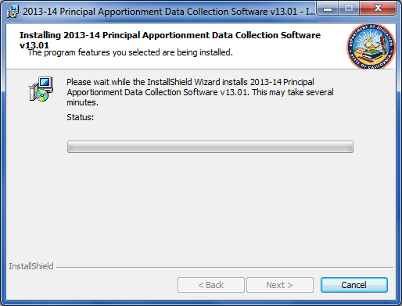
Figure 8: Installation Progress Window

- When the installation is complete, the Installation Completed window displays, and the dialog box shows that the software installed successfully (Figure 9).
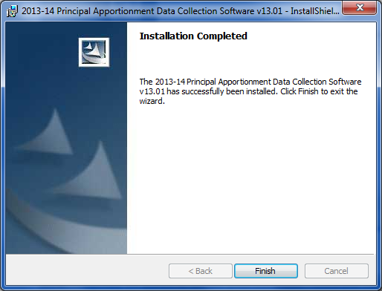
Figure 9: Installation Completed Successfully Window
- Click Finish.
Note: You may be asked to restart your computer. Click the Yes button. After the computer restarts, you can start using the Software.

Setting Compatibility Mode
After installing the Principal Apportionment Data Collection Software (PADC), right click on the shortcut on your desktop (Figure 10) to set the compatibility mode to Windows XP (Service Pack 3) as shown in Figure 11. If you are using Windows XP your system should already be set to Windows XP. However, if you are using Windows 7 we strongly recommend you run the PADC Software in this mode to alleviate errors caused by compatibility issues between Windows 7 and the PADC Software.

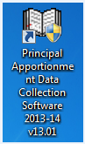
Figure 10: Principal Apportionment Data Collection Software Shortcut

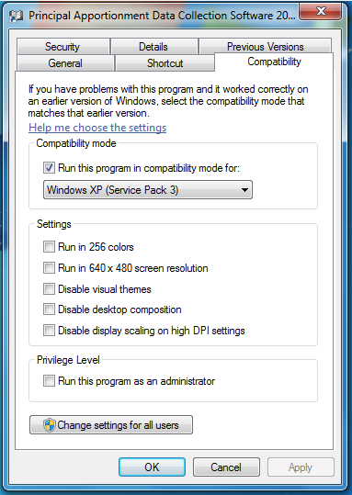
Figure 11: Compatibility Mode Window

