California Department of Education
Revised May 6, 2025

Physical Education Elementary School Site Plan:
Sample Design B
Small School Site Guidelines
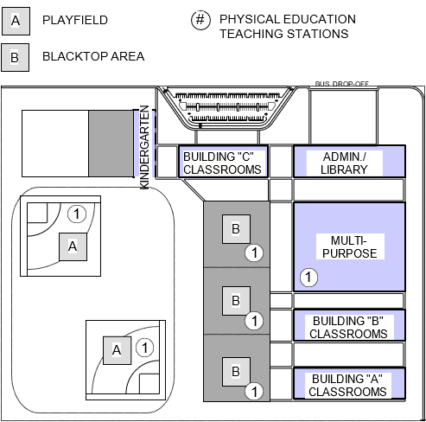

Full Text Description
This image above displays a rectangular design of a Physical Education Elementary School Site Plan. A legend includes the following items:
- (A) Playfield
- (B) Blacktop Area
- (#) Physical Education Teaching Stations
At the top-center of the design is a parking lot. To the right of the parking lot is an area marked for “Bus Drop Off”. To describe the rest of the image it will be categorized into two levels:
- Upper
- Lower
The Upper left area of the design includes a building labeled “Kindergarten”. The upper middle area is a building labeled “Building “C” Classrooms”. The upper right building is labeled Admin./Library.
The lower-left area appears to be two baseball/softball fields labeled [labeled (A)(1)] which means it is used as a playfield and physical education teaching station. The lower center contains 3 blacktop areas that are used for physical education teaching stations [labeled (B)(1)] stacked in a vertical orientation
The Lower right area contains three buildings stacked in vertical orientation. The uppermost building is a multi-purpose room. The building under the multi-purpose room is labeled “Building “B” Classrooms”. The building under “Building “B” Classrooms” is labeled “Building “A” Classrooms”

