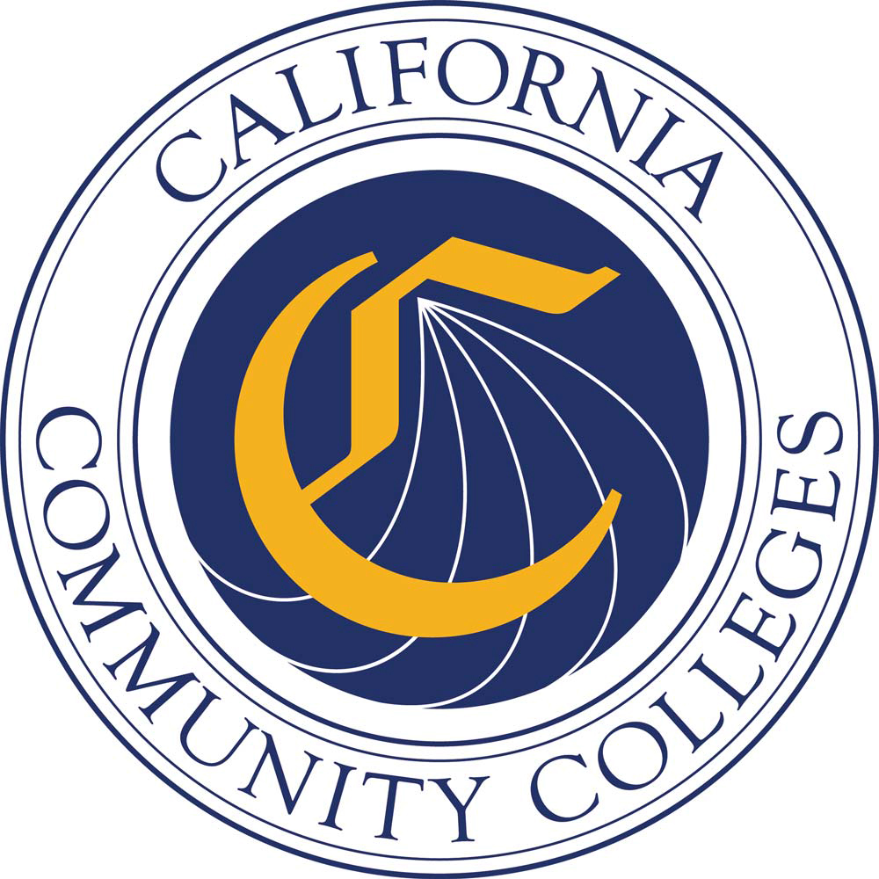

April 1, 2020

Joint statement from the California State Board of Education, California Department of Education, California State University, University of California, California Community Colleges and the Association of Independent California Colleges and Universities:
California’s K-12 and higher education communities are committed to helping high school and community college students overcome university admissions and placement challenges presented by the suspension of in-person instruction.
The State Board of Education (SBE), California Department of Education (CDE), California State University (CSU), University of California (UC), California Community Colleges, and independent nonprofit colleges and universities have been working together to understand and address the heightened concerns of students and families and the difficult conditions of this time.
As described in guidance from each of the sectors, the State Board and CDE have identified means to support:
- A range of distance learning
- Strategies for flexibility in grading
- Guidance for adjustments of local graduation requirements
The higher education community has offered assurances regarding:
- Re-evaluation of the financial needs, as well as the eligibility for federal and college financial aid, for families whose circumstances have changed;
- Acceptance of Credit/No Credit grades in lieu of letter grades for A-G high school courses completed in winter/spring/summer 2020;
- Flexibilities associated with the receipt of official transcripts and confirmation of admissions offers, including deferments of deposits or fees, where needed;
- Flexibility and support for students currently enrolled in dual enrollment course offerings;
- For community college students seeking to transfer to a four-year university: Acceptance of Credit/No Credit in lieu of letter grades in “Golden Four” and General Education/prerequisite courses completed at a community college in winter/spring/summer 2020.
These are represented in guidance from each of the sectors, available https://www.cde.ca.gov/ls/he/hn/coronavirus.asp. We also encourage interested parties to contact university admissions offices with specific questions.
As educators, we understand the anxieties triggered by the many uncertainties students now face and trust these accommodations provide a measure of relief. We look forward to the days far past this pandemic when we can welcome back our students and greet new ones with a handshake or a hug.

