California Department of Education Modified 01-Apr-2015
Historical Document

The State Superintendent of Public Instruction
Prepared by: Assembly Legislative Reference Service
March 14, 1963
(Continued)

Appointment of the Board by the Governor was opposed on the ground that under such a situation the Board could not be representative of the people and the State. Election of the Board by the school districts gives a grass roots representation.
The Superintendent of Public Instruction was to be appointed by the State Board of Education. His qualifications, other than those set forth by the law, and his salary, would be set by the Board.¹⁹
In reply to the Hardesty Report the Department of Education put out a brochure stating what they believed to be sound principles of public school administration. The Department held that the existent system of Governor appointment and Senate confirmation was perfectly in line with the “well accepted pattern for many governmental boards and agencies.”²⁰ The Department felt that election by school district placed undue power in the hands of small school districts.
They further felt that the existent system of direct election of the State Superintendent most fully realized the “grass roots” philosophy of democracy, and that in addition, “an elective office so designed can furnish the highest type of leadership and recognition in public education, intimately responsive to the desires of the people of the State.”²¹

19. The California Commission on Public School Administration
A Pattern for Public School Administration in California, Cecil Hardesty, Chairman (May 1955), pp. 41-44, 58-61
20. California State Department of Education. We Believe (Sacramento, January 1956, p. 2
21. Ibid. pp. 3-4
In 1958 a ballot proposal (Proposition 13) was placed before the voters to change the Constitution to allow the State Board of Education to appoint the Superintendent of Public Instruction. This proposition was defeated 2,522,998 to 1,519,209.
Roy E. Simpson, Superintendent of Public Instruction in 1959, suggested, in testifying before the Assembly Interim Subcommittee on Higher Education Beyond the Twelfth Grade, that the Superintendent be appointed by the State Board of Education. He further suggested that the Board fix his term of office and his salary.
Simpson’s proposal called for the creation of a new State Board of Education consisting of 11 members. The members should be appointed for staggered 10-year terms by the Governor, by and with the consent of the Senate.²² The subcommittee included Simpson’s proposal as an appendix to their report, but made no findings or suggestions on the matter.
The most recent proposals were those introduced into the Senate and Assembly in 1961 and favored by Governor Brown.²³ SCA 8, introduced by Senator McCarthy, on January 18, 1961, proposed that the State Board of Education should be composed of 10 members elected by district in the general election. The amendment outlined a Superintendent of Public Instruction, by and with consent of thirds of the members of suggested six districts. This Board was to have the power of appointing the Senate.

22. Assembly Interim Committee on Education. Report of the Subcommittee on Higher Education Beyond the Twelfth Grade, Assembly Interim Committee Reports 1957-1959, Vol. 10, No. 14 (Assembly of the State of California, 1959). p. 32, pp. 53-55
23. Phillips, The Sacramento Bee, p. 44
Amended, the proposed amendment gave the Legislature the power to set the manner and time of the election.²⁴
SCA 31, sponsored by Senators Fisher, Miller, O’Sullivan, Rattigan, Arnold, Robert D. Williams, and Farr, proposed to have the Superintendent appointed by the Governor by and with the consent of the senate, to hold office at the pleasure of the Governor, but was amended to give the State Board of Education the power in place of the Governor.²⁵
ACA 56, introduced by Messrs. Rees, Unruh, Waldie, Sumner, Cameron, DeLotto, Holmes, Kennick, Nisbet, Petris, George A. Willson, and Z’berg, originally suggested the Governor be given the appointive power, but-was amended to give the power to the State Board of Education.²⁶
ACA 56, SCA 31, and SCA 8 all died in committee.
This year Messrs. Dymally, Rumford, Ferrell, Song, Bane, and Warren have introduced ACA 2 which proposes that the Superintendent of Public Instruction be appointed by the State Board of Education, and serve a four—year term. He may be removed at the pleasure of the State Board. The amendment was referred to the Committee on Governmental Efficiency and Economy.²⁷ ACA 8, by Assemblymen Cologne and Monagan, is the other legislation introduced this session relating to the superintendent of Public Instruction. The proposed amendment would provide for the election of a four—man Board from four districts in the State. The members would

24. SCA 8, January 18, 1961
25. SCA 31, April 13, 1961
26. ACA 56, March 23, 1961
27. ACA 2, January 8, 1963
serve staggered terms and would appoint the Superintendent. The amendment was referred to the Committee on Governmental Efficiency and Economy.²⁸

28. ACA 8, January 29, 1963

APPENDIX
DUTIES
STATE SUPERINTENDENT OF PUBLIC INSTRUCTION

The Office of Superintendent of Public Instruction is an elective office created by the Constitution. The Superintendent of Public Instruction is ex officio the Director of Education and the executive officer of the State Board of Education and as such possesses not only all administrative and executive functions of that office but those of the Department of Education which, subject to the policies established by the State Board of Education, are under the control of the Director of Education. He has duties in connection with the administration of the office of Superintendent of Public Instruction, the office of Director of Education, and the Department of Education. The law imposes certain duties and authority upon the Superintendent of Public Instruction, others upon the Director of Education, others upon the Department of Education, and others upon the Board of Education. Because it is not feasible or practical to do otherwise, insofar as organization is concerned, the Department of Education is, in its organization, deemed to consist of the four agencies mentioned and is administered as a unit through these six divisions and the Bureau of Vocational Rehabilitation:

- Division of Departmental Administration under a Deputy Superintendent of Public Instruction.
- Division of Instruction under an Associate Superintendent of public Instruction.
- Division of Public School Administration under an Associate Superintendent of Public Instruction.
- Division of Special Schools and Services under a Deputy Superintendent of Public Instruction
- Division of Higher Education under an Associate Superintendent of Public Instruction.
- Division of Libraries under the State Librarian

Section 403 of the Education Code imposes upon the Superintendent of Public Instruction the following specific duties:

“The Director of Education may, with the approval of the Director of Finance, accept on behalf of, and in the name of, the State such gifts, donations, bequests, and devises as may be made to the Department of Education, or to any school, college, or other institution administered by the Director of Education or the Department of Education, which in his judgment would be of benefit to the State and, if made to a school, college, or other institution, would be of benefit to the school, college, or other institution. Gifts, donations, bequests, and devises may be made subject to such conditions or restrictions as the Director of Education may deem advisable.”

The duties and responsibilities of the Superintendent of Public Instruction with respect to the Department of Education are those of the four agencies considered as comprising the Department of Education. A complete list of such duties and responsibilities cannot be given in the limited space available but among the principal ones, not necessarily listed in the order of importance, are the following:

1. The administration o the Department of Education, the State Library, the two California Schools for the Deaf, the California School for the Blind, the two Schools for Cerebral Palsied Children, the Oakland Orientation Center for the Blind, the California Industries for the Blind, and the California Academies (when placed in operation).

2. The apportionment to school districts and county superintendents or schools of all moneys appropriated therefor by the Legislature and by the federal government.

3. The achievement of the most effective, efficient, and coordinated administration possible of the office of Superintendent of Public Instruction, the off ice of Director of Education, and the Department of Education.

He has additional duties in connection with the following:

1. The issuance of all credentials authorizing persons to serve in the public kindergarten, elementary, and secondary schools

2. The printing and distribution of all textbooks and teacher’s manuals adopted by the State Board of Education.

3. The administration in California of the federal school lunch program, the distribution of federal surplus property to educational institutions, federal aid for public school education of Indians, and federally aided programs of vocational education and vocational rehabilitation, and child care centers.

4. The coordination of the various units of the public school system within the limits permitted by law.

5. The maintenance of relationships between the Department of Education, the public school system, and the various professional and lay organizations and the people of the State generally.

His ex officio duties are as follows:

1. Ex officio member of the: Governor’s Council; Regents of the University of California; Trustees of California State Colleges; State Allocation Board; Board of Governors of the California Maritime Academy (executive member); Commission of Credentials; State Curriculum Commission (chairman); Retirement Investment Board of he State Teachers’ Retirement System; Board of Public Building Reconstruction; State School Building Finance Committee; and Coordinating Council on State Programs for the Blind.

2. Ex officio; Secretary and Executive Officer, State Board of Education; Secretary, State Teachers’ Retirement Board.

State Department of Education
Office of the Superintendent
STATE BOARD OF EDUCATION
March 31, 1959

I. The State Constitution provides:

A. For creation of a State Board of Education (Art. 1X0 Sec. 7)

B. For adoption of uniform series of Free Textbooks (Art. IX, Sec. 7)

C. A definition of the public school system (Art. IX, Sec. 6)

D. For appointment of deputy and associate superintendents (Art. IX, Sec. 2.1)

II. The Education Code provides

A. Concerning the general administration of the public school system that the
State Board:

- Shall make rules and regulations for the government thereof (Sec. 112)

- Shall study the educational needs of the State and cake a report and recommendations to the Governor (Sec. 116 and 117)

- Establish minimum standards for curriculum (Sees. 9036, 10094. 10172, 10181, 10200, 10501, 10601)

- Shall consider petitions and establish minimum standard for district organization (Chapters 7-16 of Div. 2)

- Shall prescribe rules and regulations relative to attendance accounting in all schools (Sec. 6801)

- Shall license teachers for service as certificated personnel in the public schools and accredit teacher education institutions (Secs. 12005 and 12041)

- Authorized to adopt rules and regulations concerning the transfer of cumulative school records of pupils from one district to another (Sec!. 24676, Ed. C.; effective date: July 1, 1960)

B. Concerning the regulation of public elementary schools, that the State Board

- May adopt minimum standards for courses of study (Sees. 10009 and 10010)

- shall adopt textbooks for elementary schools
(Chapter 2, Div. 6)

C. Concerning the regulation of public Junior Colleges, that the State Board

- Approve courses of study for each junior college (Sec. 10601)

- Shall establish minimum standards for the formation of junior college districts (Sec. 4233)

D. Concerning the regulation of other secondary schools, that the State Board

- Approves a course of study for each high school and junior high school (Secs. 10501 and 10503.5)

- Provide minimum standards of curriculum for the secondary schools (Secs. 10009 and 10010)

- Shall classify all instructional material used in high schools and indicate which materials are textbooks (Sec. 11652)

- Prescribe regulations for the establishment of the list of approved textbooks, etc. (Seas. 11651, 11744 and 11762)

E. Concerning the State Colletes, that the State Board

- Confirm appointments to the college advisory boards (Sec. 20361)

- Shall prescribe the rules for their government and for reports of officers and teachers (Sec. 20347)

- Adopt rules determining St ate Board meetings for the consideration of State College problems (Sec. 20348)

- Approve the determination of the duties of all presidents, members of teaching staff , officers and employees of the State Colleges (Sec. 20373)

- Define “community relation responsibilities” and establish rules and regulations governing expenditures in support thereof (Sec. 20373.1)

- Prescribe rules and regulations governing the standards of service relative to leaves of absence (Sec. 20382)

- Appoint members of the commission for vocational education (Sec. 20490)

- May adopt rules for the standardization of courses (Sec. 20453)

- Approve courses of instruction (Art VI of Div. 10)

- Establish minimum standards authorizing the college to grant degrees (Sec. 20452)

- Provide standards for admission and transfer of students (Sec. 20426)

- May provide standards for graduation and for the granting of degrees (Secs. 20481 and 20482)

- May adopt rules concerning the use of State adopted textbooks in the State Colleges (Sec. 20501)

- Provide for and finance dormitories (Secs. 20541 et seq.)

F. Concerning the administration of the State Department of Education, that the
state Board

- Act as the governing and policy determining body of the department (Sec. 172)

- Establish divisions within the department (Sec. 186)

- Establish a commission to deal with problems of discrimination in connection with the employment of certificated employees (Sec. 187)

G. For licensing foreign language schools (Secs. 24801 - 24810)

H. Miscellaneous powers of the State Board

- Power to issue subpoenas to compel the attendance of witnesses (Sec. 113)

- Required to appoint an acting secretary (Sec. 118)

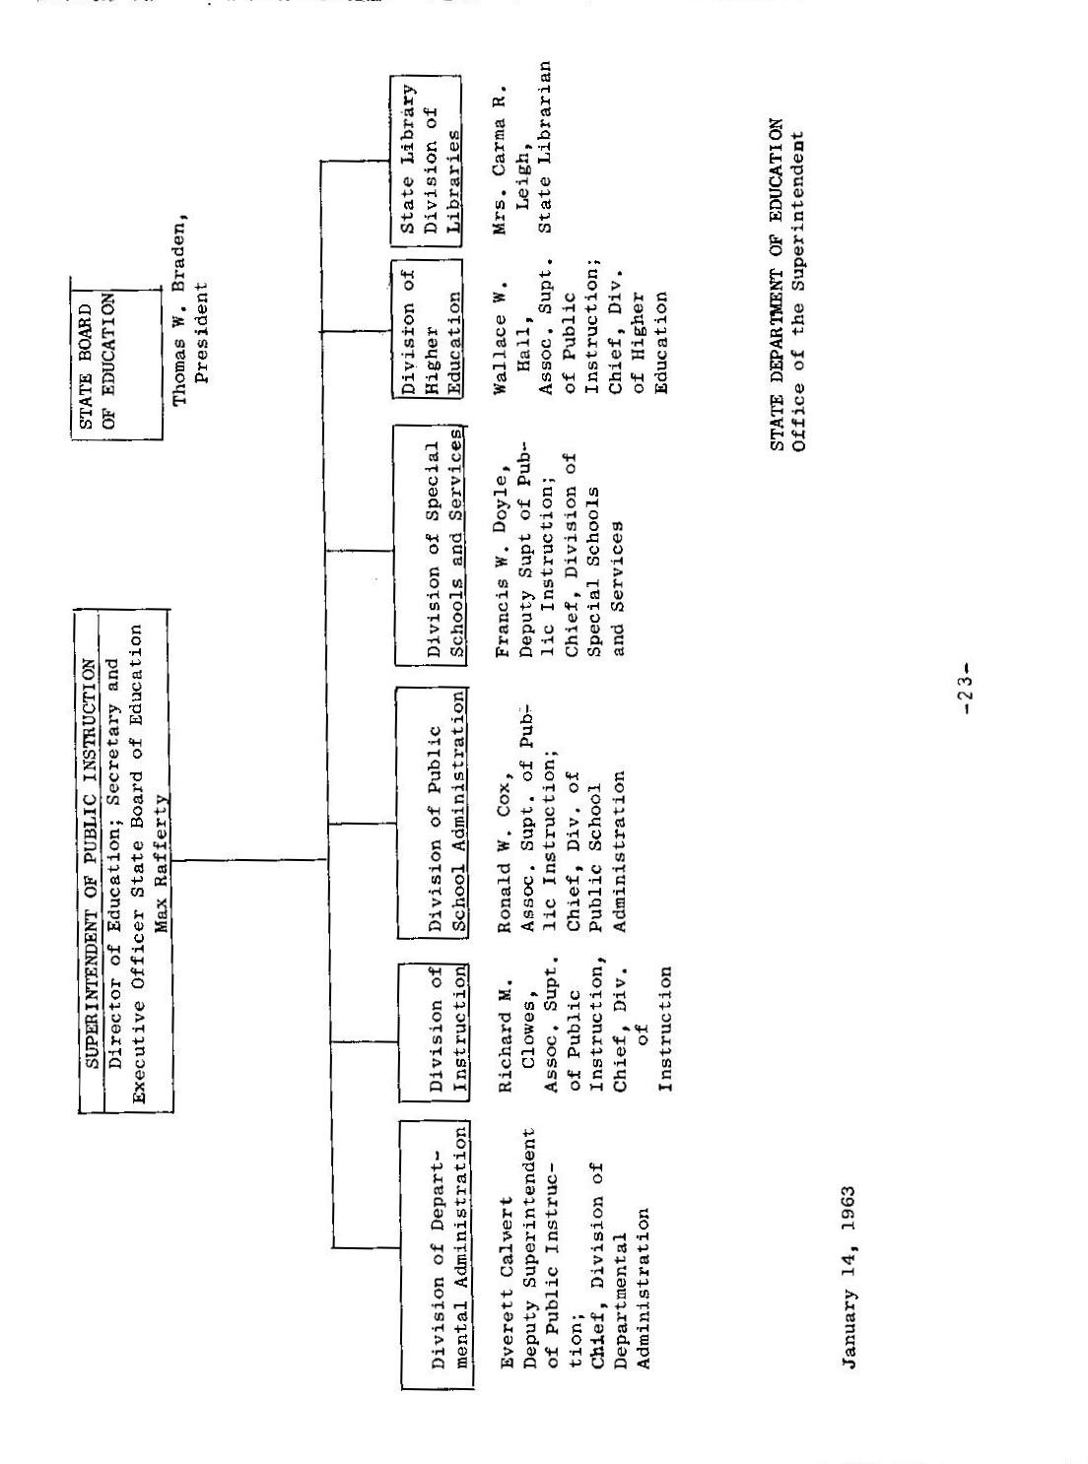

Past Superintendents of Pb1ic Instruction:¹

1851 - 1853 John G. Marvin

1854 - 1856 Paul K. Hubbs

1857 — 1862 Andrew J. Moulder

1863 — 1867 John Swett

1867 — 1871 Oscar P. Fitzgerald

1871 — 18Th Henry N. Bolander

1875 - 1879 Ezra S. Carr

1880 — 1882 Frederick N. Campbell

1883 - 1886 William T. Weicker

1887 — 1890 Ira G. Hoitt

1891 - 1894 James W. Anderson

1895 — 1898 Samuel T. Black

1898 Charles T. Meredith

1899 - 1906 Thomas J. Kirk

1907 - 1918 Edward Hyatt

1919 — 1927 Will C. Wood

1927 — 1929 William John Cooper

1929 — 1937 Vierling Kersey

1937 — 1945 Walter F. Dexter

1945 — 1961 Roy E. Simpson
1. This section and the following one were prepared with the aid of Mr. Ron Larson, Legislative Intern, 1961
Brief Background Material on Past Superintendents¹

John G. Marvin

Mr. Marvin was elected as an independent out of a field of 10 candidates. He received his law degree from Harvard in 1844 and was editor and publisher of the Sonora Herald in Tuoloumne County. Upon losing the Democratic nomination to his opponent Paul K. Hubbs, Mr. Marvis returned to his duties with his paper. He died in Honolulu in December of 1857.
For a summary of his program see p. 24.

Paul K. Hubbs

Born in New Jersey in March of 1800, Mr. Hubbs was popularly known as the “Colonel” and was elected to the office of State Superintendent of Public Instruction in 1854 after winning the Democratic nomination from Mr. Marvin. Previous to becoming the State Superintendent M. Hubbs had been a lawyer and a State Senator from Tuolumne County. In 1856, Mr. Hubbs moved to Vallejo where he continued to practice law until his death in December of 1874.
For a summary of his program see p. 27.

Andrew J. Moulder

Mr. Moulder was elected in 1856 and again in 1859. Originally educated in Virginia, he became a teacher. He retired from the Superintendency in 1863 and entered the brokerage business. He was on the Board of Regents of the University of California, and from 1883 and 1886 served as Superintendent of San Francisco schools. He died in October of 1895.
For a summary of his program see p. 37.

John Swett

A teacher, Mr. Swett was elected on the Union ticket in 1862. He ran again in 1863, due to an amendment in the Constitution which was adopted at the same e1ectin in which he had previously won the office, and was again victorious. Running as a Unionist with Republican backing in 1867, Swett lost to Oscar P. Fitzgerald, a Democratic preacher.
For a summary of his program see p. 40.

1. All page numbers refer to R. W. Cloud, Education in California, Stanford University Press (Palo Alto, 1952).
Oscar P. Fitzgerald

Born in North Carolina in August of 1829, Mr. Fitzgerald had been a journalist, a teacher, and a preacher, before being elected in 1867. In 1871 he lost the election to Mr. Henry N. Bolander, and returned to journalism, editing the California Teacher for two years, He then went to Tennessee as the editor and publisher of the Christian Advocate. He died in Tennessee in June of 1911.
For a summary of his program see p. 59.

Henry N. Bolander

Mr. Bolander was born in Prussia in 1831 and was a teacher at the time of his election. He chose not to run for reelection. He was later elected Superintendency of San Francisco schools, but after only a year in the position resigned and went to Guatemala. He returned to teach in Oregon where he died in 1897.
For a summary of his program see p. 60.

Ezra S. Carr, M.D.

Originally a New Yorker, born there in 1819, Mr. Carr was elected as a Republican in 1875. His wife, Jeannie, was his chief deputy. Mr. Carr had been a professor of Horticulture at the University of California arid held degrees in engineering and medicine. He had also been a president of the California Teachers’ Association. He did not seek reelection. In 1894 he died in Pasadena.
For a summary of his program see p. 62.

Frederick N. Campbell

Another New Yorker, Mr. Campbell was born in 1837. He was elected as a Republican in 1879. He had been a teacher and a president of the California Teachers’ Association. He did not choose to run for reelection and instead obtained a position in Washington, D. C., as a secretary to a Congressman. He died there in 1905.
For a summary of his program see p. 71.

William T. Weicker

Born in Tennessee in 1830, Mr. Weicker was elected in 1883 and was the first rra to serve the full four—year term. He had been educated at west Point and had been a teacher at the University of California. He did not run for reelection in 1886 and instead retired to Berkeley where he died in 1900.
For a summary of his program see p. 84.

Ira G. Hoitt

New Hampshire born, Mr. Hoitt was in the advertising business when he was elected to the Superintendency. He had been educated at Dartmouth. He had held positions as a broker, a teacher, a member of the San Francisco Board of Education and had been a member of the Assembly and a chairman of the Education Committee. He died in Menlo Park in 1905.
For a summary of his program see p. 87.

James W. Anderson

Mr. Anderson, born in Pennsylvania in 1831, was elected as a Republican in 1890. Previous to his election he had been serving as the Superintendent of San Francisco schools. He had been educated at Washington and Jefferson. He retired to farming in Fresno. He died in Oakland in 1920.
For a summary of his program see p. 89.

Samuel P. Black

Originally from England, where he was born in 1846, Mr. Black was elected as a Republican. He resigned in 1898 to become President of San Diego State Normal. He died in San Diego in 1917.
For a summary of his program see p. 99.

Major Charles P. Meredith

Born in Kentucky in 1845, Major Meredith was appointed to succeed Mr. Black in 1898. He only served three months and then returned to teaching at San Diego State Normal. He later became associated with the Hoitt School in Menlo Park (founded by Ira G. Hoitt). He died in Los Angeles in 1925.

Thomas J. Kirk

Missouri born Mr. Kirk served two terms as State Superintendent. On leaving the office he took a position with Heald’s Business College, He died in’ 1909.
For a summary of his program see p. 101.

Edward Hyatt

Mr. Hyatt, born in Pennsylvania in 1858, was the first Superintendent to be elected under the direct primary law. In 1918 he lost the election to will C. wood. He died in Sacramento in 1919.
For a summary of his program see p. 119.
Will C. Wood

California born (1880) Mr. Wood, a teacher with his Masters from the University of Southern California, was elected to three terms. He resigned after three weeks of his third term to enter the banking business. He died in 1939.
For a summary of his program see pp. 139-48

William J. Cooper

Another native son of California (born 1882) Mr. Cooper was appointed to replace Wood in 1927. He resigned after two years to accept President Coolidge’s request to be U. S. Commissioner of Education. He resigned this job to teach at George Washington University. He died in 1925.
For a summary of his program see p. 149.

Vierling Kersey

Born in California in 1890, Mr. Kersey was appointed to succeed Mr. Cooper. He was educated at Los Angeles Normal School. In 1930 he was elected and again in 1934. In February of 1937 he resigned to become Superintendent of Los Angeles City Schools.
For a summary of his program see p. 172.

Walter F. Dexter

Mr. Dexter, who had been born in Illinois in 1886, was appointed to take the place of Mr. Kersey. He was educated at Pennsylvania, Columbia and Harvard. He was reelected in 1938 and 1942. He died in office in October of 1945.
For a summary of his program see p. 195.

Roy E. Simpson

Born in California in 1893, Mr. Simpson was appointed to succeed Mr. Dexter. He was educated at Heald’s college, Claremont College and the University of California. He served as principal at Anderson High School and at Emerson Junior High School. He was superintendent of the Gilroy High School District and was city superintendent in both Santa Rosa and South Pasadena. He did not seek reelection in 1962 and was succeeded by Dr. Maxwell Rafferty who was elected in November, 162.

