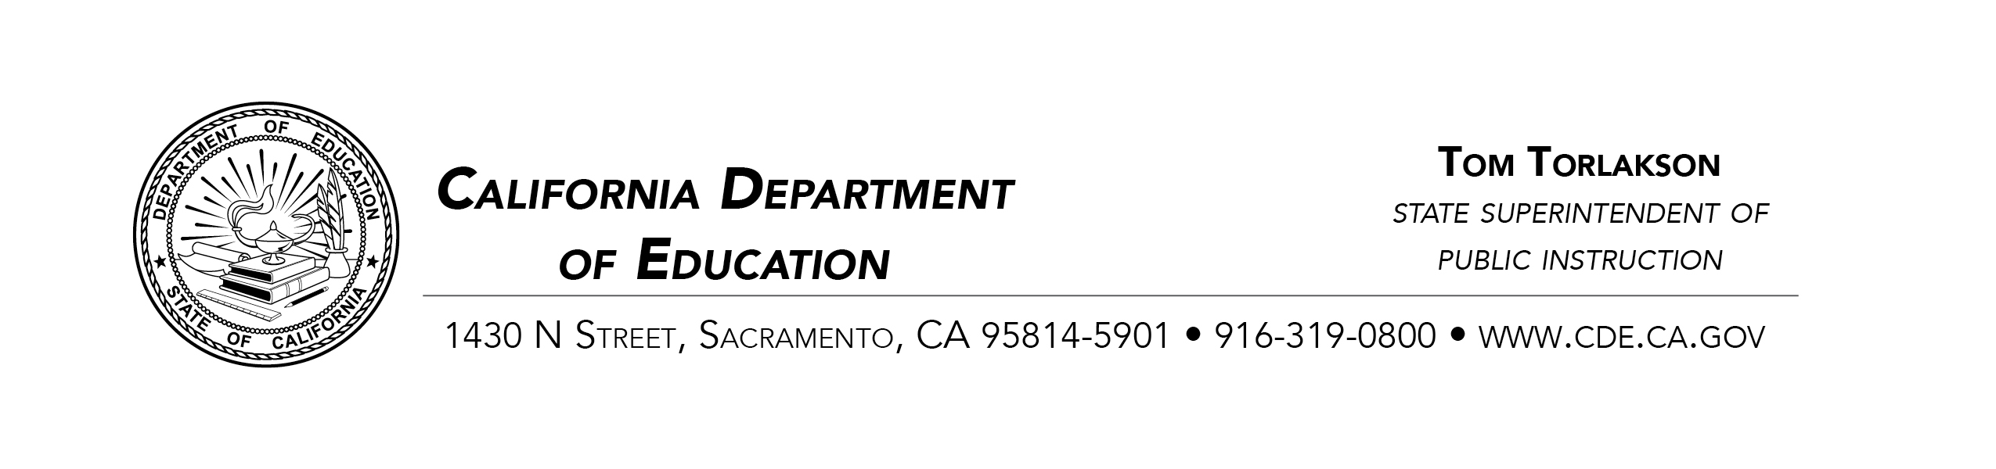
- PROHIBITION OF DISCRIMINATION, HARASSMENT, INTIMIDATION, AND BULLYING IN CALIFORNIA PUBLIC SCHOOLS
  - The following information describes where and how to file a complaint of discrimination, harassment, intimidation, and/or bullying based on a protected class.
  - The California Code of Regulations, Title 5 (5 CCR), Section 4600 et seq. establishes Uniform Complaint Procedures (UCP) to be followed for complaints of discrimination, harassment, intimidation, and/or bullying based on a protected class. The regulations require:
    - The local educational agency (LEA), which consists of local school districts, county offices of education, or a direct-funded charter schools, to adopt policies and procedures that are consistent with 5 CCR, sections 4600–4687.
    - The LEA’s complaint procedures should be published in the student handbook. If not, contact the LEA and request a copy of the nondiscrimination policy and complaint procedures.
    - The complaint must first be filed with the LEA; follow the directions, steps, and time lines in the LEA’s complaint procedures; if there are questions about the procedures, ask for the name of the person responsible for handling discrimination, harassment, intimidation, and/or bullying complaints; contact the person for questions and clarification.
    - The complaint must be written and signed and can be filed by students, parents, and/or interested parties or organizations; it must be filed within six months from the date of the alleged discrimination, harassment, intimidation, and/or bullying; or when knowledge of the facts were first acquired.
    - The LEA has 60 days to complete an investigation into the allegations and prepare a final written decision/investigative report that is to be sent to the person(s) that filed the complaint; during this process, an opportunity to submit evidence is provided. If the investigation and report are not completed in 60 days, you may contact the California Department of Education (CDE).
    - If all the steps of the LEA complaint procedures have been followed and there is disagreement with the decision, an appeal to the CDE can be made; an appeal must be filed within 15 calendar days of the receipt of the LEA’s final decision on the complaint.
  - For questions or assistance to submit and Education Equity UCP appeal, please contact:
    - The California Department of Education, Education Equity UCP Office by mail at 1430 N Street, Suite 5502, Sacramento, CA 95814; telephone: 916-319-8239; facsimile: 916-319-0966; or e-mail at eeucpo@cde.ca.gov.
    - The CDE Education Equity UCP Office Web site at: https://www.cde.ca.gov/re/di/eo/index.asp.
  - An appeal to the CDE must:
    - Be in writing
    - Include a copy of the original complaint filed with the LEA and the LEA’s final decision
    - Specify the basis for the appeal and whether the facts in the decision are incorrect and/or the law is misapplied
  - Unless requested by the CDE, do not include additional evidence from the parties that was not submitted to the LEA’s investigator during the investigation. If necessary, the CDE may request additional information from the parties.
  - CDE’s Appeal Procedures: When an appeal request is complete, the CDE obtains the LEA’s investigation file and determines whether:
    - The LEA followed its complaint procedures
    - The evidence supports the LEA’s findings of fact
    - The LEA correctly applied the law
  - If the CDE determines the evidence supports the decision and the law is correctly applied, the appeal shall be denied.
  - The CDE may, if there is a lack of evidence or a procedural defect in the investigation, return the matter to the LEA for further investigation of the allegations which are the subject of the appeal.
  - If the CDE finds merit in the appeal, the CDE’s decision on appeal shall contain the following:
    - A finding that the LEA complied or did not comply with its complaint procedures
    - The CDE’s finding of fact and conclusions of law regarding the issue on appeal
    - Where a determination is made that the LEA failed to comply with the applicable state or federal law or regulations, remedial orders and/or required actions to address the violation(s), including a remedy that specified the LEA’s obligation to comply with the California Education Code, Section 49013(d) and Section 4600(u).
  - Important information for students, parents, and/or others when filing a complaint of discrimination, harassment, intimidation, and/or bullying with your LEA:
    - Make sure the law applies to the situation you are complaining about; to constitute discriminations, harassment, intimidation, and/or bullying, the LEA’s actions must be based on one or more of the listed protected classes: disability, gender, gender identity, gender expression, nationality, race or ethnicity, religion, sexual orientation, lactation, immigrant status, and/or LGBTQ; the LEA’s action must also adversely affect the student.
    - Explain why it is discrimination, harassment, intimidation, and/or bullying based on a protected class; provide as much specific documentation and information as possible, including the names and contact information of any witnesses. Evidence that could have been submitted to the LEA during the investigation may not be considered by the CDE on appeal.

    - Explain what you would like to have happen as a result of the complaint; give your name, address, and telephone numbers where you can be reached.
  - For additional information or concerns, please contact the CDE’s Education Equity UCP Office in writing by e-mail at the aforementioned e-mail address.
California Department of Education
Education Equity UCP Office
Created May 2017

