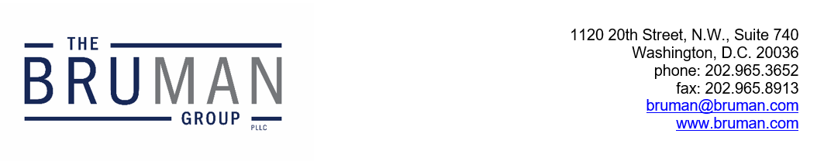

The Federal Update for December 19, 2025

From: Michael Brustein, Julia Martin, Steven Spillan, Kelly Christiansen
Re: Federal Update
Date: December 19, 2025
Legislation and Guidance 1
Senate Inches Forward on Appropriations Bill 1
Congress Sends Whole Milk Bill to President 2
News 2
Agreement Reached to End SAVE Plan 2

Due to the upcoming holidays, the next issue of the Federal Update will be published on January 9th. The Bruman Group, PLLC will notify clients should any events transpire prior to the next issue which may require an urgent response.

Legislation and Guidance

Senate Inches Forward on Appropriations Bill
Lawmakers in the Senate this week worked to bring an appropriations package closer to a vote to finalize funding levels for federal fiscal year (FY) 2026. Though legislative language was not released this week, negotiators were reportedly close to a deal on the nine appropriations bills remaining to be passed (three full-year bills, including U.S. Department of Agriculture appropriations, were attached to the temporary funding measure passed in November). However, the legislation was unable to garner enough support Thursday to advance before lawmakers leave town for their end of year recess, in part because the proposed closure of a climate research facility created new objections among Senate Democrats. The last bills to be negotiated are the largest, including the Labor-HHS-Education appropriations bill, along with Defense Department appropriations and the Energy and Water bill.
Among the topics lawmakers planned to discuss in the Senate were measures to protect education programs. Senators Patty Murray (D-WA) and Tammy Baldwin (D-WI), the ranking members of the Senate Appropriations Committee and the Labor-HHS-Education Subcommittee, said they would offer an amendment to prohibit interagency agreements to manage any education programs in other agencies and to require sufficient staffing for the Education Department to meet statutory requirements. A prior version of the bill included language that would prohibit transferring “significant responsibilities relating to” running special education or Title I to another agency and limitations on how much funding can be transferred among programs; another section in the prior proposal requires funding to be provided on time for formula grant programs.
Once the Senate gets agreement on funding levels, it can fast-track a measure for full passage. But objections to the bills were unable to be resolved before lawmakers break, and there are significant differences between the Senate and House bills that stand between the current discussions and final passage. Senate leaders stated Thursday evening that they are committed to passing funding legislation after returning in the new year. The House recessed for the holidays Thursday afternoon, meaning that no votes will occur until 2026.
Lawmakers have until January 30th to work out full-year appropriations numbers or pass another short-term funding extension. The FY 2026 funding, which is currently being negotiated, should go out to States and institutions in July of 2026.
Author: JCM

Congress Sends Whole Milk Bill to President
The House passed the Whole Milk for Healthy Kids Act with bipartisan support in a vote on Monday, sending the legislation to the President for signature. The legislation was passed by the Senate last month.
The legislation expands the types of milk schools are permitted to offer under federal school meal programs, including whole and reduced fat milk, flavored or unflavored. In addition, students with dietary restrictions can now access milk substitutions through a parent or guardian, as opposed to a written note from a doctor. Under the legislation, saturated fat from milk is excluded from the nutrition standards calculations required for school meal programs.
The President is expected to sign the legislation.
Author: KSC

News

Agreement Reached to End SAVE Plan
Last week, the U.S. Department of Education (ED) announced a proposed settlement agreement that would end the Saving on a Valuable Education (SAVE) plan. After the U.S. Supreme Court blocked a debt relief program in 2023, the previous administration implemented the SAVE plan, one of many income-driven repayment programs. The SAVE plan limited monthly payments and shortened the time period for many borrowers to receive forgiveness for the balance of their loans.
However, the plan was challenged by the State of Missouri and has been blocked by courts since the middle of last year, leaving borrowers uncertain of the future. Under the new administration, Missouri reached an agreement with ED. If the settlement agreement is approved by the court, ED will not enroll any additional borrowers into the plan, deny any applications, and move all currently enrolled borrowers into other plans. The agreement would accelerate the 2028 phase-out timeline for the plan built into the One Big Beautiful Bill Act that Congress passed this summer.
In ED’s announcement of the settlement agreement, it referred to the SAVE plan as “illegal” and a “deceptive scheme” that would “unlawfully shift student loan debt onto American taxpayers.” ED has already begun encouraging borrowers enrolled in the SAVE plan to consider other repayment plans.
ED’s announcement can be found here.
Author: BTW
The Federal Update has been prepared to inform The Bruman Group, PLLC’s legislative clients of recent events in federal education legislation and/or administrative law. It is not intended as legal advice, should not serve as the basis for decision-making in specific situations, and does not create an attorney-client relationship between The Bruman Group, PLLC and the reader.
© The Bruman Group, PLLC 2025
Contributors: Julia Martin, Kelly Christiansen, Brandi Wills
Posted by the California Department of Education, December 2025

