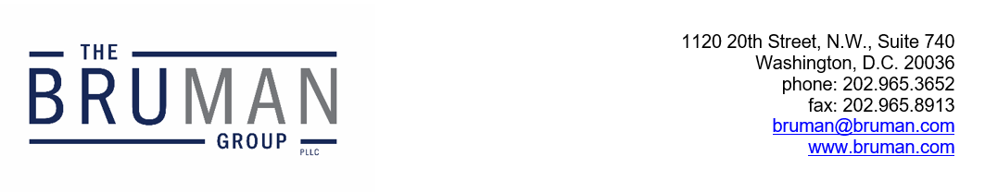

The Federal Update for August 29, 2025

From: Michael Brustein, Julia Martin, Steven Spillan, Kelly Christiansen
Re: Federal Update
Date: August 29, 2025
Legislation and Guidance 1
DOL Encourages Grantees to Use Funds for AI Training 1
Senators Hold Up Whole Milk Bill 2
News 2
Administration Won’t Defend Program for Hispanic-Serving Institutions 2

Legislation and Guidance

DOL Encourages Grantees to Use Funds for AI Training
The U.S. Department of Labor issued a Training and Employment Guidance Letter (TEGL) this week encouraging State and local workforce development boards (LWDBs) to use Workforce Innovation and Opportunity Act (WIOA) funding to support Artificial Intelligence (AI) skill development. The guidance was issued in response to President Trump’s April Executive Order on “Advancing Artificial Intelligence Education for American Youth.”
The guidance notes the sections of WIOA that allow State and local LWDBs to use funds under Title I to expand digital literacy skills, interpreting that to include AI training. The guidance pushes LWDBs to use WIOA Title I youth, adult, and dislocated worker funds, as well as the governor’s reserve, to support AI education and training, including through work experiences in AI for youth and training and individualized career services for adult and dislocated worker participants. The guidance also states that there may be AI training and work opportunities outside of the Eligible Training Provider List and that local boards should consider contracts with AI-experienced entities, such as institutions of higher education.
The letter also announces that the administration is taking action to expand AI literacy among K-12 students as well, with the White House Task Force on AI Education developing public-private partnerships to establish online AI resources. The letter states that information about those resources will be available on AI.gov.
The full TEGL is available here.
Author: KSC

Senators Hold Up Whole Milk Bill
Several Democratic Senators have placed the bipartisan Whole Milk for Healthy Kids Act, S. 222, on an anonymous hold, raising questions about the future of the legislation and whether the minority will engage in new techniques to slow legislation.
One of the lawmakers blocking the legislation, who is no longer anonymous, is Senator Ben Ray Lujan (D-NM), who told reporters he wants the proposal amended to ensure the future of the Community Eligibility Provision, which allows schools to provide free meals to students. Other Congressional Democrats have expressed concern that Congress wants to eliminate or weaken the provision, which was passed into law in 2010 in the Healthy, Hunger-Free Kids Act.
The other two Senators who have placed a hold on the legislation are anonymous, meaning that their opposition is known only to leadership. The lack of statements from these Senators has led other lawmakers to speculate that they want to add other policy riders to the bill because they anticipate few other pieces of legislation will pass this Congress.
The legislation, which was fast-tracked after it passed out of the Senate Agriculture Committee in June with bipartisan support, would explicitly permit schools to serve plane and flavored whole milk, as well as non-dairy alternatives, and would remove the saturated fat content in whole milk from the calculation of total fat in a meal. Under the hold process, lawmakers will raise an objection to the full Senate considering the legislation, meaning that in order to pass the bill, lawmakers would have to force a cloture motion requiring 60 votes to move forward. Senate Majority Leader John Thune (R-SD) told reporters he hopes to resolve concerns and get the bill through the Senate by October.
Author: JCM

News

Administration Won’t Defend Program for Hispanic-Serving Institutions
In a letter to Speaker of the House Mike Johnson (R-LA), the Department of Justice (DOJ) said that it would not defend against a lawsuit challenging a program for Hispanic-serving institutions (HSIs).
In June, the State of Tennessee and Students for Fair Admissions (SFFA) filed a lawsuit arguing that the definition of HSI in the Higher Education Act is unconstitutional. The statute allows the U.S. Department of Education (ED) to award grants to institutions where at least 25 percent of the student population is Hispanic. Tennessee and SFFA rely on the Supreme Court’s 2023 ruling striking down affirmative action in college admissions to argue that it creates incentives for institutions to engage in affirmative action. They also assert that federal funds should not support programs that “turn on race or ethnicity.”
The DOJ’s letter to Congress on the lawsuit says that they have determined that the statute violates the Constitution and that “the government lacks any legitimate interest in differentiating among universities based on whether ‘a specified number of seats in each class are occupied by ‘individuals from the preferred ethnic groups.’” The DOJ is required to notify Congress when it plans to forgo defending a lawsuit on constitutional grounds.
In response, the Hispanic Association of Colleges and Universities has requested to intervene in the case so that it can defend the program. The judge has not yet ruled on their request.
However, higher education officials are concerned about the future of the program. ED opened the program for applications in June, and institutions have already submitted proposals. Along with the requirement to have a quarter of the student population be Hispanic, institutions must also have at least half of their population coming from low-income families to qualify. The funding, they say, does not go just to Hispanic students; it goes to facilities, faculty training, and other costs that benefit all students at the institutions. The program was set to award over $350 million for this fiscal year, but ED has not yet confirmed how or if it will implement the program.
Resources:
Ryan Quinn, “DOJ Deems Definition of Hispanic-Serving Institutions Unconstitutional,” Inside Higher Ed, August 22, 2025.
Author: BTW
The Federal Update has been prepared to inform The Bruman Group, PLLC’s legislative clients of recent events in federal education legislation and/or administrative law. It is not intended as legal advice, should not serve as the basis for decision-making in specific situations, and does not create an attorney-client relationship between The Bruman Group, PLLC and the reader.
© The Bruman Group, PLLC 2025
Contributors: Julia Martin, Kelly Christiansen, Brandi Wills
Posted by the California Department of Education, August 2025

