CSMT Staff and Support
Marla Clayton Johnson
Education Administrator I
916-324-4543
mjohnson@cde.ca.gov
Grant Leung
Technical Support
IMODS & Braille-n-Teach
916-323-4735
gleung@cde.ca.gov
James Morrison
APH & Assistive Technology
916-323-1329
jmorrison@cde.ca.gov
Mike Morse
Warehouse Manager
916-373-3191
mmorse@cde.ca.gov
Steven Parker
Large Print Production
916-327-0224
sparker@cde.ca.gov
Erin Coppedge
Braille Production
916-445-1887
ecoppedge@cde.ca.gov

Susan Hardesty
Production Services Manager
Audio, Braille, and Large Print
916-323-4737
shardesty@cde.ca.gov
Jeannette Reyes
Electronic files & NIMAC
916-445-1674
jreyes@cde.ca.gov
Martina Guerra
Education Programs Consultant
916-445-4558
mguerra@cde.ca.gov
General Assistance:
CSMT@cde.ca.gov

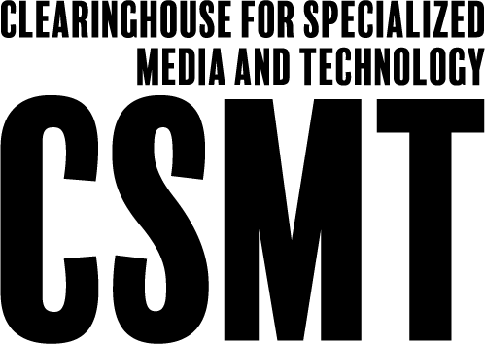

Clearinghouse for Specialized Media and
Technology Reference Guide
1430 N Street, Suite 3207
Sacramento, CA 95814-5901
Telephone 916-445-5103 / FAX 916-319-0172
The Clearinghouse for Specialized Media and Technology helps to
close the achievement gap by providing instructional resources in
accessible formats to students with disabilities in California.
California Department of Education
Instruction and Measurement Branch
Curriculum Frameworks & Instructional Resources Division
Visit CSMT at https://www.cde.ca.gov/re/pn/sm

Instructional Materials Ordering and Distribution System
The online Instructional Materials Ordering and Distribution System (IMODS) allows school districts to order and access free state-adopted instructional materials for K–8 students with print disabilities. Student textbooks, workbooks, and literature books adopted by the State Board of Education are produced and made available in a variety of formats:
Braille
Large Print
Electronic Files
Audio Recordings
Digital Talking Books
American Sign Language (ASL)
Video Books
American Printing House for the Blind (APH) Assistive Technology & Products
Educators and support personnel employed by California public schools who serve students with visual impairments or other disabilities may order through IMODS. There is no cost to schools in California that have students who qualify for these services. These authorized users may log in and order state-adopted specialized formats of K–8 instructional materials. We also provide the APH products for educators and personnel authorized by a public or private agency that serve students who are registered with the APH.

Electronic Files
The Clearinghouse for Specialized Media and Technology (CSMT) provides downloadable electronic media files in various formats to empower students who require access to braille, large print, and audio to obtain their information. These formats include: portable document format (PDF), National Instructional Materials Accessibility Standard (NIMAS), rich text format (RTF), DAISY, braille files, and MP3, which are used on computers and other assistive technology devices.

Braille
The CSMT contracts with certified braillists to transcribe, format, proof, create tactiles, and emboss state-adopted books into braille. The process can take several months depending on the size and complex nature of the book. These books are on loan to California public schools serving students who are blind and visually impaired.

Large Print
The CSMT has a contractor who enlarges curriculum books. These books are available to educators who have students who require enlarged text (20 point font) or PDF files. These books are on loan to California public schools serving students who have low vision or other disabilities.

Recorded Audio Books
The CSMT records, provides script narrations, edits, and produces high-quality audio books by using a human or text-to-speech voice. Graphics, diagrams, maps, charts, and tables are interpreted for the listener and are presented in a logical and understandable manner. The audio book has tones which will alert the listener to the beginning of a new page, chapter, or glossary. The recorded books are available to educators in MP3 downloadable file(s) on IMODS and are used by students on computers, MP3 players, or CDs.

APH Federal Quota Program
The CSMT oversees the APH Federal Quota Program for California students. The annual census of eligible students is used to determine California’s allocation of federal quota money for the purchase of APH products. Students must be enrolled in a formally organized public or private nonprofit educational program on the first Monday in January. Educators and personnel authorized by a public or private agency that serves qualified students can use their quota funds to purchase assistive technology and instructional materials from APH through IMODS. APH also has the Louis Database, which contains accessible materials in a variety of formats. Learn more about APH at http://www.aph.org.

NIMAC
The National Instructional Material Access Center (NIMAC) is for NIMAS files. Publishers provide files so states can create curriculum in formats for qualified students with print disabilities. The CSMT is your authorized agent to access these files. If you find a book on their website (www.NIMAC.us), email us at CSMT@cde.ca.gov, and we can retrieve and convert to a Word document for you.

Education List Services
The CSMT administers a list service for educators and school administrators. Braille-N-Teach is available for those who serve visually impaired students. The purpose of the list service is to exchange ideas, share materials, and provide resources to support students. To join the list service, download and fill out the application on the CSMT website.

Book and Material Return
When these specialized books are no longer needed, return them
“Free Matter for the Blind” to:
California Department of Education
CSMT Media Warehouse
3740 Seaport Blvd., #20
West Sacramento, CA 95691-3525

CSMT Website
https://www.cde.ca.gov/re/pn/sm

