 

# CA Early Childhood Inclusion Support Fall 2025 Newsletter

California Department of Education  
September 10, 2025

## Inspirational Video and Cartoon

[First IRONMAN® athlete with Down's syndrome (Video; 4:45)](https://www.youtube.com/watch?v=t0kGWg7SEio)

*“Just because a man lacks the use of his eyes doesn’t mean he lacks vision.” — Stevie Wonder*

[First Ironman athlete with Down's syndrome holding the 2022 Guinness World Records book.
](https://www.youtube.com/watch?v=t0kGWg7SEio)

[A Comics Collection of the ‘Absurdities & Realities of Special Education’ (Vermont Public)](https://www.vermontpublic.org/vpr-news/2021-02-16/a-comics-collection-of-the-absurdities-realities-of-special-education)

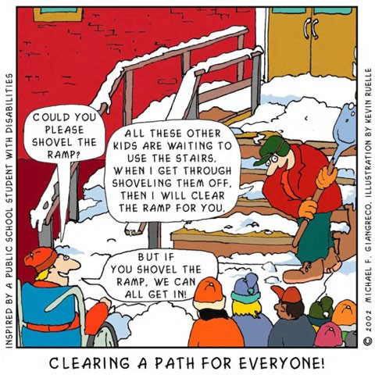  
Comic full text description

## Cartoon of a person shoveling snow on stairs. Clearing a path for everyone!Early Learning and Care Inclusion News

The California Department of Education (CDE) has released a notice for local educational agencies (LEAs) regarding the passage of Assembly Bill 1938 which went into effect on January 1, 2025. This bill requires LEAs to consider the full language access needs of students who are deaf, hard of hearing, or deafblind when implementing universal design for learning initiatives, pursuant to *Education Code* (*EC*) sections 56326.5(a) and 56345(d). When an individualized family service plan or individualized education program (IEP) team is determining the least restrictive environment for deaf, hard of hearing, or deaf-blind students, they must consider the language needs of the student pursuant to *EC* sections 56326.5(a) and 56345(d) and review services and placements options.

Please see the official guidance posted on the CDE web page at [Inclusion and Universal Design for Learning for Deaf, Hard of Hearing, and Deafblind Students – Laws, Regulations, and Policies](https://www.cde.ca.gov/sp/se/lr/om062725.asp).

If you have any questions regarding this subject, please contact the CDE at [CDESPEDDIRECTOR@cde.ca.gov.](mailto:CDESPEDDIRECTOR@cde.ca.gov)

## Inclusion Spotlight

### The CHIME Preschool Inclusion Program



The CHIME Preschool Program, originally known as the Children's Center Handicapped Integration Model Educational (CCHIME) Project, was established in 1990, provides interdisciplinary, developmentally appropriate programming, services and support for inclusion of young children with disabilities in a general education preschool setting. In partnership with an early childhood program on the campus of California State University, Northridge, (CSUN) our program features include:

* Developmentally appropriate interventions and therapies embedded within typical early childhood classroom settings and activities
* Emphasis on natural social and communication skills practice with peers
* Individualized instructional techniques and approaches to classroom accommodations and modifications planning
* Interdisciplinary team planning and provision of services within the classroom environment
* Multidisciplinary staff that includes Early Childhood Special Education Credential Teachers, Speech Pathologist, Occupational Therapist and Physical Therapist

#### Here are some highlights:

**General Education and Special Education Collaboration and Partnership:** We believe that a high-quality early childhood education program can provide the best learning environment for all young children, including those with extensive support needs. In our experience, by following a developmentally appropriate framework, such programs encourage children to learn through exploration and play and consider children’s individual characteristics. In addition, children can learn a great deal from observing and playing with each other. By offering opportunities for children of all abilities to learn together, same-age peers can provide more advanced models of important skills including play, social skills, and language.

#### We utilize the following practices:

* **Universal Design for Learning (UDL):** By utilizing a UDL framework with proactive team planning we can address the diverse group of children we serve, creating increased opportunities for accessing and processing of information. We see in our practice that having multiple options for engagement, representation, and expression, enables every child to participate fully and learn according to their individual strengths and interests.
* **Naturalistic approaches and embedded instruction:** We also know that some children with disabilities may require specific interventions and specialized instruction. Therefore, our model includes a multidisciplinary team that includes early childhood special education teachers, a speech and language pathologist, and occupational and physical therapists to support children alongside the general education staff. A great deal of collaboration, including interdisciplinary team planning and provision of services within the classroom environment allows instruction to occur in typically occurring activities, routines and transitions. Teaching opportunities are either child initiated or based on the child's interest and allow us to address a wide range of developmental needs and IEP objectives. Supporting children’s participation in a number of developmentally appropriate activities alongside same-age peers is an effective practice for teaching a wide range of skills including language, social and pre-academic skills. This practice also supports the generalization of skills across settings, activities and people.

#### Collaboration with Families: Quotes on Benefits of Inclusive Opportunities

We strive to establish and maintain collaborative relationships with families by recognizing each family’s strengths and by welcoming their participation in a variety of activities. By creating a welcoming environment, we can best support families in achieving the goals they have for their child. The partnership between families and staff also leads to establishing high expectations for each child. Some of the feedback from families when asked to send us quotes on “the benefits of inclusive opportunities in CHIME for their child” are the following:

* *“CHIME’s inclusive model has been a significant contributor to our child’s social-emotional development and academic progress. He has meaningful connections both with his classmates and the teachers. Full inclusion means he is a true member of the community, developing alongside his peers and contributing towards the rich tapestry that makes our world a better place.”*
* *“We have seen our child’s developmental skills soar as a result of his participation. He went from having only one or two verbal words at the age of 2, to speaking in clear and full sentences before he turned 5. He can proudly recognize and pronounce all the letters of the alphabet, count up to 10, and spell his own name. He has made a number of friends which makes him excited to attend school every day. He has gained confidence in himself and learned how to function in a classroom setting.”*
* *“Since being in an inclusive setting at CHIME, my son has made amazing progress. His social skills have really grown as he’s playing more with other kids and making friends. His speech is clearer, and he’s communicating more. He’s gotten better with daily routines, table activities, and listening to adult directions. Overall, he’s a more confident and happy four-year-old. The inclusive setting at CHIME has truly helped him thrive!”*
* *“My child is not only supported in their learning and development, but also fully accepted and included in the classroom. What sets CHIME apart is its commitment to inclusion in the truest sense—where all students, regardless of ability, learn and grow together. We’ve seen firsthand how this approach benefits everyone: children with special needs gain confidence and connection, while typically developing peers grow in empathy, understanding, and leadership.”*

#### Demonstration site with Supporting Inclusive Practices

We are proud to have been a demonstration site for Supporting Inclusive Practices. In addition to showing what a fully inclusive early childhood program looks like, and the opportunity to learn from staff and families, we also share the importance of our partnership with CSUN. All CHIME educational programs are demonstration and educator development sites for CSUN and we use a collaborative team approach among teachers and professional staff, parents, and CSUN faculty and students. There are many mutual benefits of school-university partnerships including reducing the gap between research and practice and enhancing professional development and we highly recommend it.

After 35 years, we hope to continue to demonstrate that collaboration and partnerships—with and between staff members, families, university and community—are what makes early childhood inclusion work.

## Transitions

Children grow and change so quickly—it’s amazing to watch! Early Intervention (EI) services are designed to support children from birth until their third birthday. After that, EI services end. If a child is likely to need continued support as they enter preschool, it’s important for families and educators to work together early on. Thoughtful planning helps ensure a smooth and successful transition for the child. Check out the transition resources shared from the Center for Parent Information on transitions

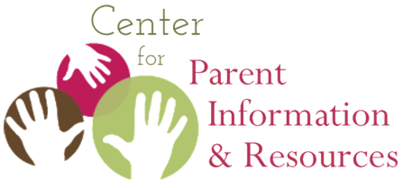

[Transition to Preschool  
Center for Parent Information and Resources](https://www.parentcenterhub.org/transitionpreschool/)

## Social Emotional Resource Highlight

The ***Preschool/Transitional Kindergarten Learning Foundations*** (PTKLF) provides guidance to all California early education programs, including transitional kindergarten, federal and state preschool programs (for example, California State Preschool Program, Head Start), private preschool, and family childcare homes, on the wide range of social and emotional knowledge and skills that children age three to five and a half typically attain when attending a high-quality early education program. Teachers can use the PTKLF to guide their observations, set learning goals for children, and plan for developmentally appropriate, equitable, inclusive practice, including how to design learning environments and create learning experiences that promote children’s learning and development in the Social and Emotional Development domain.

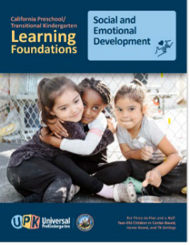  
[CA PTKLF Social and Emotional Development - Resources](https://www.cde.ca.gov/sp/cd/re/documents/ptklfsocialemotionaldev.pdf)

## Upcoming Events and Learning Opportunities

* **Division for Early Childhood (DEC) Conference:** October 7–10, 2025. Portland, Oregon. [DEC’s 41st Annual International Conference on Young Children with Disabilities and Their Families (DEC)](https://www.decconference.org/). DEC is the Division for Early Childhood; part of the Council for Exceptional Children.
* **Early Childhood Investigations Webinar:** October 8, 2025. Virtual - [Lights On, Joy Up: Reframing Challenging Behaviors and Reigniting Your Purpose by Dr. Nefertiti Poyner (Early Childhood Webinars)](https://earlychildhoodwebinars.com/webinar/lights-on-joy-up-reframing-challenging-behaviors-and-reigniting-your-purpose-by-dr-nefertiti-poyner?utm_campaign=email-promotion&utm_medium=email&_hsenc=p2ANqtz-9aGxSwlG5MCveSoNZvdsH_71ODgy9AS6xcu-PocwUr-n4LpxWLdpf-gpGYuCZvm49rDc2WlAqazqqHQn7oSoRs_G3aVQ&_hsmi=356859785&utm_source=email-marketing)
* **Early Childhood Investigations Webinar:** October 16, 2025. Virtual - [The Compassionate Coach: Building Bridges to Support Educators with Challenging Behaviors by Prerna Richards, MBA (Early Childhood Webinars)](https://earlychildhoodwebinars.com/webinar/the-compassionate-coach-building-bridges-to-support-educators-with-challenging-behaviors-by-prerna-richards-mba?utm_campaign=email-promotion&utm_medium=email&_hsenc=p2ANqtz-9aGxSwlG5MCveSoNZvdsH_71ODgy9AS6xcu-PocwUr-n4LpxWLdpf-gpGYuCZvm49rDc2WlAqazqqHQn7oSoRs_G3aVQ&_hsmi=356859785&utm_source=email-marketing)
* **California Early Childhood Special Education Network (CalECSE):** October 7–8, 2025. San Diego, CA - ["Reaching New Heights" 3rd CalECSE Symposium (CalECSE)](https://www.calecse.org/symposium2025)
* **Every Child California Fall Technical Assistance:** October 28–30, 2025. Newport Beach, CA - [Fall Technical Assistance (EveryChild California)](https://www.everychildca.org/fall-ta)
* **National Association for the Education of Young Children (NAEYC) Annual Conference:** November 19–22, 2025. Orlando, Florida - [Annual Conference (NAEYC)](https://www.naeyc.org/events/annual)

## In case you missed it

**CalECSE Assessment Practices Resources** - Would you like to learn more about early childhood assessments? Please visit the CalECSE “Resources” page and click on the “Assessment Practices” link. There you will find videos of highly reviewed trainings including Early Childhood Autism Assessments, as well as downloadable training portable document formats (PDFs) on a wide range of topics. For more information, please visit the [CalECSE Resources](https://www.calecse.org/news-resources) web page.

**edWebinars** - [The Creating Empathic and Inclusive Spaces Where Every Child Belongs (edWeb)](https://home.edweb.net/webinar/classroommanagement20250410/) webinar, presented by Miriam Beloglovsky, Author, Professor Emeritus, International Speaker, Designer, and Consultant, Playful Transformation, LLC, can be watched on their webpage as a recording.

**The DEC eLearning Library** - Welcome to [DEC's eLearning Library](https://www.dec-sped.org/elearning-library)! This page brings together all the DEC eLearning materials in one place to help our members and visitors find DEC's e-based learning resources easily (modules, courses, webinars, and so on).

## Contact Us

[Impact Inclusion Workgroup - Child Development](https://www.cde.ca.gov/sp/cd/op/impactinclusionworkgroup.asp)

**Email the Inclusive Universal PreKindergarten Office, CDE:**  
[InclusionSupport@cde.ca.gov](mailto:InclusionSupport@cde.ca.gov)

To receive future newsletters and other early education announcements and news from the CDE, please subscribe to [subscribe-cdep3updates@mlist.cde.ca.gov](mailto:subscribe-cdep3updates@mlist.cde.ca.gov)



## Image Full Text Descriptions

### Clearing a Path for Everyone Comic

Inspired by students with disabilities. A person is shoveling snow off stairs. Next to the stairs is a ramp covered in snow. There is a group of people nearby. One person in the group is in a wheelchair and has a speech bubble that reads “Could you please shovel the ramp?”. The shoveler responds “All these other kids are waiting to use the stairs. When I get through shoveling them off, then I will clear the ramp for you.” The person in the wheelchair responds, “But if you shovel the ramp, we can all get in!”