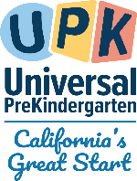

CA Early Childhood Inclusion Support
Summer 2026 Newsletter
California Department of Education
June 9, 2026

Inspiration Highlight
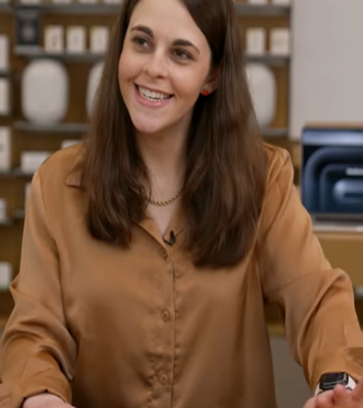
Meet Jordyn Zimmerman!
Jordyn Zimmerman is an educator and nationally recognized disability advocate whose journey with autism fuels her commitment to inclusive communication. Gaining access to augmentative communication at 18 transformed her life and sparked global advocacy through speaking, writing, and leadership. A Forbes Accessibility 100 honoree, Apple Distinguished Educator, and Board Chair of CommunicationFIRST, Jordyn champions access, equity, and truly inclusive communities for all learners. Check out the interview with Jordyn (YouTube video; 5:16).

Early Learning and Care Inclusion News
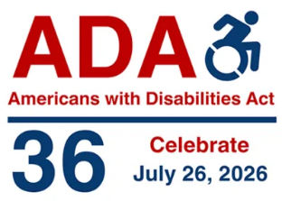
The Americans with Disabilities Act (ADA) was signed into law 36 years ago on July 26, 1990.
The ADA of 1990 is a landmark civil rights law prohibiting discrimination against individuals with disabilities in all areas of public life, including jobs, schools, transportation, and public/private places open to the general public. It ensures equal opportunity, accessibility, and reasonable accommodations, functioning across five titles covering employment, government services, public accommodations, telecommunications, and miscellaneous provisions. To learn more about the ADA, visit the Americans with Disabilities Act (ADA.gov).
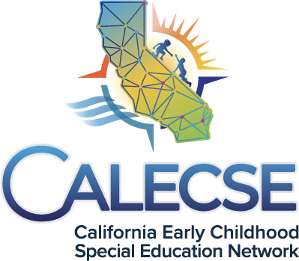
The California Department of Education (CDE) Special Education Division recently released a new video series called Transition from Early Start Video Series. These are a set of parent-friendly videos designed to support families as they navigate the transition from Individuals with Disabilities Education Act Part C to Part B services. Developed by the CDE in partnership with the California Early Childhood Special Education Network (CalECSE), this engaging series is offered in six languages—English, Spanish, Mandarin, Korean, Vietnamese, and American Sign Language. The videos are designed to educate, empower, and guide parents in understanding the transition process and accessing the services their children may need. Click on the link to access the video series https://calecse.org/parent-videos.

Inclusion Spotlight

San Mateo-Foster City School District
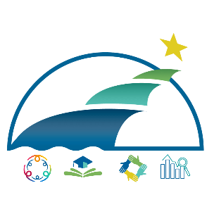
The San Mateo–Foster City School District is committed to ensuring that all young learners have equitable access to high-quality, inclusive early learning environments. As an Inclusive Early Education Expansion Program (IEEEP) grantee and through purposeful collaboration between General Education and Special Education, the District has developed a cohesive preschool system that prioritizes access, consistency, and family-centered practices. By utilizing funds from their IEEEP grant, they have been able to align systems, strengthen cross-department partnerships, and embed inclusion into enrollment and program design. The district has created structures that better support children with diverse learning needs while fostering meaningful participation alongside peers.
This spotlight highlights the district’s intentional efforts to strengthen collaboration, expand inclusive preschool opportunities, center family voice, and enhance learning environments. Together, these initiatives reflect a systemwide commitment to inclusive practices that promote belonging, development, and success for every child.

General Education and Special Education collaboration and partnership
The San Mateo-Foster City School District has strengthened the partnership between General Education and Special Education through intentional, systemwide collaboration focused on improving access, coordination, and inclusive practices in preschool programs. This collaboration is reflected in the shared work of preschool administrators, enrollment specialists, and special education leadership, who have come together to design and implement more coherent and aligned processes across departments.
Through this partnership, teams have worked collaboratively to streamline districtwide enrollment, referral, and placement systems. A key outcome of this work has been the clarification of communication pathways between general education and special education staff, ensuring that information is shared efficiently and consistently across teams. In addition, the district has standardized how inclusion spaces are identified and offered to families, promoting equitable access and reducing variability in decision-making. Enrollment staff have also been cross-trained to support both general and special education processes, enabling them to guide families through eligibility, assessment, and placement in a way that is unified, transparent, and responsive to family needs.
To further deepen collaboration, the district centralized its PreK evaluation teams at the main preschool center, creating a shared space where general education and special education professionals work in close partnership. By co-locating psychologists, speech and language providers, special education staff, enrollment specialists, and preschool leadership, the district has fostered a more integrated approach to supporting children and families. This structure has enhanced real-time collaboration, allowing teams to engage in immediate problem-solving, align decisions, and coordinate services more effectively. It has also strengthened communication with families by providing a single, welcoming location where multiple supports and services are accessible.
As a result of this strong General Education and Special Education partnership, the district has reduced fragmentation across systems. Most importantly, this collaboration has created more cohesive, family-centered structures that support inclusive practices and ensure that all children have access to high-quality early learning environments.

The spectrum of inclusion services the program offers
The district offers a comprehensive spectrum of inclusion services designed to ensure that children with exceptional needs have meaningful access to high-quality early learning environments alongside their peers. This spectrum reflects a strong commitment to the least restrictive environment (LRE) and is grounded in intentional, systemwide planning across preschool leadership, site administrators, special education teams, and enrollment staff.
For the 2025–26 school year, the district expanded inclusive access across Early Learning Centers by designing 21 preschool classrooms to each include three designated inclusion enrollment spaces. These spaces are not incidental but purposefully built into classroom structures to ensure that children with disabilities can be served within general education settings. This approach allows for a continuum of supports, where children receive individualized services—such as speech and language therapy, specialized instruction, or behavioral supports—while actively participating in the daily routines and learning experiences of a general education classroom.
This inclusive model promotes social connection, language development, and peer learning, while also ensuring that specialized supports are delivered in natural, integrated environments. By embedding inclusion into enrollment and classroom design, the District moves beyond isolated or separate programming and instead creates equitable access points for all learners.
Together, these efforts represent a cohesive and sustainable system of inclusion services that aligns enrollment practices with LRE requirements, increases access to inclusive placements, and reinforces the district’s commitment to welcoming and supporting every child within community-based early learning settings.

Parent Testimony
“Como padre, he visto en mi hijo un progreso muy grande desde que forma parte del programa preescolar de inclusión. Uno de los cambios más notables ha sido en la comunicación. Él está aprendiendo a hablar por primera vez y siento que realmente tiene voz propia. Su voz se fortalece cada día.Ahora conversa más conmigo y estoy seguro de que este progreso es en gran parte por el tiempo que pasa en la escuela aprendiendo con sus compañeros. Como padre, me siento muy apoyado. Durante este tiempo he formado parte de las conversaciones y decisiones sobre la educación de mi hijo y dónde es el mejor lugar para él, lo cual ha marcado la diferencia. Me siento agradecido por la colaboración y las muchas oportunidades que el programa nos ha brindado.”
As a parent, I have seen incredible progress in my child since being part of an inclusive preschool program. One of the most meaningful changes has been in his communication. He is learning how to speak, and for the first time, I truly feel like he has a voice. That voice is growing stronger every day. He talks with me so much more now, and I know that this progress is connected to the time he spends learning alongside his peers. I also feel deeply supported as a parent. Throughout this process, I have felt included in conversations and decisions about my child’s placement, which has made a significant difference. I am grateful for the care, collaboration, and opportunities this program has provided.

Additional Information - Facility Enhancements and Improvements
Turnbull Child Development Center has transformed its outdoor environment into a space that reflects the developmental needs of all learners. The enhanced playground offers safe, engaging, and meaningful opportunities for play, ensuring that every child can access and participate fully. These updates have brought a renewed sense of excitement to the campus while creating an inclusive outdoor space that better supports the diverse needs of students.
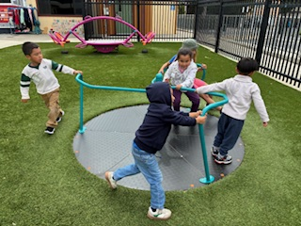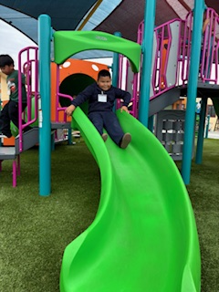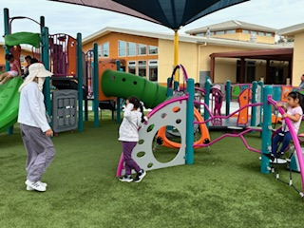

Transitions

Supporting the Universal PreKindergarten to Kindergarten Transition Using Scripted Stories
Moving from an early childhood or transitional kindergarten program to kindergarten is an exciting milestone, but it can also be stressful for young children with disabilities and their families. Kindergarten can bring longer days, busier classrooms, new routines, and unfamiliar adults. With intentional planning and collaboration, this transition can be supportive and successful.
Prepare Children Ahead of Time
One way to help with this transition is by using scripted stories. They are a way to introduce children to what kindergarten will be like. These short, personalized stories explain changes in simple language, recognize possible emotions, and highlight positive supports such as teachers who will help them learn. Including pictures makes the information easier to understand and can reduce anxiety.
Photo books are another effective tool. A simple book with pictures of the new classroom, teachers, lunchroom, and school building helps children become familiar with their new environment over the summer. Unlike social stories, photo books focus only on introducing people and places.
Below are a couple of links to help with ideas and the creation of scripted stories in your program.
Scripted Story Archives (National Center for Pyramid Model Innovations)
Personal Stories to Help Children Get Ready for School (NAEYC)

Social Emotional Resource Highlight
- Coming Soon! A Toolkit for supporting social-emotional development and reducing suspension and expulsion will be released in Fall 2026 by the California Department of Social Services (CDSS) to support educators and programs working with young children. Stay tuned!
- Save the Date! Beginning in August 2026, the CDSS will be partnering with the Pyramid Model Consortium to offer funded slots to interested parties to take the Pyramid Model ePyramid Courses. The ePyramid Model is an online training program for the early childhood workforce. Participants will learn how to enhance social-emotional development in young children, without ever leaving the classroom. These online courses make new-hire and recurrent training for staff easier. Like all of the Pyramid Model work, the courses are evidence-based and promote nurturing relationships between staff and children. Each course is on-demand so the workforce learns at their own pace.
- Resource Highlight from the Inclusive Early Education Resources website
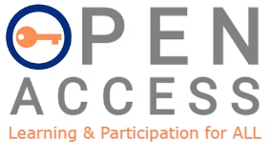
The goal of Open Access is to build and support California schools with long-term, sustainable changes, so schools include and provide access for ALL students. Leadership teams are critical in building a statewide system of support in Universal Design for Learning (UDL), Accessible Technology, and Augmentative Alternative Communication content areas. This project is developed and supported by Placer County Special Education Local Plan Area, Placer County Office of Education, California Collaborative for Education Excellence, and the CDE. Open Access 2.0 - Learning and Participation for All Students

Children With Disabilities Office Hours
More to come Fall 2026

Upcoming Events and Learning Opportunities
- Division for Early Childhood (DEC) Coffee and Policy Chats - Special Edition: Tuesdays and Thursdays every other week January through June 2026. Virtual. DEC Coffee Chats Policy and Advocacy Special Edition.
Join DEC and your fellow community members for DEC Coffee Chats Policy and Advocacy Special Edition – Held virtually Tuesdays and Thursdays every other week January through June 2026! We will discuss current policy issues and share resources. Each chat will begin with 20–30 minutes of federal updates followed by time for you to connect with your peers.
Members and non-members alike are welcome to attend!
DEC Coffee and Policy Chats are not recorded to help facilitate a space for open discussion.
- CalECSE 2026 4th Annual Conference: October 20–21, 2026. Burlingame, California. “Tiny Steps to Golden Futures” CalECSE Symposium.
For the first time, CalECSE's annual Symposium is heading to Northern California! Join early childhood leaders, educators, service providers, and family partners for two inspiring days of learning, connection, and collaboration in the heart of the San Francisco Bay Area. Tiny Steps to Golden Futures centers California's youngest learners with disabilities and the adults who support them - honoring the small, intentional steps that lead to meaningful, lifelong outcomes.
- DEC 42nd Annual International Conference on Young Children with Disabilities and Their Families: October 26–29, 2026. Omaha, Nebraska.
DEC2026 is the premier international conference focused on inclusive early childhood practices, early intervention, and early childhood special education. The conference brings together practitioners, researchers, faculty, family members, and community partners from around the world to engage in evidence-based learning, innovative research, and collaborative dialogue grounded in the DEC Recommended Practices.
Join us for four days of learning, connection, and shared commitment to advancing equity, inclusion, and positive outcomes for young children with disabilities and their families. DEC 42nd Annual International Conference on Young Children with Disabilities and Their Families.
- The ZERO TO THREE LEARN Conference 2026: October 27–29, 2026. Portland, Oregon. Ready for the biggest gathering in early childhood? The ZERO TO THREE LEARN Conference 2026 has it all. Educators, mental health leaders, researchers, advocates, policymakers and you. Whatever your role, you will find your people here. Register today 2026 LEARN Conference (Elevate Early Childhood Education).
- Every Child California’s Fall Technical Assistance: October 27–29, 2026. Newport Beach, California.
Join EveryChild CA at our biggest annual event, the Fall Technical Assistance. You’ll enjoy 3 days packed with insights, inspiration, professional growth, and support. We have 30+ sessions to choose from as presented by industry experts and directly from the CDE, CDSS, and Community Care Licensing Division. Our packed schedule includes many opportunities to connect with over 500 of your colleagues in ECE, industry partners, community experts, and much more. We look forward to seeing you at our most popular signature event of the year!
- 4th Annual CAUDLeading the Way Summit: December 7–8, 2026. Stockton, California.
This exciting two-day event will bring together the best of California's UDL practitioners for a dynamic experience featuring:
- Local UDL experts
- Interactive workshops
- Inspiring presentations
- Collaborative discussions
- Opportunities to connect and network
Whether you're new to UDL or a seasoned practitioner, this summit is your chance to learn, share, and grow alongside a passionate community.
Registration opens August 23, 2026!
CAUDL Summit Website: CAUDLeading the Way
- Early Childhood Conferences 2026: The Best Early Childhood Conferences of 2026 (Zero to Three).
- Inclusion Webinars Coming Soon! Starting in the Fall of 2026, the CDSS, in partnership with WestEd, will be offering a series of five webinars on inclusion related topics, with the opportunity for technical assistance and collaborative conversations following each webinar. More information to come soon!
- Teaching Pyramid Coming Soon! Beginning in the Fall of 2026, the CDSS, in partnership with WestEd, will be offering California Teaching Pyramid training and coaching to groups of family child care providers in English and Spanish. More information to come soon!

In case you missed it

The CDE released the Inclusion Toolkit Supporting Inclusive Preschool Practices for All Children. You can find the Inclusion Toolkit, as well as other toolkits, on the CDE Toolkit web page, or you can go directly to the Inclusion Toolkit. The Inclusion Toolkit can also be accessed on the CDE Inclusive Early Education Resources web page.

Contact Us
Impact Inclusion Workgroup
Email the Inclusive Universal PreKindergarten Office, CDE: InclusionSupport@cde.ca.gov
For information on CDE news related to our P-3 initiative and to ensure you receive updates about future webinars and learning opportunities, email "subscribe” to subscribe-cdep3updates@mlist.cde.ca.gov.

