California Department of Education
Page 1 of 3
Modified: September, 2021

District of Choice Data File Download Instructions
Instructions for importing the District of Choice text data files into Excel.
- Open Excel.
- Select the File tab in the upper left corner and select the option to Open.
- Select “Browse” and change the files of type to text.
- Navigate to where you saved the file and select the file and click Open.
- Excel will open a “Text Import Wizard.”
- In Step 1 of 3 in Text Import Wizard, select the “Delimited” radio button.
Image 1: Text Import Wizard Step 1 of 3
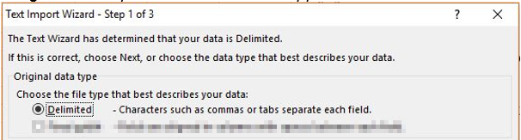
Long description for image 1 is available in Appendix A
- Then click the “Next” button on the bottom left corner.
- In Step 2 of 3, check only the “Tab” box under Delimiters.
Image 2: Text Import Wizard Step 2 of 3
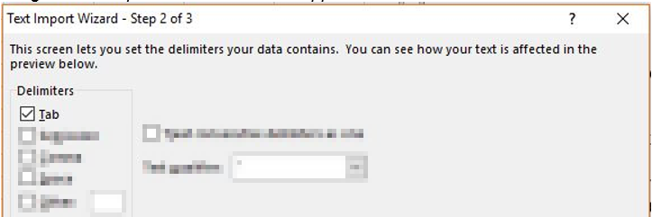
Long descriptive for image 2 is available in Appendix A

- Click the “Next” button on the bottom right corner.
- In Step 3 of 3, select “General” under the Column data format.
Image 3: Text Import Wizard Step 3 of 3
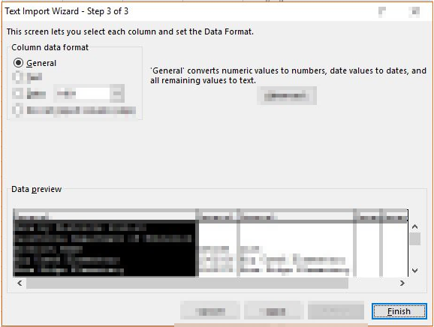
Long descriptive for image 3 is available in Appendix A
- Click the “Finish” button and the file will be imported correctly.

Appendix A

Descriptive Text for Images

Image 1: Text Import Wizard – Step 1 of 3 Window
The Text Wizard has determined that your data is Delimited. If this is correct, choose Next, or choose the data type that best describes your data.
Original data type:
Choose the file type that best describes your data:
- Delimited (radio button is selected) – Characters such as commas or tabs separate each field.

Image 2: Text Import Wizard – Step 2 of 3 Window
This screen lets you set the delimiters your data contains. You can see how your text is affected in the preview below:
The Delimiter check box named “Tab” is checked.

Image 3: Text Import Wizard – Step 3 of 3 Window
This screen lets you select each column and set the Data Format.
In the “Column data format” section, the “General” radio button I selected,
The “Finish” button is highlighted in the bottom right corner.

